Supplementary Information

Table S1: Linear regression equations for scaled root mean square error (SRMSE) for each parameter in which breaking lineages into low-divergence and high-divergence groups improved the regression model, summarizing how accuracy declines with diminished sample sizes. Parameters are effective population size (ν₁ and ν₂), time since divergence (T), and Θ (defined as 4N_{ref}μ, where N_{ref} is ancestral population size and μ is mutation rate per generation). Note that these are based on SMRSE values (to enable among-lineage comparisons; Table 3). Thus, y in the regression equation y = mx + b is SMRSE for that particular demographic variable (m is slope, x is N, and b is the y intercept).
SMRSE for variable | Regression equation (y = mx + b) | r² | P
ν₁ (low-div group) | y = -0.04467 * N + 0.40622 | 0.304 | 0.0052
ν₁ (high-div group) | y = -0.30251 * N + 1.68585 | 0.189 | 0.0299
ν₂ (low-div group) | y = -0.10533 * N + 0.69169 | 0.355 | 0.0021
ν₂ (high-div group) | y = -0.21646 * N + 1.25166 | 0.352 | 0.0018
T (low-div group) | y = -0.04739 * N + 0.40888 | 0.395 | 0.0010
T (high-div group) | y = -0.15276 * N + 0.99239 | 0.328 | 0.0028
Θ (low-div group) | y = -0.02843 * N + 0.26395 | 0.202 | 0.0275
Θ (high-div group) | y = -0.04878 * N + 0.43241 | 0.303 | 0.0043

Table S2. Genomes used for calculation of substitution rates and time since most recent common ancestor (TMRCA, from Claramunt & Cracraft, 2015), substitution rate, and generation time for each lineage in which demographic parameters are translated into biologically meaningful values in this paper.

 | Genome | GenBank accession number | TMRCA (my) | Substitution rate (subs/site/gen) | Generation time (yrs) | Sources
Tringa brevipes /T. incana | Charadrius vociferus | GCA_000708025.2 | 53.5153 | 2.453 x 10⁻⁹ | 4.88 | (Gill, McCaffery, & Tomkovich, 2002)
Pinicola enucleator subspp. | Zonotrichia albicollis | GCA_000385455.1 | 21.7098 | 1.577 x 10⁻⁹ | 2 | (Adkisson, 1999)
Pica pica/Pica hudsonia | Taeniopygia guttata | GCA_000151805.2 | 41.5132 | 1.304 x 10⁻⁹ | 2.5 | (Trost, 1999)

Supplementary Information figures
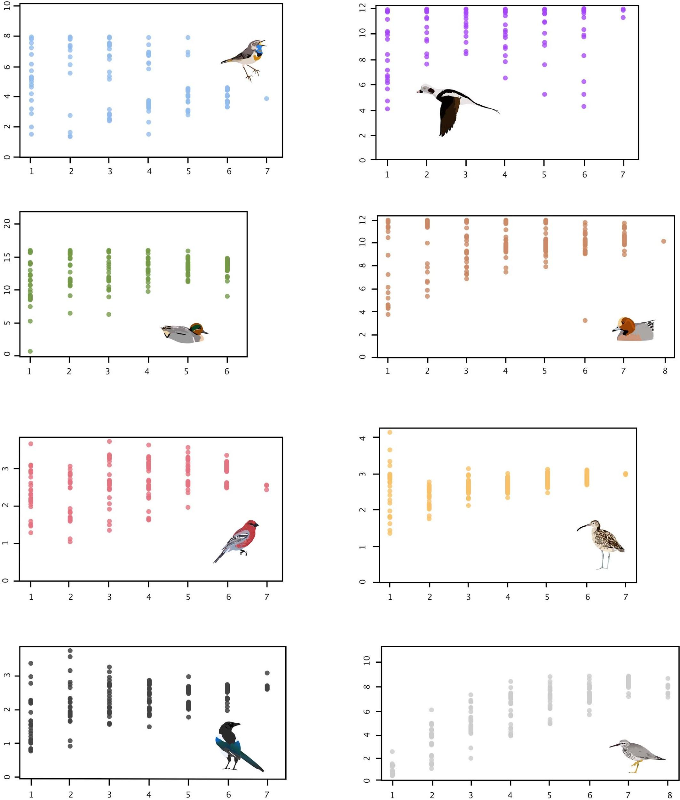
Figure S1: Estimates of ν₁ (effective size of population 1) at varying sample sizes in eight lineages (vertical axis is ν₁, and horizontal axis is sample size as number of individuals). Parameters are raw, unconverted values directly from δaδi analyses.

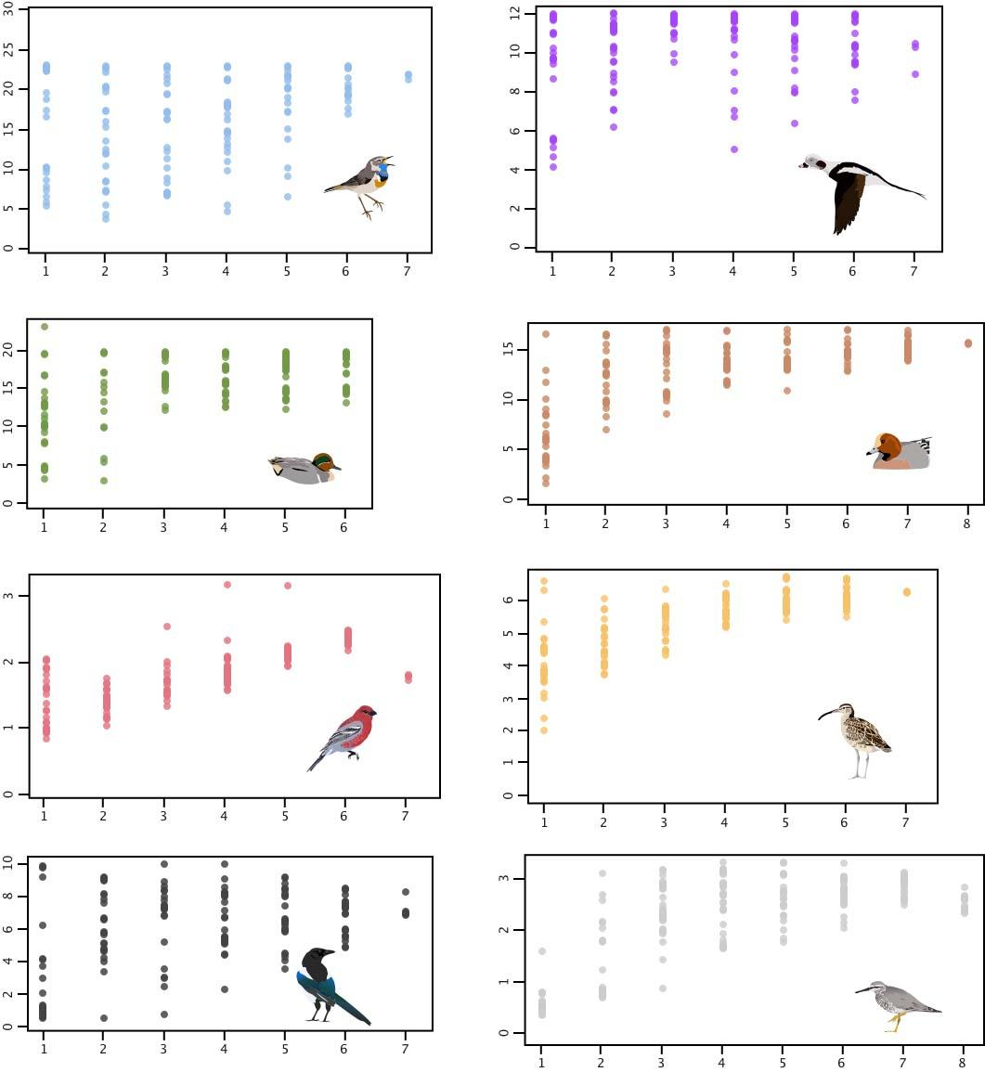
Figure S2: Estimates of ν₂ (effective size of population 2) at varying sample sizes in eight lineages (vertical axis is ν₂, and horizontal axis is sample size as number of individuals). Parameters are raw, unconverted values directly from δaδi analyses.

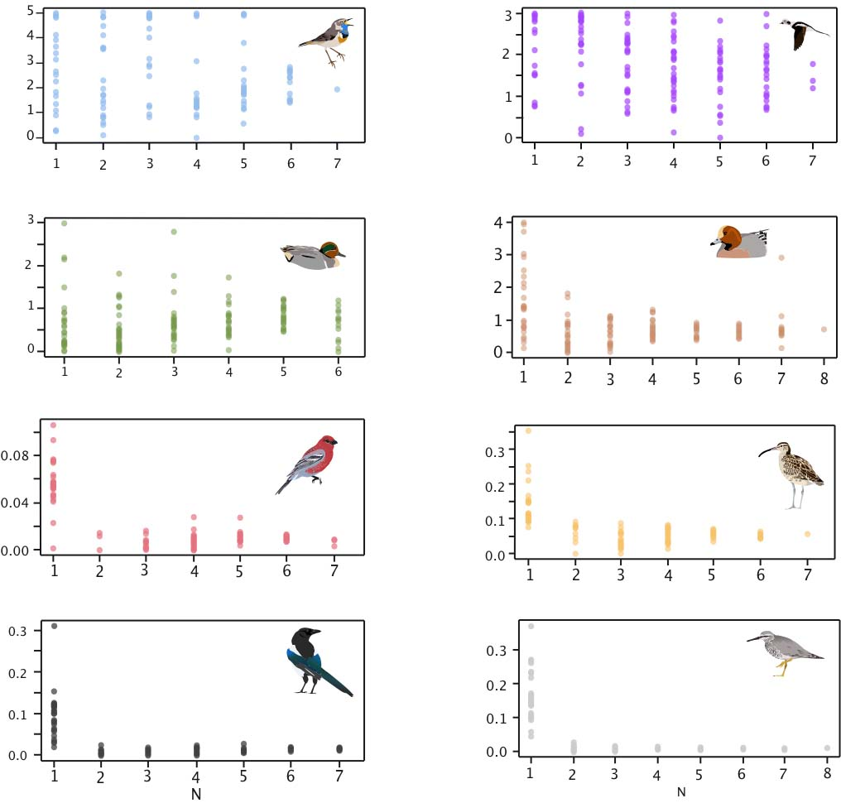
Figure S3: Estimates of m (migration or gene flow) at varying sample sizes in eight lineages (vertical axis is m, and horizontal axis is sample size as number of individuals). Parameters are raw, unconverted values directly from δaδi analyses.

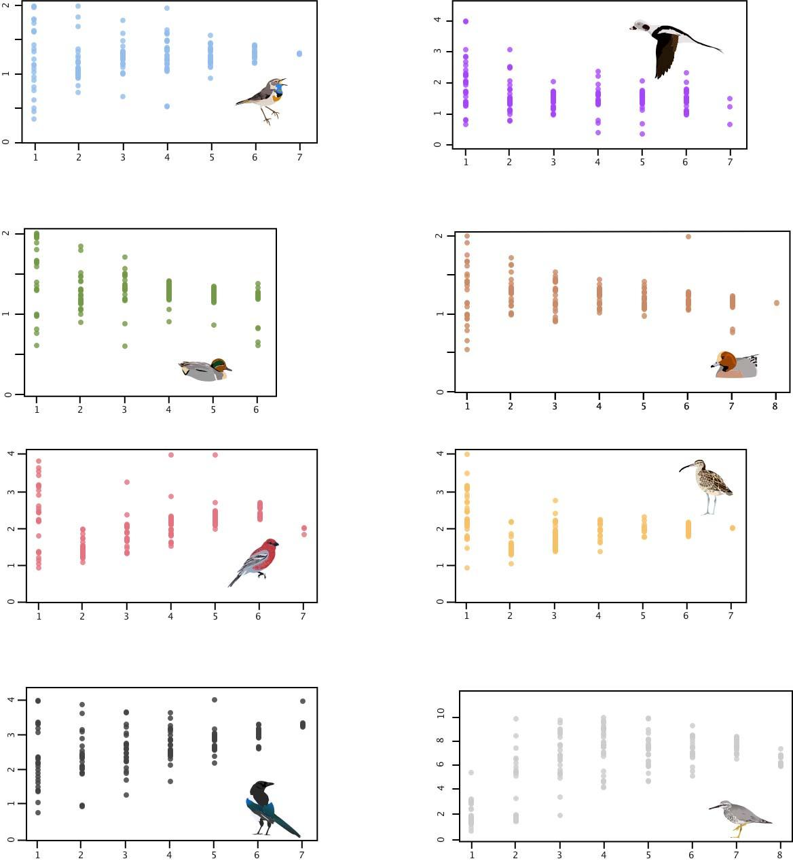
Figure S4: Estimates of T (time since divergence) at varying sample sizes in eight lineages (vertical axis is T, and horizontal axis is sample size as number of individuals). Parameters are raw, unconverted values directly from δaδi analyses.

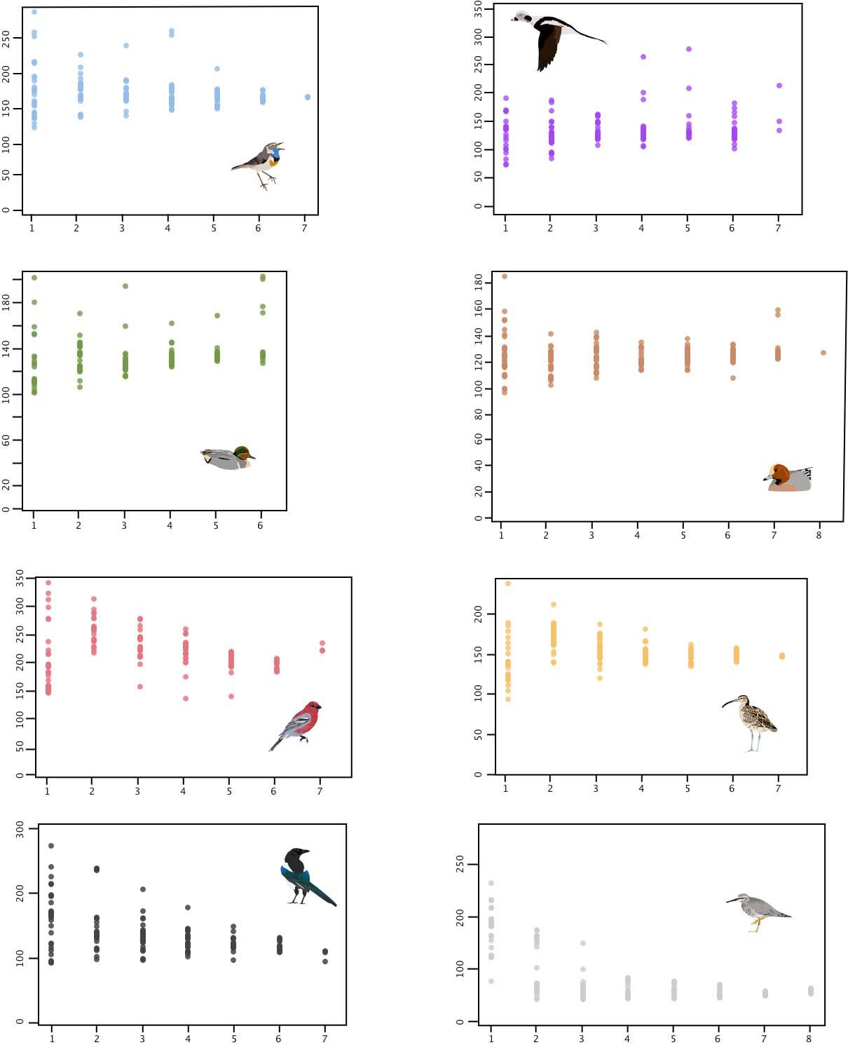
Figure S5: Estimates of Θ (4N_{ref}μ) at varying sample sizes in eight lineages (vertical axis is Θ, and horizontal axis is sample size as number of individuals). Parameters are raw, unconverted values directly from δaδi analyses.
Figure S6. Parameter-specific scaled root mean square error (SRMSE) values plotted against sample size (N). Note that vertical scales vary in each panel.
Low-divergence lineages High-divergence lineages
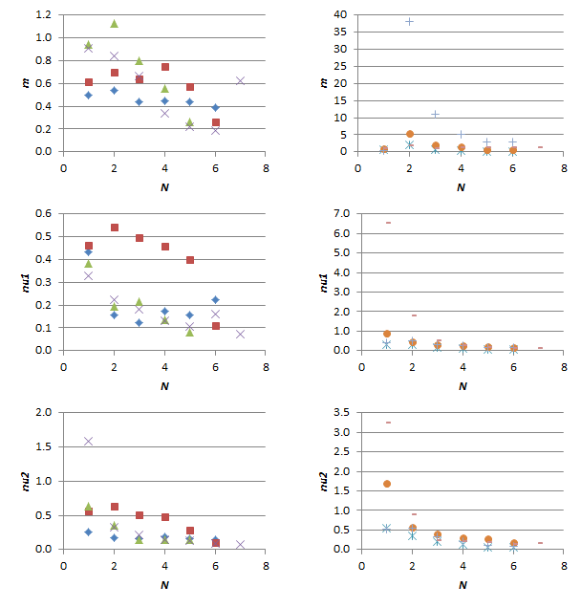

Figure S6, continued. Parameter-specific scaled root mean square error (SRMSE) values plotted against sample size (N). Note that vertical scales vary in each panel.
Low-divergence lineages High-divergence lineages
