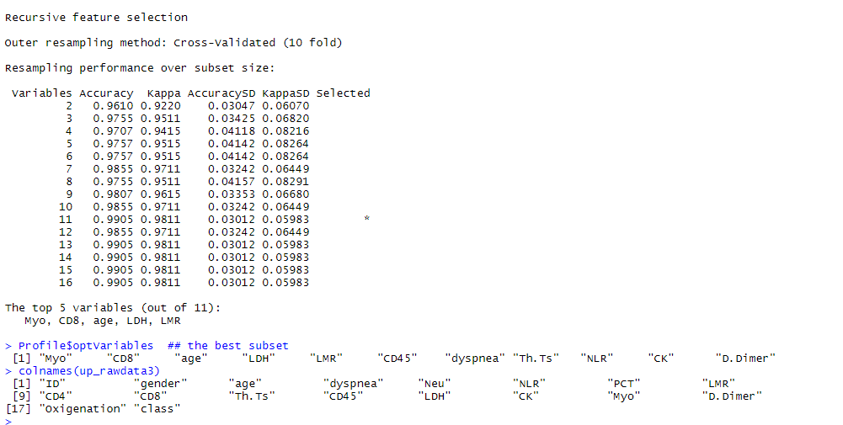
- The original data of the Recursive feature elimination (RFE) process of the feature selection with 10-fold cross-validation.
- The original data of the optimal mtry selection with 5-fold cross-validation.

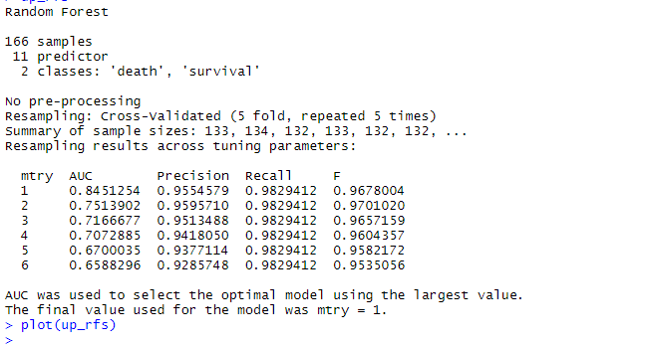

- The description of partial dependence correlation analysis.

Description
Description Partial dependence plot gives a graphical depiction of the marginal effect of a variable on the class probability (classification) or response (regression).

Details
The function being plotted was defined as:
${\tilde{f}}_{\left(x\right)}=\frac{1}{n}\sum_{n=1}^{n}{f\left(x,x_{ic}\right)}$
where x is the variable corresponding to the chosen clinical characteristic, and xiC represents the other variables in the clinical information. The summand was the predicted logits (log of a fraction of votes) for classification:
$f\left(x\right)=\log_{Pk}\left(x\right)-\frac{1}{k}\sum_{j=1}^{k}{\log_{Pj}⁡\left(x\right)}$
where K is the number of classes, and Pj is the proportion of votes for class j.

References:
Friedman, J. (2001). Greedy function approximation: the gradient boosting machine, Ann. of Stat.
Greenwell BM. 2017. pdp: An R package for constructing partial dependence plots. The R Journal 9:421-436.

