CHROMATOGRAMS FOR EXTERNAL STANDARDS
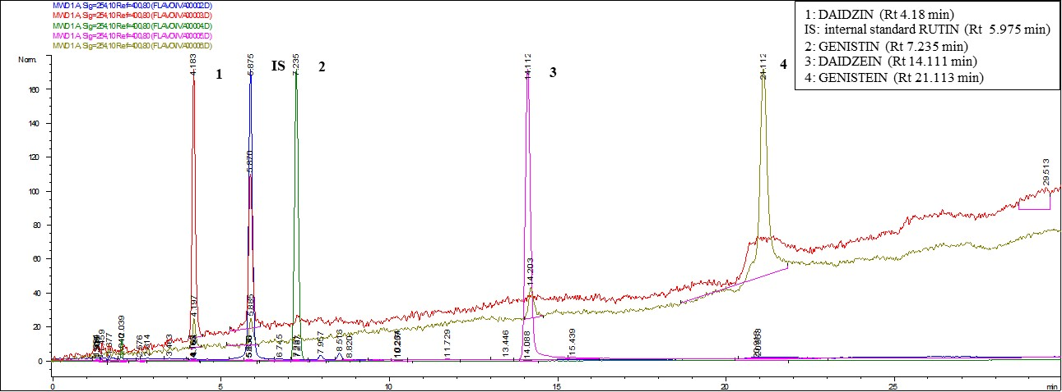

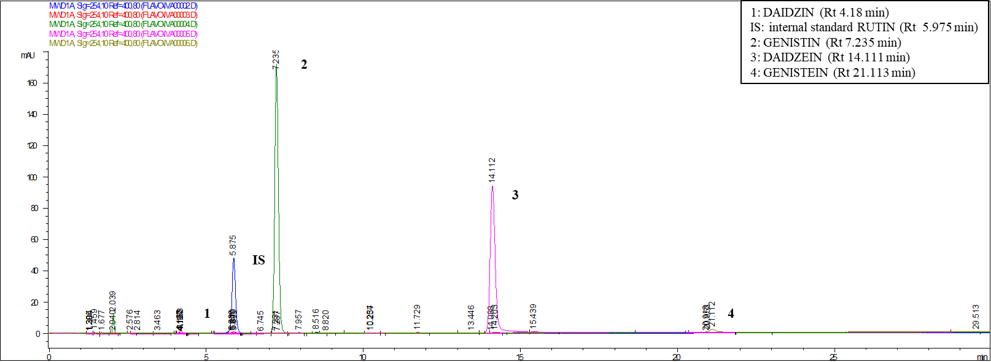

DAVIS CHROMATOGRAM EXAMPLE: SOYBEAN SEEDS EXTRACTS: CONTROL (BLUE) AND HERBIVORY (RED)

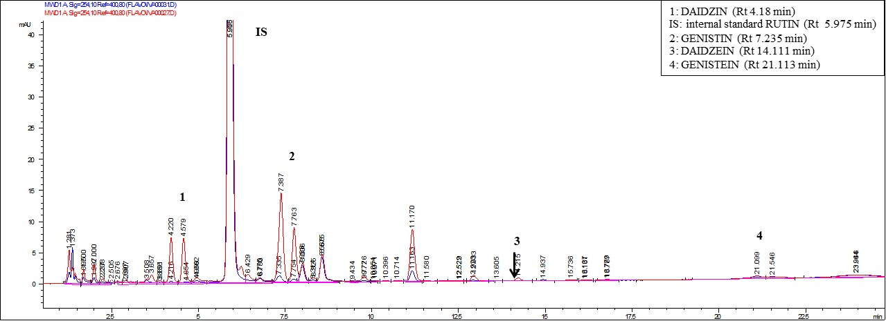

IAC-100 CHROMATOGRAM EXAMPLE: SOYBEAN SEEDS EXTRACTS: CONTROL (BLUE) AND HERBIVORY (RED)

