Supporting Information for

Building blocks for commodity augmented reality-based molecular visualization and modeling in web browsers

Luciano Andrés Abriata

Laboratory for Biomolecular Modeling, School of Life Sciences, École Polytechnique Fédérale de Lausanne and Swiss Institute of Bioinformatics, CH-1015 Lausanne, Switzerland.

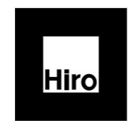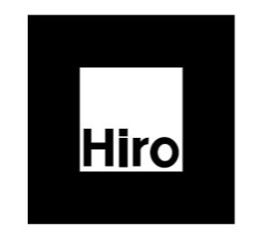
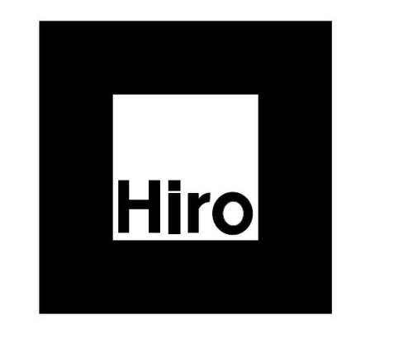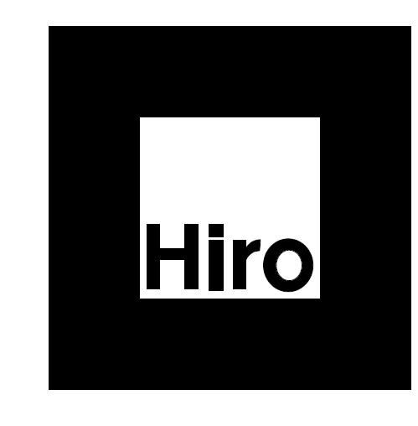
Figure S1. The Kanji and Hiro markers laid out in four different sizes, ready to print. It is recommended to glue the used markers on small devices that can be easily handled.

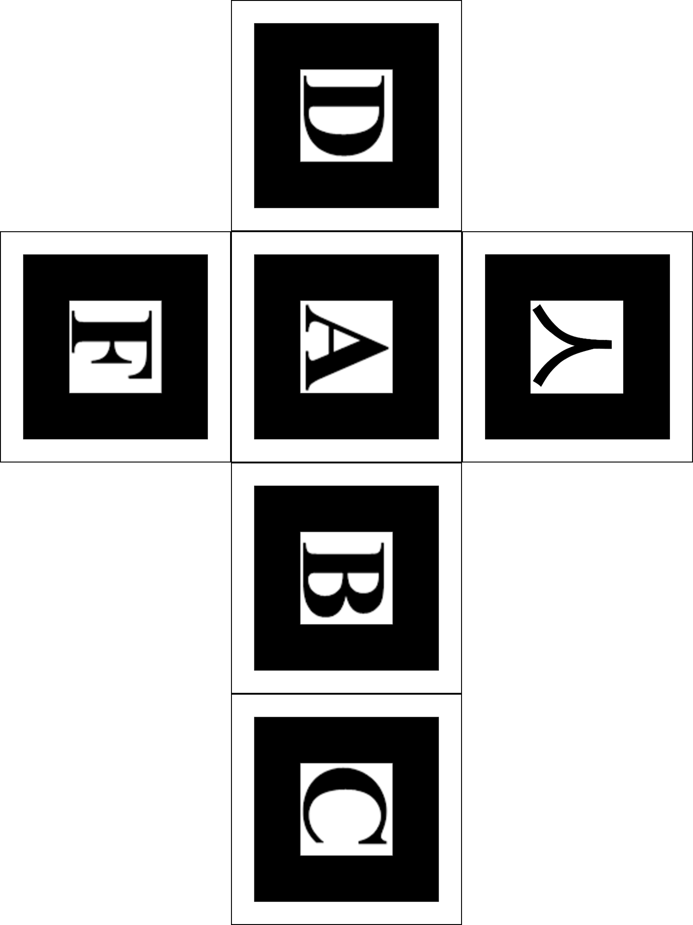

Figure S2. An example cubic marker, by Prof. Lee Stemkoski and available at https://github.com/stemkoski/AR-Examples/blob/master/markers/cube.png
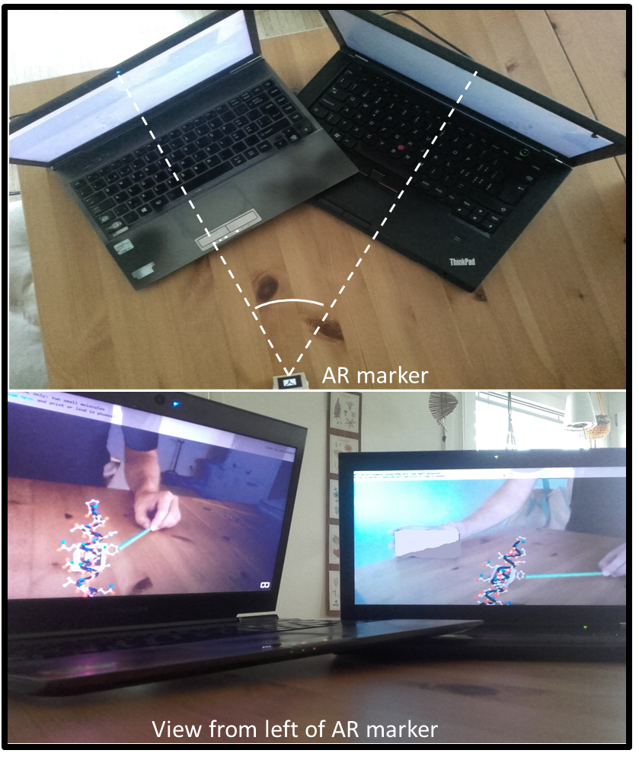
Figure S3. A small protein helix including an aromatic side chain, displayed on the same physical marker observed from two orientations. A physical green stick points at the aromatic amino acid. The example shows how marker-based AR facilitates concurrent view by multiple users.

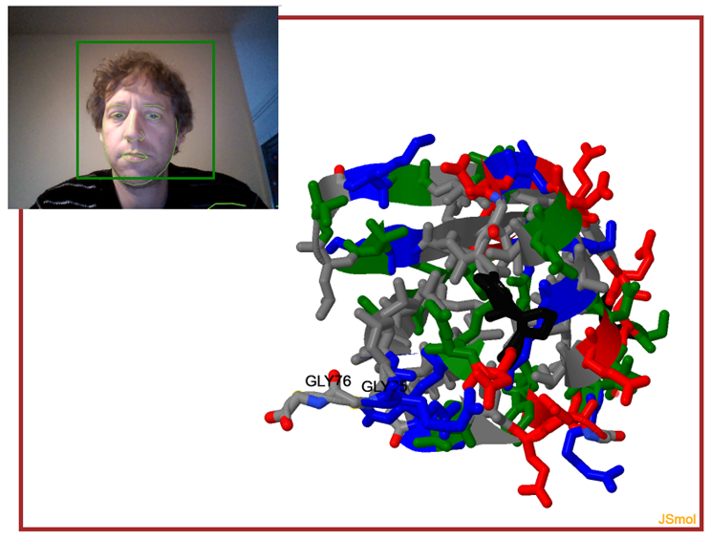Figure S4. WebGazer.js put to work to control JSmol, so that whatever region of the protein the user looks at comes to the front. I acknowledge Angel Herráez for help integrating both libraries. Example accessible at https://lucianoabriata.altervista.org/jsinscience/jsmolwebgazer/jsmolwebgazer.html.

