- Download the code from the below link
https://github.com/GaberAbutaleb/NoSQL-Authentication-API
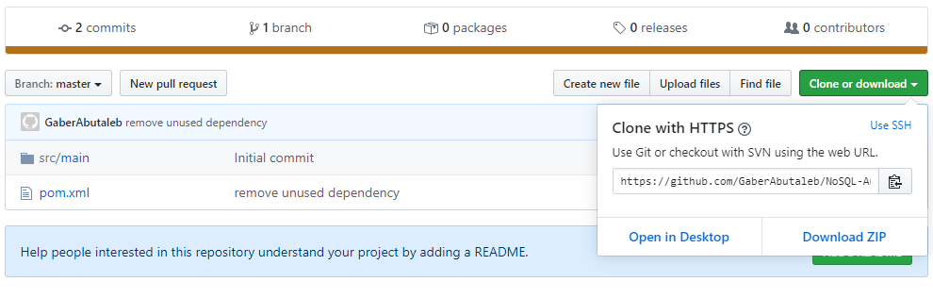
- Download Apache Directory Studio from the below link
https://directory.apache.org/studio/downloads.html
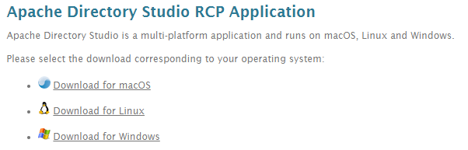
- Setup up the Apache Directory Studio
- Run the Apache Directory Service from the LDAP Servers tab.
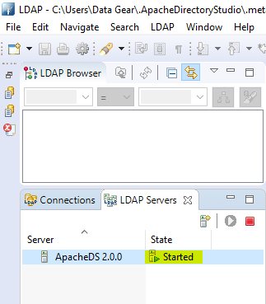

- Create a connection to the Apache Directory Service.
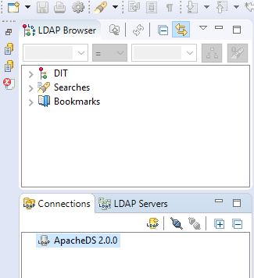
- Expand DIT (Data information tree) to show all available domains.
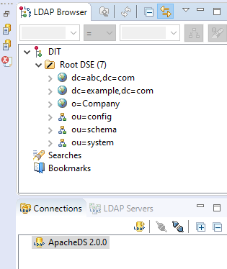

- Import the ads.ldif to the Apache directory studio
- Right-click on the Root DES button.
- Choose the import option
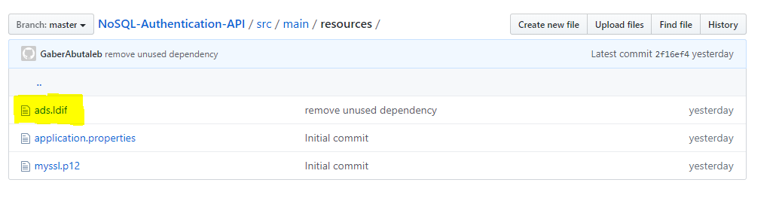
- Now Apache directory is running on localhost under 10389 port.
- Run the code of our application.
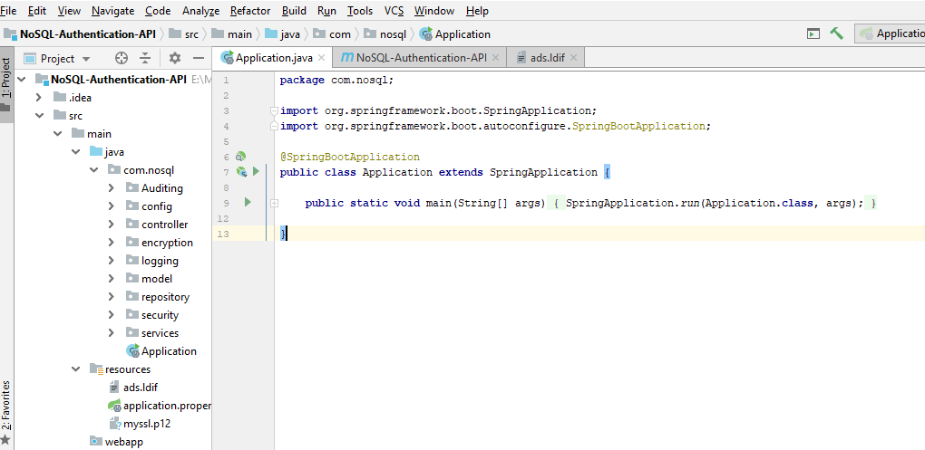
- Now our application is ready to use by any NoSQL database Management system.
