Supplementary Information
Characterization and evaluation of the photocatalytic activity of oxides based on TiO₂ synthesized by hydrolysis controlled by the use of water/acetone mixtures
Werick A. Machado*ª, Antonio E. H. Machado^{a,b}
ªUniversidade Federal de Uberlândia, Instituto de Química, Laboratório de Fotoquímica e Ciência de Materiais. Av. João Naves de Ávila, 2121 – Bloco 5K. CEP 38408-100 Uberlândia, MG, Brazil
^{b}Universidade Federal de Catalão, Unidade Acadêmica Especial de Física, Programa de Pós-Graduação em Ciências Exatas e Tecnológicas. Av. Lamartine P. Avelar, 1120. CEP 75704-020 Catalão, GO, Brazil

Table

Table S1 - Quality factors of the Rietveld refinement, obtained for synthesized oxides.
Oxide | S | R_{wp} | R_{exp}
W1 | 1.28 | 8.93 | 6.98
W1-25 | 1.31 | 9.21 | 7.00
W1-50 | 1.31 | 9.31 | 7.08
W1-75 | 1.22 | 8.73 | 7.11

Figures
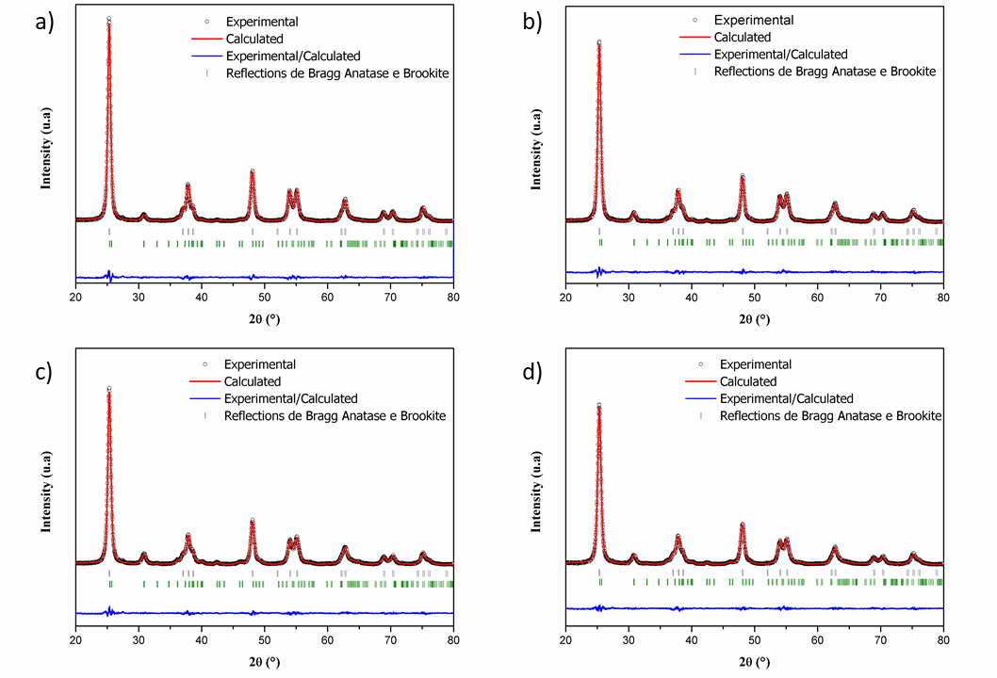
Supplementary Figure 1- Diffratograms obtained after Rietveld refinement for the synthesized oxides: (a) W1, (b) W1-25, (c) W1-50 and (d) W1-75.

Supplementary Figure 2- Particle size distribution histograms of the synthesized oxides: (a) W1, (b) W1-25, (b) W1-50, and (d) W1-75.
Supplementary Figure 3- Degradation of P4R by direct photolysis, and photocatalytic performance in the mineralization (a) and discoloration (b) of P4R by the studied oxides.
Supplementary Figure 4 – Photocatalytic performance in a reuse assay of W1-50 in mineralization (a) and discoloration (b) of P4R: obtaining a mineralization constant of 4.0 x10³ min⁻¹ in the first stage, and 10.0 x10³ min⁻¹ in the second of the reaction using the recycled catalyst.
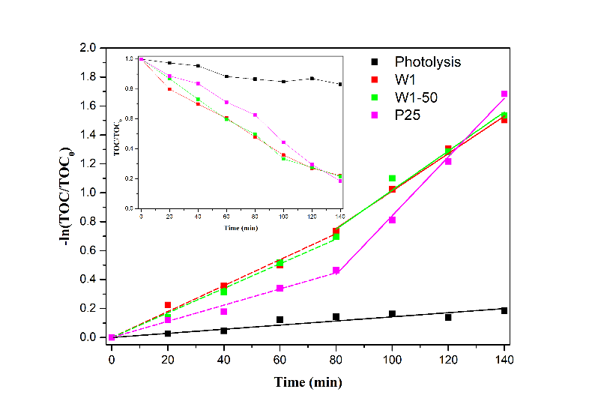 | 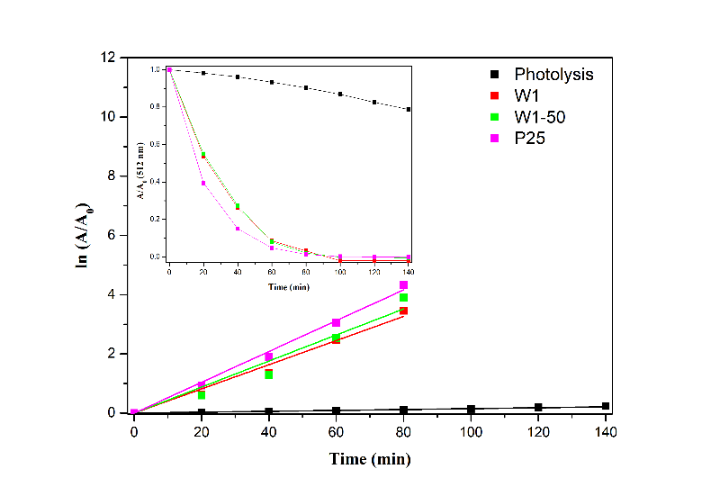
Supplementary Figure 5 - Degradation of RR120 by direct photolysis, and photocatalytic performance in the mineralization (a) and discoloration (b) of RR120 by the studied oxides.

