Synthesis and biological activity of 1,4-pentadien-3-one derivatives containing a triazine scaffold
Xu Tang†, Mei Chen†, Jun He, Shijun Su, Rongjiao Xia, Tao Guo, Shichun Jiang, Liwei Liu, Wei Xue*
State Key Laboratory Breeding Base of Green Pesticide and Agricultural Bioengineering, Key Laboratory of Green Pesticide and Agricultural Bioengineering, Ministry of Education, Center for Research and Development of Fine Chemicals, Guizhou University, Guiyang, 550025.China.
E-mail: wxue@gzu.edu.cn (Wei Xue);
Tel: 0086-0851-88292920; Fax: 0086-851-88292
1. Experimental section

Melting points were determined using an XT-4 digital melting-point apparatus (Beijing Tech. Instrument Co., China) and readings were uncorrected. ¹ H NMR, ¹³ C NMR and ¹⁹ F NMR spectra were recorded on a 400 MHz spectrometer (Swiss Bruker) with DMSO and CDCl₃ as the solvent and tetramethylsilane as the internal standard. HRMS data were obtained using Thermo Scientific Q Exactive Hybrid Quadrupole Mass Spectrometer (Thermo Scientific Inc., St Louis, MO, USA).The course of the reaction was monitored by thin-layer-chromatography analysis on silica gel GF₂₅₄ (Qingdao Haiyang Chemical Company, Ltd., Qingdao, China), and spots were visualized with ultraviolet (UV) light. The molecular docking was performed by using DS-CDocker implemented in Discovery Studio (version 4.5). All reagents and solvents were purchased from Chinese Chemical Reagent Company and were of analytical grade reagents.

2. Biological activities tests

2.1. Antibacterial activity in vitro

Antibacterial activities of the title compounds 4a−4r against Xanthomonas axonopodispv. citri (Xac), Xanthomonas oryzaepv. oryzae (Xoo) and Ralstonia solanacearum (Rs) were evaluated by using the turbidimeter test in vitro. Dimethyl sulfoxide in sterile distilled water served as a blank control. Bismerthiazol served as positive controls. Approximately 4 mL of solvent NB (1.5 g beef extract, 2.5 g peptone, 0.5 g yeast powder, 5.0 g glucose,and 500 mL distilled water; pH 7.0–7.2) containing Xoo, Rs and Xac, incubated in the phase of logarithmic growth, was added to 5 mL of solvent NB containing different concentrations of the test compounds and positive control, such as 100, 50 μg/mL (for preliminary bioassay), 100, 50, 25, 12.5, 6.25 μg/mL. The inoculated test tubes were incubated at 28 ± 1ºC and continuously shaken at 180 rpm for 24–48 h until the bacteria were incubated in the logarithmic growth phase. The growth of the cultures was monitored on amicroplate reader by measuring the optical density at 595 nm (OD ₅₉₅) given by turbidity corrected values = OD _{bacterial wilt} – OD _{no bacterial wilt} , and the inhibition rate I was calculated by I = (C - T)/C * 100%. C is the corrected turbidity values of bacterial growth on untreated NB (blank control), and T is the corrected turbidity values of bacterial growth on treated NB. By using the SPSS 17.0 software and the obtained inhibition rates at different concentrations, a regression equation was provided. The results of antibacterial activities (expressed by EC₅₀) against Xoo, Rs and Xac were calculated from the equation. The experiment was repeated three times.

2.2. Antiviral activities in vivo

2.2.1. Curative activity of the target compounds against TMV in vivo
Growing N. tabacum L. leaves of the same age were selected. The leaves were inoculated with TMV (concentration of 6×10⁻³ mg/mL) by dipping and brushing the whole leaves, which had previously been scattered with silicon carbide. The leaves were then washed with water after inoculation for 0.5 h. The compound solution was smeared on the left side of the leaves, and the solvent was smeared on the right side as the control. The number of local lesions was counted and recorded 3–4 d after inoculation. Three replicates were set up for each.

2.2.2. Protection activity of the target compounds against TMV in vivo
The compound solutions were smeared on the left side of the N. tabacum L. leaves, and the solvents were smeared on the right side as the control sample for growing N. tabacum L. leaves. After 12 h, crude TMV (concentration of 6×10⁻³ mg/mL) was inoculated on whole leaves at the same concentration on each side of the leaves, which were previously scattered with silicon carbide. After 0.5 h, the leaves were washed with water and then dried. The number of local lesions was recorded 3–4 d after inoculation. Three replicates were used for each compound. The inhibitory rate (I %) of the compound was calculated according to the following formula.

2.2.3. Inactivation activity of the title compounds against TMV in vivo
The virus was inhibited after it was mixed with a compound solution of the same volume for 30 min. The right side of the N. tabacum L. leaves was then inoculated with the solvent and virus mixture for control. All of the leaves were previously scattered with silicon carbide. The number of local lesions was recorded three to four days after the inoculation. Three replications were reproduced for each compound. The inhibition rates (I %) of the compounds were calculated according to the following formula:
(I %) = (C_{num} − T_{num})/ C_{num}× 100%
C_{num}: average local lesion number of control(not treated with compounds)
T_{num}: average local lesion number smeared with compounds
2.3. Molecular docking
Molecular docking. The molecular docking was performed by using DS-CDocker implemented in Discovery Studio (version 4.5). The coat protein subunit amino acid sequence of tobacco mosaic virus (TMV) was searched by the UniProt database. The Protein BLAST server was used to search the template protein and the homologies of TMV-CP sequences were aligned. Homology modeling of TMV-CP was carried out using Create Homology Models, which is a module integrated in Discovery Studio. The obtained models were evaluated by Ramachandran plots. The 3D structures of the compounds were constructed using the Sketching module and optimized by the Full Minimization module. All parameters are default during the docking process.
3. ¹ H NMR, ¹³ C NMR, ¹⁹ F NMR and HRMS spectrum of the title compounds
(1E,4E)-1-(4-(2-((5,6-diphenyl-1,2,4-triazin-3-yl)thio)ethoxy)phenyl)-5-(thiophen-2-yl)penta-1,4-dien-3-one(4a): yellow solid, yield: 45%, m.p: 166.3-167.1ºC; ¹H NMR (400 MHz, DMSO-d₆) δ 7.95 (d, J = 15.8 Hz, 1H, Ar-H), 7.77 (d, J = 5.0 Hz, 1H, Ar-(4-OH)-CH=CH), 7.74 (s, 1H, thiofuran-4-H), 7.71 (d, J = 6.0 Hz, 1H, thiofuran-2-H), 7.66 (s, 1H, thiofuran-CH=CH), 7.59 (d, J = 3.4 Hz, 1H, Ar-(4-OH)-2-H), 7.50 (d, J = 1.6 Hz, 1H, Ar-(4-OH)-6-H), 7.47 (d, J = 2.5 Hz, 2H, 2Ar-H), 7.46 (t, J = 2.4 Hz, 2H, 2Ar-H), 7.44 – 7.42 (m, 2H, 2Ar-H), 7.41 (d, J = 1.7 Hz, 1H, Ar-H), 7.39 (d, J = 3.0 Hz, 1H, Ar-H), 7.38 – 7.35 (m, 1H, thiofuran-3-H), 7.27 – 7.18 (m, 2H, 2Ar-H), 7.09 (d, J = 8.8 Hz, 2H, 2CO=CH), 6.96 (d, J = 15.8 Hz, 2H, Ar-(4-OH)-3,5-2H), 4.46 (t, J = 6.4 Hz, 2H, -OCH₂-), 3.75 (t, J = 6.4 Hz, 2H, -SCH₂-); ¹³C NMR (101 MHz, DMSO-d₆) δ 188.10 (s, C=O), 169.83 (s), 160.53 (s), 156.27 (s), 154.74 (s), 142.74 (s), 140.33 (s), 135.57 (d, J = 18.8 Hz), 132.91 (s), 131.26 (s), 130.95 (s), 130.54 (s), 130.16 (s), 129.74 (s), 129.08 (d, J = 28.5 Hz), 128.89 (s), 128.10 (s), 125.18 (s), 123.82 (s), 115.52 (s), 66.63 (s, -OCH₂-), 29.48 (s, -SCH₂-); HRMS calcd for: C₃₂H₂₆N₃O₂S₂ [M+H]+: 548.14514, found: 548.14609.
(1E,4E)-1-(4-chlorophenyl)-5-(2-(2-((5,6-diphenyl-1,2,4-triazin-3-yl)thio)ethoxy)phenyl)penta-1,4-dien-3-one(4b): yellow solid, yield: 51%, m.p:127.8-128.1ºC; ¹H NMR (400 MHz, DMSO-d₆) δ 7.95 (d, J = 16.1 Hz, 1H, Ar-(2-OH)-CH=CH), 7.79 (dd, J = 8.1, 6.3 Hz, 3H, Ar-(4-Cl)-CH=CH, 2Ar-H), 7.73 (s, 1H, Ar-(4-Cl)-2-H), 7.50 (d, J = 8.5 Hz, 2H, Ar-(4-Cl)-3,5-2H), 7.48 – 7.41 (m, 8H, Ar-(4-Cl)-4-H,7Ar-H), 7.40 – 7.32 (m, 4H, Ar-H, Ar-(2-OH)-3,4,5-3H), 7.23 (dd, J = 12.1, 7.9 Hz, 2H, CO=CH, Ar-(2-OH)-2-H), 7.04 (t, J = 7.5 Hz, 1H, CO=CH), 4.54 (t, J = 6.1 Hz, 2H, -OCH₂-), 3.86 (t, J = 6.1 Hz, 2H, -SCH₂-); ¹³C NMR (101MHz, DMSO-d₆) δ 188.91 (s, C=O), 169.84 (s), 157.61 (s), 156.24 (s), 154.73 (s), 141.63 (s), 138.03 (s), 135.70 (s), 135.45 (d, J = 5.3 Hz), 134.12 (s), 132.61 (s), 131.22 (s), 130.64 (s), 130.14 (s), 129.95 – 129.41 (m), 128.86 (d, J = 7.8 Hz), 127.54 (s), 126.06 (s), 123.63 (s), 121.65 (s), 113.45 (s), 66.96 (s, -OCH₂- ), 29.75 (s, -SCH₂-); HRMS calcd for: C₃₄H₂₇N₃O₂SCl [M+H]+: 576.14978, found: 576.15070.
(1E,4E)-1-(2-(2-((5,6-diphenyl-1,2,4-triazin-3-yl)thio)ethoxy)phenyl)-5-(4-nitrophenyl)penta-1,4-dien-3-one(4c): yellow solid, yield: 35%, m.p: 169.9-170.7°C; ¹H NMR (400 MHz, DMSO-d₆) δ 8.30 (d, J = 8.8 Hz, 1H, Ar-(4-NO₂)-3H), 8.10 – 7.98 (m, 3H, Ar-(4-NO₂) -3H- 2,5,6-3H), 7.85 (dd, J = 16.0, 8.7 Hz, 2H, Ar-(2-OH)-CH=CH, Ar-(4-NO₂)-CH=CH), 7.54 – 7.34 (m, 14H, 10Ar-H, Ar-(2-OH)-3,4,5,6-4H) , 7.27 (d, J = 8.3 Hz, 1H, CO=CH), 7.08 (t, J = 7.4 Hz, 1H, CO=CH), 4.63 – 4.54 (m, 2H, -OCH₂-), 3.89 (t, J = 6.1 Hz, 2H, -SCH₂-); ¹³C NMR (101 MHz, DMSO-d₆) δ 188.90 (s, C=O), 169.84 (s), 162.79 (s), 157.68 (s), 156.22 (s), 154.71 (s), 148.45 (s), 141.70 (s), 140.27 (s), 138.68 (s), 135.56 (d, J = 22.6 Hz), 135.44 – 135.26 (m), 132.80 (s), 131.23 (s), 130.48 (s), 130.03 (d, J = 18.3 Hz), 129.74 (s), 128.86 (d, J = 8.3 Hz), 125.98 (s), 124.50 (s), 123.54 (s), 121.68 (s), 113.49 (s), 66.99 (s, -OCH₂-), 36.26 (s, -SCH₂-); HRMS calcd for: C₃₄H₂₇N₄O₄S [M+H]+: 587.17021, found: 587.17025.
(1E,4E)-1-(4-chlorophenyl)-5-(4-(2-((5,6-diphenyl-1,2,4-triazin-3-yl)thio)ethoxy)-3-methoxyphenyl)penta-1,4-dien-3-one(4d): yellow oil, yield: 46%, ¹H NMR (400 MHz, DMSO-d₆) δ 7.83 (d, J = 8.5 Hz, 2H, Ar-(4-OH)-CH=CH, Ar-(4-Cl)-CH=CH), 7.79 – 7.69 (m, 2H, Ar-(4-Cl)-2,6-2H), 7.53 (d, J = 8.4 Hz, 2H, 2Ar-H), 7.49 – 7.44 (m, 5H, Ar-(4-Cl)-3,5-2H, 3Ar-H), 7.44 – 7.35 (m, 7H, 5Ar-H, Ar-(4-OH)-2,6-2H), 7.26 (d, J = 7.0 Hz, 1H, Ar-(4-OH)-3-H), 7.17 (dd, J = 26.1, 12.2 Hz, 2H, 2C=O), 4.43 (t, J = 6.4 Hz, 2H, -OCH₂-), 3.84 (d, J = 7.9 Hz, 3H, -OCH₃), 3.75 (t, J = 6.4 Hz, 2H, -SCH₂-); ¹³C NMR (101 MHz, DMSO-d₆)) δ 188.71 (s, C=O), 169.86 (s), 156.23 (s), 154.69 (s), 150.38 (s), 149.59 (s), 143.87 (s), 141.15 (s), 135.95 – 135.22 (m), 134.26 (s), 131.26 (s), 130.65 (s), 130.14 (s), 129.80 (s), 129.62 (d, J = 23.8 Hz), 128.92 (d, J = 6.1 Hz), 128.40 (s), 126.61 (s), 124.53 (s), 123.65 (s), 113.52 (s), 111.48 (s), 67.22 (s, -OCH₂-), 56.17 (s, -OCH₃-), 29.42 (s, -SCH₂-); HRMS calcd for: C₃₅H₂₉N₃O₃SCl [M+H]⁺: 606.15955, found: 606.16127.
(1E,4E)-1-(3,4-dimethoxyphenyl)-5-(4-(2-((5,6-diphenyl-1,2,4-triazin-3-yl)thio)ethoxy)phenyl)penta-1,4-dien-3-one(4e): yellow solid, yield: 35%, m.p: 148.6-149.7°C; ¹H NMR (400 MHz, DMSO-d₆) δ 7.71 (dt, J = 13.6, 10.4 Hz, 3H, Ar-(3,4-2-OCH₃)- CH=CH, Ar-(4-OH)-CH=CH, Ar-(4-OH)-1-H ), 7.49 (d, J = 1.4 Hz, 1H，Ar-(4-OH) -5-H), 7.48 (d, J = 1.4 Hz, 2H, 2Ar-H), 7.46 (d, J = 1.8 Hz, 2H, 2Ar-H), 7.45 (s, 1H, Ar-H), 7.44 – 7.41 (m, 2H, 2Ar-H), 7.41 (d, J = 1.9 Hz, 2H, 2Ar-H), 7.39 (s, 1H, Ar-H), 7.37 (s, 1H, Ar-(3,4-2-OCH₃)- 2-H), 7.36 – 7.31 (m, 2H, Ar-(3,4-2-OCH₃)- 5,6-2H), 7.22 (dd, J = 16.0, 7.6 Hz, 2H, 2-CO=CH), 7.08 – 7.01 (m, 2H, Ar-(4-OH)-3,5-2H ), 4.49 – 4.40 (m, 2H, -OCH₂-), 3.86 (d, J = 10.6 Hz, 3H, -OCH₃), 3.80 (d, J = 11.8 Hz, 3H, -OCH₃), 3.75 (t, J = 5.6 Hz, 2H, -SCH₂-); ¹³C NMR (101MHz, DMSO-d₆) δ 188.61 (s, C=O), 169.84 (s), 160.45 (s), 156.24 (s), 154.72 (s), 151.54 (s), 149.46 (s), 143.23 (s), 142.41 (s), 135.56 (d, J = 18.6 Hz), 131.03 (d, J = 45.7 Hz), 130.80 – 130.62 (m), 130.15 (s), 129.77 (d, J = 6.4 Hz), 128.91 (d, J = 5.3 Hz), 128.10 (d, J = 15.5 Hz), 124.41 (s), 124.02 (s), 123.69 (s), 115.53 (s), 112.10 (s), 110.96 (s), 66.64 (s, -OCH₂-), 56.07 (s, -OCH₃), 29.50 (s, -SCH₂-); HRMS calcd for: C₃₆H₃₂N₃O₄S [M+H]⁺: 602.20882, found: 602.21080.
(1E,4E)-1-(4-(2-((5,6-diphenyl-1,2,4-triazin-3-yl)thio)ethoxy)phenyl)-5-(4-nitrophenyl)penta-1,4-dien-3-one(4f): yellow solid, yield: 34%, m.p: 125.5-126.3°C; ¹H NMR (400 MHz, DMSO-d₆) δ 8.29 (d, J = 8.8 Hz, 1H, Ar-(4-NO₂)-3-H, 8.09 – 8.03 (m, 1H, Ar-(4-NO₂)-5-H), 7.86 – 7.80 (m, 1H, Ar-(4-NO₂)-2-H), 7.73 (d, J = 8.7 Hz, 1H, Ar-(4-NO₂)-6-H), 7.56 (d, J = 16.1 Hz, 1H, Ar-4-(NO₂)-CH=CH), 7.43 (ddt, J = 20.4, 15.0, 8.1 Hz, 15H, Ar-(4-OH)-CH=CH, Ar-(4-OH)-2,6-2H, 2CO=CH, 10Ar-H), 7.20 (d, J = 16.1 Hz, 1H, Ar-(4-OH)-3-H), 7.10 (d, J = 8.7 Hz, 1H, Ar-(4-OH)-5-H), 4.50 – 4.37 (m, 2H, -OCH₂-), 3.80 – 3.68 (m, 2H, -SCH₂-); ¹³C NMR (101MHz, DMSO-d₆)) δ 188.66 (s, C=O), 169.82 (s), 160.75 (s), 156.25 (s), 154.73 (s), 148.42 (s), 144.04 (s), 141.87 (s), 139.92 (s), 135.57 (d, J = 18.8 Hz), 131.27 (s), 131.05 (s), 130.39 – 129.44 (m), 128.91 (d, J = 5.3 Hz), 127.96 (s), 124.51 (s), 124.06 (s), 115.60 (s), 66.66 (s, -OCH₂-), 29.48 (s, -SCH₂-); HRMS calcd for: C₃₄H₂₇N₄O₄S [M+H]⁺: 587.17515, found: 587.17373.
(1E,4E)-1-(4-(4-((5,6-diphenyl-1,2,4-triazin-3-yl)thio)butoxy)phenyl)-5-(pyridin-2-yl)penta-1,4-dien-3-one(4g): yellow oil, yield: 61%, ¹H NMR (400 MHz, DMSO-d₆) δ 8.70 – 8.61 (m, 1H, Pyridine-3-H), 7.87 (td, J = 7.7, 1.8 Hz, 1H, Pyridine-CH=CH), 7.79 – 7.70 (m, 3H, Ar-(4-OH)-CH=CH, Ar-(4-OH)-2,6-2H), 7.68 – 7.55 (m, 1H, Ar-H), 7.49 – 7.43 (m, 6H, 6Ar-H ), 7.42 – 7.31 (m, 7H, 3Ar-H, 2CO=CH, Pyridine- 5,6-2H), 7.24 (dd, J = 16.9, 5.7 Hz, 1H, Pyridine-4-H), 7.01 – 6.88 (m, 2H, Ar-(4-OH)-3,5-2H), 4.12 – 4.01 (m, 2H, -OCH₂-), 3.37 (d, J = 9.5 Hz, 2H, -SCH₂-), 2.00 – 1.80 (m, 4H, 2-CH₂-); ¹³C NMR (101 MHz, DMSO-d₆) δ 188.88 (s, C=O), 170.50 (s), 161.20 (s), 155.92 (s), 154.34 (s), 153.40 (s), 150.50 (s), 143.65 (s), 141.68 (s), 137.66 (s), 135.72 (s), 135.52 (s), 131.13 (d, J = 17.9 Hz), 130.10 (s), 129.72 (s), 129.29 (s), 128.87 (d, J = 6.2 Hz), 127.58 (s), 125.42 (s), 125.10 (s), 123.74 (s), 115.38 (s), 67.73 (s, -OCH₂-), 30.18 (s, -SCH₂-), 28.25 (s, -CH₂-), 26.04 (s, -CH₂-); HRMS calcd for: C₃₅H₃₁N₄O₂S [M+H]⁺: 571.21622, found: 571.21545.
(1E,4E)-1-(4-(2-((5,6-diphenyl-1,2,4-triazin-3-yl)thio)ethoxy)-3-methoxyphenyl)-5-(4-methoxyphenyl)penta-1,4-dien-3-one(4h): yellow solid, yield: 56%, m.p: 88.3-88.9°C;¹H NMR (400 MHz, CDCl₃) δ 7.74 (dd, J = 19.1, 15.8 Hz, 1H, Ar-(4-OCH₃)-CH=CH), 7.65 – 7.54 (m, 6H, Ar-(4-OH)-CH=CH, Ar-(4-OCH₃)-2,6-2H, 3Ar-H), 7.53 – 7.33 (m, 9H, 7Ar-H, Ar-(4-OH)-3,5-2H), 7.21 – 7.12 (m, 1H, Ar-(4-OH)-6-H), 7.12 – 7.04 (m, 2H, Ar-(4-OCH₃)-3,5-2H), 7.04 – 6.96 (m, 1H, CO=CH), 6.69 – 6.60 (m, 1H, CO=CH), 4.57 (td, J = 6.8, 3.8 Hz, 2H, -OCH₂-), 3.96 (d, J = 3.0 Hz, 3H, Ar-(4-OH)-2-OCH₃), 3.86 – 3.82 (m, 2H, -SCH₂-), 2.43 (s, 3H, Ar-OCH₃); ¹³C NMR (101 MHz, CDCl₃) δ 198.39 (s, C=O), 169.97 (s), 155.84 (s), 154.25 (s), 150.25 (s), 149.65 (s), 143.47 (s), 135.08 (d, J = 6.3 Hz), 131.01 (s), 130.13 (s), 129.83 (s), 129.56 (s), 129.34 (s), 128.62 (d, J = 7.2 Hz), 127.85 (s), 125.42 (s), 122.90 (s), 114.43 (s), 113.19 (s), 110.45 (s), 67.40 (s,- OCH₃-), 56.07 (s, - OCH₂-), 29.38 (s, - OCH₃-), 27.40 (s, - SCH₃-); HRMS calcd for: C₃₆H₃₂N₃O₄S [M+H]⁺: 602.21080, found: 602.20886.
(1E,4E)-1-(2,4-dimethoxyphenyl)-5-(4-(2-((5,6-diphenyl-1,2,4-triazin-3-yl)thio)ethoxy)-3-methoxyphenyl)penta-1,4-dien-3-one(4i): yellow solid, yield: 62%, m.p: 85.1-86.6°C; ¹H NMR (400 MHz, DMSO-d₆) δ 7.88 (d, J = 15.9 Hz, 1H, Ar-(2,4-2-OCH₃)-CH=CH), 7.75 (t, J = 5.7 Hz, 1H, Ar-(2,4-2-OCH₃))-6-H), 7.68 (d, J = 15.9 Hz, 1H, Ar-(4-OH)-CH=CH), 7.50 – 7.44 (m, 6H, 6Ar-H), 7.44 – 7.35 (m, 7H, 4-Ar-H, Ar-(4-OH)-3,5,6-3H), 7.29 – 7.21 (m, 2H, 2CO=CH), 7.13 (dd, J = 12.2, 3.7 Hz, 1H, Ar-(2,4-2-OCH₃)-3-H), 6.63 (dd, J = 11.3, 2.3 Hz, 1H, Ar-(2,4-2-OCH₃)-5-H), 4.46 – 4.39 (m, 2H, -OCH₂-), 3.93 – 3.70 (m, 11H, 9OCH₃, -SCH₂-); ¹³C NMR (101 MHz, DMSO-d₆) δ 188.62 (s, C=O), 169.88 (s), 163.33 (s), 156.23 (s), 154.69 (s), 150.17 (s), 142.75 (s), 137.44 (s), 135.58 (d, J = 17.5 Hz), 131.24 (s), 130.33 – 130.22 (m), 129.94 (d, J = 41.2 Hz), 128.91 (d, J = 5.8 Hz), 128.58 (s), 125.31 (s), 123.48 (d, J = 11.7 Hz), 116.41 (s), 111.46 (s), 106.77 (s), 98.85 (s), 67.22 (s, -OCH₂-), 56.54 – 55.81 (m, -OCH₃), 29.43 (s, -SCH₂-); HRMS calcd for: C₃₇H₃₄N₃O₅S [M+H]⁺:632.22137, found: 632.22028.
(1E,4E)-1-(4-(2-((5,6-dimethyl-1,2,4-triazin-3-yl)thio)ethoxy)phenyl)-5-(thiophen-2-yl)penta-1,4-dien-3-one(4j): yellow solid, yield: 58%, m.p: 125.5-126.3°C;¹H NMR (400 MHz, CDCl₃) δ 7.88 – 7.81 (m, 1H, Ar-(4-OH)-CH=CH), 7.69 (dd, J = 15.9, 6.0 Hz, 1H, thiofuran-4-H), 7.56 (d, J = 8.7 Hz, 1H, thiofuran-2-H), 7.41 (d, J = 5.1 Hz, 1H, Ar-(4-OH)-2-H), 7.34 (dd, J = 9.3, 2.8 Hz, 1H, Ar-(4-OH)-6-H), 7.08 (dd, J = 5.0, 3.7 Hz, 1H, thiofuran-CH=CH), 6.97 (t, J = 5.8 Hz, 2H, 2CO=CH), 6.93 – 6.83 (m, 3H, thiofuran-3-H, Ar-(4-OH)-3,5-2H), 4.42 – 4.31 (m, 2H, -OCH₂-), 3.70 – 3.59 (m, 2H, -SCH₂-), 2.66 – 2.56 (m, 3H, -CH₃), 2.52 – 2.44 (m, 3H, -CH₃); ¹³C NMR (101 MHz, CDCl₃) δ 188.33 (s, C=O), 169.80 (s), 160.55 (s), 159.02 (s), 153.97 (s), 142.97 (s), 140.43 (s), 135.40 (s), 131.71 (s), 130.20 (s), 128.65 (s), 128.33 (s), 127.79 (s), 124.43 (s), 123.62 (s), 115.11 (s), 66.40 (s, -OCH₂-), 29.46 (s, -SCH₂-), 21.74 (s, -CH₃), 19.13 (s, -CH₃); HRMS calcd for: C₂₂H₂₂N₃O₂S₂ [M+H]⁺: 424.11479, found: 424.11380.
(1E,4E)-1-(4-chlorophenyl)-5-(4-(2-((5,6-diphenyl-1,2,4-triazin-3-yl)thio)ethoxy)phenyl)penta-1,4-dien-3-one(4k): yellow solid, yield: 44%, m.p: 94.2-95.3°C; ¹H NMR (400 MHz, CDCl₃) δ 9.61 (dd, J = 15.9, 12.8 Hz, 1H, Ar-(4-OH)-CH=CH), (dd, J = 10.6, 5.1 Hz, 7H, Ar-(4-Cl)-CH=CH, Ar-(4-Cl)-2,6-2H, Ar-(4-OH)-2,6-2H, 2Ar-H), 9.39 – 9.30 (m, 5H, 5Ar-H), 9.30 – 9.20 (m, 6H, 3Ar-H, Ar-(4-Cl)-3,5-2H, CO=CH), 9.00 – 8.83 (m, 3H, CO=CH, Ar-(4-OH)-3, 5-2H), 6.44 – 6.31 (m, 2H, -OCH₂-), 5.67 (dt, J = 6.3, 5.5 Hz, 2H, -SCH₂-); ¹³C NMR (101 MHz, CDCl₃) δ 188.56 (s, C=O), 169.94 (s), 160.61 (s), 155.85 (s), 154.26 (s), 143.34 (s), 141.34 (s), 136.23 (s), 135.09 (d, J = 7.7 Hz), 133.46 (s), 131.03 (s), 130.26 (s), 129.82 (s), 129.41 (dd, J = 24.9, 9.1 Hz), 128.62 (d, J = 7.9 Hz), 125.98 (s), 123.43 (s), 115.18 (s), 66.53 (s, -OCH₂-), 29.68 (s, -SCH₂-); HRMS calcd for: C₃₄H₂₇N₃O₂SCl[M+H]⁺: 576.15070, found: 576.14978.
(1E,4E)-1-(2-chlorophenyl)-5-(4-(2-((5,6-diphenyl-1,2,4-triazin-3-yl)thio)ethoxy)phenyl)penta-1,4-dien-3-one(4l): yellow solid, yield: 54%, m.p: 122.6-123.2°C;¹H NMR (400 MHz, CDCl₃) δ 8.09 (d, J = 16.0 Hz, 1H, Ar-(2-Cl)-CH=CH), 7.73 – 7.66 (m, 2H, Ar-(4-OH)-CH=CH, Ar-H), 7.51 (tt, J = 4.1, 2.6 Hz, 6H, 6Ar-H), 7.45 – 7.36 (m, 4H, Ar-(4-OH)-2,6-2H, 2Ar-H), 7.36 – 7.26 (m, 6H, Ar-H, Ar-(2-Cl)-3,4,5,6-4H, CO=CH), 7.04 – 6.94 (m, 3H, CO=CH, Ar-(4-OH)-3,5-2H), 4.48 – 4.35 (m, 2H, -OCH₂-), 3.72 (dt, J = 6.5, 3.9 Hz, 2H, -SCH₂-); ¹³C NMR (101 MHz, CDCl₃) δ 188.69 (s, C=O), 169.95 (s), 160.61 (s), 155.83 (s), 154.25 (s), 143.51 (s), 138.46 (s), 135.42 – 134.87 (m), 133.23 (s), 131.05 (d, J = 2.6 Hz), 130.27 (d, J = 3.7 Hz), 129.83 (s), 129.57 (s), 129.35 (s), 128.63 (d, J = 7.4 Hz), 128.29 (s), 127.74 (d, J = 5.6 Hz), 127.13 (s), 122.98 (s), 115.18 (s), 66.52 (s, -OCH₂- ), 29.67 (s, -SCH₂-); HRMS calcd for: C₃₄H₂₇N₃O₂SCl [M+H]⁺: 576.15070, found: 576.14978.
(1E,4E)-1-(3,4-dimethoxyphenyl)-5-(2-(2-((5,6-diphenyl-1,2,4-triazin-3-yl)thio)ethoxy)phenyl)penta-1,4-dien-3-one(4m): yellow oil, yield: 36%; ¹H NMR (400 MHz, CDCl₃) δ 8.03 (dd, J = 16.1, 9.0 Hz, 2H, Ar-(3,4-2-OCH₃)-CH=CH, Ar-(2-OH)-CH=CH), 7.59 (t, J = 7.6 Hz, 2H, 2Ar-H), 7.52 – 7.47 (m, 4H, 4Ar-H ), 7.41 – 7.33 (m, 4H, 4Ar-H), 7.31 – 7.25 (m, 4H, Ar-(3,4-2-OCH₃))-2,3,6-3H, Ar-(2-OH)-5-H), 7.13 (d, J = 15.8 Hz, 1H, Ar-(2-OH)-3-H ), 6.97 (dd, J = 15.6, 8.9 Hz, 2H, Ar-(2-OH)-4,5-2H), 6.56 – 6.37 (m, 2H, 2CO=CH), 4.56 – 4.44 (m, 2H, -OCH₂-), 3.87 (d, J = 6.2 Hz, 3H, -OCH₃), 3.85 (t, J = 6.4 Hz, 2H, -SCH₂-), 3.79 (dd, J = 13.0, 4.2 Hz, 3H, -OCH₃); ¹³C NMR (101 MHz, CDCl₃) δ 190.15 (s, C=O), 169.99 (s), 162.92 (s), 160.16 (s), 157.42 (s), 155.83 (s), 154.21 (s), 138.46 (s), 137.73 (s), 135.11 (d, J = 15.4 Hz), 131.33 (s), 130.99 (s), 130.46 (s), 129.83 (s), 129.70 – 129.17 (m), 128.58 (d, J = 8.2 Hz), 126.85 (s), 124.33 (d, J = 17.7 Hz), 121.26 (s), 117.12 (s), 112.41 (s), 105.47 (s), 98.46 (s), 66.79 (s, -OCH₂-), 55.53 (d, J = 10.7 Hz, 2-OCH₃)), 29.92 (s, -SCH₂-); HRMS calcd for: C₃₆H₃₂N₃O₄S [M+H]⁺: 602.21080, found: 602.20818.
(1E,4E)-1-(2-(2-((5,6-diphenyl-1,2,4-triazin-3-yl)thio)ethoxy)phenyl)-5-(pyridin-2-yl)penta-1,4-dien-3-one(4n): yellow oil, yield: 46%; ¹H NMR (400 MHz, DMSO-d₆) δ 8.68 (dd, J = 4.7, 0.8 Hz, 1H, Pyridine-3-H ), 7.99 (d, J = 16.1 Hz, 1H, Ar-(2-OH)-CH=CH), 7.90 – 7.83 (m, 1H, Pyridine-CH=CH), 7.77 (dd, J = 11.8, 4.0 Hz, 1H, Ar-H), 7.53 (dd, J = 10.5, 5.4 Hz, 1H, Ar-H), 7.49 (s, 2H, 2Ar-H), 7.48 – 7.45 (m, 4H, 4Ar-H ), 7.43 (ddd, J = 5.2, 4.0, 1.9 Hz, 4H, 2Ar-H, Pyridine-4,5-2H), 7.41 – 7.38 (m, 2H, Pyridine-6-H, Ar-(2-OH)-6-H), 7.38 – 7.33 (m, 3H, Ar-(2-OH)-3,4,5-3H), 7.22 (d, J = 8.1 Hz, 1H, CO=CH), 7.07 – 6.99 (m, 1H, CO=CH), 4.61 – 4.48 (m, 2H, -OCH₂-), 3.84 (dt, J = 18.8, 6.1 Hz, 2H, -SCH₂-); ¹³C NMR (400 MHz, DMSO-d₆) δ 189.15 (s, C=O), 169.87 (s), 157.63 (s), 156.16 (s), 154.69 (s), 153.27 (s), 150.53 (s), 142.00 (s), 138.17 (s), 137.65 (s), 135.71 (s), 135.47 (s), 132.66 (s), 131.20 (s), 130.11 (s), 129.79 (d, J = 9.6 Hz), 129.48 (s), 128.84 (d, J = 7.4 Hz), 125.98 (s), 125.44 (s), 125.15 (s), 123.63 (s), 121.64 (s), 113.44 (s), 67.06 (s, -OCH₂-), 29.75 (s, -SCH₂-); HRMS calcd for: C₃₃H₂₇N₄O₂S [M+H]⁺: 543.18492, found: 543.18414.
(1E,4E)-1-(2-(2-((5,6-diphenyl-1,2,4-triazin-3-yl)thio)ethoxy)phenyl)-5-(m-tolyl)penta-1,4-dien-3-one(4o): yellow solid, yield: 38%, m.p: 99.8-101.2°C; ¹H NMR (400 MHz, DMSO-d₆) δ 7.96 (d, J = 16.1 Hz, 1H, Ar-(2-OH)-CH=CH), 7.83 (dd, J = 7.8, 1.5 Hz, 1H, Ar-(3-CH₃)-CH=CH), 7.79 – 7.72 (m, 1H, Ar-H), 7.64 – 7.55 (m, 2H, 2Ar-H), 7.48 (ddd, J = 5.5, 4.0, 2.3 Hz, 6H, 6Ar-H), 7.40 (dddd, J = 14.6, 13.6, 5.6, 3.8 Hz, 7H, Ar-H, Ar-(3-CH₃)-2,4,5,6-4H, Ar-(2-OH)-4,6-2H), 7.29 – 7.19 (m, 3H, Ar-(2- OH)-3,5-2H, CO=CH), 7.06 (t, J = 7.4 Hz, 1H, CO=CH), 4.56 (t, J = 6.1 Hz, 2H, -OCH₂-), 3.88 (t, J = 6.1 Hz, 2H, -SCH₂-), 2.37 (d, J = 8.3 Hz, 3H, -CH₃); ¹³C NMR (101MHz, DMSO-d₆) δ 188.96 (s, C=O), 169.85 (s), 157.58 (s), 156.23 (s), 154.73 (s), 143.22 (s), 138.69 (s), 137.71 (s), 135.72 (s), 135.49 (s), 135.08 (s), 132.52 (s), 131.70 (s), 131.21 (s), 130.14 (s), 129.76 (s), 129.43 (d, J = 13.6 Hz), 128.85 (d, J = 8.0 Hz), 126.75 (s), 126.18 (d, J = 17.9 Hz), 123.70 (s), 121.63 (s), 113.44 (s), 66.99 (s, -OCH₂- ), 29.77 (s, -SCH₂-), 21.34 (s, -CH₃); HRMS calcd for: C₃₅H₃₀N₃O₂S [M+H]⁺: 556.20532, found: 556.20471.
(1E,4E)-1-(2-(2-((5,6-diphenyl-1,2,4-triazin-3-yl)thio)ethoxy)phenyl)-5-(2-fluorophenyl)penta-1,4-dien-3-one(4p): yellow solid, yield: 41%, m.p: 111.1-112.2°C; ¹H NMR (400 MHz, DMSO-d₆) δ 7.99 – 7.87 (m, 2H, Ar-(2-F)-CH=CH, Ar-(2-OH)-CH=CH), 7.79 (dd, J = 15.1, 8.8 Hz, 2H, 2Ar-H), 7.50 – 7.45 (m, 3H, 3Ar-H), 7.45 – 7.42 (m, 4H, 4Ar-H), 7.42 – 7.39 (m, 2H, Ar-H, Ar-(2-OH)-6-H), 7.38 (s, 1H, Ar-(2-F)-6-H), 7.37 – 7.25 (m, 6H, Ar-(2-F)-3,4,5-3H, Ar-(2-OH)-3,4,5-3H), 7.23 – 7.18 (m, 1H, CO=CH), 7.06 – 6.99 (m, 1H, CO=CH), 4.53 (t, J = 6.1 Hz, 2H, -OCH₂-), 3.87 – 3.81 (m, 2H, -SCH₂-); ¹³C NMR (400 MHz, DMSO-d₆) δ 188.74 (s, C=O), 169.85 (s), 157.65 (s), 156.20 (s), 154.71 (s), 138.29 (s), 135.72 (s), 135.49 (s), 134.57 (s), 132.68 (s), 131.20 (s), 130.13 (s), 129.68 (d, J = 14.0 Hz), 129.21 – 128.61 (m), 126.34 (s), 125.49 (s), 123.57 (s), 122.79 (d, J = 11.3 Hz), 121.65 (s), 116.74 (s), 116.52 (s), 113.45 (s), 67.02 (s, -OCH₂-), 29.73 (s, -SCH₂-); HRMS calcd for: C₃₄H₂₇N₃O₂SF [M+H]⁺: 560.18025, found: 560.17932.
(1E,4E)-1-(2-(2-((5,6-diphenyl-1,2,4-triazin-3-yl)thio)ethoxy)phenyl)-5-(furan-2-yl)penta-1,4-dien-3-one(4q): yellow solid, yield: 61%, m.p: 128.1-128.7°C; ¹H NMR (400 MHz, CDCl₃) δ 8.06 (d, J = 16.2 Hz, 1H, furan-3-H), 7.63 – 7.47 (m, 7H, Ar-(2-OH)-CH=CH, furan-CH=CH, 5Ar-H), 7.45 – 7.27 (m, 8H, 5Ar-H, Ar-(2-OH)-3,4,5-3H), 7.16 (d, J = 16.2 Hz, 1H, Ar-(2-OH)-3-H), 7.09 – 6.94 (m,2H, furan-4,5-2H), 6.70 (d, J = 3.4 Hz, 1H, CO=CH), 6.46 (dd, J = 3.4, 1.8 Hz, 1H, CO=CH), 4.52 (t, J = 6.5 Hz, 2H, -OCH₂-), 3.84 (t, J = 6.5 Hz, 2H, -SCH₂-); ¹³C NMR (101 MHz, CDCl₃) δ 189.20 (s, C=O), 169.97 (s), 157.45 (s), 155.89 (s), 154.25 (s), 151.65 (s), 144.89 (s), 138.47 (s), 135.10 (d, J = 12.0 Hz), 131.67 (s), 131.02 (s), 129.84 (s), 129.38 (t, J = 14.3 Hz), 128.60 (d, J = 7.5 Hz), 127.02 (s), 124.10 (s), 122.89 (s), 121.28 (s), 115.74 (s), 112.49 (d, J = 16.5 Hz), 66.75 (s, -OCH₂-), 29.89 (s, -SCH₂-); HRMS calcd for: C₃₂H₂₆N₃O₃S [M+H]⁺: 532.16894, found: 532.16803.
(1E,4E)-1-(3-bromophenyl)-5-(2-(2-((5,6-diphenyl-1,2,4-triazin-3-yl)thio)ethoxy)phenyl)penta-1,4-dien-3-one(4r): yellow solid, yield: 60%, m.p: 109.6-110.2°C; ¹H NMR (400 MHz, DMSO-d₆) δ 7.95 (d, J = 16.1 Hz, 1H, Ar-(2-OH)-CH=CH), 7.80 (dd, J = 7.8, 1.4 Hz, 1H, Ar-(3-Br)-CH=CH), 7.73 (dd, J = 12.4, 5.6 Hz, 2H, 2Ar-H), 7.62 (d, J = 8.5 Hz, 2H, 2Ar-H), 7.56 – 7.44 (m, 6H, 6Ar-H), 7.44 – 7.32 (m, 7H, Ar-(3-Br)-2,4,5,6-4H, Ar-(2-OH)-4,5,6-3H), 7.25 (dt, J = 10.1, 5.9 Hz, 2H, Ar-(2-OH)-3-H, CO=CH), 7.07 – 6.99 (m, 1H, CO=CH), 4.55 (dd, J = 16.3, 10.2 Hz, 2H, -OCH₂-), 3.85 (t, J = 6.1 Hz, 2H, -SCH₂-); ¹³C NMR (101 MHz, DMSO-d₆) δ 188.90 (s, C=O), 169.85 (s), 157.61 (s), 156.21 (s), 154.71 (s), 141.69 (s), 138.05 (s), 135.70 (s), 135.47 (s), 134.45 (s), 132.42 (t, J = 16.2 Hz), 131.22 (s), 130.83 (s), 130.57 (s), 130.13 (s), 129.69 (d, J = 13.1 Hz), 128.85 (d, J = 8.0 Hz), 127.57 (s), 126.09 (s), 124.29 (s), 123.65 (s), 121.64 (s), 66.97 (s, -OCH₂- ), 29.77 (s, -SCH₂-); HRMS calcd for: C₃₄H₂₇N₃O₂SBr [M+H]⁺: 620.10019, found: 620.09912.

Figure S1. ¹H NMR spectrum of compound 4a
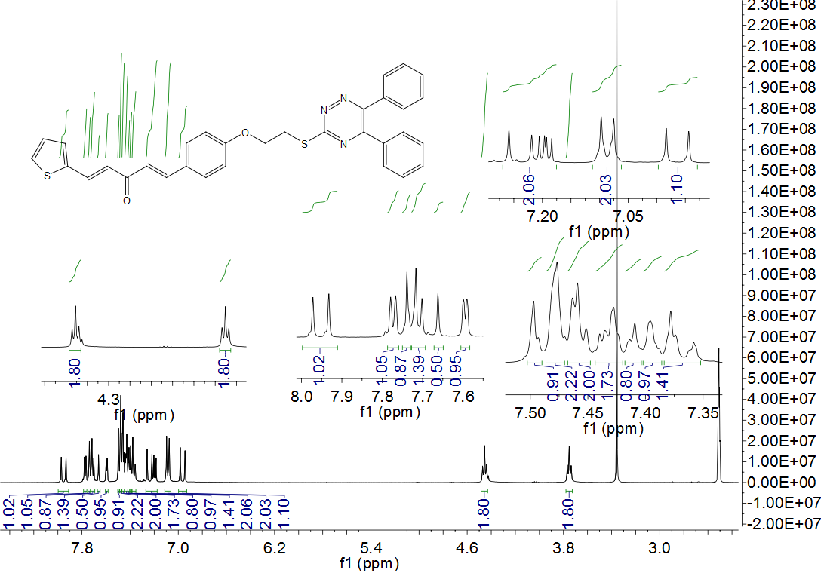
Figure S2. ¹³C NMR spectrum of compound 4a
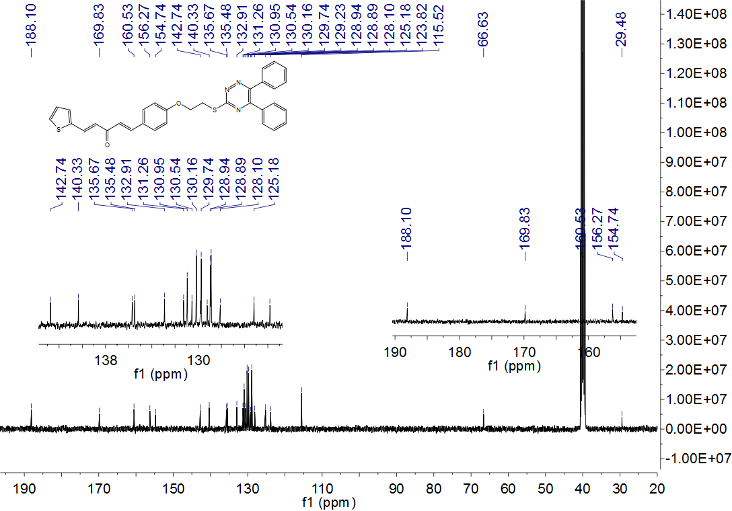

Figure S3. HRMS spectrum of compound 4a
Figure S4. ¹H NMR spectrum of compound 4b
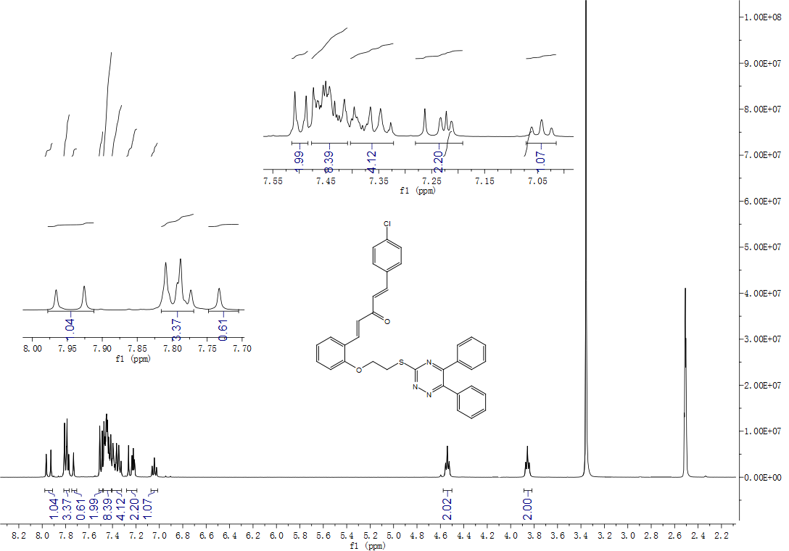
Figure S5. ¹³C NMR spectrum of compound 4b
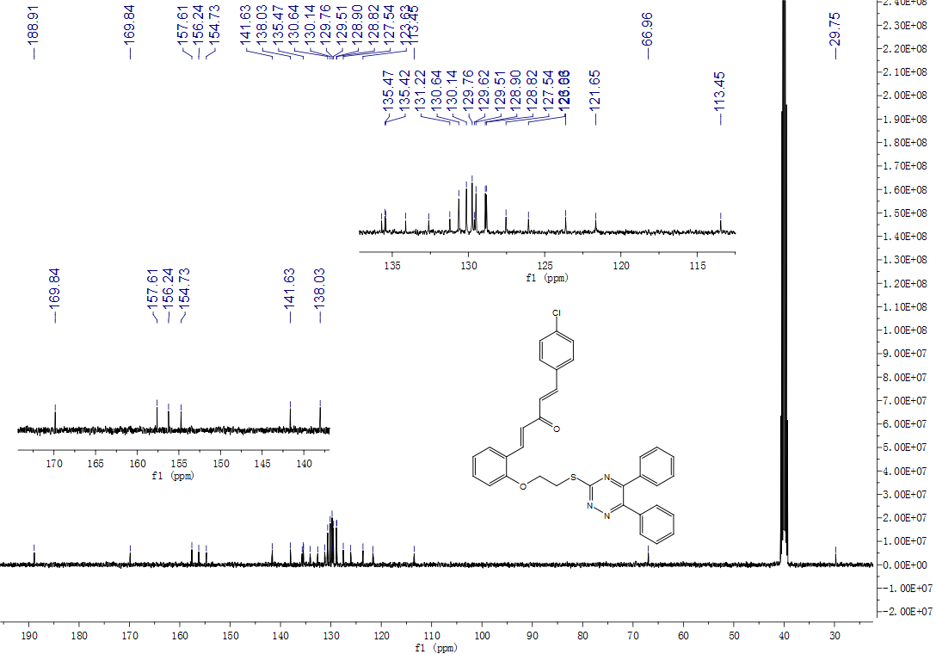

Figure S6. HRMS spectrum of compound 4b
Figure S7. ¹H NMR spectrum of compound 4c
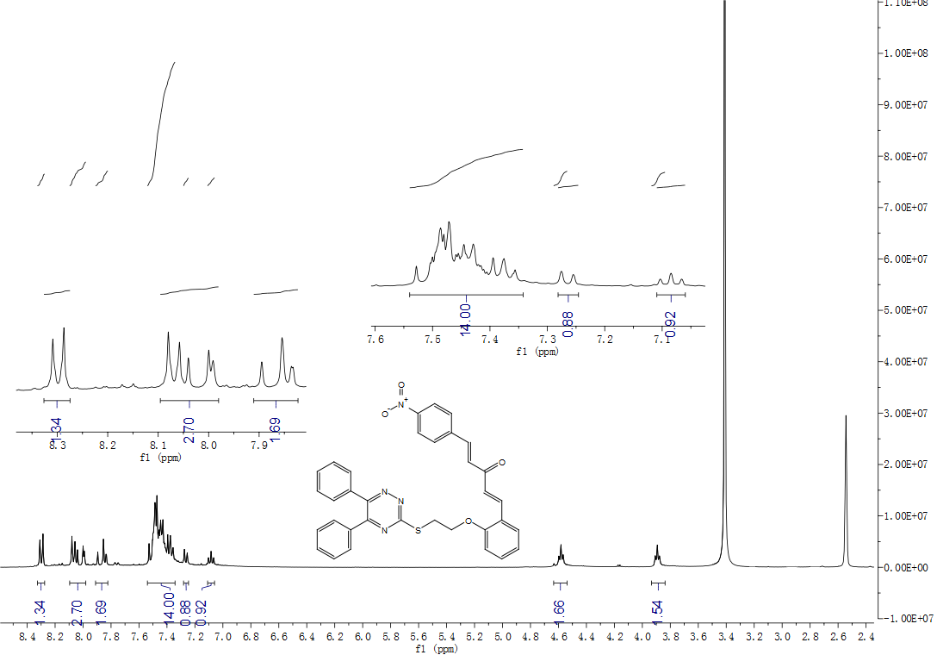
Figure S8. ¹³C NMR spectrum of compound 4c

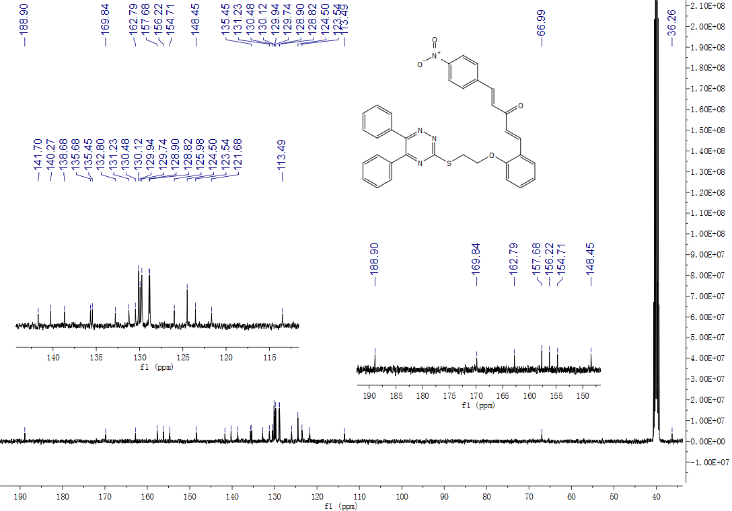

Figure S9. HRMS spectrum of compound 4c
Figure S10. ¹H NMR spectrum of compound 4d
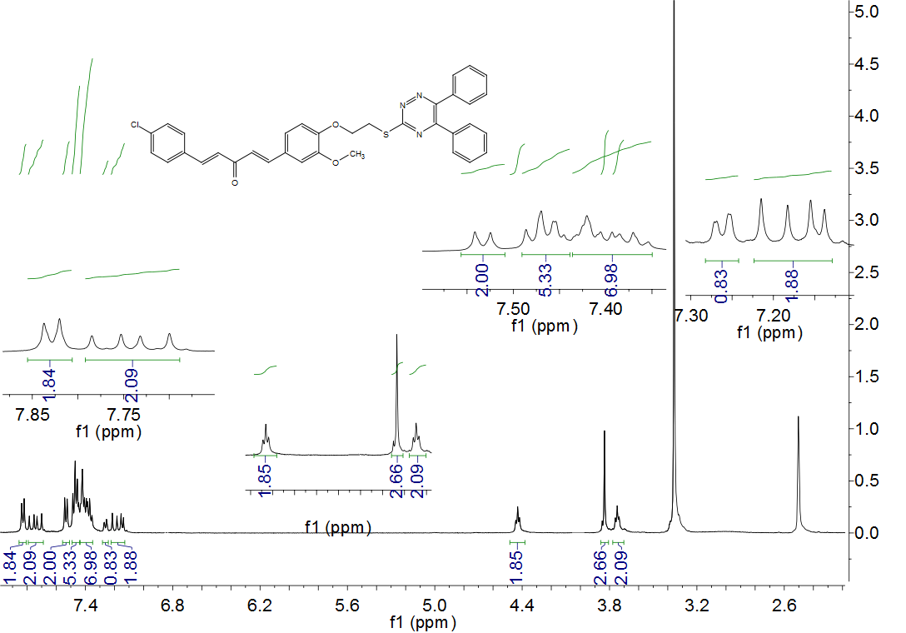
Figure S11. ¹³C NMR spectrum of compound 4d
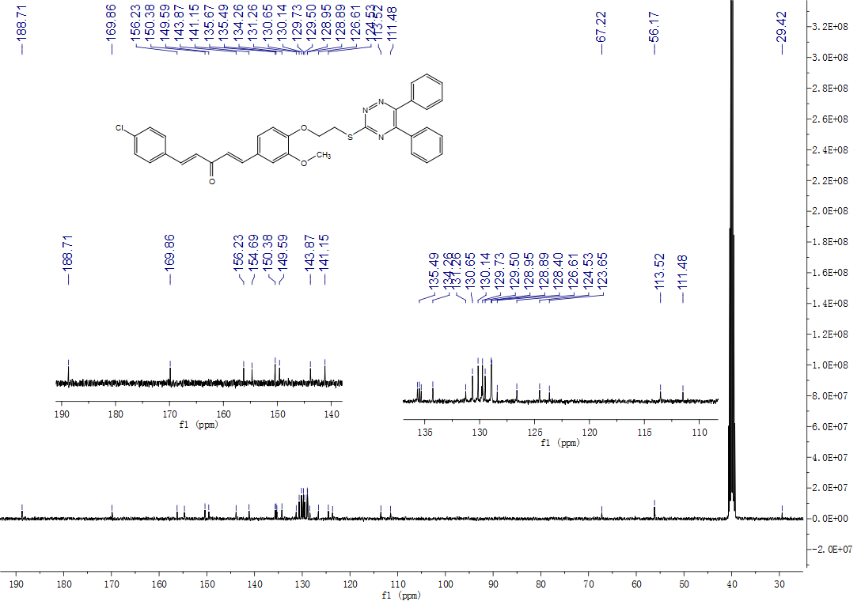

Figure S12. HRMS spectrum of compound 4d

Figure S13. ¹H NMR spectrum of compound 4e
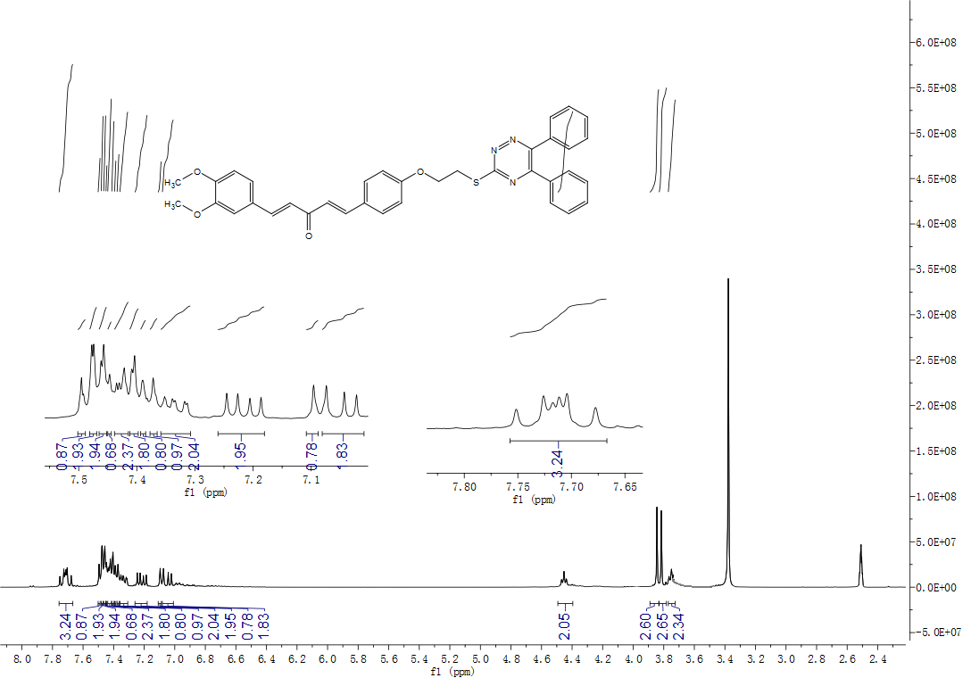 Figure S14. ¹³C NMR spectrum of compound 4e
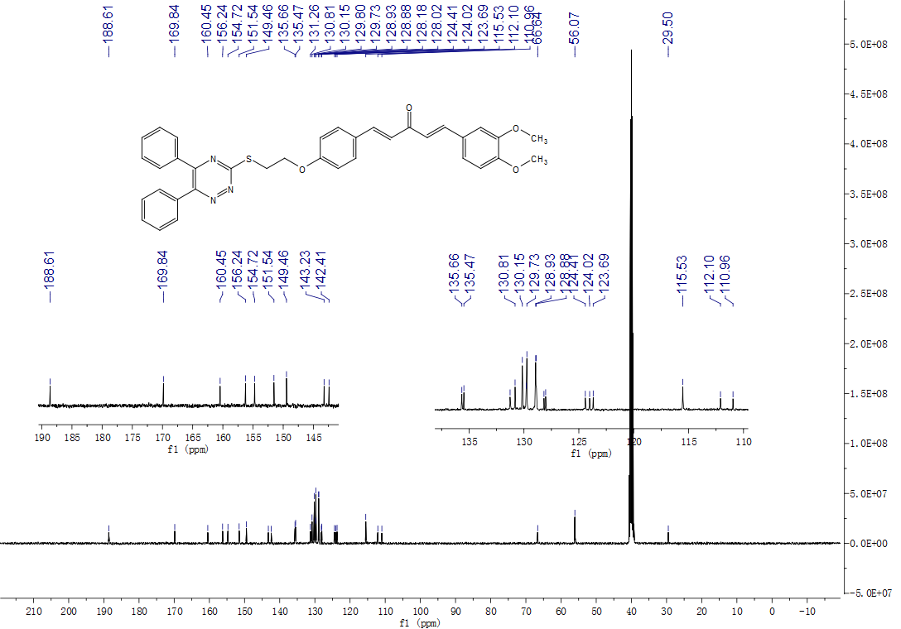
Figure S15. HRMS spectrum of compound 4e
Figure S16. ¹H NMR spectrum of compound 4f
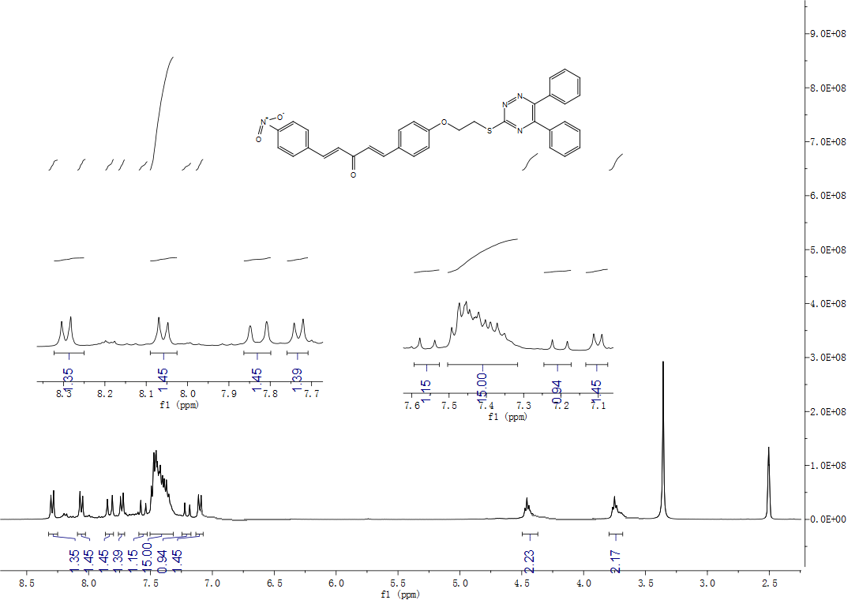
Figure S17. ¹³C NMR spectrum of compound 4f
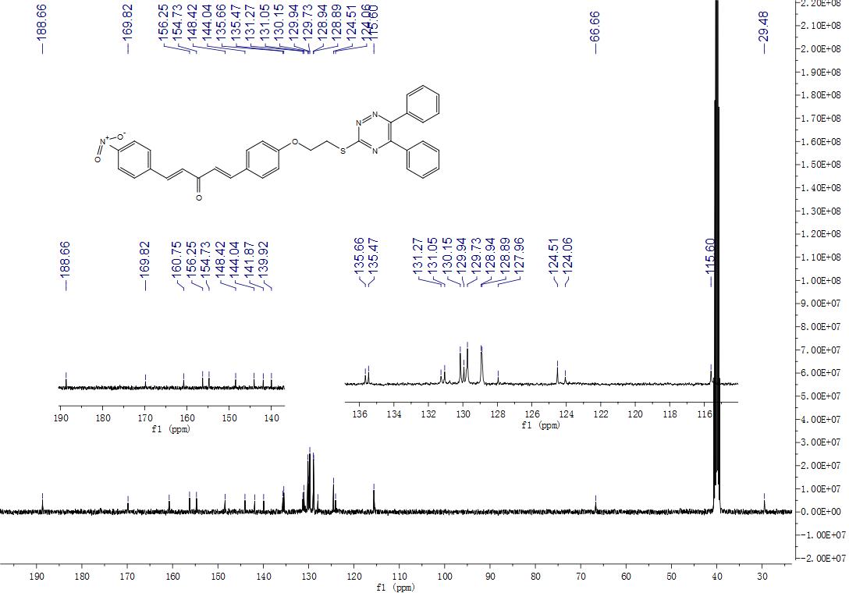

Figure S18. HRMS spectrum of compound 4f

Figure S19. ¹H NMR spectrum of compound 4g
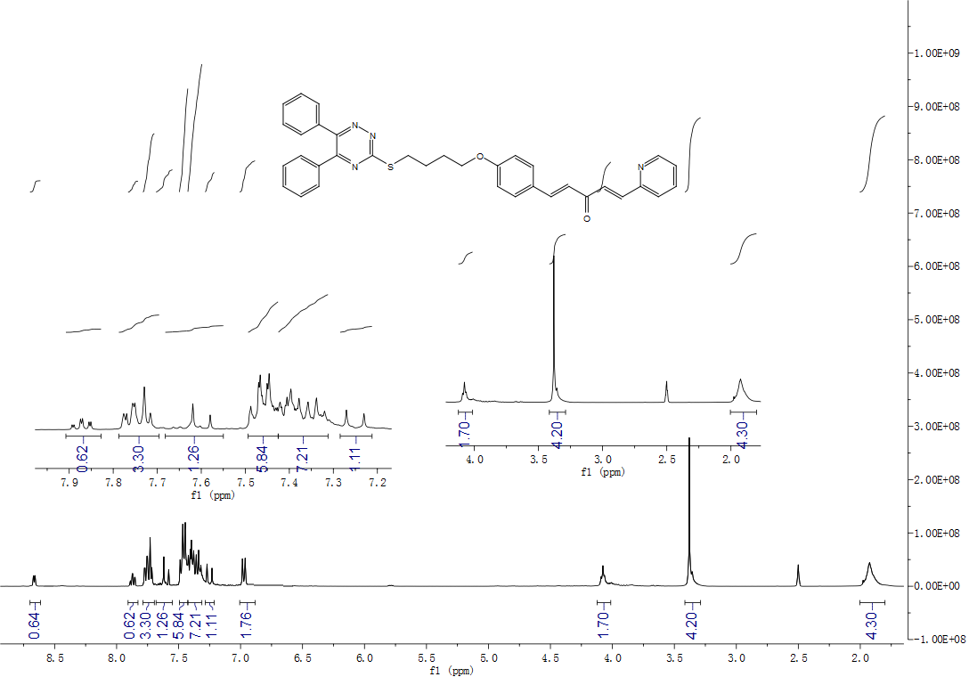
Figure S20. ¹³C NMR spectrum of compound 4g
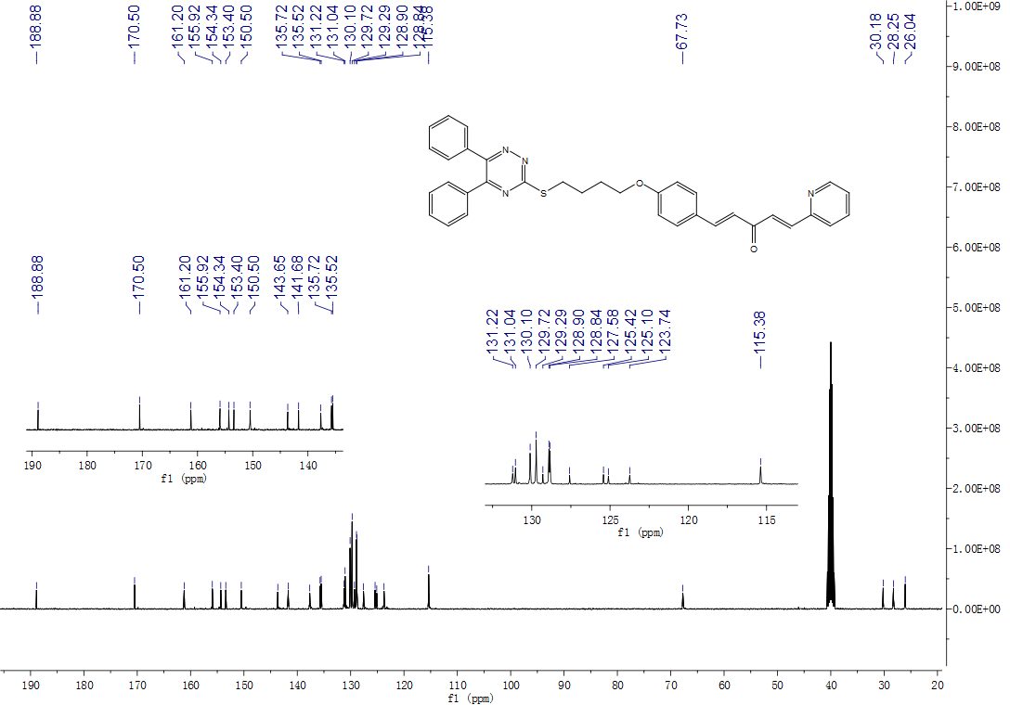

Figure S21. HRMS spectrum of compound 4g
Figure S22. ¹H NMR spectrum of compound 4h
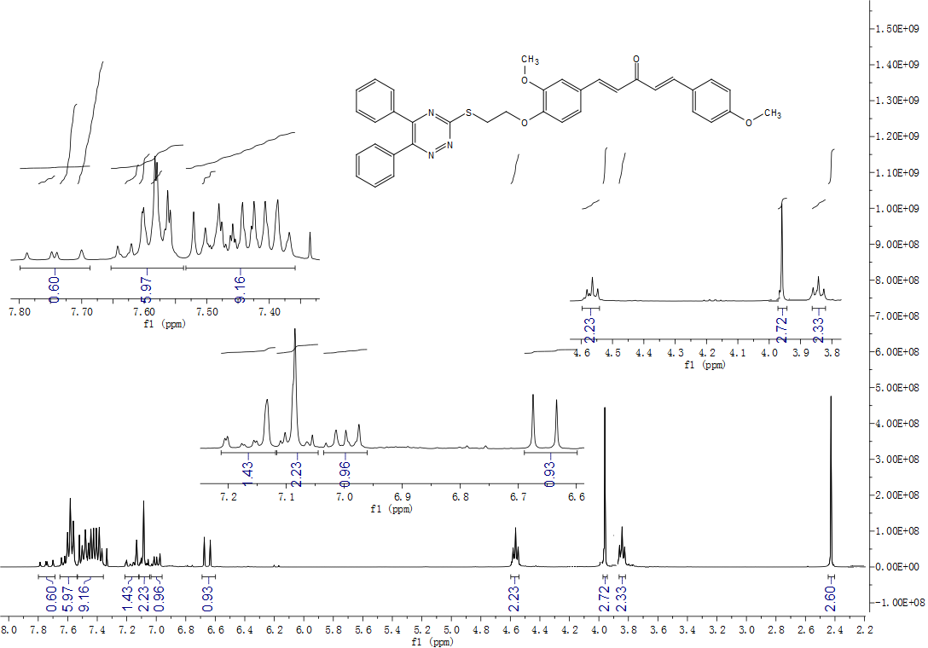
Figure S23. ¹³C NMR spectrum of compound 4h
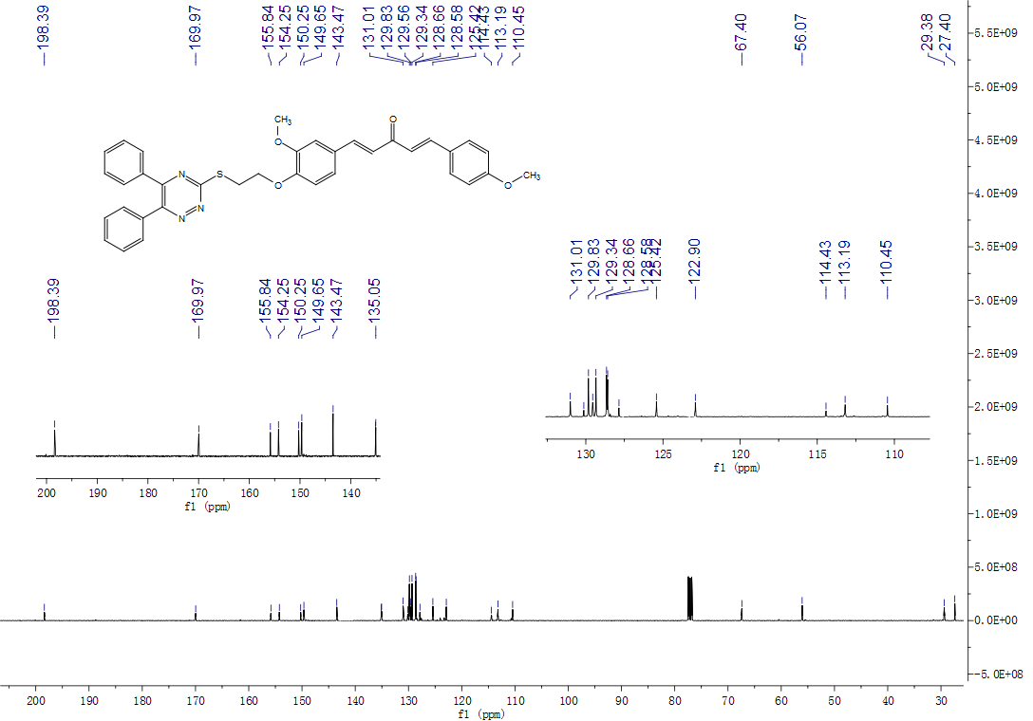

Figure S24. HRMS spectrum of compound 4h
Figure S25. ¹H NMR spectrum of compound 4i
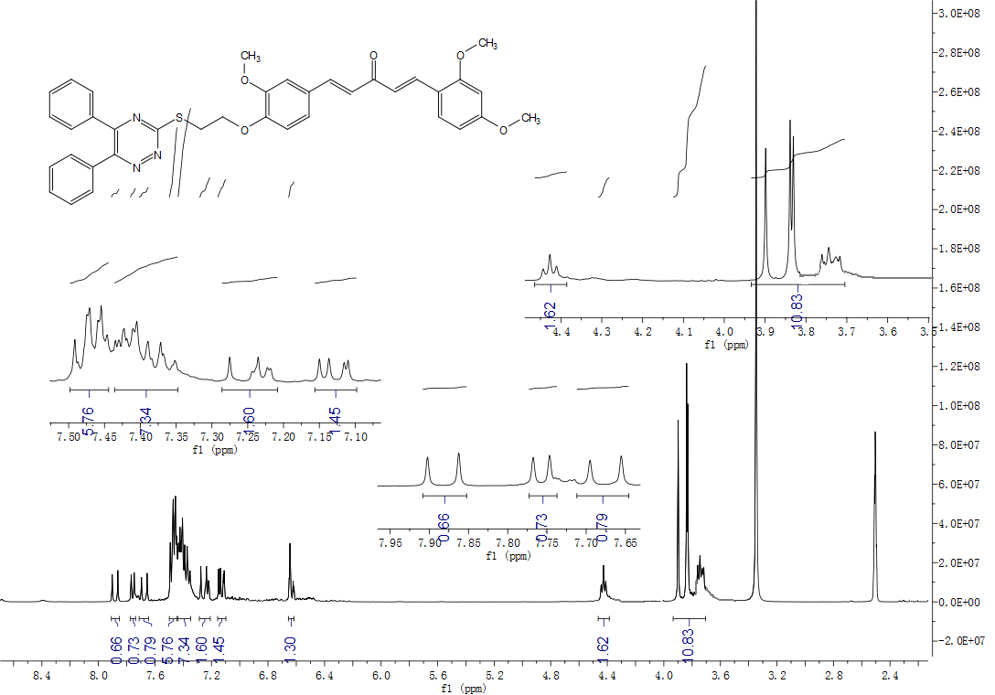
Figure S26. ¹³C NMR spectrum of compound 4i
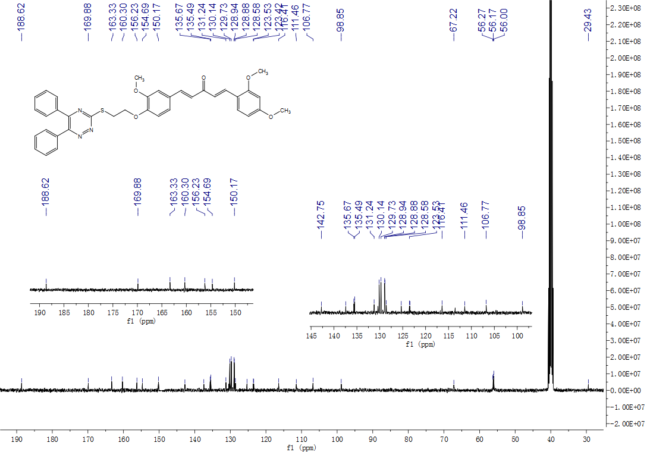

Figure S27. HRMS spectrum of compound 4i
Figure S28. ¹H NMR spectrum of compound 4j
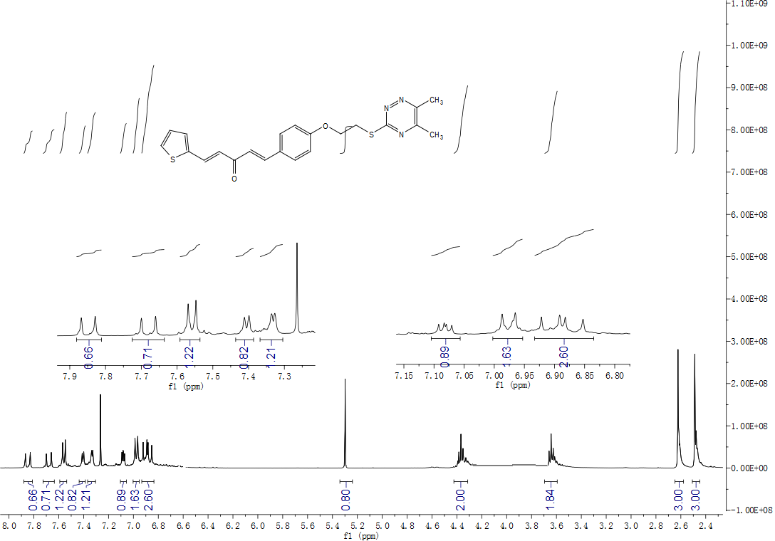
Figure S29. ¹³C NMR spectrum of compound 4j
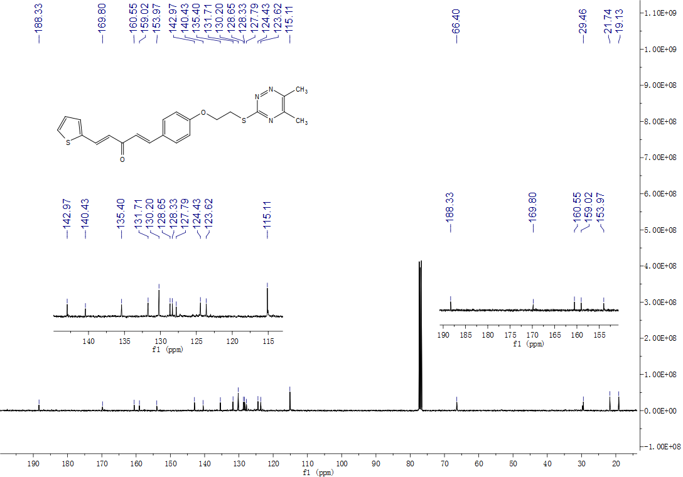

Figure S30. HRMS spectrum of compound 4j
Figure S31. ¹H NMR spectrum of compound 4k
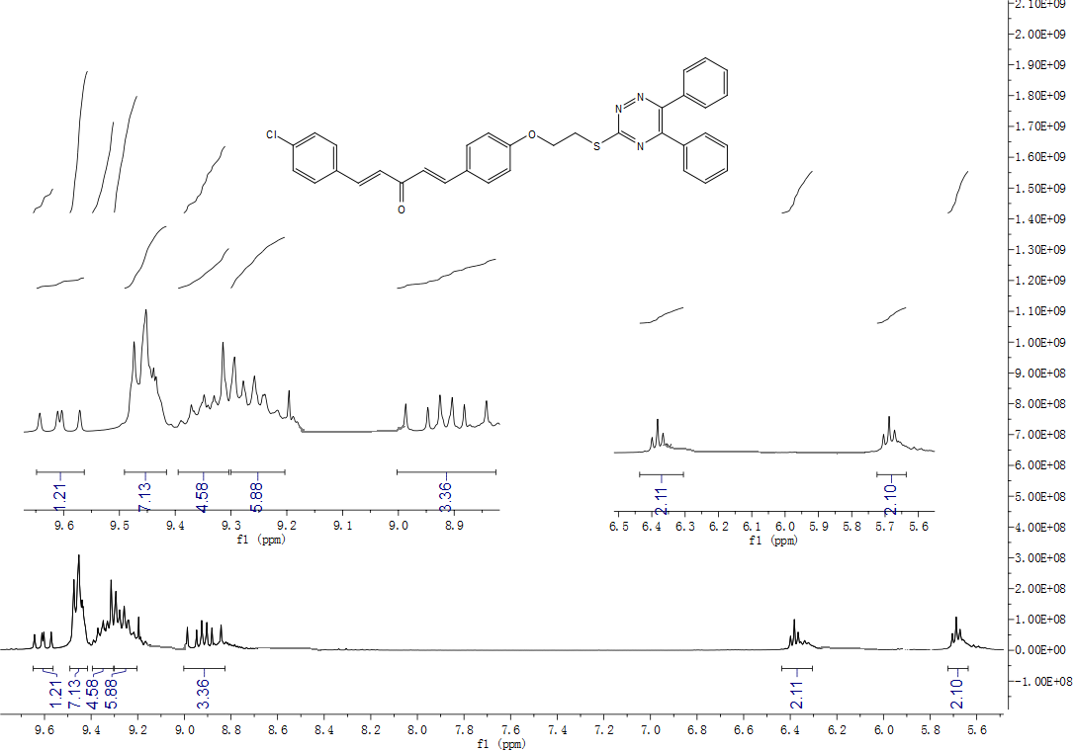
Figure S32. ¹³C NMR spectrum of compound 4k
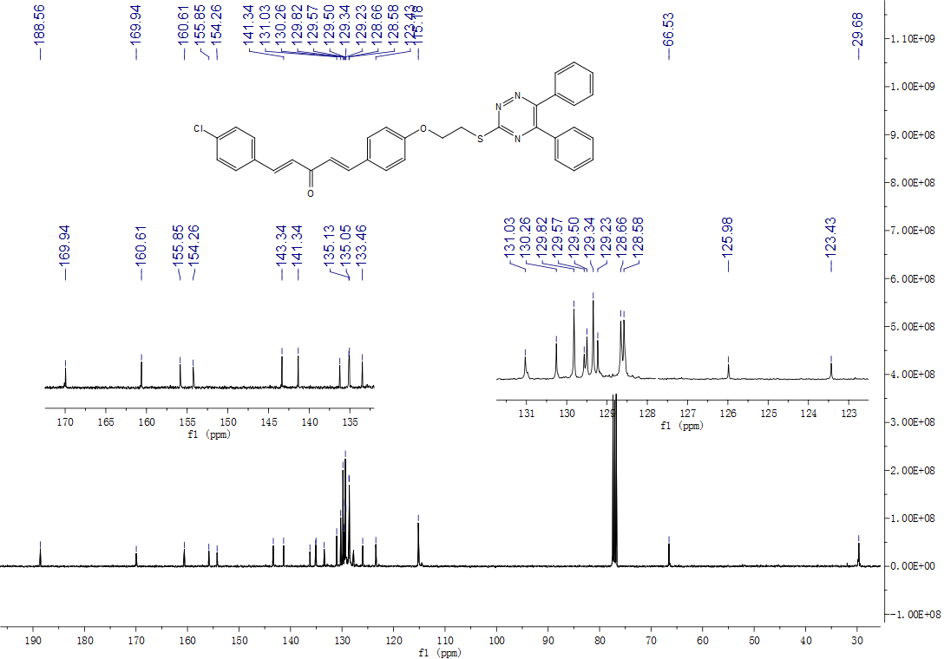

Figure S33. HRMS spectrum of compound 4k
Figure S34. ¹H NMR spectrum of compound 4l
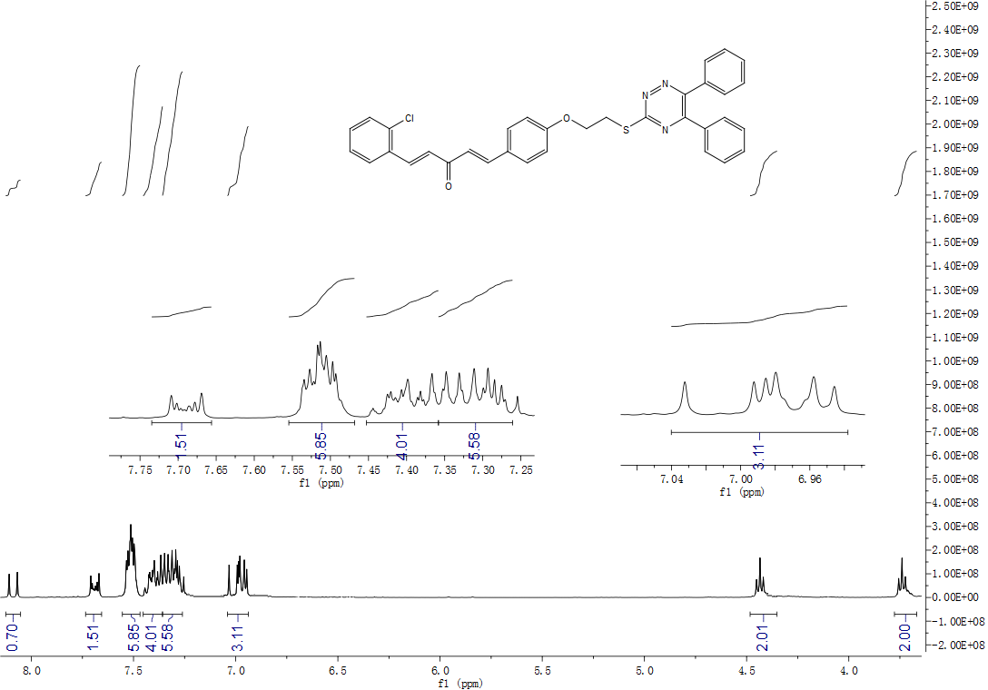
Figure S35. ¹³C NMR spectrum of compound 4l
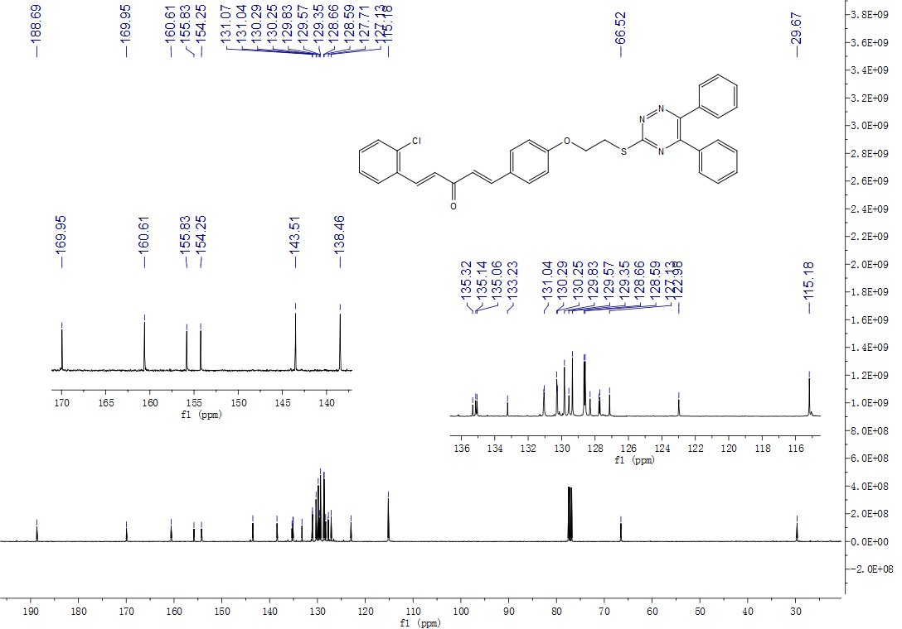

Figure S36. HRMS spectrum of compound 4l
Figure S37. ¹H NMR spectrum of compound 4m
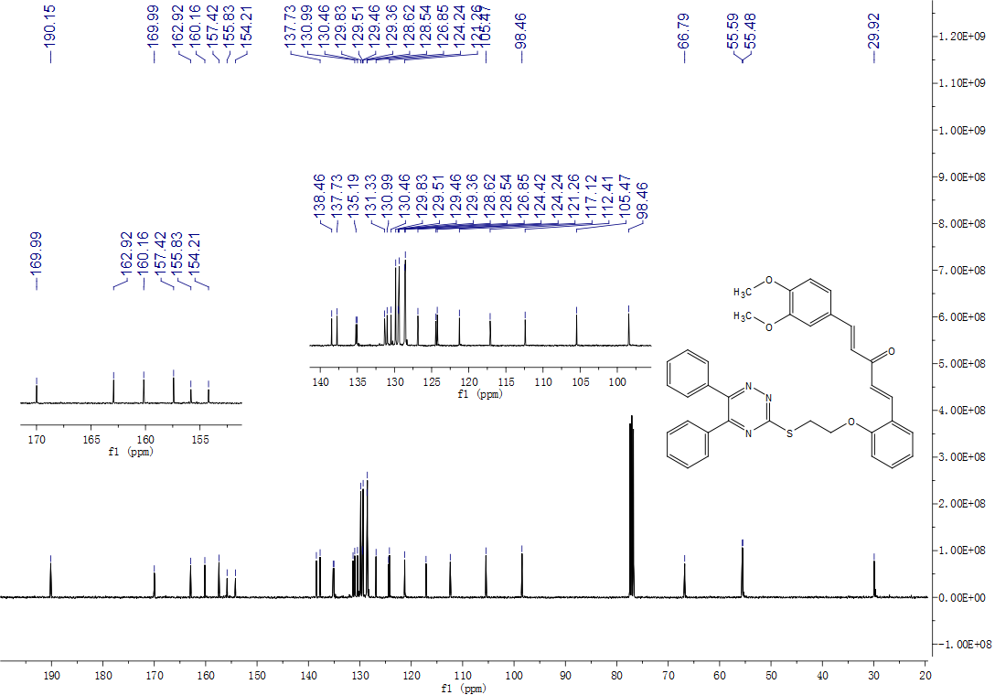
Figure S38. ¹³C NMR spectrum of compound 4m
Figure S39. HRMS spectrum of compound 4m
Figure S40. ¹H NMR spectrum of compound 4n
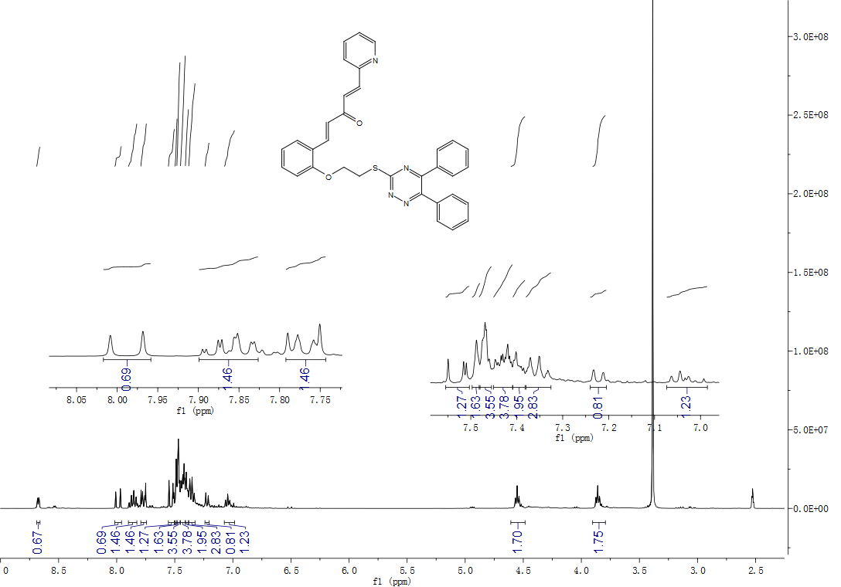
Figure S41. ¹C NMR spectrum of compound 4n
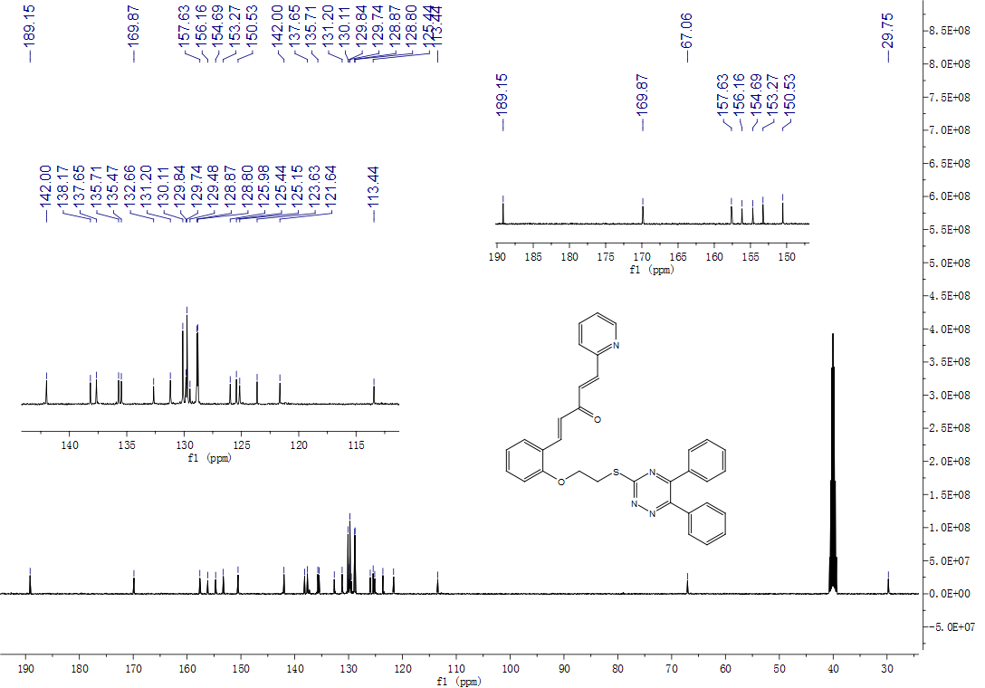
Figure S42. HRMS spectrum of compound 4n
Figure S43. ¹H NMR spectrum of compound 4o
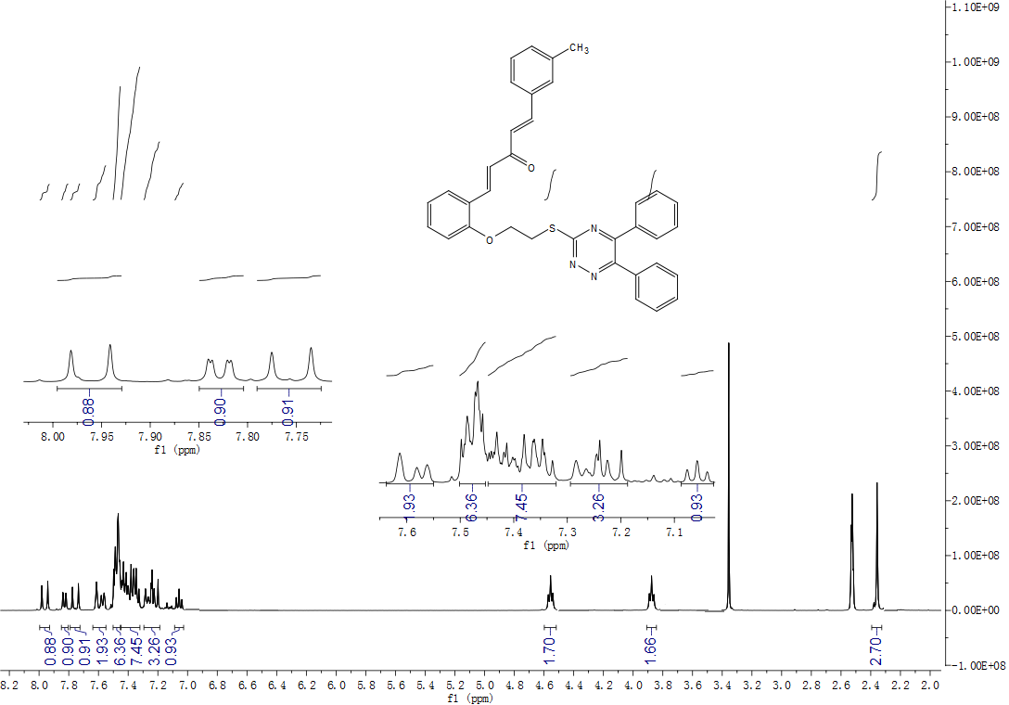
Figure S44. ¹C NMR spectrum of compound 4o
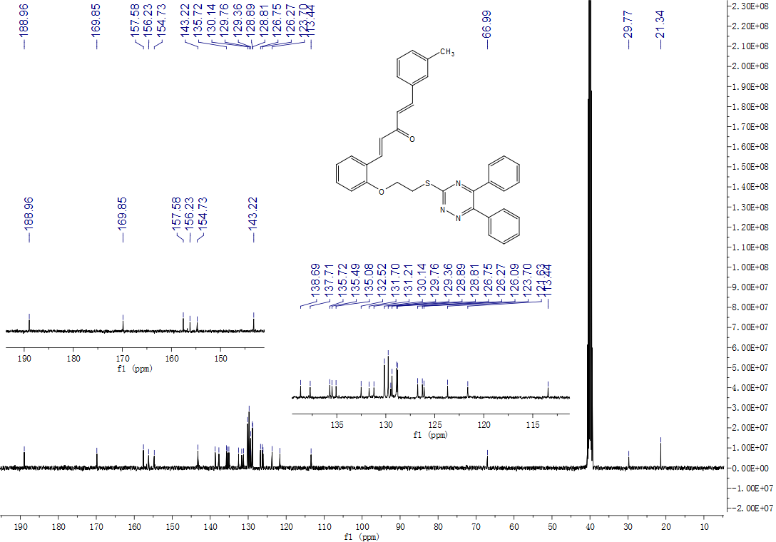
Figure S45. HRMS spectrum of compound 4o
Figure S46. ¹H NMR spectrum of compound 4P
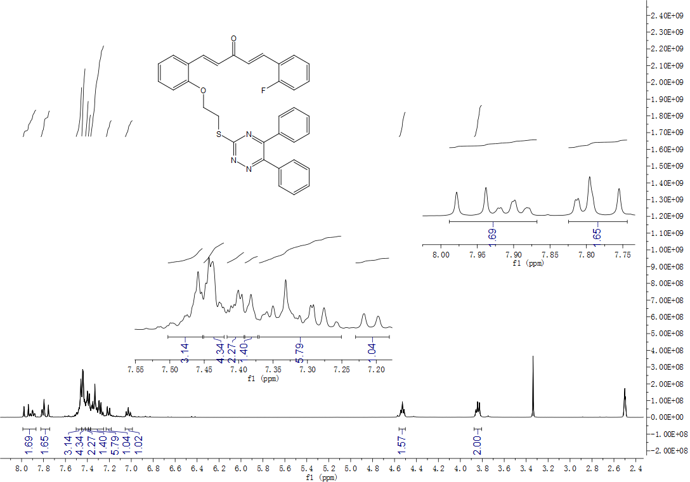

Figure S47. ¹C NMR spectrum of compound 4p
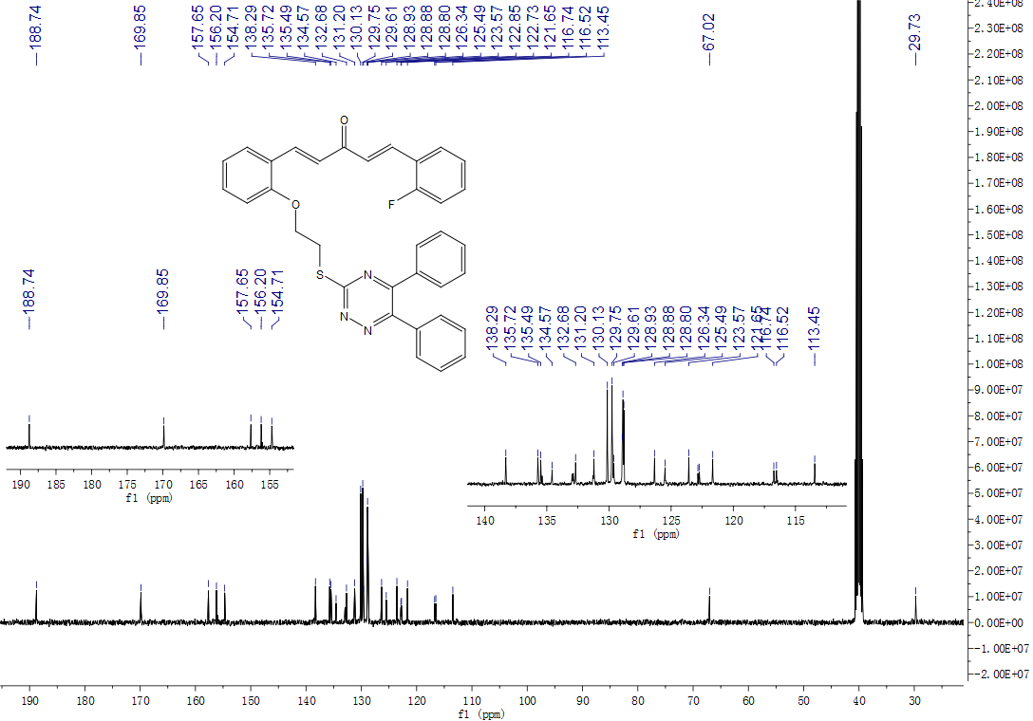
Figure S48. ¹⁹ F NMR spectrum of compound 4p
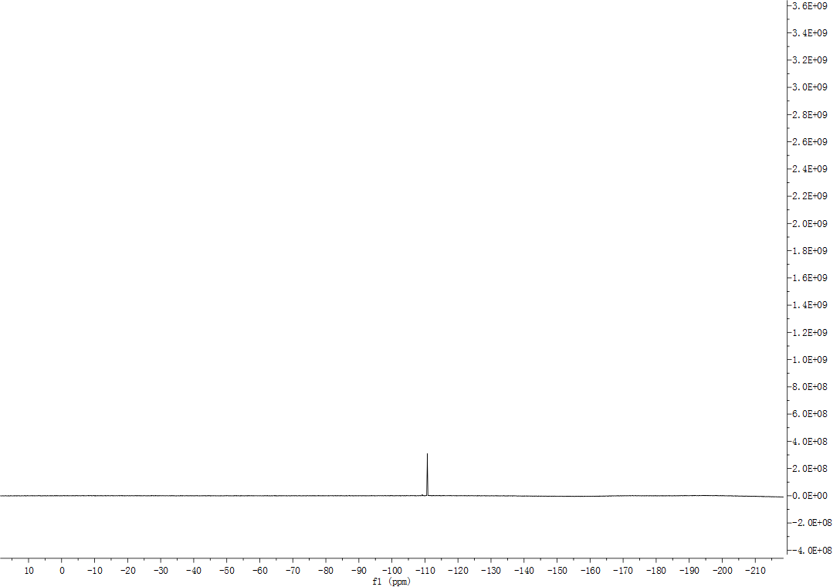

Figure S49. HRMS spectrum of compound 4P
Figure S50. ¹H NMR spectrum of compound 4q
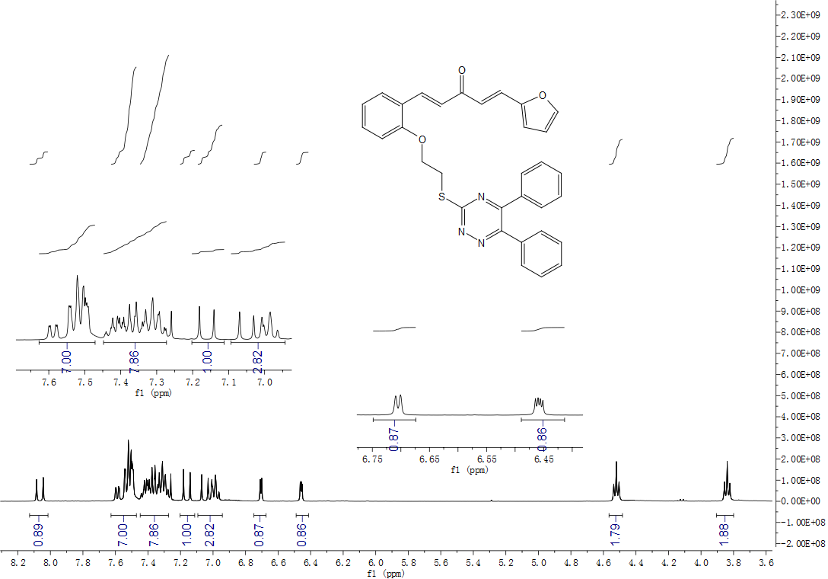
Figure S51. ¹³C NMR spectrum of compound 4q
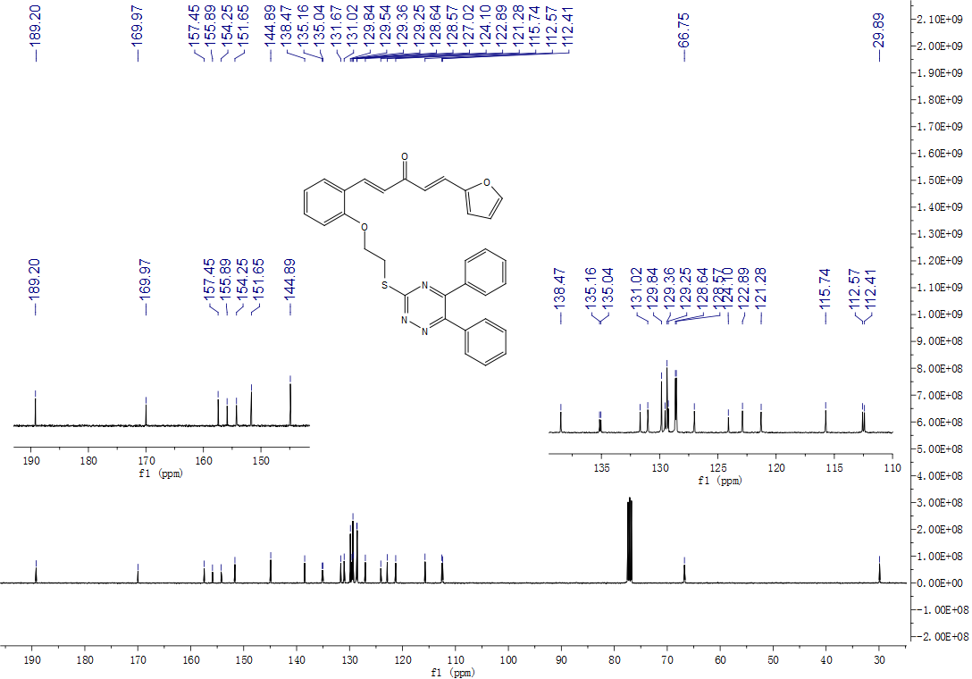
Figure S52. HRMS spectrum of compound 4q
Figure S53. ¹H NMR spectrum of compound 4r
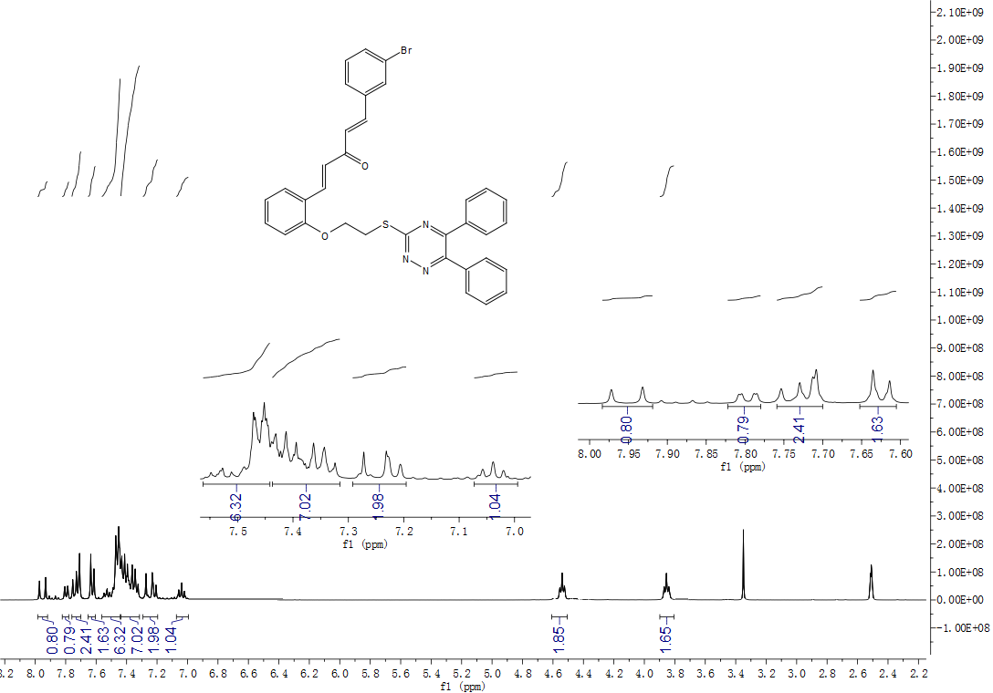
Figure S54. ¹³C NMR spectrum of compound 4r
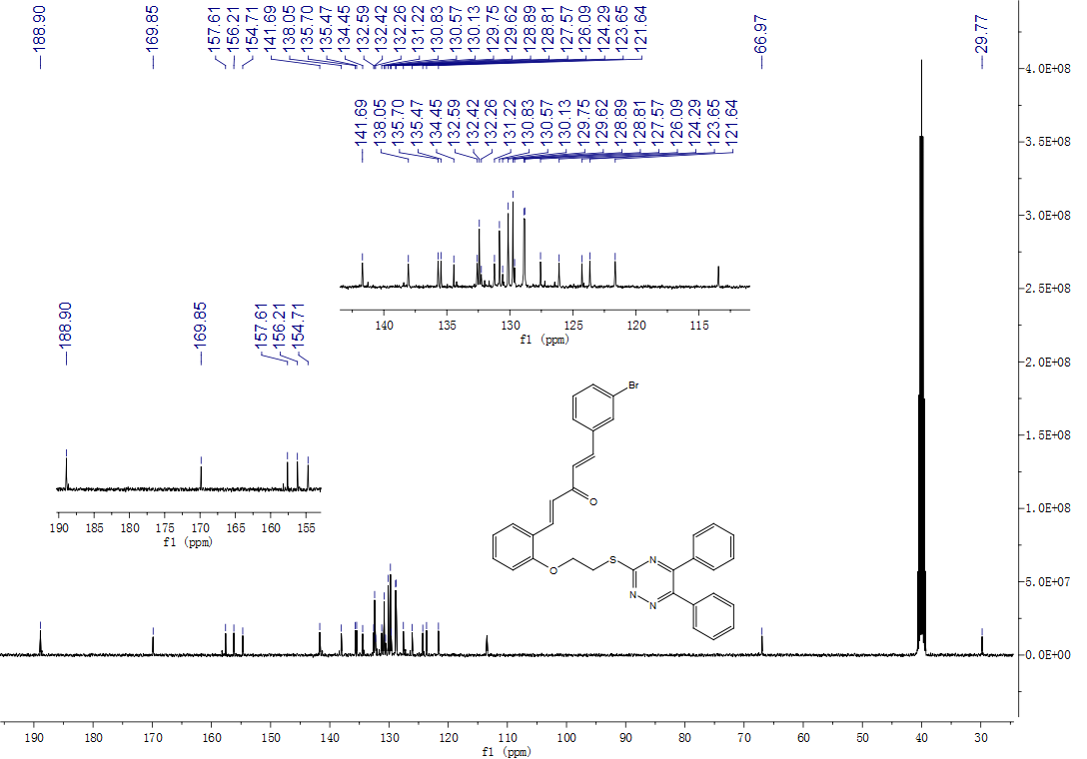

Figure S55. HRMS spectrum of compound 4r

