Supplemental Files

Tackling the SARS-CoV-2 main protease using hybrid derivatives of 1,5-disubstituted tetrazole-1,2,3-triazoles: an in silico assay

Carlos J. Cortés-García¹, Luis Chacón- García¹, Jorge Emmanuel Mejía-Benavides²,
Erik Díaz-Cervantes^{3*}

¹Laboratorio de Diseño Molecular, Instituto de Investigaciones Químico-Biológicas, Universidad Michoacana de San Nicolás de Hidalgo. Morelia, Michoacán, México
²Departamento de Enfermería y Obstetricia, Centro Interdisciplinario del Noreste (CINUG), Universidad de Guanajuato, Tierra Blanca, Guanajuato, México
³Departamento de Alimentos, Centro Interdisciplinario del Noreste (CINUG), Universidad de Guanajuato, Tierra Blanca, Guanajuato, México

Cartesian cordinates

Compound 1e
C -9.92730 15.56110 68.68180
N -9.31700 16.50170 67.77190
N -8.03190 16.58440 68.34200
N -7.91900 15.84870 69.36860
N -9.11540 15.18220 69.61510
H -9.19530 18.47870 65.87830
C -11.34190 15.02120 68.51650
H -11.36450 14.11180 69.15650
H -11.90900 12.48570 67.65700
N -12.37060 15.93240 69.06410
H -11.94630 19.56330 66.78010
H -10.77370 17.62050 65.80050
H -8.19540 19.04530 68.28820
H -9.14230 18.53020 69.72850
H -9.38400 20.96940 69.25120
H -10.95690 20.10240 69.17180
H -9.18450 20.96060 66.78340
C -9.22360 18.88170 68.67790
H -14.66440 10.94420 73.21240
C -9.96940 20.22190 68.67380
N -11.39340 7.06810 70.72130
C -10.17200 20.73500 67.24300
C -11.68690 14.56840 67.10130
C -11.74480 15.47220 66.02330
C -12.07060 15.03140 64.73800
C -12.36890 13.67020 64.50110
C -12.27690 12.76940 65.56800
C -11.95140 13.21030 66.85330
H -13.74680 8.71700 72.72940
H -12.07210 15.75540 63.93500
H -12.47140 11.71730 65.40160
H -10.99170 17.69780 68.25360
C -12.21580 16.24090 70.49510
H -13.30550 15.48150 68.92210
H -12.77200 17.16580 70.74520
H -11.14460 16.36630 70.76300
C -13.59050 14.17490 70.92520
C -12.79380 15.14360 71.34390
N -12.53720 14.93890 72.72140
N -13.17010 13.89300 73.06910
N -13.91230 13.30470 72.02320
H -13.95760 14.05220 69.91060
H -10.99430 20.07900 65.34510
C -13.40380 11.97840 71.77580
C -12.39920 11.81280 70.81300
C -11.87920 10.54370 70.54040
C -12.36110 9.42370 71.22890
C -13.36620 9.57700 72.19120
C -13.88760 10.84490 72.46510
H -12.01870 12.67160 70.27430
H -11.10200 10.43620 69.79320
C -11.82470 8.11800 70.94750
H -10.75960 21.67780 67.27160
C -9.97600 17.82910 67.81750
C -10.91490 19.70200 66.38740
C -10.17830 18.35620 66.38390
O -12.65770 13.15110 63.24300
H -11.52380 16.52150 66.16930
C -12.81040 11.74790 63.27020
H -12.68730 11.36250 62.23740
H -13.83420 11.47380 63.60240
H -12.03840 11.25070 63.90130

Molecular electrostatic potential surfaces

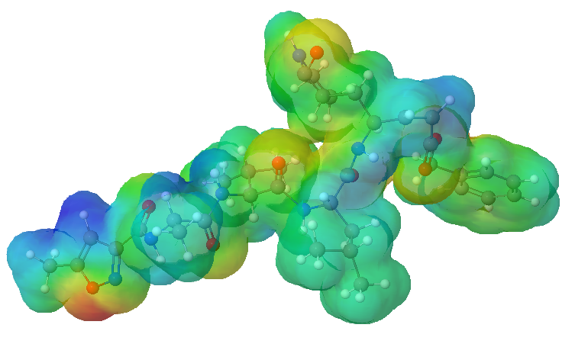
Fig. S1. Molecular electrostatic potential surface for the co-crystalized molecule (into the SARS-CoV-2-M^{Pro}).

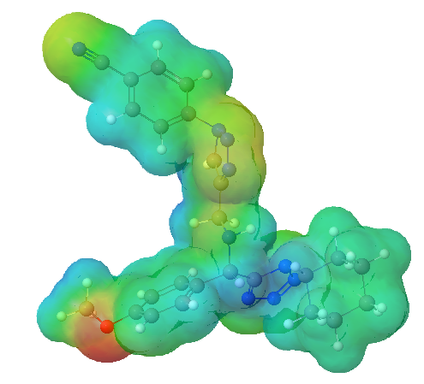
Fig. S2. Molecular electrostatic potential surface for the 1e molecule.

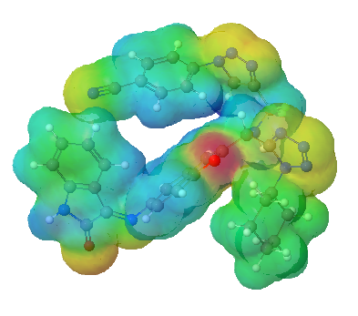
Fig. S3. Molecular electrostatic potential surface for the P8 molecule.

