Additional File 1. The maps of distribution for (A) Geotrochus and (B) Trochomorpha species based on the records with coordinate information obtained from Global Biodiversity Information Facility (GBIF).

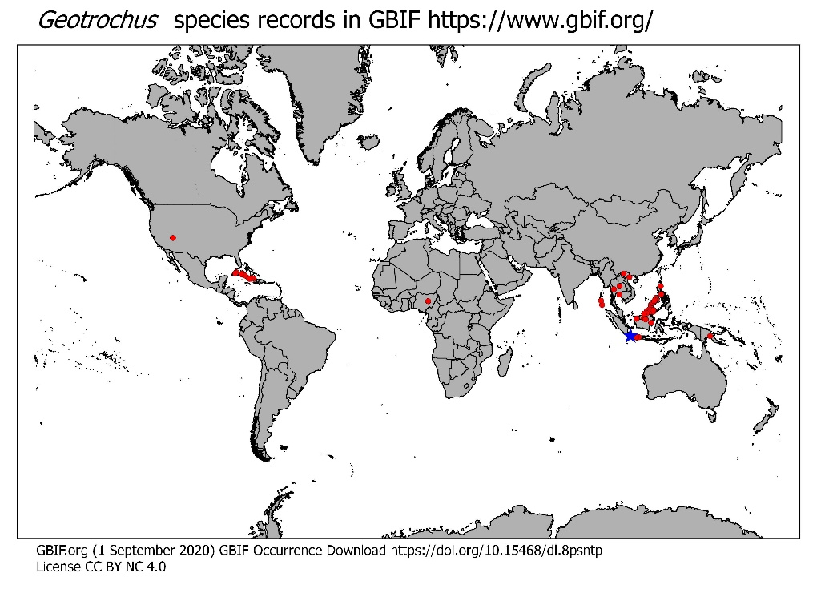
Figure 1. Geotrochus species distribution map based on records in GBIF (red circles) and the type locality (blue star). The base map is from Global Administrative Areas ( 2012). GADM database of Global Administrative Areas, version 2.0. [online] URL: www.gadm.org.

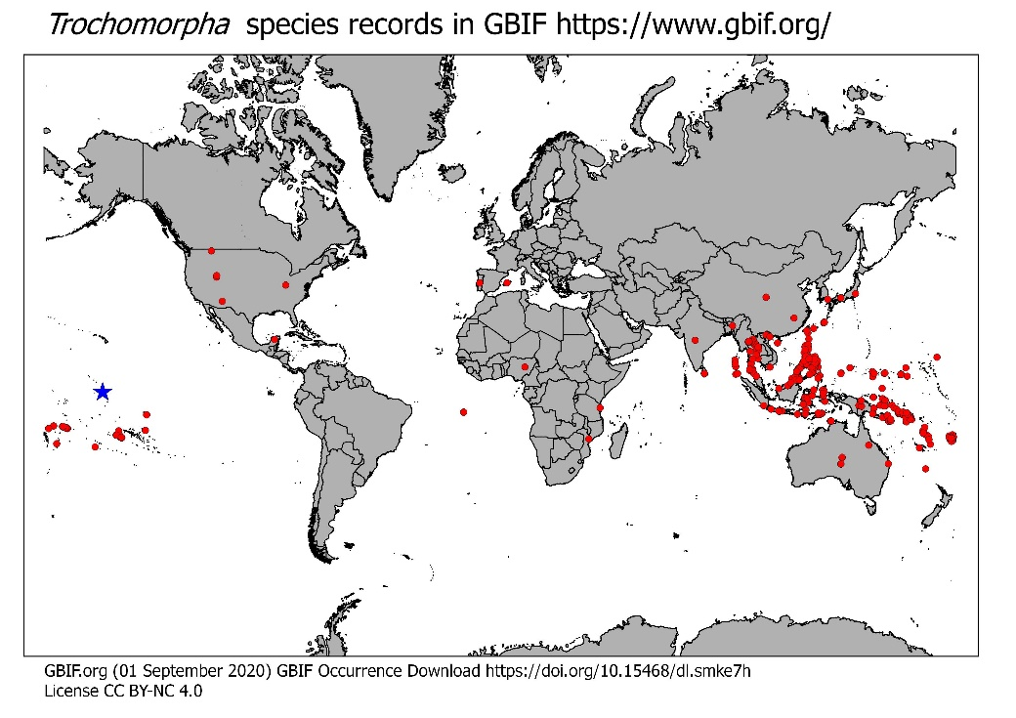

Figure 2. Trochomorpha species distribution map based on records in GBIF (red circles) and the type locality (blue star). The base map is from Global Administrative Areas ( 2012). GADM database of Global Administrative Areas, version 2.0. [online] URL: www.gadm.org.

