The reaction results were compared：

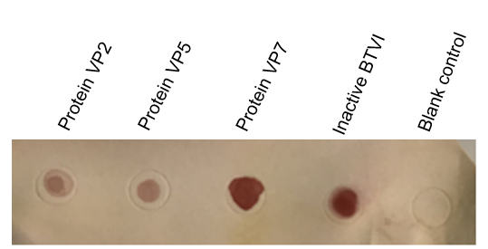

The result of the reaction of BTV1 VP2/VP5/VP7/inactivated BTV1 with BTV1 positive serum.