Supplementary S2: The arrangement of camera traps, capture-recapture locations, and the tracks of tiger and leopard detected in camera traps.

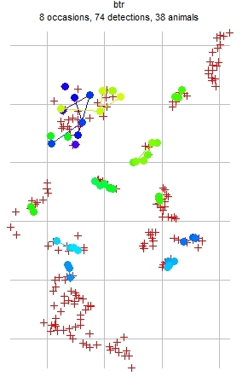
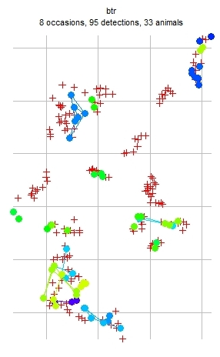

Camera traps are represented by red crosses; the colored dots represent the unique individuals of tiger (on left panel) and leopard (on right panel). The lines connecting the dots represent the tracks.

