Supplementary data
All of them were characterized by ¹³C NMR, ¹H NMR, melting properties and MS analysis, which were exactly accord with the structure described.

Representative ¹HNMR spectra
5,8-Dihydroxynaphthalene-1,4-dione (Naphthoquinone, PubChem CID: 10141)
Red powder，Mp: 227°C. ¹H NMR (600 MHz, CDCl₃) δ 12.41 (s, 2H, -OH), 7.15 (s, 4H, Ar-H). ¹³C NMR (151 MHz, CDCl₃) δ 172.85 (s, 1C, 4C, 5C, 8C), 134.65 (s, 2C, 3C, 6C, 7C), 111.87 (s, 9C, 10C). ESI-TOF, calcd for C₁₀H₆O₄ ([M+H]⁺), 191.03, found 190.96. Anal. Calcd for C₁₀H₆O₄: C, 63.16; H, 3.18; O, 33.65; Found: C, 63.08; H, 3.20; O, 33.66.
(R)-5,8-Dihydroxy-2-(1-hydroxy-4-methylpent-3-en-1-yl)naphthalene-1,4-dione (Shikonin, PubChem CID: 479503)
Red powder，Mp: 147-148°C. ¹H NMR (600 MHz, CDCl₃) δ 12.60 (s, 1H, -OH), 12.49 (s, 1H, -OH), 7.20 (t, J = 7.2 Hz, 2H, Ar-H), 7.18 – 7.17 (m, 1H, -C-CH=C), 5.21 (dd, J = 8.0, 6.9 Hz, 1H, -OH), 4.93 – 4.90 (m, 1H, -C-CH=C), 4.12 (dd, J = 14.3, 7.1 Hz, 1H, -O-CH), 2.67 – 2.62 (m, 1H, -CH₂), 2.39 – 2.33 (m, 1H, -CH₂), 1.76 (s, 3H, -CH₃), 1.66 (s, 3H, -CH₃). ¹³C NMR (151 MHz, CDCl₃) δ 180.66 (s, 8C), 179.86 (s, 5C), 165.48 (s, 4C), 164.87 (s, 1C), 151.44 (s, 7C), 137.48 (s, 6C), 132.41 (s, 14C), 132.30 (s, 2C), 131.87 (s, 3C), 118.44 (s,13C), 112.03 (s, 9C), 111.55 (s, 10C), 68.35 (s, 11C), 35.68 (s, 12C), 25.97 (s, 15C), 18.10 (s, 16C). ESI-TOF, calcd for C₁₆H₁₆O₅ ([M+H]⁺), 289.10, found 288.78. Anal. Calcd for C₁₆H₁₆O₅: C, 66.66; H, 5.59; O, 27.75; Found: C, 66.65; H, 5.58; O, 27.72.
(S)-5,8-Dihydroxy-2-(1-hydroxy-4-methylpent-3-en-1-yl)naphthalene-1,4-dione (Alkanin, PubChem CID: 32465)
Red powder，Mp: 149°C. ¹H NMR (600 MHz, CDCl₃) δ 12.60 (d, J = 4.8 Hz, 1H, -OH), 12.50 (d, J = 5.0 Hz, 1H, -OH), 7.21 (t, J = 7.2 Hz, 2H, Ar-H), 7.19 – 7.17 (m, 1H, -C-CH=C), 5.21 (ddd, J = 8.1, 2.7, 1.3 Hz, 2H, -OH, -O-CH), 4.92 (dd, J = 7.8, 4.3 Hz, 1H, -C-CH=C), 2.68 – 2.63 (m, 1H, -CH₂), 2.36 (dd, J = 14.8, 7.6 Hz, 1H, -CH₂), 1.76 (s, 3H, -CH₃), 1.66 (s, 3H, -CH₃). ¹³C NMR (151 MHz, CDCl₃) δ 180.66 (s, 8C), 179.86 (s, 5C), 165.48 (s, 4C), 164.87 (s, 1C), 151.44 (s, 7C), 137.48 (s, 6C), 132.41 (s, 14C), 132.30 (s, 2C), 131.87 (s, 3C), 118.44 (s,13C), 112.03 (s, 9C), 111.55 (s, 10C), 68.35 (s, 11C), 35.68 (s, 12C), 25.97 (s, 15C), 18.10 (s, 16C). ESI-TOF, calcd for C₁₆H₁₆O₅ ([M+H]⁺), 289.10, found 288.78. Anal. Calcd for C₁₆H₁₆O₅: C, 66.66; H, 5.59; O, 27.75; Found: C, 66.67; H, 5.62; O, 27.71.
(R)-1-(5,8-Dihydroxy-1,4-dioxo-1,4-dihydronaphthalen-2-yl)-4-methylpent-3-en-1-yl 3-methylbut-2-enoate (β, β-dimethylacrylshikonin, PubChem CID: 479499)
Red powder，Mp: 103-105°C. ¹H NMR (600 MHz, CDCl₃) δ 12.60 (s, 1H, -OH), 12.44 (s, 1H, -OH), 7.18 (s, 1H, -C-CH=C), 7.00 – 6.97 (m, 2H, Ar-H), 6.03 (ddd, J = 18.2, 7.3, 4.0 Hz, 1H, -C-CH=C), 5.79 – 5.77 (m, 1H, -O-CH-), 5.15 (t, J = 7.3 Hz, 1H, -C-CH=C), 2.63 (dt, J = 11.7, 6.6 Hz, 1H, -CH₂-), 2.48 (dt, J = 14.9, 7.3 Hz, 1H, -CH₂-), 2.15 (d, J = 10.1 Hz, 3H, -CH₃), 1.94 (d, J = 0.8 Hz, 3H, -CH₃), 1.69 (s, 3H, -CH₃), 1.58 (s, 3H, -CH₃). ¹³C NMR (151 MHz, CDCl₃) δ 179.03 (s, 8C), 177.53 (s, 5C), 166.79 (s, 17C), 166.25 (s, 4C), 165.27 (s, 1C), 159.01 (s, 19C), 149.05 (s, 7C), 135.86 (s, 6C), 132.60 (s, 14C), 132.45 (s, 2C), 131.60 (s, 3C), 118.01 (s, 13C), 115.26 (s, 18C), 111.87 (s, 9C), 111.60 (s, 10C), 68.63 (s, 11C), 32.90 (s, 12C), 27.59 (s, 21C), 25.77 (s, 16C), 20.38 (s, 20C), 17.97 (s, 15C). ESI-TOF, calcd for C₂₁H₂₂O₆ ([M+H]⁺), 371.14, found 370.10. Anal. Calcd for C₂₁H₂₂O₆: C, 68.09; H, 5.99; O, 25.92; Found: C, 68.09; H, 5.98; O, 25.91
(R)-1-(5,8-Dihydroxy-1,4-dioxo-1,4-dihydronaphthalen-2-yl)-4-methylpent-3-en-1-yl acetate (Acetylshikonin, PubChem CID: 479501)
Red powder，Mp: 86°C. ¹H NMR (600 MHz, CDCl₃) δ 12.59 (s, 1H, -OH), 12.43 (s, 1H, -OH), 7.19 (s, 2H, Ar-H), 6.99 (s, 1H, -C-CH=C), 6.02 (dd, J = 7.2, 4.6 Hz, 1H, -O-CH-), 5.12 (t, J = 7.3 Hz, 1H, -C-CH=C), 2.65 – 2.60 (m, 2H, -CH₂-), 2.14 (s, 3H, -CH₃), 1.69 (s, 3H, -CH₃), 1.58 (s, 3H, -CH₃). ¹³C NMR (151 MHz, CDCl₃) δ 178.23 (s, 8C), 176.71 (s, 5C), 169.79 (s, 17C), 167.48 (s, 4C), 166.96 (s, 1C), 148.22 (s, 7C), 136.14 (s, 6C), 132.90 (s, 14C), 132.74 (s, 2C), 131.47 (s, 3C), 117.67 (s, 13C), 111.83 (s, 9C), 111.57 (s, 10C), 69.53 (s, 11C), 32.83 (s, 12C), 25.78 (s, 16C), 21.00 (s, 18C), 17.95 (s, 15C). ESI-TOF, calcd for C₁₈H₁₈O₆ ([M+H]⁺), 331.34, found 331.12. Anal. Calcd for C₁₈H₁₈O₆: C, 65.45; H, 5.49; O, 29.06; Found: C, 65.40; H, 558; O, 29.03.

Representative ¹HNMR spectra
¹H NMR of Compound Naphthoquinone

¹H NMR of Compound Shikonin

¹H NMR of Compound Alkanin

¹H NMR of Compound β, β-dimethylacrylshikonin

¹H NMR of Compound Acetylshikonin

Representative ¹³CNMR spectra

¹³C NMR of Compound Naphthoquinone

¹³C NMR of Compound Shikonin

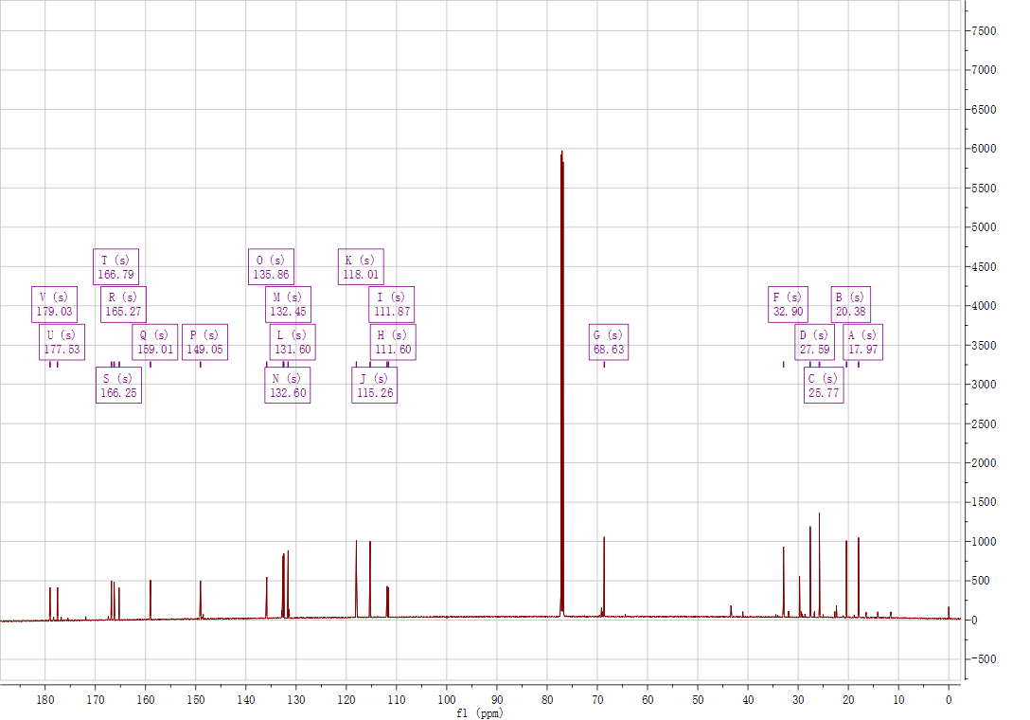
¹³C NMR of Compound β, β-dimethylacrylshikonin

¹³C NMR of Compound Acetylshikonin

