Comparative analysis and implications of the chloroplast genomes of three thistles (Carduus L., Asteraceae)
Joonhyung Jung¹, Hoang Dang Khoa Do^{1,2}, JongYoung Hyun¹, ChangKyun Kim¹, Joo‑Hwan Kim¹*
¹ Department of Life Science, Gachon University, Seongnam, Republic of Korea 13120
² Nguyen Tat Thanh Hi-Tech Institute, Nguyen Tat Thanh University, Ho Chi Minh City, Vietnam

Author for correspondence:
Joo-Hwan Kim
Department of Life Science, Gachon University, Seongnam, Republic of Korea 13120
Tell: +82317508827
Fax: +82317508738
Email: kimjh2009@gachon.ac.kr
Supplementary Materials:
The following are available online: Table S1: List of species for phylogenomic analysis and whole cpDNA alignment. Table S2: List of regions for calculating Pi values. Table S3. Genes composition of the Carduus chloroplast genomes. Table S4: Feature of SSR in three Carduus species. Table S5: Feature of repeats in three Carduus species. Figure S1: The alignment of matK among three Carduus. The asterisk indicates the positions of single nucleotide polymorphism (SNP). The red square indicates SNP site for design primer pairs. Figure S2: The alignment of partial matK sequences which include selected SNP among Carduus species. The light blue-shaded letter indicates the specific SNP of C. crispus in matK. Figure S3: The design of the primer pairs based on SNP site that is specific for Carduus crispus. The red bar indicates location of SNP in matK. The yellow arrows represent the position of primers CD_SNP_F2 and CD_SNP_R2 whereas the normal blue arrows means the location of primers CD_SNP_F1 and CD_SNP_R1. The bold blue arrows show the sites of matK463F and matK1162R. The two headed arrows indicate the size of each primer pairs: 700 bp for the pairs of matK463F and matK1162R, 421 bp for two pairs of matK463F-CD_SNP_R1 and matK463F-CD_SNP_R2, and 323 bp for two pairs of CD_SNP_F1-matK1162R and CD_SNP_F2-matK1162R. Figure S4: The Bayesian Inference tree of Carduus and related taxa inferred from whole cpDNA sequences (A), non-coding regions of cpDNA (B), and eight hotspot regions (C).Figure S5: The PCR results of specific primer pairs for Carduus crispus. The combination of matK_463F, matK_1162R, CD_SNP_F1, and CD_SNP_R1. The number from 1 to 12: Carduus crispus; from 13 to 20: Carduus acanthoides; from 21 to 24: Carduus tenuiflorus. Figure S6: The PCR results of specific primer pairs for Carduus crispus. The combination of matK_463F, matK_1162R, CD_SNP_F2, and CD_SNP_R2. The number from 1 to 12: Carduus crispus; from 13 to 20: Carduus acanthoides; from 21 to 24: Carduus tenuiflorus. Figure S7: The MAUVE alignment of chloroplast genomes among Carduus and related species.

Supplementary Table S1: List of species for phylogenomic analysis and whole cpDNA alignment
Species | Accession number | Taxonomy
Scaevola porocarya* | KR604961 | Goodeniaceae
Ambrosia artemisiifolia* | MG019037 | Asteraceae; Asteroideae; Heliantheae
Anaphalis sinica* | KX148081 | Asteraceae; Asteroideae; Gnaphalieae
Lactuca sativa* | AP007232 | Asteraceae; Cichorioideae; Cichorieae; Lactucinae
Arctium lappa*§ | MH375874 | Asteraceae; Carduoideae; Cardueae; Carduinae
Aster indicus * | MG710386 | Asteraceae; Asteroideae; Astereae; Australasian lineages
Atractylodes chinensis*§ | MG874805 | Asteraceae; Carduoideae; Cardueae; Carlininae
Baccharis genistelloides* | KX063864 | Asteraceae; Asteroideae; Astereae; South American lineages
Carduus acanthoides*§ | MK652228 | Asteraceae; Carduoideae; Cardueae; Carduinae
Carduus crispus*§ | MK652229 | Asteraceae; Carduoideae; Cardueae; Carduinae
Carduus tenuiflorus*§ | MK652230 | Asteraceae; Carduoideae; Cardueae; Carduinae
Carthamus tinctorius*§ | KP404628 | Asteraceae; Carduoideae; Cardueae; Centaureinae
Centaurea diffusa*§ | KJ690264 | Asteraceae; Carduoideae; Cardueae; Centaureinae
Cirsium arvense*§ | KY562583 | Asteraceae; Carduoideae; Cardueae; Carduinae
Conyza bonariensis* | MF276802 | Asteraceae; Asteroideae; Astereae; North American clade
Cynara humilis*§ | KP299292 | Asteraceae; Carduoideae; Cardueae; Carduinae
Cynara baetica | KP842706 | Asteraceae; Carduoideae; Cardueae; Carduinae
Cynara cornigera | KP842707 | Asteraceae; Carduoideae; Cardueae; Carduinae
Cynara cardunculus var. scolymus | KP842708 | Asteraceae; Carduoideae; Cardueae; Carduinae
Cynara cardunculus var sylvestris | KP842721 | Asteraceae; Carduoideae; Cardueae; Carduinae
Diplostephium cinereum* | KX063889 | Asteraceae; Asteroideae; Astereae; South American lineages
Eschenbachia blinii* | KX085421 | Asteraceae; Asteroideae; Astereae
Galinsoga quadriradiata* | KX752097 | Asteraceae; Asteroideae; Heliantheae alliance; Millerieae
Helianthus annuus*§ | NC007977 | Asteraceae; Asteroideae; Heliantheae alliance; Heliantheae
Silybum marianum*§ | KT267161 | Asteraceae; Carduoideae; Cardueae; Carduinae
Taraxacum mongolicum* | KU736961 | Asteraceae; Cichorioideae; Cichorieae; Crepidinae
Lagenophora cuchumatanica* | KX063879 | Asteraceae; Asteroideae; Astereae; Australasian lineages
Sonchus oleraceus*§ | MG878405 | Asteraceae; Cichorioideae; Cichorieae; Hyoseridinae
Saussurea polylepis*§ | MF695711 | Asteraceae; Carduoideae; Cardueae; Carduinae
Pluchea indica*§ | MG452144 | Asteraceae; Asteroideae; Inuleae; Plucheinae
Mikania micrantha* | KX154571 | Asteraceae; Asteroideae; Heliantheae alliance; Eupatorieae
Pityopsis falcata* | KY045817 | Asteraceae; Asteroideae; Astereae; North American clade
Lactuca sativa | NC_007578 | Asteraceae; Cichorioideae; Cichorieae; Lactucinae
Nicotiana tabacum | NC_001879 | Solanaceae;Nicotianoideae; Nicotianeae
The bold names indicate the species for whole cpDNA alignment; The asterisks mean the taxa for phylogenomic analysis. The § symbol indicate the species for phylogenetic analysis inferred from non-coding regions.
Supplementary Table S2: The nucleotide diversity (Pi (π) value) of coding and non-coding regions among three Carduus species
No | Region | Length (bp) | Pi value | SD value
1 | trnH-psbA | 388 | 0.00172 | 0.000081
2 | psbA-trnK | 222 | 0.00629 | 0.00296
3 | trnK-matK | 278 | 0.00483 | 0.00161
4 | matK | 1521 | 0.00351 | 0.00101
5 | matK-trnK | 735 | 0.00091 | 0.00043
6 | trnK-rps16 | 784 | 0.00537 | 0.00146
7 | rps16 | 215 | 0.0031 | 0.00146
8 | rps16 intron | 856 | 0.00547 | 0.00191
9 | rps16-trnQ | 941 | 0.00361 | 0.0014
10 | trnQ-psbK | 356 | 0.00376 | 0.00177
11 | psbK-psbI | 404 | 0.0033 | 0.0011
12 | psbI-trn S | 140 | 0.00952 | 0.00449
13 | trn S-trnC | 621 | 0.00859 | 0.00248
14 | trnC-petN | 537 | 0.00381 | 0.0018
15 | petN-psbM | 505 | 0.00542 | 0.00181
16 | psbM-trnD | 647 | 0.00516 | 0.00146
17 | trnE-rpoB | 872 | 0.0082 | 0.00346
18 | rpoB | 3183 | 0.00126 | 0.00037
19 | rpoC1 | 2070 | 0.00064 | 0.0003
20 | rpoC1 intron | 732 | 0.00364 | 0.00136
21 | rpoC2 | 4146 | 0.00177 | 0.00058
22 | rpoC2-rps2 | 234 | 0.00286 | 0.00135
23 | rps2 | 711 | 0.00094 | 0.00044
24 | rps2-atpI | 215 | 0.0031 | 0.00146
25 | atpI-atpH | 1139 | 0.0047 | 0.00196
26 | atpF | 555 | 0.0012 | 0.00057
27 | atpF intron | 707 | 0.00377 | 0.00178
28 | atpA-trnR | 126 | 0.00529 | 0.00249
29 | trnR-trnG | 323 | 0.00935 | 0.00441
30 | trnG intron | 706 | 0.00094 | 0.00045
31 | trnG-trnT | 161 | 0.00414 | 0.00195
32 | trnT-psbD | 1206 | 0.0039 | 0.0012
33 | psbC | 1422 | 0.00094 | 0.00044
34 | psbC-trn S | 234 | 0.01709 | 0.00806
35 | trn S-psbZ | 337 | 0.002 | 0.00094
36 | psaB | 2205 | 0.0006 | 0.0002
37 | psaA | 2253 | 0.0003 | 0.00014
38 | psaA-ycf3 | 740 | 0.00183 | 0.00086
39 | ycf3 | 507 | 0.00131 | 0.00062
40 | ycf3 intron 2 | 742 | 0.0009 | 0.00042
41 | ycf3 intron 1 | 698 | 0.00382 | 0.00142
42 | ycf3-trn S | 912 | 0.00366 | 0.00142
43 | rps4 | 606 | 0.0022 | 0.00073
44 | trnT-trnL | 545 | 0.00881 | 0.00361
45 | trnL intron | 436 | 0.00459 | 0.00161
46 | trnF-ndhJ | 674 | 0.00396 | 0.00147
47 | ndhJ | 477 | 0.0014 | 0.00066
48 | n dh K | 678 | 0.00197 | 0.00093
49 | ndhC | 363 | 0.00184 | 0.00087
50 | ndhC-trnV | 1150 | 0.0035 | 0.0014
51 | trnV intron | 573 | 0.00349 | 0.00165
52 | trnM-atpE | 213 | 0.00626 | 0.00209
53 | atpB | 1494 | 0.00223 | 0.00087
54 | atpB-rbcL | 791 | 0.00349 | 0.00164
55 | rbcL | 1431 | 0.00514 | 0.00221
56 | rbcL-accD | 466 | 0.00143 | 0.00067
57 | accD | 1530 | 0.00261 | 0.00087
58 | accD-psaI | 669 | 0.00312 | 0.00147
59 | ycf4-cemA | 846 | 0.00476 | 0.00224
60 | cemA-petA | 233 | 0.00287 | 0.00135
61 | petA | 963 | 0.00138 | 0.00046
62 | petA-psbJ | 792 | 0.00172 | 0.00057
63 | psbE-petL | 1282 | 0.00367 | 0.00133
64 | trnW-trnP | 164 | 0.00417 | 0.00196
65 | trnP-psaJ | 308 | 0.00216 | 0.00102
66 | psaJ-rpl33 | 430 | 0.00161 | 0.00076
67 | rpl33 | 201 | 0.00332 | 0.00156
68 | rps18 | 306 | 0.00218 | 0.00103
69 | rps18-rpl20 | 248 | 0.0027 | 0.00127
70 | rpl20-rps12 | 746 | 0.0027 | 0.00095
71 | rps12-clpP | 155 | 0.00436 | 0.00205
72 | clpP | 591 | 0.00226 | 0.00075
73 | clpP intron 2 | 627 | 0.00108 | 0.00051
74 | clpP intron 1 | 803 | 0.00333 | 0.00096
75 | clpP-psbB | 448 | 0.00149 | 0.0007
76 | psbB | 1527 | 0.00262 | 0.00105
77 | psbB-psbT | 184 | 0.00366 | 0.00173
78 | psbT-psbN | 73 | 0.00913 | 0.00431
79 | psbH | 222 | 0.00601 | 0.002
80 | psbH-petB | 124 | 0.01613 | 0.0076
81 | petB | 648 | 0.00412 | 0.00153
82 | petB-petD | 188 | 0.00355 | 0.00167
83 | petD | 483 | 0.00276 | 0.0013
84 | petD intron | 698 | 0.00579 | 0.00193
85 | petD-rpoA | 197 | 0.01015 | 0.00479
86 | rpoA | 1009 | 0.00332 | 0.00104
87 | rpoA-rps11 | 80 | 0.00833 | 0.00393
88 | rps11-rpl36 | 105 | 0.00635 | 0.00299
89 | rpl36-infA | 115 | 0.0058 | 0.00273
90 | infA | 234 | 0.00285 | 0.00134
91 | rps8 | 405 | 0.00329 | 0.00155
92 | rps8-rpl14 | 186 | 0.00368 | 0.00174
93 | rpl16 | 408 | 0.00327 | 0.00154
94 | rpl16 intron | 1013 | 0.00529 | 0.00197
95 | rpl16-rps3 | 149 | 0.00939 | 0.00313
96 | rps3 | 657 | 0.00203 | 0.00068
97 | rpl22 | 474 | 0.00141 | 0.00066
98 | rps19 | 279 | 0.00239 | 0.00113
99 | rpl2 intron | 665 | 0.001 | 0.00047
100 | rpl23-trnI | 165 | 0.00404 | 0.0019
101 | ycf2 | 6882 | 0.00039 | 0.00014
102 | ycf2-trnL | 408 | 0.00163 | 0.00077
103 | ndhB-rps7 | 289 | 0.00231 | 0.00109
104 | rrn23 | 2809 | 0.00024 | 0.00011
105 | ycf1 | 5322 | 0.00696 | 0.00218
106 | ycf1-rps15 | 433 | 0.00644 | 0.00304
107 | ndhH | 1182 | 0.00113 | 0.00053
108 | ndhA | 1092 | 0.00244 | 0.00115
109 | ndhA intron | 1082 | 0.00379 | 0.00111
110 | ndhI-ndhG | 340 | 0.00392 | 0.00185
111 | ndhG | 531 | 0.00251 | 0.00118
112 | ndhE | 306 | 0.00218 | 0.00103
113 | ndhD | 1503 | 0.00133 | 0.00036
114 | ndhD-ccsA | 246 | 0.00272 | 0.00128
115 | ccsA | 969 | 0.00275 | 0.00092
116 | ccsA-trnL | 148 | 0.00469 | 0.00221
117 | trnL-rpl32 | 860 | 0.00787 | 0.00246
118 | rpl32-ndhF | 1051 | 0.00449 | 0.00163
119 | ndhF | 2235 | 0.00239 | 0.0008
120 | atpF-atpA | 66 | 0 | 0
121 | psbZ-trnG | 315 | 0 | 0
122 | trnG-trnfM | 186 | 0 | 0
123 | rps4-trnT | 372 | 0 | 0
124 | trnL-trnF | 365 | 0 | 0
125 | psaI-ycf4 | 406 | 0 | 0
126 | psbN-psbH | 102 | 0 | 0
127 | petB intron | 772 | 0 | 0
128 | ycf15-trnV | 695 | 0 | 0
129 | rrn5-trnR | 251 | 0 | 0
130 | ndhA-ndhI | 101 | 0 | 0
131 | ndhG-ndhE | 222 | 0 | 0

Supplementary Table S3. Genes composition of the Carduus chloroplast genomes
Groups of genes | Names of genes
Ribosomal RNAs | rrn4.5(2x), rrn5(2x), rrn16(2x), rrn23(2x)
Transfer RNAs | trnA-UGC*(2x), trnC-GCA, trnD-GUC, trnE-UUC, trnF-GAA, trnG_UCC*, trnG-GCC, trnH-GUG(2x), trnI-CAU(2x),trnI-GAU*(2x), trnK-UUU*, trnL-UAA*, trnL-UAG, trnL-CAA(2x), trnfM-CAU, trnM-CAU, trnN-GUU(2x), trnP-UGG, trnQ-UUG, trnR-UCU, trnR-ACG(2x),trnS-GCU, trnS-UGA, trnS-GGA, trnT-GGU, trnT-UGU, trnV-UAC*, trnV-GAC(2x), trnW-CCA, trnY-GUA
Photosystem I | psaA, psaB, psaC, psaI, psaJ
Photosystem II | psbA, psbB, psbC, psbD, psbE, psbF, psbH, psbI, psbJ, psbK, psbL, psbM,psbN, psbT, psbZ
Cytochrome | petA, petB*, petD*, petG, petL, petN
ATP synthases | atpA, atpB, atpE, atpF*, atpH, atpI
Large unit of Rubisco | rbcL
NADH dehydrogenase | ndhA*, ndhB*(2x), ndhC, ndhD, ndhE, ndhF, ndhG, ndhH, ndhI, ndhJ, ndhK
ATP-dependent protease subunit P | clpP*
Envelope membrane protein | cemA
Large units of ribosome | rpl2*(2x), rpl14, rpl16*, rpl20, rpl22, rpl23(2x), rpl32, rpl33, rpl36
Small units of ribosome | rps2, rps3, rps4, rps7(2x), rps8, rps11, rps12*(2x), rps14, rps15, rps16*, rps18, rps19
RNA polymerase | rpoA, rpoB, rpoC1*,rpoC2
Initiation factor | infA
Miscellaneous protein | accD, ccsA, matK
Hypothetical proteins and conserved reading frames | ycf1, ycf2(2x), ycf3*, ycf4, ycf15(2x)
*- genes with introns; 2x-duplicated genes; ^{Ψ}-pseudogenes.

Supplementary Table S4: Feature of SSR in three Carduus species.
C. acanthoides
Types of repeat | Sequence | Start position | End position | Length | Position in cpDNA
TTTC Repeat | TTTCTTTCTTTC | 81,725 | 81,736 | 12 | rpl16 intron
GTTT Repeat | GTTTGTTTGTTT | 109,103 | 109,114 | 12 | ycf1
TTTC Repeat | TTTCTTTCTTTC | 116,647 | 116,658 | 12 | ndhA intron
AATC Repeat | AATCAATCAATC | 111,793 | 111,804 | 12 | ycf1
GATT Repeat | GATTGATTGATT | 116,240 | 116,251 | 12 | ndhA intron
TAA Repeat | TAATAATAATAA | 30,700 | 30,711 | 12 | IGS (trnT_CGU-psbD)
TTC Repeat | TTCTTCTTCTTC | 34,159 | 34,170 | 12 | psbC
AAT Repeat | AATAATAATAAT | 58,546 | 58,557 | 12 | IGS (accD-psaI)
GAA Repeat | GAAGAAGAAGAA | 108,950 | 108,961 | 12 | ycf1
TA Repeat | TATATATATAT | 18,238 | 18,247 | 10 | rpoC1
AT Repeat | ATATATATATA | 19,234 | 19,243 | 10 | rpoC2
AT Repeat | ATATATATATA | 26,183 | 26,193 | 10 | IGS (atpH-atpF)
TA Repeat | TATATATATATA | 67,324 | 67,335 | 12 | IGS (rpl33-rps18)
A Repeat | AAAAAAAAAA | 12,968 | 12,977 | 10 | rpoB
A Repeat | AAAAAAAAAA | 18,015 | 18,024 | 10 | rpoC1
T Repeat | TTTTTTTTTT | 25,625 | 25,634 | 10 | IGS (atpI-atpH)
A Repeat | AAAAAAAAAA | 77,274 | 77,283 | 10 | IGS (petD-rpoA)
T Repeat | TTTTTTTTTT | 58,890 | 58,899 | 10 | IGS (psaI-ycf4)
A Repeat | AAAAAAAAAA | 112,169 | 112,178 | 10 | ycf1
T Repeat | TTTTTTTTTTTT | 27,558 | 27,569 | 12 | IGS (atpF-atpA)
A Repeat | AAAAAAAAAAAA | 68,599 | 68,610 | 12 | IGS (rpl20-rps12)
T Repeat | TTTTTTTTTTTTTTTT | 79,952 | 79,967 | 16 | IGS (rps8-rpl14)
A Repeat | AAAAAAAAAA | 43,620 | 43,629 | 10 | IGS (ycf3-trnS_GGA)
A Repeat | AAAAAAAAAAAAA | 107,016 | 107,026 | 13 | IGS (trnR_ACG-rrn5S)
T Repeat | TTTTTTTTTTT | 62,755 | 62,765 | 11 | IGS (petA-psbJ)
A Repeat | AAAAAAAAAAAAA | 107,016 | 107,028 | 13 | IGS (ycf15-ycf1)
T Repeat | TTTTTTTTTTT | 1,969 | 1,979 | 11 | trnK_UUU intron
T Repeat | TTTTTTTTTT | 46,079 | 46,088 | 10 | IGS (trnT_UGU-trnL_UAA)
A Repeat | AAAAAAAAAAAAAA | 64,999 | 65,012 | 14 | IGS (psbE-petL)
T Repeat | TTTTTTTTTTTTTTT | 64,575 | 64,589 | 15 | IGS (psbE-petL)
T Repeat | TTTTTTTTTT | 77,520 | 77,529 | 10 | rpoA
C. crispus
Types of repeat | Sequence | Start position | End position | Length | Position in cpDNA
AAAT Repeat | AAATAAATAAAT | 124,174 | 124,188 | 12 | IGS (rpl32-ndhF)
TTTC Repeat | TTTCTTTCTTTCT | 81,453 | 81,465 | 12 | rpl16 intron
GTTT Repeat | GTTTGTTTGTTT | 108,823 | 108,835 | 12 | ycf1
TTTC Repeat | TTTCTTTCTTTC | 116,329 | 116,341 | 12 | ndhA intron
TTTC Repeat | TTTCTTTCTTTCT | 116,348 | 116,360 | 12 | ndhA intron
GATT Repeat | AATCAATCAATC | 111,507 | 111,518 | 12 | ycf1
GATT Repeat | GATTGATTGATT | 115,920 | 115,931 | 12 | ndhA intron
TAA Repeat | TAATAATAATAA | 30,469 | 30,480 | 12 | IGS (trnT_CGU-psbD)
TTC Repeat | TTCTTCTTCTTC | 33,937 | 33,948 | 12 | psbC
AAT Repeat | AATAATAATAAT | 58,287 | 58,299 | 12 | IGS (accD-psaI)
GAA Repeat | GAAGAAGAAGAA | 108,670 | 108,681 | 12 | ycf1
AT Repeat | TATATATATA | 18,114 | 18,124 | 10 | rpoC1
AT Repeat | ATATATATAT | 19,110 | 19,120 | 10 | rpoC2
AT Repeat | ATATATATAT | 26,061 | 26,071 | 10 | IGS (atpH-atpF)
AT Repeat | TATATATATATA | 67,070 | 67,081 | 12 | IGS (rpl33-rps18)
A Repeat | TTTTTTTTTT | 34,138 | 34,147 | 10 | IGS (psbC-trnS_UGA)
A Repeat | TTTTTTTTTT | 70,688 | 70,697 | 10 | clpP intron
A Repeat | TTTTTTTTTT | 12,844 | 12,853 | 10 | rpoB
A Repeat | TTTTTTTTTT | 17,891 | 17,900 | 10 | rpoC1
T Repeat | TTTTTTTTTT | 25,503 | 25,512 | 10 | IGS (atpI-atpH)
A Repeat | AAAAAAAAAA | 77,010 | 77,019 | 10 | IGS (petD-rpoA)
T Repeat | TTTTTTTTTT | 113,388 | 113,397 | 10 | IGS (ycf1-rps15)
T Repeat | TTTTTTTTTTT | 9,335 | 9,345 | 11 | IGS (trnC_GCA-petN)
C Repeat | CCCCCCCCCCC | 5,383 | 5,393 | 11 | rps16 intron
A Repeat | AAAAAAAAAAA | 24,561 | 24,571 | 11 | IGS (atpI-atpH)
T Repeat | TTTTTTTTTTT | 73,211 | 73,221 | 11 | IGS (psbB-psbT)
A Repeat | AAAAAAAAAAA | 116,277 | 116,287 | 11 | ndhA intron
T Repeat | TTTTTTTTTTT | 58,625 | 58,635 | 11 | IGS (psaI-ycf4)
A Repeat | AAAAAAAAAAA | 111,882 | 111,892 | 11 | ycf1
T Repeat | TTTTTTTTTTT | 27,436 | 27,446 | 11 | IGS (atpF-atpA)
A Repeat | AAAAAAAAAAA | 68,345 | 68,355 | 11 | IGS (rpl20-rps12)
T Repeat | TTTTTTTTTTT | 79,685 | 79,695 | 11 | IGS (rps8-rpl14)
A Repeat | AAAAAAAAAAAA | 110,886 | 110,897 | 12 | ycf1
A Repeat | AAAAAAAAAAAA | 43,397 | 43,408 | 12 | IGS (ycf3-trnS_GGA)
A Repeat | AAAAAAAAAAAA | 106,737 | 106,748 | 12 | IGS (trnR_ACG-rrn5S)
T Repeat | TTTTTTTTTTTT | 62,501 | 62,512 | 12 | IGS (petA-psbJ)
A Repeat | AAAAAAAAAAAA | 106,737 | 106,748 | 12 | IGS (ycf15-ycf1)
A Repeat | TTTTTTTTTTTTT | 45,493 | 45,505 | 13 | IGS (rps4-ndhJ)
T Repeat | TTTTTTTTTTTTT | 1,970 | 1,982 | 13 | trnK_UUU intron
T Repeat | TTTTTTTTTTTTTT | 45,859 | 45,872 | 14 | IGS (trnT_UGU-trnL_UAA)
A Repeat | AAAAAAAAAAAAAAA | 64,755 | 64,769 | 15 | IGS (psbE-petL)
T Repeat | TTTTTTTTTTTTTTTT | 64,331 | 64,346 | 16 | IGS (psbE-petL)
T Repeat | TTTTTTTTTTTTTTTTT | 77,253 | 77,269 | 17 | rpoA
C. tenuiflorus
Types of repeat | Sequence | Start position | End position | Length | Position in cpDNA
AAAT Repeat | AAATAAATAAAT | 124,253 | 124,265 | 12 | IGS (rpl32-ndhF)
TTTC Repeat | TTTCTTTCTTTC | 81,552 | 81,563 | 12 | rpl16 intron
GTTT Repeat | GTTTGTTTGTTT | 108,934 | 108,945 | 12 | ycf1
TTTC Repeat | TTTCTTTCTTTC | 116,436 | 116,447 | 12 | ndhA intron
TTTC Repeat | TTTCTTTCTTTC | 116,455 | 116,466 | 12 | ndhA intron
GATT Repeat | AATCAATCAATC | 111,618 | 111,629 | 12 | ycf1
GATT Repeat | GATTGATTGATT | 116,030 | 116,041 | 12 | ndhA intron
TAA Repeat | TAATAATAATAATAA | 30,566 | 30,580 | 15 | IGS (trnT_CGU-psbD)
TTC Repeat | TTCTTCTTCTTC | 34,034 | 34,045 | 12 | psbC
AAT Repeat | AATAATAATAAT | 58,389 | 58,401 | 13 | IGS (accD-psaI)
GAA Repeat | GAAGAAGAAGAA | 108,781 | 108,792 | 12 | ycf1
AT Repeat | TATATATATAT | 18,190 | 18,200 | 10 | rpoC1
AT Repeat | ATATATATATA | 19,186 | 19,196 | 10 | rpoC2
AT Repeat | ATATATATATA | 26,140 | 26,150 | 10 | IGS (atpH-atpF)
AT Repeat | TATATATATATA | 67,159 | 67,170 | 12 | IGS (rpl33-rps18)
A Repeat | TTTTTTTTTT | 34,235 | 34,244 | 10 | IGS (psbC-trnS_UGA)
A Repeat | TTTTTTTTTT | 70,781 | 70,790 | 10 | clpP intron
A Repeat | AAAAAAAAAA | 12,920 | 12,929 | 10 | rpoB
A Repeat | AAAAAAAAAA | 17,967 | 17,976 | 10 | rpoC1
T Repeat | TTTTTTTTTT | 25,582 | 25,591 | 10 | IGS (atpI-atpH)
A Repeat | AAAAAAAAAA | 77,102 | 77,111 | 10 | IGS (petD-rpoA)
C Repeat | CCCCCCCCCC | 5,355 | 5,364 | 10 | rps16 intron
A Repeat | AAAAAAAAAAAAA | 24,638 | 24,650 | 13 | IGS (atpI-atpH)
T Repeat | TTTTTTTTTT | 73,304 | 73,313 | 10 | IGS (psbB-psbT)
T Repeat | TTTTTTTTTT | 58,727 | 58,736 | 10 | IGS (psaI-ycf4)
A Repeat | AAAAAAAAAAA | 111,993 | 112,003 | 11 | ycf1
T Repeat | TTTTTTTTTT | 27,515 | 27,524 | 10 | IGS (atpF-atpA)
A Repeat | AAAAAAAAAA | 68,433 | 68,442 | 10 | IGS (rpl20-rps12)
T Repeat | TTTTTTTTTTTT | 79,778 | 79,789 | 12 | IGS (rps8-rpl14)
A Repeat | AAAAAAAAAAAA | 110,997 | 111,008 | 12 | ycf1
A Repeat | AAAAAAAAAAAA | 43,495 | 43,506 | 12 | IGS (ycf3-trnS_GGA)
A Repeat | AAAAAAAAAAAAA | 106,847 | 106,859 | 13 | IGS (trnR_ACG-rrn5S)
T Repeat | TTTTTTTTTTTT | 62,602 | 62,613 | 12 | IGS (petA-psbJ)
A Repeat | AAAAAAAAAAAAA | 106,847 | 106,859 | 13 | IGS (ycf15-ycf1)
A Repeat | TTTTTTTTTTT | 45,591 | 45,601 | 11 | IGS (rps4-ndhJ)
T Repeat | TTTTTTTTTTTTT | 1,980 | 1,992 | 13 | trnK_UUU intron
T Repeat | TTTTTTTTTTTTTT | 45,954 | 45,967 | 14 | IGS (trnT_UGU-trnL_UAA)
A Repeat | AAAAAAAAAAAAAA | 64,854 | 64,867 | 14 | IGS (psbE-petL)
T Repeat | TTTTTTTTTTTTTT | 64,432 | 64,445 | 14 | IGS (psbE-petL)
T Repeat | TTTTTTTTTTTTTTTTTT | 77,345 | 77,362 | 18 | rpoA

Supplementary Table S5: Feature of repeats in three Carduus species.

Species | No | Type of repeat | Length | Sequence | Position
Carduus acanthoides | 1 | F | 45 | AAAGAATATAATTATAATAAAGAATAGAATTATAATAATTATAAT | trnR-UCU-trnG-UCC IGS
 | 2 | P | 48 | AATTGAAGTAATGAGCCTCCCAATATTGGGAGGCTCATTACTTCAATT | psbT-psbN IGS
 | 3 | F | 24 | GAAGAAGAGGATGAGGATGTAAAG | ycf1
 | 4 | P | 34 | TTTTTTTTATTTTTTAATTAAAAAATAAAAAAAA | trnT-UGU-trnL-UAA IGS
 | 5 | F | 34 | AAATACTTGACAAAAATAAAAAATATGAAGAAAA | ycf1
 | 6 | R | 28 | AATAATAAATATAAAATATAAATAATAA | accD-psaI IGS
 | 7 | P | 26 | GAAGCAGATGATTAATCATCTGCTTC | ycf2
 | 8 | F | 25 | TACAGAACCGTACATGAGATTTTCA | ycf3 intron 1/rps12-ycf15 IGS/ndhA intron
 | 9 | F | 24 | ACGATATTGATGCTAGTGACGATA | ycf2
 | 10 | F | 24 | AAGAGGATAGCAAGTTACAAATT | psaJ-rpl33 IGS/ycf15-trnV-GAC IGS
 | 11 | F | 23 | ATATGGGTGCTAGTTACGATAT | ycf2
 | 12 | F | 21 | AGGATGAGTATTTTTTTGGAA | ycf1
 | 13 | F | 21 | AGAGAGGGATTCGAACCCTCG | trnS-GCU/ trnS-UGA/ trnS-GGA
 | 14 | F | 21 | GACAGGATTTGAACCCGTGAC | trnfM-CAU/trnP-UGG
 | 15 | F | 20 | TATAATAAGATATCTTTATA | accD-psaI IGS
Carduus crispus | 1 | P | 48 | AATTGAAGTAATGAGCCTCCCAATATTGGGAGGCTCATTACTTCAATT | psbT-psbN IGS
 | 2 | F | 34 | AAATACTTGACAAAAATAAAAAATATGAAGAAAA | ycf1
 | 3 | F | 25 | TACAGAACCGTACATGAGATTTTCA | ycf3 intron 1/rps12-ycf15 IGS/ndhA intron
 | 4 | F | 24 | ACGATATTGATGCTAGTGACGATA | ycf2
 | 5 | F | 24 | AAGAGGATAGCAAGTTACAAATT | psaJ-rpl33 IGS/ycf15-trnV-GAC IGS
 | 6 | F | 23 | TGAGACTAAAAACAAAAATAATT | ycf1
 | 7 | F | 23 | CAAACAAGAGAAAGAAACAAGTA | ndhA-ndhI IGS
 | 8 | F | 23 | ATATGGGTGCTAGTTACGATAT | ycf2
 | 9 | F | 21 | AGAGAGGGATTCGAACCCTCG | trnS-GCU/ trnS-UGA/ trnS-GGA
 | 10 | F | 21 | GACAGGATTTGAACCCGTGAC | trnfM-CAU/trnP-UGG
 | 11 | F | 20 | TATAATAAGATATCTTTATA | accD-psaI IGS
 | 12 | F | 20 | GCTCTACCAACTGAGCTATA | trnV-UAC/trnA-UGC
 | 13 | F | 20 | AAAGAAAAATTTTTTAACAT | ycf1/ trnL-UAG-rpl32 IGS
 | 14 | F | 20 | TTTTTCTTTCTTTCTCTAT | ndhA intron
 | 15 | F | 21 | AGGATGAGTATTTTTTTGGAA | ycf1
 | 16 | F | 25 | ATTTGAGTTTGAGGCAATGGATACT | rbcL
Carduus tenuiflorus | 1 | P | 48 | AATTGAAGTAATGAGCCTCCCAATATTGGGAGGCTCATTACTTCAATT | psbT-psbN IGS
 | 2 | F | 34 | AAATACTTGACAAAAATAAAAAATATGAAGAAAA | ycf1
 | 3 | R | 26 | GAAGCAGATGATTAATCATCTGCTTC | ycf2
 | 4 | F | 26 | AGGATGAGTATTTTTTTGGAAAGCAA | ycf1
 | 5 | F | 25 | TACAGAACCGTACATGAGATTTTCA | ycf3 intron 1/rps12-ycf15 IGS/ndhA intron
 | 6 | F | 25 | ATTTGAGTTTGAGGCAATGGATACT | rbcL
 | 7 | F | 24 | ACGATATTGATGCTAGTGACGATA | ycf2
 | 8 | F | 24 | AAGAGGATAGCAAGTTACAAATT | psaJ-rpl33 IGS/ycf15-trnV-GAC IGS
 | 9 | F | 23 | TGAGACTAAAAACAAAAATAATT | ycf1
 | 10 | F | 23 | ATATGGGTGCTAGTTACGATAT | ycf2
 | 11 | F | 21 | AGAGAGGGATTCGAACCCTCG | trnS-GCU/ trnS-UGA/ trnS-GGA
 | 12 | F | 21 | GACAGGATTTGAACCCGTGAC | trnfM-CAU/trnP-UGG
 | 13 | F | 20 | TATAATAAGATATCTTTATA | accD-psaI IGS
 | 14 | F | 20 | AAAGAAAAATTTTTTAACAT | ycf1/ trnL-UAG-rpl32 IGS
 | 15 | F | 20 | GCTCTACCAACTGAGCTATA | trnV-UAC/trnA-UGC
 | 16 | F | 20 | TTTTTTCTTTCTTTCTCTAT | ndhA intron

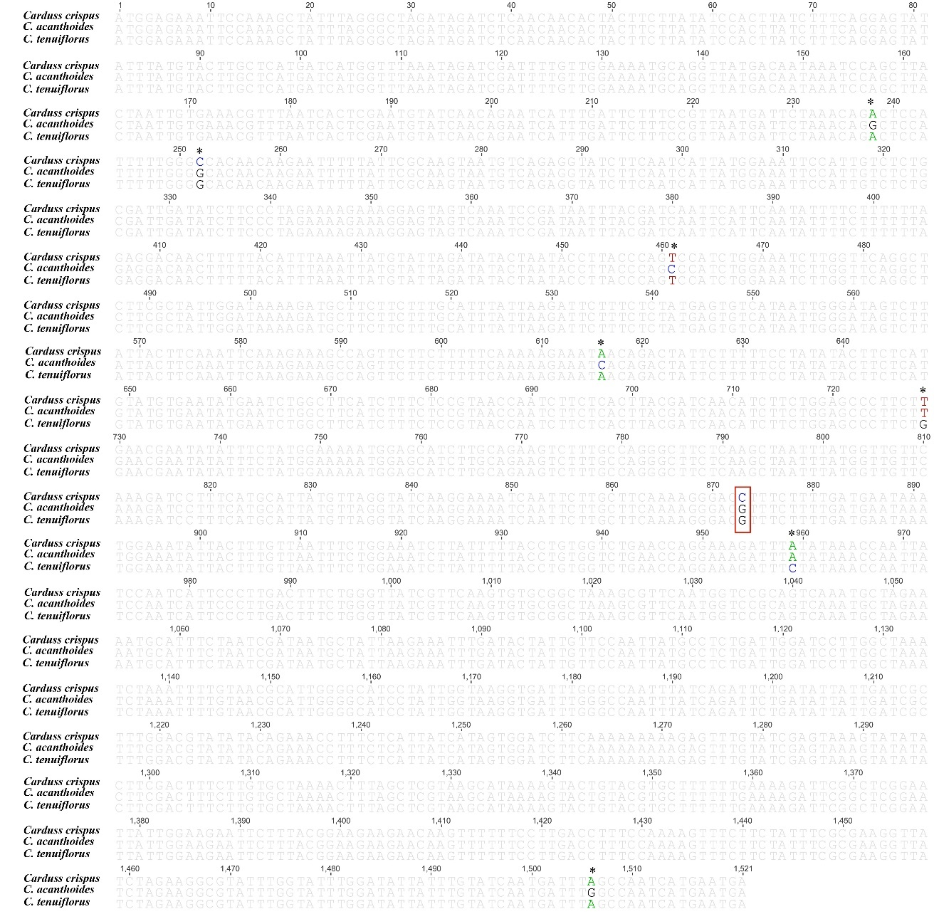
Figure S1: The alignment of matK among three Carduus. The asterisk indicates the positions of single nucleotide polymorphism (SNP). The red square indicates SNP site for design primer pairs.

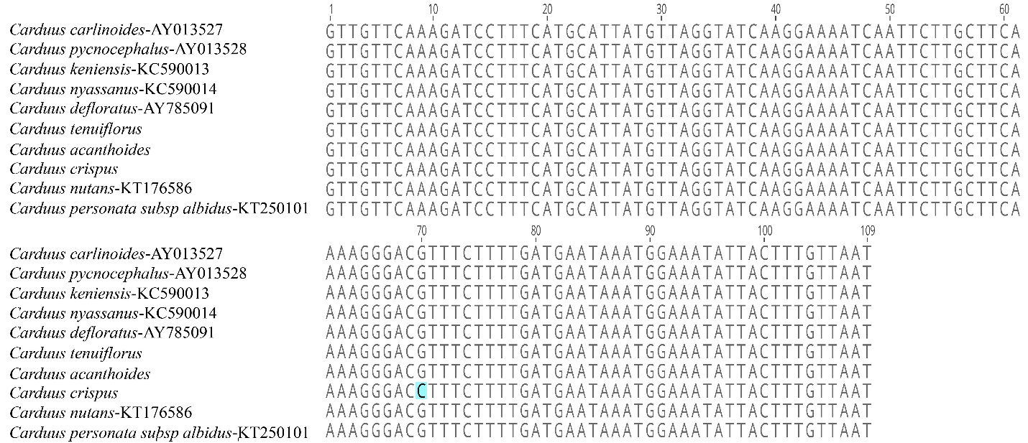
Figure S2: The alignment of partial matK sequences which include selected SNP among Carduus species. The light blue-shaded letter indicates the specific SNP of C. crispus in matK.

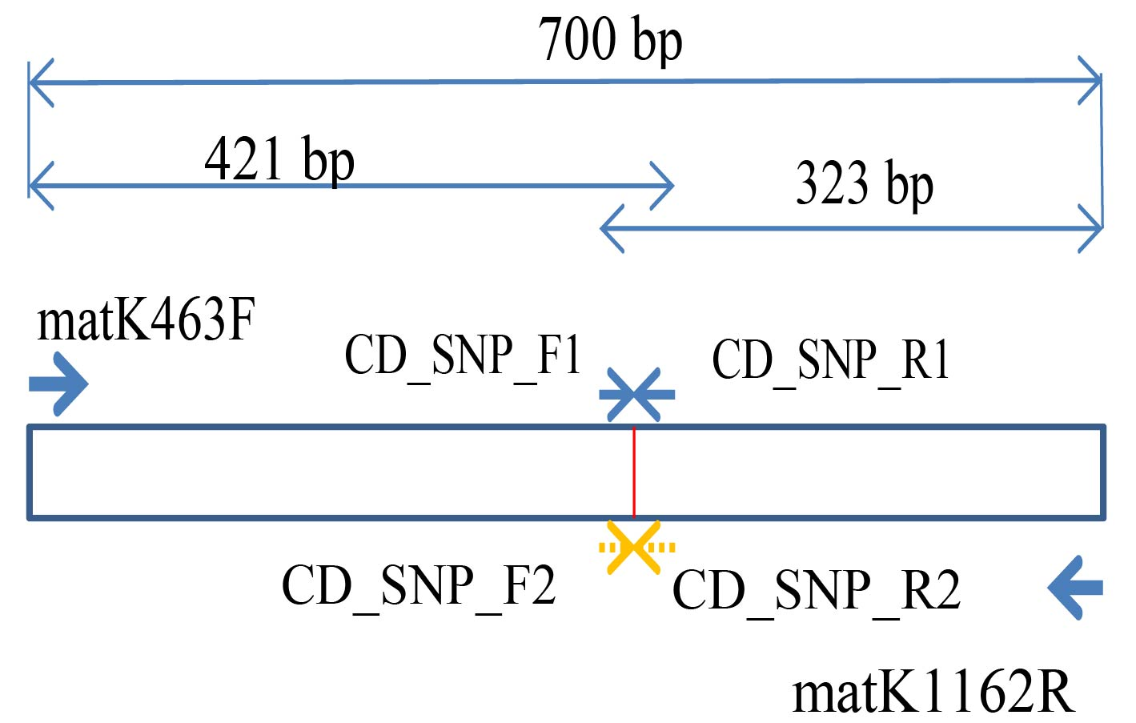
Figure S3: The design of the primer pairs based on SNP site that is specific for Carduus crispus. The red bar indicates location of SNP in matK. The yellow arrows represent the position of primers CD_SNP_F2 and CD_SNP_R2 whereas the normal blue arrows means the location of primers CD_SNP_F1 and CD_SNP_R1. The bold blue arrows show the sites of matK463F and matK1162R. The two headed arrows indicate the size of each primer pairs: 700 bp for the pairs of matK463F and matK1162R, 421 bp for two pairs of matK463F-CD_SNP_R1 and matK463F-CD_SNP_R2, and 323 bp for two pairs of CD_SNP_F1-matK1162R and CD_SNP_F2-matK1162R.

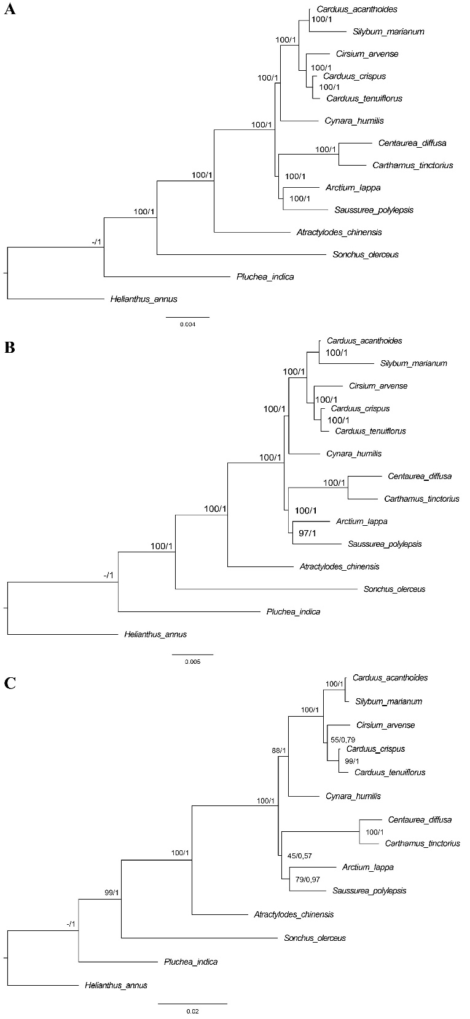
Figure S4: The Bayesian Inference tree of Carduus and related taxa inferred from whole cpDNA sequences (A), non-coding regions of cpDNA (B), and eight hotspot regions (C). The numbers mean supporting values (Bootstrap (BP)/ Posterior probability (PP)). The dash (-) means no support values.
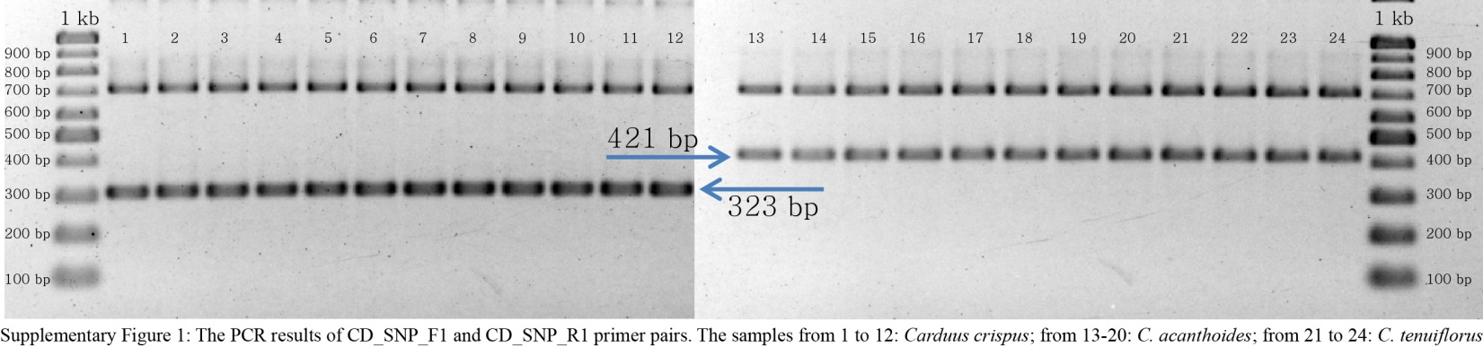
Figure S5: The PCR results of specific primer pairs for Carduus crispus. The combination of matK_463F, matK_1162R, CD_SNP_F1, and CD_SNP_R1. The number from 1 to 2: Carduus crispus; from 13 to 20: Carduus acanthoides; from 21 to 24: Carduus tenuiflorus.

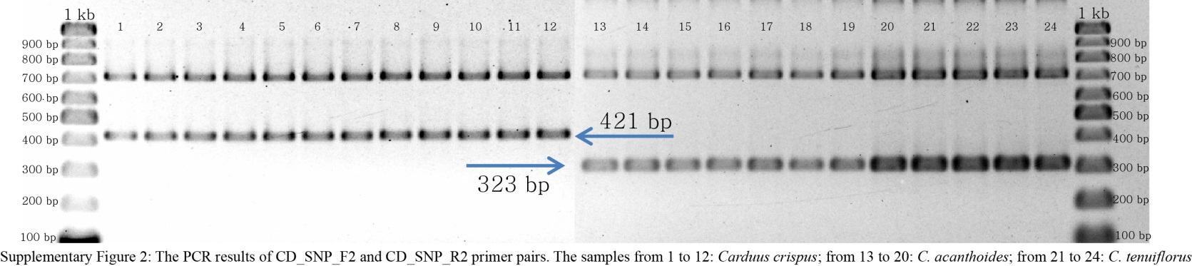
Figure S6: The PCR results of specific primer pairs for Carduus crispus. The combination of matK_463F, matK_1162R, CD_SNP_F2, and CD_SNP_R2. The number from 1 to 12: Carduus crispus; from 13 to 20: Carduus acanthoides; from 21 to 24: Carduus tenuiflorus.

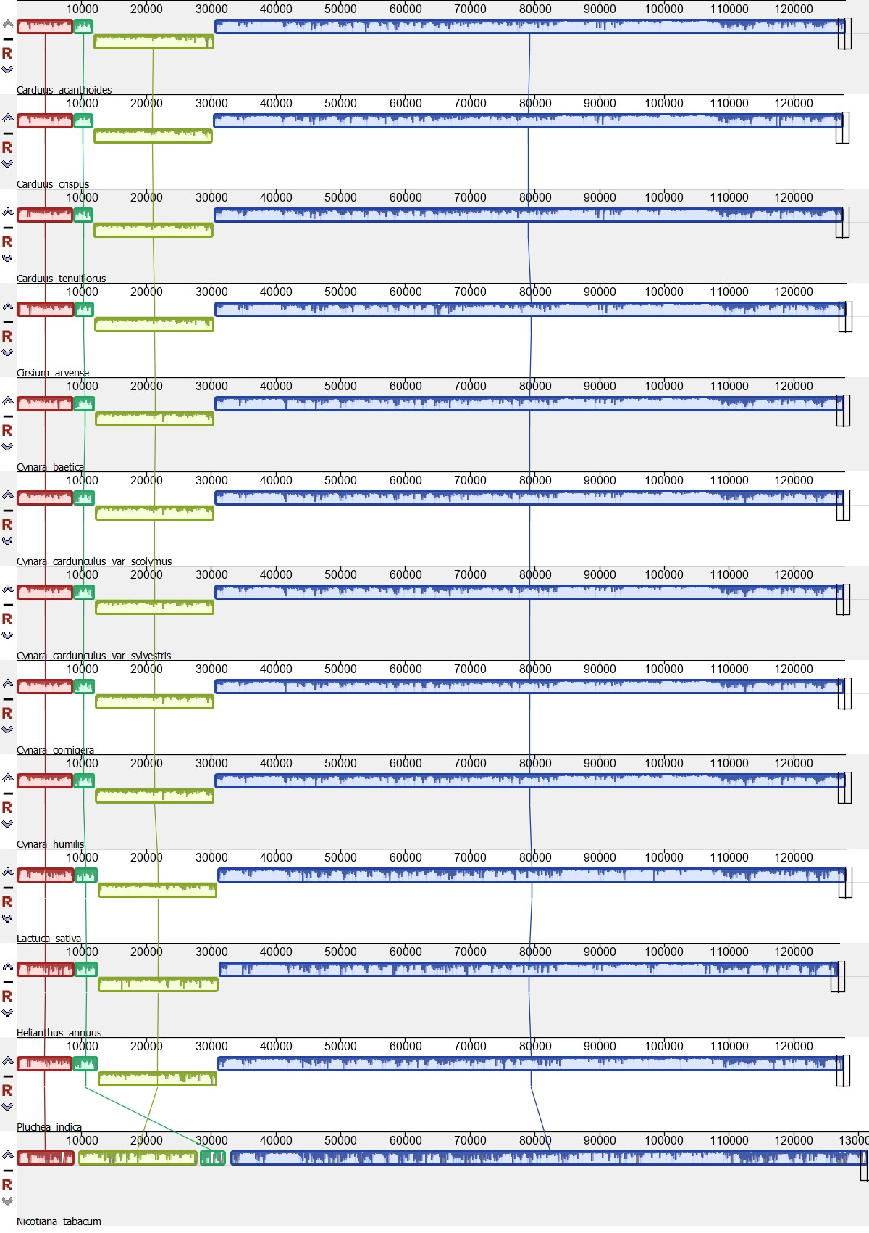
Figure S7: The MAUVE alignment of chloroplast genomes among Carduus and related species. Nicotiana tabacum is outgroup.

