**Raw data of apoptosis experiment results**

1、DMSO group

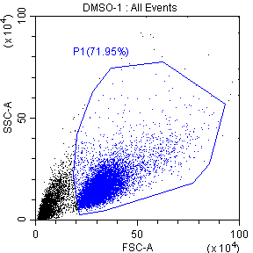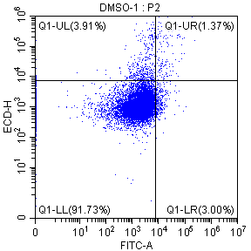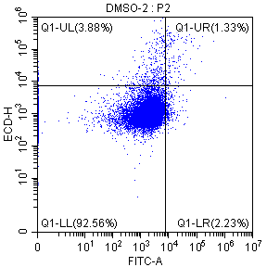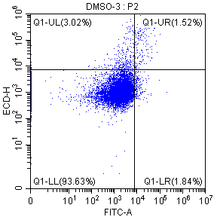

2、10 μM group

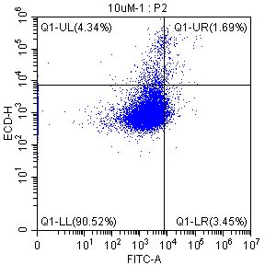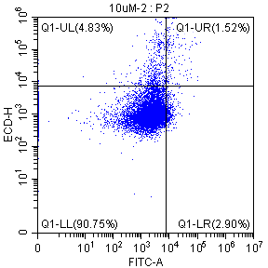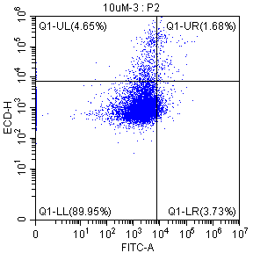

3、25 μM group

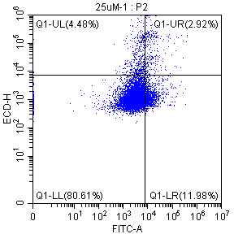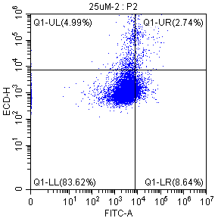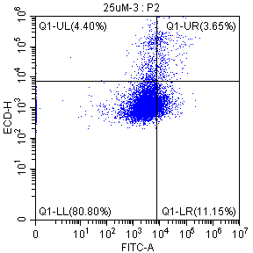

4、50 μM group

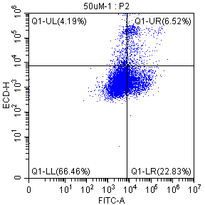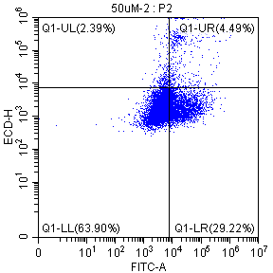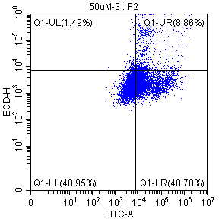

|  |  |  |  |
| --- | --- | --- | --- |
| **Group** | **Early apoptosis rate** | **Late apoptosis rate** | **Apoptosis rate** |
| DMSO | 3 | 1.37 | 4.37 |
| 2.23 | 1.33 | 3.56 |
| 1.84 | 1.52 | 3.36 |
| 10 μM | 3.45 | 1.69 | 5.14 |
| 2.9 | 1.52 | 4.42 |
| 3.73 | 1.68 | 5.41 |
| 25 μM | 11.98 | 2.92 | 14.9 |
| 8.64 | 2.74 | 11.38 |
| 11.15 | 3.65 | 14.8 |
| 50 μM | 22.83 | 6.52 | 29.35 |
| 29.22 | 4.49 | 33.71 |
| 48.7 | 8.86 | 57.56 |