Supplemental Table 1. Correlation analysis of serum BDNF levels with HAMD-17 scores and BPRS scores

 | Baseline HAMD-17 scores | Baseline BPRS scores | HAMD-17 scores after the last ECT | BPRS scores after the last ECT | Changes in HAMD-17 scores | Changes in BPRS scores
Baseline serum BDNF levels | r=0.071 | r=0.162 | - | - | - | -
Baseline serum BDNF levels | P=0.710 | P=0.392 |  | - | - | -
Serum BDNF levels after the last ECT | - | - | r=-0.198 | r=0.058 | - | -
Serum BDNF levels after the last ECT | - | - | P=0.294 | P=0.762 | - | -
Changes in serum BDNF levels | - | - | - | - | r=0.052 | r=0.004
Changes in serum BDNF levels | - | - | - | - | P=0.787 | P=0.983
Abbreviations: BDNF=brain-derived neurotrophic factor; BPRS=the Brief Psychiatric Rating Scale; ECT=electroconvulsive therapy; HAMD-17=the 17-item Hamilton Depression Rating Scale; r=Pearson coefficient of correlation.

Supplemental Figure 1. Baseline serum BDNF levels in patients with TRD and healthy controls
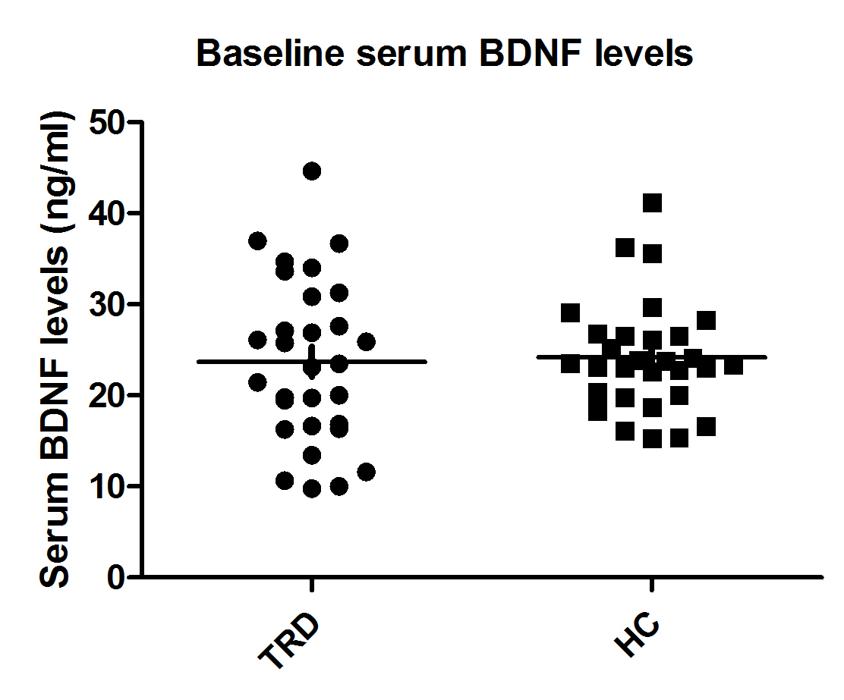
Notes: no significant difference was found between patients with TRD and healthy controls at baseline (p>0.05).
Abbreviations: BDNF=brain-derived neurotrophic factor; HCs=healthy controls; TRD=treatment-refractory depression.
Supplemental Figure 2. Changes in psychotic symptoms following eight ECT treatments

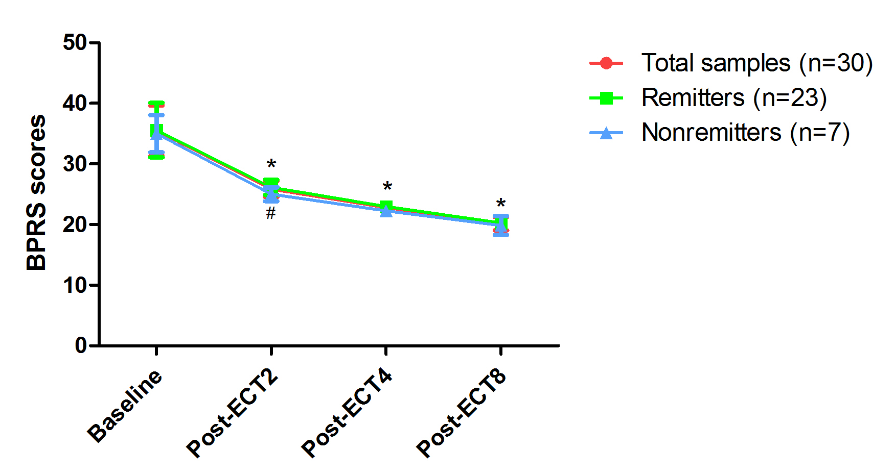

*Significant difference was found at indicated times when compared baseline (p<0.05).
#Significant difference was found between remitters and nonremitters at indicated times (p<0.05).
Abbreviations: ECT=electroconvulsive therapy; BPRS=the Brief Psychiatric Rating Scale.

