Miame Checklist
Part 1 Experiment description
- Blood samples were collected from poorly controlled type 2 diabetic patients at before and after receiving 1,000 mg/day vitamin C for six weeks.
- Changed miRNA expression at post- supplementation were analyzed compared to pre- supplementation in 5 participants.
- The significantly expressed miRNAs from NanoString platform were next validated by qRT-PCR.
Part 2 Array design
We used the Nanostring human miRNA panel which is a customed-commercial platform to detect miRNA expressions.
- nCounter® Human v3 miRNA Expression Assay from NanoString Technologies which is digitally direct counts of each miRNA without the use of reverse transcription or amplification.
- 800 human miRNAs can be detected.
- miRNA in the sample can be bound by specific oligonucleotide tags (miRtags). The direct molecular barcoding and digital detection of target molecules using a color-coded probe pair.
- The probe pair consists of a Reporter Probe, which carries the signal on its 5’ end, and a Capture Probe, which carries a biotin on its 3’ end.
- The complexity of the color codes, comprised of four colors in six positions, allows a large diversity of targets present in the same sample to be individually resolved and identified during data collection.
- The purified target/probe complexes were eluted off the beads and immobilized on the nCounter SPRINT Cartridge for data collection.
- 6 positive controls, 8 negative controls, 3 ligation positive controls, 3 ligation negative controls, and spike-in controls, cel-miR-39 and cel-miR-254, were used for quality control and normalization.
Part 3 Samples
- Plasma sample from EDTA blood of poorly controlled type 2 diabetic patients who received vitamin C treatment for six weeks
- Total RNA extraction following the miRNeasy Serum/Plasma kit’s protocol (Qiagen, Germany) from 200 ul of the plasma sample
- Target miRNAs in sample were ligated with specific oligonucleotide tags (miRtags)
- miRNA sample prep protocol including annealing step, ligation step, purification step and hybridization step.
- Sample preparation for the detection is shown in Figure 1.
Part 4 Hybridizations
- Hybridization step was followed the manufacturer’s protocol as summarized in Figure 2.
- Each sample was separated into an individual tube but used reagents from the same master mix prep.
- Hybridization time was 12 hours.
- After hybridization, excess probes were washed away using a two-step magnetic bead-based purification that performed by The SPRINT Profiler instrument.
Part 5 Measurements
- The nCounter SPRINT Profiler instrument was used for both post hybridization processing and data collection (Instrument name: 150p0007, Software version: 2.2.1.10).
- This nCounter Digital Analyzer is a multi-channel epifluorescence scanner specifically configured for use with NanoString’s nCounter Cartridges.
- The Digital Analyzer is a Class 1 laser product. The instrument contains an internal Class 2 laser barcode reader.
- It collects data by taking images of the immobilized fluorescent reporters in the sample cartridge with a CCD camera through a microscope objective len.
- 196 fields of view (FOV) were collected per flow cell (cartridge lane).
- Images were processed and each lane produced one RCC (Reporter Code Count) file. The zipped RCC files were downloaded via USB flash drive and imported into the nSolverTM v4.0 analysis software for QC and analysis.
- Number of miRNA expression from NanoString represents number of miRNA counts. Normalized ratios can be analyzed by nSolver analysis software.
- Run data were exported as a comma separated values (CSV) format file that can be opened by Microsoft excel.
Part 6 Normalization controls
All of our samples were done in one cartridge at the same time. We aimed to compare miRNA expression changes between pre-and post-supplementation. All data had no any flags. Background thresholding by count value > 100 counts were set to eliminate all targets with low expression. Normalization included two steps as described below
1. A positive control normalization; 6 spiked in positive controls were firstly calculated to adjust variations across samples, lanes, cartridges, days, and user techniques and processes.
2. A CodeSet content normalization was next calculated using reference gene, spike-in controls miR-254, to adjust for differences in analyte abundance and/or analyte quality across samples.
The analyses were analyzed using the NanoString’s nSolver Analysis Software or other data analysis and visualization software packages.
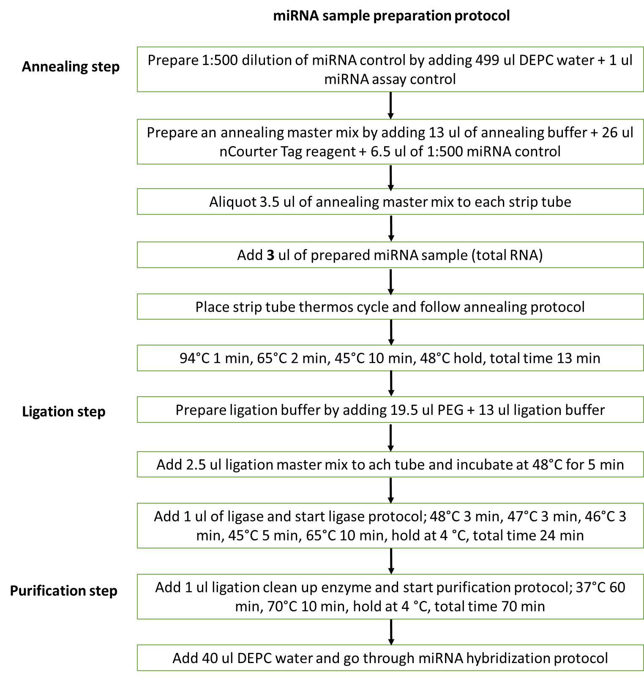

Figure 1 miRNA sample preparation protocol.

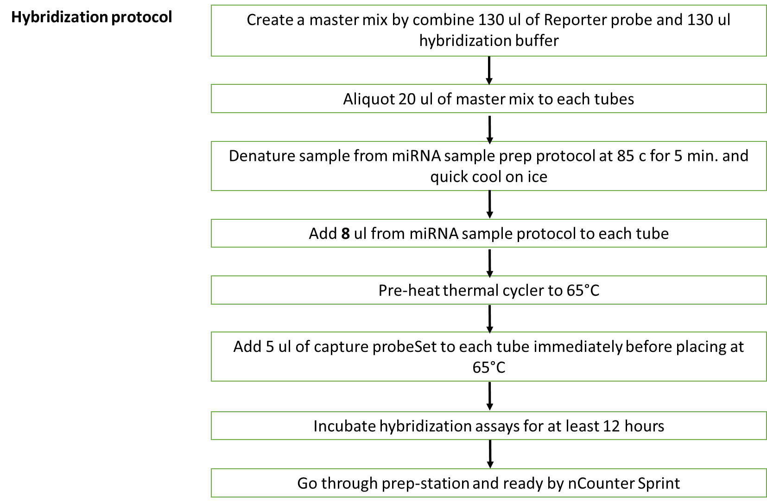

Figure 2 Hybridization protocol. Final volume of each tube was 33 ul. The reagents included 10 ul reporter code set + 10 ul hybridization buffer + 8 ul miRNA sample prep protocol + 5 ul capture probe set.

