Supplementary data_2
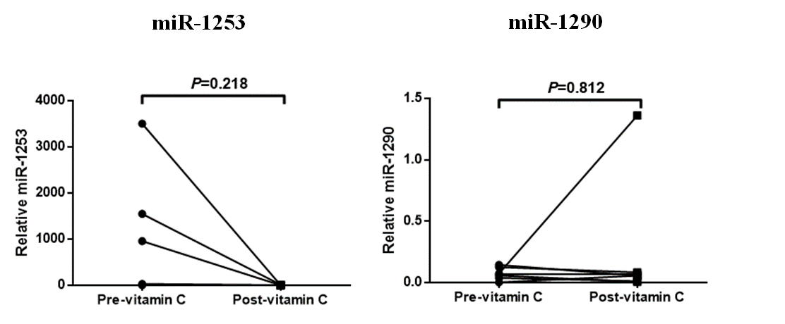

Figure S2 qPCR data of mi-1253 and miR-1290. The data showed no significant difference of both miRNAs.

