List of specimens
Species | Specimen | Locality
E. fuscus | 40540-003 | Miller Cave
E. fuscus | 40540-004 | Miller Cave
E. fuscus | 40540-005 | Miller Cave
E. fuscus | 40540-007 | Miller Cave
M. velifer | 40540-132 | Miller Cave
M. velifer | 40540-133 | Miller Cave
M. velifer | 40540-202-2 | Miller Cave
M. velifer | 41229-10043 | Hall’s cave
M. velifer | 41229-10046 | Hall’s cave
M. velifer | 41229-10048 | Hall’s cave
M. velifer | 41229-1038 | Hall’s cave
M. velifer | 41229-10477 | Hall’s cave
M. velifer | 41229-10533 | Hall’s cave
M. velifer | 41229-10534 | Hall’s cave
M. velifer | 41229-10888 | Hall’s cave
M. velifer | 41229-10889 | Hall’s cave
M. velifer | 41229-10950 | Hall’s cave
M. velifer | 41229-11099 | Hall’s cave
M. velifer | 41229-11174 | Hall’s cave
M. velifer | 41229-11285 | Hall’s cave
E. fuscus | 41229-11303 | Hall’s cave
M. velifer | 41229-11306 | Hall’s cave
M. velifer | 41229-11308 | Hall’s cave
M. velifer | 41229-11333 | Hall’s cave
M. velifer | 41229-11334 | Hall’s cave
M. velifer | 41229-11342 | Hall’s cave
M. velifer | 41229-11408 | Hall’s cave
M. velifer | 41229-1154 | Hall’s cave
M. velifer | 41229-11548 | Hall’s cave
M. velifer | 41229-11613 | Hall’s cave
M. velifer | 41229-11650 | Hall’s cave
M. velifer | 41229-1172 | Hall’s cave
M. velifer | 41229-11826 | Hall’s cave
M. velifer | 41229-11827 | Hall’s cave
M. velifer | 41229-11860 | Hall’s cave
M. velifer | 41229-11861 | Hall’s cave
M. velifer | 41229-11862 | Hall’s cave
M. velifer | 41229-11870 | Hall’s cave
M. velifer | 41229-11873 | Hall’s cave
M. velifer | 41229-11879 | Hall’s cave
M. velifer | 41229-11880 | Hall’s cave
E. fuscus | 41229-1191 | Hall’s cave
M. velifer | 41229-1197 | Hall’s cave
M. velifer | 41229-1199 | Hall’s cave
M. velifer | 41229-1203 | Hall’s cave
M. velifer | 41229-1228 | Hall’s cave
M. velifer | 41229-131 | Hall’s cave
E. fuscus | 41229-1739 | Hall’s cave
M. velifer | 41229-1753 | Hall’s cave
E. fuscus | 41229-1760 | Hall’s cave
M. velifer | 41229-1817 | Hall’s cave
M. velifer | 41229-2520 | Hall’s cave
E. fuscus | 41229-2685 | Hall’s cave
E. fuscus | 41229-2690 | Hall’s cave
E. fuscus | 41229-2717 | Hall’s cave
M. velifer | 41229-2967 | Hall’s cave
E. fuscus | 41229-3892 | Hall’s cave
E. fuscus | 41229-3894 | Hall’s cave
M. velifer | 41229-4051 | Hall’s cave
M. velifer | 41229-4122 | Hall’s cave
M. velifer | 41229-4123 | Hall’s cave
M. velifer | 41229-4564 | Hall’s cave
M. velifer | 41229-4810 | Hall’s cave
M. velifer | 41229-4856 | Hall’s cave
M. velifer | 41229-5450 | Hall’s cave
M. velifer | 41229-5462 | Hall’s cave
M. velifer | 41229-5471 | Hall’s cave
M. velifer | 41229-5496 | Hall’s cave
M. velifer | 41229-550 | Hall’s cave
M. velifer | 41229-566 | Hall’s cave
M. velifer | 41229-5733 | Hall’s cave
M. velifer | 41229-575 | Hall’s cave
M. velifer | 41229-5839 | Hall’s cave
E. fuscus | 41229-589 | Hall’s cave
E. fuscus | 41229-6012 | Hall’s cave
E. fuscus | 41229-6013 | Hall’s cave
E. fuscus | 41229-6014 | Hall’s cave
E. fuscus | 41229-6015 | Hall’s cave
E. fuscus | 41229-6017 | Hall’s cave
E. fuscus | 41229-6018 | Hall’s cave
E. fuscus | 41229-6028 | Hall’s cave
E. fuscus | 41229-6029 | Hall’s cave
E. fuscus | 41229-6030 | Hall’s cave
E. fuscus | 41229-605 | Hall’s cave
E. fuscus | 41229-607 | Hall’s cave
E. fuscus | 41229-6083 | Hall’s cave
M. velifer | 41229-610 | Hall’s cave
M. velifer | 41229-611 | Hall’s cave
M. velifer | 41229-6139 | Hall’s cave
M. velifer | 41229-614 | Hall’s cave
M. velifer | 41229-6184 | Hall’s cave
M. velifer | 41229-6187 | Hall’s cave
M. velifer | 41229-6189 | Hall’s cave
M. velifer | 41229-6226 | Hall’s cave
M. velifer | 41229-6230 | Hall’s cave
M. velifer | 41229-6233 | Hall’s cave
M. velifer | 41229-6234 | Hall’s cave
M. velifer | 41229-6311 | Hall’s cave
E. fuscus | 41229-632 | Hall’s cave
M. velifer | 41229-6564 | Hall’s cave
M. velifer | 41229-6565 | Hall’s cave
M. velifer | 41229-6566 | Hall’s cave
M. velifer | 41229-6567 | Hall’s cave
M. velifer | 41229-6568 | Hall’s cave
M. velifer | 41229-6570 | Hall’s cave
M. velifer | 41229-6571 | Hall’s cave
M. velifer | 41229-6572 | Hall’s cave
M. velifer | 41229-6573 | Hall’s cave
M. velifer | 41229-6638 | Hall’s cave
M. velifer | 41229-6660 | Hall’s cave
M. velifer | 41229-6663 | Hall’s cave
M. velifer | 41229-6677 | Hall’s cave
M. velifer | 41229-6681 | Hall’s cave
M. velifer | 41229-6713 | Hall’s cave
M. velifer | 41229-6714 | Hall’s cave
M. velifer | 41229-6717 | Hall’s cave
M. velifer | 41229-6874 | Hall’s cave
M. velifer | 41229-6974 | Hall’s cave
M. velifer | 41229-7072 | Hall’s cave
M. velifer | 41229-7080 | Hall’s cave
M. velifer | 41229-7081 | Hall’s cave
M. velifer | 41229-7136 | Hall’s cave
M. velifer | 41229-7137 | Hall’s cave
M. velifer | 41229-7142 | Hall’s cave
M. velifer | 41229-768 | Hall’s cave
M. velifer | 41229-789 | Hall’s cave
M. velifer | 41229-793 | Hall’s cave
E. fuscus | 41229-872 | Hall’s cave
M. velifer | 41229-8931 | Hall’s cave
M. velifer | 41229-8933 | Hall’s cave
M. velifer | 41229-8934 | Hall’s cave
E. fuscus | 41229-897 | Hall’s cave
M. velifer | 41229-899 | Hall’s cave
M. velifer | 41229-942 | Hall’s cave
M. velifer | 41229-9854 | Hall’s cave
M. velifer | 41229-9855 | Hall’s cave
M. velifer | 41229-9875 | Hall’s cave
M. velifer | 41229-9879 | Hall’s cave
M. velifer | 41229-9910 | Hall’s cave
M. velifer | 41229-9924 | Hall’s cave
M. velifer | 41229-9925 | Hall’s cave
M. velifer | 41229-9926 | Hall’s cave
M. velifer | 41229-9928 | Hall’s cave
M. velifer | 41229-9929 | Hall’s cave
M. velifer | 41229-9930 | Hall’s cave
M. velifer | 41229-9931 | Hall’s cave
M. velifer | 41343-193 | Inner Space Caverns
M. velifer | 41343-194 | Inner Space Caverns
M. velifer | 41343-195 | Inner Space Caverns
M. velifer | 41343-196 | Inner Space Caverns
M. velifer | 41343-197 | Inner Space Caverns
M. velifer | 41343-198 | Inner Space Caverns
M. velifer | 41343-199 | Inner Space Caverns
M. velifer | 41343-201 | Inner Space Caverns
M. velifer | 41343-202 | Inner Space Caverns
M. velifer | 41343-206 | Inner Space Caverns
M. velifer | 41343-207 | Inner Space Caverns
M. velifer | 41343-208 | Inner Space Caverns
M. velifer | 41343-209 | Inner Space Caverns
M. velifer | 41343-210 | Inner Space Caverns
M. velifer | 41343-211 | Inner Space Caverns
M. velifer | 41343-212 | Inner Space Caverns
M. velifer | 41343-213 | Inner Space Caverns
M. velifer | 41343-215 | Inner Space Caverns
M. velifer | 41343-219 | Inner Space Caverns
M. velifer | 41343-220 | Inner Space Caverns
M. velifer | 41343-222 | Inner Space Caverns
M. velifer | 41343-223 | Inner Space Caverns
M. velifer | 41343-224 | Inner Space Caverns
M. velifer | 41343-225 | Inner Space Caverns
M. velifer | 41343-226 | Inner Space Caverns
M. velifer | 41343-227 | Inner Space Caverns
M. velifer | 41343-228 | Inner Space Caverns
M. velifer | 41343-229 | Inner Space Caverns
M. velifer | 41343-230 | Inner Space Caverns
M. velifer | 933-3997 | Friesenhahn Cave
M. velifer | 933-3999A | Friesenhahn Cave
M. velifer | 933-4001A | Friesenhahn Cave
M. velifer | 933-4001C | Friesenhahn Cave
M. velifer | 933-4002 | Friesenhahn Cave
M. velifer | 933-5003 | Friesenhahn Cave

M. velifer

Shape - Centroid Size ~ Minimum Age
✔ M. velifer shape is significantly predicted by centroid size, when tested using a Procrustes ANOVA with permutation (procD.lm function in geomorph). p=0.004

✔ M. velifer shape is significantly predicted by minimum age per specimen, when tested using a Procrustes ANOVA with permutation (procD.lm function in geomorph). p=0.001

X M. velifer shape is not significantly predicted by a combination of centroid size and minimum age, when tested using a Procrustes ANOVA with permutation (procD.lm function in geomorph package). p=0.228

Centroid Size - Climate
✔ M. velifer centroid size does significantly vary across different temperature regimes, when tested using Pairwise T-Tests with correction for multiple testing (pairwise.t.test function in stats package). Specimens from environments with modern temperature levels are smaller than specimens from both cooler and warmer environments, which are indistinguishable relative to each other.

Supplementary Table 1: M. velifer centroid size by temperature
p-values | Cool | Modern
Modern | 0.014 | -
Warm | 0.844 | 0.014

✔ M. velifer centroid size does significantly vary across different precipitation regimes, when tested using Pairwise T-Tests with correction for multiple testing (pairwise.t.test function in stats package). Specimens from dry environments are larger than specimens from wet environments.

Supplementary Table 2: M. velifer centroid size by precipitation
p-values | Dry | Modern
Modern | 0.7476 | -
Wet | 0.0025 | 0.1019

✔ M. velifer centroid size does significantly vary across different climatic regimes, when tested using Pairwise T-Tests with correction for multiple testing (pairwise.t.test function in stats package).

The directionality of the difference is given by comparing row by column. E.g. Cool, Wet specimens are significantly smaller than Cool, Dry specimens.

Supplementary Table 3: M. velifer centroid size by climate
p-values | Cool, Dry | Cool, Wet | Modern Temp., Modern Precip. | Modern Temp., Wet | Warm, Dry
Cool, Wet | 0.0014 (smaller) | - | - | - | -
Modern Temp., Modern Precip. | 0.0156  (smaller) | 0.3661 | - | - | -
Modern Temp., Wet | 0.0981 | 1.0000 | 0.7236 | - | -
Warm, Dry | 0.1106 | 0.3661 | 0.1106 | 0.5796 | -
Warm, Modern. Precip. | 1.0000 | 0.1106 | 0.0421  (larger) | 0.2562 | 0.7236

Shape - Climate
✔ M. velifer shape does significantly vary across different temperature regimes, when tested using Permutation Testing For Group Differences with correction for multiple testing (permudist function in Morpho package). Specimens from environments that are warmer than modern levels are significantly different in terms of shape to specimens from environments that are cooler than modern levels.

Supplementary Table 4: M. velifer shape by temperature
p-values | Cool | Modern
Modern | 0.1762 | -
Warm | 0.0003 | 0.3179

✔ M. velifer shape does significantly vary across different precipitation regimes, when tested using Permutation Testing For Group Differences with correction for multiple testing (permudist function in Morpho package). Specimens from dry and wet environments differ from each other but no other group differences are significant.

Supplementary Table 5: M. velifer shape by precipitation
p-values | Dry | Modern
Modern | 0.4514 | -
Wet | 0.0024 | 0.4514

✔ M. velifer shape does significantly vary across different climatic regimes, when tested using Permutation Testing For Group Differences with correction for multiple testing (permudist function in Morpho package). Only cool dry environments differed from other environments.

Supplementary Table 6: M. velifer shape by climate
p-values | Cool, Dry | Cool, Wet | Modern Temp., Modern Precip. | Modern Temp., Wet | Warm, Dry
Cool, Wet | 0.0015 | - | - | - | -
Modern Temp., Modern Precip. | 0.5400 | 1.0000 | - | - | -
Modern Temp., Wet | 0.1164 | 1.0000 | 1.0000 | - | -
Warm, Dry | 0.0015 | 0.2024 | 1.0000 | 1.0000 | -
Warm, Modern. Precip. | 0.0156 | 1.0000 | 1.0000 | 1.0000 | 1.0000

Centroid Size - Age
Each specimen is associated with an Upper and Lower Age Estimate. Using a Linear Model (lm function in stats package):

X M. velifer Lower Age Estimate does not significantly predict centroid size. p=0.053

✔ M. velifer Upper Age Estimate does significantly predict centroid size. p=0.0478
Older specimens have a larger Centroid Size.

E. fuscus

Shape - Centroid Size ~ Minimum Age
X E. fuscus shape is not significantly predicted by centroid size, when tested using a Procrustes ANOVA with permutation (procD.lm function in geomorph). p=0.092

X E. fuscus shape is not significantly predicted by minimum age per specimen, when tested using a Procrustes ANOVA with permutation (procD.lm function in geomorph). p=0.129

✔ E. fuscus shape is significantly predicted by a combination of centroid size and minimum age, when tested using a Procrustes ANOVA with permutation (procD.lm function in geomorph package). p=0.022

Centroid Size - Climate
X E. fuscus centroid size does not significantly vary across different temperature regimes, when tested using Pairwise T-Tests with correction for multiple testing (not applicable in this specific instance in any case; pairwise.t.test function in stats package).

Supplementary Table 1: E. fuscus centroid size by temperature
p-values | Modern
Cool | 0.072

✔ E. fuscus centroid size does significantly vary across different precipitation regimes, when tested using Pairwise T-Tests with correction for multiple testing (pairwise.t.test function in stats package). Specimens from environments that are drier than modern levels are significantly larger than specimens from environments that are either equal to modern levels of precipitation or wetter.

Supplementary Table 2: E. fuscus centroid size by precipitation
p-values | Dry | Modern
Modern | 0.029 | -
Wet | 0.029 | 0.393

✔ E. fuscus centroid size does significantly vary across different climatic regimes, when tested using Pairwise T-Tests with correction for multiple testing (pairwise.t.test function in stats package). Specimens from environments that are cooler and drier than modern day levels are significantly larger than specimens from both environments that are cooler and wetter than modern day, as well as environments that are warmer and with modern levels of precipitation.

The directionality of the difference is given by comparing row by column. E.g. Cool, Wet specimens are significantly smaller than Cool, Dry specimens.

Supplementary Table 3: E. fuscus centroid size by climate
p-values | Cool, Dry | Cool, Wet
Cool, Wet | 0.029  (smaller) | -
Warm,  Modern  Precip. | 0.029  (smaller) | 0.393

Shape - Climate
✔ E. fuscus shape does significantly vary across different temperature regimes, when tested using Permutation Testing For Group Differences with correction for multiple testing (not applicable in this specific instance in any case; permudist function in Morpho package).

Supplementary Table 4: E. fuscus shape by temperature
p-values | Modern
Cool | 0.0281

X E. fuscus shape does not significantly vary across different precipitation regimes, when tested using Permutation Testing For Group Differences with correction for multiple testing (permudist function in Morpho package).

Supplementary Table 5: E. fuscus shape by precipitation
p-values | Dry | Modern
Modern | 0.1257 | -
Wet | 0.8010 | 0.1257

X E. fuscus shape does not significantly vary across different climatic regimes, when tested using Permutation Testing For Group Differences with correction for multiple testing (permudist function in Morpho package).

Supplementary Table 6: E. fuscus shape by climate
p-values | Cool, Dry | Cool, Wet
Cool, Wet | 0.8116 | -
Warm,  Modern  Precip. | 0.1158 | 0.1158

Centroid Size - Age
Each specimen is associated with an Upper and Lower Age Estimate. Using a Linear Model (lm function in stats package):

✔ E. fuscus Lower Age Estimate does significantly predict centroid size. p=0.0199

Older specimens have a larger Centroid Size.

✔ E. fuscus Upper Age Estimate does significantly predict centroid size. p=0.00724

Older specimens have a larger Centroid Size.

PCA

Scree Plots
Supplementary Figure 1: Scree plot of PCA

Supplementary Table 13: Variation described per Principal Component
 | PC1 | PC2 | PC3 | PC4 | PC5 | PC6
fuscus | 36.70% | 16.34% | 13.26% | 7.25% | 5.94% | 4.64%
velifer | 20.89% | 17.66% | 11.87% | 7.83% | 6.35% | 5.83%
 | PC7 | PC8 | PC9 | PC10 | PC11 | PC12
fuscus | 2.71% | 2.21% | 1.93% | 1.54% | 1.06% | 0.86%
velifer | 4.74% | 3.43% | 2.92% | 2.23% | 1.70% | 1.66%
 | PC13 | PC14 | PC15 | PC16 | PC17 | PC18
fuscus | 0.70% | 0.67% | 0.57% | 0.45% | 0.37% | 0.31%
velifer | 1.51% | 1.18% | 1.13% | 0.87% | 0.82% | 0.74%

M. velifer PC tests

PCs – Age
Each specimen is associated with an Upper and Lower Age Estimate. Using a Linear Model (lm function in stats package):
✔ M. velifer PCs 1 and 2 are significantly predicted by both Lower and Upper Age Estimates.

X M. velifer PC 3 is not significantly predicted by either Lower or Upper Age Estimates.

Supplementary Table 14: M. velifer PCs by age
p-values | Lower Age Estimate | Upper Age Estimate
PC1 | 0.00374 | 0.00521
PC2 | 0.00683 | 0.00507
PC3 | 0.125 | 0.0809

PCs – Climate
X M. velifer PCs 1, 2 and 3 do not significantly vary across different temperature regimes, when tested using Permutation Testing For Group Differences with correction for multiple testing (permudist function in Morpho package).

Supplementary Figure 2: M. velifer PCs by temperature
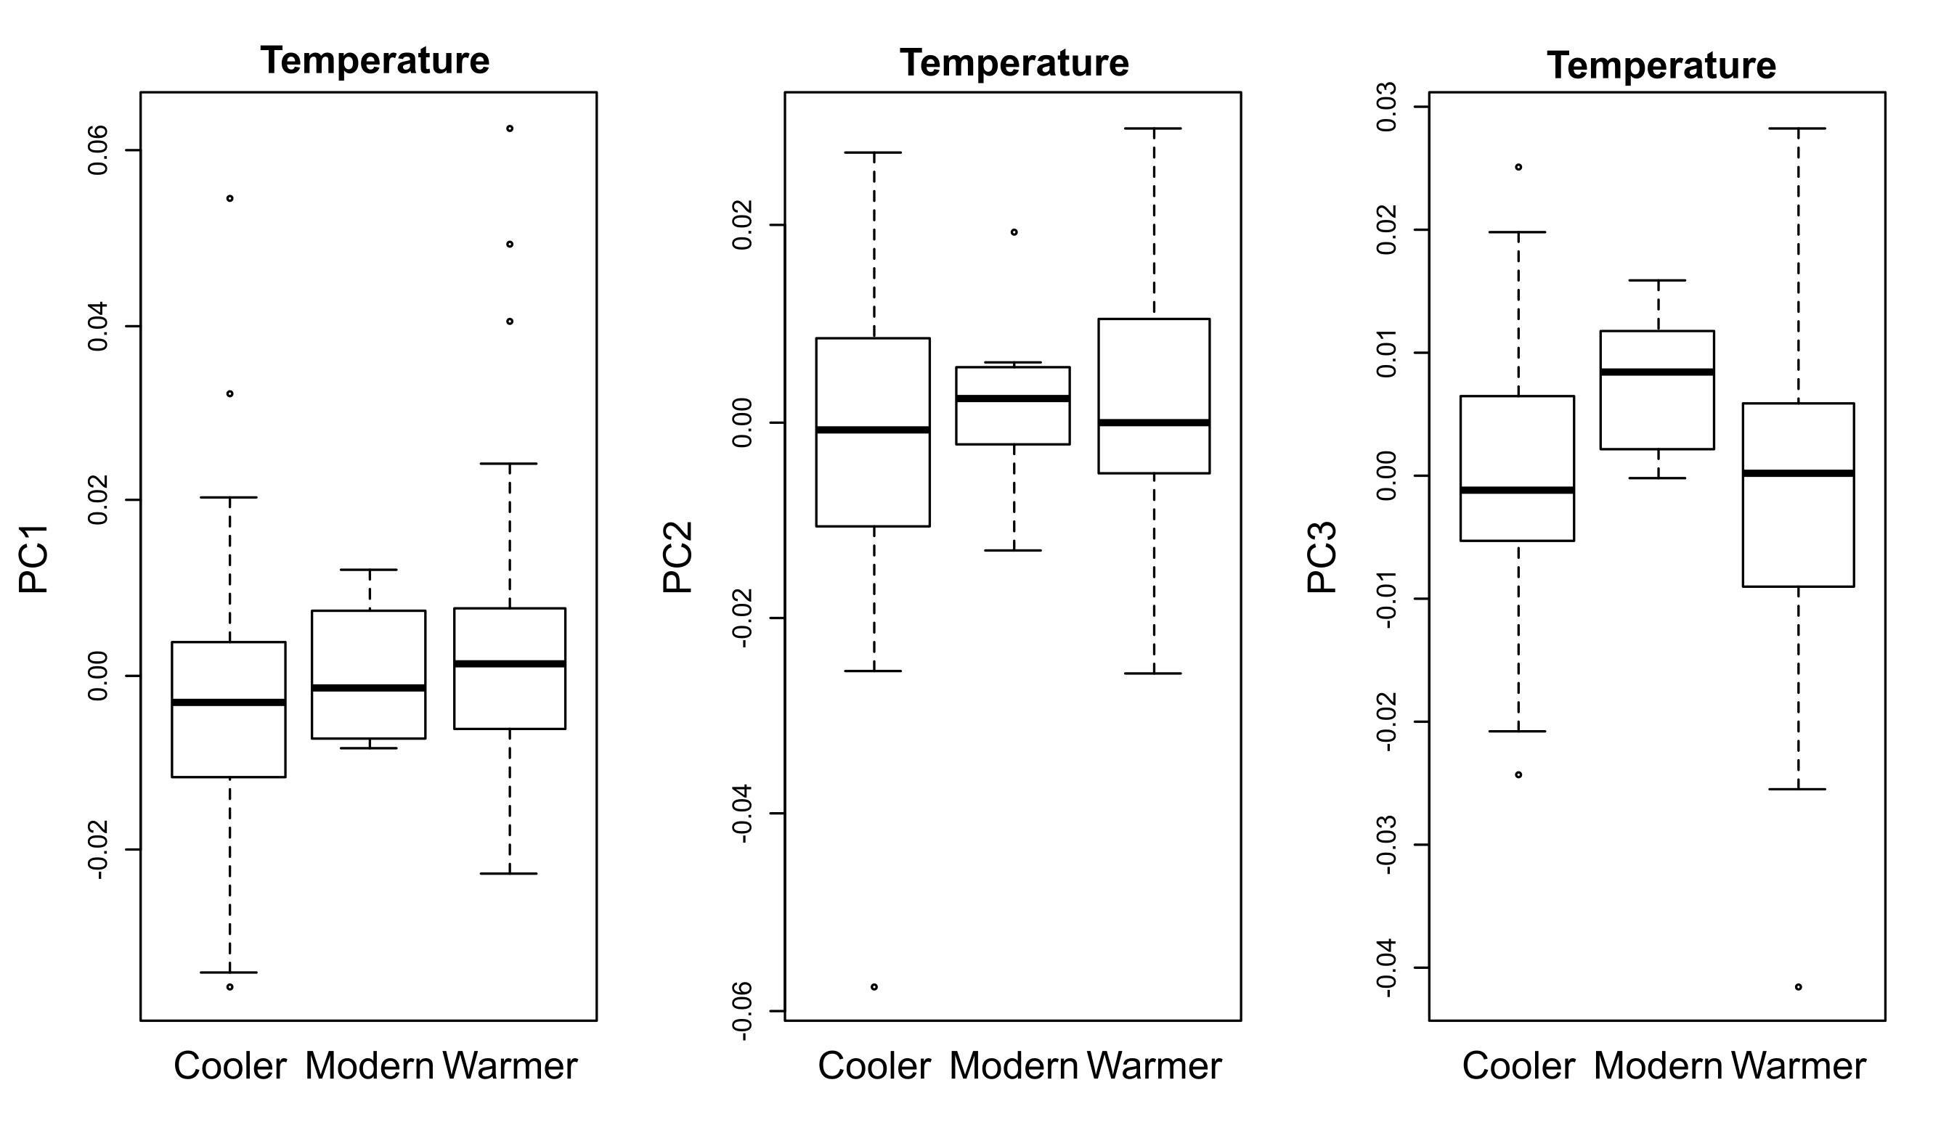

Supplementary Table 15: M. velifer PC1 by temperature
p-values | Cool | Modern
Modern | 1.0000 | -
Warm | 0.0564 | 1.0000

Supplementary Table 16: M. velifer PC2 by temperature
p-values | Cool | Modern
Modern | 0.9270 | -
Warm | 0.5058 | 0.9270

Supplementary Table 17: M. velifer PC3 by temperature
p-values | Cool | Modern
Modern | 0.2073 | -
Warm | 0.9261 | 0.2073

X M. velifer PCs 1, 2 and 3 do not significantly vary across different precipitation regimes, when tested using Permutation Testing For Group Differences with correction for multiple testing (permudist function in Morpho package).

Supplementary Figure 3: M. velifer PCs by precipitation
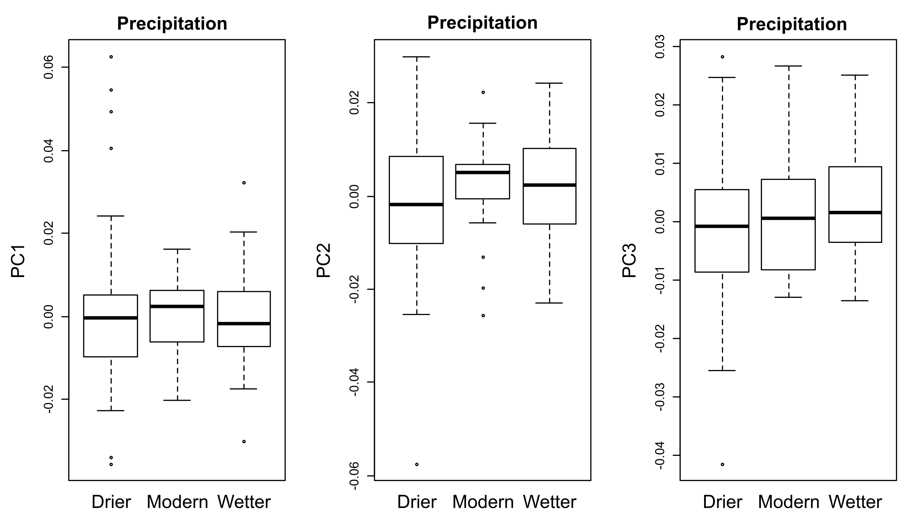

Supplementary Table 18: M. velifer PC1 by precipitation
p-values | Dry | Modern
Modern | 1 | -
Wet | 1 | 1

Supplementary Table 19: M. velifer PC2 by precipitation
p-values | Dry | Modern
Modern | 0.7546 | -
Wet | 0.2817 | 0.7546

Supplementary Table 20: M. velifer PC3 by precipitation
p-values | Dry | Modern
Modern | 0.7552 | -
Wet | 0.1218 | 0.7552

✔ M. velifer PCs 1, 2 and 3 do significantly vary across different climate regimes, when tested using Permutation Testing For Group Differences with correction for multiple testing (permudist function in Morpho package). The sole significant relationship established is that between PC1 and the pairwise comparison of specimens from environments that are on the one hand cooler and drier than modern day and the on the other hand warmer and drier than modern day.

Supplementary Figure 4: M. velifer PCs by climate
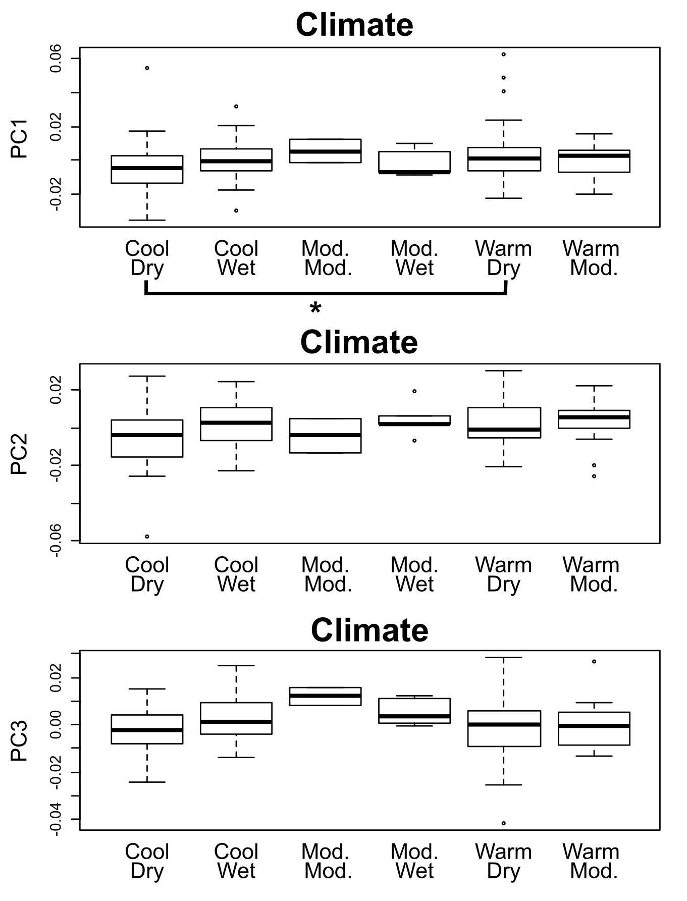

Supplementary Table 21: M. velifer PC1 by climate
p-values | Cool, Dry | Cool, Wet | Modern Temp., Modern Precip. | Modern Temp., Wet | Warm, Dry
Cool, Wet | 1.0000 | - | - | - | -
Modern Temp., Modern Precip. | 1.0000 | 1.0000 | - | - | -
Modern Temp., Wet | 1.0000 | 1.0000 | 1.0000 | - | -
Warm, Dry | 0.0465 | 1.0000 | 1.0000 | 1.0000 | -
Warm, Modern. Precip. | 1.0000 | 1.0000 | 1.0000 | 1.0000 | 1.0000

Supplementary Table 22: M. velifer PC2 by climate
p-values | Cool, Dry | Cool, Wet | Modern Temp., Modern Precip. | Modern Temp., Wet | Warm, Dry
Cool, Wet | 0.1815 | - | - | - | -
Modern Temp., Modern Precip. | 1.0000 | 1.0000 | - | - | -
Modern Temp., Wet | 1.0000 | 1.0000 | 1.0000 | - | -
Warm, Dry | 0.2716 | 1.0000 | 1.0000 | 1.0000 | -
Warm, Modern. Precip. | 0.6461 | 1.0000 | 1.0000 | 1.0000 | 1.0000

Supplementary Table 23: M. velifer PC3 by climate
p-values | Cool, Dry | Cool, Wet | Modern Temp., Modern Precip. | Modern Temp., Wet | Warm, Dry
Cool, Wet | 0.7350 | - | - | - | -
Modern Temp., Modern Precip. | 0.8946 | 1.0000 | - | - | -
Modern Temp., Wet | 1.0000 | 1.0000 | 1.0000 | - | -
Warm, Dry | 1.0000 | 1.0000 | 1.0000 | 1.0000 | -
Warm, Modern. Precip. | 1.0000 | 1.0000 | 1.0000 | 1.0000 | 1.0000

PCs – Centroid Size
X M. velifer PCs 1, 2 and 3 are not significantly predicted by centroid size, when tested with a Linear Model (lm function in stats package).

Supplementary Table 24: M. velifer PCs by centroid size
p-values | Centroid Size
PC1 | 0.308
PC2 | 0.165
PC3 | 0.907

E. fuscus PC tests

PCs – Age
Each specimen is associated with an Upper and Lower Age Estimate. Using a Linear Model (lm function in stats package):
X E. fuscus PCs 1, 2 and 3 were not significantly predicted by either Lower or Upper Age Estimates.

Supplementary Table 25: E. fuscus PCs by age
p-values | Lower Age Estimate | Upper Age Estimate
PC1 | 0.364 | 0.322
PC2 | 0.366 | 0.409
PC3 | 0.940 | 0.966

PCs – Climate
X E. fuscus PCs 1, 2 and 3 did not significantly vary across different temperature regimes, when tested using Permutation Testing For Group Differences with correction for multiple testing (permudist function in Morpho package).

Supplementary Figure 5: E. fuscus PCs by temperature
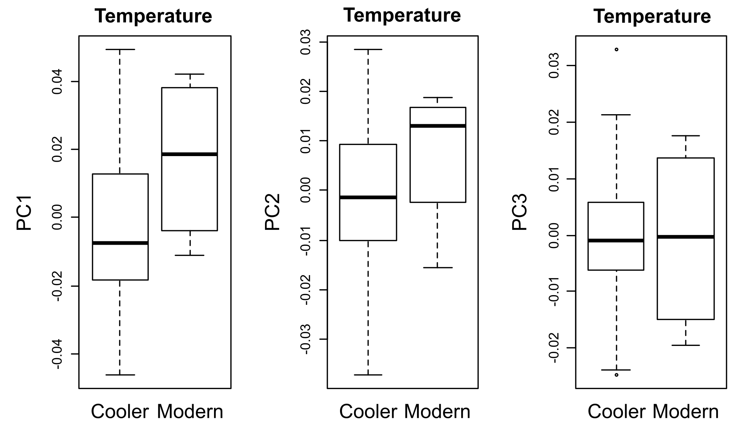

Supplementary Table 26: E. fuscus PC1 by temperature
p-values | Modern
Cool | 0.1828

Supplementary Table 27: E. fuscus PC2 by temperature
p-values | Modern
Cool | 0.325

Supplementary Table 28: E. fuscus PC3 by temperature
p-values | Modern
Cool | 0.9184

PCs – Centroid Size
X M. velifer PCs 1, 2 and 3 are not significantly predicted by centroid size, when tested with a Linear Model (lm function in stats package).

Supplementary Table 29: E. fuscus PCs by centroid size
p-values | Centroid Size
PC1 | 0.370
PC2 | 0.554
PC3 | 0.833

