Supplemental Data S2

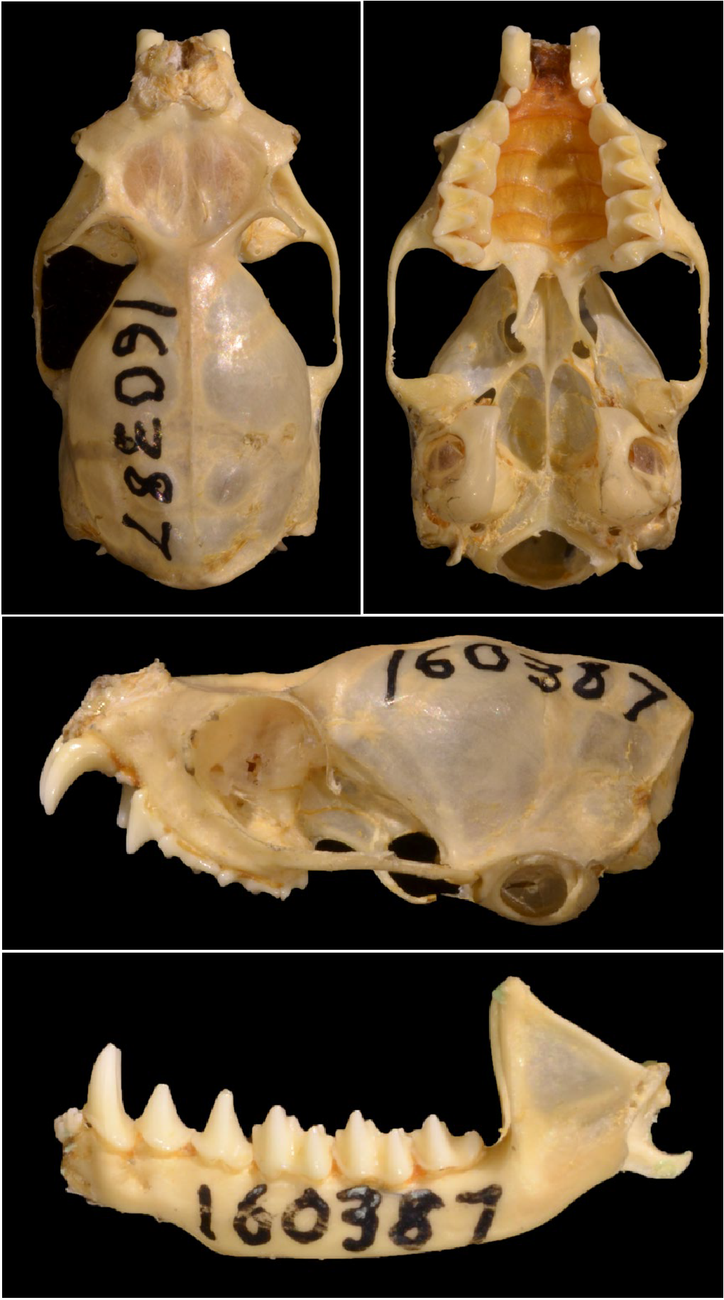

Figure S2.1: Taphozous georgianus AMNH160387, Katherine, NT. Scale bar 5 mm.

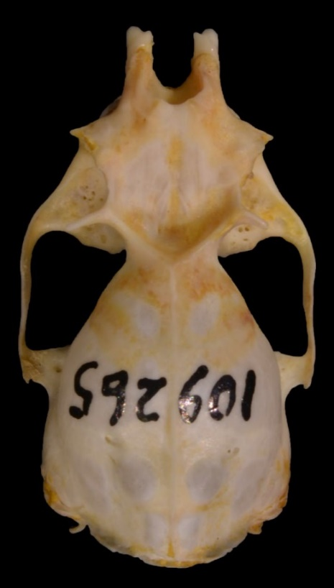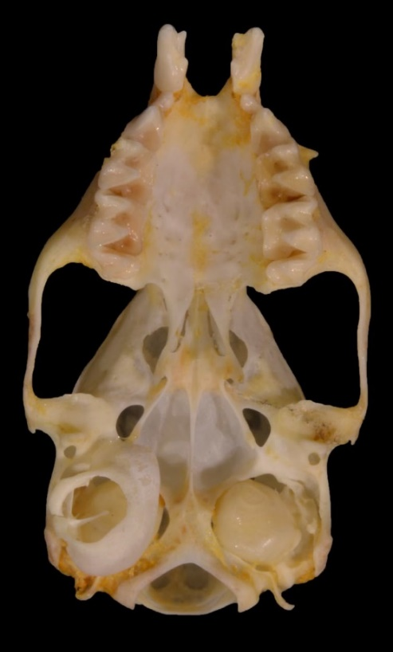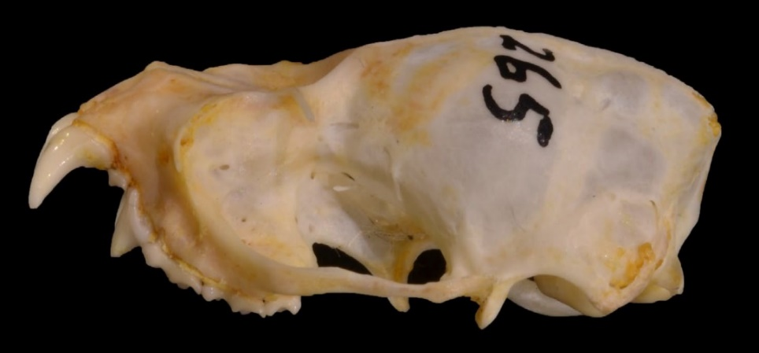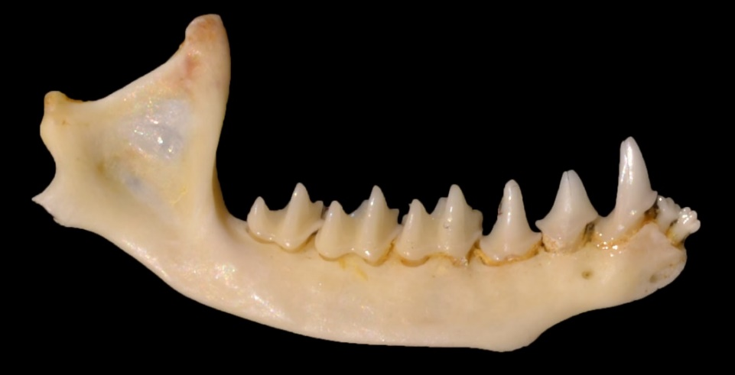

Figure S2.2: Taphozous troughtoni AMNH109265, Quamby, QLD. Scale bar 5 mm.

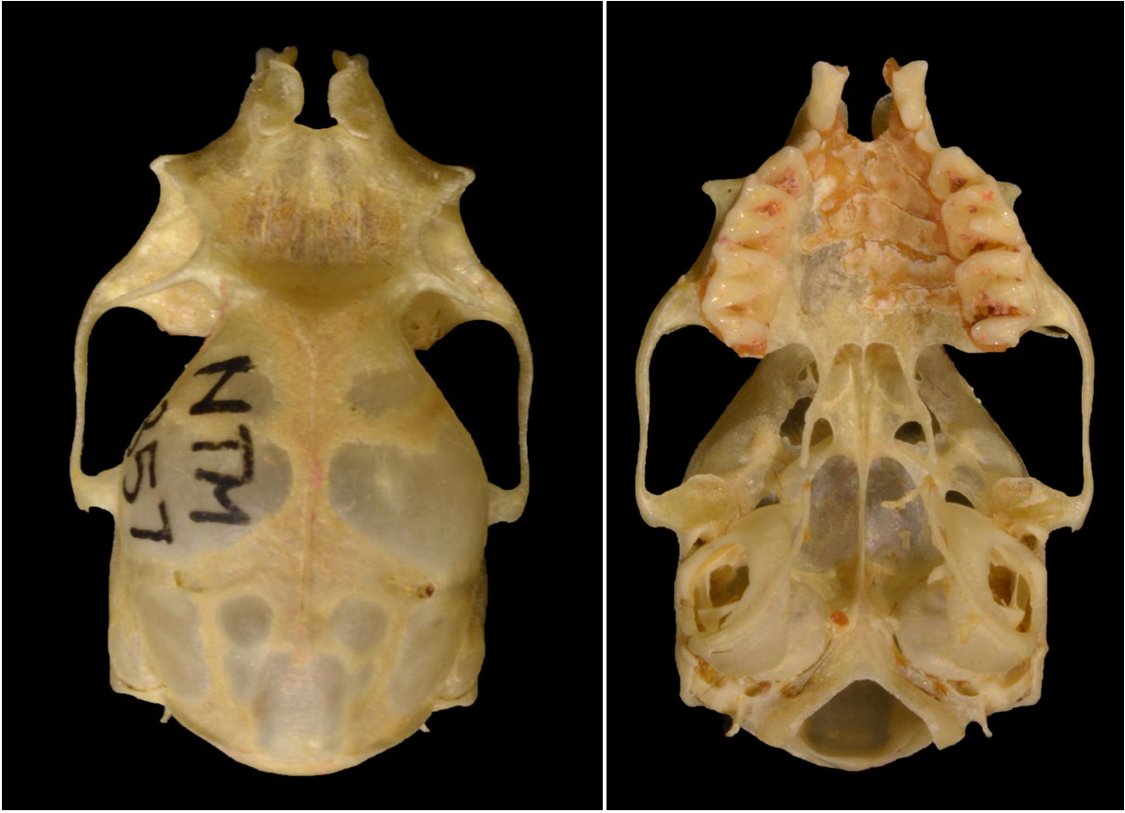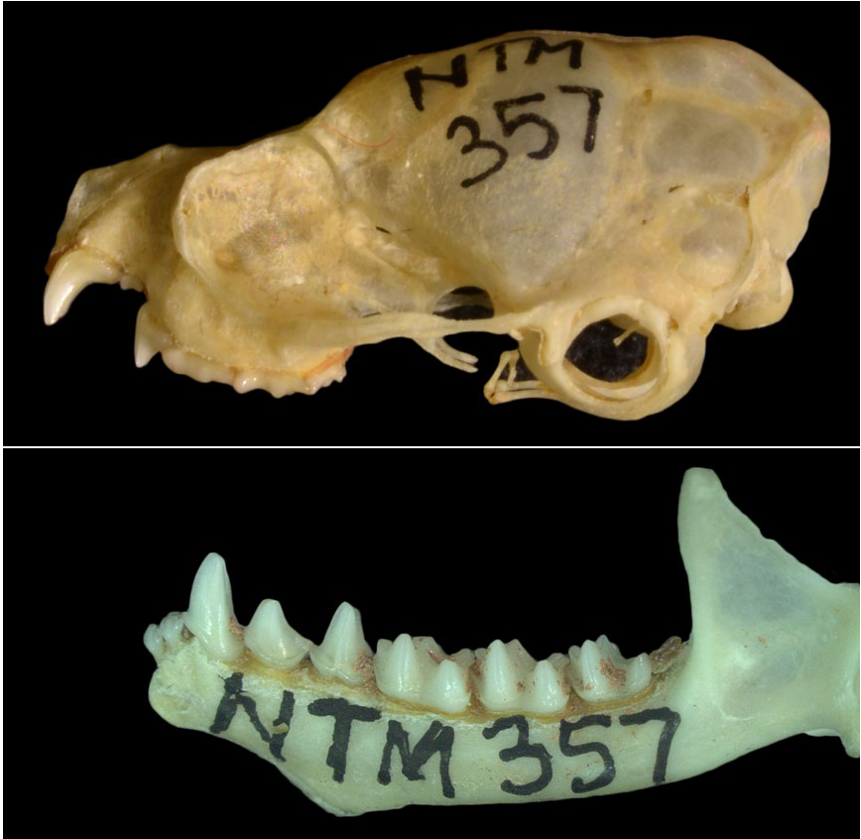

Figure S2.3: Taphozous hilli U3889 (NTM 357), Tennant Creek, NT. Scale bar 5 mm.

Figure S2.4: Saccolaimus flaviventris AM M5057 (CAM 57), Groote Eylandt, NT. Scale bar 5 mm.

