Data S4. Distribution of different structure variants in ITS1.
ITS1 additional loop HA
Structural variant 1 (A)
CCRGYAGAAYGACCCGUGAACYUGUUGA
.((((((.(((...)))....)))))).
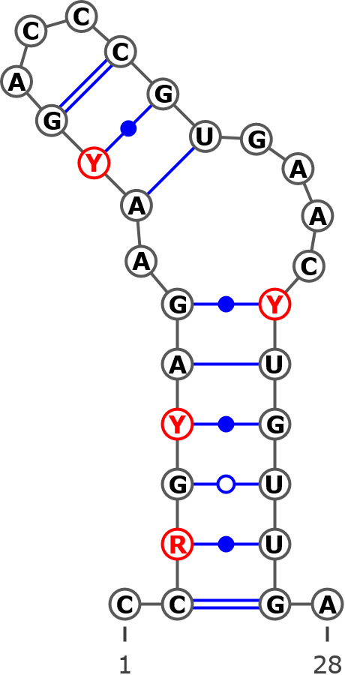
AB243915 Betula apoiensis, haplotype:ap17
AB243914 Betula apoiensis, haplotype:ap14
AB243913 Betula apoiensis, haplotype:ap16
AB243898 Betula ovalifolia, haplotype:ov3
AB243897 Betula ovalifolia, haplotype:ov2
AB243895 Betula middendorffii, haplotype:mi
KT309023 Betula ovalifolia isolate 2
KT309022 Betula ovalifolia isolate 1
KT309021 Betula pumila
KT308989 Betula tianschanica
KT308966 Betula raddeana
AY761132 Betula raddeana isolate 3338
AY761131 Betula pumila isolate 3246
KT309019 Betula nana subsp. exilis
AJ783644 Betula populifolia
AJ783643 Betula humilis
AJ783642 Betula pumila
AJ783641 Betula alnoides
AB243911 Betula apoiensis, haplotype:ap12
AB243910 Betula apoiensis, haplotype:ap10
AB243909 Betula apoiensis, haplotype:ap11
AJ006445 Betula pendula
AJ783646 Betula nigra
AJ783645 Betula insignis
AJ251683 Betula alba
AM503889.2| Betula pendula
AB243907 Betula apoiensis, haplotype:ap5
AB243906 Betula apoiensis, haplotype:ap9
AB243905 Betula apoiensis, haplotype:ap8
AB243904 Betula apoiensis, haplotype:ap7
AB243903 Betula apoiensis, haplotype:ap6
AB243902 Betula apoiensis, haplotype:ap3
AB243901 Betula apoiensis, haplotype:ap2
AB243900 Betula apoiensis, haplotype:ap1
AB243899 Betula apoiensis, haplotype:ap4
AB243894 Betula davurica, haplotype:da2
AB243893 Betula davurica, haplotype:da1
AB243892 Betula grossa, haplotype:gr
AB243891 Betula platyphylla, haplotype:pl
AB243890 Betula maximovicziana, haplotype:ma
AB243889 Betula ermanii, haplotype:er4
AB243888 Betula ermanii, haplotype:er3
AB243887 Betula ermanii, haplotype:er2
AB243886 Betula ermanii, haplotype:er1
AB243885 Betula corylifolia, haplotype:co2
AB243884 Betula corylifolia, haplotype:co1
AB243882 Betula chichibuensis, haplotype:ch2
AB243881 Betula chichibuensis, haplotype:ch1
AB243880 Betula schmidtii, haplotype:sc
KT309028 Betula occidentalis isolate 2
KT309027 Betula occidentalis isolate 1
KT309026 Betula humilis isolate 3
KT309025 Betula humilis isolate 2
KT309024 Betula humilis isolate 1
KT309020 Betula nana isolate 2
KT309018 Betula nana isolate 1
KT309017 Betula glandulosa isolate 2
KT309016 Betula cordifolia isolate 2
KT309015 Betula cordifolia isolate 1
KT309014 Betula papyrifera var. commutata
KT309013 Betula papyrifera isolate 3
KT309012 Betula papyrifera isolate 2
KT309011 Betula papyrifera isolate 1
KT309010 Betula populifolia isolate 3
KT309009 Betula populifolia isolate 2
KT309008 Betula pendula subsp. mandshurica isolate 5
KT309007 Betula pendula subsp. pendula isolate 6
KT309006 Betula pendula subsp. pendula isolate 5
KT309005 Betula pendula subsp. mandshurica isolate 4
KT309004 Betula pendula subsp. szechuanica isolate 3
KT309003 Betula pendula subsp. szechuanica isolate 2
KT309002 Betula pendula subsp. pendula isolate 4
KT309001 Betula pendula subsp. pendula isolate 3
KT309000 Betula pendula subsp. pendula isolate 2
KT308999 Betula pendula subsp. mandshurica isolate 3
KT308998 Betula pendula subsp. pendula isolate 1
KT308997 Betula pendula subsp. szechuanica isolate 1
KT308996 Betula pendula subsp. mandshurica isolate 2
KT308995 Betula glandulosa isolate 1
KT308994 Betula populifolia isolate 1
KT308993 Betula obscura
KT308992 Betula turkestanica
KT308991 Betula pendula
KT308990 Betula pendula subsp. mandshurica isolate 1
KT308988 Betula × caerulea isolate 2
KT308987 Betula × caerulea isolate 1
KT308986 Betula middendorffii
KT308985 Betula minor
KT308984 Betula microphylla
KT308983 Betula pubescens var. litwinowii isolate 2
KT308982 Betula pubescens var. pubescens isolate 4
KT308981 Betula pubescens var. pubescens isolate 3
KT308980 Betula pubescens var. pumila isolate 3
KT308979 Betula × utahensis
KT308978 Betula michauxii
KT308977 Betula pubescens subsp. celtiberica isolate 2
KT308976 Betula pubescens var. pumila isolate 2
KT308975 Betula pubescens var. fragans isolate 2
KT308974 Betula pubescens var. fragans isolate 1
KT308973 Betula pubescens var. pumila isolate 1
KT308972 Betula pubescens subsp. celtiberica isolate 1
KT308971 Betula pubescens var. litiwinowii isolate 1
KT308970 Betula pubescens var. pubescens isolate 2
KT308969 Betula pubescens var. pubescens isolate 1
KT308968 Betula browicziana
KT308967 Betula halophila
KT308965 Betula nigra isolate 2
KT308964 Betula nigra isolate 1
KT308963 Betula dahurica isolate 2
KT308962 Betula dahurica isolate 1
KT308961 Betula ashburneri isolate 3
KT308960 Betula lanata isolate 2
KT308959 Betula lanata isolate 1
KT308958 Betula costata
KT308957 Betula ermanii isolate 2
KT308956 Betula ermanii isolate 1
KT308955 Betula utilis var. prattii
KT308954 Betula albosinensis isolate 2
KT308953 Betula ashburneri isolate 2
KT308952 Betula ashburneri isolate 1
KT308951 Betula utilis var. jacquemontii
KT308950 Betula utilis var. occidentalis isolate 2
KT308949 Betula utilis isolate 2
KT308948 Betula utilis isolate 1
KT308947 Betula albosinensis var. septentrionalis
KT308946 Betula maximovicziana isolate 2
KT308945 Betula maximovicziana isolate 1
KT308943 Betula luminifera isolate 2
KT308942 Betula hainanensis
KT308941 Betula cylindrostachya
KT308940 Betula alnoides
KT308938 Betula lenta f. uber isolate 2
KT308937 Betula lenta f. uber isolate 1
KT308936 Betula lenta
KT308935 Betula grossa isolate 2
KT308934 Betula grossa isolate 1
KT308933 Betula megrelica isolate 2
KT308932 Betula megrelica isolate 1
KT308931 Betula medwediewii isolate 2
KT308930 Betula medwediewii isolate 1
KT308929 Betula insignis subsp. fansipanensis
KT308928 Betula insignis isolate 2
KT308927 Betula insignis isolate 1
KT308926 Betula murrayana
KT308925 Betula alleghaniensis
KT308924 Betula albosinensis isolate 1
KT308923 Betula utilis var. occidentalis
KT308921 Betula delavayi isolate 2
KT308920 Betula schmidtii isolate 2
KT308919 Betula schmidtii isolate 1
KT308916 Betula chichibuensis isolate 2
KT308915 Betula chichibuensis isolate 1
KT308914 Betula calcicola
KT308913 Betula delavayi isolate 1
KT308912 Betula bomiensis isolate 2
KT308911 Betula bomiensis isolate 1
KT308910 Betula potaninii isolate 2
KT308909 Betula potaninii isolate 1
KT308908 Betula corylifolia isolate 2
KT308907 Betula corylifolia isolate 1
JN247411 Betula pendula voucher MCA 221
FJ011780 Betula utilis voucher MacAtrher-Tibet Expedition452
FJ011779 Betula schmidtii Lee s.n.
FJ011778 Betula platyphylla Lee s.n.
FJ011777 Betula pendula voucher CS03022
FJ011773 Betula davurica voucher Tibet218
FJ011772 Betula davurica voucher UNA63303V
FJ011771 Betula davurica voucher UNA64631H
FJ011770 Betula davurica voucher Lee s.n.
AY763113 Betula luminifera isolate 2841
AY761134 Betula utilis isolate 2893
AY761133 Betula schmidtii isolate 2875
AY761130 Betula pubescens isolate 2895
AY761129 Betula populifolia isolate 2890
AY761128 Betula platyphylla isolate 2934
AY761127 Betula pendula isolate 2902
AY761126 Betula papyrifera isolate 2892
AY761125 Betula occidentalis isolate 2883
AY761124 Betula nigra isolate 2927
AY761122 Betula nana isolate 3337
AY761121 Betula michauxii isolate 3406
AY761119 Betula maximovicziana isolate 3463
AY761118 Betula maximovicziana isolate 2932
AY761117 Betula luminifera isolate 3299
AY761116 Betula luminifera isolate 2828
AY761114 Betula humilis isolate 2894
AY761113 Betula grossa isolate 3459
AY761112 Betula grossa isolate 2948
AY761109 Betula fruticosa isolate 3339
AY761108 Betula ermanii isolate 2961
AY761107 Betula delavayi isolate 3462
AY761106 Betula corylifolia isolate 3457
AY761105 Betula chinensis isolate 2903
AY761104 Betula chichibuensis isolate 2977
AY761103 Betula calcicola isolate 3460
AY761102 Betula apoiensis isolate 3249
AY761101 Betula alnoides isolate 3352
AY761100 Betula alleghaniensis isolate 2880
AY761099 Betula albosinensis isolate 3018
AY352337 Betula costata
AY352336 Betula nana
AY352335 Betula davurica
AY352333 Betula populifolia
AY352332 Betula pendula
AY352331 Betula nigra
AF432067 Betula papyrifera
DQ397523 Betula occidentalis
MH231211 Betula atrata
MH014808 Betula borysthenica (KW0061415, holotype)
MH238480 Betula klokovii (KW006422, holotype)
MH231207 Betula kotulae (KW006426, holotype)
MH178103 Betula kotulae (KW008349)
MH178104 Betula kotulae (KW06427)
MH178105 Betula kotulae (KW128013)
MH178106 Betula kotulae (KW128014)
MH178107 Betula kotulae (KW128016)
MH178108 Betula kotulae (KW128018)
MH231208 Betula kotulae (KW128019)
MH231209 Betula kotulae (KW128020)
MH178109 Betula kotulae (KW128022)
MH231210 Betula kotulae (KW128023)
MH238474 Betula kotulae
MH238475 Betula kotulae (LW032758)
MH231213 Betula kotulae (LW006898)
MH238478 Betula kotulae (LWS27022)
MH238477 Betula kotulae (LWS27026)
MH231214 Betula kotulae
MH238476 Betula oycowiensis (LWKS031322)
MH014809 Betula pubescens ssp. carpatica
MH231206 Betula pubescens var. sibakademica (LE01041130, type)
MH238471 Betula pubescens var. sibakademica (KW128012)
MH178102 Betula pubescens var. sibakademica (KW128024)
MH238472 Betula pubescens var. sibakademica
MH238473 Betula pubescens var. sibakademica
MH231212 Betula pubescens var. sibakademica (LWKS031322)

Structural variant 2 (B)
CCAGCAGAACGACCCGUGAACAUGUUGA
.(((((..(((...))).....))))).
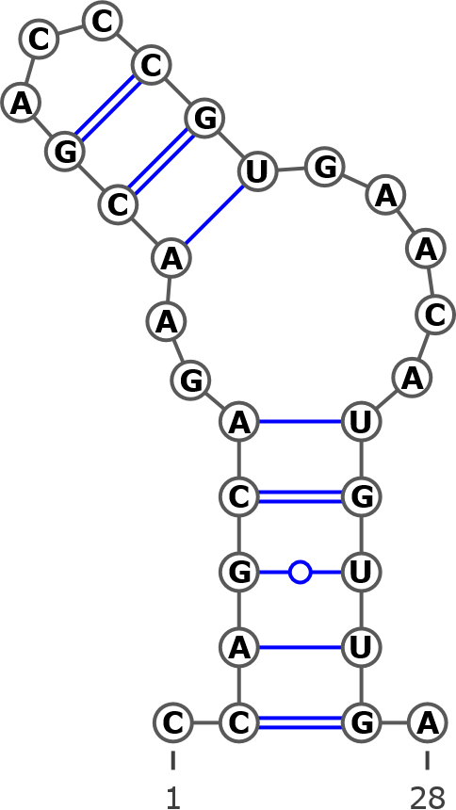
AB243883 Betula globispica, haplotype:gl
KT308918 Betula chinensis isolate 2
KT308917 Betula chinensis isolate 1
KT308906 Betula fargesii
KT308905 Betula globispica isolate 2
KT308904 Betula globispica isolate 1
AY761120 Betula medwediewii isolate 3465
AY761111 Betula globispica isolate 2942
AY761110 Betula glandulosa isolate 3251
AY761115 Betula lenta isolate 2936
AY352334 Betula uber
AY352330 Betula lenta

Structural variant 3 (C)
CCAGCAGAACGACCCGCGAACCUGUUGA
.((((((..((...)).....)))))).
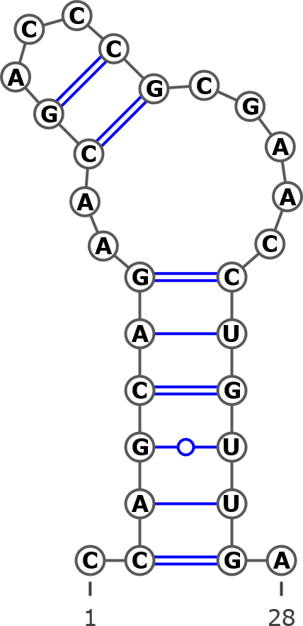
KT308944 Betula luminifera isolate 3
AY763114 Betula alnoides isolate 3464

Structural variant 4 (D)
CAGCAGAACGACCCGUGAACCUGUUS
.(((((.(((...)))....))))).
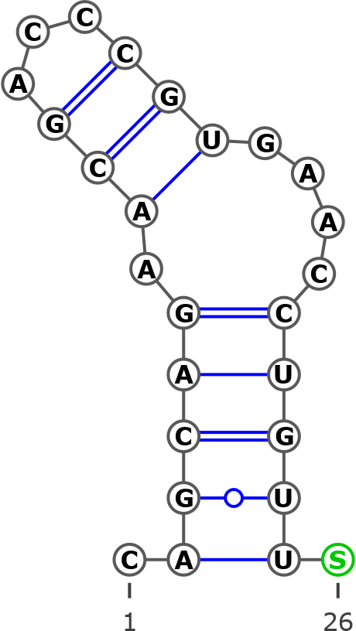
AB243912 Betula apoiensis, haplotype:ap15
AB243908 Betula apoiensis, haplotype:ap13
Helix 1
Structural variant 1 (A)
CUGGGGGYGGGGGGCGAUCUYGCCCCUUGYCCYCGA
.(((((((((((((((....))))))))))))))).
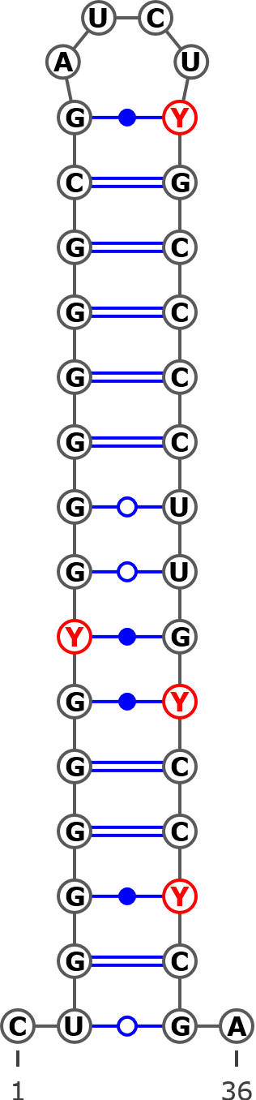
AJ783644 Betula populifolia
AJ783643 Betula humilis
AJ783642 Betula pumila
AJ783641 Betula alnoides
AB243911 Betula apoiensis, haplotype:ap12
AB243910 Betula apoiensis, haplotype:ap10
AB243909 Betula apoiensis, haplotype:ap11
AB243908 Betula apoiensis, haplotype:ap13
AB243906 Betula apoiensis, haplotype:ap9
AB243905 Betula apoiensis, haplotype:ap8
AB243904 Betula apoiensis, haplotype:ap7
AB243903 Betula apoiensis, haplotype:ap6
AB243902 Betula apoiensis, haplotype:ap3
AB243901 Betula apoiensis, haplotype:ap2
AB243900 Betula apoiensis, haplotype:ap1
AB243893 Betula davurica, haplotype:da1
AB243892 Betula grossa, haplotype:gr
AB243890 Betula maximovicziana, haplotype:ma
AB243888 Betula ermanii, haplotype:er3
AB243887 Betula ermanii, haplotype:er2
AB243886 Betula ermanii, haplotype:er1
KT309027 Betula occidentalis isolate 1
KT309026 Betula humilis isolate 3
KT309025 Betula humilis isolate 2
KT309024 Betula humilis isolate 1
KT309020 Betula nana isolate 2
KT309018 Betula nana isolate 1
KT309017 Betula glandulosa isolate 2
KT309016 Betula cordifolia isolate 2
KT309015 Betula cordifolia isolate 1
KT309014 Betula papyrifera var. commutata
KT309012 Betula papyrifera isolate 2
KT309011 Betula papyrifera isolate 1
KT309010 Betula populifolia isolate 3
KT309009 Betula populifolia isolate 2
KT308995 Betula glandulosa isolate 1
KT308994 Betula populifolia isolate 1
KT308988 Betula × caerulea isolate 2
KT308987 Betula × caerulea isolate 1
KT308986 Betula middendorffii
KT308985 Betula minor
KT308984 Betula microphylla
KT308983 Betula pubescens var. litwinovii isolate 2
KT308982 Betula pubescens var. pubescens isolate 4
KT308981 Betula pubescens var. pubescens isolate 3
KT308980 Betula pubescens var. pumila isolate 3
KT308979 Betula × utahensis
KT308977 Betula pubescens subsp. celtiberica isolate 2
KT308976 Betula pubescens var. pumila isolate 2
KT308975 Betula pubescens var. fragans isolate 2
KT308974 Betula pubescens var. fragans isolate 1
KT308973 Betula pubescens var. pumila isolate 1
KT308972 Betula pubescens subsp. celtiberica isolate 1
KT308971 Betula pubescens var. litwinowii isolate 1
KT308970 Betula pubescens var. pubescens isolate 2
KT308969 Betula pubescens var. pubescens isolate 1
KT308967 Betula halophila
KT308963 Betula dahurica isolate 2
KT308962 Betula dahurica isolate 1
KT308961 Betula ashburneri isolate 3
KT308960 Betula lanata isolate 2
KT308959 Betula lanata isolate 1
KT308955 Betula utilis var. prattii
KT308954 Betula albosinensis isolate 2
KT308953 Betula ashburneri isolate 2
KT308952 Betula ashburneri isolate 1
KT308951 Betula utilis var. jacquemontii
KT308950 Betula utilis var. occidentalis isolate 2
KT308949 Betula utilis isolate 2
KT308948 Betula utilis isolate 1
KT308947 Betula albosinensis var. septentrionalis
KT308946 Betula maximovicziana isolate 2
KT308945 Betula maximovicziana isolate 1
KT308936 Betula lenta
KT308935 Betula grossa isolate 2
KT308934 Betula grossa isolate 1
KT308924 Betula albosinensis isolate 1
KT308923 Betula utilis var. occidentalis isolate 1
FJ011780 Betula utilis voucher MacAtrher-Tibet Expedition 452
FJ011773 Betula davurica voucher Tibet218
FJ011772 Betula davurica voucher UNA63303V
FJ011771 Betula davurica voucher UNA64631H
FJ011770 Betula davurica voucher Lee s.n.
AY761134 Betula utilis isolate 2893
AY761130 Betula pubescens isolate 2895
AY761129 Betula populifolia isolate 2890
AY761126 Betula papyrifera isolate 2892
AY761119 Betula maximovicziana isolate 3463
AY761118 Betula maximovicziana isolate 2932
AY761113 Betula grossa isolate 3459
AY761112 Betula grossa isolate 2948
AY761109 Betula fruticosa isolate 3339
AY761108 Betula ermanii isolate 3339
AY761106 Betula corylifolia isolate 3457
AY761105 Betula chinensis isolate 2903
AY761102 Betula apoiensis isolate 3249
AY761099 Betula albosinensis isolate 3018
AY352337 Betula costata
AY352335 Betula davurica
AF432067 Betula papyrifera
MH014808 Betula borysthenica (KW0061415, holotype)
MH238480 Betula klokovii (KW006422, holotype)
MH238476| Betula oycowiensis (LW032763)
MH231206 Betula pubescens var. sibakademica (LE01041130, type)
MH238471 Betula pubescens var. sibakademica (KW128012)
MH178102 Betula pubescens var. sibakademica (KW128024)
MH238472 Betula pubescens var. sibakademica
MH238473 Betula pubescens var. sibakademica
MH231212 Betula pubescens var. sibakademica (LWKS031322)

Structural variant 2 (B)
CUGGGGGYRKGGGGCGWUCUCGCCCCKUGYCYYCGA
.((((((((.((((((....)))))).)))))))).
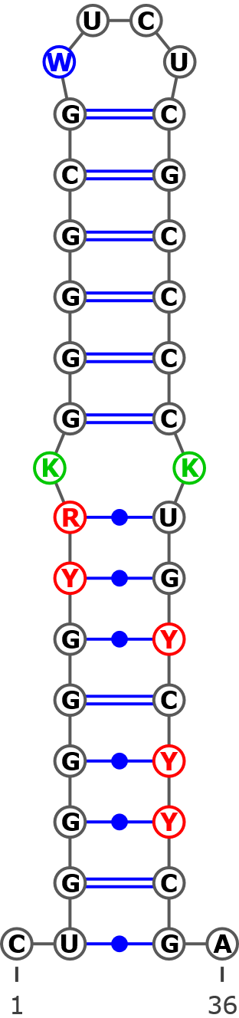
MH014809 Betula pubescens ssp. carpatica
AJ006445 Betula pendula
AJ783646 Betula nigra
AJ783645 Betula insignis
AJ251683 Betula alba
AM503889.2 Betula pendula
AB243907 Betula apoiensis, haplotype:ap5
AB243899 Betula apoiensis, haplotype:ap4
AB243889 Betula ermanii, haplotype:er4
AB243891 Betula platyphylla, haplotype:pl
AB243885 Betula corylifolia, haplotype:co2
AB243884 Betula corylifolia, haplotype:co1
AB243883 Betula globispica, haplotype:gl
AB243882 Betula chichibuensis, haplotype:ch2
AB243881 Betula chichibuensis, haplotype:ch1
AB243880 Betula schmidtii, haplotype:sc
KT309028 Betula occidentalis isolate 2
KT309013 Betula papyrifera isolate 3
KT309008 Betula pendula subsp. mandshurica isolate 5
KT309007 Betula pendula subsp. pendula isolate 6
KT309006 Betula pendula subsp. pendula isolate 5
KT309005 Betula pendula subsp. mandshurica isolate 4
KT309004 Betula pendula subsp. szechuanica isolate 3
KT309003 Betula pendula subsp. szechuanica isolate 2
KT309002 Betula pendula subsp. pendula isolate 4
KT309001 Betula pendula subsp. pendula isolate 3
KT309000 Betula pendula subsp. pendula isolate 2
KT308999 Betula pendula subsp. mandshurica isolate 3
KT308998 Betula pendula subsp. pendula isolate 1
KT308997 Betula pendula subsp. szechuanica isolate 1
KT308996 Betula pendula subsp. mandshurica isolate 2
KT308993 Betula obscura
KT308992 Betula turkestanica
KT308991 Betula pendula subsp. mandshurica isolate 1
KT308990 Betula pendula
KT308978 Betula michauxii
KT308968 Betula browicziana
KT308965 Betula nigra isolate 2
KT308964 Betula nigra isolate 1
KT308958 Betula costata
KT308957 Betula ermanii isolate 2
KT308956 Betula ermanii isolate 1
KT308944 Betula luminifera isolate 3
KT308943 Betula luminifera isolate 2
KT308942 Betula hainanensis
KT308941 Betula cylindrostachya
KT308940 Betula alnoides
KT308938 Betula lenta f. uber isolate 2
KT308937 Betula lenta f. uber isolate 1
KT308933 Betula megrelica isolate 2
KT308932 Betula megrelica isolate 1
KT308931 Betula medwediewii isolate 2
KT308930 Betula medwediewii isolate 1
KT308929 Betula insignis subsp. fansipanensis
KT308928 Betula insignis isolate 2
KT308927 Betula insignis isolate 1
KT308926 Betula murrayana
KT308925 Betula alleghaniensis
KT308921 Betula delavayi isolate 2
KT308920 Betula schmidtii isolate 2
KT308919 Betula schmidtii isolate 1
KT308918 Betula chinensis isolate 2
KT308917 Betula chinensis isolate 1
KT308916 Betula chichibuensis isolate 2
KT308915 Betula chichibuensis isolate 1
KT308914 Betula calcicola
KT308913 Betula delavayi isolate 1
KT308912 Betula bomiensis isolate 2
KT308911 Betula bomiensis isolate 1
KT308910 Betula potaninii isolate 2
KT308909 Betula potaninii isolate 1
KT308908 Betula corylifolia isolate 2
KT308907 Betula corylifolia isolate 1
KT308906 Betula fargesii
KT308905 Betula globispica isolate 2
KT308904 Betula globispica isolate 1
JN247411 Betula pendula voucher MCA 221
FJ011779 Betula schmidtii voucher Lee s.n.
FJ011778 Betula platyphylla voucher Lee s.n.
AY763113 Betula luminifera isolate 2841
AY761133 Betula schmidtii isolate 2875
AY761128 Betula platyphylla isolate 2934
AY761127 Betula pendula isolate 2902
AY761125 Betula occidentalis isolate 2883
AY761124 Betula nigra isolate 2927
AY761122 Betula nana isolate 3337
AY761121 Betula michauxii isolate 3406
AY761120 Betula medwediewii isolate 3465
AY761117 Betula luminifera isolate 3299
AY761116 Betula luminifera isolate 2828
AY761115 Betula lenta isolate 2936
AY761114 Betula humilis isolate 2894
AY761111 Betula globispica isolate 2942
AY761110 Betula glandulosa isolate 3251
AY761107 Betula delavayi isolate 3462
AY761104 Betula chichibuensis isolate 2977
AY761103 Betula calcicola isolate 3460
AY761101 Betula alnoides isolate 3352
AY761100 Betula alleghaniensis isolate 2880
AY352336 Betula nana
AY352334 Betula uber
AY352332 Betula pendula
AY352331 Betula nigra
AY352330 Betula lenta
DQ397523 Betula occidentalis
MH231211 Betula atrata
MH231207 Betula kotulae (KW006426, holotype)
MH178103 Betula kotulae (KW008349)
MH178104 Betula kotulae (KW06427)
MH231207 |Betula kotulae
MH178105 Betula kotulae (KW128013)
MH178106 Betula kotulae (KW128014)
MH178107 Betula kotulae (KW128016)
MH178108 Betula kotulae (KW128018)
MH231208 Betula kotulae (KW128019)
MH231209 Betula kotulae (KW128020)
MH178109 Betula kotulae (KW128022)
MH231210 Betula kotulae (KW128023)
MH238474 Betula kotulae
MH238475 Betula kotulae (LW032758)
MH231213 Betula kotulae (LW006898)
MH238478 Betula kotulae (LWS27022)
MH238477 Betula kotulae (LWS27026)
MH231214 Betula kotulae

Structural variant 3 (C)
YUGGGGGYGGGGGGCUCUCGCCCCUUGCCCCCGA
.((((((((((((((....)))))))))))))).
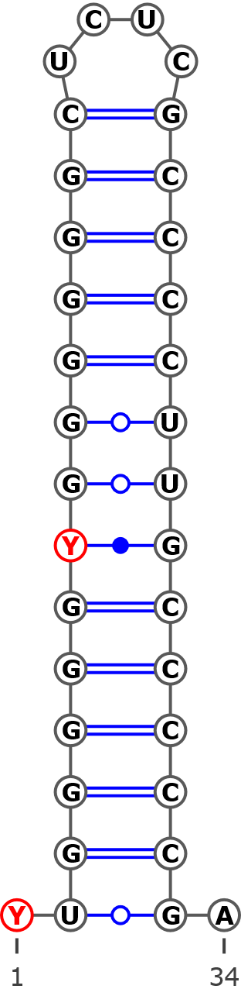
AB243915 Betula apoiensis, haplotype:ap17
AB243914 Betula apoiensis, haplotype:ap14
AB243913 Betula apoiensis, haplotype:ap16
AB243912 Betula apoiensis, haplotype:ap15
AB243898 Betula ovalifolia, haplotype:ov3
AB243897 Betula ovalifolia, haplotype:ov2
AB243895 Betula middendorffii, haplotype:mi
KT309023 Betula ovalifolia isolate 2
KT309022 Betula ovalifolia isolate 1
KT309021 Betula pumila
KT309019 Betula nana subsp. exilis
KT308989 Betula tianschanica
KT308966 Betula raddeana
AY761132 Betula raddeana isolate 3338
AY761131 Betula pumila isolate 3246

Structural variant 4 (D)
CUGGGGGUGGGGGGCGAUCUCACCCCUUGCCCCCGA
.(((((((((((((.(....).))))))))))))).
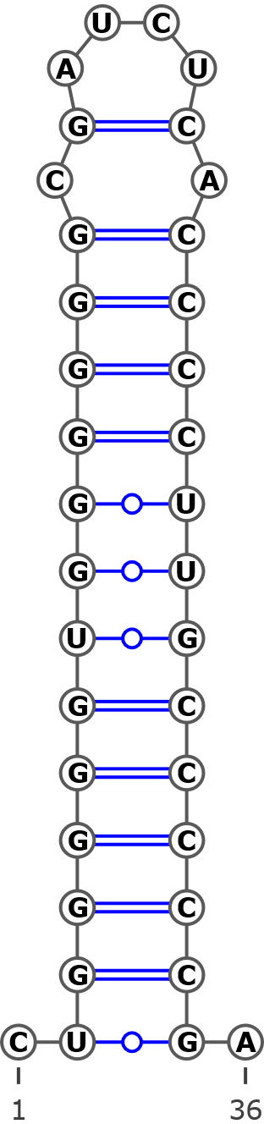
AB243894 Betula davurica, haplotype:da2

Structural variant 5 (E)
GGGGGGUGUGGGGCGAUCUCGCCCCUUGCCCCCG
.(((((((.((((((....)))))).))))))).
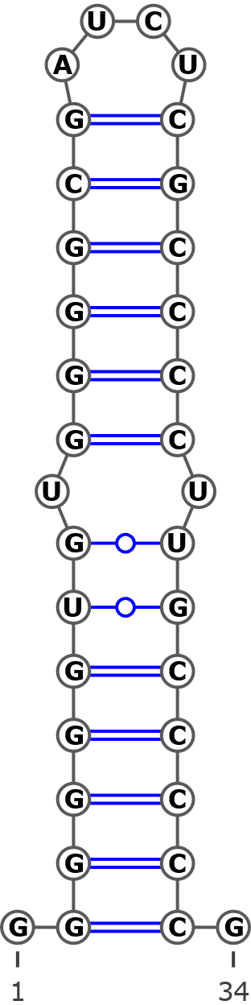
FJ011777 Betula pendula voucher CS03022
Structural variant 6 (F) optional
CUGGGGGNGGGGGGCGAUCUCGCCCCUUGUCCCCGA
.((((((.((((((((....)))))))).)))))).
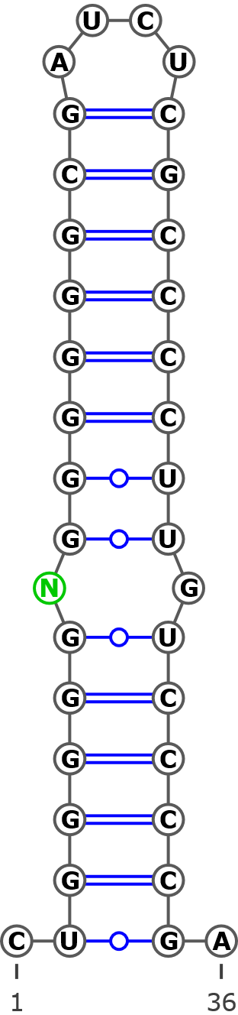
AY352333 Betula populifolia
Structural variant 7 (G) optional
CUGGGGGCGGGGGGCRAUCUCGCCCCGUGCCCCCGA
.((((((((.(((((......))))).)))))))).
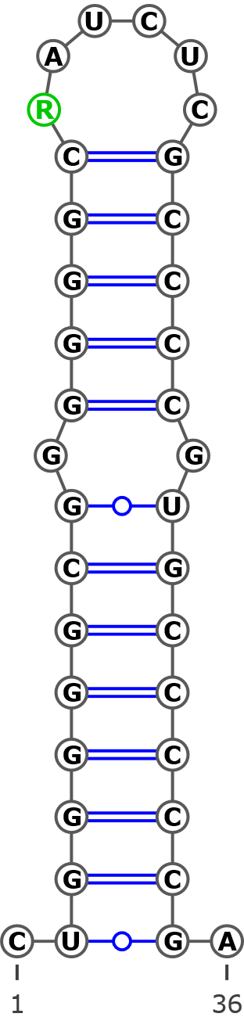
AY763114 Betula alnoides

Helix 2
Structural variant 1 (A)
AYGGYAGGGAGACACUYGUGCAUCCCUGCYGA
.(((((((((..((....))..))))))))).
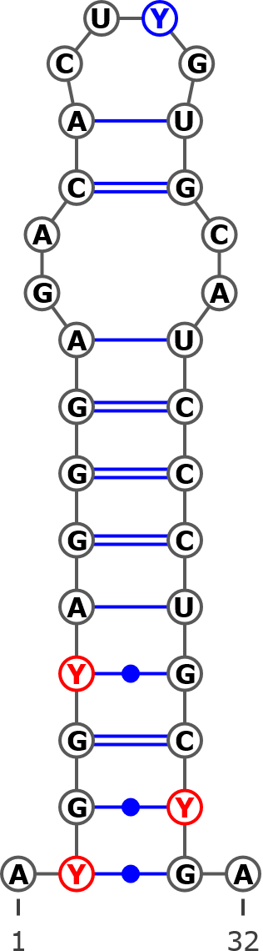
AB243915 Betula apoiensis, haplotype:ap17
AB243914 Betula apoiensis, haplotype:ap14
AB243913 Betula apoiensis, haplotype:ap16
AB243912 Betula apoiensis, haplotype:ap15
AB243898 Betula ovalifolia, haplotype:ov3
AB243897 Betula ovalifolia, haplotype:ov2
AB243895 Betula middendorffii, haplotype:mi
KT309023 Betula ovalifolia isolate 2
KT309022 Betula ovalifolia isolate 1
KT309021 Betula pumila
KT308989 Betula tianschanica
KT308966 Betula raddeana
AY761132 Betula raddeana isolate 3338
AY761131 Betula pumila isolate 3246
KT309019 Betula nana subsp. exilis
AB243894 Betula davurica, haplotype:da2
AB243883 Betula globispica, haplotype:gl
KT308918 Betula chinensis isolate 2
KT308917 Betula chinensis isolate 1
KT308906 Betula fargesii
KT308905 Betula globispica isolate 2
KT308904 Betula globispica isolate 1
AY761120 Betula medwediewii isolate 3465
AY761111 Betula globispica isolate 2942
AY761110 Betula glandulosa isolate 3251
AY761115 Betula lenta isolate 2936
AY352334 Betula uber
AY352330 Betula lenta
AJ006445 Betula pendula
AJ783646 Betula nigra
AJ783645 Betula insignis
AJ251683 Betula alba
AM503889.2| Betula pendula
AB243907 Betula apoiensis, haplotype:ap5
AB243899 Betula apoiensis, haplotype:ap4
AB243891 Betula platyphylla, haplotype:pl
AB243889 Betula ermanii, haplotype:er4
AB243885 Betula corylifolia, haplotype:co2
AB243884 Betula corylifolia, haplotype:co1
AB243882 Betula chichibuensis, haplotype:ch2
AB243881 Betula chichibuensis, haplotype:ch1
AB243880 Betula schmidtii, haplotype:sc
KT309028 Betula occidentalis isolate 2
KT309013 Betula papyrifera isolate 3
KT309008 Betula pendula subsp. mandshurica isolate 5
KT309007 Betula pendula subsp. pendula isolate 6
KT309006 Betula pendula subsp. pendula isolate 5
KT309005 Betula pendula subsp. mandshurica isolate 4
KT309004 Betula pendula subsp. szechuanica isolate 3
KT309003 Betula pendula subsp. szechuanica isolate 2
KT309002 Betula pendula subsp. pendula isolate 4
KT309001 Betula pendula subsp. pendula isolate 3
KT309000 Betula pendula subsp. pendula isolate 2
KT308999 Betula pendula subsp. mandshurica isolate 3
KT308998 Betula pendula subsp. pendula isolate 1
KT308997 Betula pendula subsp. szechuanica isolate 1
KT308996 Betula pendula subsp. mandshurica isolate 2
KT308993 Betula obscura
KT308992 Betula turkestanica
KT308991 Betula pendula subsp. mandshurica isolate 1
KT308990 Betula pendula
KT308978 Betula michauxii
KT308968 Betula browicziana
KT308965 Betula nigra isolate 2
KT308964 Betula nigra isolate 1
KT308958 Betula costata
KT308957 Betula ermanii isolate 2
KT308956 Betula ermanii isolate 1
KT308944 Betula luminifera isolate 3
KT308943 Betula luminifera isolate 2
KT308942 Betula hainanensis
KT308941 Betula cylindrostachya
KT308940 Betula alnoides
KT308938 Betula lenta f. uber isolate 2
KT308937 Betula lenta f. uber isolate 1
KT308933 Betula megrelica isolate 2
KT308932 Betula megrelica isolate 1
KT308931 Betula medwediewii isolate 2
KT308930 Betula medwediewii isolate 1
KT308926 Betula murrayana
KT308925 Betula alleghaniensis
KT308921 Betula delavayi isolate 2
KT308920 Betula schmidtii isolate 2
KT308919 Betula schmidtii isolate 1
KT308916 Betula chichibuensis isolate 2
KT308915 Betula chichibuensis isolate 1
KT308914 Betula calcicola
KT308913 Betula delavayi isolate 1
KT308912 Betula bomiensis isolate 2
KT308911 Betula bomiensis isolate 1
KT308910 Betula potaninii isolate 2
KT308909 Betula potaninii isolate 1
KT308908 Betula corylifolia isolate 2
KT308907 Betula corylifolia isolate 1
JN247411 Betula pendula voucher MCA 221
FJ011779 Betula schmidtii voucher Lee s.n.
FJ011778 Betula platyphylla voucher Lee s.n.
FJ011777 Betula pendula voucher CS03022
AY763113 Betula luminifera isolate 2841
AY761133 Betula schmidtii isolate 2875
AY761128 Betula platyphylla isolate 2934
AY761127 Betula pendula isolate 2902
AY761125 Betula occidentalis isolate 2883
AY761124 Betula nigra isolate 2927
AY761122 Betula nana isolate 3337
AY761121 Betula michauxii isolate 3406
AY761117 Betula luminifera isolate 3299
AY761116 Betula luminifera isolate 2828
AY761114 Betula humilis isolate 2894
AY761107 Betula delavayi isolate 3462
AY761104 Betula chichibuensis isolate 2977
AY761103 Betula calcicola isolate 3460
AY761101 Betula alnoides isolate 3352
AY761100 Betula alleghaniensis isolate 2880
AY352336 Betula nana
AY352332 Betula pendula
AY352331 Betula nigra
DQ397523 Betula occidentalis
AY763114 Betula alnoides
AF432067 Betula papyrifera
AJ783644 Betula populifolia
AJ783643 Betula humilis
AJ783642 Betula pumila
AJ783641 Betula alnoides isolate 3464
AB243911 Betula apoiensis, haplotype:ap12
AB243910 Betula apoiensis, haplotype:ap10
AB243909 Betula apoiensis, haplotype:ap11
AB243908 Betula apoiensis, haplotype:ap13
AB243906 Betula apoiensis, haplotype:ap9
AB243905 Betula apoiensis, haplotype:ap8
AB243904 Betula apoiensis, haplotype:ap7
AB243903 Betula apoiensis, haplotype:ap6
AB243902 Betula apoiensis, haplotype:ap3
AB243901 Betula apoiensis, haplotype:ap2
AB243900 Betula apoiensis, haplotype:ap1
AB243893 Betula davurica, haplotype:da1
AB243892 Betula grossa, haplotype:gr
AB243890 Betula maximovicziana, haplotype:ma
AB243888 Betula ermanii, haplotype:er3
AB243887 Betula ermanii, haplotype:er2
AB243886 Betula ermanii, haplotype:er1
KT309027 Betula occidentalis isolate 1
KT309026 Betula humilis isolate 3
KT309025 Betula humilis isolate 2
KT309024 Betula humilis isolate 1
KT309020 Betula nana isolate 2
KT309018 Betula nana isolate 1
KT309017 Betula glandulosa isolate 2
KT309016 Betula cordifolia isolate 2
KT309015 Betula cordifolia isolate 1
KT309014 Betula papyrifera var. commutata
KT309012 Betula papyrifera isolate 2
KT309011 Betula papyrifera isolate 1
KT309010 Betula populifolia isolate 3
KT309009 Betula populifolia isolate 2
KT308995 Betula glandulosa isolate 1
KT308994 Betula populifolia isolate 1
KT308988 Betula × caerulea isolate 2
KT308987 Betula × caerulea isolate 1
KT308986 Betula middendorffii
KT308985 Betula minor
KT308984 Betula microphylla
KT308983 Betula pubescens var. litiwinowii isolate 2
KT308982 Betula pubescens var. pubescens isolate 4
KT308981 Betula pubescens var. pubescens isolate 3
KT308980 Betula pubescens var. pumila isolate 3
KT308979 Betula × utahensis
KT308977 Betula pubescens subsp. celtiberica isolate 2
KT308976 Betula pubescens var. pumila isolate 2
KT308975 Betula pubescens var. fragans isolate 2
KT308974 Betula pubescens var. fragans isolate 1
KT308973 Betula pubescens var. pumila isolate 1
KT308972 Betula pubescens subsp. celtiberica isolate 1
KT308971 Betula pubescens var. litiwinowii isolate 1
KT308970 Betula pubescens var. pubescens isolate 2
KT308969 Betula pubescens var. pubescens isolate 1
KT308967 Betula halophila
KT308963 Betula dahurica isolate 2
KT308962 Betula dahurica isolate 1
KT308961 Betula ashburneri isolate 3
KT308960 Betula lanata isolate 2
KT308959 Betula lanata isolate 1
KT308955 Betula utilis var. prattii
KT308954 Betula albosinensis isolate 2
KT308953 Betula ashburneri isolate 2
KT308952 Betula ashburneri isolate 1
KT308951 Betula utilis var. jacquemontii
KT308950 Betula utilis var. occidentalis isolate 2
KT308949 Betula utilis isolate 2
KT308948 Betula utilis isolate 1
KT308947 Betula albosinensis var. septentrionalis
KT308946 Betula maximovicziana isolate 2
KT308945 Betula maximovicziana isolate 1
KT308936 Betula lenta
KT308935 Betula grossa isolate 2
KT308934 Betula grossa isolate 1
KT308924 Betula albosinensis isolate 1
KT308923 Betula utilis var. occidentalis isolate 1
FJ011780 Betula utilis voucher MacAtrher-Tibet Expedition 452
FJ011773 Betula davurica voucher Tibet218
FJ011772 Betula davurica voucher UNA63303V
FJ011771 Betula davurica voucher UNA64631H
FJ011770 Betula davurica voucher Lee s.n
AY761134 Betula utilis isolate 2893
AY761130 Betula pubescens isolate 2895
AY761129 Betula populifolia isolate 2890
AY761126 Betula papyrifera isolate 2892
AY761119 Betula maximovicziana isolate 3463
AY761118 Betula maximovicziana isolate 2932
AY761113 Betula grossa isolate 3459
AY761112 Betula grossa isolate 2948
AY761109 Betula fruticosa isolate 3339
AY761108 Betula ermanii isolate 2961
AY761106 Betula corylifolia isolate 3457
AY761105 Betula chinensis isolate 2903
AY761102 Betula apoiensis isolate 3249
AY761099 Betula albosinensis isolate 3018
AY352337 Betula costata
AY352335 Betula davurica
AY352333 Betula populifolia
MH231211 Betula atrata
MH014808 Betula borysthenica (KW0061415, holotype)
MH238480 Betula klokovii (KW006422, holotype)
MH231207 Betula kotulae (KW006426, holotype)
MH178103 Betula kotulae (KW008349)
MH178104 Betula kotulae (KW06427)
MH178105 Betula kotulae (KW128013)
MH178106 Betula kotulae (KW128014)
MH178107 Betula kotulae (KW128016)
MH178108 Betula kotulae (KW128018)
MH231208 Betula kotulae (KW128019)
MH231209 Betula kotulae (KW128020)
MH178109 Betula kotulae (KW128022)
MH231210 Betula kotulae (KW128023)
MH238474 Betula kotulae
MH238475 Betula kotulae (LW032758)
MH231213 Betula kotulae (LW006898)
MH238478 Betula kotulae (LWS27022)
MH238477 Betula kotulae (LWS27026)
MH231214 Betula kotulae
MH238476 Betula oycowiensis (LWKS031322)
MH014809 Betula pubescens ssp. carpatica
MH231206 Betula pubescens var. sibakademica (LE01041130, type)
MH238471 Betula pubescens var. sibakademica (KW128012)
MH178102 Betula pubescens var. sibakademica (KW128024)
MH238472 Betula pubescens var. sibakademica
MH238473 Betula pubescens var. sibakademica
MH231212 Betula pubescens var. sibakademica (LWKS031322)

Structural variant 2 (B)
CGGCAGGGAGACACUCGUGCAUCCCUGCCU
.((((((((..((....))..)))))))).
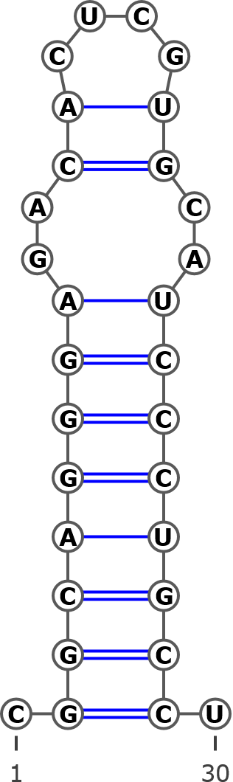
KT308929 Betula insignis subsp. fansipanensis
KT308928 Betula insignis isolate 2
KT308927 Betula insignis isolate 1

Helix 3
CGGCGCGGUSYGYGCCA
.((((((...)))))).
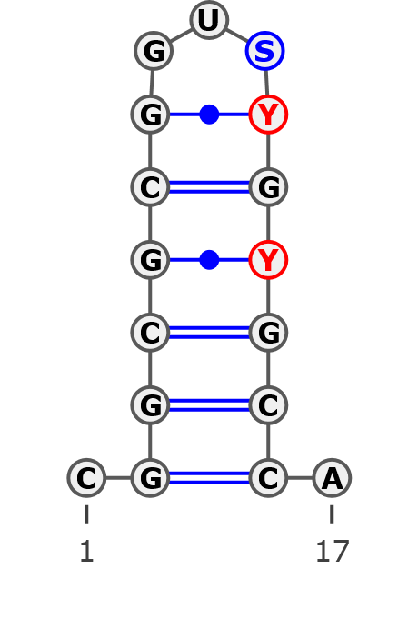
Structurally identical for all analyzed sequences
Helix 4
Variant 1 (A)
AGGAAMUUUAACGAAAGAVUGCCUCYNGCCGYCUCGGAAACGGUGUGCGUGCGGGRGGYGAAUCUUGUCUAGAACCA
.((...((((....((((..((((((.(((((.(((....)))...))).)).))))))...))))...)))).)).
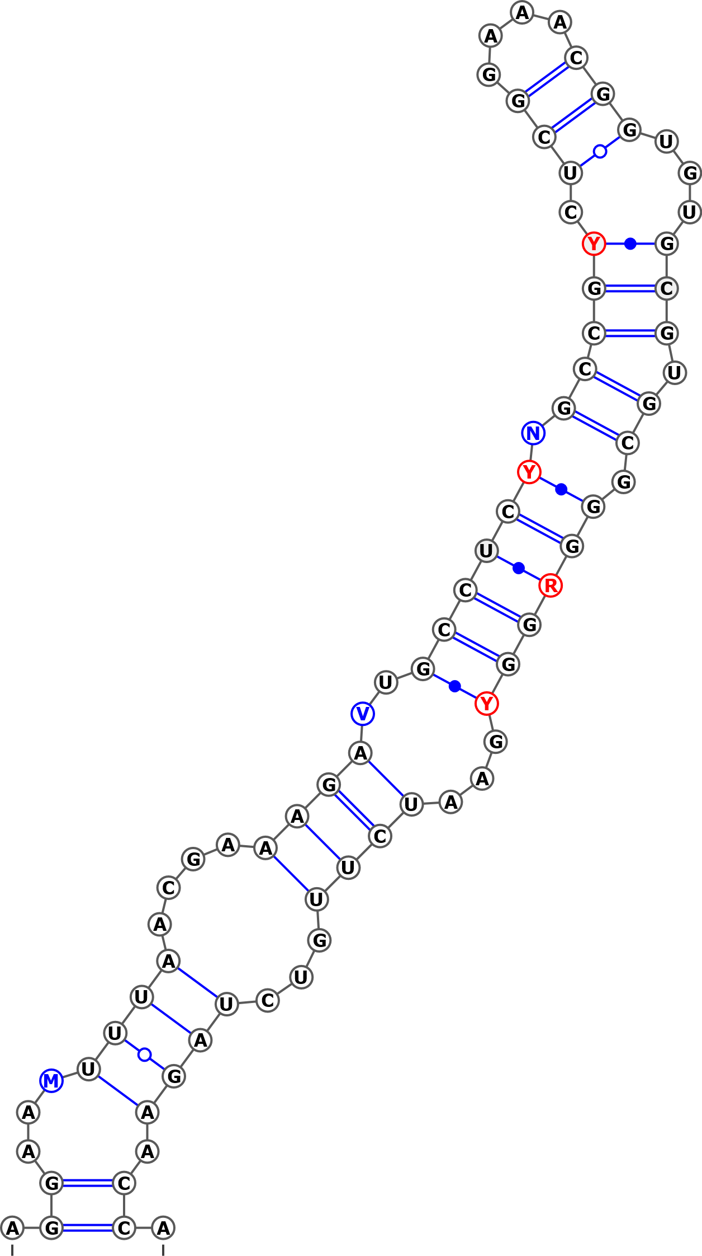
AB243915 Betula apoiensis, haplotype:ap17
AB243914 Betula apoiensis, haplotype:ap14
AB243913 Betula apoiensis, haplotype:ap16
AB243912 Betula apoiensis, haplotype:ap15
AB243898 Betula ovalifolia, haplotype:ov3
AB243897 Betula ovalifolia, haplotype:ov2
AB243895 Betula middendorffii, haplotype:mi
KT309023 Betula ovalifolia isolate 2
KT309022 Betula ovalifolia isolate 1
KT309021 Betula pumila
KT308989 Betula tianschanica
KT308966 Betula raddeana
AY761132 Betula raddeana isolate 3338
AY761131 Betula pumila isolate 3246
KT309019 Betula nana subsp. exilis
AB243894 Betula davurica, haplotype:da2
AB243883 Betula globispica, haplotype:gl
KT308918 Betula chinensis isolate 2
KT308917 Betula chinensis isolate 1
KT308906 Betula fargesii
KT308905 Betula globispica isolate 2
KT308904 Betula globispica isolate 1
AY761120 Betula medwediewii isolate 3465
AY761111 Betula globispica isolate 2942
AY761110 Betula glandulosa isolate 3251
AY761115 Betula lenta isolate 2936
AY352334 Betula uber
AY352330 Betula lenta
AJ006445 Betula pendula
AJ783645 Betula insignis
AJ251683 Betula alba
AM503889.2| Betula pendula
AB243907 Betula apoiensis, haplotype:ap5
AB243899 Betula apoiensis, haplotype:ap4
AB243891 Betula platyphylla, haplotype:pl
AB243889 Betula ermanii, haplotype:er4
AB243885 Betula corylifolia, haplotype:co2
AB243884 Betula corylifolia, haplotype:co1
AB243882 Betula chichibuensis, haplotype:ch2
AB243880 Betula schmidtii, haplotype:sc
KT309028 Betula occidentalis isolate 2
KT309013 Betula papyrifera isolate 3
KT309008 Betula pendula subsp. mandshurica isolate 5
KT309007 Betula pendula subsp. pendula isolate 6
KT309006 Betula pendula subsp. pendula isolate 5
KT309005 Betula pendula subsp. mandshurica isolate 4
KT309004 Betula pendula subsp. szechuanica isolate 3
KT309003 Betula pendula subsp. szechuanica isolate 2
KT309002 Betula pendula subsp. pendula isolate 4
KT309001 Betula pendula subsp. pendula isolate 3
KT309000 Betula pendula subsp. pendula isolate 2
KT308999 Betula pendula subsp. mandshurica isolate 3
KT308998 Betula pendula subsp. pendula isolate 1
KT308997 Betula pendula subsp. szechuanica isolate 1
KT308996 Betula pendula mandshurica isolate 2
KT308993 Betula obscura
KT308992 Betula turkestanica
KT308991 Betula pendula mandshurica isolate 1
KT308990 Betula pendula
KT308978 Betula michauxii
KT308968 Betula browicziana
KT308958 Betula costata
KT308957 Betula ermanii isolate 2
KT308956 Betula ermanii isolate 1
KT308944 Betula luminifera isolate 3
KT308943 Betula luminifera isolate 2
KT308942 Betula hainanensis
KT308941 Betula cylindrostachya
KT308940 Betula alnoides
KT308938 Betula lenta f. uber isolate 2
KT308937 Betula lenta f. uber isolate 1
KT308933 Betula megrelica isolate 2
KT308932 Betula megrelica isolate 1
KT308931 Betula medwediewii isolate 2
KT308930 Betula medwediewii isolate 1
KT308926 Betula murrayana
KT308925 Betula alleghaniensis
KT308920 Betula schmidtii isolate 2
KT308919 Betula schmidtii isolate 1
KT308916 Betula chichibuensis isolate 2
KT308915 Betula chichibuensis isolate 1
KT308914 Betula calcicola
KT308913 Betula delavayi isolate 1
KT308912 Betula bomiensis isolate 2
KT308911 Betula bomiensis isolate 1
KT308910 Betula potaninii isolate 2
KT308909 Betula potaninii isolate 1
KT308908 Betula corylifolia isolate 2
KT308907 Betula corylifolia isolate 1
JN247411 Betula pendula voucher MCA 221
FJ011779 Betula schmidtii voucher Lee s.n.
FJ011778 Betula platyphylla voucher Lee s.n.
FJ011777 Betula pendula voucher CS03022
AY763113 Betula luminifera isolate 2841
AY761133 Betula schmidtii isolate 2875
AY761128 Betula platyphylla isolate 2934
AY761127 Betula pendula isolate 2902
AY761125 Betula occidentalis isolate 2883
AY761122 Betula nana isolate 3337
AY761121 Betula michauxii isolate 3406
AY761117 Betula luminifera isolate 3299
AY761116 Betula luminifera isolate 2828
AY761114 Betula humilis isolate 2894
AY761107 Betula delavayi isolate 3462
AY761104 Betula chichibuensis isolate 2977
AY761101 Betula alnoides isolate 3352
AY761100 Betula alleghaniensis isolate 2880
AY352336 Betula nana
AY352332 Betula pendula
DQ397523 Betula occidentalis
AY763114 Betula alnoides isolate 3464
AF432067 Betula papyrifera
AJ783644 Betula populifolia
AJ783643 Betula humilis
AJ783642 Betula pumila
AJ783641 Betula alnoides
AB243911 Betula apoiensis, haplotype:ap12
AB243910 Betula apoiensis, haplotype:ap10
AB243909 Betula apoiensis, haplotype:ap11
AB243908 Betula apoiensis, haplotype:ap13
AB243906 Betula apoiensis, haplotype:ap9
AB243905 Betula apoiensis, haplotype:ap8
AB243904 Betula apoiensis, haplotype:ap7
AB243903 Betula apoiensis, haplotype:ap6
AB243902 Betula apoiensis, haplotype:ap3
AB243901 Betula apoiensis, haplotype:ap2
AB243900 Betula apoiensis, haplotype:ap1
AB243893 Betula davurica, haplotype:da1
AB243892 Betula grossa, haplotype:gr
AB243890 Betula maximovicziana, haplotype:ma
AB243888 Betula ermanii, haplotype:er3
AB243887 Betula ermanii, haplotype:er2
AB243886 Betula ermanii, haplotype:er1
KT309027 Betula occidentalis isolate 1
KT309026 Betula humilis isolate 3
KT309025 Betula humilis isolate 2
KT309024 Betula humilis isolate 1
KT309020 Betula nana isolate 2
KT309018 Betula nana isolate 1
KT309017 Betula glandulosa isolate 2
KT309016 Betula cordifolia isolate 2
KT309015 Betula cordifolia isolate 1
KT309014 Betula papyrifera var. commutata
KT309012 Betula papyrifera isolate 2
KT309011 Betula papyrifera isolate 1
KT309010 Betula populifolia isolate 3
KT309009 Betula populifolia isolate 2
KT308995 Betula glandulosa isolate 1
KT308994 Betula populifolia isolate 1
KT308988 Betula × caerulea isolate 2
KT308987 Betula × caerulea isolate 1
KT308986 Betula middendorffii
KT308985 Betula minor
KT308984 Betula microphylla
KT308983 Betula pubescens var. litwinowii isolate 2
KT308982 Betula pubescens var. pubescens isolate 4
KT308981 Betula pubescens var. pubescens isolate 3
KT308980 Betula pubescens var. pumila isolate 3
KT308979 Betula × utahensis
KT308977 Betula pubescens subsp. celtiberica isolate 2
KT308976 Betula pubescens var. pumila isolate 2
KT308975 Betula pubescens var. fragrans isolate 2
KT308974 Betula pubescens var. fragrans isolate 1
KT308973 Betula pubescens var. pumila isolate 1
KT308972 Betula pubescens subsp. celtiberica isolate 1
KT308971 Betula pubescens var. litwinowii isolate 1
KT308970 Betula pubescens var. pubescens isolate 2
KT308969 Betula pubescens var. pubescens isolate 1
KT308967 Betula halophila
KT308963 Betula dahurica isolate 2
KT308962 Betula dahurica isolate 1
KT308961 Betula ashburneri isolate 3
KT308960 Betula lanata isolate 2
KT308959 Betula lanata isolate 1
KT308955 Betula utilis var. prattii
KT308954 Betula albosinensis isolate 2
KT308953 Betula ashburneri isolate 2
KT308952 Betula ashburneri isolate 1
KT308951 Betula utilis var. jacquemontii
KT308950 Betula utilis var. occidentalis isolate 2
KT308949 Betula utilis isolate 2
KT308948 Betula utilis isolate 1
KT308947 Betula albosinensis var. septentrionalis
KT308946 Betula maximovicziana isolate 2
KT308945 Betula maximovicziana isolate 1
KT308936 Betula lenta
KT308935 Betula grossa isolate 2
KT308934 Betula grossa isolate 1
KT308924 Betula albosinensis isolate 1
KT308923 Betula utilis var. occidentalis isolate 1
FJ011780 Betula utilis voucher MacAtrher-Tibet Expedition 452
FJ011773 Betula davurica voucher Tibet218
FJ011772 Betula davurica voucher UNA63303V
FJ011771 Betula davurica voucher UNA64631H
FJ011770 Betula davurica voucher Lee s.n.
AY761134 Betula utilis isolate 2893
AY761130 Betula pubescens isolate 2895
AY761129 Betula populifolia isolate 2890
AY761126 Betula papyrifera isolate 2892
AY761119 Betula maximovicziana isolate 3459
AY761118 Betula maximovicziana isolate 2932
AY761113 Betula grossa isolate 3459
AY761112 Betula grossa isolate 2948
AY761109 Betula fruticosa isolate 3339
AY761108 Betula ermanii isolate 2961
AY761106 Betula corylifolia isolate 3457
AY761105 Betula chinensis isolate 2903
AY761102 Betula apoiensis isolate 3249
AY761099 Betula albosinensis isolate 3018
AY352337 Betula costata
AY352335 Betula davurica
AY352333 Betula populifolia
KT308929 Betula insignis subsp. fansipanensis
KT308928 Betula insignis isolate 2
AY761103 Betula calcicola isolate 3460
MH231211 Betula atrata
MH014808 Betula borysthenica (KW0061415, holotype)
MH238480 Betula klokovii (KW006422, holotype)
MH231207 Betula kotulae (KW006426, holotype)
MH178103 Betula kotulae (KW008349)
MH178104 Betula kotulae (KW06427)
MH178105 Betula kotulae (KW128013)
MH178106 Betula kotulae (KW128014)
MH178107 Betula kotulae (KW128016)
MH178108 Betula kotulae (KW128018)
MH231208 Betula kotulae (KW128019)
MH231209 Betula kotulae (KW128020)
MH178109 Betula kotulae (KW128022)
MH231210 Betula kotulae (KW128023)
MH238474 Betula kotulae
MH238475 Betula kotulae (LW032758)
MH231213 Betula kotulae (LW006898)
MH238478 Betula kotulae (LWS27022)
MH238477 Betula kotulae (LWS27026)
MH231214 Betula kotulae
MH238476 Betula oycowiensis (LWKS031322)
MH014809 Betula pubescens ssp. Carpatica
MH231206 Betula pubescens var. sibakademica (LE01041130, type)
MH238471 Betula pubescens var. sibakademica (KW128012)
MH178102 Betula pubescens var. sibakademica (KW128024)
MH238472 Betula pubescens var. sibakademica
MH238473 Betula pubescens var. sibakademica
MH231212 Betula pubescens var. sibakademica (LWKS031322)

Structural variant 2 (B)
AGGAACUUUAACGAAAGAGUGCCUCCGGCCGCCUCGGAAACGGUGUGCGUGCAGGAAAACAAUCUUGUCUAGAACCA
.((...((((....((((.((..(((.(((((.(((....)))...))).)).)))...)).))))...)))).)).
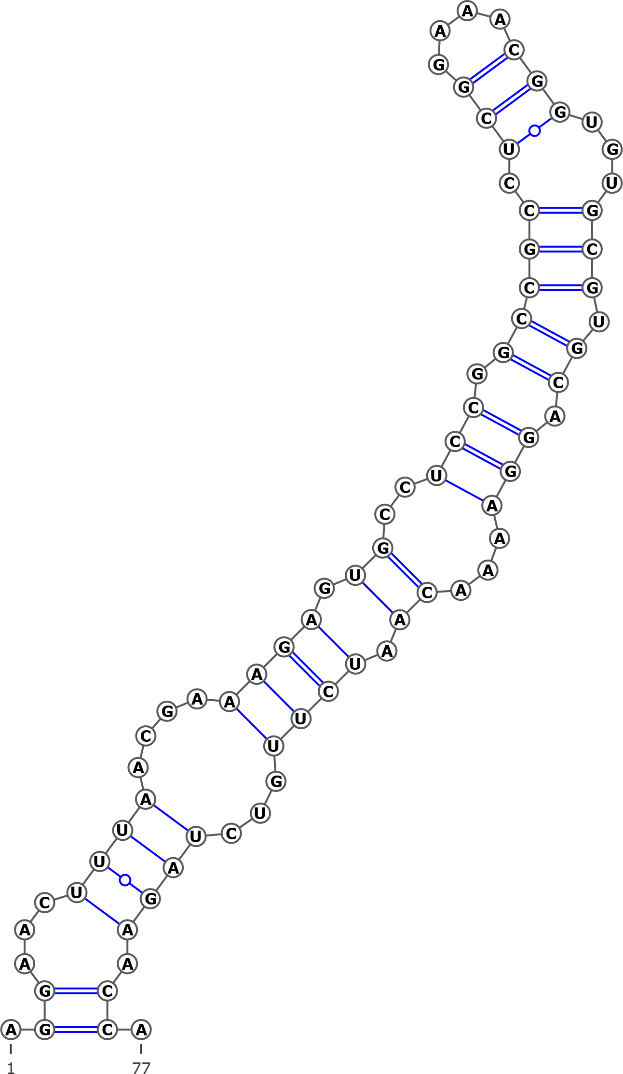
AJ783646 Betula nigra
KT308965 Betula nigra
KT308964 Betula nigra isolate 1
AY761124 Betula nigra isolate 2927
AY352331 Betula nigra
AJ783646 Betula nigra
Structural variant 3 (C)
AGGAAAUUUAACGAAAGAGUGCCUCYGGCCGCCUCGGAAACGGUGUGCGUGCGGGAGGUGAAUCUUGUCUAGAACCA
.((...((((....((((..(((((..(((((.(((....)))...))).))..)))))...))))...)))).)).
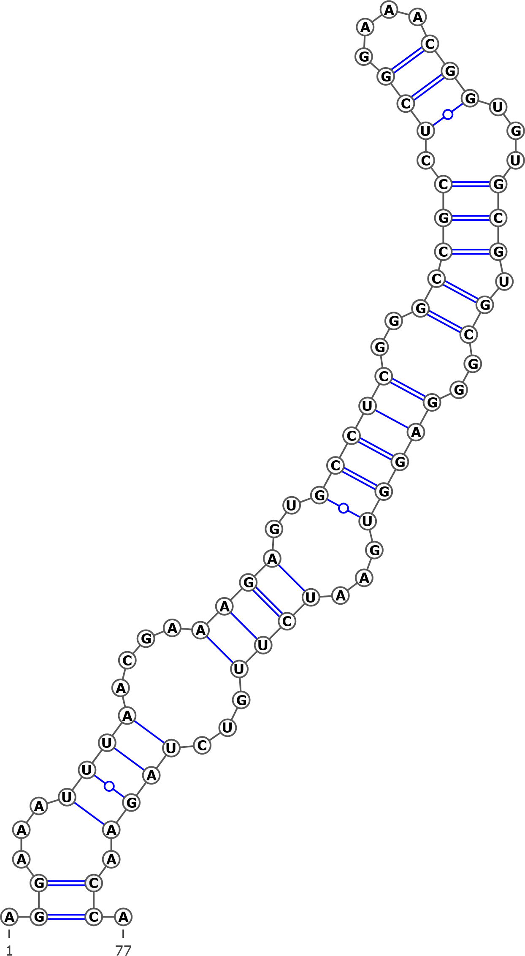
KT308921 Betula delavayi isolate 2
AY761103 Betula calcicola isolate 3460

Structural variant 4 (D)
AGGAACUUUAACGAAAGAGUGCCUCCGGCCGCCUCGGAAACGGUGUGCGUGCGGUAGGUGAAUCUUGUCUAGAACCA
.((...((((....((((..((((.(.(((((.(((....)))...))).)).).))))...))))...)))).)).
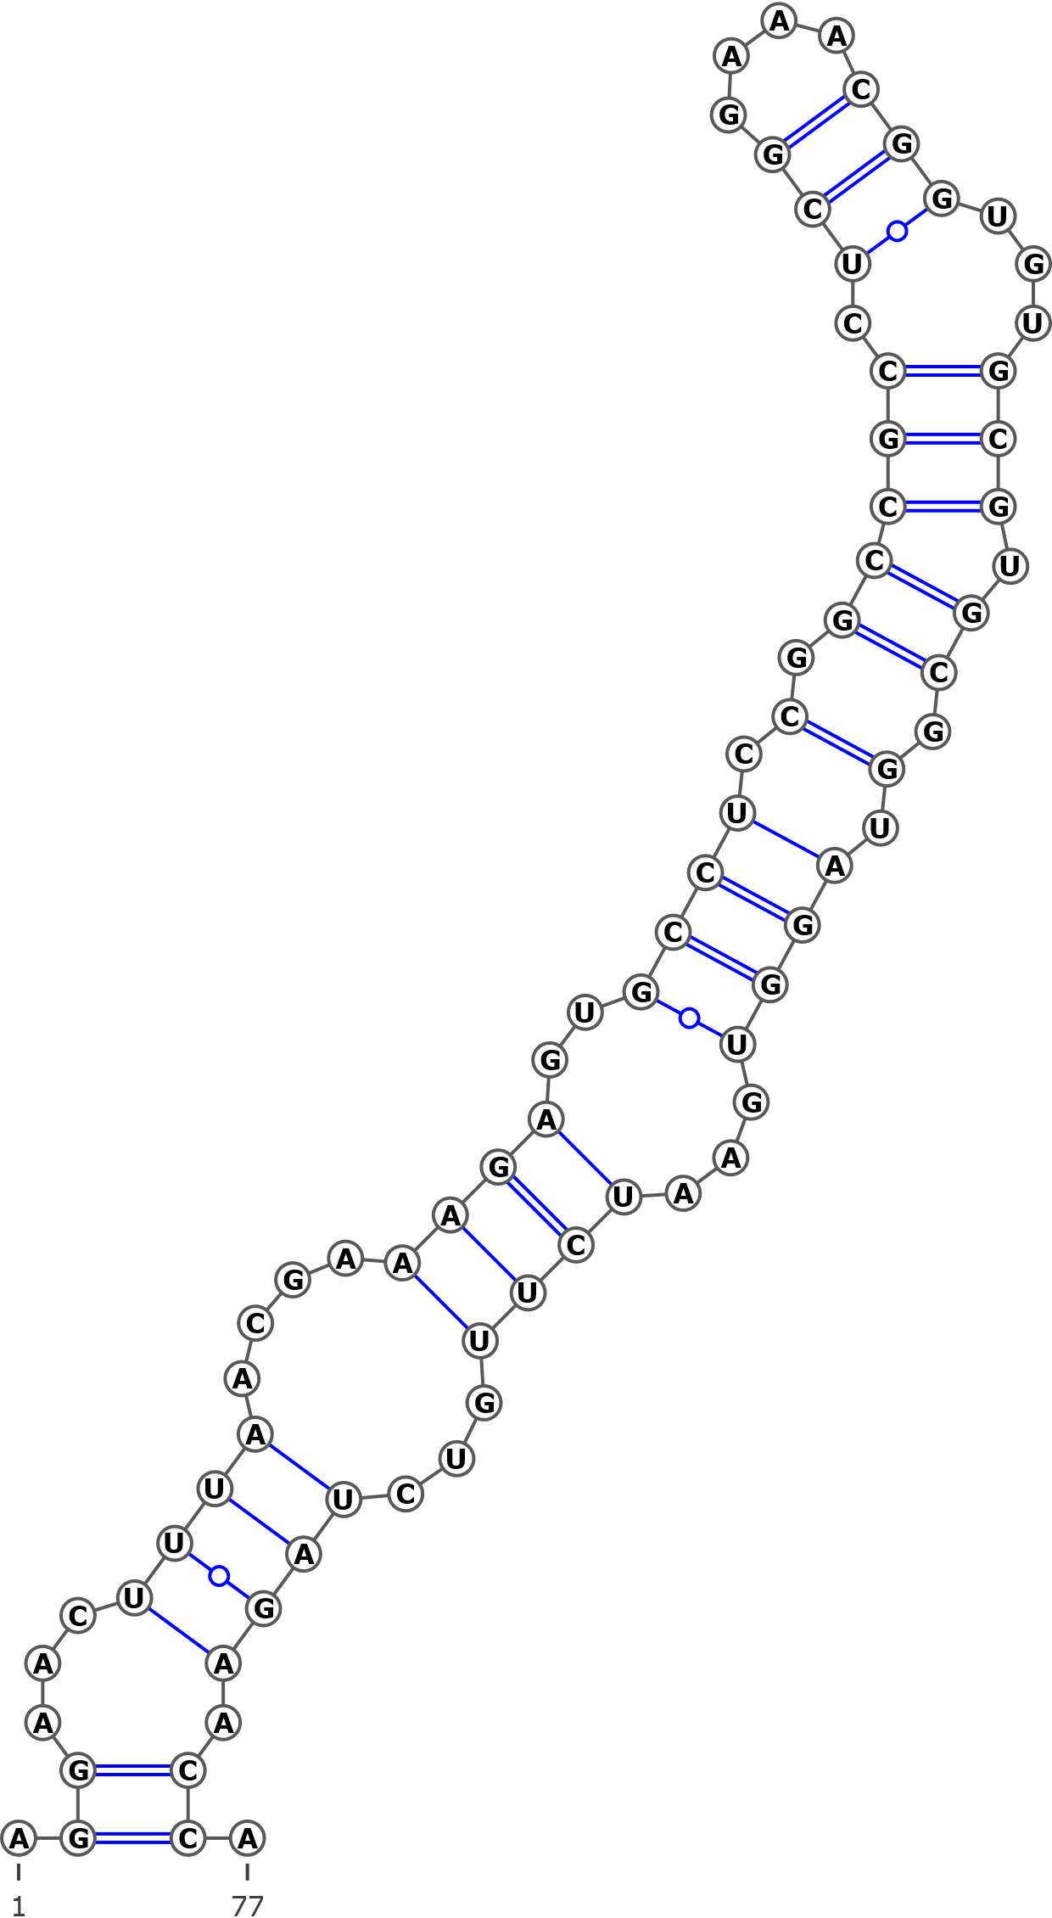
AB243881 Betula chichibuensis, haplotype:ch1

