Data S5. Distribution of different structure variants in ITS2.
Helix1
Structural variant 1 (A)
GUUGCCCCCAACCCCAUCUCCUUGHAAAGGGAYGARGGGGCYUGYGGGGCAGA
.(((((((((.((((.(((((((....))))).)).))))..)).))))))).
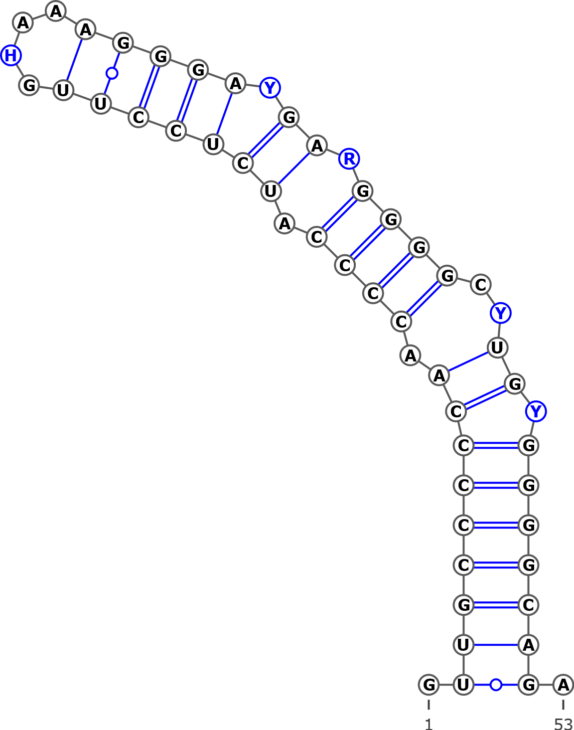
AJ006445 Betula pendula
AJ783644 Betula populifolia
AJ783643 Betula humilis
AJ783642 Betula pumila
AJ783641 Betula alnoides
AJ251683 Betula alba
AM503889.2| Betula pendula
AB243915 Betula apoiensis, haplotype:ap17
AB243914 Betula apoiensis, haplotype:ap14
AB243912 Betula apoiensis, haplotype:ap15
AB243911 Betula apoiensis, haplotype:ap12
AB243910 Betula apoiensis, haplotype:ap10
AB243909 Betula apoiensis, haplotype:ap11
AB243908 Betula apoiensis, haplotype:ap13
AB243907 Betula apoiensis, haplotype:ap5
AB243906 Betula apoiensis, haplotype:ap9
AB243905 Betula apoiensis, haplotype:ap8
AB243904 Betula apoiensis, haplotype:ap7
AB243903 Betula apoiensis, haplotype:ap6
AB243902 Betula apoiensis, haplotype:ap3
AB243901 Betula apoiensis, haplotype:ap2
AB243899 Betula apoiensis, haplotype:ap4
AB243898 Betula ovalifolia, haplotype:ov3
AB243897 Betula ovalifolia, haplotype:ov2
AB243896 Betula ovalifolia, haplotype:ov1
AB243895 Betula middendorffii, haplotype:mi
AB243892 Betula grossa, haplotype:gr
AB243891 Betula platyphylla, haplotype:pl
AB243890 Betula maximovicziana, haplotype:ma
AB243889 Betula ermanii, haplotype:er4
AB243888 Betula ermanii, haplotype:er3
AB243887 Betula ermanii, haplotype:er2
AB243886 Betula ermanii, haplotype:er1
AB243882 Betula chichibuensis, haplotype:ch2
AB243881 Betula chichibuensis, haplotype:ch1
AB243880 Betula schmidtii genes, haplotype:sc
KT960303 Betula nana voucher ZA2012-3214
KT960259 Betula nana voucher ZA2012-3461
KT960160 Betula nana voucher ZA2012-2518
JN998979 Betula pumila voucher 09PROBE-05905
JN998978 Betula glandulosa voucher BIOUG<CAN>:09PROBE-05527
JN998977 Betula glandulosa voucher BIOUG<CAN>:09PROBE-05118
JN998976 Betula glandulosa voucher BIOUG<CAN>:09PROBE-05010
JN998975 Betula glandulosa voucher 09PROBE-05279
KT309028 Betula occidentalis isolate 2
KT309027 Betula occidentalis isolate 1
KT309026 Betula humilis isolate 3
KT309025 Betula humilis isolate 2
KT309024 Betula humilis isolate 1
KT309023 Betula ovalifolia isolate 2
KT309022 Betula ovalifolia isolate 1
KT309021 Betula pumila
KT309020 Betula nana isolate 2
KT309019 Betula nana subsp. exilis
KT309018 Betula nana isolate 1
KT309017 Betula glandulosa isolate 2
KT309016 Betula cordifolia isolate 2
KT309015 Betula cordifolia isolate 1
KT309014 Betula papyrifera var. commutata
KT309013 Betula papyrifera isolate 3
KT309012 Betula papyrifera isolate 2
KT309011 Betula papyrifera isolate 1
KT309010 Betula populifolia isolate 3
KT309009 Betula populifolia isolate 2
KT309008 Betula pendula subsp. mandshurica isolate 5
KT309007 Betula pendula subsp. pendula isolate 6
KT309006 Betula pendula subsp. pendula isolate 5
KT309005 Betula pendula subsp. mandshurica isolate 4
KT309004 Betula pendula subsp. szechuanica isolate 3
KT309003 Betula pendula subsp. szechuanica isolate 2
KT309002 Betula pendula subsp. pendula isolate 4
KT309001 Betula pendula subsp. pendula isolate 3
KT309000 Betula pendula subsp. pendula isolate 2
KT308999 Betula pendula subsp. mandshurica isolate 3
KT308998 Betula pendula subsp. pendula isolate 1
KT308997 Betula pendula subsp. szechuanica isolate 1
KT308996 Betula pendula subsp. mandshurica isolate 2
KT308995 Betula glandulosa isolate 1
KT308994 Betula populifolia isolate 1
KT308993 Betula obscura
KT308992 Betula turkestanica
KT308991 Betula pendula subsp. mandshurica isolate 1
KT308990 Betula pendula
KT308989 Betula tianschanica
KT308988 Betula × caerulea isolate 2
KT308987 Betula × caerulea isolate 1
KT308986 Betula middendorffii
KT308985 Betula minor
KT308984 Betula microphylla
KT308983 Betula pubescens var. litiwinowii isolate 2
KT308982 Betula pubescens var. pubescens isolate 4
KT308981 Betula pubescens var. pubescens isolate 3
KT308980 Betula pubescens var. pumila isolate 3
KT308979 Betula × utahensis
KT308978 Betula michauxii
KT308977 Betula pubescens subsp. celtiberica isolate 2
KT308976 Betula pubescens var. pumila isolate 2
KT308975 Betula pubescens var. fragans isolate 2
KT308974 Betula pubescens var. fragans isolate 1
KT308973 Betula pubescens var. pumila isolate 1
KT308972 Betula pubescens subsp. celtiberica isolate 1
KT308971 Betula pubescens var. litiwinowii isolate 1
KT308970 Betula pubescens var. pubescens isolate 2
KT308969 Betula pubescens var. pubescens isolate 1
KT308968 Betula browicziana
KT308967 Betula halophila
KT308966 Betula raddeana
KT308960 Betula lanata isolate 2
KT308959 Betula lanata isolate 1
KT308957 Betula ermanii isolate 2
KT308956 Betula ermanii isolate 1
KT308955 Betula utilis var. prattii
KT308954 Betula albosinensis isolate 2
KT308947 Betula albosinensis var. septentrionalis
KT308946 Betula maximovicziana isolate 2
KT308945 Betula maximovicziana isolate 1
KT308938 Betula lenta f. uber isolate 2
KT308937 Betula lenta f. uber isolate 1
KT308936 Betula lenta
KT308935 Betula grossa isolate 2
KT308934 Betula grossa isolate 1
KT308933 Betula megrelica isolate 2
KT308932 Betula megrelica isolate 1
KT308931 Betula medwediewii isolate 2
KT308930 Betula medwediewii isolate 1
KT308929 Betula insignis subsp. fansipanensis
KT308928 Betula insignis isolate 2
KT308927 Betula insignis isolate 1
KT308926 Betula murrayana
KT308925 Betula alleghaniensis
KT308924 Betula albosinensis isolate 1
KT308923 Betula utilis var. occidentalis
KT308921 Betula delavayi isolate 2
KT308920 Betula schmidtii isolate 2
KT308919 Betula schmidtii isolate 1
KT308916 Betula chichibuensis isolate 2
KT308915 Betula chichibuensis isolate 1
KT308914 Betula calcicola
KT308913 Betula delavayi isolate 1
KT308910 Betula potaninii isolate 2
KT308909 Betula potaninii isolate 1
KT308905 Betula globispica isolate 2
JN247411 Betula pendula voucher MCA 221
FJ011779 Betula schmidtii voucher Lee s.n.
FJ011778 Betula platyphylla voucher Lee s.n.
FJ011777 Betula pendula voucher CS03022 18S
FJ011776 Betula papyrifera voucher CS78048
FJ011775 Betula lenta voucher CS89165
FJ011774 Betula glandulosa voucher CS78027
AY761133 Betula schmidtii isolate 2875
AY761132 Betula raddeana isolate 3338
AY761131 Betula pumila isolate 3246
AY761130 Betula pubescens isolate 2895
AY761129 Betula populifolia isolate 2890
AY761128 Betula platyphylla isolate 2934
AY761127 Betula pendula isolate 2902
AY761126 Betula papyrifera isolate 2902
AY761125 Betula occidentalis isolate 2883
AY761123 Betula neoalaskana isolate 3466
AY761122 Betula nana isolate 3337
AY761121 Betula michauxii isolate 3406
AY761120 Betula medwediewii isolate 3465
AY761119 Betula maximovicziana isolate 3463
AY761118 Betula maximovicziana isolate 2932
AY761115 Betula lenta isolate 2936
AY761114 Betula humilis isolate 2894
AY761113 Betula grossa isolate 3459
AY761112 Betula grossa isolate 2948
AY761109 Betula fruticosa isolate 3339
AY761108 Betula ermanii isolate 2961
AY761107 Betula delavayi isolate 3462
AY761104 Betula chichibuensis isolate 2977
AY761103 Betula calcicola isolate 3460
AY761102 Betula apoiensis isolate 3249
AY761100 Betula alleghaniensis isolate 2880
AY352337 Betula costata
AY352336 Betula nana
AY352332 Betula pendula
AY352330 Betula lenta
AF432067 Betula papyrifera
DQ397523 Betula occidentalis
LC382209.1 Betula platyphylla var. japonica
LC382208.1 Betula platyphylla var. japonica
LC382207.1 Betula ermanii
LC382206.1 Betula ermanii
LC382205.1 Betula ovalifolia
LC382204.1 Betula ovalifolia
LC382025.1 Betula ovalifolia × Betula ermanii clone: C2
LC382024.1 Betula ovalifolia × Betula ermanii clone: C1
MG237810.1 Betula minor
MG237745.1 Betula populifolia voucher MT00179824
MG237590.1 Betula occidentalis voucher CCDB-18325-E2
MG237484.1 Betula neoalaskana voucher CCDB-18325-H2
MG237429.1 Betula nana voucher CCDB-18325-F1
MG237283.1 Betula occidentalis voucher CCDB-18325-F2
MG237175.1 Betula lenta voucher CCDB-18297-B07
MG236939.1 Betula papyrifera voucher CCDB-18325-B2
MG236820.1 Betula kenaica voucher CCDB-18325-D1 5.8S
MG236767.1 Betula glandulosa voucher CCDB-18325-B1
MG236556.1 Betula occidentalis voucher CCDB-18325-D2
MG236141.1 Betula neoalaskana voucher CCDB-18325-G2
MG235907.1 Betula nana voucher CCDB-18325-E1
MG235784.1 Betula alleghaniensis voucher CCDB-18325-G1
MG235525.1 Betula cordifolia voucher CCDB-18297-A07
MG235191.1 Betula neoalaskana voucher CCDB-18325-A1
MG234781.1 Betula michauxii voucher CCDB-18297-D07
MG234627.1 Betula kenaica voucher CCDB-18325-C1
MG234564.1 Betula lenta voucher CCDB-18297-C07
MH042914 Betula atrata
MH014808 Betula borysthenica (KW0061415, holotype)
MH014819 Betula klokovii (KW006422, holotype)
MH014809 Betula pubescens ssp. carpatica
MH042917 Betula kotulae (KW006426, holotype)
MH178103 Betula kotulae (KW008349)
MH042912 Betula kotulae (KW008349)
MH178104 Betula kotulae (KW06427)
MH178105 Betula kotulae (KW128013)
MH042913 Betula kotulae (KW128013)
MH178106 Betula kotulae (KW128014)
MH178107 Betula kotulae (KW128016)
MH178108 Betula kotulae (KW128018)
MH178109 Betula kotulae (KW128022)
MH300135 Betula kotulae (KW128023)
MH042916 Betula kotulae (LW006898)
MH042918 Betula kotulae (live)
MH178101 Betula pubescens var. sibakademica (LE01041130 (R), type)
MH014819 Betula pubescens var. sibakademica (KW128012)
MH178102 Betula pubescens var. sibakademica (KW128024)
MH042911 Betula pubescens var. sibakademica (KW128024)
MH042915 Betula pubescens var. sibakademica (LWKS031322)

Structural variant2 (B)
GUUGCCCCCWACCCCAUCUCCUUKYAAAGGGACGAGGGGGCCHGUGGGGYAGA
.((((((((..((((.(((((((....))))).)).))))...).))))))).
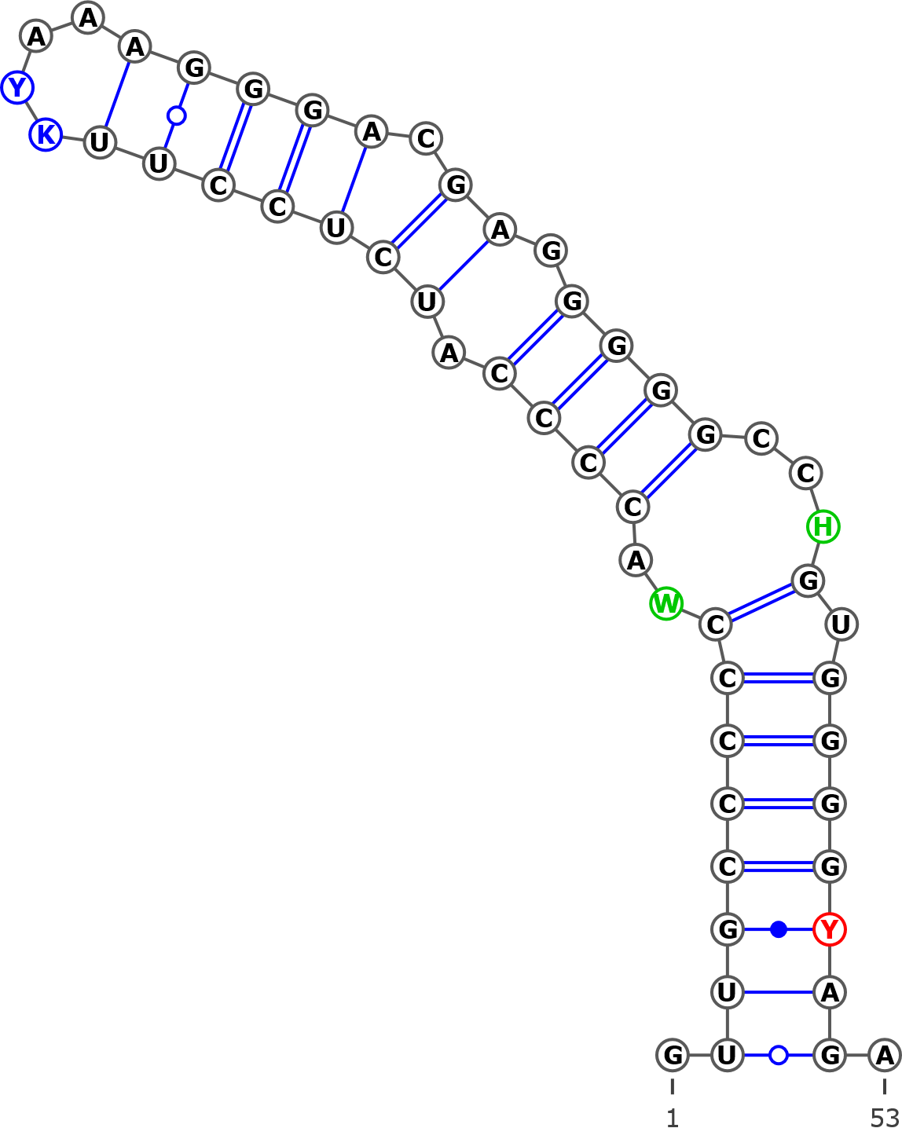
AB243900 Betula apoiensis genes for ITS1, 5.8S rRNA, ITS2, haplotype:ap1
AB243894 Betula davurica, haplotype:da2
AB243893 Betula davurica, haplotype:da1
KT308964 Betula nigra isolate 1
KT308963 Betula dahurica isolate 2
KT308962 Betula dahurica isolate 1
KT308961 Betula ashburneri isolate 3
KT308958 Betula costata
KT308953 Betula ashburneri isolate 2
KT308952 Betula ashburneri isolate 1
KT308951 Betula utilis var. jacquemontii
KT308950 Betula utilis var. occidentalis isolate 2
KT308949 Betula utilis isolate 2
KT308948 Betula utilis isolate 1
KT308944 Betula luminifera isolate 3
KT308943 Betula luminifera isolate 2
KT308940 Betula alnoides
KT308939 Betula luminifera isolate 1
KT308922 Betula delavayi isolate 3
KT308912 Betula bomiensis isolate 2
KT308911 Betula bomiensis isolate 1
FJ011780 Betula utilis voucher MacAtrher-Tibet Expedition 452
FJ011773 Betula davurica voucher Tibet218
FJ011772 Betula davurica voucher UNA63303V
FJ011771 Betula davurica voucher UNA64631H
FJ011770 Betula davurica voucher Lee s.n.
AY763114 Betula alnoides isolate 3464
AY761134 Betula utilis isolate 2893
AY761105 Betula chinensis isolate 2903
AY761101 Betula alnoides isolate 3352
AY761099 Betula albosinensis isolate 3018

Structural variant 3 (C)
GUUGCCCCCAACCCCAUCUCCUUGCAAAGGGACGAGGGGCUUGUGGGGCAGA
.(((((((((..(((.(((((((....))))).)).)))..)).))))))).
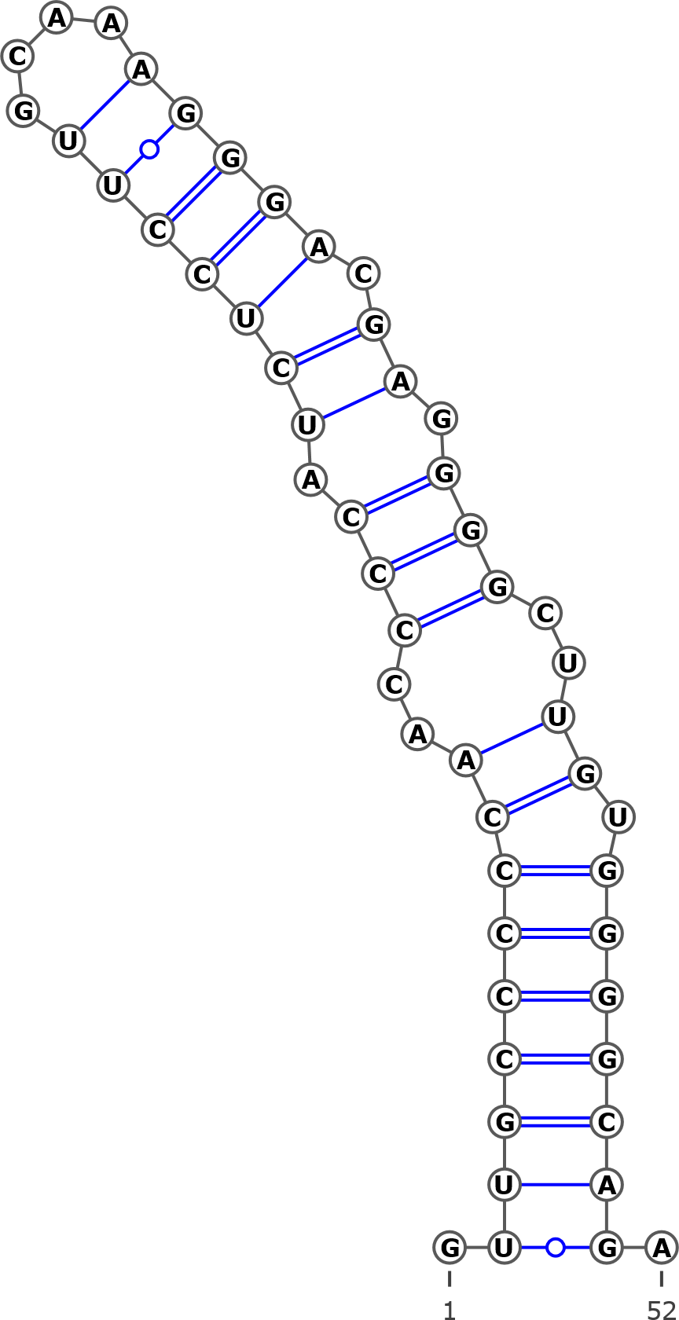
AJ783645 Betula insignis
AB243885 Betula corylifolia
AB243884 Betula corylifolia
AB243883 Betula globispica
KT308918 Betula chinensis isolate 2
KT308917 Betula chinensis isolate 1
KT308908 Betula corylifolia isolate 2
KT308907 Betula corylifolia isolate 1
KT308906 Betula fargesii
KT308904 Betula globispica isolate 1
AY761111 Betula globispica isolate 2942
AY761110 Betula glandulosa isolate 3251
AY761106 Betula corylifolia isolate
Structural variant 4 (D)
GUUGCCCCCAACCCCAUCUCCUUGCAAAGGGACGAGGGGGCCAAUGGGGCAGA
.(((((((...((((.(((((((....))))).)).)))).....))))))).
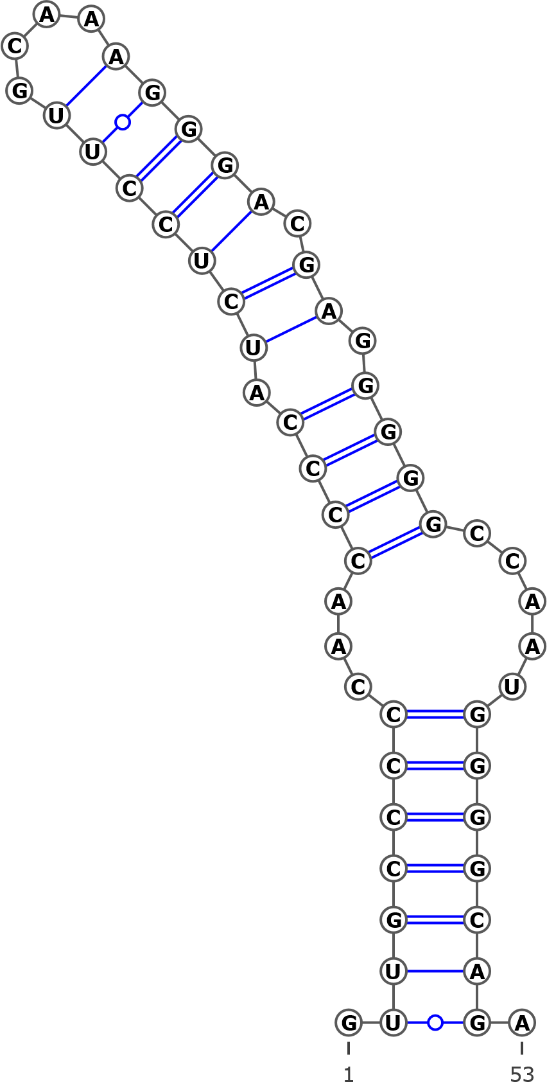
KT308942 Betula hainanensis
KT308941 Betula cylindrostachya
FJ011769 Betula alnoides voucher Wen6405
AY763113 Betula luminifera isolate 2841
AY761117 Betula luminifera isolate 3299
AY761116 Betula luminifera isolate 2828

Structural variant 5 (E)
GUUGCCCCCAACCCCAUCUCCUUGCAAAGGGACGAGAGGGCCAGUGGGGUAGA
.((((((((..(((..(((((((....))))).))..)))...).))))))).
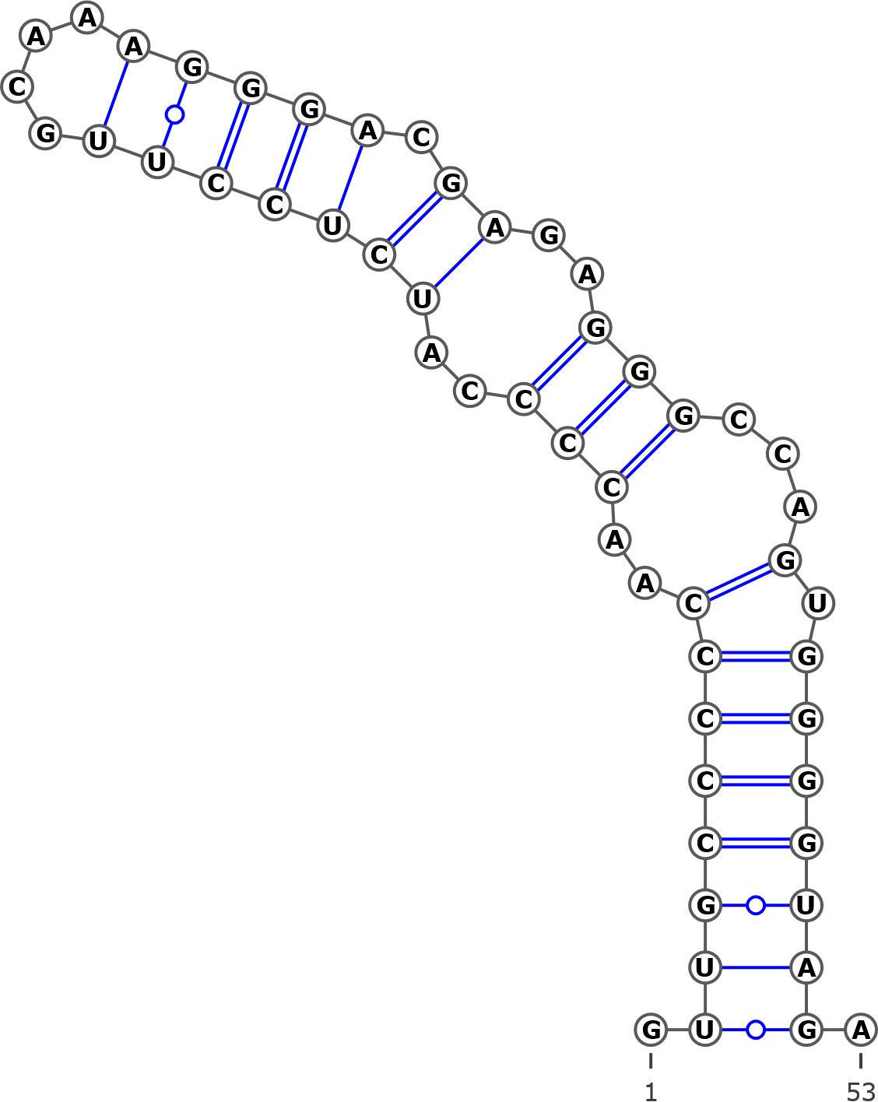
AJ783646 Betula nigra
KT308965 Betula nigra isolate 2
AY761124 Betula nigra isolate 2927
AY352331 Betula nigra
Structural variant 6 (F)
GUUGCCCCCAACCCAUCUCCUUGCAAAGGGACGAGGGGGCCUGUGGGGCAGA
.(((((((((.(((.(((((((....))))).))..)))..)).))))))).
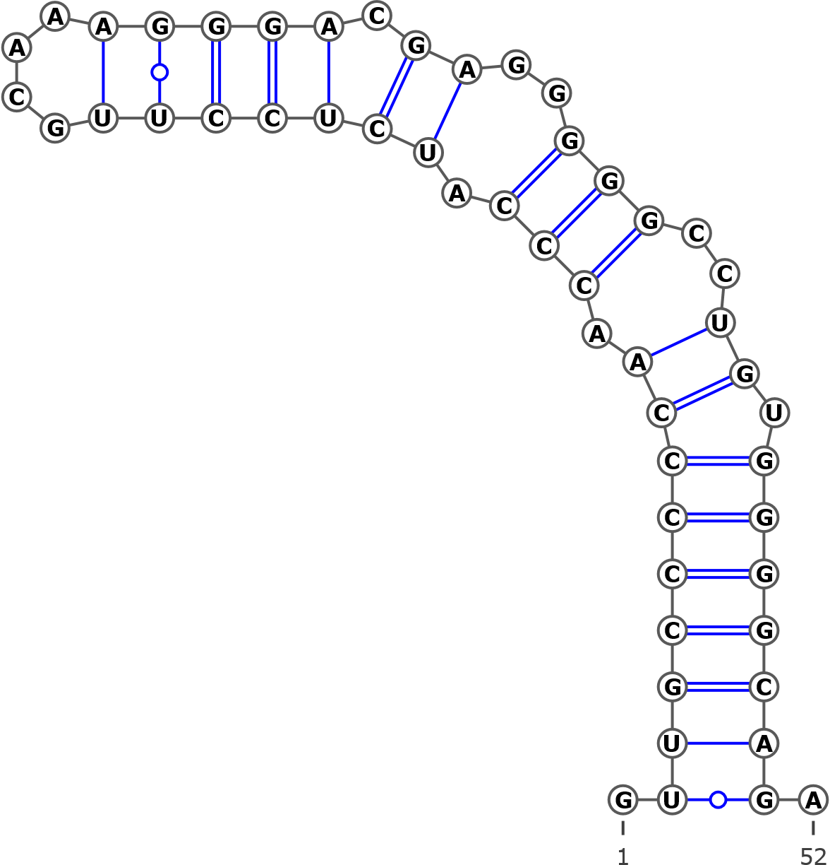
AB243913 Betula apoiensis haplotype:ap16
Helix 2
UGGCCUCCCGUGWGCUYWYGCRUGCGGUUGGYCU
.((((..(((((.((....)).)))))..)))).
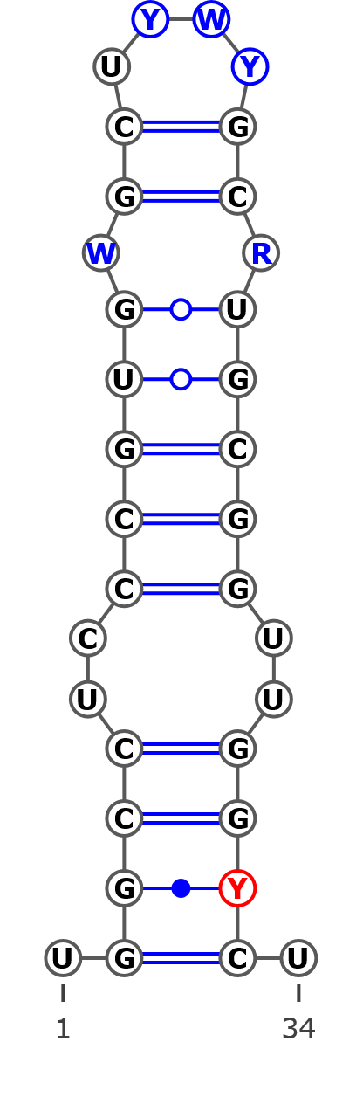
Structurally identical for all analyzed sequences

Helix 3
Structural variant 1 (A)
ARYGAGUYCUCGGCGACGCGYGCCRCGRCAAUCGGUGGUUGWCAAACCYUCGUGUCCCGUCGUGYGUGNCGYGUYGYYCMUYGUG
.((((......((((((((((((((((((...(((.((((....)))).)))......)))))).))).)))))))))..)))).
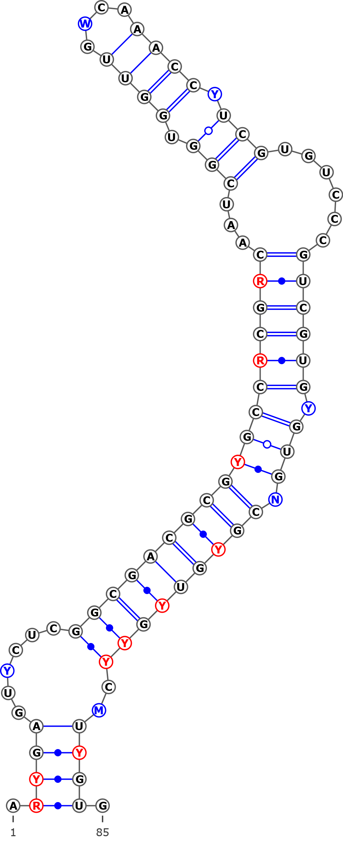
AJ006445 Betula pendula
AJ783645 Betula insignis
AJ783644 Betula populifolia
AJ783643 Betula humilis
AJ783642 Betula pumila
AJ783641 Betula alnoides
AJ251683 Betula alba
AM503889.2 Betula pendula
AB243915 Betula apoiensis, haplotype:ap17
AB243914 Betula apoiensis, haplotype:ap14
AB243913 Betula apoiensis, haplotype:ap16
AB243912 Betula apoiensis, haplotype:ap15
AB243911 Betula apoiensis, haplotype:ap12
AB243910 Betula apoiensis, haplotype:ap10
AB243909 Betula apoiensis, haplotype:ap11
AB243908 Betula apoiensis, haplotype:ap13
AB243907 Betula apoiensis, haplotype:ap5
AB243906 Betula apoiensis, haplotype:ap9
AB243905 Betula apoiensis, haplotype:ap8
AB243904 Betula apoiensis, haplotype:ap7
AB243903 Betula apoiensis, haplotype:ap6
AB243902 Betula apoiensis, haplotype:ap3
AB243901 Betula apoiensis, haplotype:ap2
AB243899 Betula apoiensis, haplotype:ap4
AB243898 Betula ovalifolia, haplotype:ov3
AB243897 Betula ovalifolia, haplotype:ov2
AB243896 Betula ovalifolia, haplotype:ov1
AB243895 Betula middendorffii, haplotype:mi
AB243892 Betula grossa, haplotype:gr
AB243891 Betula platyphylla, haplotype:pl
AB243890 Betula maximovicziana, haplotype:ma
AB243889 Betula ermanii, haplotype:er4
AB243888 Betula ermanii, haplotype:er3
AB243887 Betula ermanii, haplotype:er2
AB243886 Betula ermanii, haplotype:er1
AB243884 Betula corylifolia, haplotype:co1
AB243883 Betula globispica, haplotype:gl
AB243882 Betula chichibuensis, haplotype:ch2
AB243881 Betula chichibuensis, haplotype:ch1
KT960303 Betula nana voucher ZA2012-3214
KT960259 Betula nana voucher ZA2012-3461
KT960160 Betula nana voucher ZA2012-2518
JN998979 Betula pumila voucher 09PROBE-05905
JN998978 Betula glandulosa voucher BIOUG<CAN>:09PROBE-05527
JN998977 Betula glandulosa voucher BIOUG<CAN>:09PROBE-05118
JN998976 Betula glandulosa voucher BIOUG<CAN>:09PROBE-05010
JN998975 Betula glandulosa voucher 09PROBE-05279
KT309028 Betula occidentalis
KT309027 Betula occidentalis
KT309026 Betula humilis
KT309025 Betula humilis
KT309024 Betula humilis
KT309023 Betula ovalifolia
KT309022 Betula ovalifolia
KT309021 Betula pumila
KT309020 Betula nana
KT309019 Betula nana subsp. exilis
KT309018 Betula nana isolate 1
KT309017 Betula glandulosa isolate 2
KT309016 Betula cordifolia isolate 2
KT309015 Betula cordifolia isolate 1
KT309014 Betula papyrifera var. commutata
KT309013 Betula papyrifera isolate 3
KT309012 Betula papyrifera isolate 2
KT309011 Betula papyrifera isolate 1
KT309010 Betula populifolia isolate 3
KT309009 Betula populifolia isolate 2
KT309008 Betula pendula subsp. mandshurica isolate 5
KT309007 Betula pendula subsp. pendula isolate 6
KT309006 Betula pendula subsp. pendula isolate 5
KT309005 Betula pendula subsp. mandshurica isolate 4
KT309004 Betula pendula subsp. szechuanica isolate 3
KT309003 Betula pendula subsp. szechuanica isolate 2
KT309002 Betula pendula subsp. pendula isolate 4
KT309001 Betula pendula subsp. pendula isolate 3
KT309000 Betula pendula subsp. pendula isolate 2
KT308999 Betula pendula subsp. mandshurica isolate 3
KT308998 Betula pendula subsp. pendula isolate 1
KT308997 Betula pendula subsp. szechuanica isolate 1
KT308996 Betula pendula subsp. mandshurica isolate 2
KT308995 Betula glandulosa isolate 1
KT308994 Betula populifolia isolate 1
KT308993 Betula obscura
KT308992 Betula turkestanica
KT308991 Betula pendula subsp. mandshurica isolate 1
KT308990 Betula pendula
KT308989 Betula tianschanica
KT308988 Betula × caerulea isolate 2
KT308987 Betula × caerulea isolate 1
KT308986 Betula middendorffii
KT308985 Betula minor
KT308984 Betula microphylla
KT308983 Betula pubescens var. litiwinowii isolate 2
KT308982 Betula pubescens var. pubescens isolate 4
KT308981 Betula pubescens var. pubescens isolate 3
KT308980 Betula pubescens var. pumila isolate 3
KT308979 Betula × utahensis
KT308977 Betula pubescens subsp. celtiberica isolate 2
KT308976 Betula pubescens var. pumila isolate 2
KT308975 Betula pubescens var. fragrans isolate 2
KT308974 Betula pubescens var. fragrans isolate 1
KT308973 Betula pubescens var. pumila isolate 1
KT308972 Betula pubescens subsp. celtiberica isolate 1
KT308971 Betula pubescens var. litiwinowii isolate 1
KT308970 Betula pubescens var. pubescens isolate 2
KT308969 Betula pubescens var. pubescens isolate 1
KT308968 Betula browicziana
KT308967 Betula halophila
KT308966 Betula raddeana
KT308960 Betula lanata isolate 2
KT308959 Betula lanata isolate 1
KT308957 Betula ermanii isolate 2
KT308956 Betula ermanii isolate 1
KT308955 Betula utilis var. prattii
KT308954 Betula albosinensis isolate 2
KT308947 Betula albosinensis var. septentrionalis
KT308946 Betula maximovicziana isolate 2
KT308945 Betula maximovicziana isolate 1
KT308938 Betula lenta f. uber isolate 2
KT308937 Betula lenta f. uber isolate 1
KT308936 Betula lenta
KT308935 Betula grossa isolate 2
KT308934 Betula grossa isolate 1
KT308933 Betula megrelica isolate 2
KT308932 Betula megrelica isolate 1
KT308931 Betula medwediewii isolate 2
KT308930 Betula medwediewii isolate 1
KT308927 Betula insignis isolate 1
KT308926 Betula murrayana
KT308925 Betula alleghaniensis
KT308924 Betula albosinensis isolate 1
KT308923 Betula utilis var. occidentalis isolate 1
KT308921 Betula delavayi isolate 2
KT308918 Betula chinensis isolate 2
KT308917 Betula chinensis isolate 1
KT308916 Betula chichibuensis isolate 2
KT308915 Betula chichibuensis isolate 1
KT308914 Betula calcicola
KT308913 Betula delavayi isolate 1
KT308910 Betula potaninii isolate 2
KT308909 Betula potaninii isolate 1
KT308908 Betula corylifolia isolate 2
KT308907 Betula corylifolia isolate 1
KT308906 Betula fargesii
KT308905 Betula globispica isolate 2
KT308904 Betula globispica isolate 1
JN247411 Betula pendula voucher MCA 221
FJ011778 Betula platyphylla voucher Lee s.n.
FJ011777 Betula pendula voucher CS03022
FJ011776 Betula papyrifera voucher CS78048
FJ011775 Betula lenta voucher CS78048
FJ011774 Betula glandulosa voucher CS78027
AY761133 Betula schmidtii isolate 2875
AY761132 Betula raddeana isolate 3338
AY761131 Betula pumila isolate 3246
AY761126 Betula papyrifera isolate 2892
AY761125 Betula occidentalis isolate 2883
AY761123 Betula neoalaskana isolate 3466
AY761122 Betula nana isolate 3337
AY761120 Betula medwediewii isolate 3465
AY761118 Betula maximovicziana isolate 2932
AY761115 Betula lenta isolate 2936
AY761113 Betula grossa isolate 3459
AY761112 Betula grossa isolate 2948
AY761111 Betula globispica isolate 2942
AY761110 Betula glandulosa isolate 3251
AY761109 Betula fruticosa isolate 3339
AY761108 Betula ermanii isolate 2961
AY761107 Betula delavayi isolate 3462
AY761106 Betula corylifolia isolate 3457
AY761104 Betula chichibuensis isolate 2977
AY761102 Betula apoiensis isolate 3249
AY761100 Betula alleghaniensis isolate 2880
AY352337 Betula costata
AY352336 Betula nana
AY352332 Betula pendula
AY352331 Betula nigra
AY352330 Betula lenta
DQ397523 Betula occidentalis
AJ783646 Betula nigra
AB243900 Betula apoiensis, haplotype:ap1
AB243894 Betula davurica, haplotype:da2
AB243893 Betula davurica, haplotype:da1
KT308965 Betula nigra isolate 2
KT308964 Betula nigra isolate 1
KT308963 Betula dahurica isolate 2
KT308962 Betula dahurica isolate 1
KT308961 Betula ashburneri isolate 3
KT308958 Betula costata
KT308953 Betula ashburneri isolate 2
KT308952 Betula ashburneri isolate 1
KT308951 Betula utilis var. jacquemontii
KT308950 Betula utilis var. occidentalis
KT308949 Betula utilis isolate 2
KT308948 Betula utilis isolate 1
KT308944 Betula luminifera isolate 3
KT308943 Betula luminifera isolate 2
KT308940 Betula alnoides
KT308939 Betula luminifera isolate 1
KT308922 Betula delavayi isolate 3
KT308912 Betula bomiensis isolate 2
KT308911 Betula bomiensis isolate 1
FJ011780 Betula utilis voucher MacAtrher-Tibet Expedition 452
FJ011773 Betula davurica voucher Tibet218
FJ011772 Betula davurica voucher UNA63303V
FJ011771 Betula davurica voucher UNA64631H
AY763114 Betula alnoides isolate 3464
AY761124 Betula nigra isolate 2927
AY761105 Betula chinensis isolate 2903
AY761101 Betula alnoides isolate 3352
KT308942 Betula hainanensis
KT308941 Betula cylindrostachya
FJ011769 Betula alnoides voucher Wen6405
AY763113 Betula luminifera isolate 2841
AY761117 Betula luminifera isolate 3299
AY761116 Betula luminifera isolate 2828
MG237810.1 Betula minor
MG237745.1 Betula populifolia voucher MT00179824
MG237590.1 Betula occidentalis voucher CCDB-18325-E2
MG237484.1 Betula neoalaskana voucher CCDB-18325-H2
MG237429.1 Betula nana voucher CCDB-18325-F1
MG237283.1 Betula occidentalis voucher CCDB-18325-F2
MG237175.1 Betula lenta voucher CCDB-18297-B07
MG236820.1 Betula kenaica voucher CCDB-18325-D1 5.8S
MG236767.1 Betula glandulosa voucher CCDB-18325-B1
MG236556.1 Betula occidentalis voucher CCDB-18325-D2
MG236141.1 Betula neoalaskana voucher CCDB-18325-G2
MG235907.1 Betula nana voucher CCDB-18325-E1
MG235784.1 Betula alleghaniensis voucher CCDB-18325-G1
MG235525.1 Betula cordifolia voucher CCDB-18297-A07
MG235191.1 Betula neoalaskana voucher CCDB-18325-A1
MG234781.1 Betula michauxii voucher CCDB-18297-D07
MG234627.1 Betula kenaica voucher CCDB-18325-C1
MG234564.1 Betula lenta voucher CCDB-18297-C07
MH014808 Betula borysthenica (KW0061415, holotype)
MH014819 Betula klokovii (KW006422, holotype)
MH014809 Betula pubescens ssp. carpatica
MH042917 Betula kotulae (KW006426, holotype)
MH178103 Betula kotulae (KW008349)
MH042912 Betula kotulae (KW008349)
MH178104 Betula kotulae (KW06427)
MH178105 Betula kotulae (KW128013)
MH042913 Betula kotulae (KW128013)
MH178106 Betula kotulae (KW128014)
MH178107 Betula kotulae (KW128016)
MH178108 Betula kotulae (KW128018)
MH178109 Betula kotulae (KW128022)
MH300135 Betula kotulae (KW128023)
MH042916 Betula kotulae (LW006898)
MH042918 Betula kotulae (live)
MH178101 Betula pubescens var. sibakademica (LE01041130 (R), type)
MH014819 Betula pubescens var. sibakademica (KW128012)
MH178102 Betula pubescens var. sibakademica (KW128024)
MH042911 Betula pubescens var. sibakademica (KW128024)
MH042915 Betula pubescens var. sibakademica (LWKS031322)
Structural variant 2 (B)
AGCGAGUCCUCGGCGACGCGCGCCACGACAAUCGGUGGUUGACAAACCCUCGUGUCCCGUCGUGYGUGCCGYGUCGCUCAUCMUG
.(.((......((((((((((((((((((...(((.((((....)))).)))......)))))).))).)))))))))..)).).
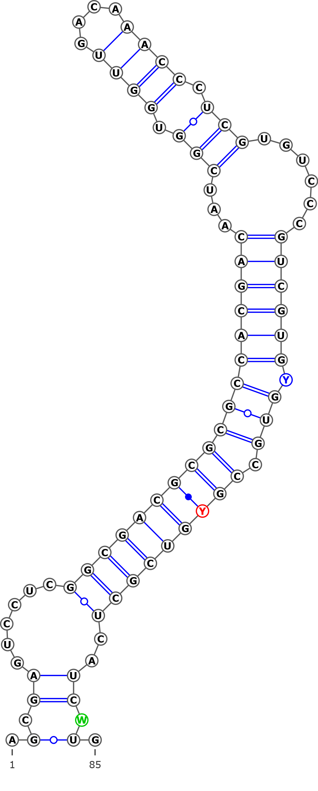
AB243885 Betula corylifolia haplotype:co2
AB243880 Betula schmidtii haplotype:sc
KT308920 Betula schmidtii isolate 2
KT308919 Betula schmidtii isolate 1
FJ011779 Betula schmidtii voucher Lee s.n.
AY761133 Betula schmidtii isolate 2875
Structural variant 3 (C)
AGCGAGUCCUGGCGACGCGCGCCACGACAAUCGGUGGUUGUCAAACCCUCGUGUCCCGUCGUGCGUGCCGCGUCGCUCAUCGUG
.((((.....((((((((((((((((((...(((.((((....)))).)))......)))))).))).)))))))))..)))).
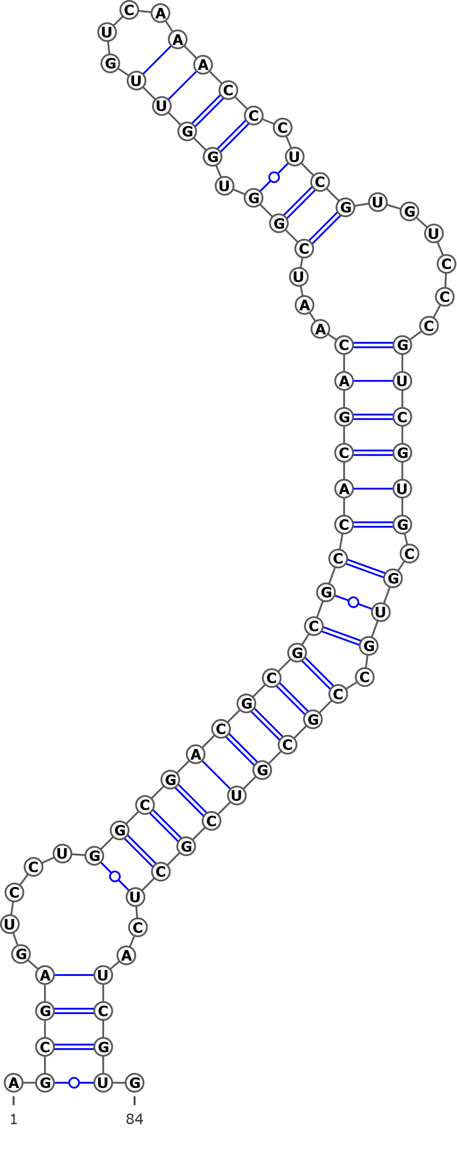
AY761130 Betula pubescens isolate 2895
AY761129 Betula populifolia isolate 2890
AY761128 Betula platyphylla isolate 2934
AY761127 Betula pendula isolate 2902
AY761114 Betula humilis isolate 2894
Structural variant 4 (D)
AGCGAGUCCUCGGCGACGCACGCCACGACAAUCGGUGGUUGUCAAACCCUCGUGUCCCGUCGUGCGUGACGCGUCGCUCAUCGUG
.((((......((((((((.(((((((((...(((.((((....)))).)))......)))))).)))..))))))))..)))).
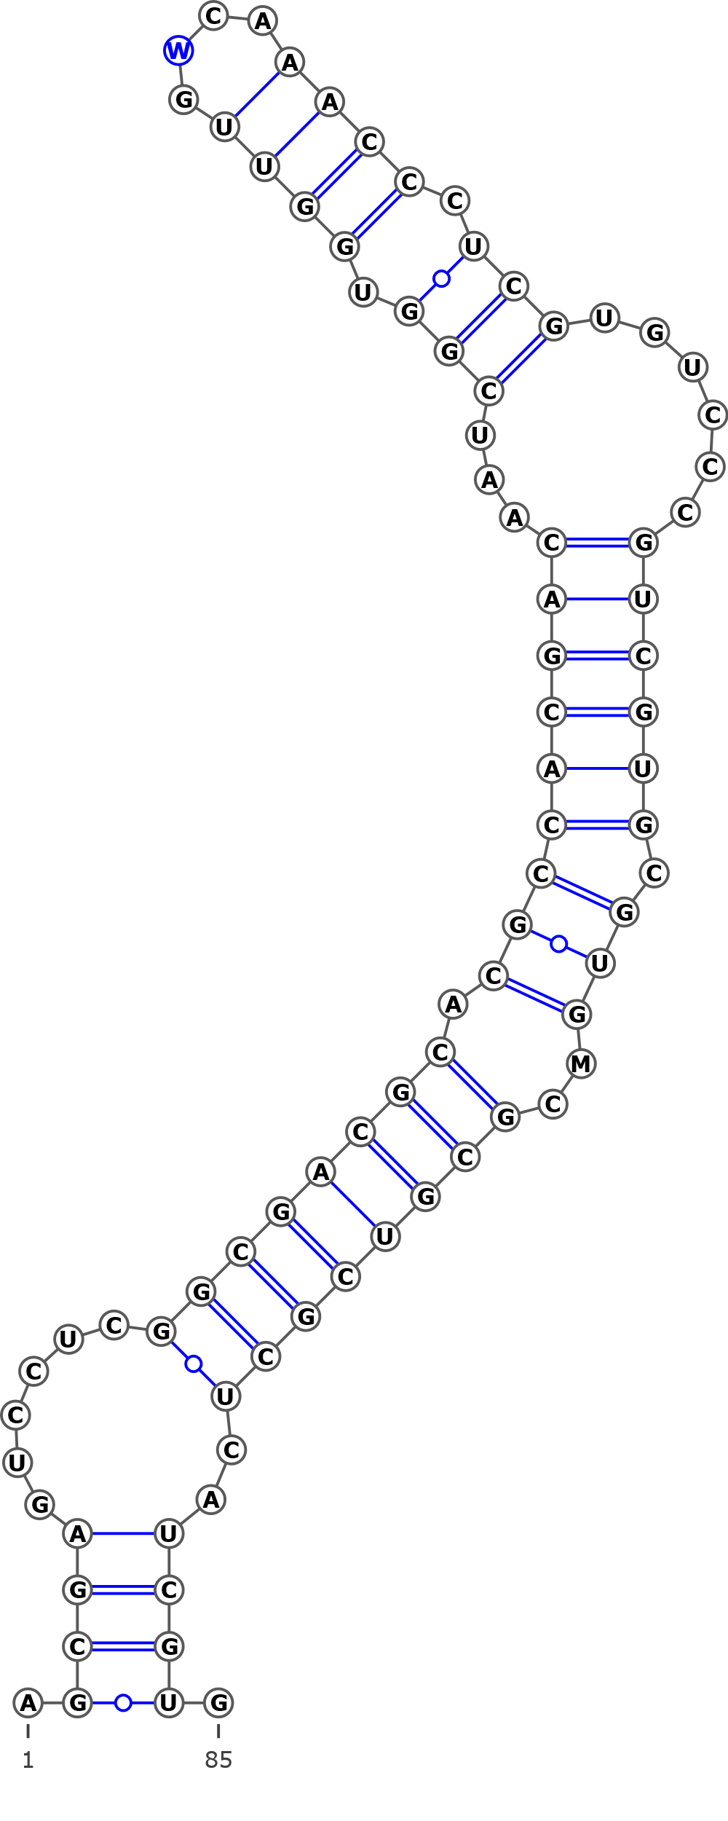
AF432067 Betula papyrifera
AY761099 Betula albosinensis isolate 3018
KT308949 Betula utilis isolate 2
MG236939.1 Betula papyrifera voucher CCDB-18325-B2
Structural variant 5 (E)
AGCGAGUCCUCGGCGACGCGCGCCACGACAAUCGGUGGUUGACAAACCCUCGUGUCCCGUCGUGCGUGCCGCGUCGCUCAUCGGG
..(((......((((((((((((((((((...(((.((((....)))).)))......)))))).))).)))))))))..)))..
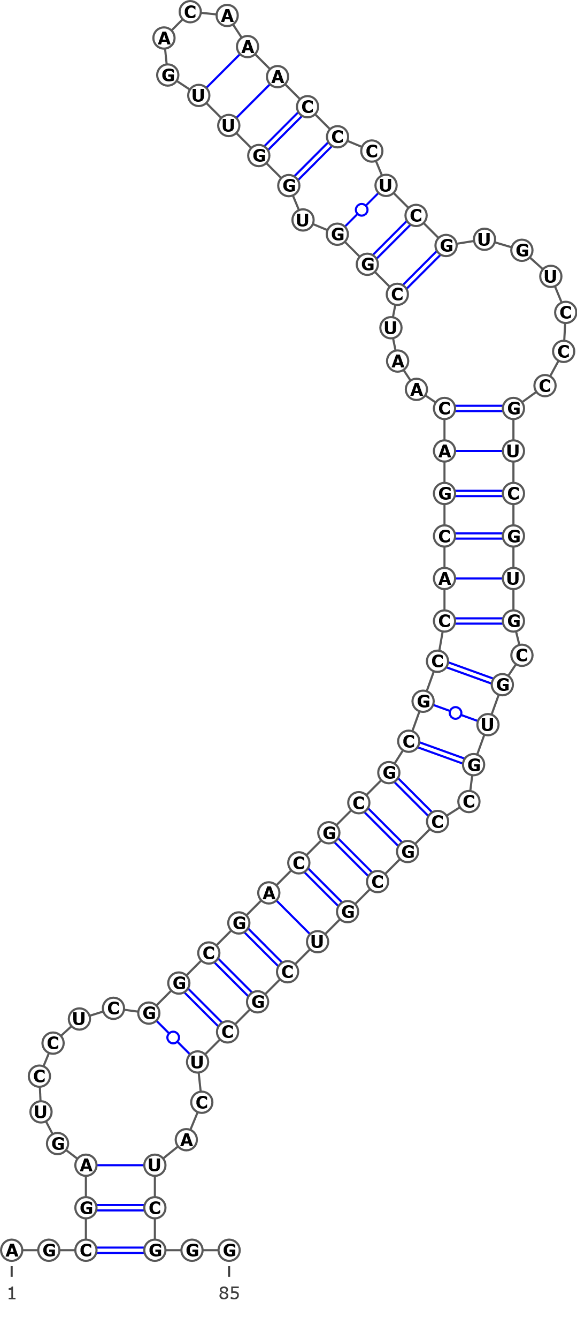
KT308929 Betula insignis subsp. fansipanensis
KT308928 Betula insignis isolate 2

Structural variant 6 (F)
AGCGAGUUCUCGGCGACGCGCGCCACGACAAUCGGUGGUUGACAAACCCUGGUGUCCCGUCGUGCGUGCCGCGUCGCUCAUCGUG
.((((......((((((((((((((((((...(((.((((....)))).)))......)))))).))).)))))))))..)))).
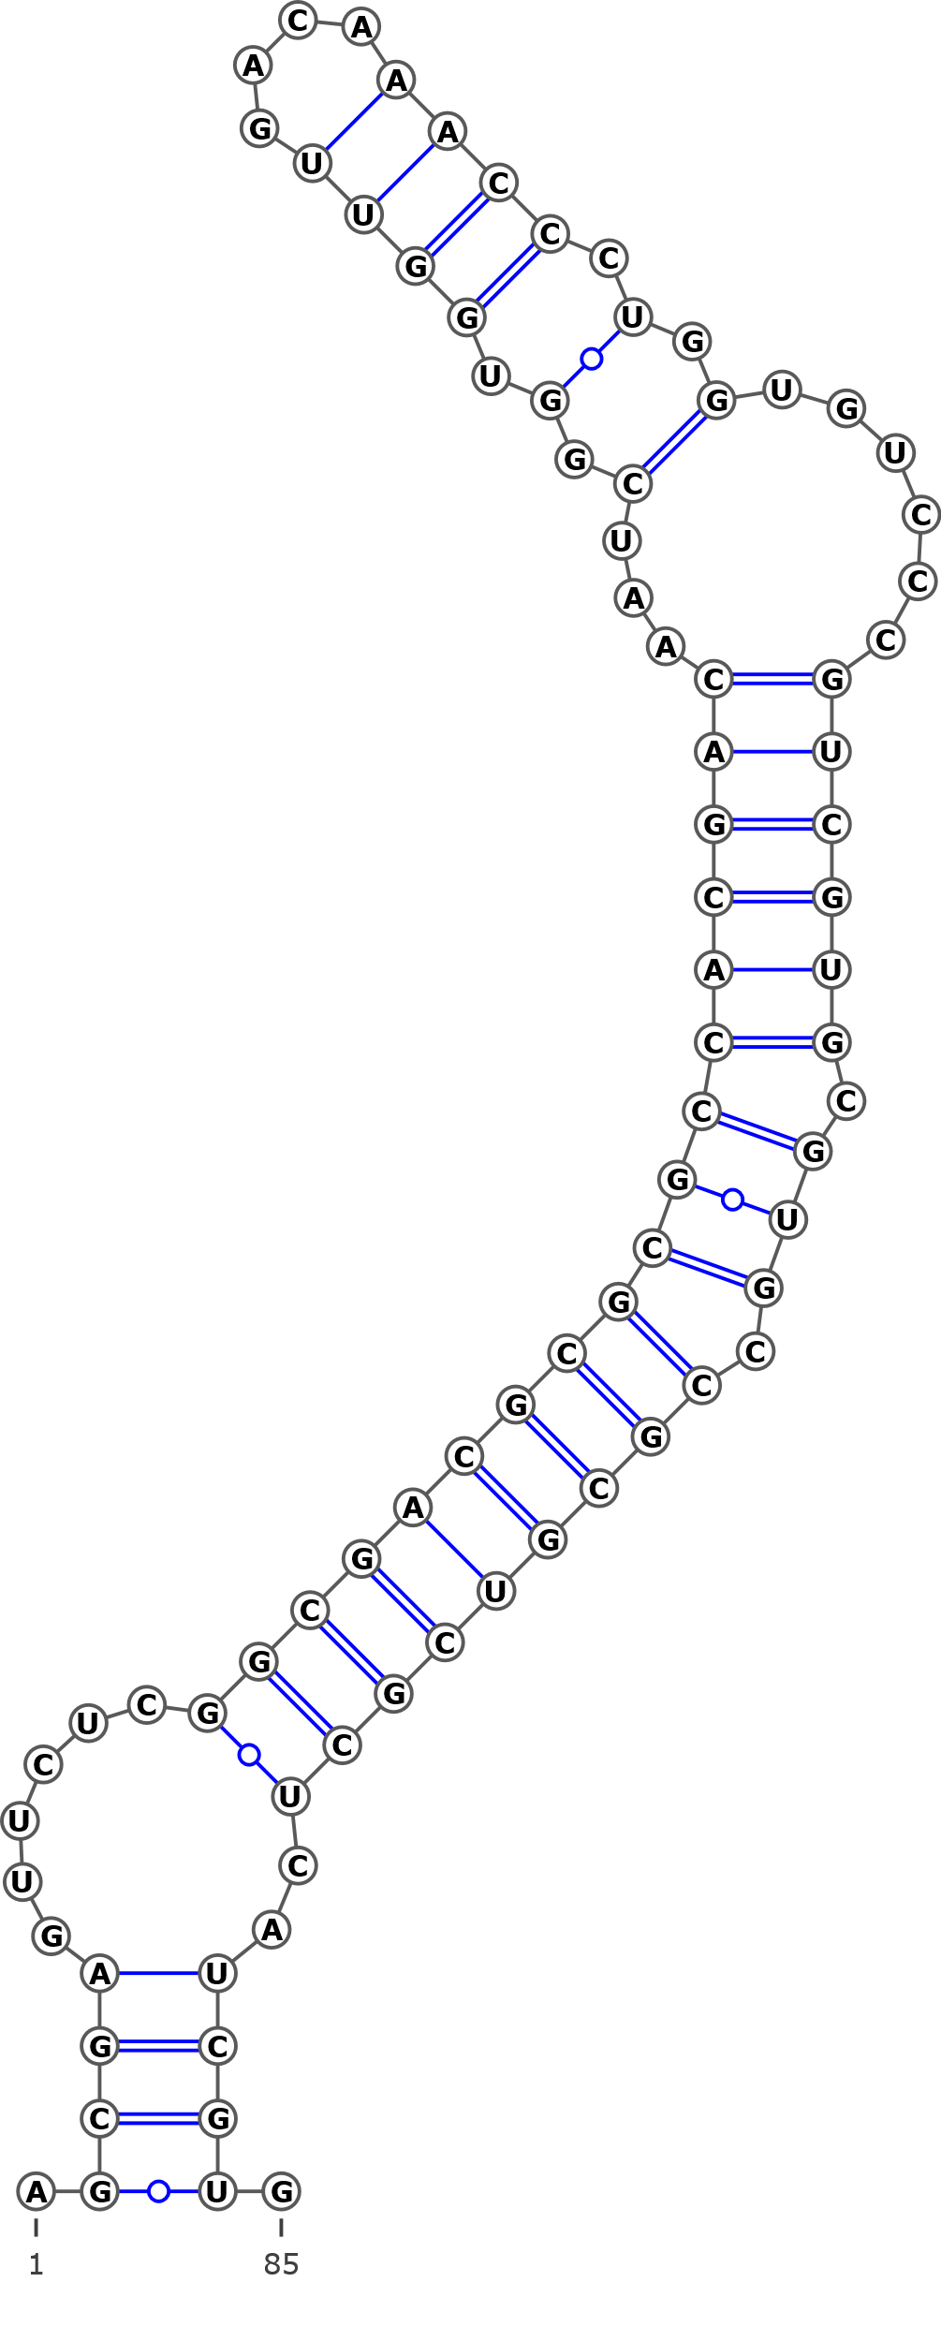
KT308978 Betula michauxii
AY761121 Betula michauxii isolate 3406

Structural variant 7 (G)
AGCGAGUCCUGGCGACGCGCGCCACGACAAUCGGUGGUUGACAAACCCUCGUGUCCCGUCGUGCGUGCCGCGUCGCUCAGCGUG
.(((......((((((((((((((((((...(((.((((....)))).)))......)))))).))).)))))))))...))).
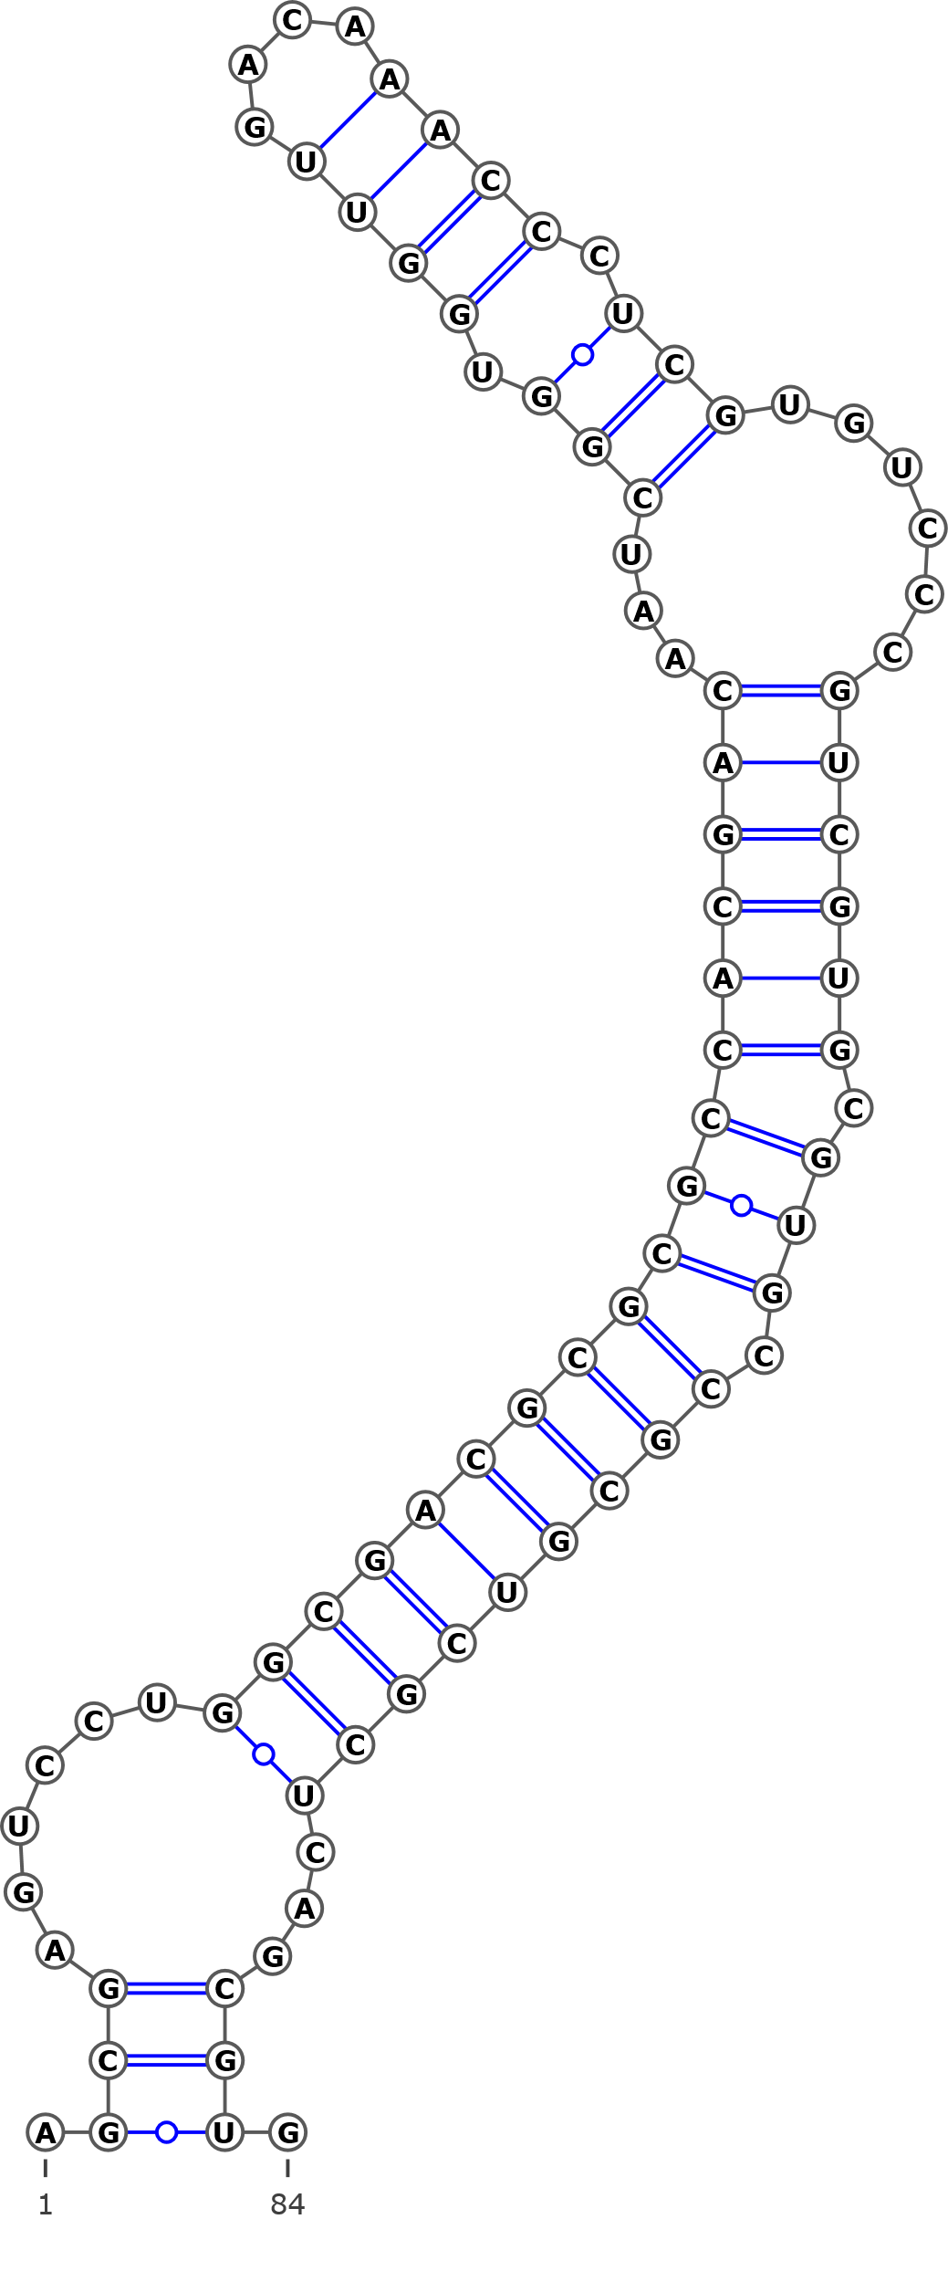
AY761134 Betula utilis isolate 2893

Structural variant 8 (H)
AGCGAGUCCUCGGCGACGCGCGCCACGACAUCGGUGGUUGACAAACCCUCGUGUCCCGUCGUGCGUGCCGCGUCGCUCAUCGUG
.((((......((((((((((((((((((..(((.((((....)))).)))......)))))).))).)))))))))..)))).
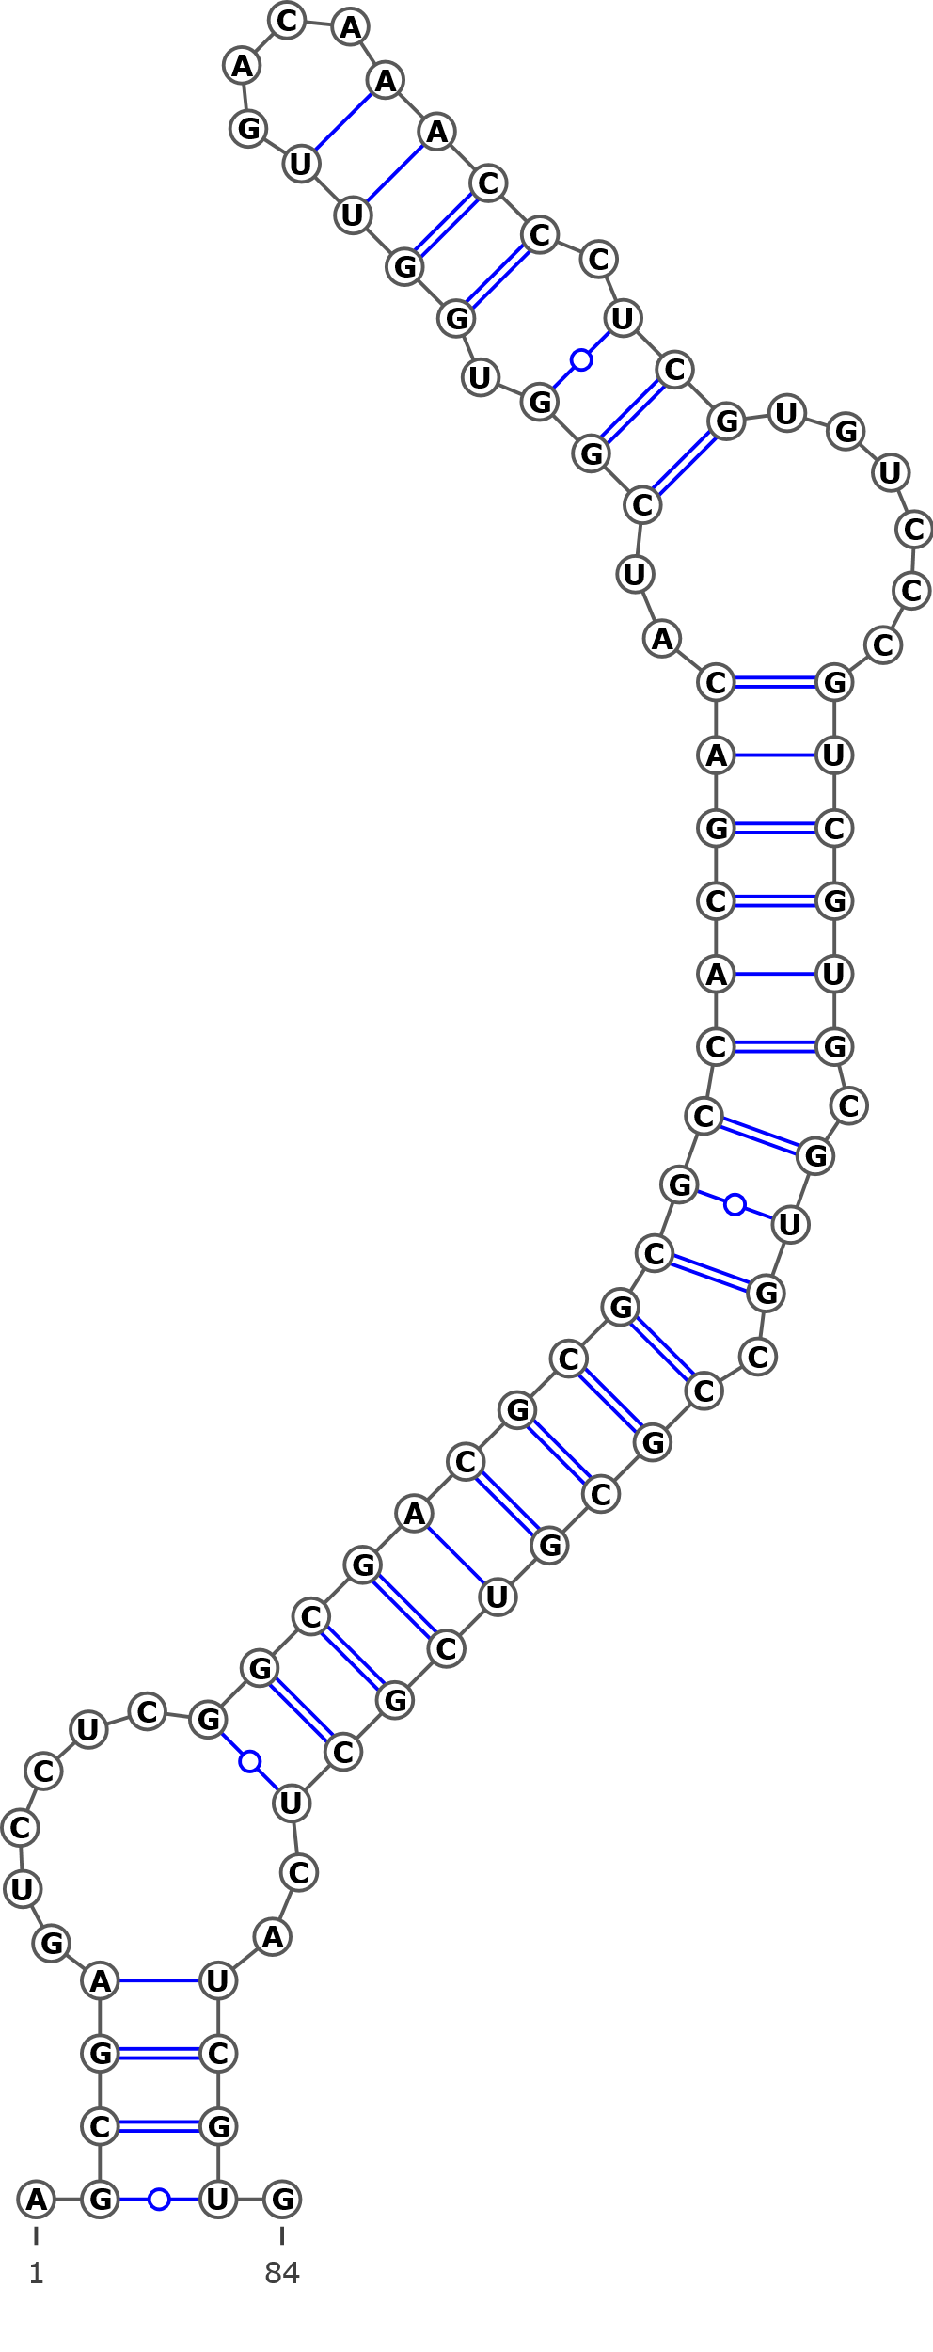
AY761119 Betula maximovicziana isolate 3463
Structural variant 9 (I)
AGCGAGUCCUCGGCGACGCGUGCCACGACAAUCGGUGGUUGACAAACCCUCGUGUCCCGUCGUGCGUGCCGCAUCGCUCAUCGUG
.((((......(((((.((((((((((((...(((.((((....)))).)))......)))))).))).))).)))))..)))).
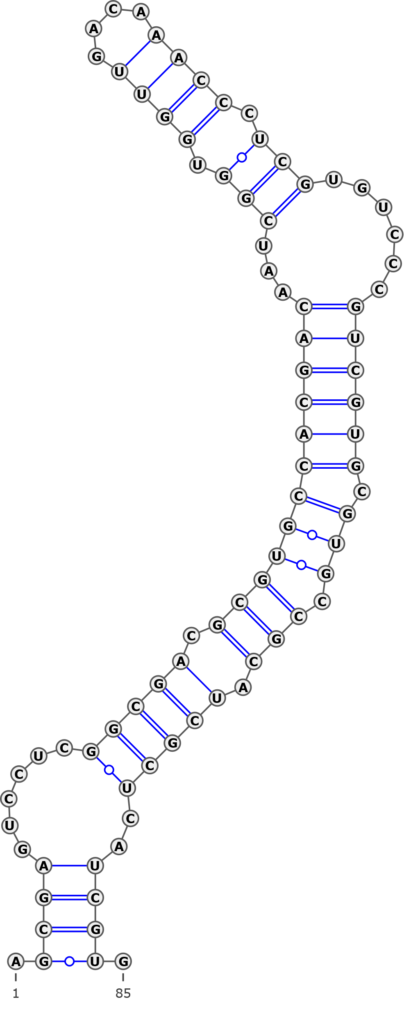
AY761103 Betula calcicola isolate 3460
Structural variant 10 (J)
AGCGAGUCCUCGGCGACGCGCGCCACGACAAUCGGUGGUUGUCAAACCCUCGUGUCCCCUCGUGCGUGACGCGUCGUUCAUCGUG
.((((......((((((((((((((((((...(((.((((....)))).)))......)))))).))).)))))))))..)))).
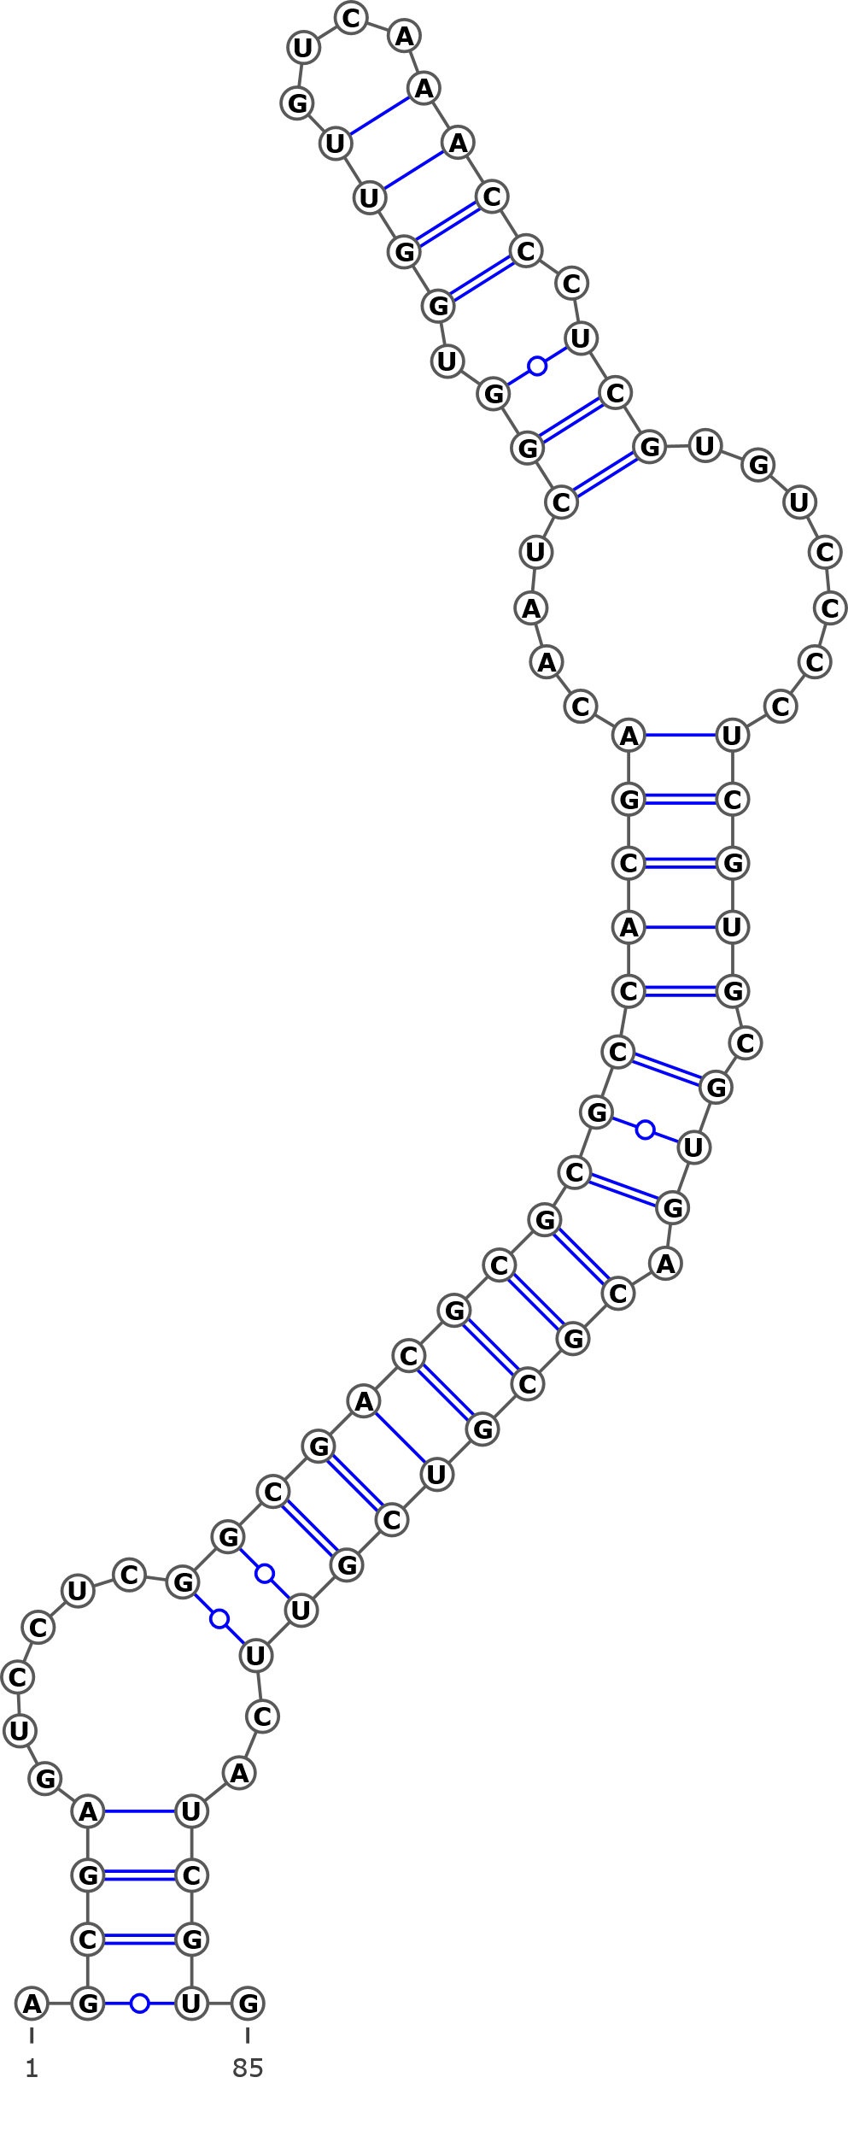
FJ011770 Betula davurica voucher Lee s.n.

