Title:
healthcareCOVID: A national cross-sectional observational study identifying risk factors for developing suspected or confirmed COVID-19 in UK healthcare workers – SUPPLEMENT MATERIAL

Supplement material

- APPENDIX 1 - healthcareCOVID survey overview
  - [Note: Ethnicity layout as per UK government¹]
- APPENDIX 2 - STrengthening the Reporting of OBservational studies in Epidemiology (STROBE) checklist² for healthcareCOVID
- APPENDIX 3 - Disclaimer for healthcareCOVID survey
- eFigure 1 - Bar graph reporting the areas of clinical contact with suspected or confirmed COVID-19 patients by participants reporting regular clinical contact (n = 3902)
- eFigure 2 - Bar graph of exposure to aerosol-generating procedures (AGPs) performed in suspected or confirmed COVID-19 patients amongst participants who had regular exposure (n = 2296)
- eTable 1 - Doctors by Specialty
- eTable 2 - Doctors by Grade
- eTable 3 - Non-doctors by Specialty
- eTable 4 - Non-doctors by Grade
- eFigure 3 - Bar graph of symptoms reported by participants during self-isolation due to symptoms or testing positive for SARS-CoV-2 (n = 1,776)
- eFigure 4 - Bar graph of reasons for inadequate PPE use during clinical contact with suspected/confirmed COVID-19 patients of those who had been in situations where they did not use adequate PPE (n = 1306)
- eTable 5 - Numbers (%) for all outcomes and composite outcome
- eTable 6 - Multivariable logistic regression model featuring constituent BAME groups
- eTable 7 - Multivariable logistic regression model with comorbidities removed to assess for collider bias with respect to smoking status
- eTable 8 - Multivariable logistic regression model including clinical areas in which healthcare workers had regular clinical contact with suspected or confirmed COVID-19 patients
- eTable 9 - Multivariable logistic regression model including AGPs to which healthcare workers were regularly exposed to when performed in suspected or confirmed COVID-19 patients
- eTable10 - Multivariable logistic regression model with the outcome being participants stating that they had laboratory-confirmed SARS-CoV-2 infection (via reverse transcription polymerase chain reaction or antibody testing)

References:
1. GOV.UK. Ethnic groups. Accessed July 9, 2020. https://design-system.service.gov.uk/patterns/ethnic-group/
2. STROBE Group. STROBE Statement: Available checklists. Accessed July 5, 2020. https://www.strobe-statement.org/index.php?id=available-checklists

APPENDIX 1 – healthcareCOVID survey overview

The following is an overview of the questions and data collected from the online survey hosted at https://intubatecovid.knack.com/healthcarecovid:

Entry Validation
- E-mail Address
  - Survey validation check to reduce number of duplicate entries from the same participant
  - Not linked to responses during data analysis

Demographics (Section 1 of 5)
- Age
  - [Free-text]
- Sex assigned at birth
  - Male
  - Female
- Does your gender match the sex you were assigned at birth?
  - Yes
  - No
    - Conditional If "No", please specify:
      - [Free-text]
- Ethnicity
  - As per layout from UK government¹
- Household environment
  - How many people live in your household, including yourself?
    - I live alone
    - I live with 1 or more persons
      - Conditional Do you have children living at home with you?
        - Yes
        - No
- Health Status
  - Do you have any of the following health problems, even if treated or under control? (optional)
    - 11 options with tick all that apply approach
  - Tobacco smoking status (optional):
    - Current smoker or Ex-smoker (within 1 year)
    - Ex-smoker (more than 1 year)
    - Never smoked

Work Details (Section 2 of 5)
- Country
  - England
  - Northern Ireland
  - Scotland
  - Wales
- County/Region
  - Drop-down list based on Country input
- Main healthcare facility
  - Hospital
  - Community healthcare facility
  - Social care facility
  - Other
- Role
  - Drop-down list with 32 options
- Grade
  - Drop-down list with 16 options
- Primary specialty
  - Drop-down list based on Role input

COVID-19 status (Section 3 of 5)
Since 1st February 2020…
- Have you ever self-isolated because of COVID-19 symptoms and/or had a positive test?
  - Yes
    - Conditional How long did you self-isolate?
      - 1 to 7 days
      - 8 to 14 days
      - More than 14 days
        - Conditional How long? (in days)
          - [Free-text]
    - Conditional Have you had to self-isolate more than once because of COVID-19 symptoms?
      - Yes
      - No
    - Conditional What symptoms did you have during self-isolation?
      - 13 options with tick all that apply approach
- Have you ever been hospitalised due to having suspected or confirmed COVID-19?
  - Yes
  - No
- Have you ever tested POSITIVE for COVID-19?
  - Yes - Oral/Nasal swab
  - Yes - Blood test
  - No - I have NOT tested positive (e.g. tests all negative, awaiting results)
  - No - I have NEVER BEEN tested

Exposure characteristics (Section 4 of 5)
Since 1st Feb 2020…
- Do you regularly use public transport to travel to work?
  - Yes
  - No
- During your usual work shift, have you had regular clinical contact with suspected or confirmed COVID-19 patients?
  - Yes
    - Conditional If "Yes" in what areas/environments?
      - 15 options with tick all that apply approach
  - No

- During your usual work shift, have you been regularly exposed to aerosol generating procedures (AGPs) performed in suspected or confirmed COVID-19 patients?
  - Yes
    - Conditional If "Yes", what AGPs?
      - 13 options with tick all that apply approach

Personal protective equipment (PPE) use (Section 5 of 5)
Since 1st Feb 2020…
- Have you had sufficient training in PPE usage?
  - Yes
  - No
- Have you had any episodes where you LACKED ACCESS to PPE items when having clinical contact with suspected or confirmed COVID-19 patients?
  - Yes
    - Conditional If "Yes", what PPE items did you LACK ACCESS to?
      - 9 options with tick all that apply approach
  - No
- Have you had any clinical contact with suspected or confirmed cases of COVID-19 where you DID NOT use adequate PPE?
  - Yes
    - Conditional If "Yes", please select:
      - Always
      - Often
      - Sometimes
      - Rarely
    - Conditional What was the reason(s) for NOT using adequate PPE during these encounter(s)?
      - 7 options with tick all that apply approach
- Have you ever had to reuse disposable PPE items?
  - Yes
  - No
- Have you ever had to improvise or make your own PPE items?
  - Yes
  - No

Other comments
- Is there anything else you would like to let us know?
  - [Free-text]

Checkbox option for participant to be contacted in future regarding further information about the survey (optional)

APPENDIX 2 – STrengthening the Reporting of OBservational studies in Epidemiology (STROBE) checklist¹ for healthcareCOVID

STROBE Statement—Checklist of items that should be included in reports of cross-sectional studies

 | Item No | Recommendation | Recorded on Page No.
Title and abstract | 1 | (a) Indicate the study’s design with a commonly used term in the title or the abstract | pg. 1
 |  | (b) Provide in the abstract an informative and balanced summary of what was done and what was found | pg. 2 – 3
Introduction
Background/rationale | 2 | Explain the scientific background and rationale for the investigation being reported | pg. 3 – 5
Objectives | 3 | State specific objectives, including any prespecified hypotheses | pg. 5
Methods
Study design | 4 | Present key elements of study design early in the paper | pg. 5 – 10
Setting | 5 | Describe the setting, locations, and relevant dates, including periods of recruitment, exposure, follow-up, and data collection | pg. 5 – 7
Participants | 6 | (a) Give the eligibility criteria, and the sources and methods of selection of participants | pg. 5 – 6
Variables | 7 | Clearly define all outcomes, exposures, predictors, potential confounders, and effect modifiers. Give diagnostic criteria, if applicable | pg. 8 – 9
Data sources/ measurement | 8* | For each variable of interest, give sources of data and details of methods of assessment (measurement). Describe comparability of assessment methods if there is more than one group | Appendix 1  (Supplement material)
Bias | 9 | Describe any efforts to address potential sources of bias | pg. 18 – 19
Study size | 10 | Explain how the study size was arrived at | N/A
Quantitative variables | 11 | Explain how quantitative variables were handled in the analyses. If applicable, describe which groupings were chosen and why | pg. 8 – 9
Statistical methods | 12 | (a) Describe all statistical methods, including those used to control for confounding | pg. 8 – 9
 |  | (b) Describe any methods used to examine subgroups and interactions | pg. 10
 |  | (c) Explain how missing data were addressed | pg. 9
 |  | (d) If applicable, describe analytical methods taking account of sampling strategy | pg. 8 – 9
 |  | (e) Describe any sensitivity analyses | N/A
Results
Participants | 13* | (a) Report numbers of individuals at each stage of study—eg numbers potentially eligible, examined for eligibility, confirmed eligible, included in the study, completing follow-up, and analysed | Figure 1
 |  | (b) Give reasons for non-participation at each stage | Figure 1
 |  | (c) Consider use of a flow diagram | Figure 1
Descriptive data | 14* | (a) Give characteristics of study participants (eg demographic, clinical, social) and information on exposures and potential confounders | Table 1
 |  | (b) Indicate number of participants with missing data for each variable of interest | N/A
Outcome data | 15* | Report numbers of outcome events or summary measures | eTable 5  (Supplement material)
Main results | 16 | (a) Give unadjusted estimates and, if applicable, confounder-adjusted estimates and their precision (eg, 95% confidence interval). Make clear which confounders were adjusted for and why they were included | Table 2
 |  | (b) Report category boundaries when continuous variables were categorized | N/A
 |  | (c) If relevant, consider translating estimates of relative risk into absolute risk for a meaningful time period | N/A
Other analyses | 17 | Report other analyses done—eg analyses of subgroups and interactions, and sensitivity analyses | pg. 13 – 14, eFigures 1 – 4 and eTables 6 – 10 (Supplement material)
Discussion
Key results | 18 | Summarise key results with reference to study objectives | pg. 14 – 15
Limitations | 19 | Discuss limitations of the study, taking into account sources of potential bias or imprecision. Discuss both direction and magnitude of any potential bias | pg. 18 – 19
Interpretation | 20 | Give a cautious overall interpretation of results considering objectives, limitations, multiplicity of analyses, results from similar studies, and other relevant evidence | pg. 14 – 20
Generalisability | 21 | Discuss the generalisability (external validity) of the study results | pg. 19 – 20
Other information
Funding | 22 | Give the source of funding and the role of the funders for the present study and, if applicable, for the original study on which the present article is based | No specific grant from any funding agency in the public, commercial, or not-for-profit sectors.

*Give information separately for exposed and unexposed groups.

Note: An Explanation and Elaboration article discusses each checklist item and gives methodological background and published examples of transparent reporting. The STROBE checklist is best used in conjunction with this article (freely available on the Web sites of PLoS Medicine at http://www.plosmedicine.org/, Annals of Internal Medicine at http://www.annals.org/, and Epidemiology at http://www.epidem.com/). Information on the STROBE Initiative is available at www.strobe-statement.org.

APPENDIX 3 – Disclaimer for healthcareCOVID survey

Disclaimer

The healthcareCOVID project has been registered as a service evaluation (ID 10834) at Guy's and St Thomas' NHS Foundation Trust (London, UK).

By submitting my responses, I confirm that:
- I understand the purpose of this survey.
- I have freely chosen to participate.
- I understand that there will be no reimbursement for my participation.
- I understand that the principal purpose of this project is to prevent disease transmission and to improve public health services. I understand that communication of findings from this project may involve presentation or publication of collected data and that all data will be de-identified and reported in aggregate.
- I understand that my data will be stored in an online encrypted database accessed only by the healthcareCOVID team, and in accordance with GDPR principles, and that no personal information will be shared with any third party.
- I will receive information as requested, only if I have confirmed as such on the survey.

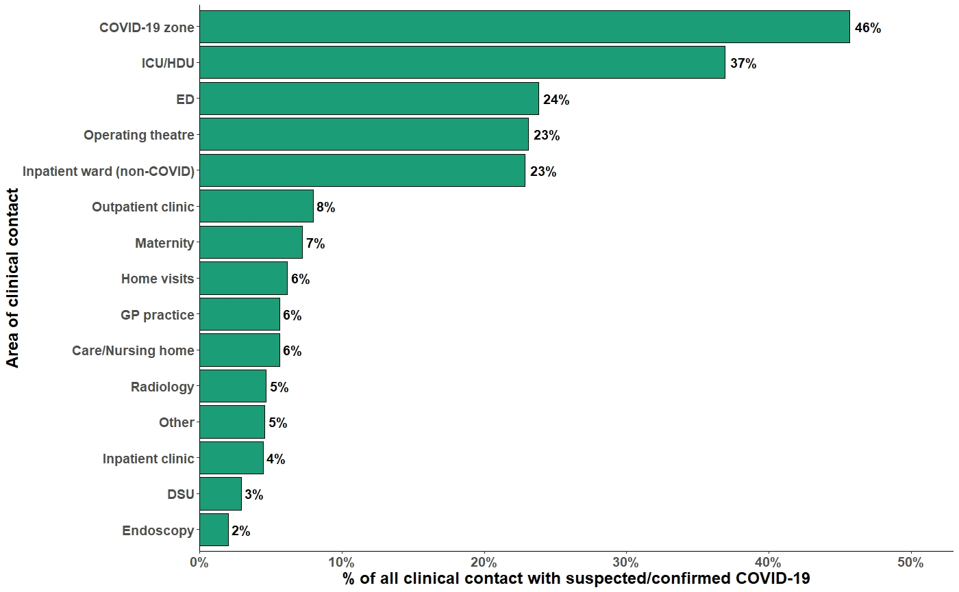

eFigure 1 Bar graph reporting the areas of clinical contact with suspected or confirmed covid-19 patients by participants reporting regular clinical contact (n = 3902).

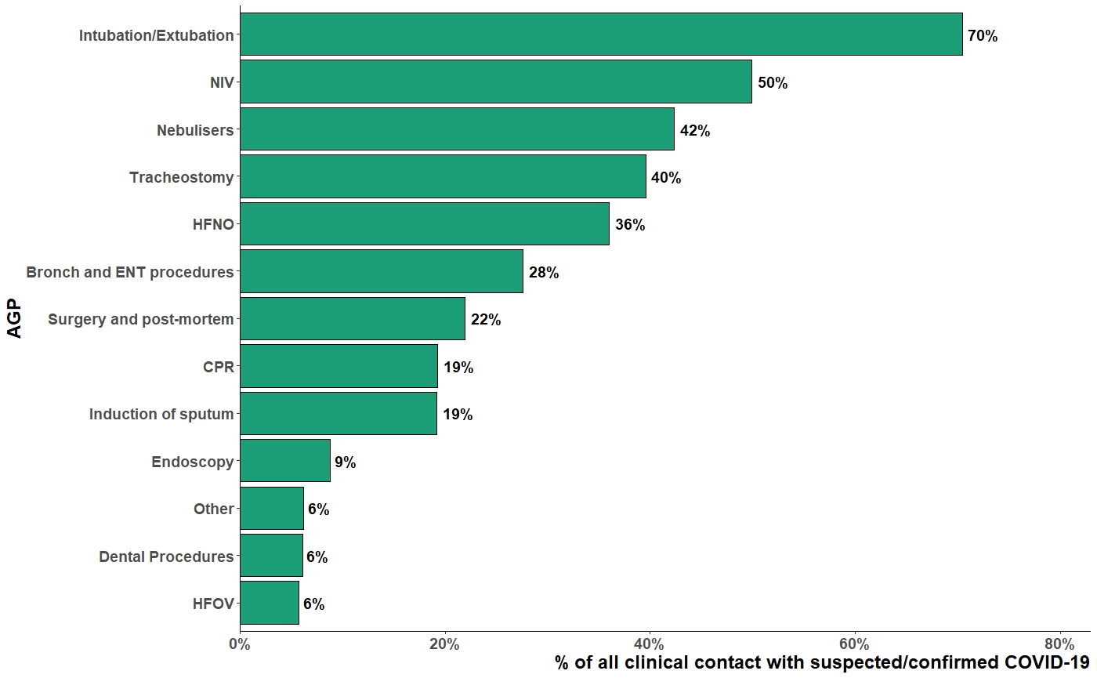

eFigure 2 Bar graph of exposure to aerosol-generating procedures (AGPs) performed in suspected or confirmed covid-19 patients amongst participants who had regular exposure (n = 2296).
Abbreviations: NIV = Non-invasive ventilation; HFNO = High-flow nasal oxygen; Bronch = Bronchoscopy; ENT = Ear, Nose and Throat; CPR = Cardiopulmonary resuscitation; HFOV = High Frequency Oscillatory Ventilation.

eTable 1. Doctors by specialty

Specialty | n | %
Acute internal medicine | 52 | 2.9
Allergy | 1 | 0.1
Anaesthetics | 406 | 23.0
Cardio-thoracic surgery | 2 | 0.1
Cardiology | 23 | 1.3
Chemical pathology | 2 | 0.1
Child and adolescent psychiatry | 5 | 0.3
Clinical genetics | 1 | 0.1
Clinical oncology | 11 | 0.6
Clinical pharmacology and therapeutics | 1 | 0.1
Clinical radiology | 20 | 1.1
Dermatology | 12 | 0.7
Emergency medicine | 96 | 5.4
Endocrinology and diabetes mellitus | 14 | 0.8
Forensic histopathology | 1 | 0.1
Forensic psychiatry | 1 | 0.1
Gastroenterology | 16 | 0.9
General (internal) medicine | 40 | 2.3
General practice | 403 | 22.8
General psychiatry | 22 | 1.2
General surgery | 38 | 2.1
Genitourinary medicine | 7 | 0.4
Geriatric medicine | 51 | 2.9
Haematology | 20 | 1.1
Histopathology | 12 | 0.7
Immunology | 2 | 0.1
Infectious diseases | 9 | 0.5
Intensive care medicine | 129 | 7.3
Medical microbiology | 4 | 0.2
Medical oncology | 6 | 0.3
Neurology | 9 | 0.5
Neurosurgery | 3 | 0.2
Obstetrics and gynaecology | 62 | 3.5
Occupational medicine | 1 | 0.1
Old age psychiatry | 11 | 0.6
Ophthalmology | 25 | 1.4
Oral and maxillofacial surgery | 7 | 0.4
OTHER | 11 | 0.6
Otolaryngology | 25 | 1.4
Paediatric and perinatal pathology | 1 | 0.1
Paediatric cardiology | 1 | 0.1
Paediatric surgery | 2 | 0.1
Paediatrics | 72 | 4.1
Palliative medicine | 11 | 0.6
Plastic surgery | 4 | 0.2
Psychiatry of learning disability | 2 | 0.1
Public health medicine | 2 | 0.1
Rehabilitation medicine | 1 | 0.1
Renal medicine | 8 | 0.5
Respiratory medicine | 32 | 1.8
Rheumatology | 12 | 0.7
Trauma and orthopaedic surgery | 34 | 1.9
Urology | 15 | 0.8
Vascular surgery | 11 | 0.6

eTable 2. Doctors by grade

Grade | n | %
Clinical Fellow | 38 | 2.1
Consultant | 776 | 43.8
CT/ACCS/ST1-2 or Trust Grade equivalent | 130 | 7.3
Foundation Year | 67 | 3.8
GP (Sessional/Salaried/Partner) | 357 | 20.2
OTHER | 9 | 0.5
SpR (ST3+) or Trust Grade equivalent | 323 | 18.2
Staff/Associate Specialist | 69 | 3.9
Student | 1 | 0.1

eTable 3. Specialties associated with working roles for healthcare workers other than doctors

Specialty | n | %
Dentistry | 161 | 3.7
Medical | 764 | 17.4
Mental Health | 197 | 4.5
OTHER | 1306 | 29.8
Paediatrics | 183 | 4.2
Pharmacy | 81 | 1.8
Prehospital & Emergency Services | 163 | 3.7
Primary Care & Public Health | 448 | 10.2
Surgical | 930 | 21.2
Women's Health | 149 | 3.4

eTable 4. Grades for healthcare workers other than doctors

Grade | n | %
Band 2 | 115 | 2.6
Band 3 | 124 | 2.8
Band 4 | 132 | 3.0
Band 5 | 795 | 18.1
Band 6 | 1162 | 26.5
Band 7 | 881 | 20.1
Band 8+ | 588 | 13.4
Consultant | 33 | 0.8
CT/ACCS/ST1-2 or Trust Grade equivalent | 4 | 0.1
Foundation Year | 3 | 0.1
GP (Sessional/Salaried/Partner) | 44 | 1.0
OTHER | 389 | 8.9
SpR (ST3+) or Trust Grade equivalent | 3 | 0.1
Staff/Associate Specialist | 63 | 1.4
Student | 46 | 1.0

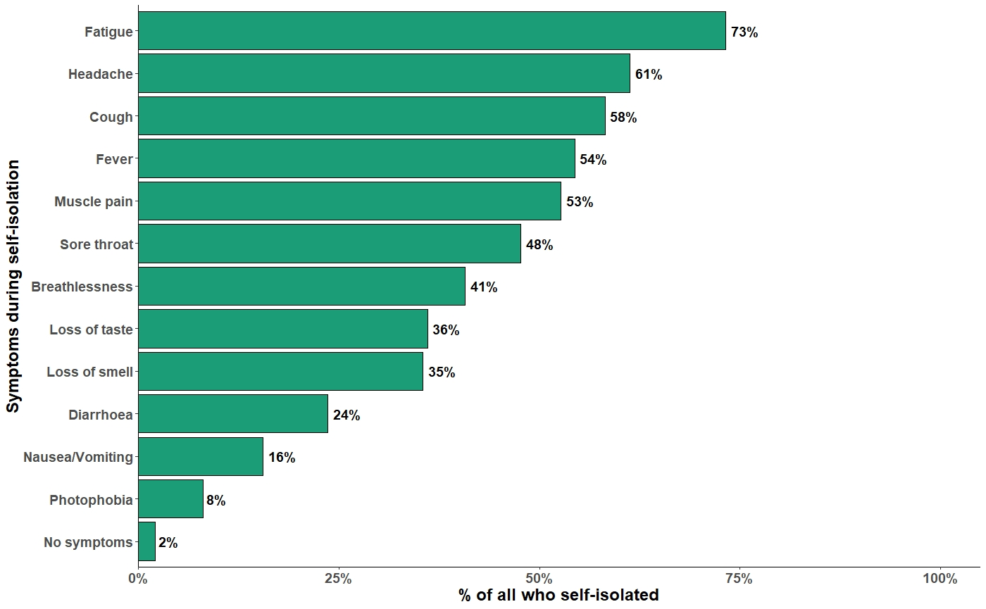

eFigure 3 Bar graph of symptoms reported by participants during self-isolation due to symptoms or testing positive for SARS-CoV-2 (n = 1,776).

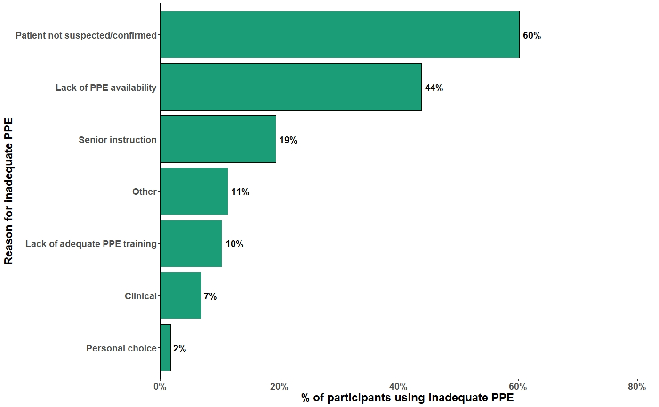

eFigure 4 Bar graph of reasons for inadequate PPE use during clinical contact with suspected/confirmed COVID-19 patients of those who had been in situations where they did not use adequate PPE (n = 1306).

 | Self-isolation |  | Hospitalised |  | COVID-19 positive |  | COVID-19 Composite
 | n | % | n | % | n | % | n | %
 | 1776 | 28.9 | 49 | 0.80 | 459 | 7.46 | 1806 | 29.4
Age
years, mean (SD) | 41.9 (10.2) |  | 42.6 (11.9) |  | 42.5 (10.2) |  | 41.9 (10.2)
Sex
Male | 379 | 6.2 | 17 | 0.3 | 126 | 2 | 390 | 6.3
Female | 1397 | 22.7 | 32 | 0.5 | 333 | 5.4 | 1416 | 23
Ethnicity
White | 1313 | 21.3 | 29 | 0.5 | 331 | 5.4 | 1330 | 21.6
BAME | 455 | 7.4 | 20 | 0.3 | 127 | 2.1 | 468 | 7.6
Prefer not to say | 8 | 0.1 | 0 | 0 | 1 | 0 | 8 | 0.1
Household
Lives alone | 200 | 3.3 | 6 | 0.1 | 49 | 0.8 | 205 | 3.3
Lives with 1 or more persons; no children | 654 | 10.6 | 25 | 0.4 | 168 | 2.7 | 664 | 10.8
Lives with 1 or more persons; has children | 922 | 15 | 18 | 0.3 | 242 | 3.9 | 937 | 15.2
Comorbidities
Hypertension | 157 | 2.6 | 6 | 0.1 | 35 | 0.6 | 158 | 2.6
Diabetes | 54 | 0.9 | 6 | 0.1 | 17 | 0.3 | 57 | 0.9
Cancer | 28 | 0.5 | 0 | 0 | 5 | 0.1 | 28 | 0.5
Heart disease | 23 | 0.4 | 0 | 0 | 4 | 0.1 | 23 | 0.4
Immunosuppression | 27 | 0.4 | 2 | 0 | 2 | 0 | 27 | 0.4
Respiratory disease | 192 | 3.1 | 15 | 0.2 | 49 | 0.8 | 198 | 3.2
Renal disease | 10 | 0.2 | 2 | 0 | 3 | 0 | 10 | 0.2
Liver disease | 10 | 0.2 | 0 | 0 | 2 | 0 | 10 | 0.2
Neurological disease | 18 | 0.3 | 0 | 0 | 3 | 0 | 18 | 0.3
Obesity | 234 | 3.8 | 8 | 0.1 | 47 | 0.8 | 236 | 3.8
Prefer not to say | 0 | 0.4 | 0 | 0 | 0 | 0.1 | 0 | 0.4
Smoking status
Never smoked | 1258 | 20.4 | 38 | 0.6 | 327 | 5.3 | 1279 | 20.8
Current or Ex-smoker within 1 year | 139 | 2.3 | 3 | 0 | 27 | 0.4 | 142 | 2.3
Ex-smoker > 1 year | 357 | 5.8 | 7 | 0.1 | 96 | 1.6 | 361 | 5.9
Prefer not to say | 22 | 0.4 | 1 | 0 | 9 | 0.1 | 24 | 0.4
Country
England | 1615 | 26.3 | 49 | 0.8 | 419 | 6.8 | 1645 | 26.7
Northern Ireland | 15 | 0.2 | 0 | 0 | 6 | 0.1 | 15 | 0.2
Scotland | 89 | 1.4 | 0 | 0 | 18 | 0.3 | 89 | 1.4
Wales | 57 | 0.9 | 0 | 0 | 16 | 0.3 | 57 | 0.9
Main Healthcare Facility
Hospital | 1331 | 21.6 | 38 | 0.6 | 375 | 6.1 | 1356 | 22
Community healthcare facility | 316 | 5.1 | 7 | 0.1 | 56 | 0.9 | 319 | 5.2
Social care facility | 48 | 0.8 | 1 | 0 | 16 | 0.3 | 49 | 0.8
Other | 81 | 1.3 | 3 | 0 | 12 | 0.2 | 82 | 1.3
Role Group
Nurses, midwives and associated staff | 752 | 12.2 | 16 | 0.3 | 194 | 3.2 | 759 | 12.3
Allied health professionals | 274 | 4.5 | 9 | 0.1 | 54 | 0.9 | 280 | 4.6
Dentists and dental staff | 28 | 0.5 | 0 | 0 | 2 | 0 | 29 | 0.5
Doctors | 578 | 9.4 | 20 | 0.3 | 172 | 2.8 | 592 | 9.6
Other | 144 | 2.3 | 4 | 0.1 | 37 | 0.6 | 146 | 2.4
Used public transport to travel to work
No | 1343 | 21.8 | 38 | 0.6 | 362 | 5.9 | 1363 | 22.2
Yes | 433 | 7 | 11 | 0.2 | 97 | 1.6 | 443 | 7.2
Regular clinical contact with suspected or confirmed COVID-19 patients
No | 533 | 8.7 | 10 | 0.2 | 88 | 1.4 | 540 | 8.8
Yes | 1243 | 20.2 | 39 | 0.6 | 371 | 6 | 1266 | 20.6
Regular exposure to AGP(s) performed in suspected or confirmed COVID-19 patients
No | 1129 | 18.4 | 29 | 0.5 | 289 | 4.7 | 1142 | 18.6
Yes | 647 | 10.5 | 20 | 0.3 | 170 | 2.8 | 664 | 10.8
Sufficient training in PPE use
No | 591 | 9.6 | 16 | 0.3 | 130 | 2.1 | 598 | 9.7
Yes | 1185 | 19.3 | 33 | 0.5 | 329 | 5.3 | 1208 | 19.6
Lacked access to PPE items for clinical contact with suspected or confirmed COVID-19 patients
No | 1246 | 20.3 | 32 | 0.5 | 297 | 4.8 | 1271 | 20.7
Yes | 530 | 8.6 | 17 | 0.3 | 162 | 2.6 | 535 | 8.7
Clinical contact without adequate PPE
Never | 1258 | 20.4 | 31 | 0.5 | 299 | 4.9 | 1279 | 20.8
Rarely | 0 | 3.1 | 0 | 0.1 | 0 | 0.9 | 0 | 3.2
Sometimes | 227 | 3.7 | 9 | 0.1 | 74 | 1.2 | 230 | 3.7
Often | 67 | 1.1 | 3 | 0 | 17 | 0.3 | 68 | 1.1
Always | 33 | 0.5 | 1 | 0 | 15 | 0.2 | 34 | 0.6
Reused disposable PPE
No | 1239 | 20.1 | 35 | 0.6 | 325 | 5.3 | 1260 | 20.5
Yes | 537 | 8.7 | 14 | 0.2 | 134 | 2.2 | 546 | 8.9
Used improvised PPE
No | 1518 | 24.7 | 40 | 0.7 | 401 | 6.5 | 1540 | 25
Yes | 258 | 4.2 | 9 | 0.1 | 58 | 0.9 | 266 | 4.3

eTable 5. Outcomes and composite summary
% out of all participants (n = 6152)
Abbreviations: SD = Standard Deviation, BAME = Black, Asian and Minority Ethnic, AGP = Aerosol-Generating Procedures, PPE = Personal Protective Equipment.
 | Multivariable adjusted OR | 95%CI | p-value
Age
Age (per year)* | 0.98 | 0.98 - 0.99 | <0.001
Sex
Female | Ref | Ref | Ref
Male | 0.92 | 0.79 - 1.06 | 0.255
Ethnicity
White | Ref | Ref | Ref
Another ethnic group | 0.96 | 0.67 - 1.36 | 0.828
Asian or Asian British | 0.96 | 0.80 - 1.14 | 0.643
Black, African, Black British or Caribbean | 1.03 | 0.79 - 1.33 | 0.845
Mixed or multiple ethnic groups | 0.99 | 0.68 - 1.40 | 0.937
Prefer not to say | 0.91 | 0.36 - 2.06 | 0.827
Household - Persons
Lives alone | Ref | Ref | Ref
Lives with 1 or more persons; no children | 0.88 | 0.72 - 1.07 | 0.182
Lives with 1 or more persons; has children | 1.00 | 0.83 - 1.21 | 0.961
Comorbidities
Hypertension | 1.13 | 0.91 - 1.40 | 0.260
Diabetes | 1.00 | 0.71 - 1.40 | 0.995
Cancer* | 1.66 | 1.01 - 2.67 | 0.041
Heart disease | 1.18 | 0.69 - 1.97 | 0.529
Immunosuppression | 0.83 | 0.52 - 1.29 | 0.420
Respiratory disease* | 1.26 | 1.04 - 1.52 | 0.015
Renal disease | 1.08 | 0.49 - 2.23 | 0.840
Liver disease | 1.17 | 0.51 - 2.52 | 0.691
Neurological disease | 0.88 | 0.49 - 1.52 | 0.659
Obesity* | 1.31 | 1.10 - 1.56 | 0.003
Prefer not to say | 0.94 | 0.58 - 1.48 | 0.780
Smoking status
Never smoked | Ref | Ref | Ref
Current or Ex-smoker within 1 year* | 0.80 | 0.64 - 0.98 | 0.037
Ex-smoker > 1 year | 1.10 | 0.94 - 1.27 | 0.231
Prefer not to say | 1.14 | 0.68 - 1.87 | 0.604
Country
England | Ref | Ref | Ref
Northern Ireland* | 0.44 | 0.24 - 0.75 | 0.004
Scotland | 0.95 | 0.73 - 1.23 | 0.705
Wales | 1.17 | 0.84 - 1.62 | 0.345
Main Healthcare Facility
Hospital | Ref | Ref | Ref
Community healthcare facility | 0.99 | 0.84 - 1.17 | 0.944
Other | 0.82 | 0.61 - 1.08 | 0.168
Social care facility | 1.17 | 0.80 - 1.68 | 0.402
Role Group
Nurses, midwives and associated staff | Ref | Ref | Ref
Allied health professionals* | 0.81 | 0.69 - 0.96 | 0.016
Dentists and dental staff* | 0.53 | 0.33 - 0.82 | 0.006
Doctors* | 1.21 | 1.04 - 1.41 | 0.013
Other | 0.99 | 0.79 - 1.24 | 0.924
Used public transport to travel to work* | 1.38 | 1.20 - 1.59 | <0.001
Regular clinical contact with suspected or confirmed COVID-19 patients* | 1.33 | 1.15 - 1.54 | <0.001
Regular exposure to AGP(s) performed in suspected or confirmed COVID-19 patients* | 0.81 | 0.71 - 0.94 | 0.004
Sufficient training in PPE usage* | 0.86 | 0.75 - 0.98 | 0.024
Lacked access to PPE items for clinical contact with suspected or confirmed COVID-19 patients* | 1.28 | 1.09 - 1.51 | 0.002
Clinical contact without adequate PPE
Never | Ref | Ref | Ref
Rarely | 1.06 | 0.87 - 1.29 | 0.557
Sometimes* | 1.70 | 1.37 - 2.10 | <0.001
Often* | 1.84 | 1.28 - 2.63 | 0.001
Always* | 2.93 | 1.71 - 5.05 | <0.001
Reused disposable PPE | 0.98 | 0.86 - 1.13 | 0.814
Used improvised PPE* | 0.81 | 0.68 - 0.97 | 0.020

eTable 6. Multivariable logistic regression model featuring constituent BAME groups

Multivariate odds ratio (OR), 95% confidence intervals (95%CI)

* p-value <0.05

Abbreviations: Ref = Reference value, BAME = Black, Asian and Minority Ethnic, AGP = Aerosol-Generating Procedures, PPE = Personal Protective Equipment
 | Multivariable adjusted OR | 95%CI | p-value
Age
Age (per year)* | 0.99 | 0.98 - 0.99 | <0.001
Sex
Female | Ref | Ref | Ref
Male | 0.92 | 0.79 - 1.06 | 0.242
Ethnicity
White | Ref | Ref | Ref
BAME | 0.98 | 0.85 - 1.12 | 0.756
Prefer not to say | 0.90 | 0.36 - 2.03 | 0.804
Household – Persons
Lives alone | Ref | Ref | Ref
Lives with 1 or more persons; no children | 0.86 | 0.71 - 1.05 | 0.130
Lives with 1 or more persons; has children | 0.98 | 0.81 - 1.18 | 0.820
Smoking status
Never smoked | Ref | Ref | Ref
Current or Ex-smoker within 1 year* | 0.79 | 0.64 - 0.98 | 0.034
Ex-smoker > 1 year | 1.10 | 0.95 - 1.28 | 0.208
Prefer not to say | 1.15 | 0.69 - 1.88 | 0.578
Country
England | Ref | Ref | Ref
Northern Ireland* | 0.44 | 0.24 - 0.75 | 0.004
Scotland | 0.96 | 0.74 - 1.24 | 0.783
Wales | 1.17 | 0.83 - 1.62 | 0.356
Main Healthcare Facility
Hospital | Ref | Ref | Ref
Community healthcare facility | 0.99 | 0.84 - 1.17 | 0.913
Other | 0.80 | 0.60 - 1.06 | 0.132
Social care facility | 1.15 | 0.79 - 1.65 | 0.467
Role Group
Nurses, midwives and associated staff | Ref | Ref | Ref
Allied health professionals* | 0.8 | 0.68 - 0.94 | 0.008
Dentists and dental staff* | 0.51 | 0.32 - 0.79 | 0.004
Doctors* | 1.18 | 1.02 - 1.37 | 0.028
Other | 1.00 | 0.79 - 1.25 | 0.974
Used public transport to travel to work* | 1.38 | 1.19 - 1.58 | <0.001
Regular clinical contact with suspected or confirmed COVID-19 patients* | 1.32 | 1.14 - 1.52 | <0.001
Regular exposure to AGP(s) performed in suspected or confirmed COVID-19 patients* | 0.82 | 0.71 - 0.94 | 0.004
Sufficient training in PPE usage* | 0.85 | 0.74 - 0.97 | 0.019
Lacked access to PPE items for clinical contact with suspected or confirmed COVID-19 patients* | 1.28 | 1.09 - 1.50 | 0.002
Clinical contact without adequate PPE
Never | Ref | Ref | Ref
Rarely | 1.07 | 0.88 - 1.30 | 0.495
Sometimes* | 1.71 | 1.38 - 2.11 | <0.001
Often* | 1.85 | 1.29 - 2.65 | 0.001
Always* | 2.87 | 1.69 - 4.94 | <0.001
Reused disposable PPE | 0.99 | 0.86 - 1.13 | 0.859
Used improvised PPE* | 0.82 | 0.69 - 0.98 | 0.030

eTable 7. Multivariable logistic regression model with comorbidities removed to assess for collider bias with respect to smoking status

Multivariate odds ratio (OR), 95% confidence intervals (95%CI)

* p-value <0.05

Abbreviations: Ref = Reference value, BAME = Black, Asian and Minority Ethnic, AGP = Aerosol-Generating Procedures, PPE = Personal Protective Equipment
 | Multivariable adjusted OR | 95%CI | p-value
Age
Age (per year)* | 0.99 | 0.98 - 0.99 | <0.001
Sex
Female | Ref | Ref | Ref
Male | 0.96 | 0.81 - 1.15 | 0.687
Ethnicity
White | Ref | Ref | Ref
BAME | 0.97 | 0.82 - 1.16 | 0.770
Prefer not to say | 0.99 | 0.32 - 2.72 | 0.980
Household – Persons
Lives alone | Ref | Ref | Ref
Lives with 1 or more persons; no children | 0.92 | 0.73 - 1.17 | 0.504
Lives with 1 or more persons; has children | 1.02 | 0.81 - 1.28 | 0.899
Comorbidities
Hypertension | 1.23 | 0.93 - 1.62 | 0.144
Diabetes | 0.92 | 0.59 - 1.41 | 0.707
Cancer | 1.77 | 0.86 - 3.59 | 0.114
Heart disease | 1.04 | 0.46 - 2.25 | 0.916
Immunosuppression | 1.00 | 0.52 - 1.85 | 0.991
Respiratory disease | 1.18 | 0.92 - 1.50 | 0.181
Renal disease | 1.30 | 0.48 - 3.26 | 0.583
Liver disease | 1.42 | 0.51 - 3.69 | 0.480
Neurological disease | 0.85 | 0.40 - 1.69 | 0.649
Obesity* | 1.30 | 1.04 - 1.62 | 0.018
Prefer not to say | 0.59 | 0.29 - 1.09 | 0.107
Smoking status
Never smoked | Ref | Ref | Ref
Current or Ex-smoker within 1 year | 0.83 | 0.64 - 1.07 | 0.161
Ex-smoker > 1 year | 1.08 | 0.90 - 1.30 | 0.412
Prefer not to say | 1.18 | 0.62 - 2.18 | 0.594
Country
England | Ref | Ref | Ref
Northern Ireland* | 0.42 | 0.21 - 0.76 | 0.007
Scotland | 0.88 | 0.63 - 1.21 | 0.431
Wales | 1.42 | 0.93 - 2.14 | 0.096
Main Healthcare Facility
Hospital | Ref | Ref | Ref
Community healthcare facility | 1.20 | 0.86 - 1.69 | 0.288
Other | 1.15 | 0.68 - 1.93 | 0.588
Social care facility | 0.96 | 0.50 - 1.81 | 0.909
Role Group
Nurses, midwives and associated staff | Ref | Ref | Ref
Allied health professionals | 0.86 | 0.69 - 1.06 | 0.161
Dentists and dental staff | 0.71 | 0.25 - 1.90 | 0.511
Doctors | 1.19 | 0.99 - 1.44 | 0.070
Other | 0.94 | 0.65 - 1.36 | 0.758
Used public transport to travel to work* | 1.28 | 1.08 - 1.52 | 0.005
Clinical areas where healthcare workers were regularly in clinical contact with suspected or confirmed COVID-19 patients
covid-19 zone | 1.09 | 0.93 - 1.27 | 0.274
Care/nursing home | 1.16 | 0.77 - 1.72 | 0.476
Inpatient clinic* | 1.41 | 1.01 - 1.97 | 0.043
Outpatient clinic | 1.04 | 0.80 - 1.36 | 0.750
Day surgery unit | 0.96 | 0.59 - 1.51 | 0.857
Emergency department | 0.96 | 0.80 - 1.15 | 0.640
Endoscopy | 0.89 | 0.50 - 1.54 | 0.691
GP practice | 0.68 | 0.45 - 1.02 | 0.063
Home visits* | 0.68 | 0.47 - 0.98 | 0.040
Intensive care/High dependency unit* | 0.78 | 0.65 - 0.94 | 0.007
Inpatient ward (non-COVID) | 1.08 | 0.91 - 1.29 | 0.370
Maternity | 0.79 | 0.59 - 1.05 | 0.114
Operating theatre* | 0.71 | 0.57 - 0.87 | 0.001
Radiology* | 0.62 | 0.42 - 0.91 | 0.016
Other* | 0.69 | 0.48 - 0.98 | 0.044
Regular exposure to AGP(s) performed in suspected or confirmed COVID-19 patients | 0.95 | 0.79 - 1.14 | 0.571
Sufficient training in PPE usage* | 0.83 | 0.70 - 0.99 | 0.043
Lacked access to PPE items for clinical contact with suspected or confirmed COVID-19 patients* | 1.30 | 1.09 - 1.57 | 0.004
Clinical contact without adequate PPE
Never | Ref | Ref | Ref
Rarely | 1.02 | 0.82 - 1.26 | 0.887
Sometimes* | 1.55 | 1.24 - 1.95 | <0.001
Often* | 1.53 | 1.04 - 2.24 | 0.029
Always* | 2.53 | 1.42 - 4.56 | 0.002
Reused disposable PPE | 0.97 | 0.83 - 1.14 | 0.731
Used improvised PPE | 0.83 | 0.67 - 1.02 | 0.077

eTable 8. Multivariable logistic regression model including clinical areas in which healthcare workers had regular clinical contact with suspected or confirmed COVID-19 patients
Multivariate odds ratio (OR), 95% confidence intervals (95%CI)

* p-value <0.05

Abbreviations: Ref = Reference value, BAME = Black, Asian and Minority Ethnic, GP = General practitioner, AGP = Aerosol-Generating Procedures, PPE = Personal Protective Equipment
 | Multivariable adjusted OR | 95%CI | p-value
Age
Age* | 0.98 | 0.97 - 0.99 | <0.001
Sex
Female | Ref | Ref | Ref
Male | 0.95 | 0.76 - 1.20 | 0.681
Ethnicity
White | Ref | Ref | Ref
BAME | 0.99 | 0.78 - 1.25 | 0.934
Prefer not to say | 1.22 | 0.33 - 4.09 | 0.751
Household - Persons
Lives alone | Ref | Ref | Ref
Lives with 1 or more persons; no children | 0.96 | 0.71 - 1.32 | 0.812
Lives with 1 or more persons; has children | 1.23 | 0.91 - 1.67 | 0.189
Comorbidities
Hypertension | 1.30 | 0.90 - 1.88 | 0.159
Diabetes | 0.93 | 0.50 - 1.64 | 0.796
Cancer | 2.03 | 0.71 - 5.72 | 0.177
Heart disease | 0.67 | 0.23 - 1.68 | 0.425
Immunosuppression | 1.11 | 0.42 - 2.68 | 0.825
Respiratory disease | 0.96 | 0.68 - 1.34 | 0.803
Renal disease | 2.39 | 0.87 - 6.31 | 0.080
Liver disease | 2.14 | 0.60 - 7.06 | 0.215
Neurological disease | 1.16 | 0.38 - 3.14 | 0.779
Obesity | 1.14 | 0.85 - 1.53 | 0.383
Prefer not to say | 0.59 | 0.19 - 1.51 | 0.310
Smoking status
Never smoked | Ref | Ref | Ref
Current or Ex-smoker within 1 year | 1.03 | 0.74 - 1.42 | 0.841
Ex-smoker > 1 year | 1.03 | 0.79 - 1.32 | 0.839
Prefer not to say | 0.87 | 0.32 - 2.10 | 0.760
Country
England | Ref | Ref | Ref
Northern Ireland* | 0.41 | 0.16 - 0.90 | 0.039
Scotland | 0.77 | 0.48 - 1.22 | 0.285
Wales | 1.29 | 0.76 - 2.14 | 0.331
Main Healthcare Facility
Hospital | Ref | Ref | Ref
Community healthcare facility | 1.72 | 0.94 - 3.14 | 0.078
Other | 1.50 | 0.76 - 2.92 | 0.235
Social care facility | 1.23 | 0.21 - 6.34 | 0.804
Role Group
Nurses, midwives and associated staff | Ref | Ref | Ref
Allied health professionals* | 0.74 | 0.56 - 0.98 | 0.039
Dentists and dental staff | 0.39 | 0.14 - 1.05 | 0.062
Doctors | 1.16 | 0.90 - 1.50 | 0.258
Other* | 1.83 | 1.03 - 3.21 | 0.037
Used public transport to travel to work* | 1.37 | 1.09 - 1.72 | 0.007
Regular clinical contact with suspected or confirmed COVID-19 patients | 1.01 | 0.68 - 1.53 | 0.943
AGPs to which healthcare workers were regularly exposed when performed in suspected or confirmed COVID-19 patients
Bronchoscopy and ENT procedures | 0.95 | 0.75 - 1.21 | 0.705
Dental procedures | 0.87 | 0.45 - 1.61 | 0.676
Cardiopulmonary resuscitation | 0.81 | 0.62 - 1.06 | 0.127
High-flow nasal oxygen | 1.17 | 0.93 - 1.48 | 0.170
High frequency oscillatory ventilation | 1.15 | 0.75 - 1.72 | 0.516
Induction of sputum | 1.19 | 0.91 - 1.55 | 0.192
Intubation/Extubation | 0.80 | 0.63 - 1.00 | 0.054
Nebulisers | 0.96 | 0.75 - 1.22 | 0.722
Non-invasive ventilation | 1.02 | 0.81 -1.28 | 0.884
Surgery and post-mortem | 0.94 | 0.72 - 1.22 | 0.637
Tracheostomy | 0.80 | 0.63 - 1.00 | 0.051
Endoscopy | 0.88 | 0.60 - 1.27 | 0.510
Other | 0.83 | 0.55 - 1.24 | 0.371
Sufficient training in PPE usage | 0.82 | 0.63 - 1.07 | 0.135
Lacked access to PPE items for clinical contact with suspected or confirmed COVID-19 patients* | 1.41 | 1.10 - 1.81 | 0.007
Clinical contact without adequate PPE
Never | Ref | Ref | Ref
Rarely | 1.17 | 0.87 - 1.56 | 0.286
Sometimes* | 1.53 | 1.10 - 2.13 | 0.011
Often | 1.25 | 0.74 - 2.08 | 0.400
Always* | 3.82 | 1.68 - 9.11 | 0.002
Reused disposable PPE | 0.91 | 0.74 - 1.12 | 0.370
Used improvised PPE | 0.82 | 0.62 - 1.08 | 0.169

eTable 9. Multivariable logistic regression model including AGPs to which healthcare workers were regularly exposed to when performed in suspected or confirmed COVID-19 patients
Multivariate odds ratio (OR), 95% confidence intervals (95%CI)

* p-value <0.05

Abbreviations: Ref = Reference value, BAME = Black, Asian and Minority Ethnic, AGP = Aerosol-Generating Procedures, ENT = Ear, Nose and Throat, PPE = Personal Protective Equipment

 | Multivariable adjusted OR | 95%CI | p-value
Age
Age | 1.00 | 0.99 - 1.01 | 0.907
Sex
Female | Ref | Ref | Ref
Male | 1.24 | 0.97 - 1.57 | 0.077
Ethnicity
White | Ref | Ref | Ref
BAME | 0.99 | 0.77 - 1.25 | 0.914
Prefer not to say | 0.41 | 0.02 - 2.04 | 0.391
Household - Persons
Lives alone | Ref | Ref | Ref
Lives with 1 or more persons; no children | 1.00 | 0.71 - 1.41 | 0.983
Lives with 1 or more persons; has children | 1.03 | 0.75 - 1.45 | 0.844
Comorbidities
Hypertension | 0.89 | 0.59 - 1.29 | 0.548
Diabetes | 1.14 | 0.64 - 1.93 | 0.636
Cancer | 0.96 | 0.33 - 2.23 | 0.932
Heart disease | 0.77 | 0.23 - 1.94 | 0.630
Immunosuppression* | 0.23 | 0.04 - 0.74 | 0.042
Respiratory disease | 1.17 | 0.84 - 1.60 | 0.324
Renal disease | 1.59 | 0.37 - 4.60 | 0.455
Liver disease | 0.82 | 0.13 - 2.92 | 0.792
Neurological disease | 0.66 | 0.16 - 1.83 | 0.492
Obesity | 0.94 | 0.67 - 1.29 | 0.727
Prefer not to say | 1.10 | 0.48 - 2.21 | 0.811
Smoking status
Never smoked | Ref | Ref | Ref
Current or Ex-smoker within 1 year* | 0.59 | 0.38 - 0.88 | 0.014
Ex-smoker > 1 year | 1.10 | 0.85 - 1.41 | 0.481
Prefer not to say | 1.61 | 0.73 - 3.18 | 0.198
Country
England | Ref | Ref | Ref
Northern Ireland | 0.74 | 0.28 - 1.58 | 0.478
Scotland | 0.74 | 0.43 - 1.18 | 0.228
Wales | 1.29 | 0.72 - 2.17 | 0.358
Main healthcare facility
Hospital | Ref | Ref | Ref
Community healthcare facility* | 0.66 | 0.47 - 0.90 | 0.010
Other | 0.58 | 0.29 - 1.04 | 0.087
Social care facility | 1.27 | 0.68 - 2.23 | 0.431
Role group
Nurses, midwives and associated staff | Ref | Ref | Ref
Allied health professionals* | 0.63 | 0.45 - 0.85 | 0.004
Dentists and dental staff | 0.27 | 0.04 - 0.94 | 0.083
Doctors | 1.21 | 0.95 - 1.55 | 0.126
Other | 1.19 | 0.79 - 1.77 | 0.393
Used public transport to travel to work | 0.98 | 0.76 - 1.25 | 0.870
Regular clinical contact with suspected or confirmed COVID-19 patients* | 2.18 | 1.66 - 2.89 | <0.001
Regular exposure to AGP(s) performed in suspected or confirmed COVID-19 patients* | 0.65 | 0.52 - 0.81 | <0.001
Sufficient training in PPE usage | 1.14 | 0.90 - 1.46 | 0.274
Lacked access to PPE items for clinical contact with suspected or confirmed COVID-19 patients* | 1.67 | 1.28 - 2.16 | <0.001
Clinical contact without adequate PPE
Never | Ref | Ref | Ref
Rarely | 1.13 | 0.81 - 1.56 | 0.445
Sometimes* | 1.79 | 1.29 - 2.45 | <0.001
Often | 1.39 | 0.77 - 2.38 | 0.248
Always* | 3.71 | 1.89 - 6.94 | <0.001
Reused disposable PPE | 0.86 | 0.68 - 1.08 | 0.203
Used improvised PPE* | 0.63 | 0.45 - 0.85 | 0.003

eTable 10. Multivariable logistic regression model with the outcome being participants stating that they had laboratory-confirmed SARS-CoV-2 infection (via reverse transcription polymerase chain reaction or antibody testing)
Multivariate odds ratio (OR), 95% confidence intervals (95%CI)

* p-value <0.05

Abbreviations: Ref = Reference value, BAME = Black, Asian and Minority Ethnic, AGP = Aerosol-Generating Procedures, ENT = Ear, Nose and Throat, PPE = Personal Protective Equipment

