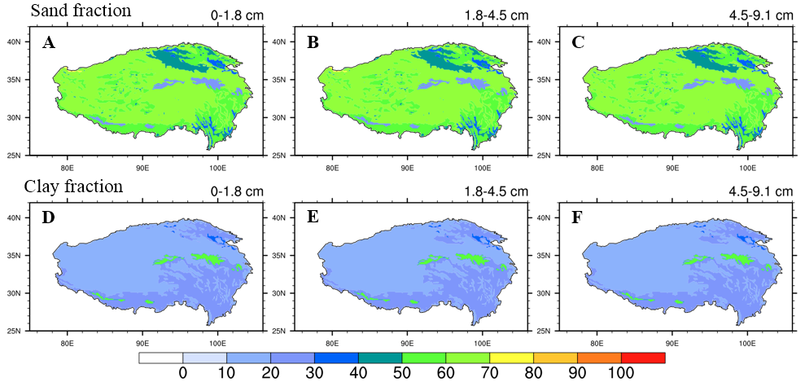
Figure S1 Surface (0-10 cm) soil (A-C) sand and (D-F) clay fraction (unit: %) over the TP (from CLM5.0 surface data).

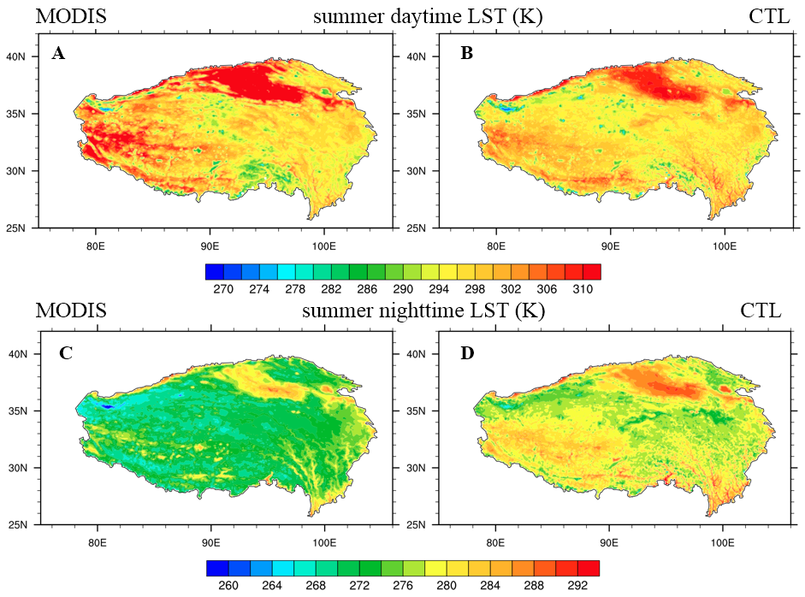
Figure S2 Spatial distribution of (A, B) daytime and (C, D) nighttime land surface temperature (unit: K) averaged over summers of 2003-2018 from MODIS/Aqua and CTL simulations.

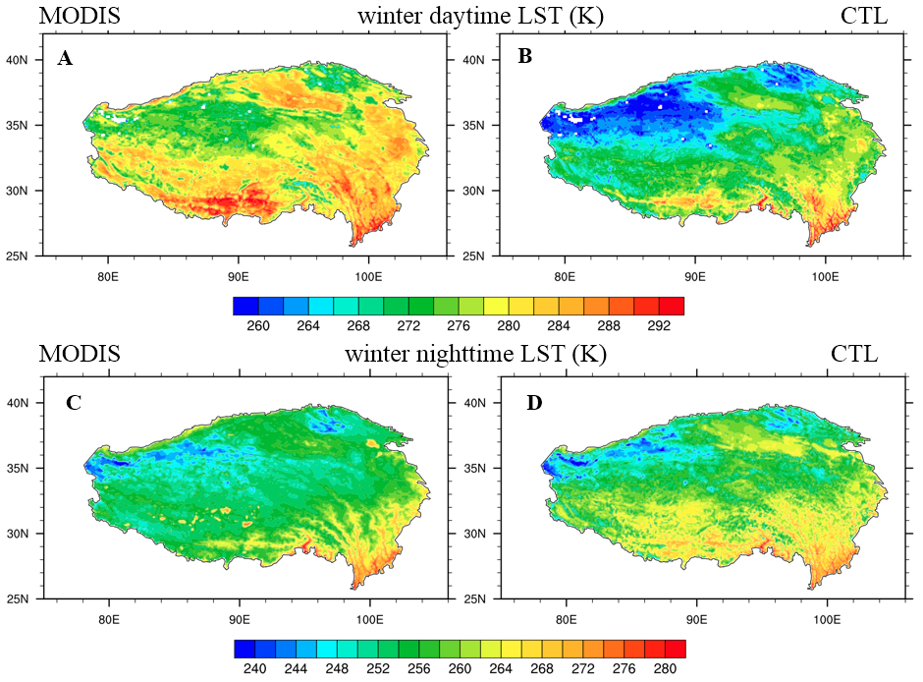
Figure S3 Spatial distribution of (A, B) daytime and (C, D) nighttime land surface temperature (unit: K) averaged over winters of 2003-2018 from MODIS/Aqua and CTL simulations.

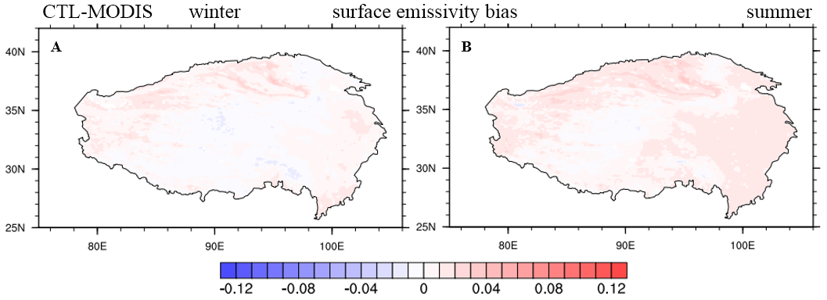
Figure S4 Seasonal distributions of the surface emissivity bias between CTL and MODIS/Aqua (CTL-MODIS) averaged over 2003-2018 for (A) winter and (B) summer.

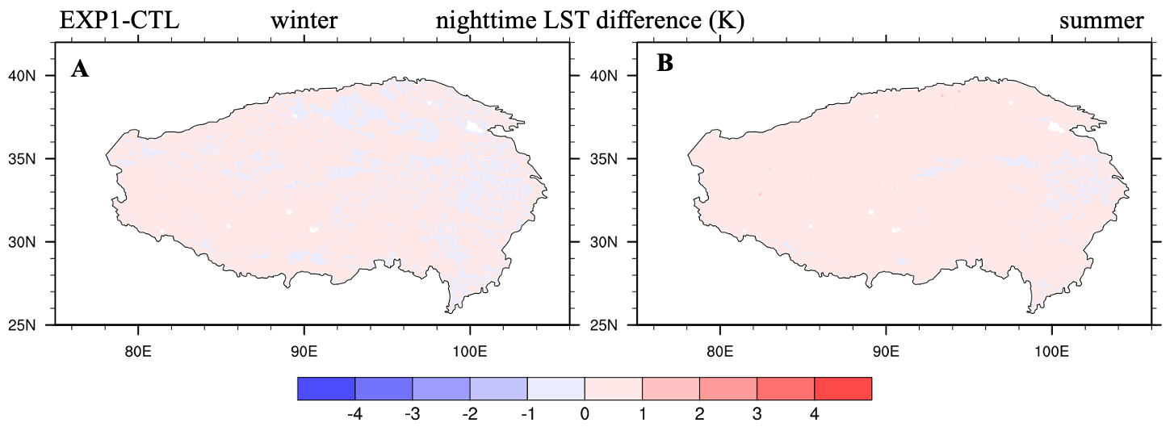
Figure S5 Seasonal distributions of the nighttime LST difference (unit: K) between EXP1 and CTL averaged over 2003-2018 for (A) winter and (B) summer.

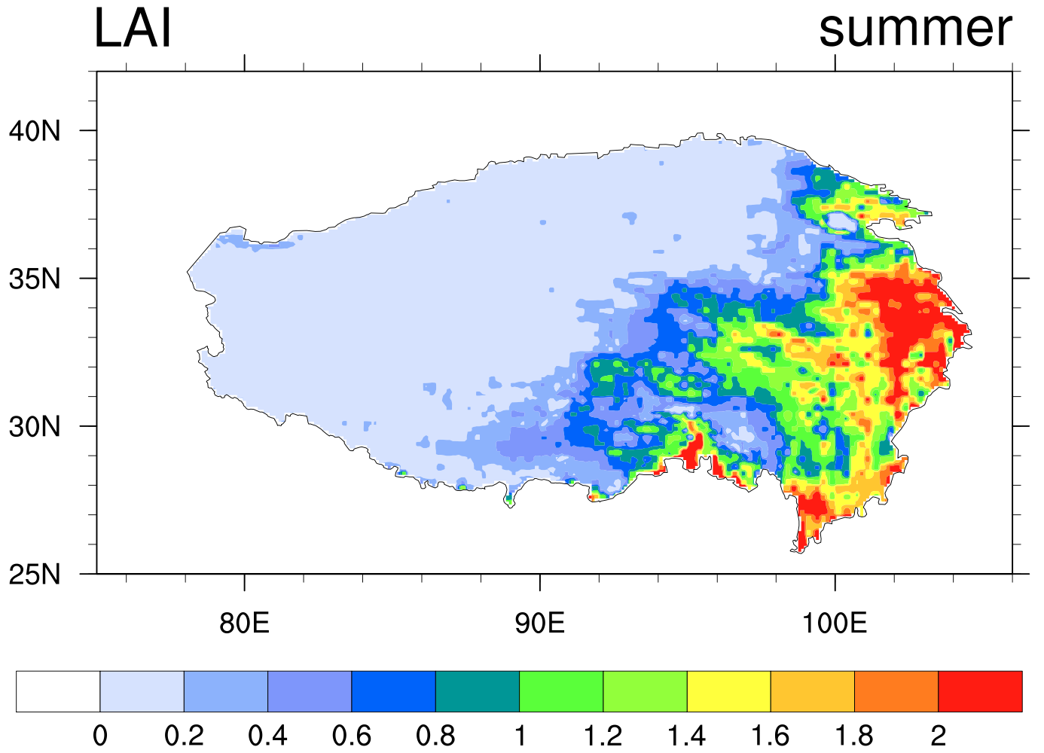
Figure S6 Spatial distribution of summer leaf area index (LAI) over the TP (from CLM5.0 surface data).

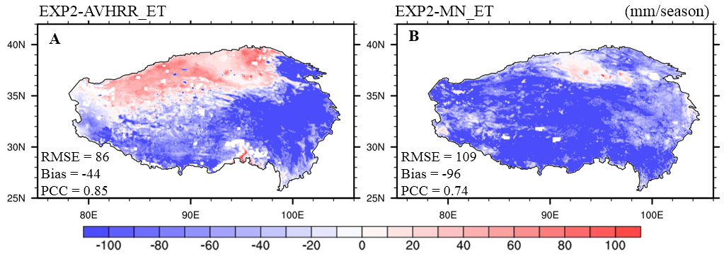
Figure S7 Seasonal distributions of the ET biases (unit: mm/season) between EXP2, (A) AVHRR_ET ¹ and (B) MN_ET ² products averaged over 2003-2018 for summer.
¹ AVHRR_ET data are from Zhang et al. (2010)
² MN_ET data are from Ma et al. (2019)
Zhang K, Kimball JS, Nemani RR, Running SW. 2010. A continuous satellite–derived global record of land surface evapotranspiration from 1983 to 2006. Water Resources Research 46: W09522 DOI 10.1029/2009WR008800.

Ma N, Szilagyi J, Zhang Y, Liu W. 2019. Complementary–relationship–based modeling of terrestrial evapotranspiration across China during 1982–2012: validations and spatiotemporal analyses. Journal of Geophysical Research: Atmospheres 124:4326–4351.

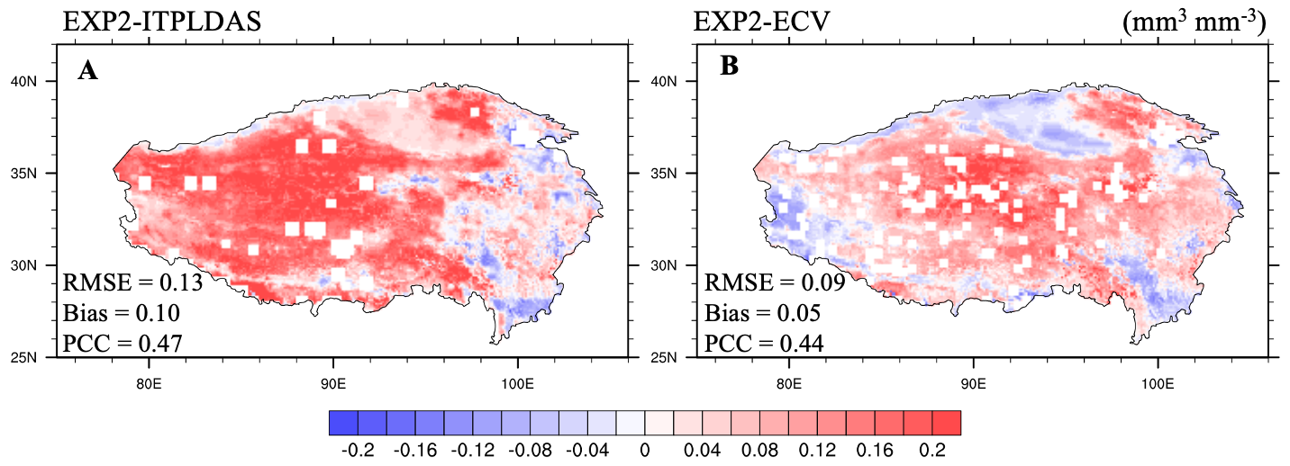
Figure S8 Seasonal distributions of the 0-5 cm soil moisture biases (unit: mm³ mm⁻³) between EXP2, (A) ITPLDAS³ and (B) ECV⁴ products averaged over 2003-2011 for summer.
³ ITPLDAS data are from Yang et al. (2018)
⁴ ECV data are from Cui et al. (2019)
Yang K. 2018. The soil moisture dataset of China based on microwave data assimilation (2002-2011). National Tibetan Plateau Data Center. DOI 10.11888/AtmosphericPhysics.tpe.249448.file.

Cui Y, Zeng C, Zhou J, Xie H, Wan W, Hu L, Xiong W, Chen X, Fan W, Hong Y. 2019. A spatio-temporal continuous soil moisture dataset over the Tibet Plateau from 2002 to 2015. Scientific Data 6:247 DOI 10.1038/s41597-019-0228-x.

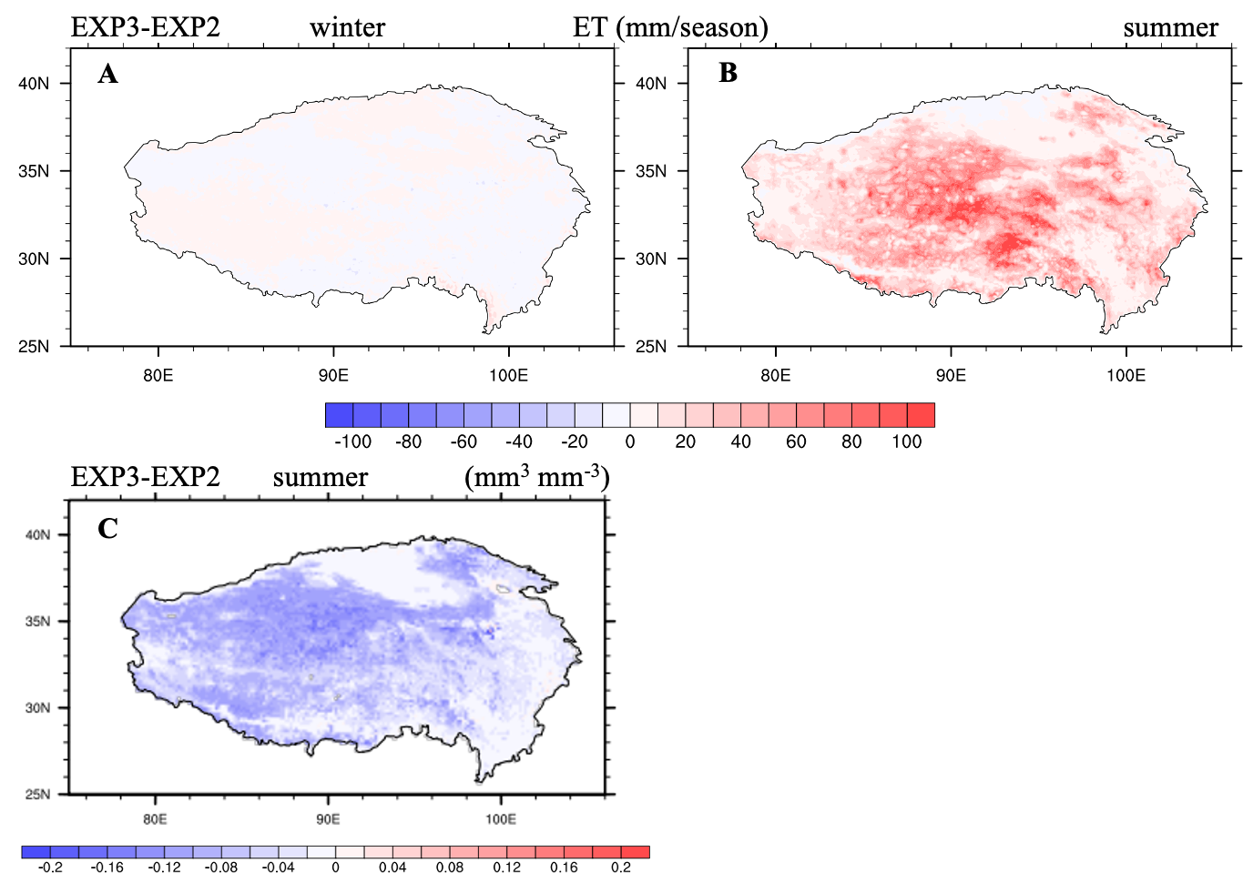
Figure S9 Seasonal distributions of the (A) winter ET, (B) summer ET (mm/season), and (C) summer surface (0-10 cm) soil moisture (mm³ mm⁻³) differences between EXP3 and EXP2 averaged over 2003-2018.

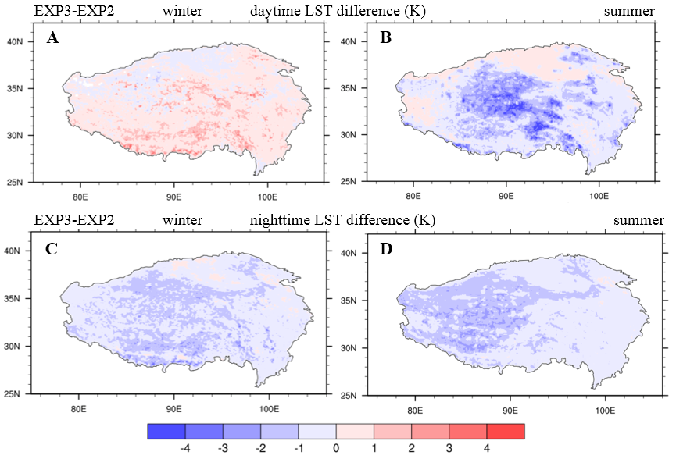
Figure S10 Seasonal distributions of the (A, B) daytime and (C, D) nighttime LST differences (unit: K) between EXP3 and EXP2 (EXP3-EXP2) averaged over 2003-2018 for winter and summer.

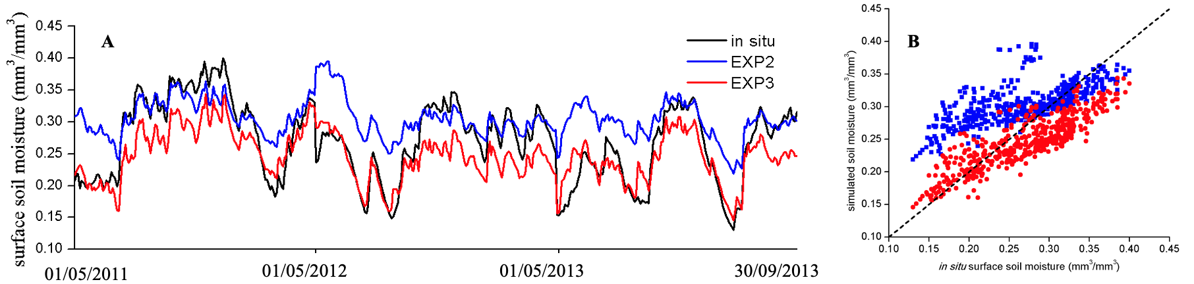
Figure S11 Comparison of the daily 0-5 cm soil moisture (unit: mm³ mm⁻³) from in situ observations for the Naqu network (black line) and CLM5.0 simulations [EXP2 (blue line) and EXP3 (red line)] during May-September 2011-2013: (A) the time series and (B) the scatterplot for the Naqu network.

