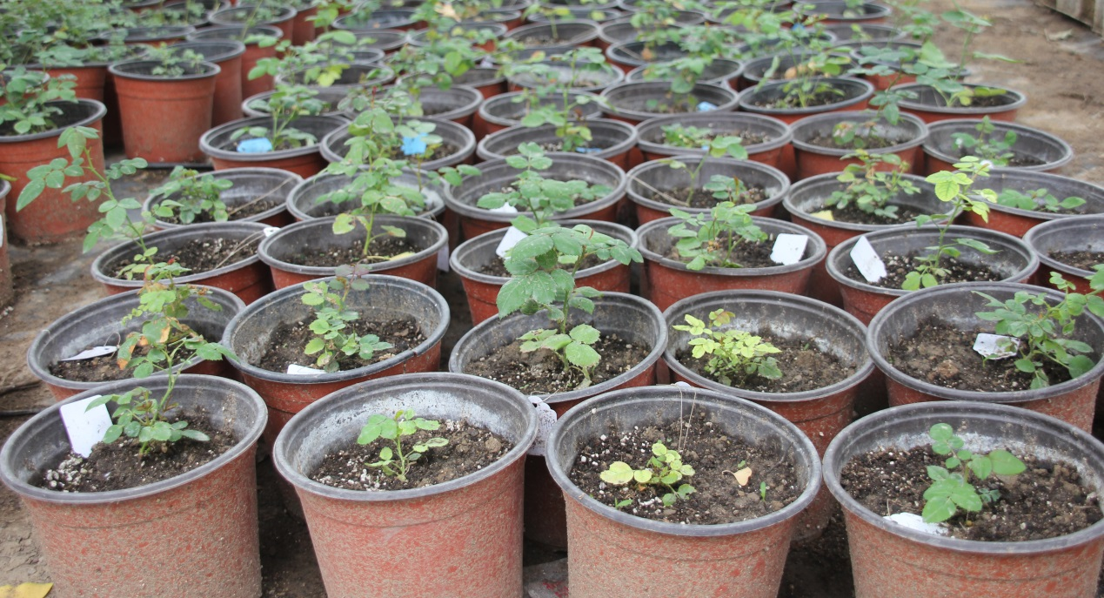

Fig.S1F1 offspring seedlingsnormally growth from seeds of colchicine-induced ‘Old Blush’ 2n pollen pollination on‘Orange Fire’ pistil.

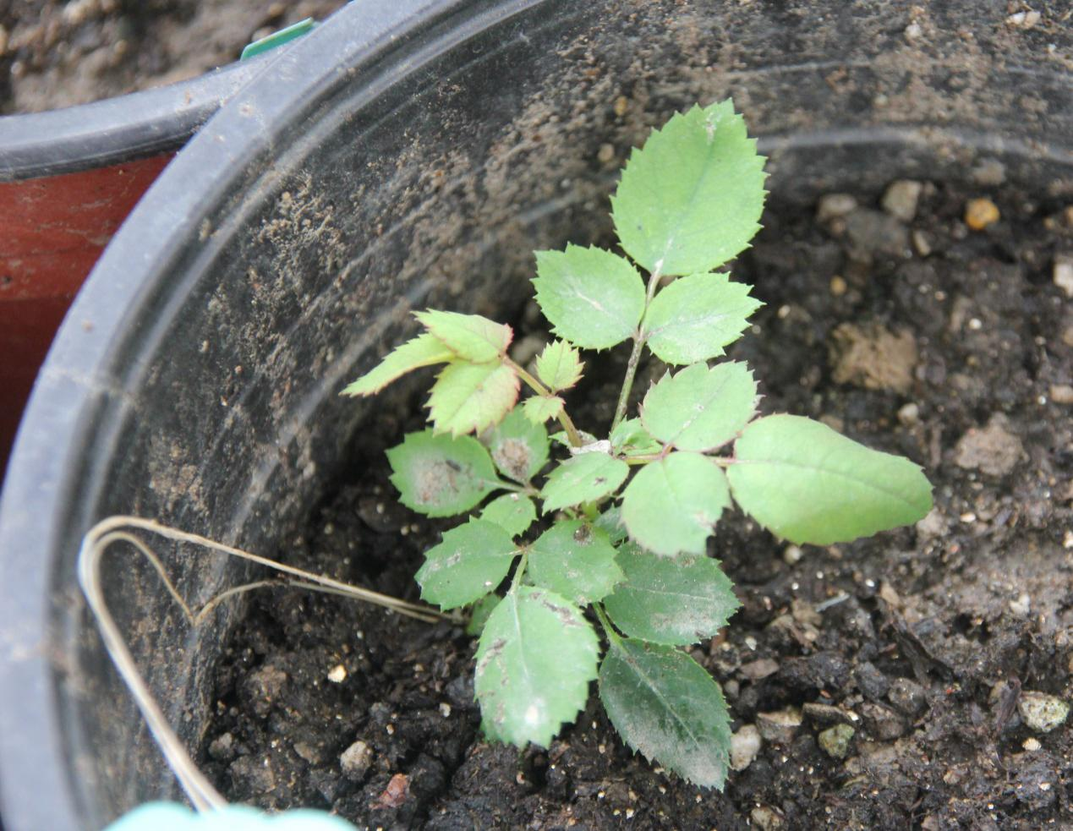

Fig.S2 F1 offspring seedling normally growth from seedof colchicine-induced‘Old Blush’ 2n pollen pollination on ‘Orange Fire’ pistil.

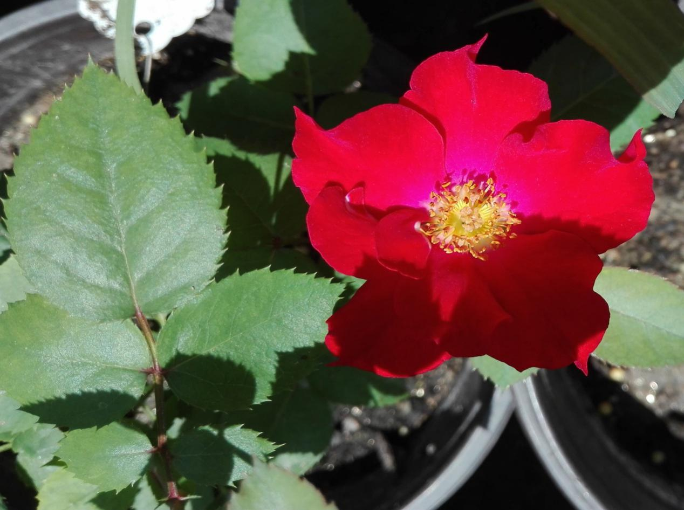

Fig. S3 F1 offspring plant normally flowering of colchicine-induced ‘Old Blush’ 2n pollen pollination on ‘Orange Fire’ pistil.

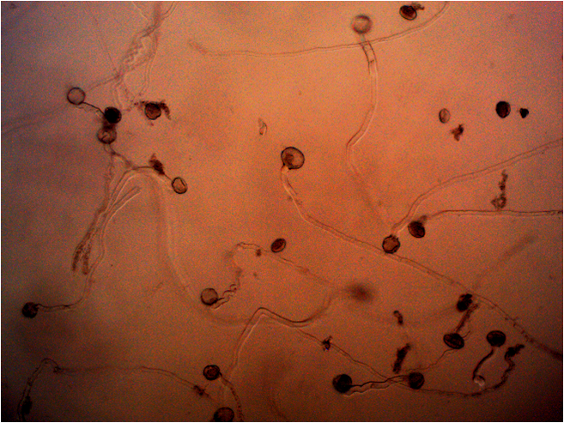

Fig. S4 original images for Figure 2C-colchicine-induced ‘Old Blush’ 2n pollen or colchicine-treated ‘Old Blush’ 1n pollen germination in vitro

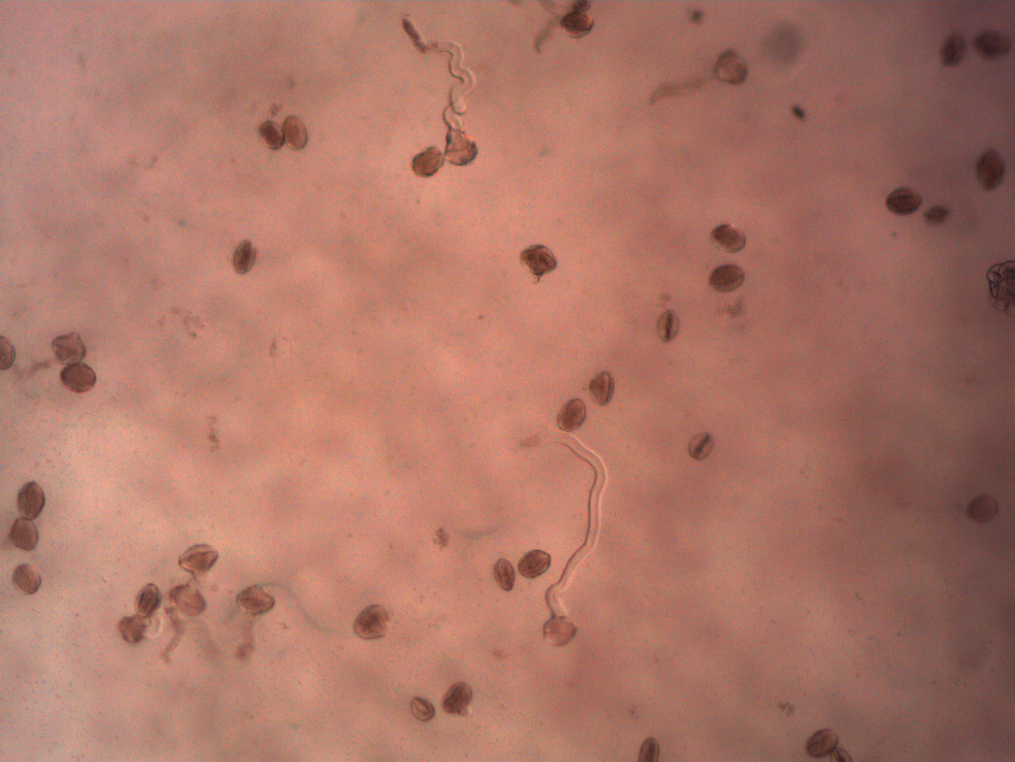

Fig. S5 original images for Figure 2B-natural 1n pollen germination in vitro