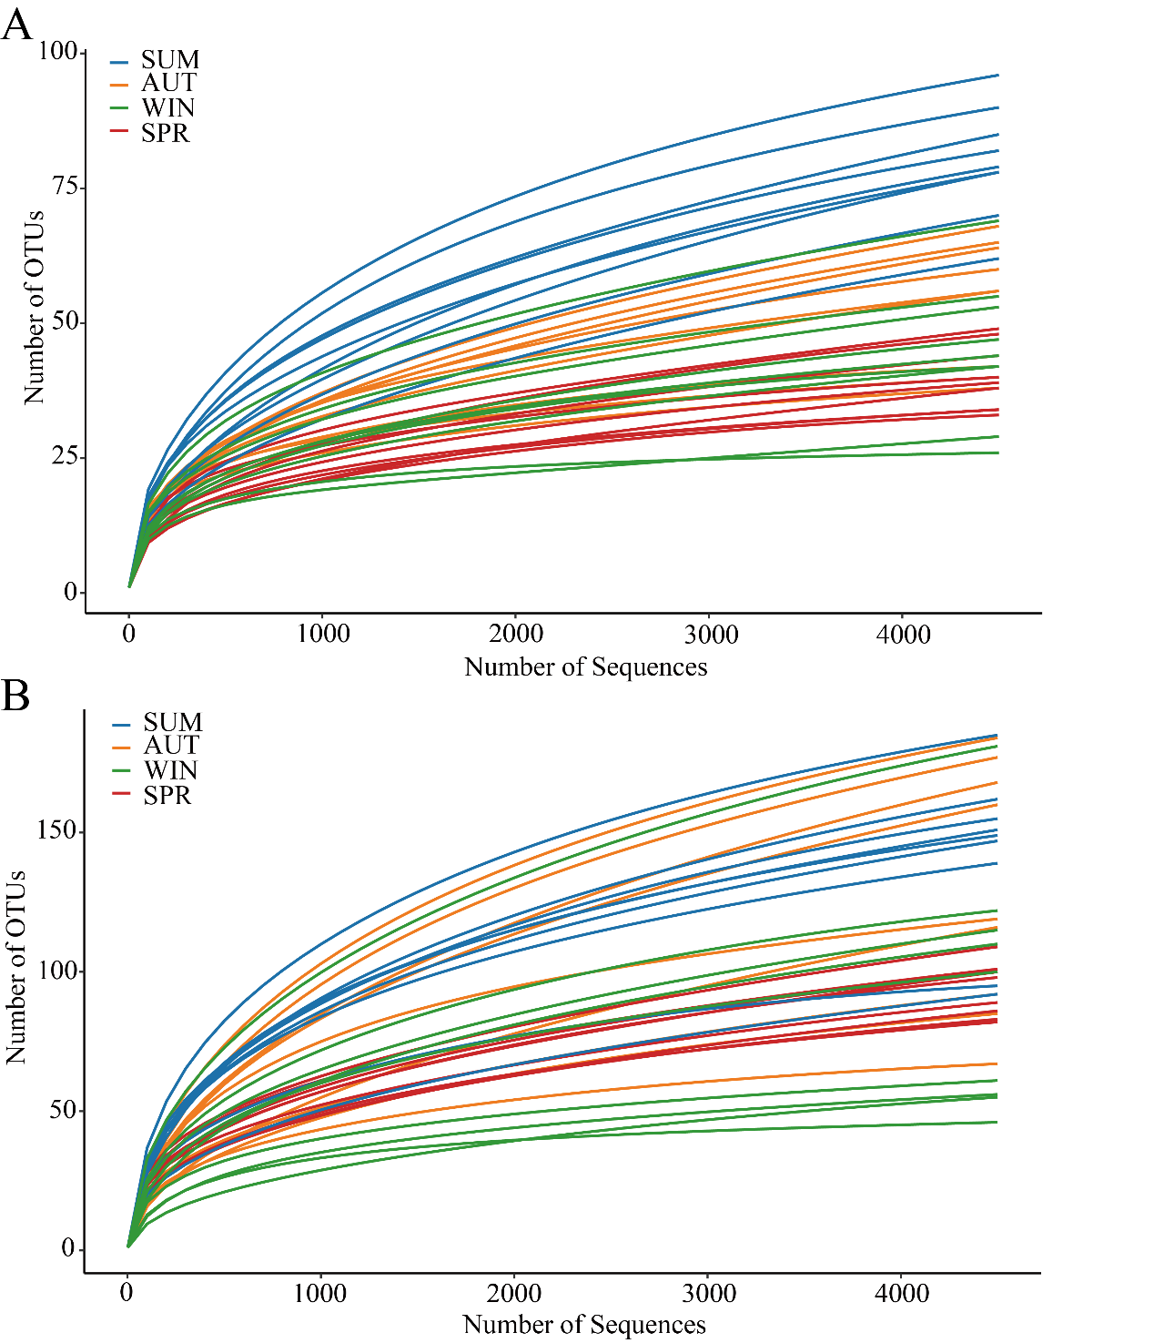
Fig. S2 Rarefaction curve for each sample based on 18S rRNA (A) and COI gene (B).

