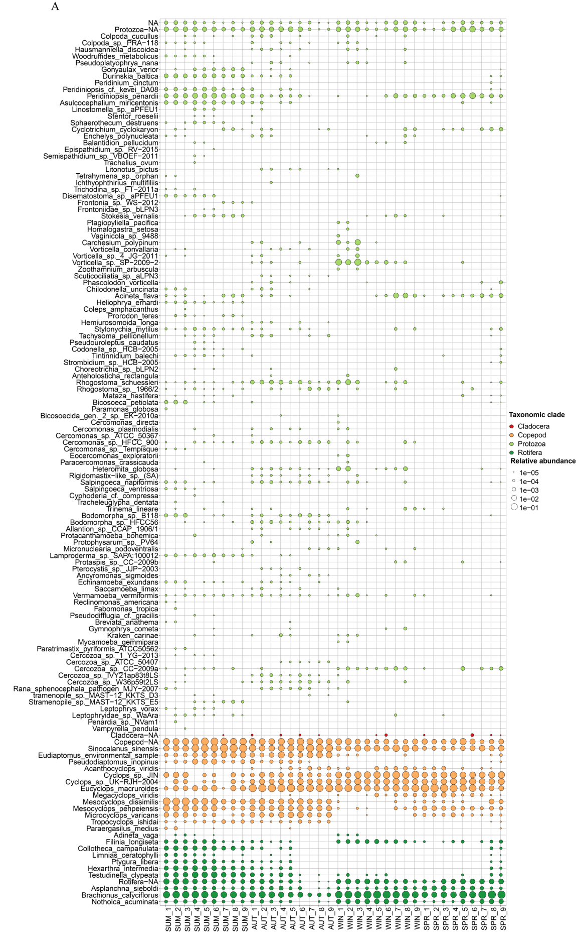
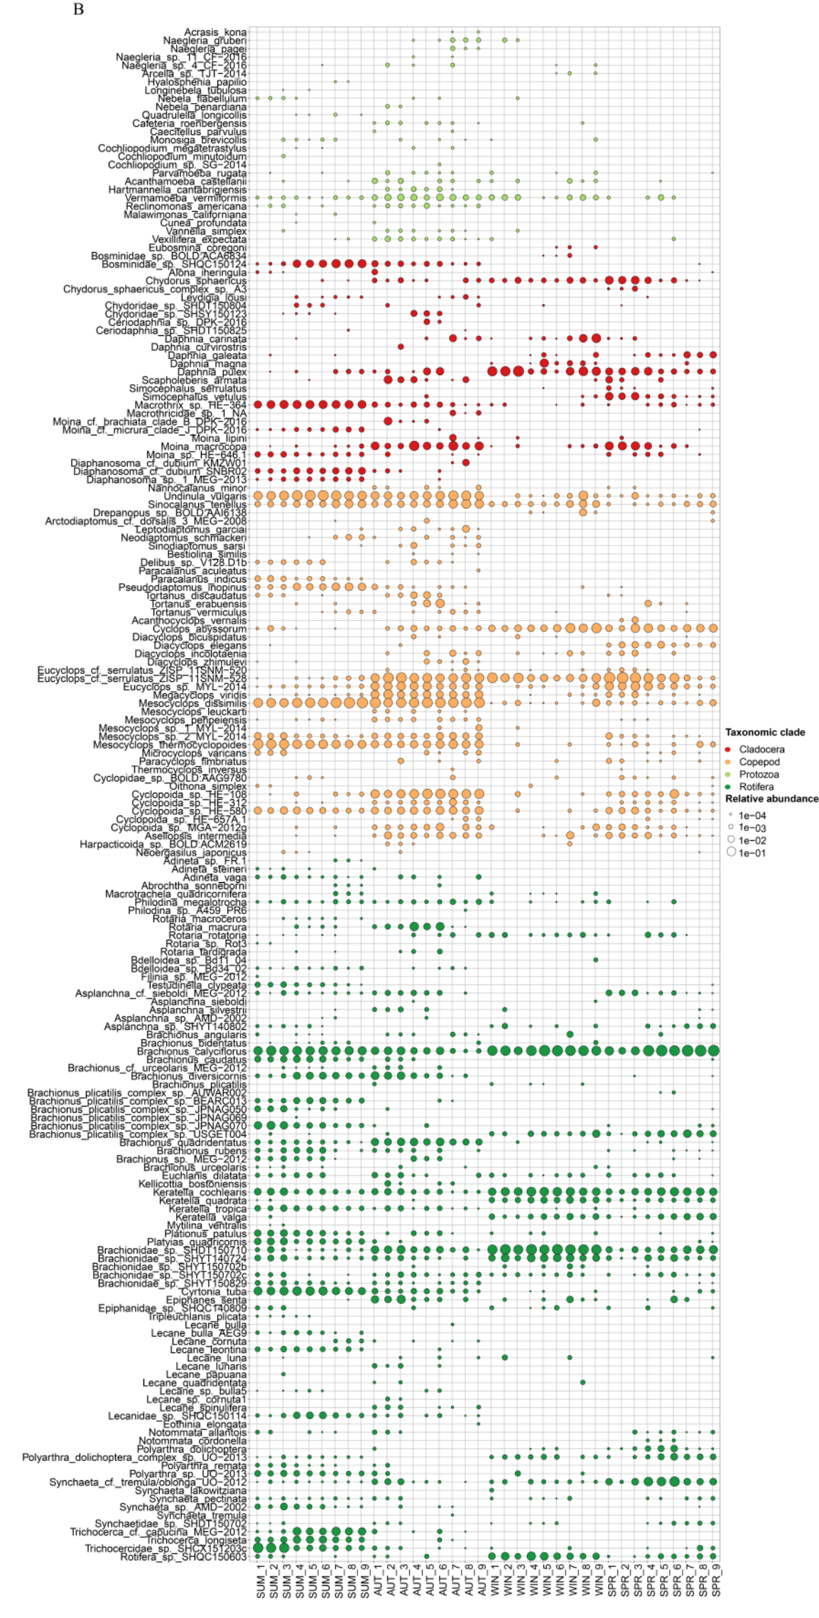
Fig. S3 The seasonal distribution of zooplankton species is sample-based. (A) 18S rRNA; (B) COI.

