Tab.S1 Corm developmental process and the morphology of Freesia hybrida ‘SN Huangjin’
Day after planting | 60～90 d | 90~120 d | 120~140 d | 140~190 d
Plant developmental stage | Five-leaf to eight-leaf stage | Eight-leaf to flower bub stage | Flower bub to blossoming stage | Late blossoming to withering stage
New corm developmental stage | Formation stage | Initial swelling stage | Fast swelling stage | Maturation stage
Plant morphology | 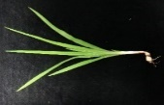 | 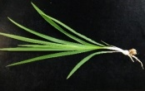 | 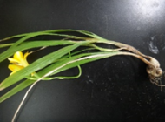 | 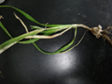
Corm morphology | 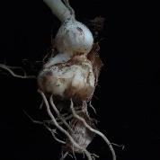  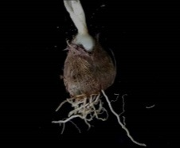 | 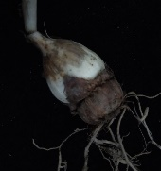  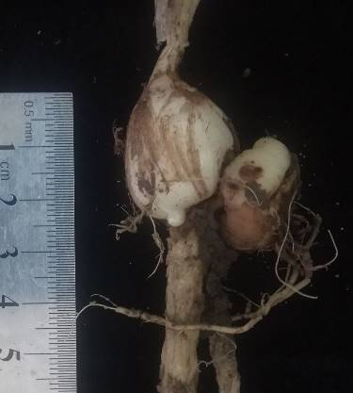 |  | 