Appendices

Additional information on tow-camera surveys
In March 2018 there were
- 3 x 50 m transects at the bommies (C20_BB, C20_BT, M12_BB, M12_BT)
- 3 x 50 m transects on the reef crest (RS1_1-3m, RS2_1-3m, RS3_1-3m)
- 5 x 50 m transects on the reef slope (RS1_1-6m, RS2_1-6m, RS3_1-6m)
In October 2019 there were
- 6 x 20 m transects at the bommies (C20_BB, C20_BT, M12_BB, M12_BT)
- 3 x 50 m transects on the reef crest (RS1_1-3m, RS2_1-3m, RS3_1-3m)
- 5 x 50 m transects on the reef slope (RS1_1-6m, RS2_1-6m, RS3_1-6m)
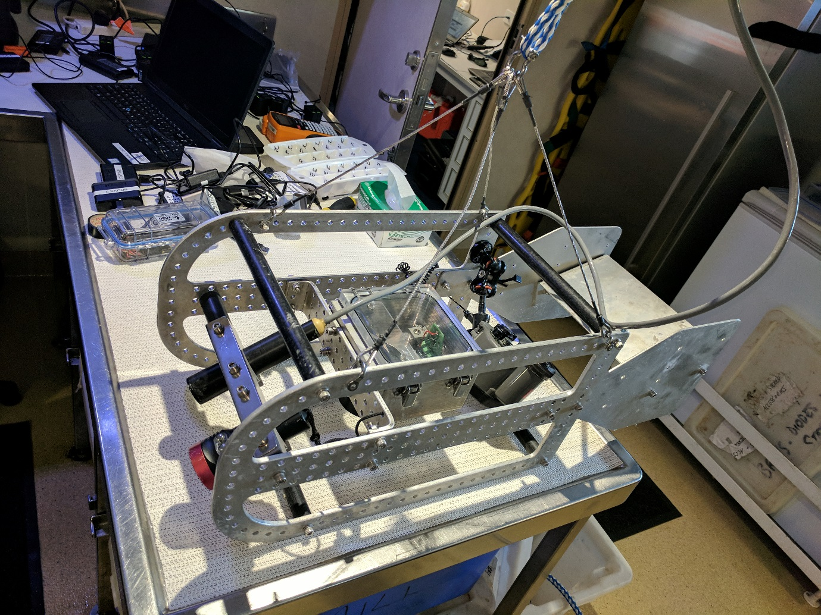
Figure S 1.1. Photograph of the tow-camera body with key elements indicated from the AIMS Slow Video (SlowVID) standard operating procedure (SOP).
Video Camera
Video Light
Still Camera Housing
Inon Strobe
Cable attachment point

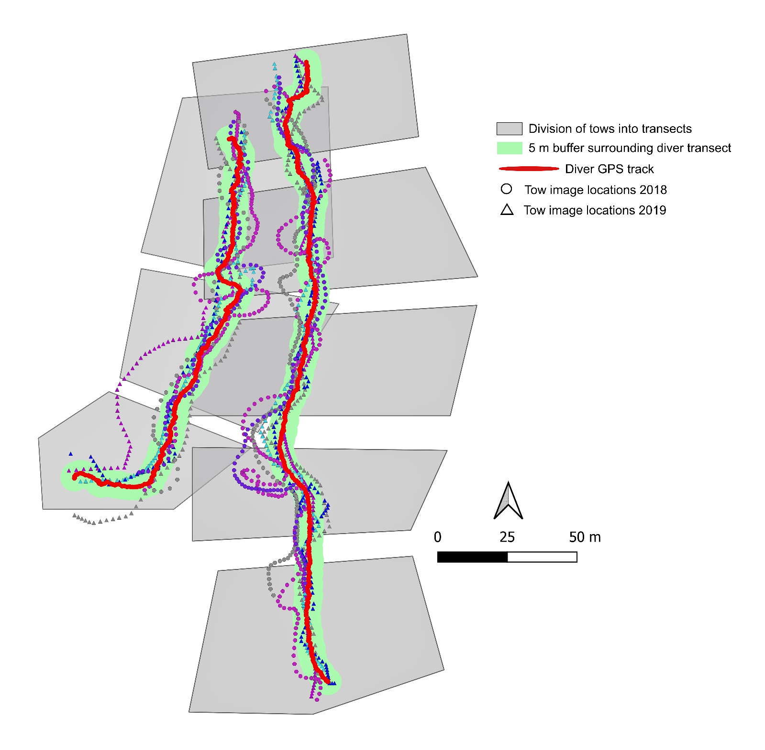
Figure S 1.2. Example of how tows were partitioned into separate transects and image selection. The red line shows the diver GPS track, which the tow followed as close as possible. The circles (2018) and triangles (2019) are the approximate GPS locations of images taken on the tows. Different colours indicate replicate tows. The green shading indicates a 5 m buffer either side of the diver track; only tow-camera images within this buffer were included in the analysis. The grey polygons show how a full site tow was divided into the underlying end-to-end transects.

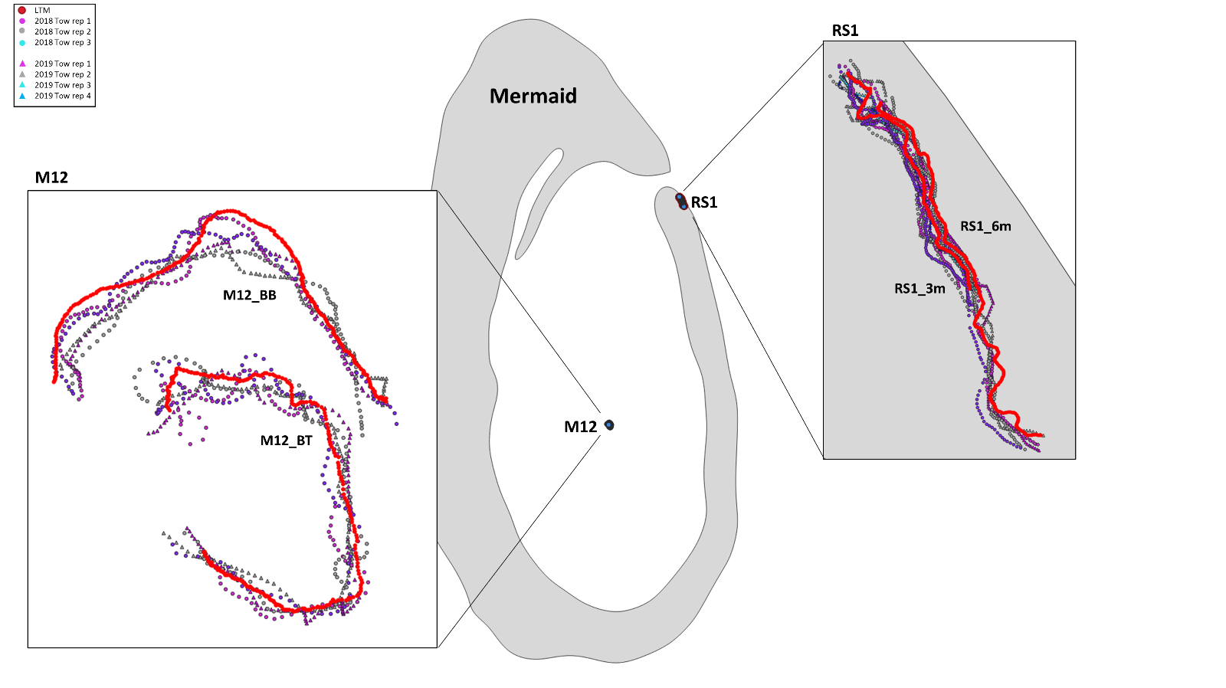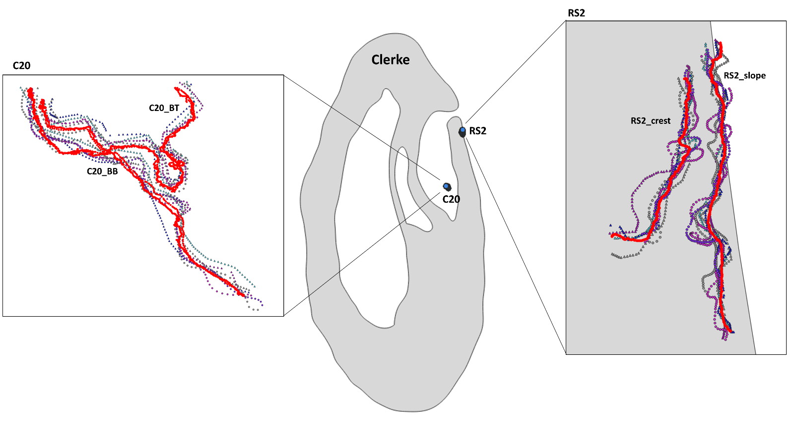
Figure S 1.3. All diver (red) and tow-camera tracks (coloured dots) at the eight Mermaid and Clerke Reef sites.

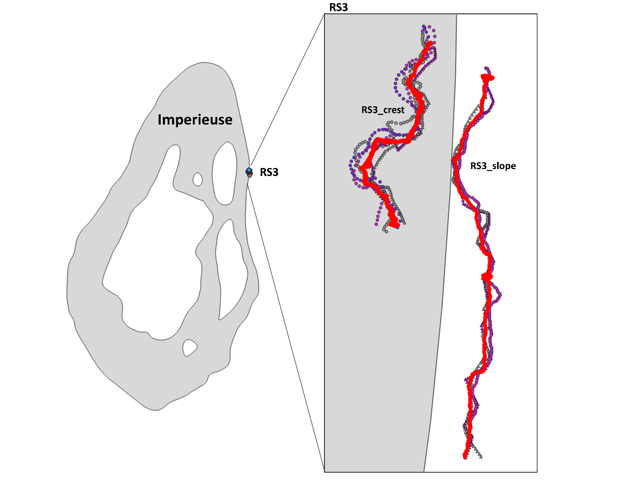
Figure S 1.4. All diver (red) and tow-camera tracks (coloured dots) at the two Imperieuse Reef sites.

Table S 1.1. Summary of images removed due to distance from diver transect and mean distances of the tow-camera images from the fixed-position diver transects before and after image removal.
Year | Habitat | Site | Total images | Images analysed | Images within buffer | Mean distance all images | Mean distance images within buffer
2018 | Lagoon floor | C20_BB | 338 | 241 | 214 | 2.1 | 1.6
2018 | Bommie | C20_BT | 195 | 142 | 132 | 2.0 | 1.6
2018 | Bommie | M12_BT | 296 | 207 | 165 | 3.0 | 2.0
2018 | Lagoon floor | M12_BB | 277 | 200 | 134 | 3.8 | 2.2
2018 | Reef crest | RS1_1_3m | 361 | 260 | 144 | 4.7 | 2.6
2018 | Reef slope | RS1_1_6m | 390 | 280 | 163 | 5.6 | 2.4
2018 | Reef crest | RS2_1_3m | 353 | 250 | 179 | 3.4 | 1.9
2018 | Reef slope | RS2_1_6m | 454 | 320 | 194 | 5.2 | 2.5
2018 | Reef crest | RS3_1_3m | 243 | 173 | 121 | 3.5 | 2.0
2018 | Reef slope | RS3_1_6m | 214 | 153 | 138 | 2.6 | 2.1
2019 | Lagoon floor | C20_BB | 490 | 490 | 389 | 2.9 | 1.8
2019 | Bommie | C20_BT | 428 | 428 | 335 | 3.5 | 2.0
2019 | Bommie | M12_BB | 273 | 273 | 156 | 5.5 | 1.9
2019 | Lagoon floor | M12_BT | 265 | 265 | 234 | 3.1 | 1.9
2019 | Reef crest | RS1_1_3m | 588 | 588 | 476 | 2.9 | 1.9
2019 | Reef slope | RS1_1_6m | 401 | 401 | 312 | 4.2 | 2.0
2019 | Reef crest | RS2_1_3m | 502 | 502 | 259 | 11.0 | 2.1
2019 | Reef slope | RS2_1_6m | 660 | 660 | 583 | 2.3 | 1.6
2019 | Reef crest | RS3_1_3m | 224 | 224 | 198 | 2.5 | 2.0
2019 | Reef slope | RS3_1_6m | 363 | 363 | 328 | 2.0 | 1.5

Additional information on covariates
Table S 2.1. Mean, standard deviation (SD) and range of slope and depths of each site
Site | Mean slope | SD slope | Maximum slope | Minimum slope | Mean depth | SD depth | Maximum depth | Minimum depth
C20_BB | 15.62922 | 6.973706 | 36.05087 | 3.144965 | -3.62301 | 1.351265 | -0.62757 | -6.69246
C20_BT | 14.07977 | 9.566393 | 33.74439 | 0.63958 | -1.17078 | 0.961841 | -0.18745 | -5.91893
M12_BB | 25.43189 | 4.540996 | 31.87066 | 16.13121 | -9.82217 | 0.974678 | -7.82711 | -12.2902
M12_BT | 7.659009 | 3.947725 | 17.73629 | 1.506977 | -3.43983 | 0.602143 | -2.43824 | -5.02123
RS1_1_3m | 27.23049 | 12.8781 | 45.94009 | 0.822844 | -4.9376 | 1.733825 | -2.27842 | -8.40957
RS1_1_6m | 38.76374 | 11.11776 | 58.77383 | 10.35546 | -8.59698 | 2.426796 | -3.99982 | -13.5148
RS2_1_3m | 2.857542 | 1.609829 | 8.867118 | 0.8115 | -3.40515 | 0.702373 | -1.82304 | -4.33967
RS2_1_6m | 17.0146 | 5.259219 | 30.06892 | 6.809129 | -8.31598 | 1.86423 | -5.45439 | -13.6511
RS3_1_3m | 7.439029 | 2.468455 | 13.65593 | 2.991309 | -4.29808 | 0.703253 | -2.59782 | -5.68995
RS3_1_6m | 3.960932 | 2.812719 | 11.11246 | 0.452653 | -7.22252 | 0.600925 | -5.88012 | -8.31287

Additional statistics
Table S 3.1. Pairwise comparison for the term method x habitat for pairs of the levels of factor method, i.e. tow-camera versus diver-camera, within each habitat level.
Benthic community
Habitat | t (perm) | P (perm) | Permutations
Crest | 1.7072 | 0.0375 | 9961
Lagoon bommie | 3.758 | 0.0001 | 9962
Lagoon floor | 4.999 | 0.0001 | 9972
Slope | 2.4707 | 0.0001 | 9957
Coral community
Crest | 1.9458 | 0.0006 | 9941
Lagoon bommie | 1.1772 | 0.247 | 9958
Lagoon floor | 1.1046 | 0.3199 | 9947
Slope | 2.3332 | 0.0001 | 9943

Table S 3.2. Mean and standard error of cover across all transects for each benthic and coral group.
 | Diver mean | Diver SE | Tow mean | Tow SE
Benthic groups
Abiotic | 8.33 | 1.27 | 16.15 | 2.28
Crustose coralline algae | 51.30 | 1.61 | 36.69 | 1.52
Hard coral | 37.56 | 1.79 | 32.56 | 1.82
Unidentified substratum | 1.29 | 0.22 | 12.58 | 1.56
Macroalgae | 3.58 | 0.42 | 2.53 | 0.27
Other organisms | 0.87 | 0.10 | 0.85 | 0.12
Soft coral | 2.28 | 0.38 | 2.23 | 0.43
Sponge | 1.60 | 0.22 | 1.17 | 0.18
Coral groups
Branching Acropora | 6.31 | 0.82 | 6.32 | 0.90
Digitate and corymbose Acropora | 7.02 | 0.58 | 4.88 | 0.40
Tabular Acropora | 3.22 | 0.39 | 4.28 | 0.41
Astreopora | 0.93 | 0.16 | 0.84 | 0.12
Unidentified coral | 0.37 | 0.00 | 0.71 | 0.10
Diploastrea | 3.41 | 0.81 | 1.71 | 0.39
Encrusting corals | 10.26 | 0.69 | 8.54 | 0.63
Foliose corals | 1.11 | 0.31 | 0.91 | 0.23
Fungiidae | 1.62 | 0.24 | 1.33 | 0.22
Isopora | 5.05 | 0.50 | 4.59 | 0.39
Merulinidae | 4.18 | 0.30 | 3.03 | 0.26
Millepora | 3.37 | 0.38 | 2.15 | 0.20
Pavona | 0.65 | 0.15 | 0.50 | 0.08
Pocilloporidae | 3.50 | 0.28 | 2.92 | 0.26
Porites | 2.01 | 0.23 | 2.01 | 0.23
Uncommon | 0.99 | 0.14 | 0.95 | 0.09

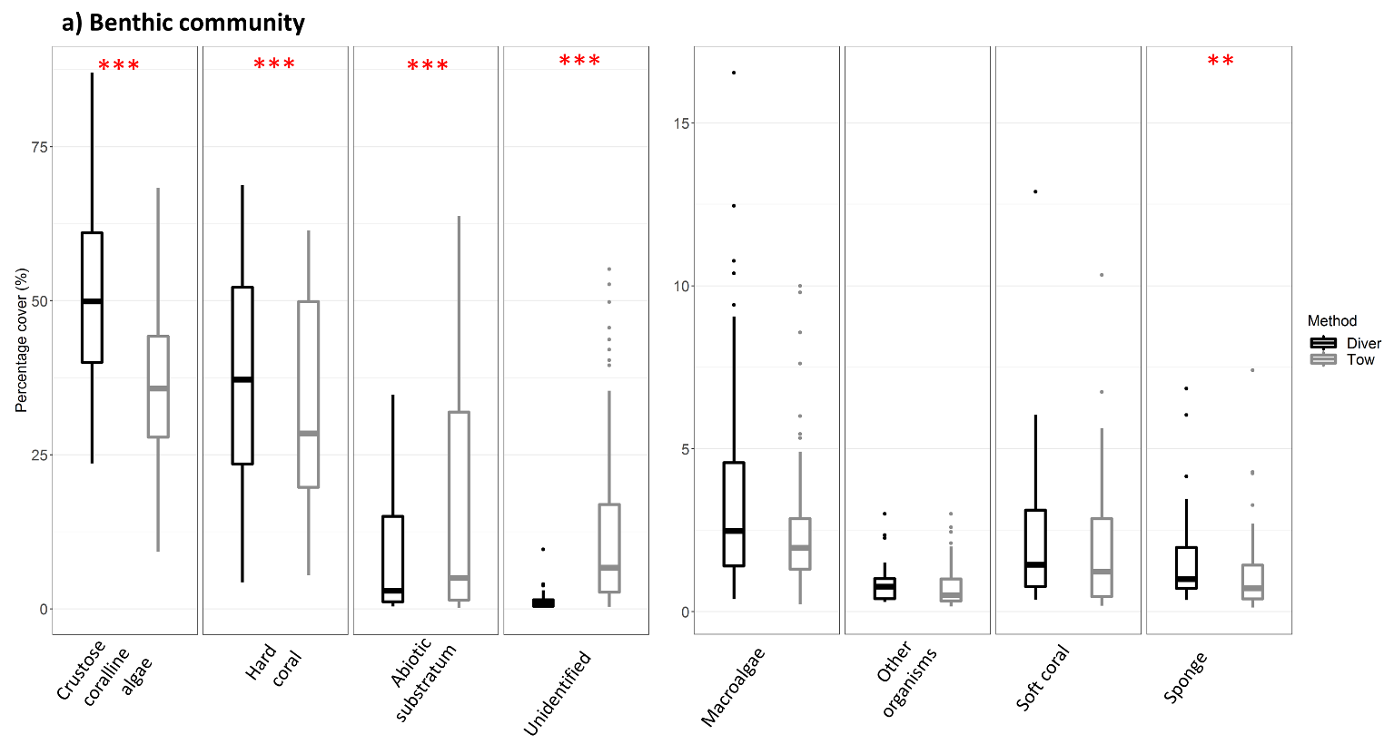
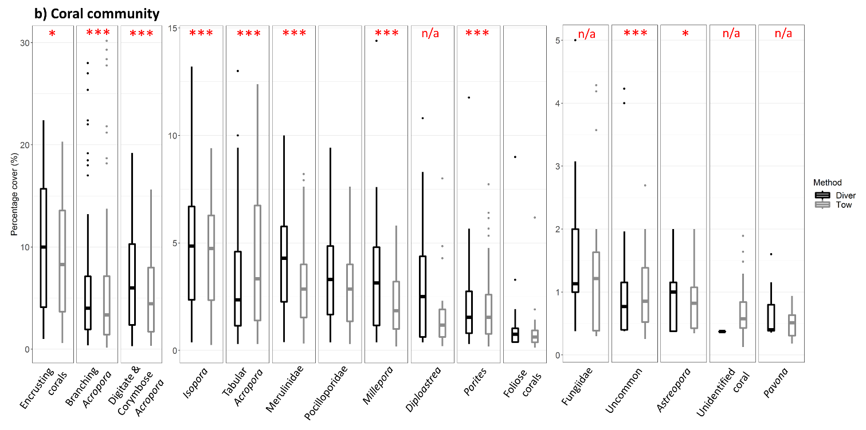
Figure S 3.1. Boxplots of each of the a) benthic and b) coral community categories for the two survey methods averaged across all transects (n = 168 transects spread over 10 sites and two years of surveys). Red asterisks indicate a significant difference between the two methods (***: p < 0.001, **p < 0.01, * p < 0.05) as determined from binomial generalised linear mixed-effects models.

Table S 3.3. Intercepts and test statistics from linear models for each benthic and coral group. The intercept gives the prediction of Δcover (diver -tow-camera) when all other variables in the models (see Table 3.3) were mean centred. Blue text (positive) indicates the diver detected more cover of a group, while red text indicates the tow-camera detected a higher cover.
Benthic groups
Group | Estimate | Std. error | t-value | P-value
Crustose coralline algae | 13.609 | 0.432 | 31.537 | <0.001
Hard coral | 4.246 | 0.359 | 11.828 | <0.001
Abiotic | -10.274 | 0.429 | -23.945 | <0.001
Unidentified substratum | -7.771 | 0.426 | -18.234 | <0.001
Macroalgae | 0.159 | 0.117 | 1.354 | 0.176
Other organisms | 0.067 | 0.037 | 1.804 | 0.072
Soft coral | 0.157 | 0.078 | 2.026 | 0.043
Sponge | -0.195 | 0.08 | -2.447 | 0.015
Coral taxa
Group | Estimate | Std. error | t-value | P-value
Branching Acropora | -0.456 | 0.157 | -2.902 | 0.004
Digitate and corymbose Acropora | 1.996 | 0.134 | 14.86 | <0.001
Tabular Acropora | -1.215 | 0.121 | -10.051 | <0.001
Astreopora | -0.035 | 0.018 | -2.019 | 0.044
Encrusting corals | 0.578 | 0.175 | 3.3 | 0.001
Foliose corals | -0.067 | 0.046 | -1.462 | 0.144
Isopora | 0.582 | 0.091 | 6.371 | <0.001
Merulinidae | 1.071 | 0.091 | 11.73 | <0.001
Millepora | 0.489 | 0.093 | 5.27 | <0.001
Pocilloporidae | 0.24 | 0.07 | 3.443 | <0.001
Porites | 0.427 | 0.064 | 6.683 | <0.001
Uncommon | 0.156 | 0.038 | 4.104 | <0.001

Table S 3.4. Test statistics from linear models for each benthic and coral group. The first term is the intercept for the crest habitat, at Clerke reef, in 2018, and all other estimates reference to this estimate. Colours match to Figure 3 in the main manuscript. Blue text indicates a positive estimate while red text is a negative estimate.
Benthic groups
group | Term | Estimate | Std. error | t-value | P-value
Crustose coralline algae | Slope_Clerke_2018 | -26.092 | 1.936 | -13.477 | <0.001
Crustose coralline algae | log (images) | -3.764 | 0.83 | -4.535 | <0.001
Crustose coralline algae | depth | 2.373 | 0.256 | 9.271 | <0.001
Crustose coralline algae | Δ Crest | 7.771 | 1.352 | 5.748 | <0.001
Crustose coralline algae | Δ Bommie | 16.827 | 1.824 | 9.226 | <0.001
Crustose coralline algae | Δ Lagoon floor | 23.852 | 1.072 | 22.26 | <0.001
Crustose coralline algae | Δ Imperieuse | -2.222 | 1.105 | -2.012 | 0.045
Crustose coralline algae | Δ Mermaid | 11.544 | 1.039 | 11.109 | <0.001
Crustose coralline algae | Δ 2019 | 22.533 | 0.946 | 23.815 | <0.001
Hard coral | Slope_Clerke_2018 | 9.282 | 1.935 | 4.796 | <0.001
Hard coral | log (slope) | 3.122 | 0.484 | 6.448 | <0.001
Hard coral | log (images) | -2.822 | 0.718 | -3.93 | <0.001
Hard coral | depth | -2.072 | 0.216 | -9.583 | <0.001
Hard coral | Δ Crest | -6.311 | 1.133 | -5.568 | <0.001
Hard coral | Δ Bommie | -10.037 | 1.533 | -6.546 | <0.001
Hard coral | Δ Lagoon floor | -10.516 | 0.891 | -11.798 | <0.001
Hard coral | Δ Imperieuse | 5.668 | 1.01 | 5.612 | <0.001
Hard coral | Δ Mermaid | 8.137 | 0.917 | 8.873 | <0.001
Hard coral | Δ 2019 | 2.945 | 0.799 | 3.685 | <0.001
Abiotic | Slope_Clerke_2018 | 20.162 | 2.313 | 8.716 | <0.001
Abiotic | log (slope) | 2.51 | 0.579 | 4.336 | <0.001
Abiotic | log (images) | 6.137 | 0.858 | 7.15 | <0.001
Abiotic | depth | -2.112 | 0.258 | -8.174 | <0.001
Abiotic | Δ Crest | -11.183 | 1.355 | -8.255 | <0.001
Abiotic | Δ Bommie | -24.01 | 1.833 | -13.101 | <0.001
Abiotic | Δ Lagoon floor | -27.298 | 1.065 | -25.622 | <0.001
Abiotic | Δ Imperieuse | -3.18 | 1.207 | -2.634 | 0.009
Abiotic | Δ Mermaid | -7.024 | 1.096 | -6.408 | <0.001
Abiotic | Δ 2019 | -11.802 | 0.955 | -12.357 | <0.001
Unidentified substratum | Slope_Clerke_2018 | -8.6 | 2.298 | -3.743 | <0.001
Unidentified substratum | log (slope) | -6.206 | 0.575 | -10.793 | <0.001
Unidentified substratum | log (images) | 2.326 | 0.853 | 2.728 | 0.007
Unidentified substratum | depth | 1.957 | 0.257 | 7.624 | <0.001
Unidentified substratum | Δ Crest | 12.003 | 1.346 | 8.919 | <0.001
Unidentified substratum | Δ Bommie | 23.761 | 1.82 | 13.052 | <0.001
Unidentified substratum | Δ Lagoon floor | 14.473 | 1.058 | 13.676 | <0.001
Unidentified substratum | Δ Imperieuse | 3.715 | 1.199 | 3.098 | 0.002
Unidentified substratum | Δ Mermaid | -13.026 | 1.089 | -11.964 | <0.001
Unidentified substratum | Δ 2019 | -9.562 | 0.949 | -10.079 | <0.001
Macroalgae | Slope_Clerke_2018 | 2.946 | 0.633 | 4.655 | <0.001
Macroalgae | log (slope) | 0.289 | 0.158 | 1.822 | 0.069
Macroalgae | log (images) | -0.788 | 0.235 | -3.355 | <0.001
Macroalgae | depth | 0.127 | 0.071 | 1.793 | 0.073
Macroalgae | Δ Crest | -1.289 | 0.371 | -3.477 | <0.001
Macroalgae | Δ Bommie | -3.743 | 0.501 | -7.465 | <0.001
Macroalgae | Δ Lagoon floor | -0.125 | 0.292 | -0.429 | 0.668
Macroalgae | Δ Imperieuse | -3.159 | 0.33 | -9.562 | <0.001
Macroalgae | Δ Mermaid | 0.69 | 0.3 | 2.3 | 0.022
Macroalgae | Δ 2019 | -4.105 | 0.261 | -15.707 | <0.001
Other organisms | Slope_Clerke_2018 | -0.81 | 0.16 | -5.065 | <0.001
Other organisms | log (slope) | 0.336 | 0.051 | 6.592 | <0.001
Other organisms | log (images) | -0.618 | 0.076 | -8.165 | <0.001
Other organisms | Δ Crest | 0.161 | 0.091 | 1.783 | 0.075
Other organisms | Δ Bommie | -0.299 | 0.103 | -2.911 | 0.004
Other organisms | Δ Lagoon floor | 0.526 | 0.09 | 5.847 | <0.001
Other organisms | Δ Imperieuse | -0.015 | 0.106 | -0.14 | 0.889
Other organisms | Δ Mermaid | -0.495 | 0.083 | -5.958 | <0.001
Other organisms | Δ 2019 | 0.336 | 0.085 | 3.962 | <0.001
Soft coral | Slope_Clerke_2018 | 0.539 | 0.348 | 1.549 | 0.122
Soft coral | log (images) | -0.306 | 0.149 | -2.053 | 0.04
Soft coral | depth | -0.087 | 0.046 | -1.888 | 0.059
Soft coral | Δ Crest | 0.121 | 0.243 | 0.498 | 0.619
Soft coral | Δ Bommie | 0.094 | 0.328 | 0.286 | 0.775
Soft coral | Δ Lagoon floor | 0.657 | 0.193 | 3.412 | <0.001
Soft coral | Δ Imperieuse | 0.2 | 0.199 | 1.009 | 0.313
Soft coral | Δ Mermaid | -0.406 | 0.187 | -2.171 | 0.03
Soft coral | Δ 2019 | -0.071 | 0.17 | -0.416 | 0.678
Sponge | Slope_Clerke_2018 | 1.646 | 0.429 | 3.839 | <0.001
Sponge | log (slope) | 0.38 | 0.107 | 3.543 | <0.001
Sponge | log (images) | -0.342 | 0.159 | -2.152 | 0.032
Sponge | depth | -0.224 | 0.048 | -4.672 | <0.001
Sponge | Δ Crest | -1.164 | 0.251 | -4.635 | <0.001
Sponge | Δ Bommie | -2.42 | 0.34 | -7.124 | <0.001
Sponge | Δ Lagoon floor | -1.571 | 0.197 | -7.953 | <0.001
Sponge | Δ Imperieuse | -0.631 | 0.224 | -2.821 | 0.005
Sponge | Δ Mermaid | 0.318 | 0.203 | 1.564 | 0.118
Sponge | Δ 2019 | -0.15 | 0.177 | -0.849 | 0.396
Coral taxa
group | Term | Estimate | Std. error | t-value | P-value
Branching Acropora | Slope_Clerke_2018 | 1.547 | 0.856 | 1.808 | 0.071
Branching Acropora | log (slope) | -0.747 | 0.192 | -3.893 | <0.001
Branching Acropora | depth | -0.198 | 0.098 | -2.019 | 0.044
Branching Acropora | Δ Crest | -0.545 | 0.48 | -1.137 | 0.256
Branching Acropora | Δ Bommie | 1.226 | 0.705 | 1.739 | 0.082
Branching Acropora | Δ Lagoon floor | -3.205 | 0.412 | -7.772 | <0.001
Branching Acropora | Δ Imperieuse | 1.072 | 0.382 | 2.805 | 0.005
Branching Acropora | Δ Mermaid | 2.779 | 0.374 | 7.422 | <0.001
Branching Acropora | Δ 2019 | 0.639 | 0.242 | 2.635 | 0.009
Digitate and corymbose Acropora | Slope_Clerke_2018 | 1.925 | 0.731 | 2.632 | 0.009
Digitate and corymbose Acropora | log (slope) | -0.582 | 0.164 | -3.551 | <0.001
Digitate and corymbose Acropora | depth | 0.351 | 0.084 | 4.173 | <0.001
Digitate and corymbose Acropora | Δ Crest | 0.99 | 0.41 | 2.414 | 0.016
Digitate and corymbose Acropora | Δ Bommie | -0.401 | 0.602 | -0.666 | 0.506
Digitate and corymbose Acropora | Δ Lagoon floor | -1.663 | 0.353 | -4.718 | <0.001
Digitate and corymbose Acropora | Δ Imperieuse | -2.027 | 0.327 | -6.208 | <0.001
Digitate and corymbose Acropora | Δ Mermaid | -2.878 | 0.32 | -8.992 | <0.001
Digitate and corymbose Acropora | Δ 2019 | 2.581 | 0.207 | 12.455 | <0.001
Tabular Acropora | Slope_Clerke_2018 | -1.223 | 0.669 | -1.828 | 0.068
Tabular Acropora | log (slope) | 0.348 | 0.152 | 2.29 | 0.022
Tabular Acropora | log (images) | -0.738 | 0.255 | -2.897 | 0.004
Tabular Acropora | depth | -0.471 | 0.076 | -6.199 | <0.001
Tabular Acropora | Δ Crest | 0.076 | 0.373 | 0.203 | 0.839
Tabular Acropora | Δ Bommie | 1.446 | 0.544 | 2.658 | 0.008
Tabular Acropora | Δ Lagoon floor | 2.245 | 0.321 | 6.993 | <0.001
Tabular Acropora | Δ Imperieuse | 1.419 | 0.301 | 4.714 | <0.001
Tabular Acropora | Δ Mermaid | 2.87 | 0.294 | 9.762 | <0.001
Tabular Acropora | Δ 2019 | -0.7 | 0.275 | -2.543 | 0.011
Astreopora | Slope_Clerke_2018 | 0.258 | 0.096 | 2.694 | 0.007
Astreopora | log (slope) | 0.047 | 0.021 | 2.183 | 0.029
Astreopora | depth | -0.049 | 0.011 | -4.439 | <0.001
Astreopora | Δ Crest | -0.147 | 0.054 | -2.741 | 0.006
Astreopora | Δ Bommie | -0.118 | 0.079 | -1.502 | 0.133
Astreopora | Δ Lagoon floor | -0.189 | 0.046 | -4.107 | <0.001
Astreopora | Δ Imperieuse | -0.059 | 0.043 | -1.387 | 0.166
Astreopora | Δ Mermaid | -0.036 | 0.042 | -0.849 | 0.396
Astreopora | Δ 2019 | 0.059 | 0.027 | 2.175 | 0.03
Encrusting corals | Slope_Clerke_2018 | 3.607 | 0.953 | 3.783 | <0.001
Encrusting corals | log (slope) | 1.941 | 0.214 | 9.08 | <0.001
Encrusting corals | depth | -0.995 | 0.11 | -9.081 | <0.001
Encrusting corals | Δ Crest | -3.916 | 0.535 | -7.325 | <0.001
Encrusting corals | Δ Bommie | -5.959 | 0.785 | -7.587 | <0.001
Encrusting corals | Δ Lagoon floor | -4.446 | 0.46 | -9.675 | <0.001
Encrusting corals | Δ Imperieuse | 2.425 | 0.426 | 5.696 | <0.001
Encrusting corals | Δ Mermaid | 4.677 | 0.417 | 11.211 | <0.001
Encrusting corals | Δ 2019 | -1.142 | 0.27 | -4.228 | <0.001
Foliose corals | Slope_Clerke_2018 | 0.966 | 0.224 | 4.319 | <0.001
Foliose corals | log (images) | -0.138 | 0.094 | -1.458 | 0.145
Foliose corals | depth | -0.131 | 0.029 | -4.592 | <0.001
Foliose corals | Δ Crest | -0.429 | 0.142 | -3.026 | 0.003
Foliose corals | Δ Bommie | -0.798 | 0.207 | -3.866 | <0.001
Foliose corals | Δ Lagoon floor | -0.189 | 0.122 | -1.545 | 0.123
Foliose corals | Δ Imperieuse | 0.177 | 0.105 | 1.69 | 0.091
Foliose corals | Δ Mermaid | 0.247 | 0.104 | 2.369 | 0.018
Foliose corals | Δ 2019 | -0.059 | 0.104 | -0.571 | 0.568
Isopora | Slope_Clerke_2018 | -1.667 | 0.448 | -3.724 | <0.001
Isopora | log (images) | -1.079 | 0.189 | -5.709 | <0.001
Isopora | depth | 0.232 | 0.057 | 4.041 | <0.001
Isopora | Δ Crest | 2.47 | 0.284 | 8.709 | <0.001
Isopora | Δ Bommie | 1.784 | 0.413 | 4.315 | <0.001
Isopora | Δ Lagoon floor | 0.491 | 0.245 | 2.004 | 0.045
Isopora | Δ Imperieuse | -0.625 | 0.209 | -2.984 | 0.003
Isopora | Δ Mermaid | -1.281 | 0.208 | -6.148 | <0.001
Isopora | Δ 2019 | 0.789 | 0.207 | 3.807 | <0.001
Merulinidae | Slope_Clerke_2018 | -2.73 | 0.505 | -5.403 | <0.001
Merulinidae | log (slope) | 0.946 | 0.115 | 8.253 | <0.001
Merulinidae | log (images) | -0.424 | 0.192 | -2.204 | 0.028
Merulinidae | depth | 0.195 | 0.057 | 3.397 | <0.001
Merulinidae | Δ Crest | 1.616 | 0.282 | 5.732 | <0.001
Merulinidae | Δ Bommie | -0.115 | 0.411 | -0.28 | 0.78
Merulinidae | Δ Lagoon floor | -1.239 | 0.242 | -5.112 | <0.001
Merulinidae | Δ Imperieuse | 0.256 | 0.227 | 1.126 | 0.261
Merulinidae | Δ Mermaid | -0.34 | 0.222 | -1.533 | 0.126
Merulinidae | Δ 2019 | 0.716 | 0.208 | 3.449 | <0.001
Millepora | Slope_Clerke_2018 | 0.05 | 0.384 | 0.13 | 0.897
Millepora | log (images) | -0.454 | 0.209 | -2.176 | 0.03
Millepora | log (slope) | 0.267 | 0.123 | 2.164 | 0.031
Millepora | Δ Crest | -0.534 | 0.209 | -2.552 | 0.011
Millepora | Δ Bommie | -0.887 | 0.257 | -3.447 | <0.001
Millepora | Δ Lagoon floor | -1.129 | 0.254 | -4.441 | <0.001
Millepora | Δ Imperieuse | 0.744 | 0.246 | 3.027 | 0.003
Millepora | Δ Mermaid | -0.063 | 0.212 | -0.298 | 0.765
Millepora | Δ 2019 | 0.476 | 0.226 | 2.107 | 0.035
Pocilloporidae | Slope_Clerke_2018 | -0.739 | 0.289 | -2.559 | 0.011
Pocilloporidae | log (images) | -1.004 | 0.157 | -6.4 | <0.001
Pocilloporidae | log (slope) | 0.613 | 0.093 | 6.599 | <0.001
Pocilloporidae | Δ Crest | -0.552 | 0.157 | -3.505 | <0.001
Pocilloporidae | Δ Bommie | -0.146 | 0.193 | -0.754 | 0.451
Pocilloporidae | Δ Lagoon floor | -0.971 | 0.191 | -5.077 | <0.001
Pocilloporidae | Δ Imperieuse | -0.196 | 0.185 | -1.06 | 0.289
Pocilloporidae | Δ Mermaid | -0.931 | 0.159 | -5.85 | <0.001
Pocilloporidae | Δ 2019 | 0.733 | 0.17 | 4.316 | <0.001
Porites | Slope_Clerke_2018 | -1.726 | 0.244 | -7.068 | <0.001
Porites | log (slope) | 0.484 | 0.083 | 5.845 | <0.001
Porites | Δ Crest | -0.215 | 0.135 | -1.592 | 0.112
Porites | Δ Bommie | 0.721 | 0.168 | 4.296 | <0.001
Porites | Δ Lagoon floor | 0.294 | 0.172 | 1.714 | 0.087
Porites | Δ Imperieuse | 1.879 | 0.164 | 11.438 | <0.001
Porites | Δ Mermaid | 0.116 | 0.139 | 0.837 | 0.403
Porites | Δ 2019 | 0.248 | 0.106 | 2.345 | 0.019
Uncommon | Slope_Clerke_2018 | -0.149 | 0.211 | -0.705 | 0.481
Uncommon | log (slope) | 0.269 | 0.048 | 5.621 | <0.001
Uncommon | log (images) | 0.306 | 0.08 | 3.81 | <0.001
Uncommon | depth | -0.057 | 0.024 | -2.396 | 0.017
Uncommon | Δ Crest | -0.197 | 0.118 | -1.676 | 0.094
Uncommon | Δ Bommie | -0.333 | 0.171 | -1.942 | 0.053
Uncommon | Δ Lagoon floor | 0.137 | 0.101 | 1.356 | 0.176
Uncommon | Δ Imperieuse | 1.052 | 0.095 | 11.09 | <0.001
Uncommon | Δ Mermaid | -0.003 | 0.093 | -0.035 | 0.972
Uncommon | Δ 2019 | -0.545 | 0.087 | -6.281 | <0.001

