<https://www.ncbi.nlm.nih.gov/nuccore/MT645231>

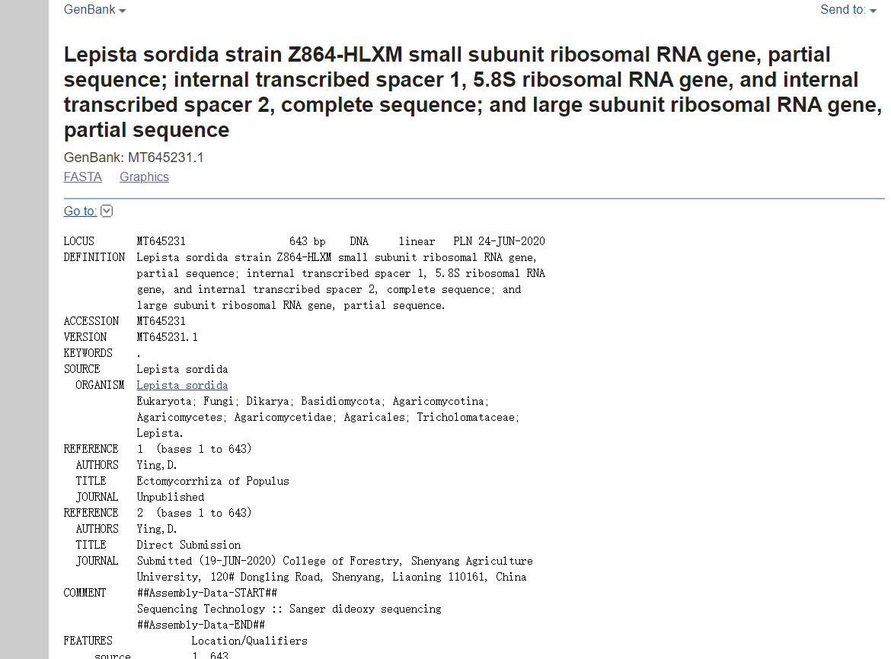

The sequence was submitted to GenBank to obtain the gene login number MT645231.