Bpl-12231_c0_g3_i2

Bpl-10897_c0_g1_i1

Bpl-10897_c0_g2_i2

Bpl-13734_c0_g2_i5
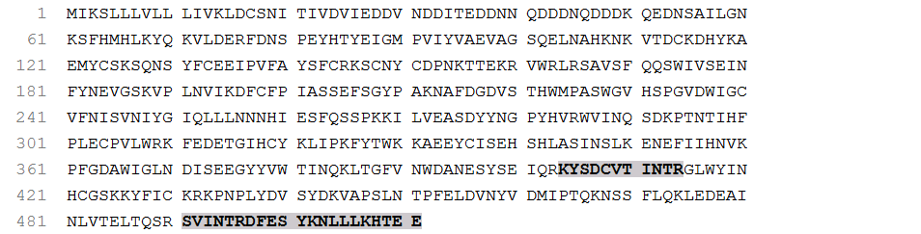

Ccr-20068_c0_g1_i1
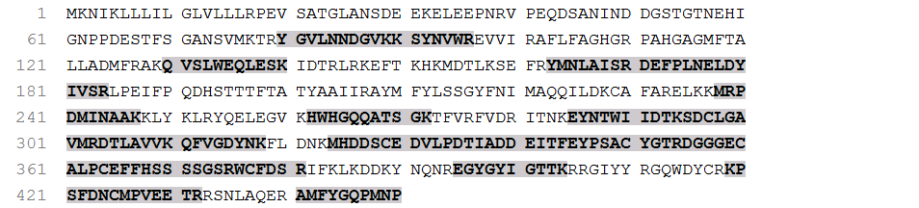

Ccr-21624_c0_g1_i1

Ccr-21624_c0_g2_i1

Ccr-22147_c7_g1_i1
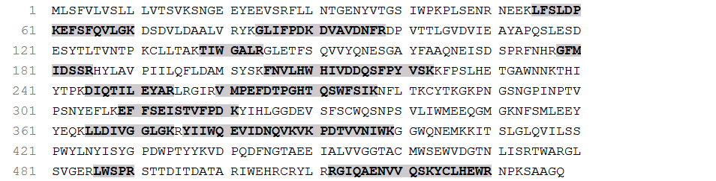

Ccr-22960_c1_g1_i4
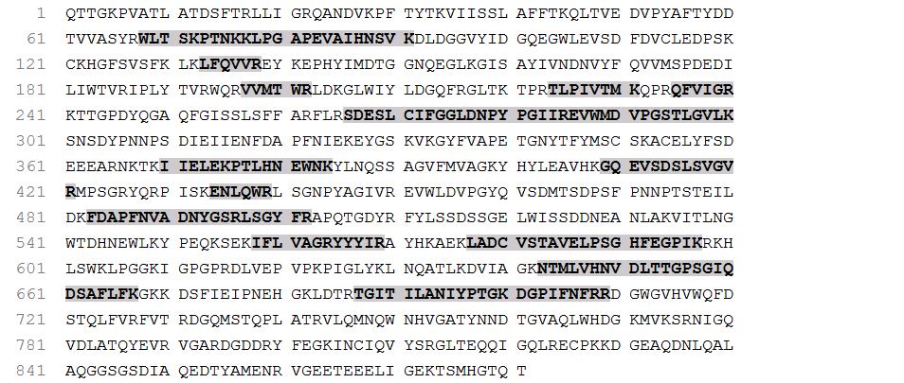

Ccr-23322_c6_g1_i2
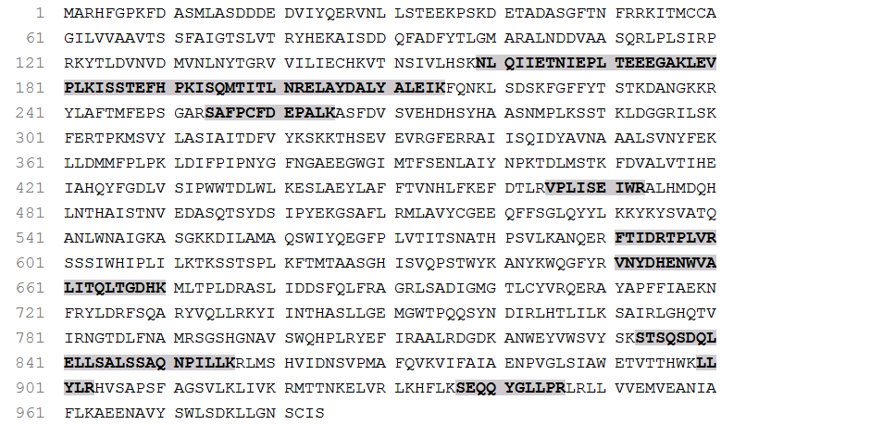

Ccr-23655_c0_g2_i1
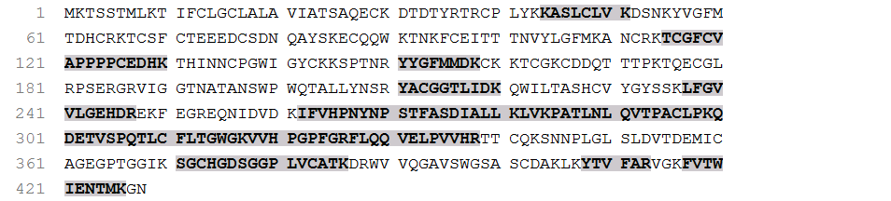

Ccr-24550_c2_g2_i2
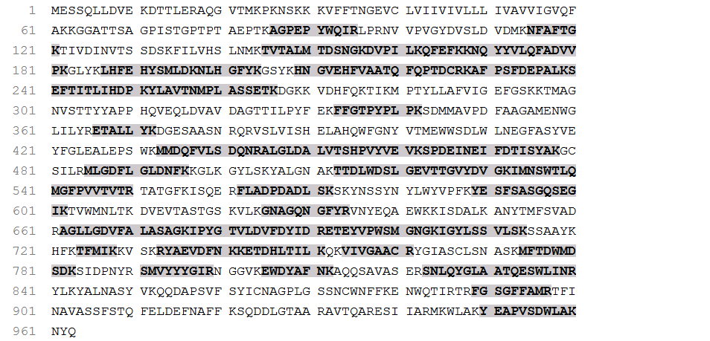

Ccr-25132_c0_g3_i1
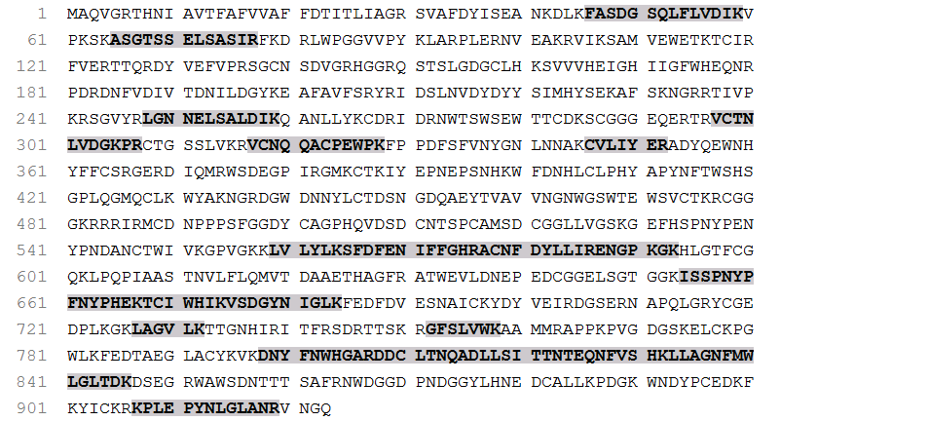

Ccr-25345_c0_g1_i2
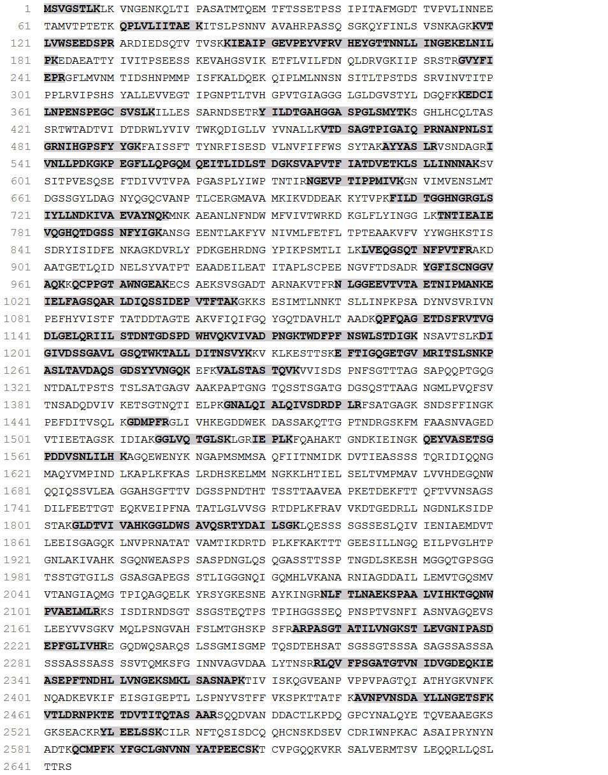

Ccr-25345_c0_g1_i4

Ccr-25694_c0_g1_i1
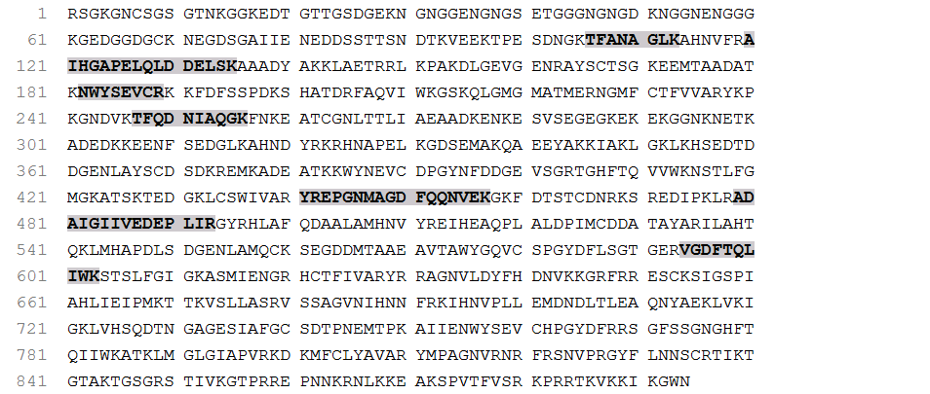

Ccr-25829_c1_g2_i1
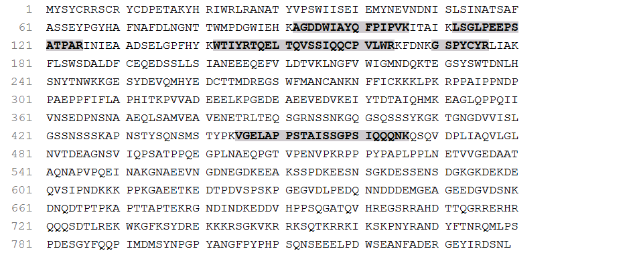

Ccr-25829_c1_g2_i3
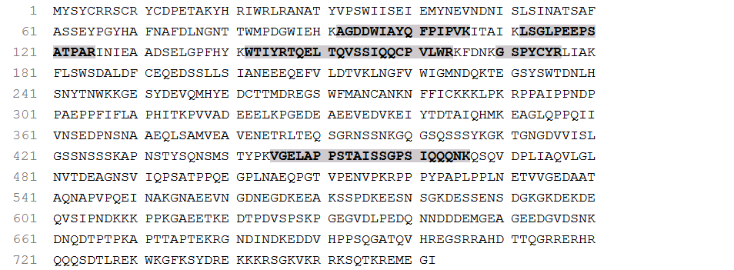

Ccr-26146_c0_g1_i2
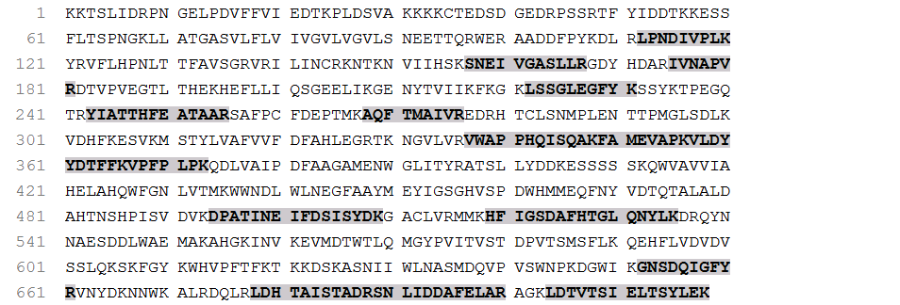

Ccr-26146_c0_g1_i3
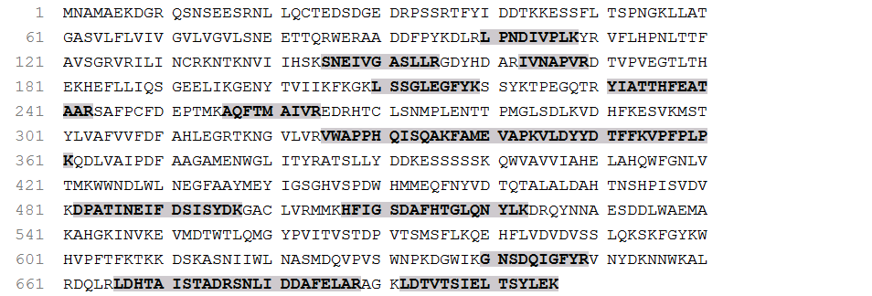

Ccr-26310_c2_g2_i1
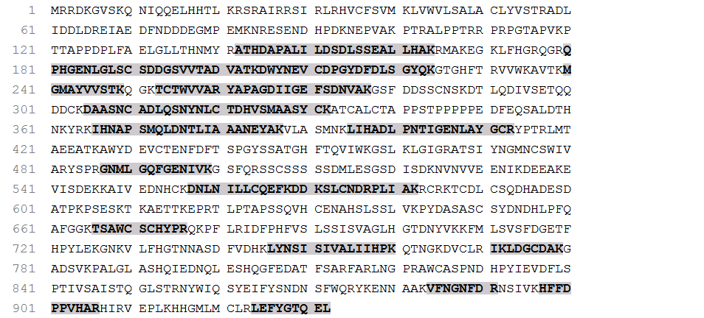

Ccr-26310_c2_g2_i4
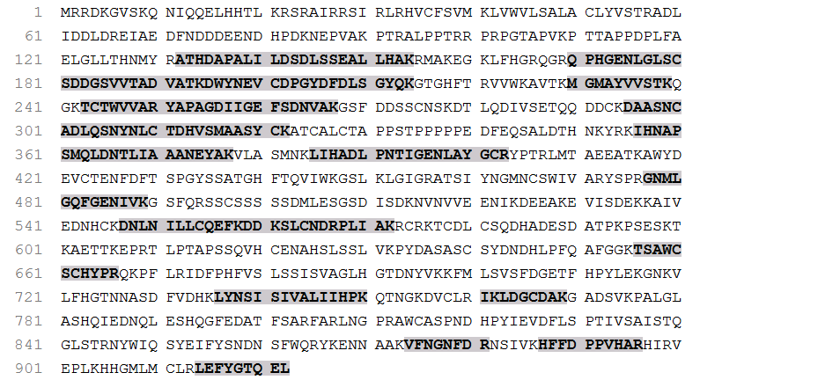

Ccr-26441_c0_g1_i1
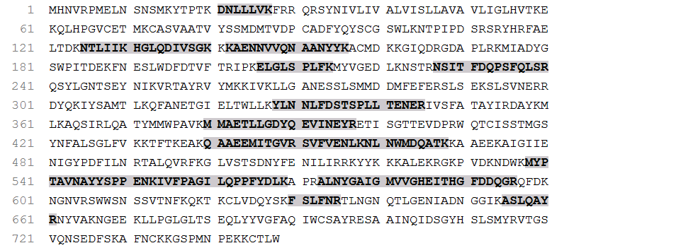

Ccr-26441_c0_g1_i2
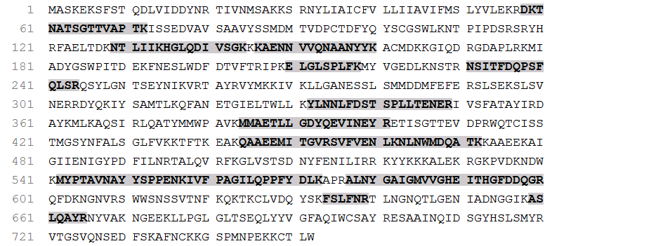

Ccr-26469_c1_g1_i1

Ccr-26526_c0_g1_i6
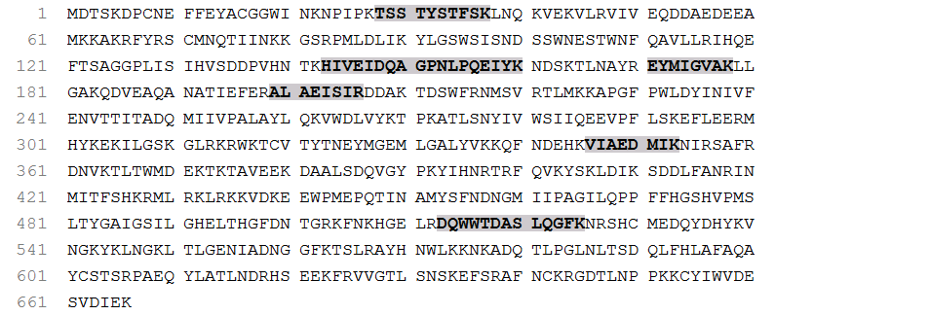

Ccr-26526_c0_g2_i3

Ccr-26740_c2_g1_i11
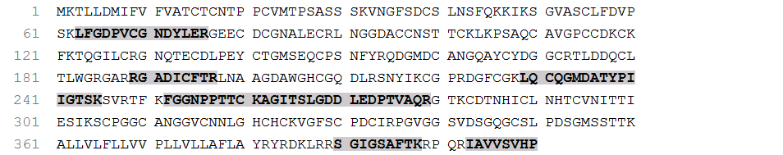

Ccr-27551_c3_g4_i1

Ccr-27708_c0_g1_i1
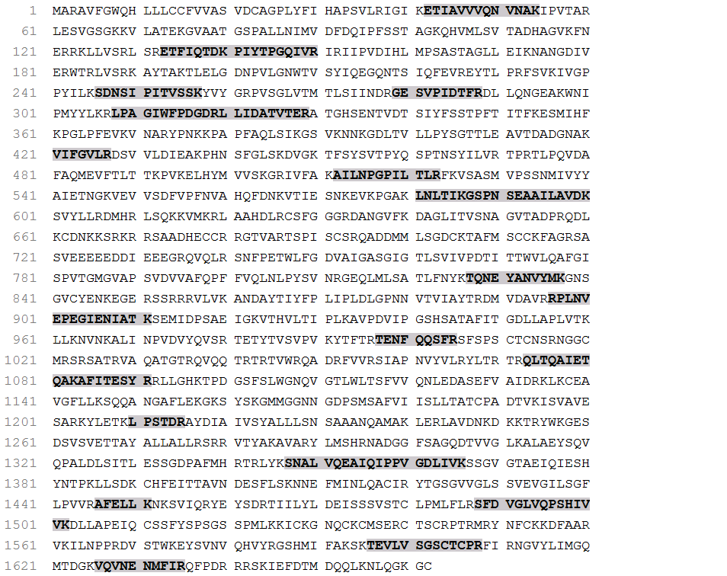

Ccr-28505_c8_g1_i11
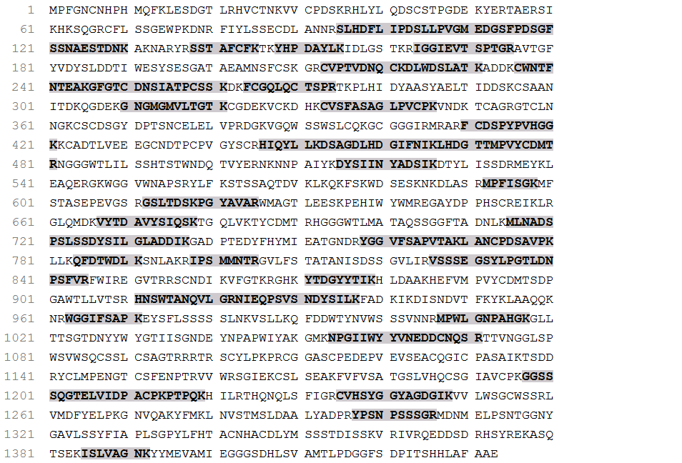

Ccr-28540_c1_g1_i1

Ccr-14907_c0_g1_i1

Ccr-15440_c0_g1_i1

Ccr-17639_c0_g1_i1

Ccr-17712_c0_g1_i2
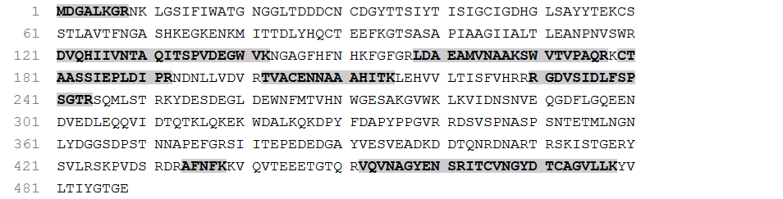

Ccr-19953_c0_g2_i1

Ccr-20386_c0_g1_i1
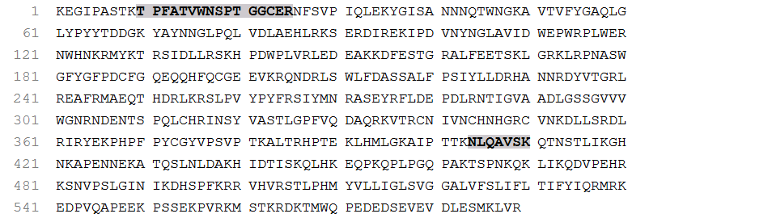

Ccr-20474_c0_g1_i6
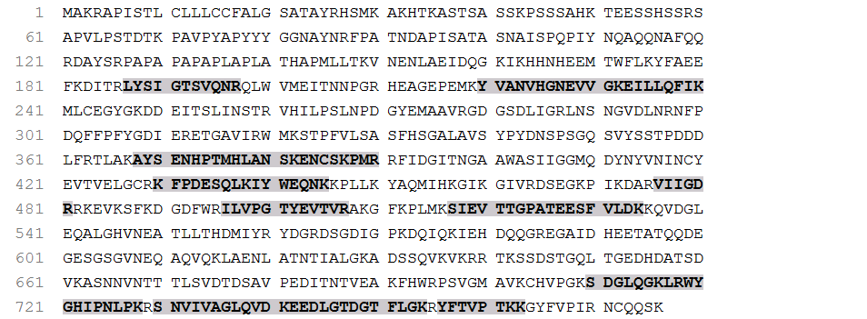

Ccr-21280_c0_g1_i2
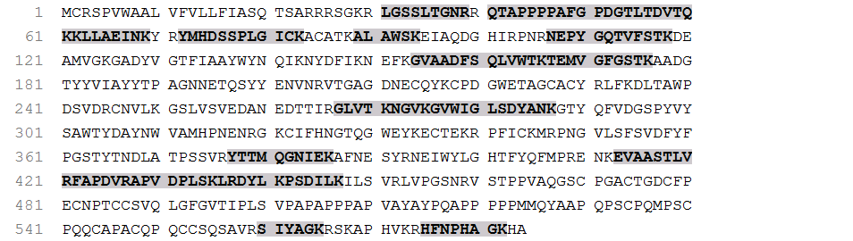

Ccr-21774_c0_g1_i1

Ccr-22270_c1_g4_i3
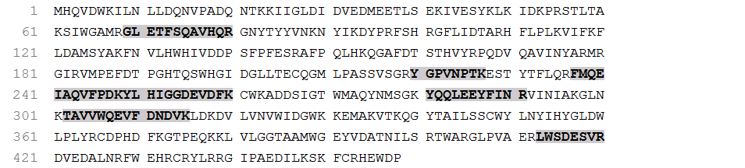

Ccr-22867_c1_g1_i1
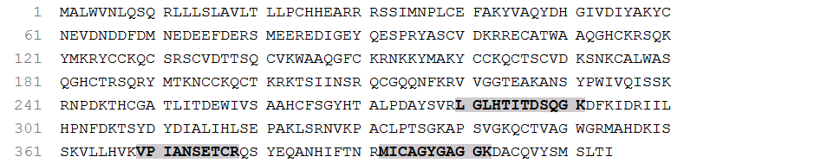

Ccr-22960_c1_g1_i1
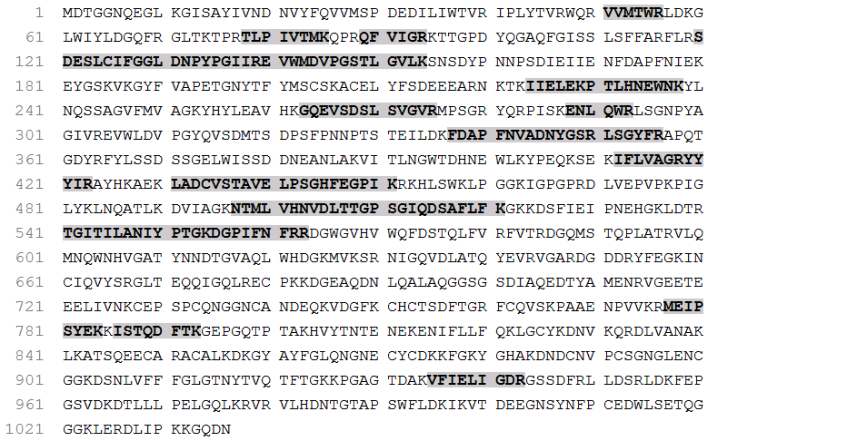

Ccr-22960_c1_g1_i2
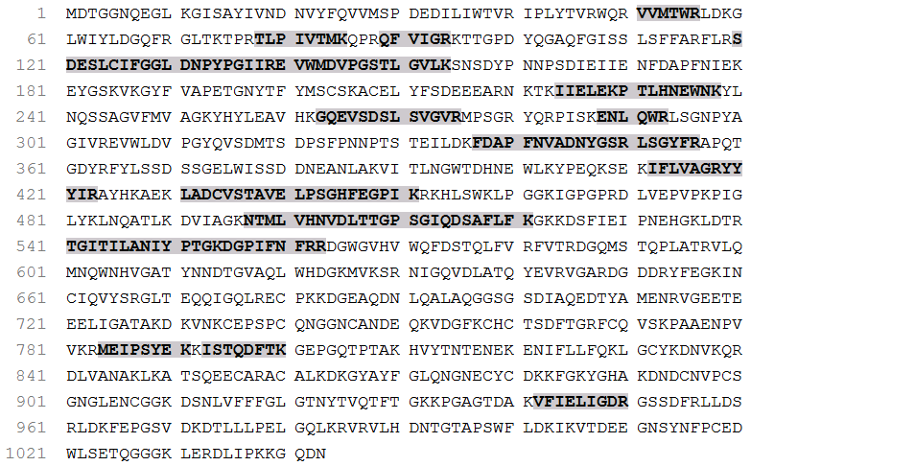

Ccr-23410_c1_g3_i3
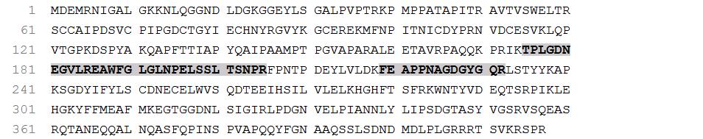

Ccr-23859_c2_g1_i6

Ccr-24923_c0_g1_i2
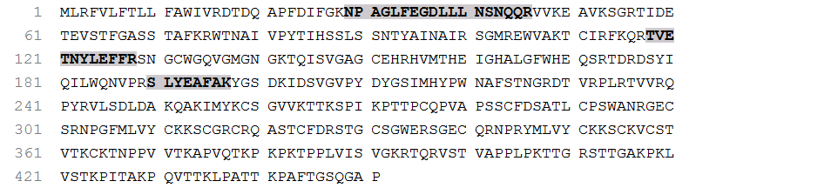

Ccr-24923_c0_g1_i3
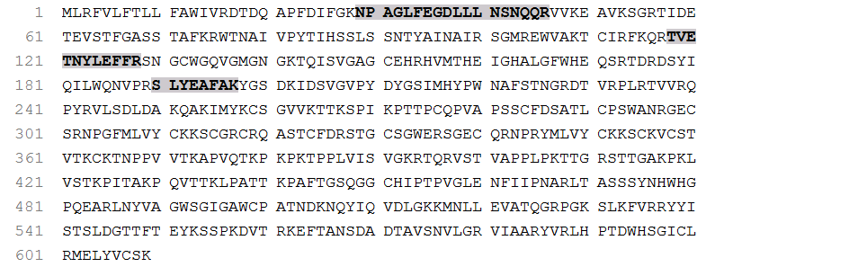

Ccr-25236_c0_g1_i1

Ccr-25236_c0_g1_i2
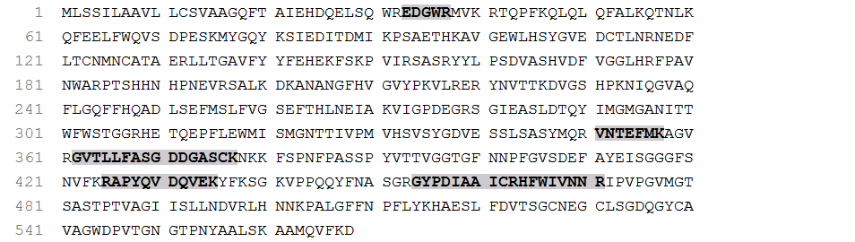
Ccr-25821_c0_g1_i2
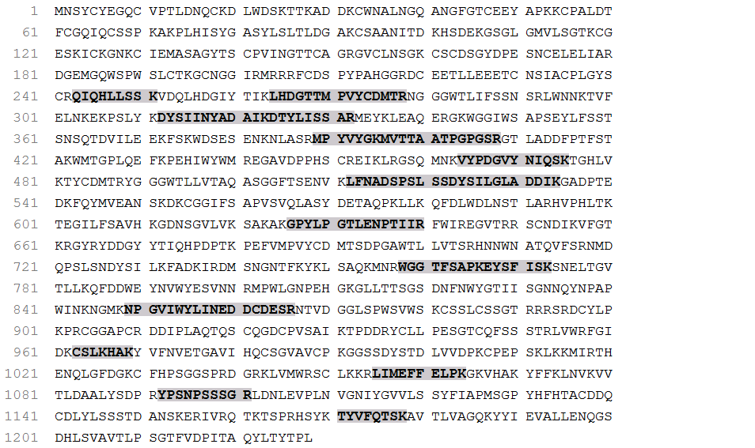

Ccr-25825_c2_g2_i1
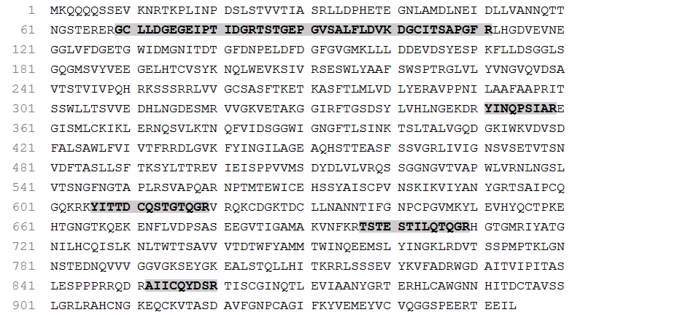

Ccr-26049_c0_g1_i6
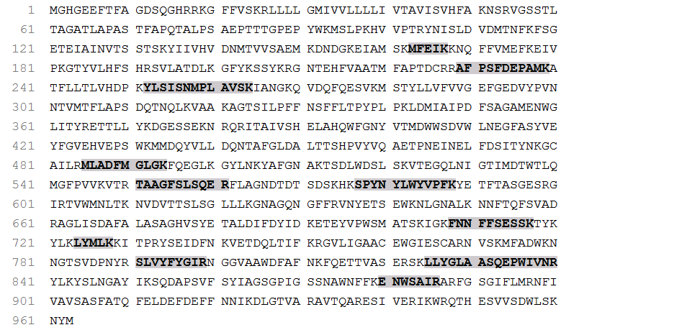

Ccr-26072_c0_g1_i6

Ccr-26072_c0_g1_i7

Ccr-26153_c0_g1_i4

Ccr-26432_c1_g2_i4

Ccr-26526_c0_g1_i13
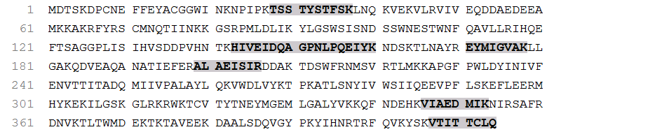

Ccr-26526_c0_g1_i7
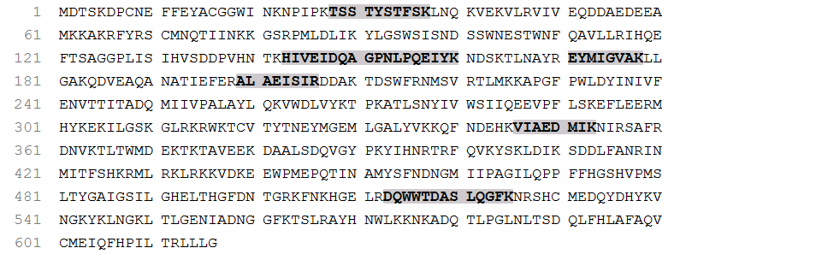

Ccr-26776_c2_g1_i2

Ccr-27169_c0_g2_i11
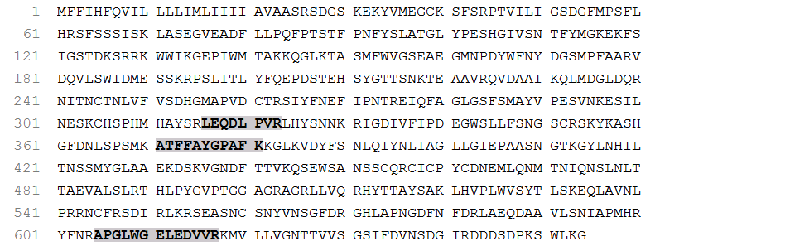

Ccr-27169_c0_g2_i12
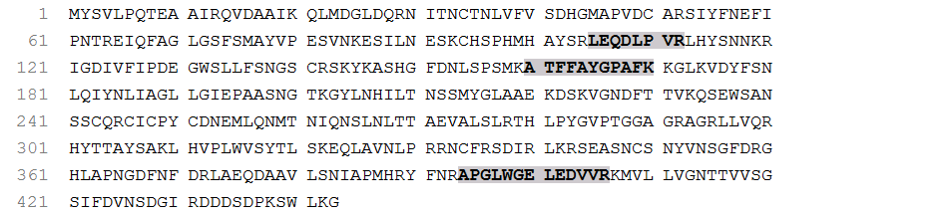

Ccr-27169_c0_g2_i3
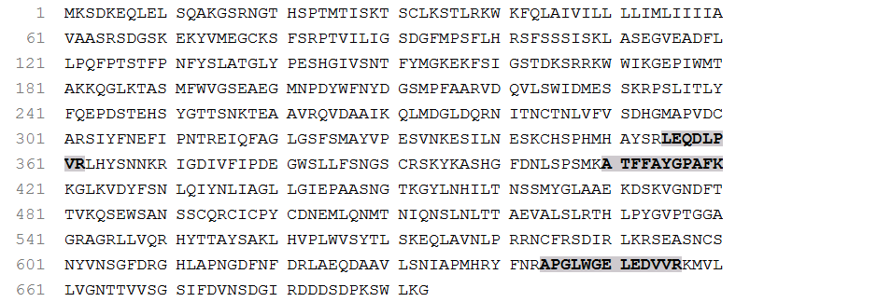

Ccr-27719_c1_g2_i1

Ccr-28128_c2_g2_i2
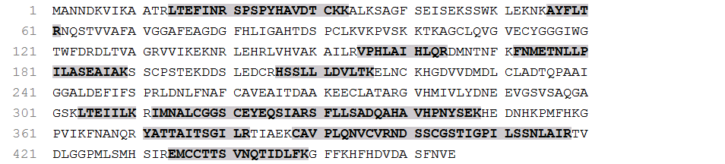

Ccr-28505_c8_g2_i5
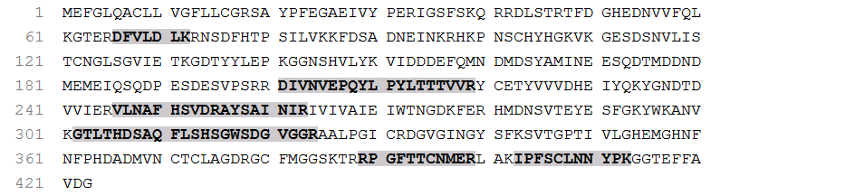

Ccr-8523_c0_g1_i1

Myx-42630_c0_g1_i4

Myx-42946_c0_g1_i3

Phy-24914_c1_g1_i5
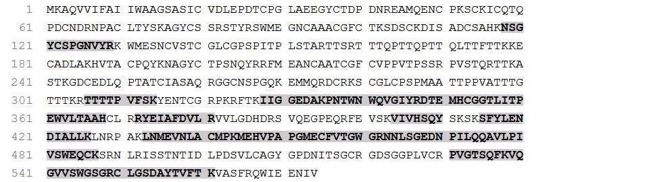

Phy-43066_c0_g1_i1

Phy-9231_c0_g1_i1

Phy-17519_c0_g1_i1
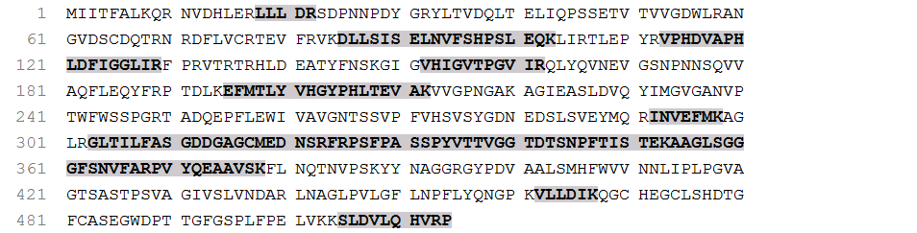

Phy-24812_c0_g1_i4
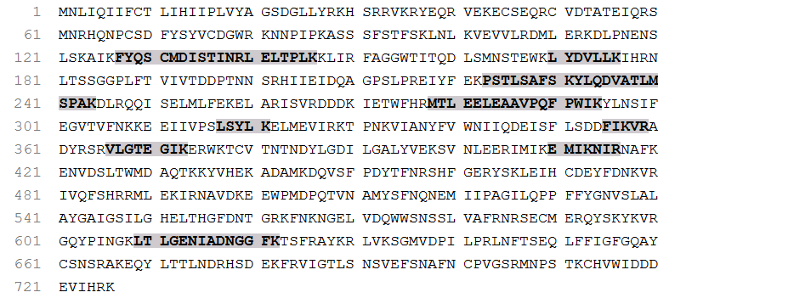

Phy-26874_c0_g1_i4
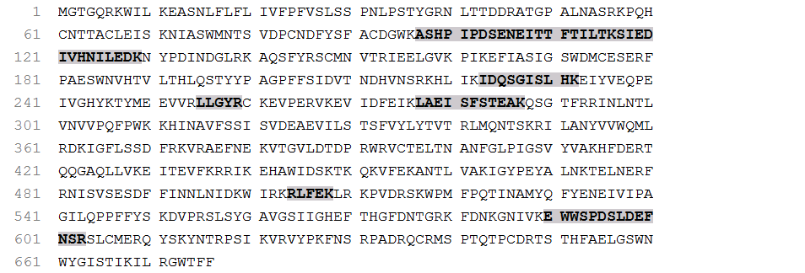

Phy-24812_c0_g1_i11
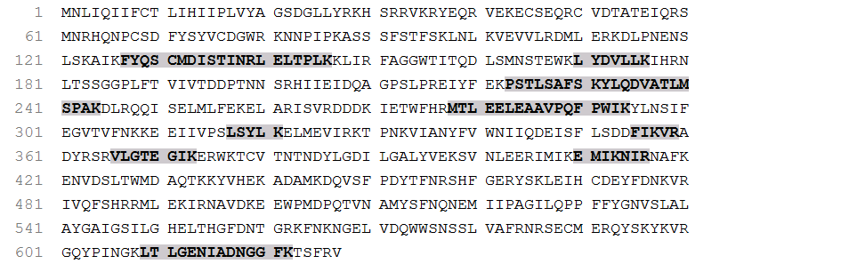

Phy-26874_c0_g1_i8
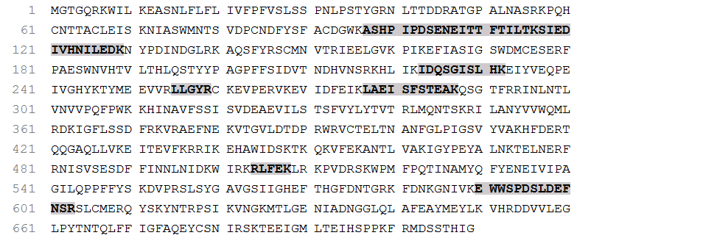

Phy-26874_c0_g1_i7
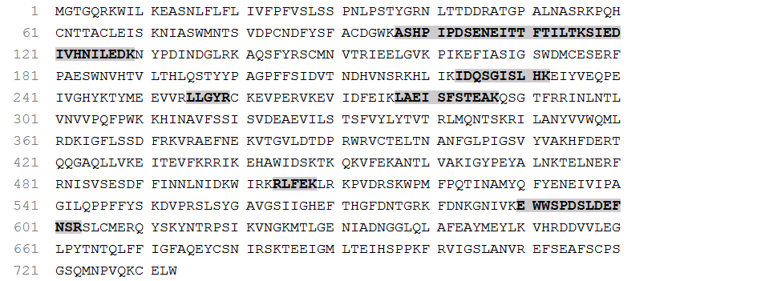

Phy-25018_c0_g1_i7
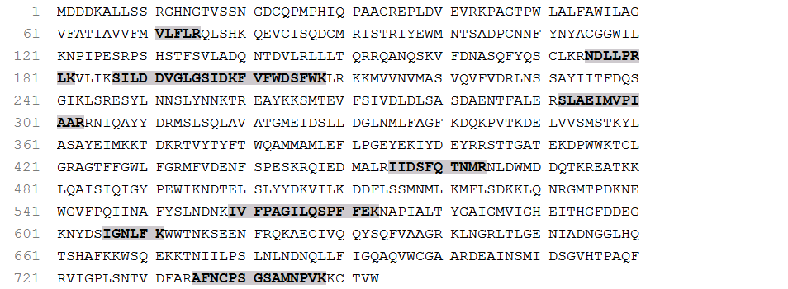

Phy-24539_c0_g2_i19
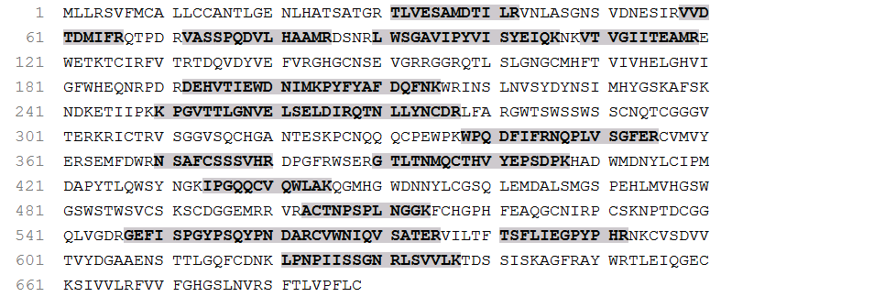

Phy-25249_c1_g3_i12
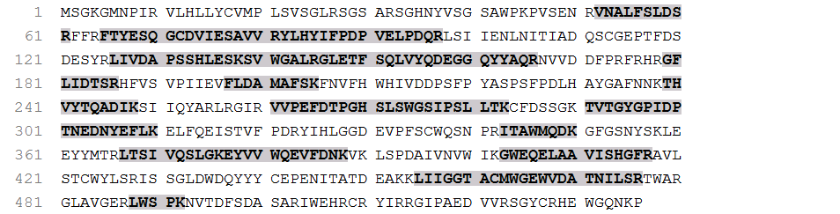

Phy-25249_c1_g3_i18
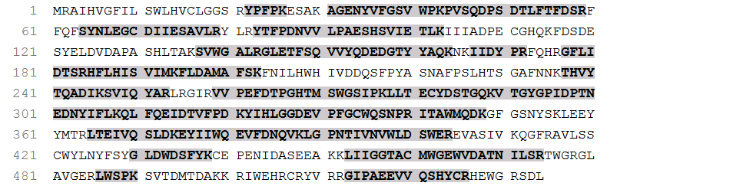

Phy-25249_c1_g3_i20
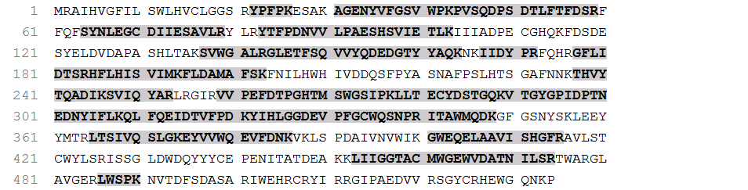

Phy-23951_c0_g1_i2
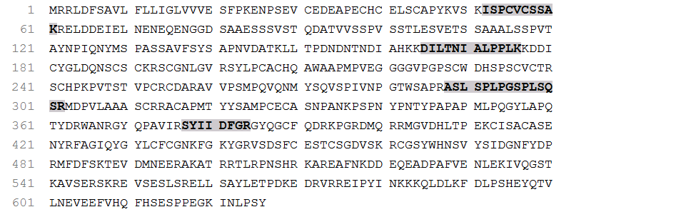

Phy-23951_c0_g1_i7
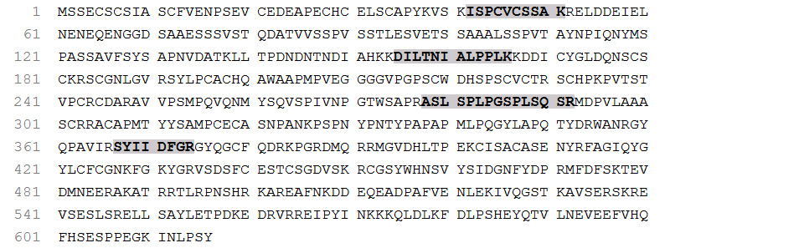

Phy-26261_c0_g1_i1
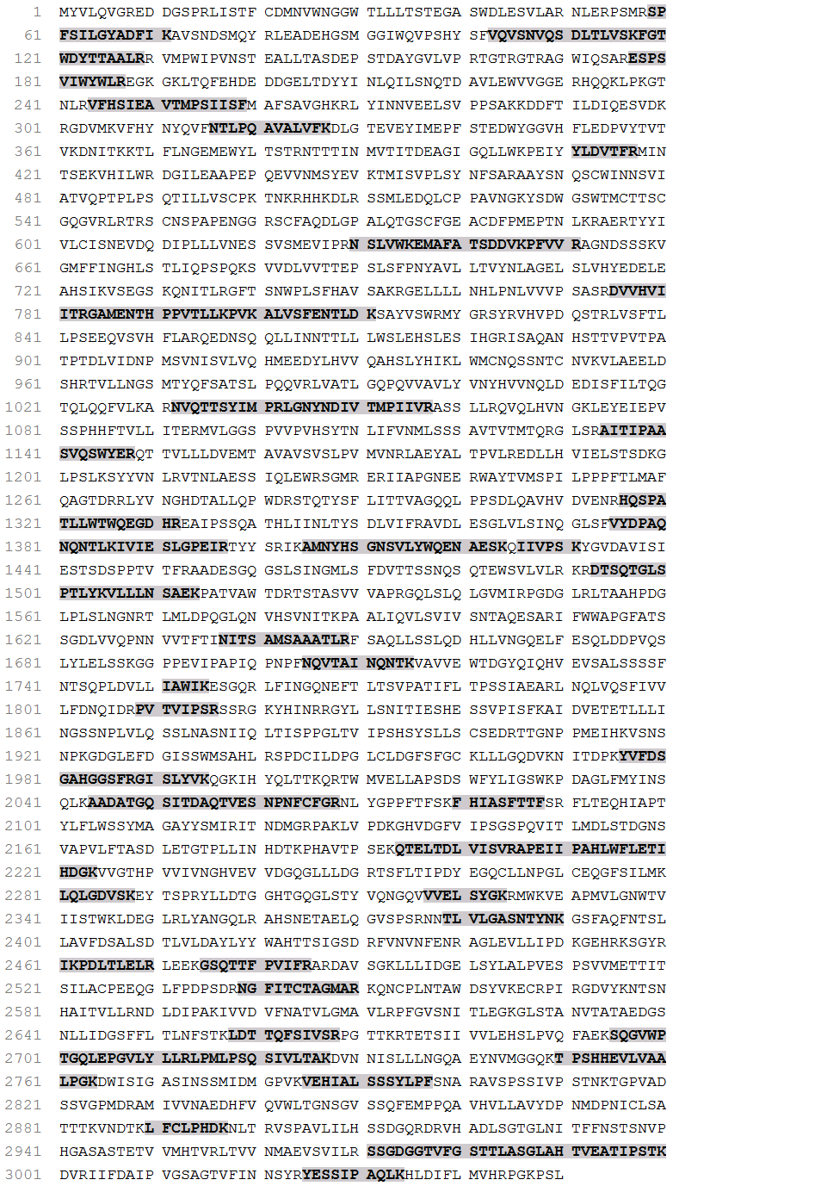
Phy-25185_c14_g1_i6
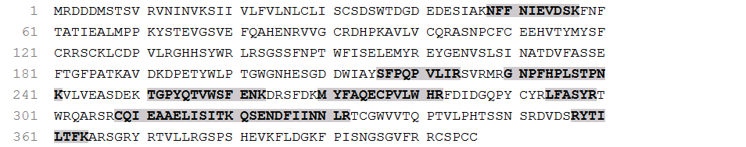

Phy-20553_c0_g1_i1
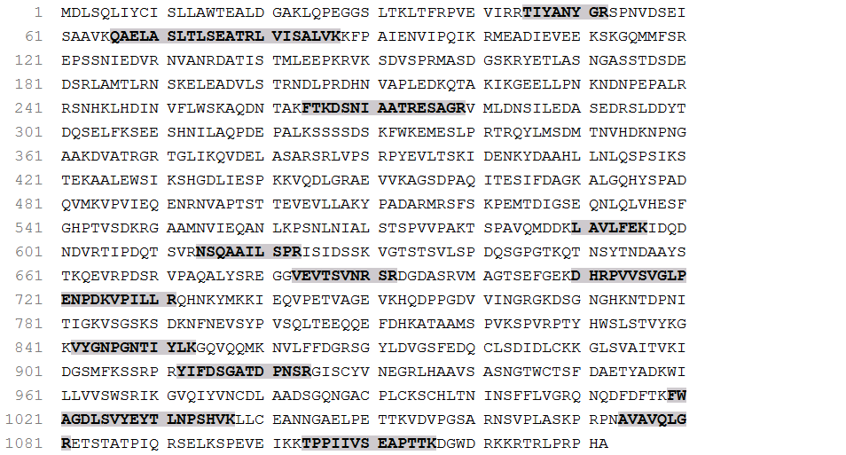

Phy-24539_c0_g2_i6
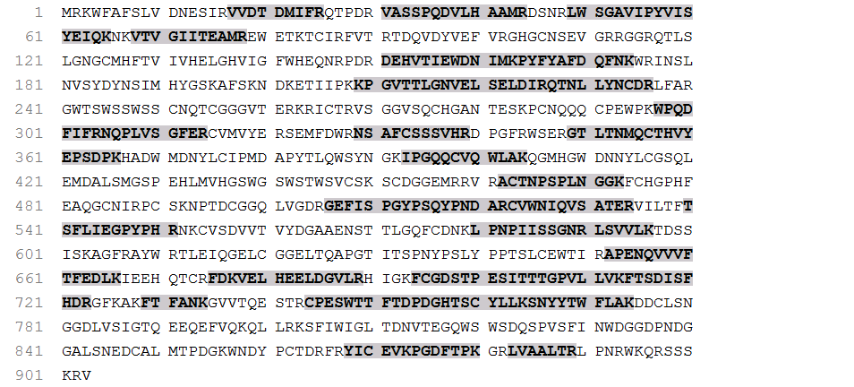

Phy-24539_c0_g2_i8
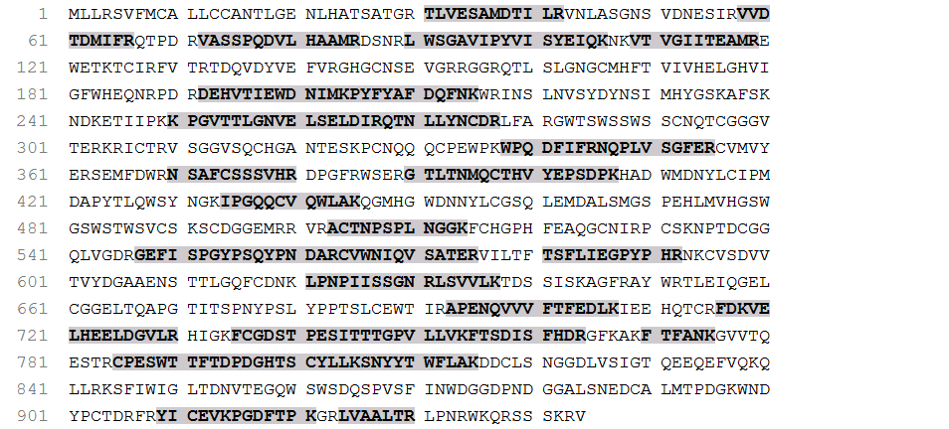

Phy-24539_c0_g1_i15
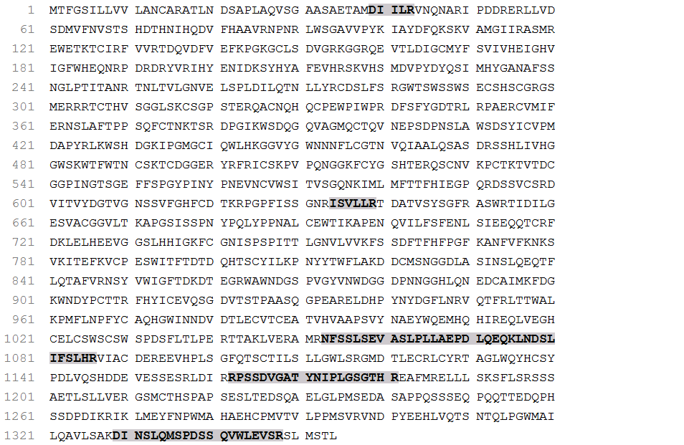

Phy-25185_c14_g1_i9
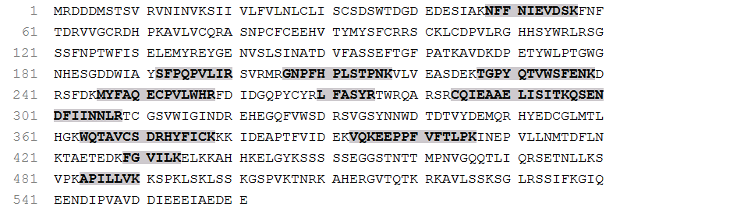

Phy-25185_c14_g1_i13
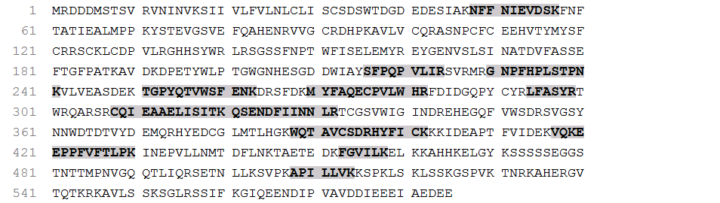

Phy-25443_c2_g3_i1
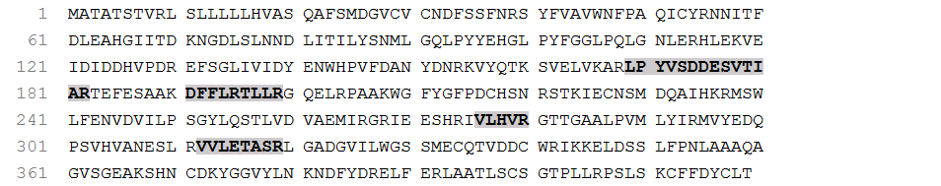

Phy-25443_c2_g3_i2
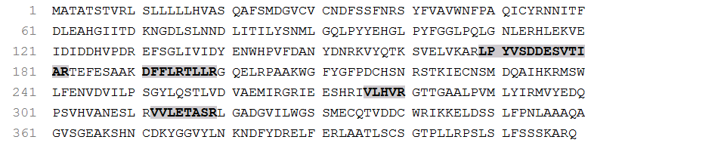

Phy-25624_c2_g4_i2
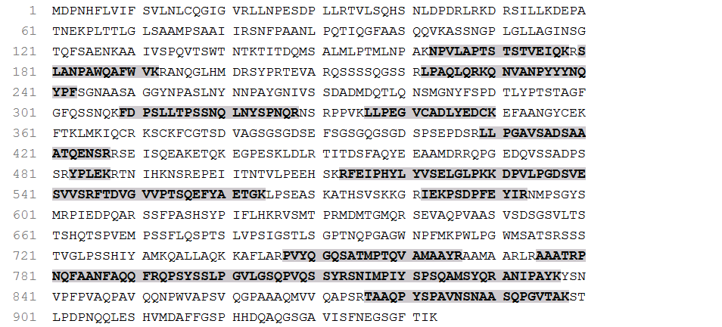

Phy-16682_c0_g1_i1

Phy-23555_c0_g1_i1

Phy-27031_c2_g1_i16
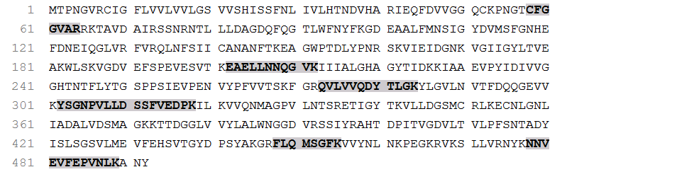

Phy-27031_c2_g1_i9
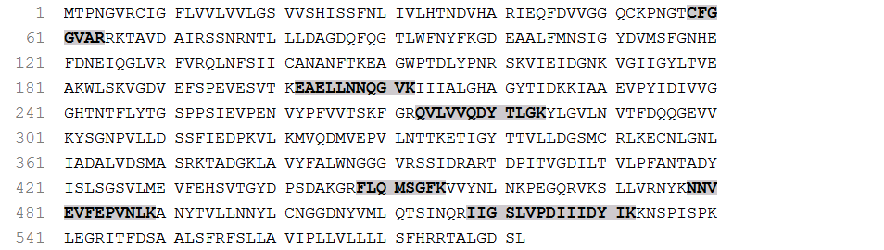

Phy-24372_c1_g9_i1

Phy-25841_c4_g1_i11
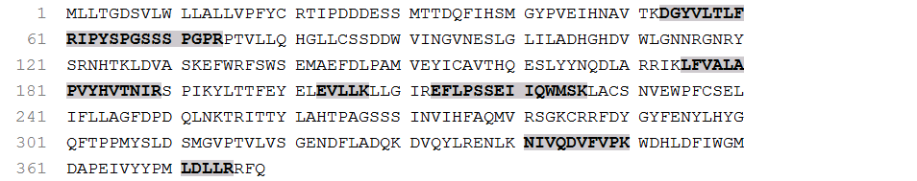

Phy-24914_c1_g6_i1
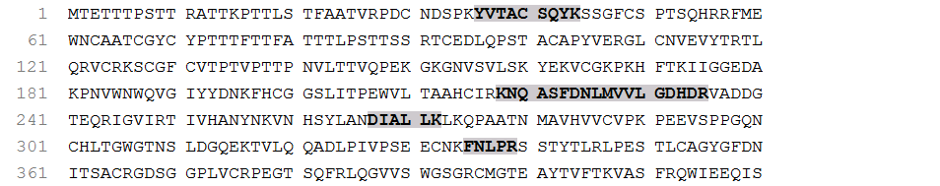

Phy-24914_c1_g1_i6
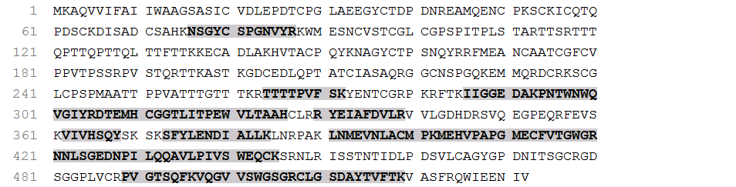

Phy-26587_c3_g2_i8
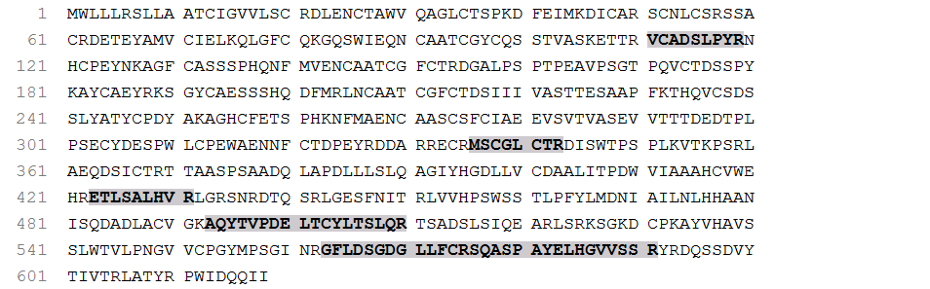

Phy-20919_c0_g1_i2
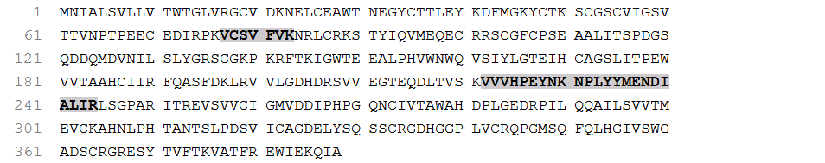

Phy-26681_c3_g2_i3

Phy-25410_c0_g1_i7

Phy-25410_c0_g1_i15

Phy-24578_c4_g1_i2
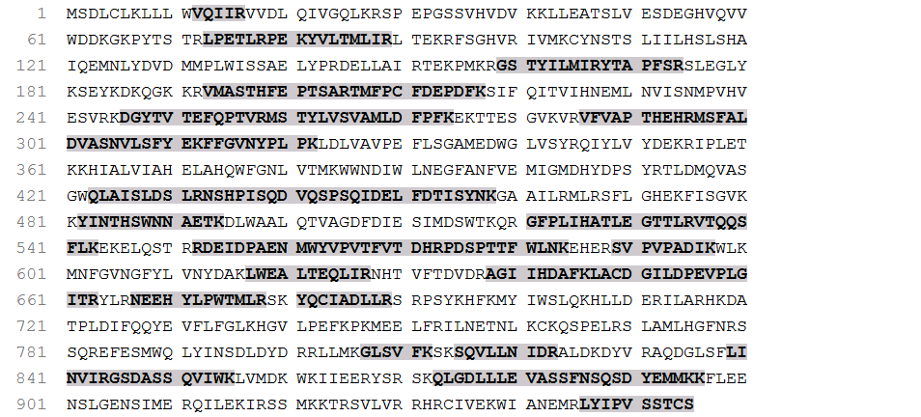

Phy-26489_c1_g1_i15
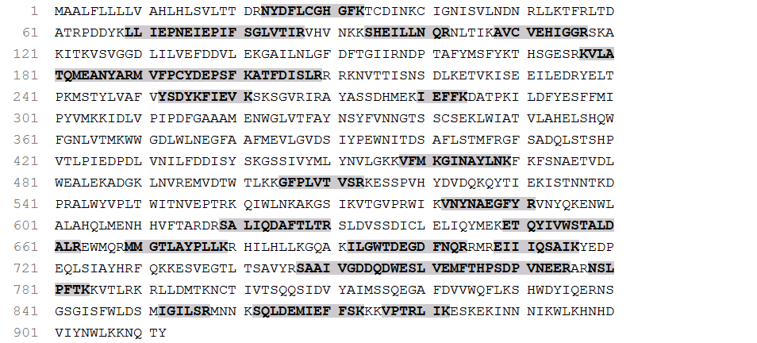

Phy-26489_c1_g1_i12
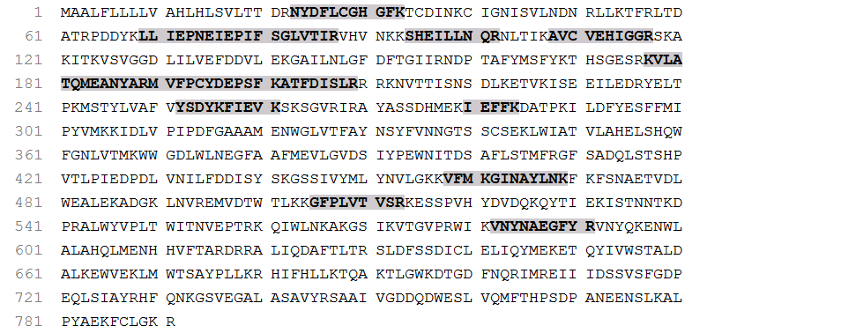

Phy-26489_c1_g1_i10
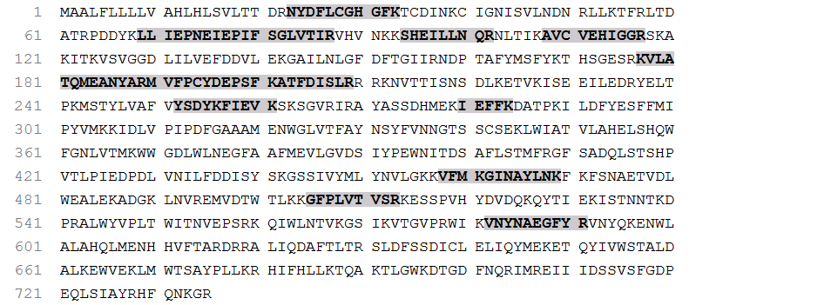

Phy-26489_c1_g1_i9
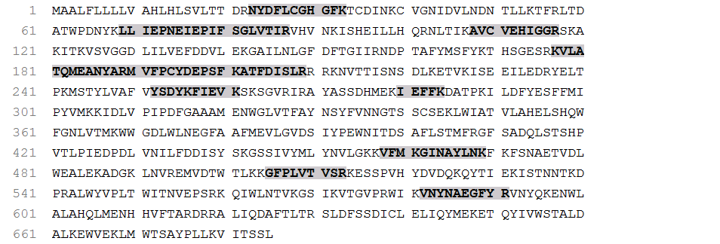

Phy-26489_c1_g2_i4
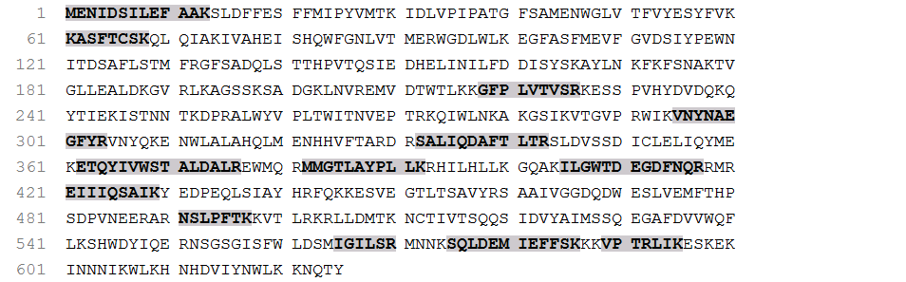

Phy-24578_c4_g1_i7
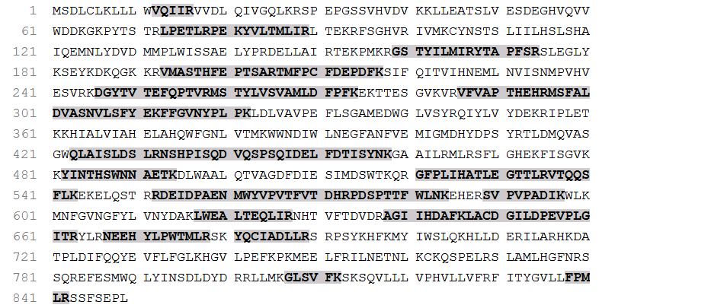

Phy-26489_c1_g1_i39
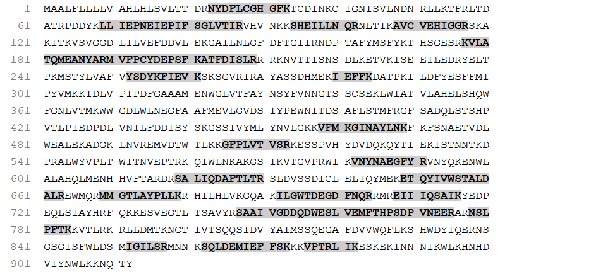

Phy-24825_c0_g1_i6
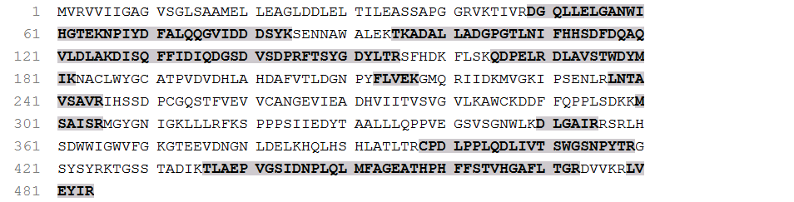

Phy-24825_c0_g1_i1
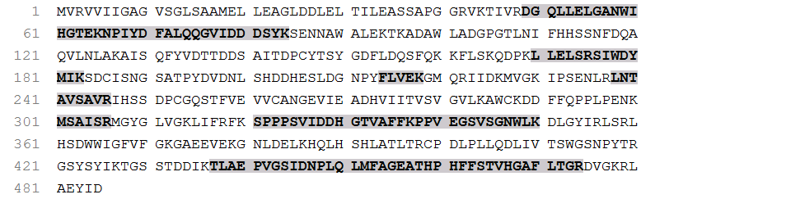

Phy-24825_c0_g1_i10

Phy-24825_c0_g1_i3
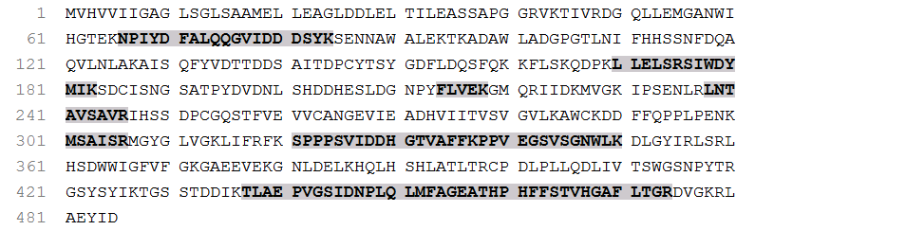

Phy-24825_c0_g1_i2
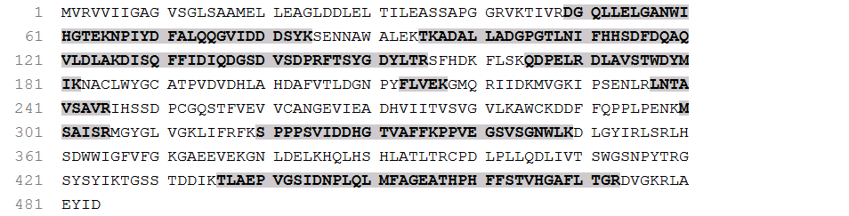

Phy-24825_c0_g1_i7
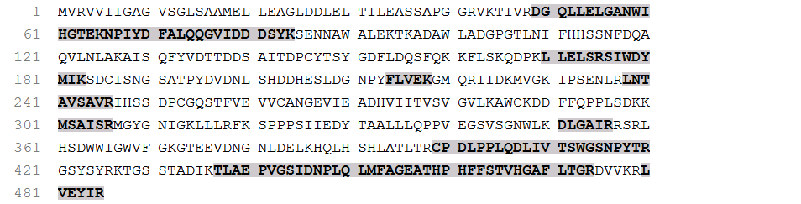

Phy-3110_c0_g1_i2

Phy-25018_c0_g1_i21
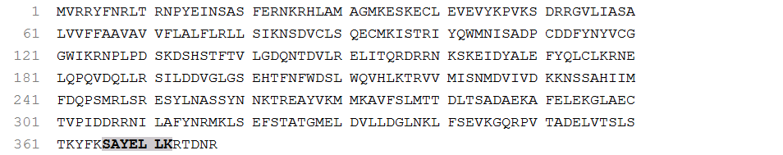

Phy-25690_c5_g1_i19

Phy-25690_c5_g1_i16

Phy-25262_c5_g2_i3
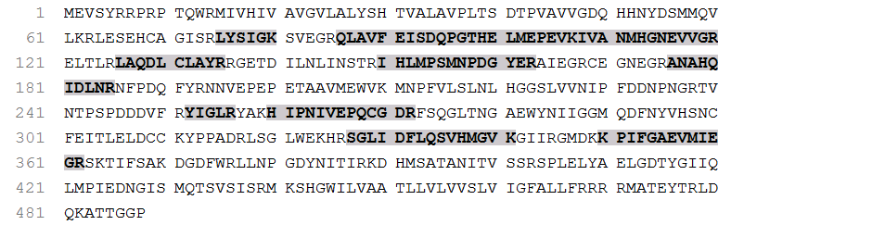

Phy-23951_c0_g1_i1
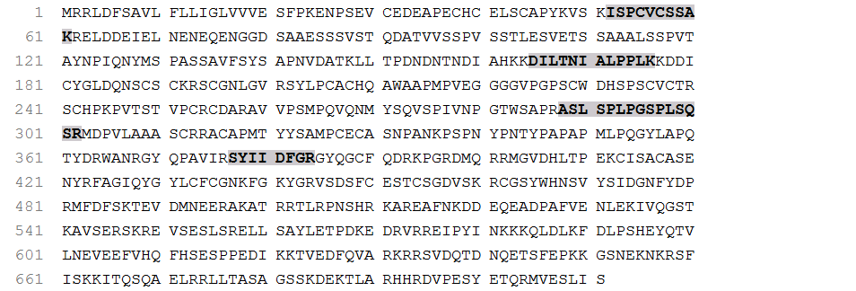

Phy-23951_c0_g1_i5
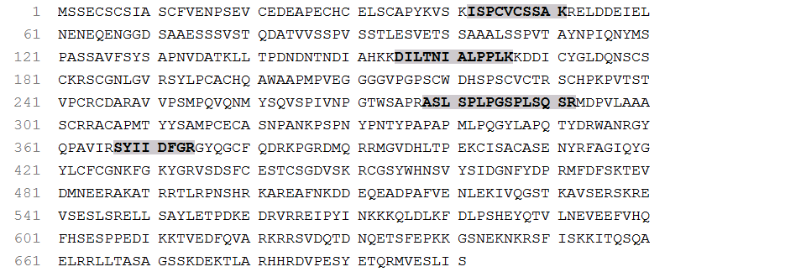

Phy-23951_c0_g1_i3
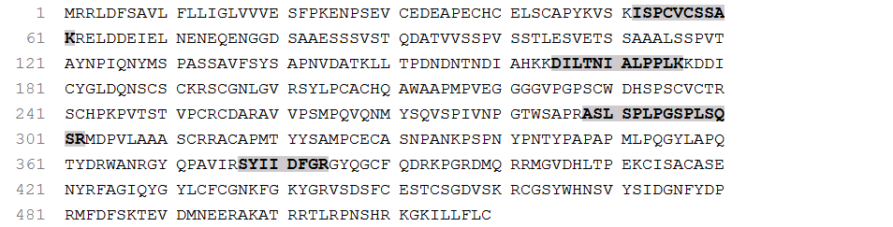

Phy-26681_c3_g3_i2

Phy-26034_c6_g2_i6

Phy-25492_c4_g1_i4
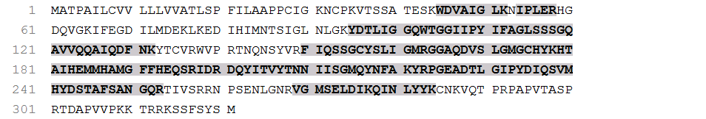

Phy-26034_c6_g2_i7

Phy-26046_c2_g1_i5

Phy-26046_c2_g1_i2
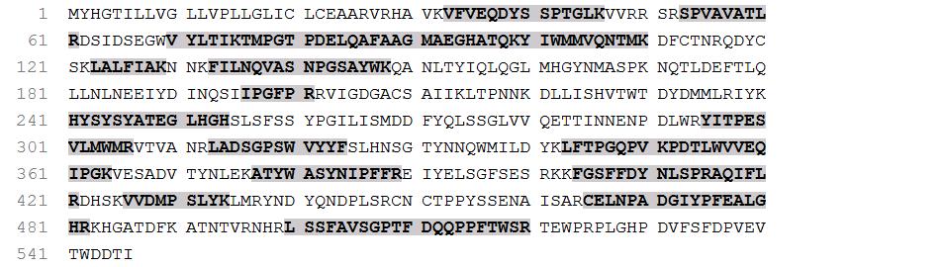

Phy-25841_c4_g1_i8
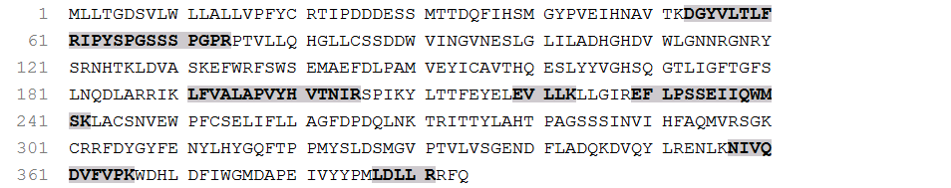

Phy-25841_c4_g1_i2

Phy-25841_c4_g1_i14
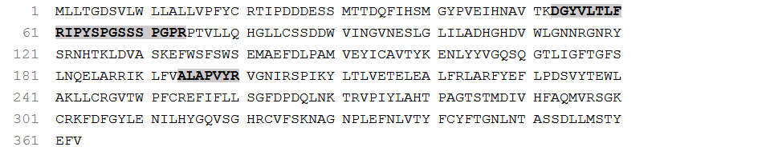

Phy-24865_c3_g1_i1
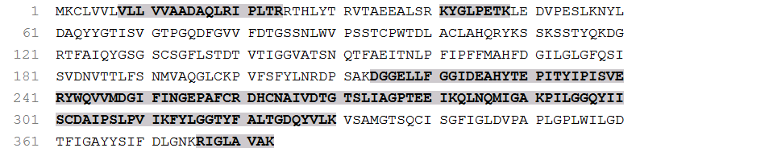

Phy-24865_c3_g1_i2

Phy-22952_c0_g1_i1

Phy-22952_c0_g1_i2

Phy-34426_c0_g1_i1

Phy-26261_c0_g1_i8
