- CENTRAL:

ID Search
#1 (brown rice):ti,ab,kw (Word variations have been searched)
#2 (prediabetes):ti,ab,kw (Word variations have been searched)
#3 (diabetes):ti,ab,kw (Word variations have been searched)
#4 (#1 ) AND (#2 OR #3)
#5 (brown rice*):ti,ab,kw AND (diabet* OR prediabet*):ti,ab,kw (Word variations have been searched)

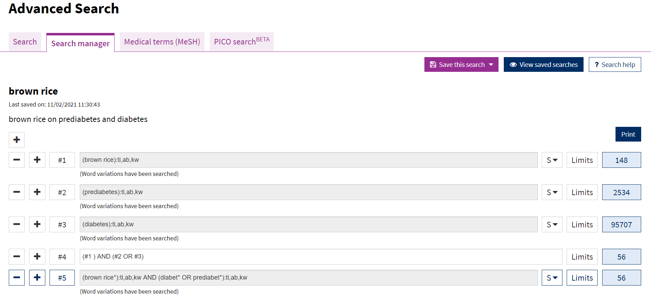
- Pubmed:

Search: (brown rice*) AND (diabet* OR prediabet*)
("brown"[All Fields] OR "browned"[All Fields] OR "browning"[All Fields] OR
"browns"[All Fields]) AND "rice*"[All Fields] AND ("diabet*"[All Fields] OR
"prediabet*"[All Fields])

