S4 UNDERWATER SOUND MEASUREMENTS
0.5 m | 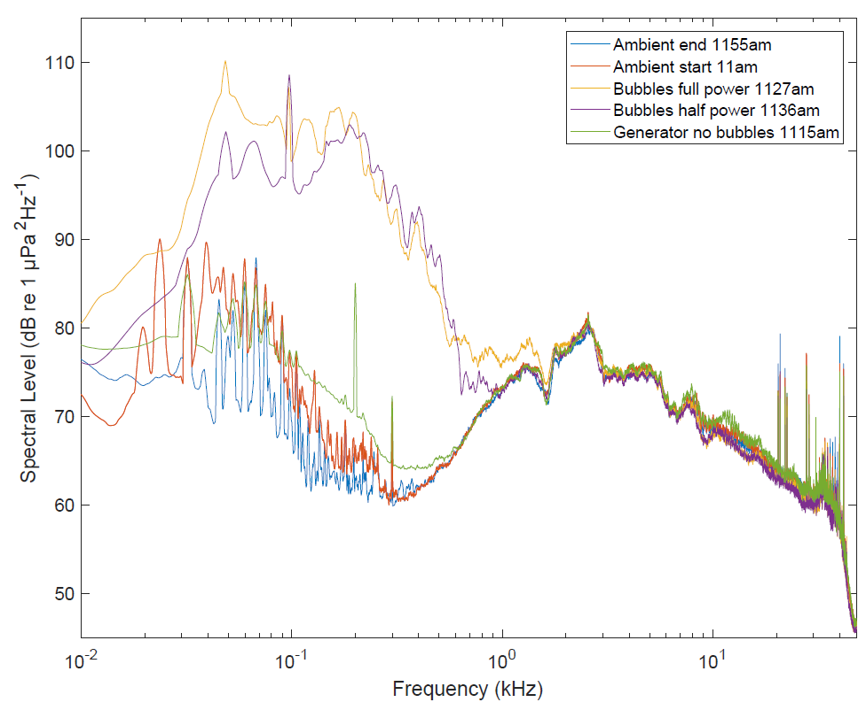
16 m | 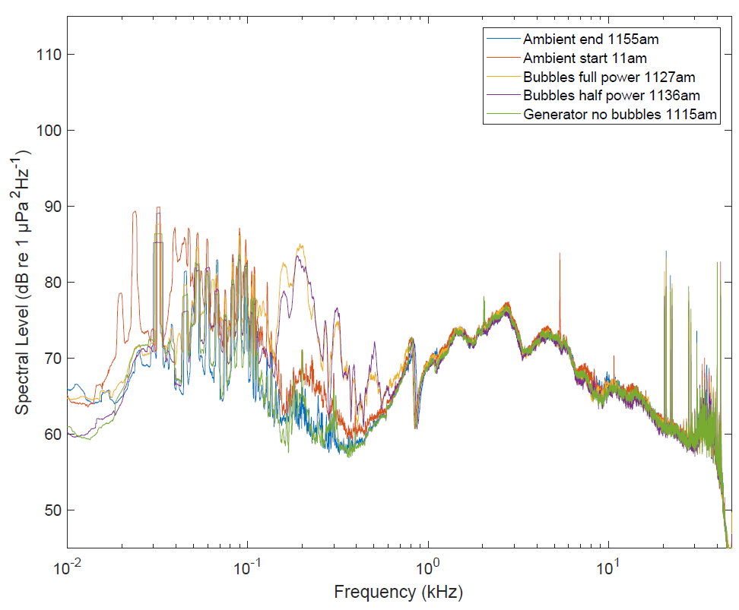
32 m | 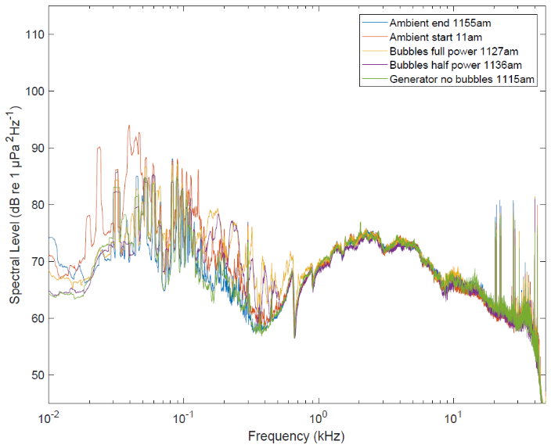
Figure S4.1. Sound field measured approximately 0.5 m (top), 16 m (middle) and 32 m (bottom) from the bubble diffusers. The top panel clearly shows sound levels above ambient; this was less evident at 16 m, and indistinguishable at 32 m from the diffusers. Red arrows indicate where sounds produced from the diffusers can be detected above ambient.

