Supplementary Materials
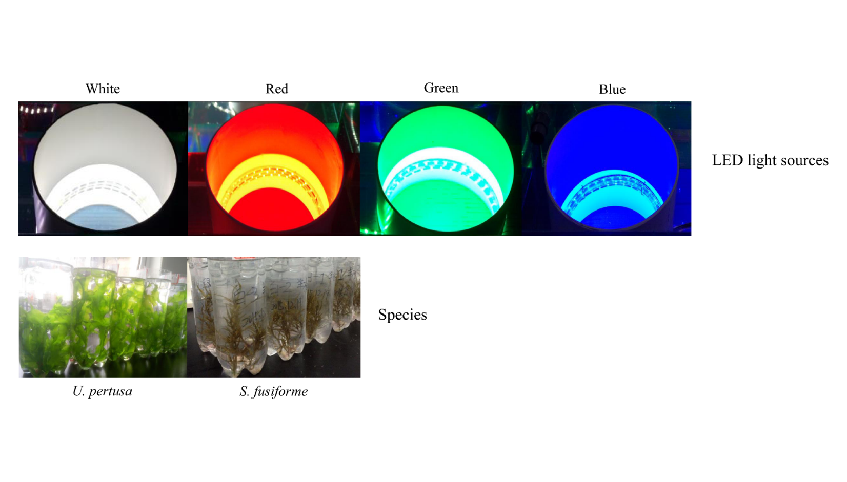
Figure S1. Photos of LED light source settings and experimental species

Table S1. Light quality effects on algal biochemical composition.

No. | Algaª | Light | Phylum | Index | Effects^{b} | References
1 | Cyclotella nana | White | Diatom | Growth | B>W>G | (Wallen & Geen, 1971a)
 |  | Blue |  | Photosynthesis | B>W>G
 |  | Green |  | Carbon metabolism | B>W>G
2 | Dunaliella tertiolecta | White | Chlorophyta | Growth | B>W>G | (Wallen & Geen, 1971a)
 |  | Blue |  | Photosynthesis | B>W>G
 |  | Green |  | Carbon metabolism | B>W>G
3 | Cyclotella nana | White | Diatom | Total carotene | G>W>B | (Wallen & Geen, 1971b)
 |  | Blue |  | Chlorophyll | B>W>G
 |  | Green
 |  |  |  | Protein | B>W>G
 |  |  |  | DNA | B>W>G
 |  |  |  | RNA | B>W>G
4 | Dunaliella tertiolecta | White | Chlorophyta | Total carotene | G>W>B | (Wallen & Geen, 1971b)
 |  | Blue |  | Chlorophyll | B>W>G
 |  | Green |  | Protein | B>W>G
 |  |  |  | DNA | B>W>G
 |  |  |  | RNA | B>W>G
5 | Isochrysis galbana | White | Haptophyta | Growth rate | B>W | (Gorai et al., 2014)
 |  | Blue |  | Chlorophyll a | W>B
 |  |  |  | Carbon content | W>B
6 | Dunaliella salina | White | Chlorophyta | Growth rate | B>W | (Gorai et al., 2014)
 |  | Blue |  | Chlorophyll a | W>B
 |  |  |  | Carbon content | W>B
7 | Chaetoceros gracilis, | White | Bacillariophyta | Growth rate | B>W | (Gorai et al., 2014)
 |  | Blue |  | Chlorophyll a | B>W
 |  |  |  | Carbon content | B>W
8 | Heterocapsa circularisquama | White | Myzozoa | Growth rate | B>W | (Gorai et al., 2014)
 |  | Blue |  | Chlorophyll a | W>B
 |  |  |  | Carbon content | W>B
9 | Porphyra leucosticta | White | Rhodophyta | PEI^{c} | G>Y>R>W>B | (Korbee, Figueroa & Aguilera, 2005)
 |  | Blue |  | Optimal quantum yield | B>W>G>Y>R
 |  | Green |  | Chlorophyll a | G>W>Y>B>R
 |  | Yellow |  | TINC^{d} | W>B>G>Y>R
 |  | Red |  | Soluble protein | W>B>G>Y>R
10 | Ulva rigida | White | Chlorophyta | Chlorophyll a | B>W>R>G | (López-Figueroa & Niell, 1990)
 |  | Blue
 |  | Green
 |  | Red
11 | Corallina elongata | White | Rhodophyta | Chlorophyll a | B>W>R>G | (López-Figueroa & Niell, 1990)
 |  | Blue |  | Phycoerythrin
 |  | Green |  | Phycocyanin
 |  | Red
12 | Plocamium cartilagineum (L.) | White | Rhodophyta | Chlorophyll a | B>W>R>G | (López-Figueroa & Niell, 1990)
 |  | Blue |  | Phycoerythrin | G>W>B>R
 |  | Green |  | Phycocyanin | R>W>B>G
 |  | Red
13 | Porphyra umbilicalis (L.) | White | Rhodophyta | Chlorophyll a | R>W>B>G | (López-Figueroa & Niell, 1990)
 |  | Blue |  | Phycoerythrin | G>W>B>R
 |  | Green |  | Phycocyanin | R>W>B>G
 |  | Red
14 | Porphyra umbilicalis | Blue | Rhodophyta | Growth rate | R>B | (Figueroa, Aguilera & Niell, 1995)
 |  | Red |  | Chlorophyll a | B>R
 |  |  |  | Phycoerythrin | B>R
 |  |  |  | Phycocyanin | B>R
 |  |  |  | Soluble protein | B>R
 |  |  |  | C | R>B
 |  |  |  | N | B>R
15 | Gracilaria birdiae | White | Rhodophyta | Growth rate | G>W>B>R | (Bonomi Barufi, Figueroa & Plastino, 2015)
 |  | Blue |  | Chlorophyll a | G>B>W>R
 |  | Green |  | Allphycocyanin | B>W>G>R
 |  | Red |  | Phycoerythrin | B>G>R>W
 |  |  |  | Phycocyanin | B>G>R>W
a Microalgae: 1 - 8, macroalgae: 9 - 15
b Example: B>W>G means blue light is more effective than white and green light while white light is superior to green light.
c PEI: Irradiance and photosynthetic effective irradiance.
d TINC: Total intracellular nitrogen content.

Table S2. Light intensity reservation rate of of the white, red, green and blue LED tubes underneath water.

 |  | White | Red | Green | Blue
Light intensity  (μmol photons m⁻² s⁻¹) | Air (4 cm)ª | 40 | 10 | 25 | 14
 | Water surface (0 cm) | 26 | 6 | 16 | 9
 | Underwater (-4 cm) | 21 | 4 | 14 | 8
Residual energy ratio^{b} |  | 95% | 90% | 97% | 97%
ª Distance from water surface
^{b} Residual energy ratio (RER): Ratio of residual energy to initial energy for every cm of distance. RER was calculated as:
$RER= \sqrt[D]{\frac{E_{B}}{E_{A}}}$ , (S1)

where E_{A} and E_{B} are the energy of the incident light (water surface) and the background light (underwater). D is the absolute distance from A to B.

Refernences:

Bonomi Barufi J, Figueroa FL, Plastino EM. 2015. Effects of light quality on reproduction, growth and pigment content of Gracilaria birdiae (Rhodophyta: Gracilariales). Scientia Marina 79:15–24. DOI: 10.3989/scimar.04049.12A.
Figueroa FL, Aguilera J, Niell FX. 1995. Red and blue light regulation of growth and photosynthetic metabolism in Porphyra umbilicalis (Bangiales, Rhodophyta). European Journal of Phycology 30:11–18. DOI: 10.1080/09670269500650761.
Gorai T, Katayama T, Obata M, Murata A, Taguchi S. 2014. Low blue light enhances growth rate, light absorption, and photosynthetic characteristics of four marine phytoplankton species. Journal of Experimental Marine Biology and Ecology 459:87–95. DOI: https://doi.org/10.1016/j.jembe.2014.05.013.
Korbee N, Figueroa FL, Aguilera J. 2005. Effect of light quality on the accumulation of photosynthetic pigments, proteins and mycosporine-like amino acids in the red alga Porphyra leucosticta (Bangiales, Rhodophyta). Journal of Photochemistry and Photobiology B: Biology 80:71–78. DOI: https://doi.org/10.1016/j.jphotobiol.2005.03.002.
López-Figueroa F, Niell FX. 1990. Effects of light quality on chlorophyll and biliprotein accumulation in seaweeds. Marine Biology 104:321–327. DOI: 10.1007/BF01313274.
Wallen DG, Geen GH. 1971a. Light quality in relation to growth, photosynthetic rates and carbon metabolism in two species of marine plankton algae. Marine Biology 10:34–43. DOI: 10.1007/BF02026764.
Wallen DG, Geen GH. 1971b. Light quality and concentration of proteins, RNA, DNA and photosynthetic pigments in two species of marine plankton algae. Marine Biology 10:44–51. DOI: 10.1007/BF02026765.

