Supplementary Figure S1. The calculation of the correlation coefficient of COL11A1, GFAP, and FGF5 with WT1 expression in GSE20685.

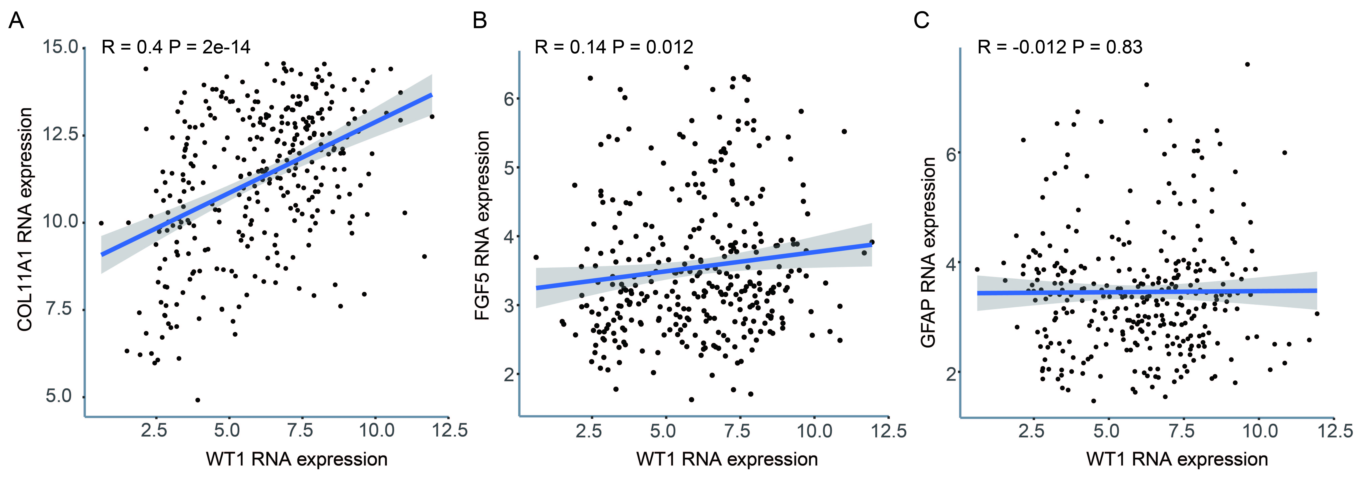
Supplementary Figure S1. The calculation of the correlation coefficient of COL11A1, GFAP, and FGF5 with WT1 expression in GSE20685.

