Appendix 10. Results from the cluster analysis (Bray-Curtis quantitative similarity index) from samples collected within the upper mixed layer (Layer 1) and intermediate layer (Layer 2). Colors indicate groups diverging at certain similarity levels.
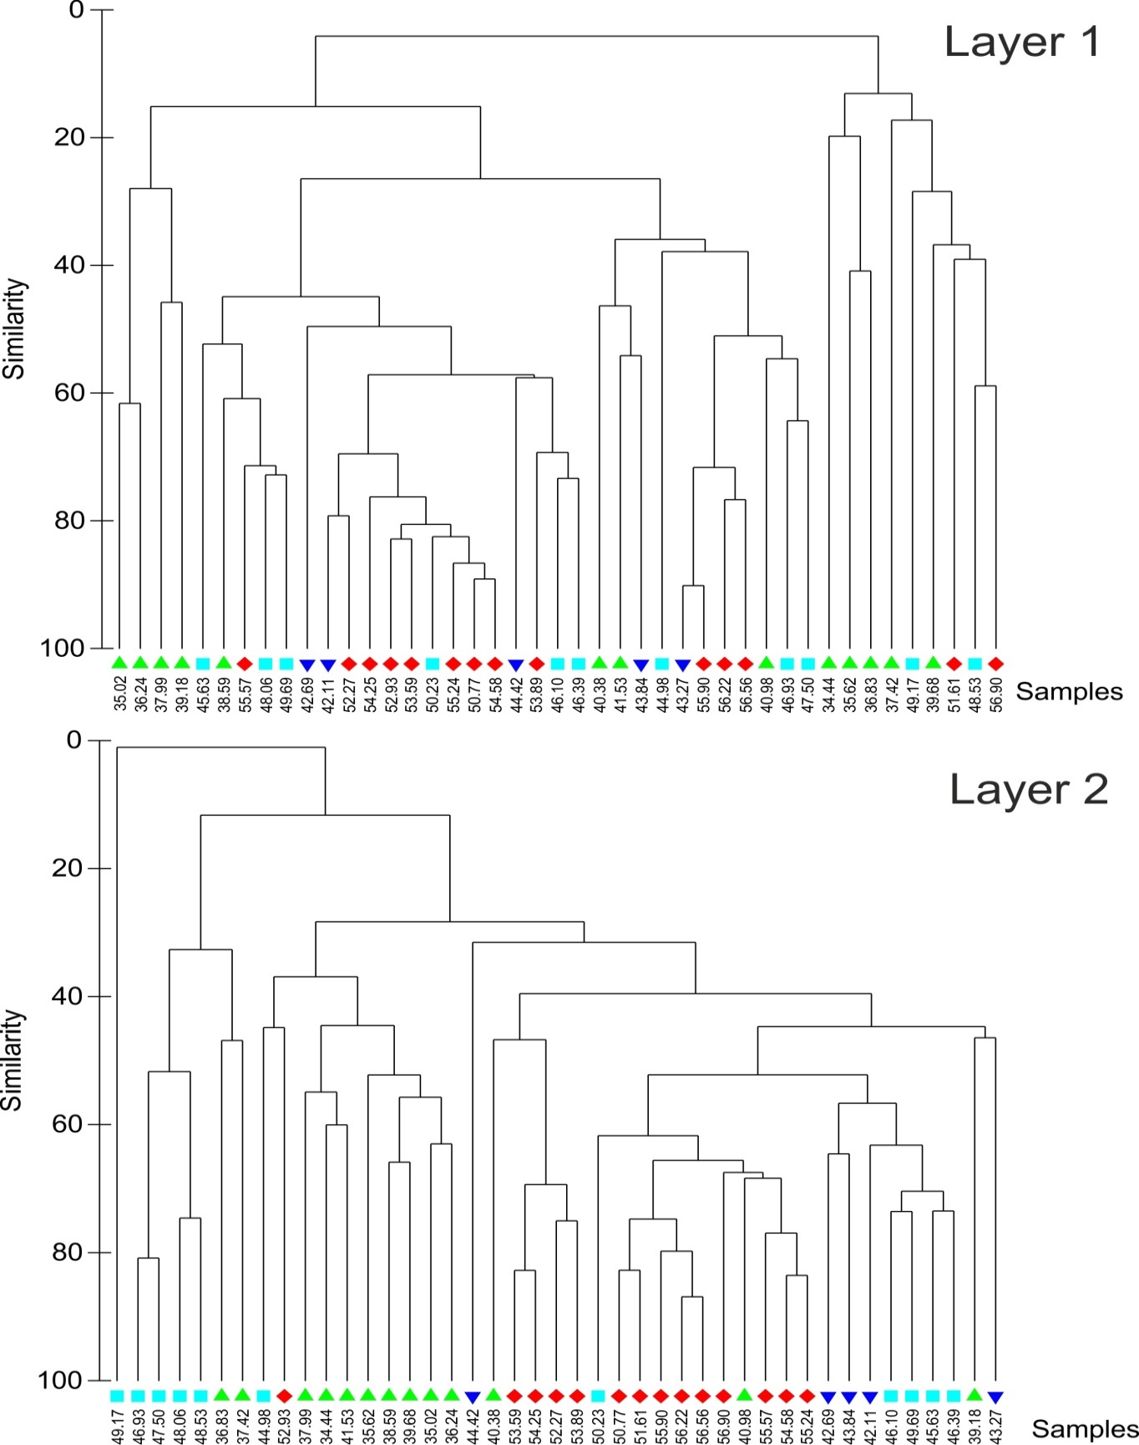
Latitudes, ºS

