Appendix 11. Results from the cluster analysis (Bray-Curtis quantitative similarity index) for samples collected within the deep layer (Layer 3) and entire 0-300 m layer (Layer 0). Colors indicate groups diverging at certain similarity levels.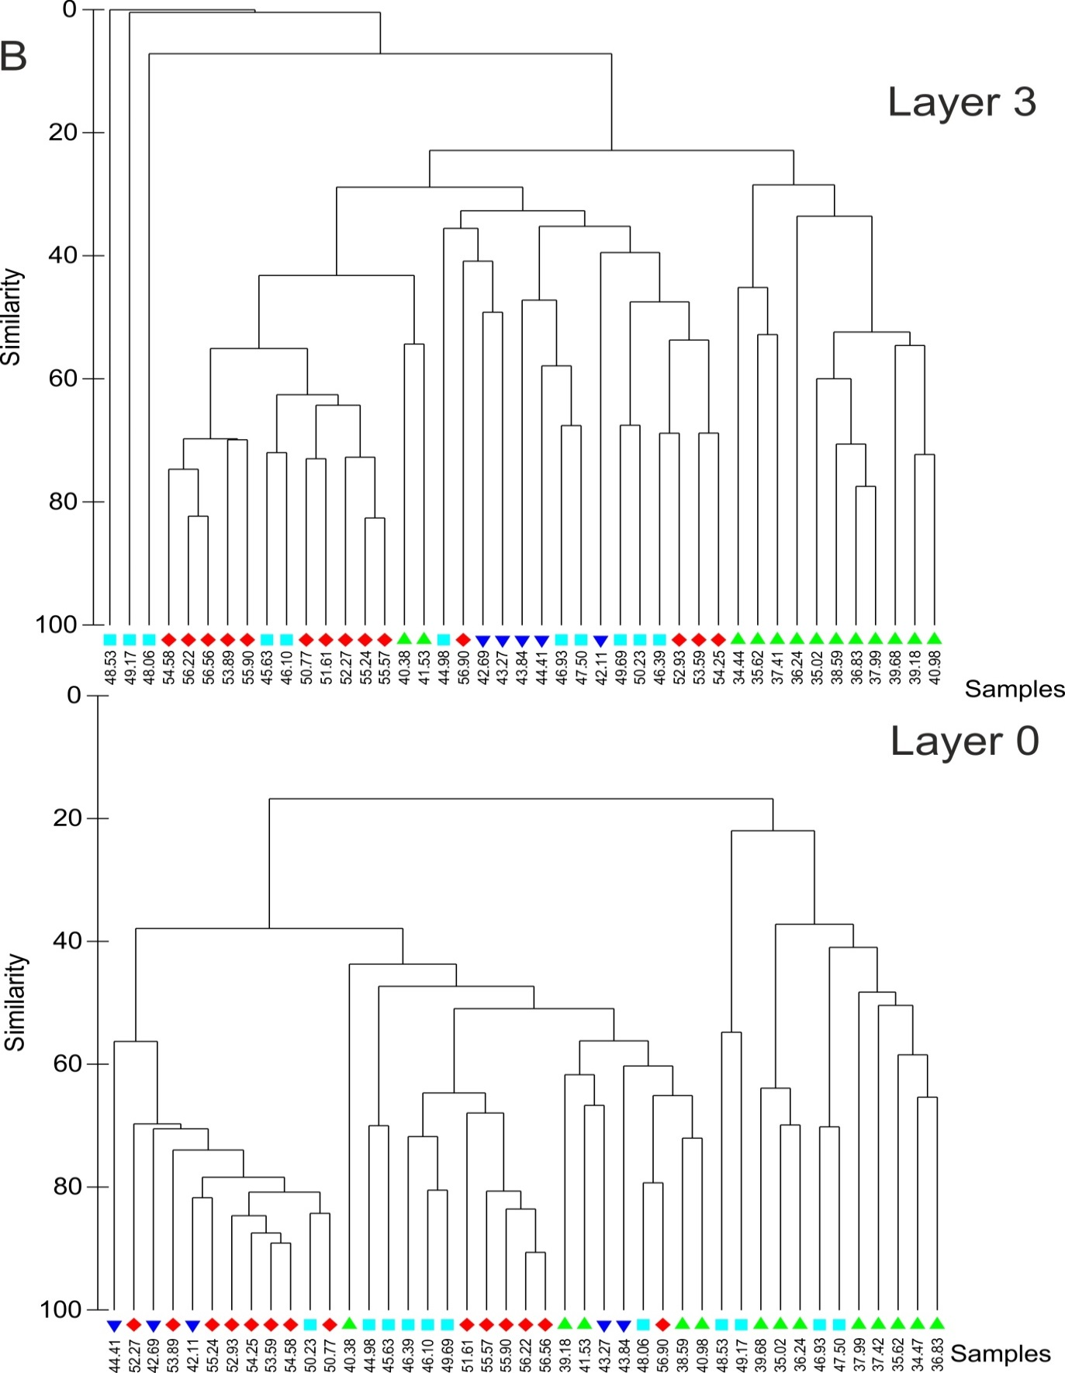
Latitudes, ºS

