Appendix. 7. Results from the cluster analysis (Bray-Curtis qualitative index) for samples collected within the upper mixed layer. All clades and nodes are robust (p <0.05), and red lines indicate minimal similarity between two marked clades (exact value unrecognizable). Colored figures on bottom indicate robust clusters.

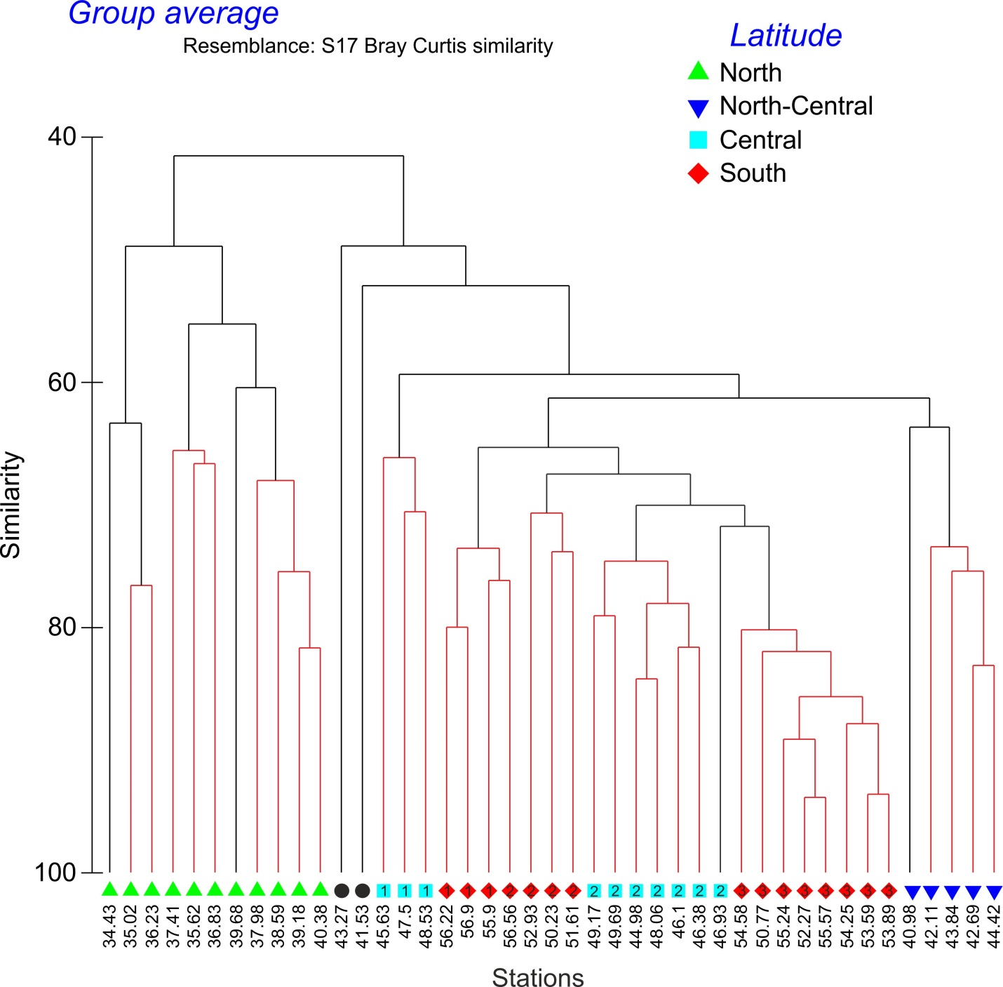
Latitudes, ºS

