Individual responses for the mental and somatic stressors

# Fatigue

# 

# Stress

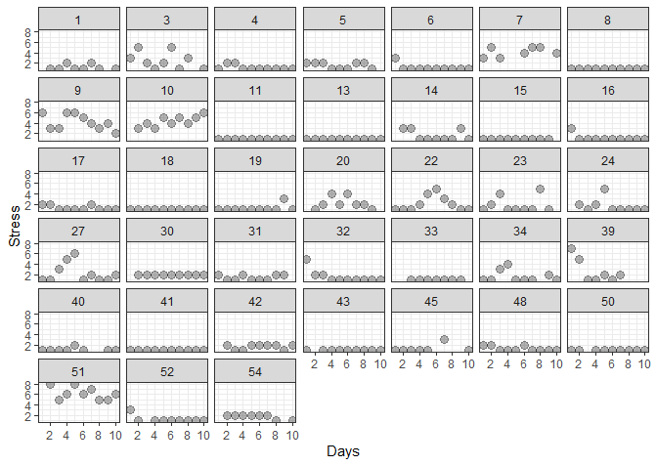

# Pain

# 

# Nausea/dizziness

# 

# Numbness/tingling

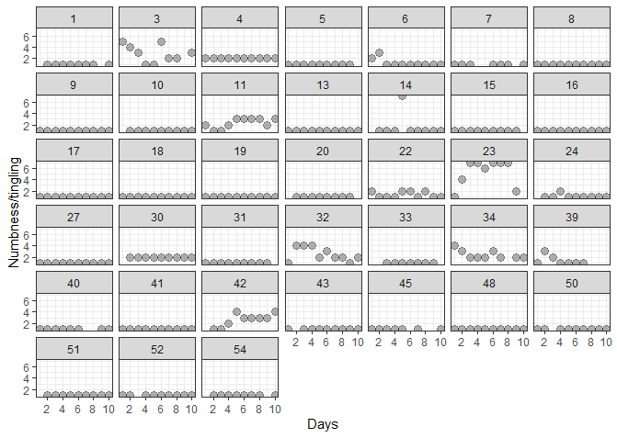

# Sadness

