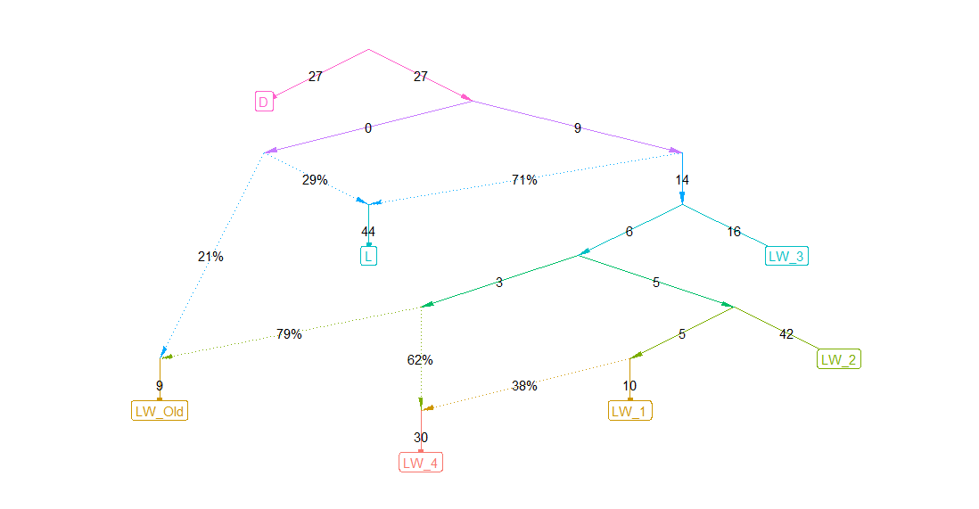 | 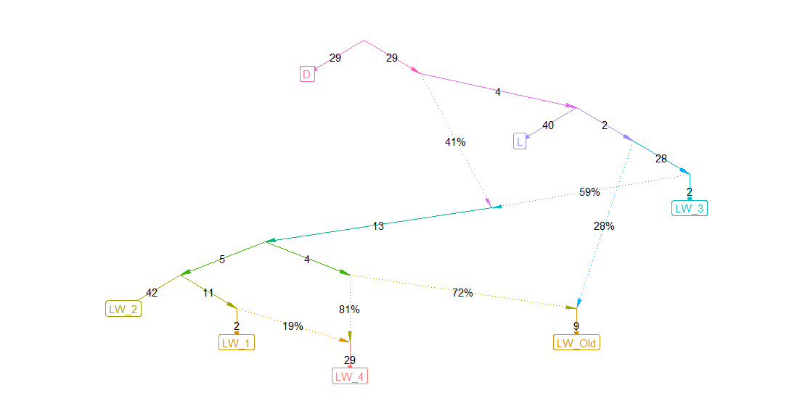 | 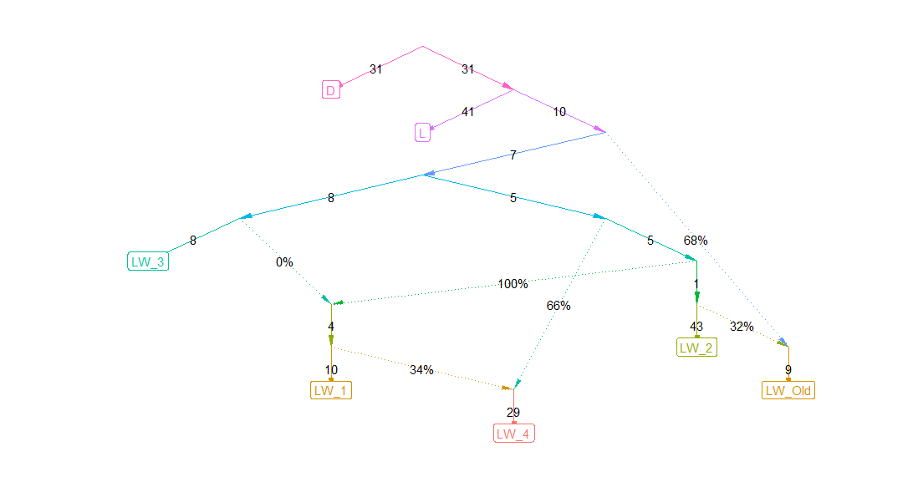
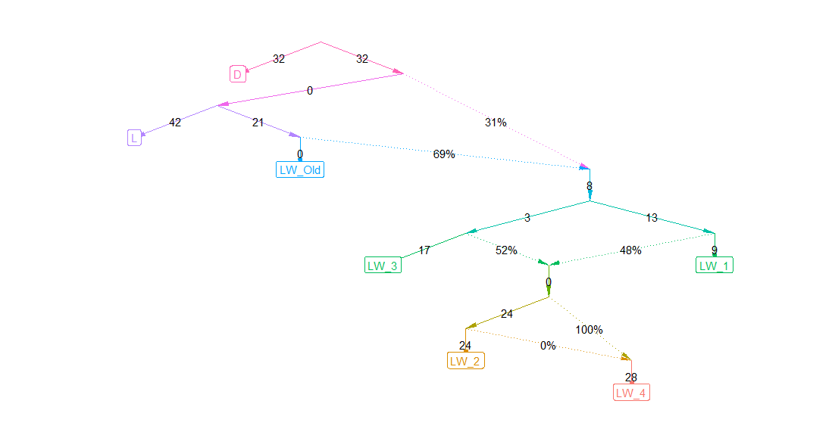 | 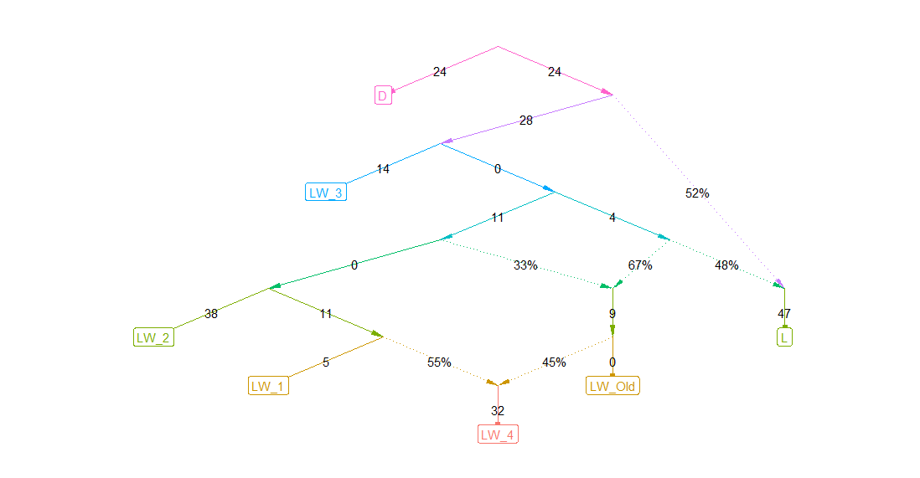 | 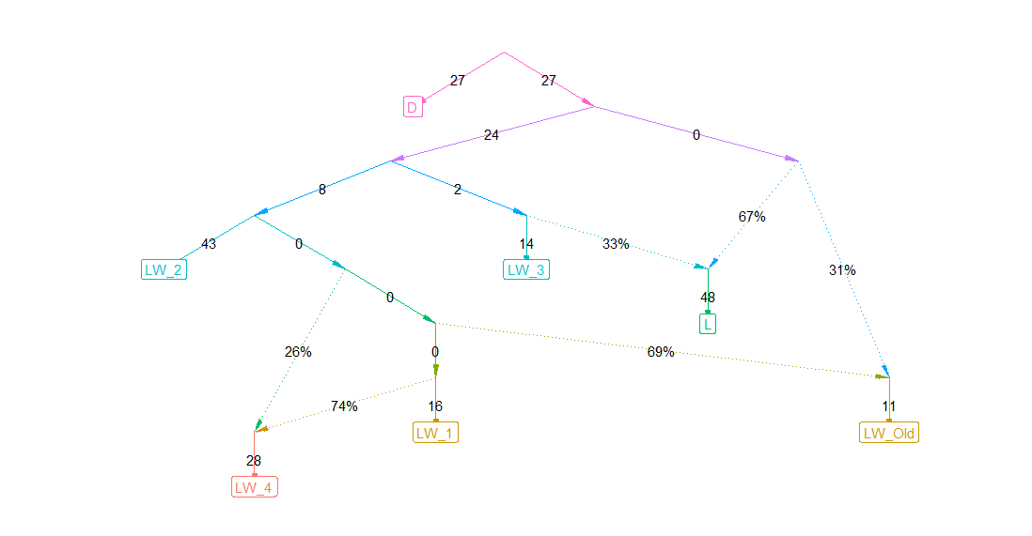
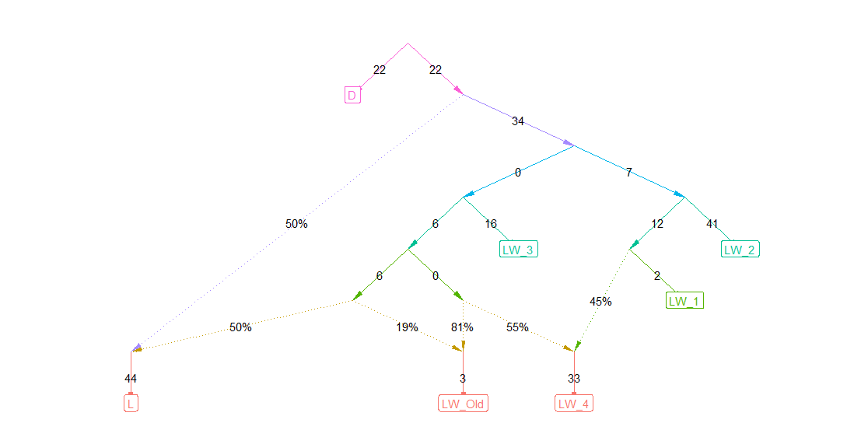 | 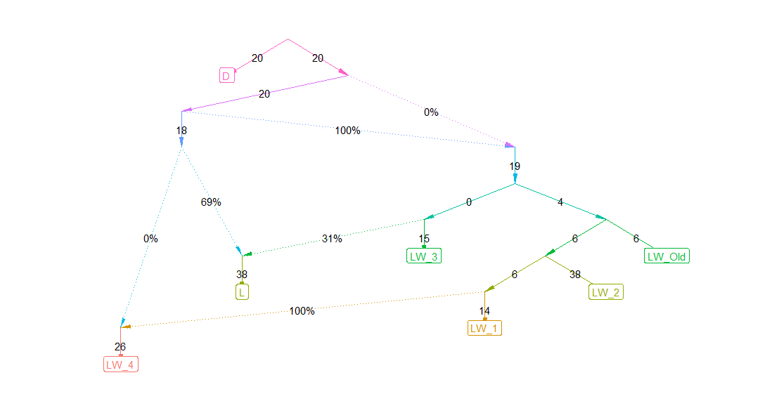 | 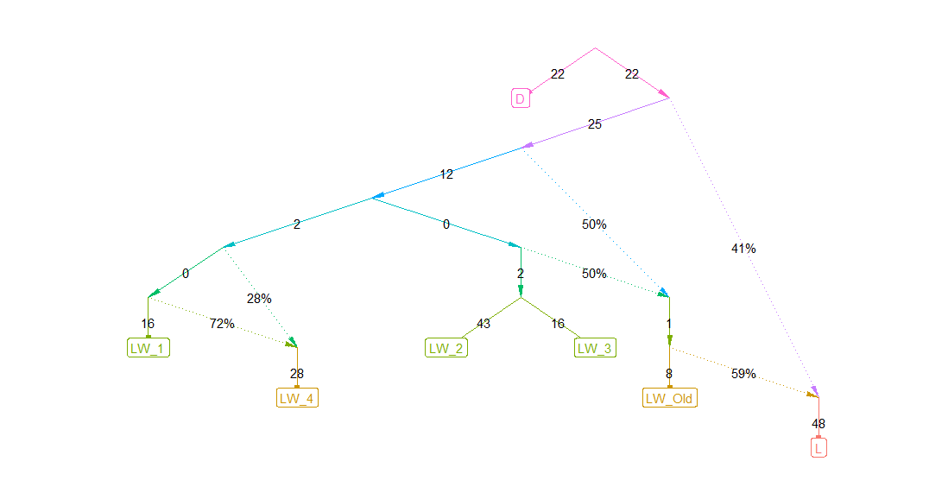
Figure S1. 9 best trees

Supp. Table 1. SNPs with the most significant signals, determined by the smoothed FST method
(LW_Old vs LW_New)
Uploaded variation | SSC | Location | Gene | SNP rs
ASGA0002802 | 1 | 51753405 | - | rs80857762
ASGA0002804 | 1 | 51818265 | RIMS1 | rs80800830
H3GA0001710 | 1 | 51880036 | RIMS1 | rs80913537
ASGA0002809 | 1 | 51918328 | RIMS1 | rs81354131
ALGA0026233 | 4 | 81493481 | - | rs80848071
MARC0083264 | 4 | 81652253 | NME7 | rs81266074
DIAS0004524 | 4 | 81769725 | NME7 | rs334130525
DRGA0004942 | 4 | 81916944 | ATP1B1 | rs81302159
DRGA0004943 | 4 | 81950375 | ATP1B1 | rs81302085
ALGA0026235 | 4 | 81986750 | ATP1B1 | rs80865817
ALGA0026236 | 4 | 82037515 | - | rs81001788
MARC0091395 | 4 | 82167212 | - | rs81271948
ALGA0026241 | 4 | 82242617 | - | rs81382225
WU_10.2_4_89965423 | 4 | 82283682 | DPT | rs325785650
INRA0015251 | 4 | 82416344 | - | rs339256957
ALGA0026246 | 4 | 82530260 | - | rs80851024
MARC0040853 | 4 | 82640649 | - | rs81232222
ALGA0026251 | 4 | 82661799 | TBX19 | rs80805879
WU_10.2_4_90543975 | 4 | 82870646 | GPR161 | rs319908869
WU_10.2_4_90706777 | 4 | 83030262 | DCAF6 | rs323730640
WU_10.2_4_90870654 | 4 | 83194885 | ADCY10 | rs80963344
ASGA0020501 | 4 | 83256996 | MPZL1 | rs80854124
ALGA0026261 | 4 | 83269208 | MPZL1 | rs80995413
ALGA0026265 | 4 | 83331520 | RCSD1 | rs80864601
ALGA0026267 | 4 | 83351551 | RCSD1 | rs80957430
M1GA0006028 | 4 | 83366667 | RCSD1 | rs80784543
WU_10.2_4_91077081 | 4 | 83401317 | RCSD1 | rs336604936
H3GA0013230 | 4 | 83466133 | CREG1 | rs80975099
WU_10.2_4_91195648 | 4 | 83519869 | CD247 | rs342976952
MARC0059073 | 4 | 83575392 | CD247 | rs80914031
WU_10.2_4_91402132 | 4 | 83726358 | POU2F1 | rs333593019
ASGA0020515 | 4 | 83900192 | STYXL2 | rs80966474
ALGA0026283 | 4 | 83928709 | GPA33 | rs80782001
WU_10.2_4_139244621 | 4 | 127146360 | - | rs329145622
ASGA0023314 | 4 | 127162411 | U2 | rs81380889
INRA0017729 | 4 | 127329631 | - | rs332269114
ASGA0023322 | 4 | 127373937 | - | rs80969221
MARC0056249 | 4 | 127417800 | GBP2 | rs80908814
WUR10000125_2 | 4 | 127441677 | GBP2 | rs80800372
WUR10000125 | 4 | 127441677 | GBP2 | rs80800372
ALGA0029524 | 4 | 127469240 | KYAT3 | rs80931093
H3GA0014860 | 4 | 127492397 | KYAT3 | rs80868308
ASGA0023344 | 4 | 127547467 | GTF2B | rs80972052
ALGA0029534 | 4 | 127598486 | PKN2 | rs80969690
ASGA0023349 | 4 | 127650044 | PKN2 | rs80881545
ALGA0029538 | 4 | 127719021 | - | rs80974336
ASGA0023354 | 4 | 127749186 | - | rs80908469
MARC0045227 | 4 | 127806086 | - | rs80904492
ASGA0023369 | 4 | 127831784 | - | rs80818844
WU_10.2_4_140106958 | 4 | 127884005 | - | rs80961883
WU_10.2_4_140281792 | 4 | 128105378 | U6 | rs325421395
MARC0071762 | 4 | 128112246 | - | rs80838629
H3GA0014885 | 4 | 128161626 | - | rs80913794
ALGA0029569 | 4 | 128175676 | - | rs80852519
ASGA0023397 | 4 | 128203397 | - | rs80835488
MARC0040196 | 4 | 128244327 | - | rs80819854
WU_10.2_5_74089491 | 5 | 71470061 | SLC2A13 | rs331576961
ALGA0032799 | 5 | 71494266 | SLC2A13 | rs81385262
MARC0029526 | 5 | 71527091 | SLC2A13 | rs81225104
ALGA0032806 | 5 | 71555828 | SLC2A13 | rs81385275
ASGA0026259 | 5 | 71599622 | SLC2A13 | rs81385292
WU_10.2_5_74315950 | 5 | 71643337 | SLC2A13 | rs340407698
MARC0015072 | 5 | 71646843 | SLC2A13 | rs81284021
ASGA0026261 | 5 | 71672068 | SLC2A13 | rs81385297
M1GA0008010 | 5 | 71694586 | - | rs81385298
WU_10.2_5_74398578 | 5 | 71725752 | - | rs337018445
MARC0076572 | 5 | 71743106 | - | rs81261794
ALGA0032819 | 5 | 71760723 | - | rs81385308
MARC0051983 | 5 | 71843440 | LRRK2 | rs81242782
WU_10.2_5_74590144 | 5 | 71881066 | LRRK2 | rs324990338
DIAS0000357 | 5 | 71904955 | LRRK2 | rs334486591
WU_10.2_5_74693783 | 5 | 71984960 | - | rs346164486
WU_10.2_5_75022148 | 5 | 72169605 | CNTN1 | rs327321401
MARC0033463 | 5 | 72192052 | CNTN1 | rs81228490
WU_10.2_5_75132228 | 5 | 72238893 | CNTN1 | rs334635547
DRGA0006005 | 5 | 72277629 | CNTN1 | rs81302978
ASGA0026270 | 5 | 72342967 | CNTN1 | rs81385324
ALGA0032834 | 5 | 72354872 | CNTN1 | rs81385330
INRA0019954 | 5 | 72393834 | CNTN1 | rs331728472
WU_10.2_5_75315384 | 5 | 72421553 | CNTN1 | rs332833778
WU_10.2_5_75349235 | 5 | 72455402 | CNTN1 | rs196955486
WU_10.2_5_75465827 | 5 | 72523648 | - | rs327502834
MARC0083381 | 5 | 72561769 | - | rs80911861
H3GA0016828 | 5 | 72610454 | PDZRN4 | rs80795265
INRA0019965 | 5 | 72637304 | PDZRN4 | rs319495888
WU_10.2_5_75602977 | 5 | 72660787 | PDZRN4 | rs327536991
MARC0056159 | 5 | 72681499 | PDZRN4 | rs80790387
WU_10.2_5_75652966 | 5 | 72710914 | PDZRN4 | rs343745666
WU_10.2_5_75678046 | 5 | 72735998 | PDZRN4 | rs322114517
ALGA0032852 | 5 | 72761996 | PDZRN4 | rs80845858
ALGA0032850 | 5 | 72774634 | PDZRN4 | rs80792002
MARC0022217 | 5 | 72783062 | PDZRN4 | rs80953364
ALGA0118476 | 6 | 45595002 | ZNF146 | rs81325388
ALGA0035270 | 6 | 45671421 | - | rs81395814
ALGA0035271 | 6 | 45683888 | - | rs81395817
ALGA0035274 | 6 | 45744000 | ZNF461 | rs81395824
MARC0013086 | 6 | 45804490 | ZNF382 | rs81268225
ASGA0028172 | 6 | 45823720 | ZNF461 | rs81395834
ASGA0083418 | 6 | 45854092 | ZNF260 | rs80859145
WU_10.2_6_99153897 | 6 | 106647339 | GREB1L | rs324979410
WU_10.2_6_99269686 | 6 | 106823884 | - | rs332543333
WU_10.2_6_99706201 | 6 | 107231177 | - | rs333865824
WU_10.2_6_99964369 | 6 | 107499283 | - | rs342019377
ASGA0084790 | 6 | 107577819 | - | rs81345398
ALGA0113175 | 6 | 107604059 | - | rs81341898
ASGA0090610 | 6 | 107705690 | - | rs81475846
MARC0020347 | 6 | 107739202 | - | rs81289650
ASGA0098402 | 6 | 107803551 | - | rs81318629
ALGA0036285 | 6 | 108061282 | - | rs81390558
ASGA0101922 | 6 | 114921710 | DSC2 | rs81323111
DRGA0006708 | 6 | 115063339 | DSC1 | rs81299113
H3GA0018683 | 6 | 115106736 | - | rs81390916
MARC0043833 | 6 | 115272451 | DSG1 | rs81235846
ASGA0090954 | 6 | 115315450 | DSG4 | rs81475861
ASGA0098807 | 6 | 115348051 | DSG3 | rs81477249
MARC0096933 | 6 | 115491651 | TTR | rs81276080
ASGA0089317 | 6 | 115501657 | TTR | rs81475807
DIAS0004318 | 6 | 115503853 | TTR | rs55618548
MARC0055381 | 6 | 115511066 | B4GALT6 | rs81245564
WU_10.2_6_108284251 | 6 | 115630713 | - | rs329207516
DRGA0006714 | 6 | 115826701 | - | rs80852301
INRA0022047 | 6 | 115933412 | RNF138 | rs346414970
ASGA0101965 | 6 | 115989400 | - | rs81323160
MARC0050502 | 6 | 116094808 | - | rs81240150
ALGA0036440 | 6 | 116228067 | GAREM1 | rs81390932
ALGA0036452 | 6 | 116681458 | - | rs81390963
DRGA0006717 | 6 | 116701805 | - | rs81299090
ALGA0036446 | 6 | 116729394 | - | rs81390951
ASGA0093226 | 6 | 117393014 | ASXL3 | rs81312128
MARC0012805 | 6 | 117440209 | ASXL3 | rs81280386
ALGA0124272 | 6 | 117505518 | ASXL3 | rs81304888
ASGA0091558 | 6 | 117519555 | ASXL3 | rs81475869
WU_10.2_6_109987667 | 6 | 117636766 | NOL4 | rs341822079
MARC0094627 | 6 | 117716544 | NOL4 | rs81274928
WU_10.2_6_110172527 | 6 | 117811884 | NOL4 | rs342920034
CASI0009620 | 6 | 117880883 | NOL4 | rs325581984
WU_10.2_6_110299648 | 6 | 117938986 | NOL4 | rs337806275
ALGA0122088 | 6 | 118058538 | NOL4 | rs81310124
ASGA0105896 | 6 | 118142600 | NOL4 | rs81306132
MARC0087051 | 6 | 118143865 | NOL4 | rs81268822
MARC0033633 | 6 | 118154602 | NOL4 | rs81227635
ASGA0094245 | 6 | 118156567 | NOL4 | rs81313364
MARC0031537 | 6 | 118367514 | DTNA | rs81225967
ASGA0094709 | 6 | 118454924 | DTNA | rs81313948
MARC0050983 | 6 | 118547338 | DTNA | rs81242840
MARC0073289 | 6 | 118553786 | DTNA | rs81259451
DIAS0000385 | 6 | 118615037 | DTNA | rs343844669
ALGA0120470 | 6 | 118745133 | DTNA | rs81327863
MARC0062521 | 6 | 118794812 | - | rs81251085
MARC0070145 | 6 | 118818260 | MAPRE2 | rs81255529
WU_10.2_6_111134306 | 6 | 118880845 | MAPRE2 | rs328704161
ASGA0029264 | 6 | 119011410 | MAPRE2 | rs81391046
MARC0071182 | 6 | 119041972 | - | rs81257667
ASGA0029261 | 6 | 119087666 | ZSCAN30 | rs81391034
ASGA0098709 | 6 | 119223012 | - | rs81319025
WU_10.2_6_111760112 | 6 | 119301317 | GALNT1 | rs341663941
H3GA0055471 | 6 | 119358759 | GALNT1 | rs81312979
MARC0102757 | 6 | 119382621 | GALNT1 | rs81279545
MARC0015284 | 6 | 119459403 | GALNT1 | rs81283256
ALGA0036515 | 6 | 119678992 | - | rs81391096
MARC0058155 | 6 | 119738186 | C18orf21 | rs81247877
MARC0009656 | 6 | 119804586 | RPRD1A | rs81258579
ALGA0116229 | 6 | 119953697 | MOCOS | rs81345674
MARC0009578 | 6 | 120053311 | FHOD3 | rs81258152
MARC0042822 | 6 | 120066519 | FHOD3 | rs81233855
H3GA0018716 | 6 | 120163897 | FHOD3 | rs81391135
MARC0056265 | 6 | 120185651 | FHOD3 | rs81246051
ASGA0029292 | 6 | 120247036 | FHOD3 | rs81391151
MARC0111696 | 6 | 120259899 | FHOD3 | rs81257158
ALGA0118431 | 6 | 120355907 | FHOD3 | rs81325333
ASGA0083580 | 6 | 120435160 | FHOD3 | rs81338371
H3GA0053043 | 6 | 120437893 | FHOD3 | rs81337502
MARC0087327 | 6 | 120497118 | FHOD3 | rs81268885
MARC0058096 | 6 | 120511919 | FHOD3 | rs81247575
ASGA0084114 | 6 | 120532935 | FHOD3 | rs81476475
ALGA0120843 | 6 | 120571461 | FHOD3 | rs81476257
MARC0067641 | 6 | 120592135 | TPGS2 | rs81254792
WU_10.2_6_113488317 | 6 | 120761993 | KIAA1328 | rs81231720
MARC0109198 | 6 | 120846100 | KIAA1328 | rs81228069
ALGA0111812 | 6 | 120862959 | KIAA1328 | rs81476443
ALGA0112500 | 6 | 120954193 | KIAA1328 | rs81341112
H3GA0056342 | 6 | 121005974 | KIAA1328 | rs81322965
ALGA0102114 | 6 | 121011821 | KIAA1328 | rs81476603
MARC0057015 | 6 | 121213301 | CELF4 | rs81246850
M1GA0008884 | 6 | 121234012 | CELF4 | rs81391175
ALGA0107778 | 6 | 121319241 | CELF4 | rs81476356
ASGA0091636 | 6 | 121327915 | CELF4 | rs81310186
ASGA0094860 | 6 | 121328865 | CELF4 | rs81314142
MARC0022914 | 6 | 121329970 | CELF4 | rs81291246
MARC0020625 | 6 | 121373131 | CELF4 | rs81288778
MARC0093627 | 6 | 121385749 | CELF4 | rs81272447
MARC0098539 | 6 | 121394974 | - | rs81277314
MARC0030522 | 6 | 121498044 | - | rs81225276
MARC0086601 | 6 | 121553230 | - | rs81269223

Supp. Table 2. QTLs, determined by the smoothed FST method (LW_Old vs LW_New)
ID QTL | SSC | Trait | Class | Group
64630 | 5 | Thoracic vertebra number | Conformation | Exterior traits
64681 | 5 | Spinal curvature | Defects | Exterior traits
31802 | 5 | PRRSV susceptibility | Disease susceptibility | Health traits
171144 | 5 | Blood urea level | Blood parameters | Health Traits
65003 | 4 | Heart weight | Anatomy | Meat and carcass trait
125479 | 6 | Intra muscular fat content | Fatness | Meat and carcass trait
153659 | 6 | Ham weight | Anatomy | Meat and carcass trait
153714 | 6 | Loin weight | Anatomy | Meat and carcass trait
160893 | 6 | Conductivity  45minute spost-mortem | Conductivity impedance | Meat and carcass trait
160958 | 6 | Dressing percentage | Anatomy | Meat and carcass trait
167239 | 6 | Backfat at last rib | Fatness | Meat and carcass trait
167248 | 6 | Backfat at tenth rib | Fatness | Meat and carcass trait
23159 | 4 | Shoulder weight | Anatomy | Meat and carcass traits
23166 | 5 | Backfat thickness  Between 3rd and 4th rib | Fatness | Meat and carcass traits
28050 | 4 | Meat colora* | Meat colour | Meat and carcass traits
29605 | 4 | Body weight weaning | Growth | Production traits
66276 | 4 | Bodyweight | Growth | Production traits
18128 | 5 | Number of stillborn | Litter traits | Reproduction traits
18146 | 4 | Gestation length | Reprodictive traits | Reproduction traits
18301 | 6 | Number of mummified pigs | Litter traits | Reproduction traits
31853 | 4 | Corpus luteum number | Litter traits | Reproduction traits
126618 | 5 | Teat number | Reproductive organ | Reproduction traits

Supp. Table 3. SNPs with the most significant signals, determined by the FLK method (LW_Old vs LW_New)
Uploaded variation | SSC | Location | Gene | SNP rs
ALGA0002916 | 1 | 43006479 | FAM184A | rs81353735
ASGA0004308 | 1 | 113630812 | - | rs81355717
H3GA0003730 | 1 | 221372453 | DOCK8 | rs81350722
ASGA0000422 | 1 | 3593533 | - | rs80804050
WU_10.2_1_4917615 | 1 | 3611749 | - | rs80801783
M1GA0000498 | 1 | 3639624 | - | rs80867878
H3GA0002682 | 1 | 122909530 | CEP152 | rs80970028
ALGA0010839 | 1 | 270610430 | - | rs81352938
INRA0003613 | 1 | 105918436 | - | rs339641713
H3GA0003733 | 1 | 221642261 | PGM5 | rs80926902
MARC0047721 | 1 | 225077683 | - | rs81239814
DRGA0002119 | 1 | 229012388 | PCSK5 | rs80905481
ALGA0005706 | 1 | 117583391 | UNC13C | rs81348106
ALGA0005711 | 1 | 117608243 | UNC13C | rs80816756
ALGA0005714 | 1 | 117633924 | UNC13C | rs80961292
DRGA0001495 | 1 | 124333001 | - | rs81296591
ALGA0005848 | 1 | 124451879 | - | rs81348378
ALGA0016905 | 2 | 146761420 | - | rs81367186
DRGA0003538 | 2 | 126841331 | CEP120 | rs81296219
ALGA0011377 | 2 | 3985548 | - | rs81357266
WU_10.2_2_148421412 | 2 | 142476638 | PCDHAC2 | rs320899654
ASGA0012763 | 2 | 147780035 | - | rs81367244
H3GA0008207 | 2 | 147728261 | - | rs81367259
ALGA0016901 | 2 | 146715517 | - | rs81367175
ALGA0120145 | 2 | 147622500 | - | rs81327481
ASGA0099180 | 2 | 147654948 | - | rs81319612
ASGA0013576 | 3 | 14516653 | AUTS2 | rs81374217
ASGA0100006 | 3 | 14515470 | AUTS2 | rs81320648
DBWU0000400 | 3 | 9463123 | CUX1 | rs55617855
ASGA0013247 | 3 | 9571294 | CUX1 | rs81370233
INRA0016754 | 4 | 111985089 | VAV3 | rs328408635
ALGA0028235 | 4 | 111423264 | FAM102B | rs80798855
ALGA0026246 | 4 | 82530260 | - | rs80851024
ASGA0019027 | 4 | 22504204 | - | rs80877304
ALGA0027760 | 4 | 105537200 | TSPAN2 | rs80792104
INRA0017183 | 4 | 119756297 | - | rs327792482
WU_10.2_4_141282346 | 4 | 128834681 | - | rs335369842
ASGA0021997 | 4 | 109578232 | - | rs80945484
ALGA0024031 | 4 | 22081785 | - | rs81381385
ASGA0021815 | 4 | 107101021 | MAGI3 | rs80855267
WU_10.2_4_117272087 | 4 | 107125678 | MAGI3 | rs331191282
DRGA0005165 | 4 | 113952913 | - | rs81302095
MARC0056159 | 5 | 72681499 | PDZRN4 | rs80790387
WU_10.2_5_75652966 | 5 | 72710914 | PDZRN4 | rs343745666
WU_10.2_5_97368087 | 5 | 92707698 | - | rs320826225
WU_10.2_5_97383238 | 5 | 92722848 | - | rs330643917
ALGA0032748 | 5 | 70121621 | MICAL3 | rs81385205
WU_10.2_5_75349235 | 5 | 72455402 | CNTN1 | rs196955486
M1GA0026700 | 5 | 65047600 | NTF3 | rs81319316
WU_10.2_5_75022148 | 5 | 72169605 | CNTN1 | rs327321401
WU_10.2_5_4846181 | 5 | 7665916 | SLC25A17 | rs330340592
H3GA0015326 | 5 | 8052127 | - | rs80880715
ASGA0025852 | 5 | 64378343 | - | rs81384683
BGIS0001413 | 5 | 38794710 | GLIPR1 | rs81212454
ALGA0031782 | 5 | 38815027 | GLIPR1 | rs81383891
WU_10.2_5_75465827 | 5 | 72523648 | - | rs327502834
ALGA0033600 | 5 | 92647755 | - | rs80985876
M1GA0008007 | 5 | 70222706 | USP18 | rs81385234
H3GA0016255 | 5 | 38599413 | CAPS2 | rs81383876
ASGA0025473 | 5 | 38741541 | - | rs81383879
ASGA0025477 | 5 | 38772761 | GLIPR1 | rs80789169
ALGA0030029 | 5 | 6866316 | MEI1 | rs80990628
MARC0036317 | 5 | 66841468 | PRMT8 | rs81229819
H3GA0016585 | 5 | 66194434 | - | rs80860217
ALGA0032428 | 5 | 65232068 | - | rs80828123
MARC0078782 | 5 | 65263327 | - | rs80826589
WU_10.2_6_35747679 | 6 | 40449361 | ZNF536 | rs345502770
ASGA0093426 | 6 | 43809208 | - | rs81312339
MARC0072609 | 6 | 44535224 | ZNF792 | rs81258771
ASGA0102371 | 6 | 78069272 | - | rs81323679
MARC0045097 | 6 | 80491095 | - | rs81237319
MARC0089589 | 6 | 104183387 | METTL4 | rs81270901
ASGA0084790 | 6 | 107577819 | - | rs81345398
ALGA0113175 | 6 | 107604059 | - | rs81341898
ASGA0090610 | 6 | 107705690 | - | rs81475846
MARC0020347 | 6 | 107739202 | - | rs81289650
ASGA0098807 | 6 | 115348051 | DSG3 | rs81477249
ASGA0089317 | 6 | 115501657 | TTR | rs81475807
MARC0055381 | 6 | 115511066 | B4GALT6 | rs81245564
DRGA0006714 | 6 | 115826701 | - | rs80852301
INRA0022047 | 6 | 115933412 | RNF138 | rs346414970
ASGA0101965 | 6 | 115989400 | - | rs81323160
ALGA0036440 | 6 | 116228067 | GAREM1 | rs81390932
MARC0012805 | 6 | 117440209 | ASXL3 | rs81280386
ALGA0124272 | 6 | 117505518 | ASXL3 | rs81304888
ASGA0091558 | 6 | 117519555 | ASXL3 | rs81475869
MARC0033633 | 6 | 118154602 | NOL4 | rs81227635
ASGA0094245 | 6 | 118156567 | NOL4 | rs81313364
ASGA0094709 | 6 | 118454924 | DTNA | rs81313948
ALGA0120470 | 6 | 118745133 | DTNA | rs81327863
MARC0070145 | 6 | 118818260 | MAPRE2 | rs81255529
ASGA0098709 | 6 | 119223012 | - | rs81319025
WU_10.2_6_111760112 | 6 | 119301317 | GALNT1 | rs341663941
MARC0058155 | 6 | 119738186 | C18orf21 | rs81247877
MARC0009656 | 6 | 119804586 | RPRD1A | rs81258579
H3GA0018716 | 6 | 120163897 | FHOD3 | rs81391135
H3GA0053043 | 6 | 120437893 | FHOD3 | rs81337502
MARC0087327 | 6 | 120497118 | FHOD3 | rs81268885
ALGA0112500 | 6 | 120954193 | KIAA1328 | rs81341112
ASGA0029311 | 6 | 122508849 | - | rs81391208
WU_10.2_6_135339230 | 6 | 146934015 | - | rs329908175
WU_10.2_6_147223902 | 6 | 159462617 | ZYG11B | rs338565316
ALGA0048360 | 8 | 79875615 | - | rs81401775
MARC0109216 | 8 | 29664380 | - | rs81245798
WU_10.2_8_84148235 | 8 | 79239404 | IQCM | rs323143709
WU_10.2_8_31165675 | 8 | 29686508 | - | rs337302298
ALGA0048346 | 8 | 79392379 | IQCM | rs81401720
ALGA0105578 | 9 | 54113499 | - | rs81332927
DRGA0009506 | 9 | 77234719 | - | rs81300269
MARC0034655 | 9 | 123180938 | CACNA1E | rs81228109
ALGA0055321 | 9 | 126718858 | - | rs81417434
ASGA0042615 | 9 | 40290530 | - | rs81409416
ALGA0053856 | 9 | 75143144 | ASB4 | rs81413399
ALGA0117593 | 9 | 9268486 | XRRA1 | rs81347393
ASGA0094412 | 9 | 9031083 | CHRDL2 | rs81477194
ASGA0048906 | 10 | 64001935 | SFMBT2 | rs81427389
ALGA0059100 | 10 | 47515492 | FRMD4A | rs81425148
ASGA0046875 | 10 | 17743923 | KIF26B | rs81421364
ALGA0059049 | 10 | 47339095 | - | rs81425058
WU_10.2_11_3896029 | 11 | 4470233 | - | rs319095277
WU_10.2_11_17192379 | 11 | 17087206 | - | rs326762479
WU_10.2_11_17102723 | 11 | 16997737 | - | rs324807535
ASGA0093177 | 12 | 40379937 | CCT6B | rs81312072
WU_10.2_12_41472772 | 12 | 39961733 | SLFN14 | rs334974208
WU_10.2_12_22810910 | 12 | 22352907 | PSMD3 | rs327628412
WU_10.2_13_18064705 | 13 | 16415777 | RBMS3 | rs329196888
ALGA0117303 | 13 | 175911737 | ROBO1 | rs81347054
ASGA0090020 | 13 | 175912123 | ROBO1 | rs81308267
WU_10.2_13_186290749 | 13 | 175854183 | ROBO1 | rs335148968
MARC0066018 | 13 | 61346407 | ITPR1 | rs81253259
WU_10.2_13_210475313 | 13 | 200399888 | SIM2 | rs337612047
ASGA0066917 | 14 | 127586033 | - | rs80886032
DRGA0014684 | 14 | 127119828 | SHTN1 | rs80797510
ASGA0060838 | 14 | 6720142 | SLC39A14 | rs80965810
ALGA0074772 | 14 | 7124862 | PEBP4 | rs80911839
ASGA0060953 | 14 | 7896731 | - | rs80812821
ALGA0075646 | 14 | 16166050 | - | rs80938569
WU_10.2_14_8410953 | 14 | 7544973 | LOXL2 | rs332569839
MARC0036731 | 15 | 77098993 | GORASP2 | rs81230364
SIRI0001080 | 15 | 1657522 | - | rs80919148
WU_10.2_15_147110047 | 15 | 133153146 | EFHD1 | rs335325248
WU_10.2_15_379190 | 15 | 1244172 | - | rs342103080
ALGA0115566 | 16 | 32462883 | MOCS2 | rs81344847
H3GA0053033 | 16 | 18490090 | MTMR12 | rs81337389
WU_10.2_16_2024086 | 16 | 1794938 | - | rs337674465
ASGA0077857 | 17 | 55108240 | CYP24A1 | rs80842245
WU_10.2_17_61656964 | 17 | 54928166 | BCAS1 | rs323332361
WU_10.2_17_61589666 | 17 | 54860869 | - | rs323238987
WU_10.2_17_11223820 | 17 | 9860385 | ZMAT4 | rs333811194
DRGA0016747 | 17 | 41675886 | - | rs80933809
MARC0012672 | 17 | 55012137 | BCAS1 | rs80844442
H3GA0049633 | 17 | 55079324 | - | rs80976648
WU_10.2_17_61625706 | 17 | 54896908 | - | rs328718092
H3GA0049027 | 17 | 41643251 | - | rs80873616
WU_10.2_17_47150684 | 17 | 41659453 | - | rs334013074
ALGA0097014 | 18 | 11247266 | - | rs81470637
WU_10.2_18_12035129 | 18 | 11343387 | - | rs323315349
ASGA0080224 | 18 | 48174205 | - | rs81470716

Supp. Table 4. QTLs, determined by the FLK method (LW_Old vs LW_New)
SSC | ID QTL | Trait | Class | Group
1 | 29590 | Intramuscular fat content | Texture | Meat and carcass trait
1 | 32101 | Linoleic acid content | Texture | Meat and carcass trait
1 | 32102 | Linoleic acid content | Texture | Meat and carcass trait
1 | 21348 | PRRSV susceptibility | Chimestry | Meat and carcass trait
1 | 65010 | Body weight | Blood parameters | Health Traits
2 | 31840 | Corpus luteum number | Blood parameters | Health Traits
2 | 106216 | Litter size | Texture | Meat and carcass trait
2 | 106221 | Piglet mortality | Chimestry | Meat and carcass trait
2 | 167245 | tenderness score | Texture | Meat and carcass trait
2 | 167246 | Shear force | Texture | Meat and carcass trait
3 | 107258 | Mean corpuscular hemoglobin content | Texture | Meat and carcass trait
3 | 107280 | Mean corpuscular volume | Texture | Meat and carcass trait
4 | 31853 | Corpus luteum number | Blood parameters | Health Traits
4 | 32068 | Palmitic acid content | Chimestry | Meat and carcass trait
4 | 164847 | Conductivity 24 hours postmortem loin | Blood parameters | Health Traits
4 | 66276 | Body weight | Blood parameters | Health Traits
4 | 164848 | Conductivity 24 hours postmortem loin | Blood parameters | Health Traits
4 | 170925 | Total number born alive | Fatty acid content | Meat and carcass trait
5 | 121909 | Backfat between 3rd and 4th last ribs | Fatness | Meat and carcass trait
5 | 167226 | Cooking yield | Blood parameters | Health Traits
5 | 31802 | PRRSV susceptibility | Chimestry | Meat and carcass trait
5 | 64629 | Thoracic vertebra number | Fatty acid content | Meat and carcass trait
5 | 64693 | Thoracolumbar vertebra number | Fatty acid content | Meat and carcass trait
5 | 64681 | Spinal curvature | Flavor | Meat and carcass trait
6 | 153714 | Loin weight | Texture | Meat and carcass trait
6 | 161058 | Conductivity 45 minutes post-mortem | Blood parameters | Health Traits
6 | 161142 | Conductivity 45 minutes post-mortem | Blood parameters | Health Traits
6 | 161032 | Conductivity 45 minutes post-mortem | Blood parameters | Health Traits
6 | 161240 | Conductivity 45 minutes post-mortem | Blood parameters | Health Traits
6 | 160981 | Dressing percentage | Blood parameters | Health Traits
6 | 161184 | Conductivity 45 minutes post-mortem | Blood parameters | Health Traits
6 | 161326 | Conductivity 45 minutes post-mortem | Blood parameters | Health Traits
6 | 160958 | Dressing percentage | Blood parameters | Health Traits
6 | 161222 | Conductivity 45 minutes post-mortem | Blood parameters | Health Traits
6 | 161129 | Conductivity 45 minutes post-mortem | Blood parameters | Health Traits
6 | 161201 | Conductivity 45 minutes post-mortem | Blood parameters | Health Traits
6 | 161075 | Conductivity 45 minutes post-mortem | Blood parameters | Health Traits
6 | 160893 | Conductivity 45 minutes post-mortem | Blood parameters | Health Traits
6 | 161243 | Conductivity 45 minutes post-mortem | Blood parameters | Health Traits
6 | 160925 | Conductivity 45 minutes post-mortem | Blood parameters | Health Traits
6 | 161230 | Conductivity 45 minutes post-mortem | Blood parameters | Health Traits
6 | 161104 | Conductivity 45 minutes post-mortem | Blood parameters | Health Traits
6 | 161105 | Conductivity 45 minutes post-mortem | Blood parameters | Health Traits
6 | 160975 | Conductivity 45 minutes post-mortem | Blood parameters | Health Traits
6 | 160974 | Conductivity 45 minutes post-mortem | Blood parameters | Health Traits
6 | 160972 | Conductivity 45 minutes post-mortem | Blood parameters | Health Traits
6 | 160973 | Conductivity 45 minutes post-mortem | Blood parameters | Health Traits
6 | 161027 | Conductivity 45 minutes post-mortem | Blood parameters | Health Traits
6 | 18119 | Number of stillborn | Chimestry | Meat and carcass trait
6 | 18301 | Number of mummified pigs | Chimestry | Meat and carcass trait
6 | 64724 | Lumbar vertebra number | Texture | Meat and carcass trait
6 | 64728 | Spinal curvature | Flavor | Meat and carcass trait
6 | 65080 | Fat weight total | Fatness | Meat and carcass trait
6 | 66277 | Body weight | Blood parameters | Health Traits
6 | 66298 | Teat number | Flavor | Meat and carcass trait
6 | 121905 | Backfat between 3rd and 4th last ribs | Fatness | Meat and carcass trait
6 | 125479 | Intramuscular fat content | Texture | Meat and carcass trait
6 | 126122 | Conformation score | Blood parameters | Health Traits
6 | 135629 | Feed conversion ratio | Feed intake | Production traits
6 | 140318 | PRRS viral load | Chimestry | Meat and carcass trait
6 | 153659 | Ham weight | Feed intake | Production traits
6 | 160909 | Conductivity 45 minutes post-mortem | Blood parameters | Health Traits
6 | 160911 | Conductivity 45 minutes post-mortem | Blood parameters | Health Traits
6 | 160930 | Conductivity 45 minutes post-mortem | Blood parameters | Health Traits
6 | 160931 | Conductivity 45 minutes post-mortem | Blood parameters | Health Traits
6 | 160932 | Conductivity 45 minutes post-mortem | Blood parameters | Health Traits
6 | 160933 | Conductivity 45 minutes post-mortem | Blood parameters | Health Traits
6 | 160935 | Conductivity 45 minutes post-mortem | Blood parameters | Health Traits
6 | 160950 | Conductivity 45 minutes post-mortem | Blood parameters | Health Traits
6 | 160959 | Conductivity 45 minutes post-mortem | Blood parameters | Health Traits
6 | 160961 | Conductivity 45 minutes post-mortem | Blood parameters | Health Traits
6 | 160962 | Conductivity 45 minutes post-mortem | Blood parameters | Health Traits
6 | 160984 | Conductivity 45 minutes post-mortem | Blood parameters | Health Traits
6 | 160987 | Conductivity 45 minutes post-mortem | Blood parameters | Health Traits
6 | 160994 | Conductivity 45 minutes post-mortem | Blood parameters | Health Traits
6 | 161006 | Conductivity 45 minutes post-mortem | Blood parameters | Health Traits
6 | 161007 | Conductivity 45 minutes post-mortem | Blood parameters | Health Traits
6 | 161017 | Conductivity 45 minutes post-mortem | Blood parameters | Health Traits
6 | 161018 | Conductivity 45 minutes post-mortem | Blood parameters | Health Traits
6 | 161021 | Conductivity 45 minutes post-mortem | Blood parameters | Health Traits
6 | 161029 | Conductivity 45 minutes post-mortem | Blood parameters | Health Traits
6 | 161030 | Conductivity 45 minutes post-mortem | Blood parameters | Health Traits
6 | 161031 | Conductivity 45 minutes post-mortem | Blood parameters | Health Traits
6 | 161040 | Conductivity 45 minutes post-mortem | Blood parameters | Health Traits
6 | 161048 | Conductivity 45 minutes post-mortem | Blood parameters | Health Traits
6 | 161055 | Conductivity 45 minutes post-mortem | Blood parameters | Health Traits
6 | 161059 | Conductivity 45 minutes post-mortem | Blood parameters | Health Traits
6 | 161060 | Conductivity 45 minutes post-mortem | Blood parameters | Health Traits
6 | 161061 | Conductivity 45 minutes post-mortem | Blood parameters | Health Traits
6 | 161071 | Conductivity 45 minutes post-mortem | Blood parameters | Health Traits
6 | 161085 | Conductivity 45 minutes post-mortem | Blood parameters | Health Traits
6 | 161090 | Conductivity 45 minutes post-mortem | Blood parameters | Health Traits
6 | 161107 | Conductivity 45 minutes post-mortem | Blood parameters | Health Traits
6 | 161120 | Conductivity 45 minutes post-mortem | Blood parameters | Health Traits
6 | 161147 | Conductivity 45 minutes post-mortem | Blood parameters | Health Traits
6 | 161150 | Conductivity 45 minutes post-mortem | Blood parameters | Health Traits
6 | 161151 | Conductivity 45 minutes post-mortem | Blood parameters | Health Traits
6 | 161161 | Conductivity 45 minutes post-mortem | Blood parameters | Health Traits
6 | 161174 | Conductivity 45 minutes post-mortem | Blood parameters | Health Traits
6 | 161175 | Conductivity 45 minutes post-mortem | Blood parameters | Health Traits
6 | 161176 | Conductivity 45 minutes post-mortem | Blood parameters | Health Traits
6 | 161177 | Conductivity 45 minutes post-mortem | Blood parameters | Health Traits
6 | 161179 | Conductivity 45 minutes post-mortem | Blood parameters | Health Traits
6 | 161187 | Conductivity 45 minutes post-mortem | Blood parameters | Health Traits
6 | 161195 | Conductivity 45 minutes post-mortem | Blood parameters | Health Traits
6 | 161219 | Conductivity 45 minutes post-mortem | Blood parameters | Health Traits
6 | 161232 | Conductivity 45 minutes post-mortem | Blood parameters | Health Traits
6 | 161235 | Conductivity 45 minutes post-mortem | Blood parameters | Health Traits
6 | 161244 | Conductivity 45 minutes post-mortem | Blood parameters | Health Traits
6 | 167239 | Backfat at last rib | Fatness | Meat and carcass trait
6 | 167240 | Backfat at last rib | Fatness | Meat and carcass trait
6 | 167248 | Backfat at tenth rib | Fatness | Meat and carcass trait
8 | 22138 | Mean corpuscular hemoglobin concentration | Texture | Meat and carcass trait
8 | 22141 | Mean corpuscular volume | Texture | Meat and carcass trait
8 | 22142 | Mean corpuscular volume | Texture | Meat and carcass trait
8 | 22143 | Mean corpuscular volume | Texture | Meat and carcass trait
9 | 22995 | Body weight birth | Blood parameters | Health Traits
9 | 23172 | Shoulder weight | Flavor | Meat and carcass trait
9 | 29538 | Average daily gain | Growth | Production traits
9 | 65105 | Lean meat weight | Texture | Meat and carcass trait
9 | 66258 | Daily feed intake | Blood parameters | Health Traits
9 | 125483 | Intramuscular fat content | Texture | Meat and carcass trait
10 | 31880 | Corpus luteum number | Blood parameters | Health Traits
10 | 107273 | Mean corpuscular hemoglobin concentration | Texture | Meat and carcass trait
11 | 55880 | Cryptorchidism | Blood parameters | Health Traits
11 | 55881 | Cryptorchidism | Blood parameters | Health Traits
11 | 65112 | Fat percentage in carcass | Blood parameters | Health Traits
11 | 167224 | Dressing percentage | Blood parameters | Health Traits
11 | 65108 | Fat percentage in carcass | Blood parameters | Health Traits
11 | 65109 | Lean meat percentage | Texture | Meat and carcass trait
11 | 65110 | Fat weight total | Fatness | Meat and carcass trait
12 | 121898 | Meat color b* | Texture | Meat and carcass trait
13 | 18134 | Number of stillborn | Chimestry | Meat and carcass trait
14 | 23006 | Body weight birth | Blood parameters | Health Traits
14 | 29574 | Average backfat thickness | Fatness | Meat and carcass trait
14 | 32128 | Linoleic acid content | Texture | Meat and carcass trait
14 | 140331 | PRRS viral load | Chimestry | Meat and carcass trait
14 | 171152 | Mean corpuscular hemoglobin content | Texture | Meat and carcass trait
14 | 178883 | Number of mummified pigs | Chimestry | Meat and carcass trait
14 | 178884 | Number of mummified pigs | Chimestry | Meat and carcass trait
14 | 178885 | Number of mummified pigs | Chimestry | Meat and carcass trait
14 | 179299 | Litter weight total | Texture | Meat and carcass trait
15 | 15128 | Bilirubin level | Blood parameters | Health Traits
15 | 170629 | Average backfat thickness | Fatness | Meat and carcass trait
15 | 170646 | Lean meat percentage | Texture | Meat and carcass trait
15 | 170898 | Days to 100 kg | Blood parameters | Health Traits
15 | 167231 | muscle protein percentage | Chimestry | Meat and carcass trait
15 | 167228 | pH 24 hr post-mortem loin | Chimestry | Meat and carcass trait
15 | 167229 | Cooking yield | Blood parameters | Health Traits
15 | 22961 | Litter weight total | Texture | Meat and carcass trait
15 | 167230 | Drip loss | Blood parameters | Health Traits
15 | 95254 | Meat color b* | Texture | Meat and carcass trait
15 | 95256 | Meat color a* | Texture | Meat and carcass trait
15 | 95263 | PH for Longissmus dorsi | Chimestry | Meat and carcass trait
15 | 95264 | Meat color b* | Texture | Meat and carcass trait
15 | 95265 | Meat color a* | Texture | Meat and carcass trait
15 | 95259 | Meat color b* | Texture | Meat and carcass trait
15 | 95262 | pH 24 hr post-mortem loin | Chimestry | Meat and carcass trait
15 | 95266 | Meat color b* | Texture | Meat and carcass trait
15 | 95267 | pH 24 hr post-mortem loin | Chimestry | Meat and carcass trait
15 | 95268 | PH for Longissmus dorsi | Chimestry | Meat and carcass trait
15 | 95269 | Meat color a* | Texture | Meat and carcass trait
15 | 95270 | Meat color b* | Texture | Meat and carcass trait
15 | 95271 | Meat color a* | Texture | Meat and carcass trait
15 | 95272 | PH for Longissmus dorsi | Chimestry | Meat and carcass trait
15 | 95273 | Meat color b* | Texture | Meat and carcass trait
15 | 95274 | Meat color b* | Texture | Meat and carcass trait
15 | 95275 | PH for Longissmus dorsi | Chimestry | Meat and carcass trait
15 | 95276 | Meat color a* | Texture | Meat and carcass trait
15 | 95277 | PH for Longissmus dorsi | Chimestry | Meat and carcass trait
15 | 95278 | PH for Longissmus dorsi | Chimestry | Meat and carcass trait
15 | 95279 | PH for Longissmus dorsi | Chimestry | Meat and carcass trait
15 | 95280 | PH for Longissmus dorsi | Chimestry | Meat and carcass trait
15 | 95281 | Meat color a* | Texture | Meat and carcass trait
15 | 95298 | Testicular length | Fatty acid content | Meat and carcass trait
15 | 95339 | Testicular percentage | Fatty acid content | Meat and carcass trait
15 | 167232 | Shear force | Texture | Meat and carcass trait
15 | 167234 | Juiciness score | Texture | Meat and carcass trait
15 | 167235 | tenderness score | Texture | Meat and carcass trait
16 | 64664 | Lumbar vertebra number | Texture | Meat and carcass trait
16 | 95388 | Arachidic acid content | Fatty acid content | Meat and carcass trait
16 | 164852 | pH 24 hr post-mortem loin | Chimestry | Meat and carcass trait
17 | 23157 | Backfat thickness between 3rd and 4th rib | Fatness | Meat and carcass trait
17 | 23164 | Backfat thickness between 3rd and 4th rib | Fatness | Meat and carcass trait
17 | 164855 | pH 24 hr post mortem ham | Chimestry | Meat and carcass trait
18 | 64671 | Lumbar vertebra number | Texture | Meat and carcass trait
18 | 126136 | Conformation score | Blood parameters | Health Traits

Supp. Table 5. SNPs with the most significant signals, determined by the smoothed FST method (LW_1 vs LW_New)
Uploaded variation | SSC | Location | Gene | SNP rs
INRA0043941 | 14 | 45509383 | TTC28 | rs343327654
ALGA0077373 | 14 | 45556841 | TTC28 | rs80978873
ASGA0063205 | 14 | 45602780 | TTC28 | rs80969675
ASGA0063206 | 14 | 45643020 | TTC28 | rs80811002
ASGA0063207 | 14 | 45656863 | TTC28 | rs80954165
DRGA0013807 | 14 | 45727087 | TTC28 | rs80971789
MARC0092574 | 14 | 45766858 | TTC28 | rs80882617
MARC0047822 | 14 | 45827810 | TTC28 | rs80968146
ALGA0077380 | 14 | 45859200 | TTC28 | rs80806354
ALGA0077382 | 14 | 46031357 | - | rs80824834
H3GA0040075 | 14 | 46084074 | - | rs80993233
H3GA0040076 | 14 | 46148505 | ZNRF3 | rs80832470
ALGA0077388 | 14 | 46219359 | ZNRF3 | rs80883638
MARC0005951 | 14 | 46297598 | KREMEN1 | rs80920419
ASGA0063217 | 14 | 46323552 | KREMEN1 | rs80928428
INRA0043964 | 14 | 46418356 | EWSR1 | rs325891452
BGIS0000437 | 14 | 46427612 | EWSR1 | rs80995717
DBNP0002145 | 14 | 46436960 | EWSR1 | rs45435082
ALGA0077394 | 14 | 46473900 | AP1B1 | rs80851887
ALGA0077399 | 14 | 46494819 | AP1B1 | rs80784711
MARC0048650 | 14 | 46520497 | AP1B1 | rs80960734
ALGA0077404 | 14 | 46563973 | NEFH | rs80809319
MARC0008762 | 14 | 46640387 | THOC5 | rs80963093
MARC0036724 | 14 | 46738288 | - | rs80796509

Supp. Table 6. QTLs, determined by the smoothed FST method (LW_1 vs LW_New)
ID QTL | SSC | Trait | Class | Group
16007 | 14 | Ratio of lifetime nonproductive days to herd life | Lifetime production | Production traits
23007 | 14 | Body weight birth | Growth | Production traits
23008 | 14 | Body weight birth | Growth | Production traits
107339 | 14 | White blood cell numbe | Imune capacity | Health traits
178883 | 14 | Mummified pigs | Litter traits | Reproduction traits
178884 | 14 | Mummified pigs | Litter traits | Reproduction traits
178885 | 14 | Mummified pigs | Litter traits | Reproduction traits
178893 | 14 | Mummified pigs | Litter traits | Reproduction traits
178894 | 14 | Mummified pigs | Litter traits | Reproduction traits
178895 | 14 | Mummified pigs | Litter traits | Reproduction traits
178896 | 14 | Mummified pigs | Litter traits | Reproduction traits
178897 | 14 | Mummified pigs | Litter traits | Reproduction traits
178898 | 14 | Mummified pigs | Litter traits | Reproduction traits
178899 | 14 | Mummified pigs | Litter traits | Reproduction traits
178900 | 14 | Mummified pigs | Litter traits | Reproduction traits
178901 | 14 | Mummified pigs | Litter traits | Reproduction traits
179293 | 14 | Litter size | Litter traits | Reproduction traits
179294 | 14 | Litter size | Litter traits | Reproduction traits
179299 | 14 | Litter weight total | Litter traits | Reproduction traits
179305 | 14 | Litter size | Litter traits | Reproduction traits
179306 | 14 | Litter size | Litter traits | Reproduction traits

Supp. Table 7. SNPs with the most significant signals, determined by the smoothed FST method (LW_2 vs LW_New)
Uploaded variation | SSC | Location | Gene | SNP rs
ASGA0003188 | 1 | 62307146 | - | rs81354504
ALGA0003898 | 1 | 62318714 | - | rs81354508
DRGA0001068 | 1 | 62371709 | - | rs81296935
INRA0002659 | 1 | 62534115 | - | rs346300123
ALGA0003900 | 1 | 62583607 | - | rs80977812
ASGA0003191 | 1 | 62598591 | - | rs80996124
DRGA0001072 | 1 | 62645599 | - | rs80813230
ALGA0003901 | 1 | 62681226 | - | rs80808398
DRGA0001073 | 1 | 62759784 | - | rs80854829
INRA0002667 | 1 | 62781138 | - | rs328370740
ASGA0003194 | 1 | 62811729 | - | rs80868692
ASGA0097561 | 1 | 62926723 | MANEA | rs80890495
ALGA0003904 | 1 | 62986317 | - | rs80910541
H3GA0001876 | 1 | 63012075 | - | rs81354534
ASGA0003200 | 1 | 63104570 | - | rs81354550
ASGA0091357 | 1 | 63189393 | - | rs81309827
MARC0112869 | 1 | 63225607 | - | rs81286784
MARC0059892 | 1 | 63244752 | - | rs81249333
CASI0007774 | 1 | 63262614 | - | rs318827837
ALGA0003917 | 1 | 63282337 | - | rs81354560
M1GA0000987 | 1 | 63294966 | - | rs81354561
H3GA0001881 | 1 | 63316569 | - | rs81354562
ALGA0003918 | 1 | 63431796 | - | rs80791165
INRA0002686 | 1 | 63513495 | - | rs319749497
ASGA0003205 | 1 | 63566792 | - | rs80870997
MARC0024388 | 1 | 63704733 | UFL1 | rs80930000
DRGA0001092 | 1 | 63726056 | FHL5 | rs80921830
DRGA0001093 | 1 | 63753893 | FHL5 | rs80855411
ALGA0102804 | 1 | 63773754 | - | rs80870517
ALGA0124376 | 1 | 63800886 | - | rs80878579
ALGA0003927 | 1 | 63856265 | - | rs80867872
MARC0059407 | 1 | 63930516 | GPR63 | rs80976465
ALGA0003935 | 1 | 63996109 | - | rs80997522
ASGA0003216 | 1 | 64079226 | KLHL32 | rs80918268
DRGA0001098 | 1 | 64119625 | KLHL32 | rs80978351
ASGA0003219 | 1 | 64135700 | KLHL32 | rs80958906
ASGA0003223 | 1 | 64154811 | KLHL32 | rs80791584
MARC0104726 | 1 | 64203044 | KLHL32 | rs80846286
ASGA0003229 | 1 | 64301394 | MMS22L | rs81354571
H3GA0001888 | 1 | 64395202 | MMS22L | rs81354573
ALGA0003946 | 1 | 64452788 | MMS22L | rs80798219
DRGA0001102 | 1 | 64553243 | - | rs80868763
ALGA0003951 | 1 | 64579689 | - | rs80958033
ASGA0003233 | 1 | 64591470 | - | rs80952489
ALGA0003952 | 1 | 64614854 | - | rs80995170
ALGA0003953 | 1 | 64674794 | - | rs80996334
H3GA0001895 | 1 | 64745294 | - | rs80929393
H3GA0001896 | 1 | 64877553 | - | rs80794355
ALGA0003960 | 1 | 64908479 | - | rs80864801
MARC0095827 | 1 | 64945916 | U6 | rs80905307
ASGA0003235 | 1 | 64978117 | - | rs80788846
WU_10.2_1_73702285 | 1 | 65152428 | - | rs325200009
ALGA0003968 | 1 | 65337586 | - | rs81354584
ALGA0003972 | 1 | 65373610 | - | rs80893006
DRGA0001106 | 1 | 65460886 | U6 | rs80886843
ASGA0003239 | 1 | 65474177 | - | rs80979692
INRA0002726 | 1 | 65537992 | - | rs341934411
ASGA0003244 | 1 | 65649768 | - | rs80891284
MARC0075306 | 1 | 65711728 | - | rs80838693
ALGA0003988 | 1 | 65759072 | - | rs80872224
INRA0002742 | 1 | 65796820 | - | rs334645174
ALGA0003991 | 1 | 65814755 | - | rs80946739
ALGA0003992 | 1 | 65841441 | POU3F2 | rs80950025
ALGA0003995 | 1 | 65859940 | - | rs80857181
DIAS0002827 | 1 | 65875605 | FBXL4 | rs80924453
ALGA0004000 | 1 | 65918133 | FBXL4 | rs80892026
ALGA0004002 | 1 | 65953598 | - | rs80915364
ASGA0003261 | 1 | 66008742 | - | rs80792488
ALGA0004005 | 1 | 66034686 | - | rs80882527
ALGA0004006 | 1 | 66047984 | - | rs80821723

Supp. Table 8. QTLs, determined by the smoothed FST method (LW_2 vs LW_New)
ID QTL | SSC | Trait | Class | Group
18270 | 1 | Mummified pigs | Litter traits | Reproduction traits
30983 | 1 | Maternal infanticide | Behavioral | Exterior traits
32098 | 1 | Palmitic acid content | Fatty acid content | Meat and carcass trait
95694 | 1 | Ham weight | Anatomy | Meat and carcass trait
126113 | 1 | Top line conformation | Conformation | Exterior traits

Supp. Table 9. SNPs with the most significant signals, determined by the smoothed FST method (LW_3 vs LW_New)
Uploaded variation | SSC | Location | Gene | SNP rs
MARC0021796 | 15 | 77070266 | GORASP2 | rs81291638
MARC0036731 | 15 | 77098993 | GORASP2 | rs81230364
H3GA0044547 | 15 | 77128890 | GORASP2 | rs80837643
MARC0046707 | 15 | 77157077 | - | rs80844498
ALGA0085987 | 15 | 77178701 | TLK1 | rs80965573
H3GA0044550 | 15 | 77232829 | TLK1 | rs80852223
ALGA0085989 | 15 | 77318065 | TLK1 | rs80999734
MARC0098380 | 15 | 77364176 | - | rs80799468
ALGA0085996 | 15 | 77440817 | - | rs80840446
ASGA0069907 | 15 | 77469771 | - | rs80981676
ASGA0069910 | 15 | 77529731 | METTL8 | rs80889278
H3GA0044561 | 15 | 77542253 | METTL8 | rs80993791
H3GA0044562 | 15 | 77566996 | METTL8 | rs81000506
ALGA0119841 | 6 | 130871443 | - | rs81327100
MARC0028469 | 6 | 130937009 | - | rs81222864
WU_10.2_6_121362776 | 6 | 130969638 | - | rs321468972
SIRI0001502 | 6 | 131101648 | - | rs321214830
ALGA0036715 | 6 | 131175703 | - | rs81391518
ALGA0036714 | 6 | 131202858 | - | rs81391515
MARC0071162 | 6 | 131244998 | - | rs81257397
ALGA0036723 | 6 | 131278864 | - | rs81391530
ALGA0036718 | 6 | 131300502 | - | rs81391526
H3GA0018809 | 6 | 131381466 | - | rs81391555
INRA0022280 | 6 | 131404149 | - | rs338651373
ALGA0036729 | 6 | 131459409 | - | rs81391549
ASGA0029413 | 6 | 131514715 | - | rs81391537
ASGA0029412 | 6 | 131528172 | - | rs80996593
ALGA0115834 | 6 | 131595818 | - | rs81345174
MARC0063627 | 6 | 131659278 | - | rs81252273
ALGA0106465 | 6 | 131681990 | - | rs81333964
ASGA0098556 | 6 | 131692557 | - | rs81476067
ALGA0116715 | 6 | 131715732 | - | rs81476575
MARC0009864 | 6 | 131767738 | ADGRL2 | rs81258912
WU_10.2_6_122065838 | 6 | 131840097 | ADGRL2 | rs340095665
DIAS0000786 | 6 | 131919402 | ADGRL2 | rs328311629
ALGA0036742 | 6 | 132005399 | ADGRL2 | rs81391579
WU_10.2_6_122438275 | 6 | 132210828 | ADGRL2 | rs322523427
WU_10.2_6_122469298 | 6 | 132241849 | ADGRL2 | rs196952550
MARC0076441 | 6 | 132363552 | ADGRL2 | rs81261721
MARC0094511 | 6 | 132429025 | - | rs81274905
DRGA0017543 | 6 | 132432954 | - | rs339759836
MARC0046692 | 6 | 132501629 | - | rs81237150
WU_10.2_6_122896738 | 6 | 132592988 | - | rs328085218
H3GA0018816 | 6 | 132710655 | - | rs81391595
H3GA0018818 | 6 | 132846185 | - | rs81391604
H3GA0018820 | 6 | 132875916 | - | rs81391613
ASGA0029430 | 6 | 132919641 | - | rs81391623
WU_10.2_6_123307483 | 6 | 132999380 | - | rs332101662
WU_10.2_6_123338444 | 6 | 133030115 | - | rs335597078
DRGA0006798 | 6 | 133134545 | - | rs81299123
ALGA0036763 | 6 | 133162201 | - | rs81391647
H3GA0018823 | 6 | 133185154 | - | rs81391651
ASGA0029438 | 6 | 133219375 | - | rs81391658
MARC0046041 | 6 | 133376793 | - | rs81237495
INRA0022295 | 6 | 133437673 | - | rs335277441
H3GA0018827 | 6 | 133453545 | - | rs81391706
ALGA0036794 | 6 | 133500969 | - | rs81391712

Supp. Table 10. QTLs, determined by the smoothed FST method (LW_3 vs LW_New)
ID QTL | SSC | Trait | Class | Group
15128 | 15 | Maternal infanticide | Behavioral | Exterior traits
22961 | 15 | Bilirubin level | Blood parameters | Health Traits
30994 | 15 | Average backfat thickness | Fatness | Meat and carcass trait
153659 | 6 | Backfat at last lumbar | Fatness | Meat and carcass trait
153714 | 6 | Backfat at last rib | Fatness | Meat and carcass trait
160893 | 6 | Backfat at last rib | Fatness | Meat and carcass trait
160909 | 6 | Backfat at last rib | Fatness | Meat and carcass trait
160911 | 6 | Backfat at last rib | Fatness | Meat and carcass trait
160925 | 6 | Backfat at tenth rib | Fatness | Meat and carcass trait
160930 | 6 | Backfat at tenth rib | Fatness | Meat and carcass trait
160931 | 6 | Backfat at tenth rib | Fatness | Meat and carcass trait
160932 | 6 | Backfat at tenth rib | Fatness | Meat and carcass trait
160933 | 6 | Conductivity 45 minutes post-mortem | Conductivity impedance | Meat and carcass trait
160935 | 6 | Conductivity 45 minutes post-mortem | Conductivity impedance | Meat and carcass trait
160950 | 6 | Conductivity 45 minutes post-mortem | Conductivity impedance | Meat and carcass trait
160958 | 6 | Conductivity 45 minutes post-mortem | Conductivity impedance | Meat and carcass trait
160959 | 6 | Conductivity 45 minutes post-mortem | Conductivity impedance | Meat and carcass trait
160961 | 6 | Conductivity 45 minutes post-mortem | Conductivity impedance | Meat and carcass trait
160962 | 6 | Conductivity 45 minutes post-mortem | Conductivity impedance | Meat and carcass trait
160972 | 6 | Conductivity 45 minutes post-mortem | Conductivity impedance | Meat and carcass trait
160973 | 6 | Conductivity 45 minutes post-mortem | Conductivity impedance | Meat and carcass trait
160974 | 6 | Conductivity 45 minutes post-mortem | Conductivity impedance | Meat and carcass trait
160975 | 6 | Conductivity 45 minutes post-mortem | Conductivity impedance | Meat and carcass trait
160981 | 6 | Conductivity 45 minutes post-mortem | Conductivity impedance | Meat and carcass trait
160984 | 6 | Conductivity 45 minutes post-mortem | Conductivity impedance | Meat and carcass trait
160987 | 6 | Conductivity 45 minutes post-mortem | Conductivity impedance | Meat and carcass trait
160994 | 6 | Conductivity 45 minutes post-mortem | Conductivity impedance | Meat and carcass trait
161006 | 6 | Conductivity 45 minutes post-mortem | Conductivity impedance | Meat and carcass trait
161007 | 6 | Conductivity 45 minutes post-mortem | Conductivity impedance | Meat and carcass trait
161017 | 6 | Conductivity 45 minutes post-mortem | Conductivity impedance | Meat and carcass trait
161018 | 6 | Conductivity 45 minutes post-mortem | Conductivity impedance | Meat and carcass trait
161021 | 6 | Conductivity 45 minutes post-mortem | Conductivity impedance | Meat and carcass trait
161027 | 6 | Conductivity 45 minutes post-mortem | Conductivity impedance | Meat and carcass trait
161029 | 6 | Conductivity 45 minutes post-mortem | Conductivity impedance | Meat and carcass trait
161030 | 6 | Conductivity 45 minutes post-mortem | Conductivity impedance | Meat and carcass trait
161031 | 6 | Conductivity 45 minutes post-mortem | Conductivity impedance | Meat and carcass trait
161032 | 6 | Conductivity 45 minutes post-mortem | Conductivity impedance | Meat and carcass trait
161040 | 6 | Conductivity 45 minutes post-mortem | Conductivity impedance | Meat and carcass trait
161048 | 6 | Conductivity 45 minutes post-mortem | Conductivity impedance | Meat and carcass trait
161055 | 6 | Conductivity 45 minutes post-mortem | Conductivity impedance | Meat and carcass trait
161058 | 6 | Conductivity 45 minutes post-mortem | Conductivity impedance | Meat and carcass trait
161059 | 6 | Conductivity 45 minutes post-mortem | Conductivity impedance | Meat and carcass trait
161060 | 6 | Conductivity 45 minutes post-mortem | Conductivity impedance | Meat and carcass trait
161061 | 6 | Conductivity 45 minutes post-mortem | Conductivity impedance | Meat and carcass trait
161071 | 6 | Conductivity 45 minutes post-mortem | Conductivity impedance | Meat and carcass trait
161075 | 6 | Conductivity 45 minutes post-mortem | Conductivity impedance | Meat and carcass trait
161085 | 6 | Conductivity 45 minutes post-mortem | Conductivity impedance | Meat and carcass trait
161090 | 6 | Conductivity 45 minutes post-mortem | Conductivity impedance | Meat and carcass trait
161104 | 6 | Conductivity 45 minutes post-mortem | Conductivity impedance | Meat and carcass trait
161105 | 6 | Conductivity 45 minutes post-mortem | Conductivity impedance | Meat and carcass trait
161107 | 6 | Conductivity 45 minutes post-mortem | Conductivity impedance | Meat and carcass trait
161120 | 6 | Conductivity 45 minutes post-mortem | Conductivity impedance | Meat and carcass trait
161129 | 6 | Conductivity 45 minutes post-mortem | Conductivity impedance | Meat and carcass trait
161142 | 6 | Conductivity 45 minutes post-mortem | Conductivity impedance | Meat and carcass trait
161147 | 6 | Conductivity 45 minutes post-mortem | Conductivity impedance | Meat and carcass trait
161150 | 6 | Conductivity 45 minutes post-mortem | Conductivity impedance | Meat and carcass trait
161151 | 6 | Conductivity 45 minutes post-mortem | Conductivity impedance | Meat and carcass trait
161161 | 6 | Conductivity 45 minutes post-mortem | Conductivity impedance | Meat and carcass trait
161174 | 6 | Conductivity 45 minutes post-mortem | Conductivity impedance | Meat and carcass trait
161175 | 6 | Conductivity 45 minutes post-mortem | Conductivity impedance | Meat and carcass trait
161176 | 6 | Conductivity 45 minutes post-mortem | Conductivity impedance | Meat and carcass trait
161177 | 6 | Conductivity 45 minutes post-mortem | Conductivity impedance | Meat and carcass trait
161179 | 6 | Conductivity 45 minutes post-mortem | Conductivity impedance | Meat and carcass trait
161184 | 6 | Conductivity 45 minutes post-mortem | Conductivity impedance | Meat and carcass trait
161187 | 6 | Conductivity 45 minutes post-mortem | Conductivity impedance | Meat and carcass trait
161195 | 6 | Conductivity 45 minutes post-mortem | Conductivity impedance | Meat and carcass trait
161201 | 6 | Conductivity 45 minutes post-mortem | Conductivity impedance | Meat and carcass trait
161219 | 6 | Conductivity 45 minutes post-mortem | Conductivity impedance | Meat and carcass trait
161222 | 6 | Conductivity 45 minutes post-mortem | Conductivity impedance | Meat and carcass trait
161230 | 6 | Conductivity 45 minutes post-mortem | Conductivity impedance | Meat and carcass trait
161232 | 6 | Conductivity 45 minutes post-mortem | Conductivity impedance | Meat and carcass trait
161235 | 6 | Conductivity 45 minutes post-mortem | Conductivity impedance | Meat and carcass trait
161240 | 6 | Conductivity 45 minutes post-mortem | Conductivity impedance | Meat and carcass trait
161243 | 6 | Conductivity 45 minutes post-mortem | Conductivity impedance | Meat and carcass trait
161244 | 6 | Conductivity 45 minutes post-mortem | Conductivity impedance | Meat and carcass trait
167231 | 6 | Conductivity 45 minutes post-mortem | Conductivity impedance | Meat and carcass trait
167236 | 6 | Conductivity 45 minutes post-mortem | Conductivity impedance | Meat and carcass trait
167238 | 6 | Conductivity 45 minutes post-mortem | Conductivity impedance | Meat and carcass trait
167239 | 6 | Conductivity 45 minutes post-mortem | Conductivity impedance | Meat and carcass trait
167240 | 6 | Conductivity 45 minutes post-mortem | Conductivity impedance | Meat and carcass trait
167241 | 6 | Dressing percentage | Anatomy | Meat and carcass trait
167243 | 6 | Dressing percentage | Anatomy | Meat and carcass trait
167248 | 6 | Ham weight | Anatomy | Meat and carcass trait
167250 | 6 | Lean meat percentage | Fatness | Meat and carcass trait
167257 | 6 | Loin weight | Anatomy | Meat and carcass trait
167258 | 6 | Loin weight | Anatomy | Meat and carcass trait
170629 | 15 | Muscle protein percentage | Chimestry | Meat and carcass trait
170646 | 15 | Days to 100 kg | Growth | Production traits
170898 | 15 | Litter weight total | Litter traits | Reproduction traits

Supp. Table 11. SNPs with the most significant signals, determined by the smoothed FST method (LW_4 vs LW_New)
Uploaded variation | SSC | Location | Gene | SNP rs
ASGA0023017 | 4 | 123920076 | CCDC18 | rs80790526
ASGA0023013 | 4 | 123966445 | CCDC18 | rs80914682
WU_10.2_4_135566902 | 4 | 124012054 | TMED5 | rs326091598
ALGA0029233 | 4 | 124037786 | - | rs80921658
ALGA0029232 | 4 | 124048185 | MTF2 | rs80871521
H3GA0014723 | 4 | 124089737 | MTF2 | rs80990190
MARC0056797 | 4 | 124163620 | - | rs80865148
ASGA0023001 | 4 | 124186629 | - | rs80947379
WU_10.2_4_135844283 | 4 | 124216278 | U6 | rs342988395
WU_10.2_4_135906408 | 4 | 124228412 | DIPK1A | rs321429919
ALGA0029201 | 4 | 124398947 | EVI5 | rs80968273
H3GA0014703 | 4 | 124421379 | EVI5 | rs80835478
H3GA0014699 | 4 | 124464881 | EVI5 | rs80930480
H3GA0014695 | 4 | 124482750 | EVI5 | rs80928870
WU_10.2_4_136122846 | 4 | 124499977 | EVI5 | rs80893135
WU_10.2_4_136181224 | 4 | 124567768 | EVI5 | rs318521790
ALGA0029186 | 4 | 124598790 | EVI5 | rs80978362
WU_10.2_4_136246749 | 4 | 124618201 | GFI1 | rs328627001
H3GA0014684 | 4 | 124664729 | - | rs81380724
WU_10.2_4_136353777 | 4 | 124684774 | - | rs328269066
ASGA0022968 | 4 | 124706568 | RPAP2 | rs81380721
WU_10.2_4_136460091 | 4 | 124791451 | GLMN | rs322700348
WU_10.2_4_136522900 | 4 | 125061511 | BRDT | rs332945547
WU_10.2_4_136543493 | 4 | 125079457 | - | rs328328631
ASGA0027714 | 6 | 19730662 | KIFC3 | rs81391898
ALGA0034691 | 6 | 19760890 | - | rs81391786
WU_10.2_6_17831619 | 6 | 19779760 | - | rs81299289
MARC0065967 | 6 | 19810566 | - | rs81252955
DIAS0000453 | 6 | 19869309 | CFAP20 | rs334905777
ALGA0034684 | 6 | 19903679 | CFAP20 | rs81391709
ALGA0104811 | 6 | 19926572 | CFAP20 | rs81332032
M1GA0025169 | 6 | 19932639 | CFAP20 | rs81346829
H3GA0054827 | 6 | 19940940 | CFAP20 | rs81475784
DIAS0002910 | 6 | 19956188 | CFAP20 | rs81218446
WU_10.2_6_17996915 | 6 | 19973006 | CSNK2A2 | rs345477428
WU_10.2_6_18061416 | 6 | 20003167 | CSNK2A2 | rs330893487
ALGA0115587 | 6 | 20040749 | - | rs81344881
ALGA0105770 | 9 | 74428112 | SGCE | rs81333124
ASGA0043786 | 9 | 74614086 | - | rs81413366
DRGA0009479 | 9 | 74725542 | PPP1R9A | rs81300512
DRGA0009480 | 9 | 74746108 | PPP1R9A | rs81299849
ALGA0053850 | 9 | 74785106 | PPP1R9A | rs80904264
ASGA0043791 | 9 | 75000208 | PON3 | rs81413387
CASI0008905 | 9 | 75039565 | PON2 | rs333740492
ASGA0043792 | 9 | 75087018 | ASB4 | rs81413393
DRGA0009485 | 9 | 75128908 | ASB4 | rs81300125
ALGA0053856 | 9 | 75143144 | ASB4 | rs81413399
ALGA0053857 | 9 | 75177787 | ASB4 | rs81413401
ASGA0043796 | 9 | 75199308 | ASB4 | rs81413407
H3GA0027806 | 9 | 75223028 | - | rs81413410
ASGA0043798 | 9 | 75259764 | PDK4 | rs81413411
MARC0053461 | 9 | 75290228 | U6 | rs81243664
CASI0008397 | 9 | 75314108 | ASB4 | rs331524345
DRGA0009488 | 9 | 75332568 | DYNC1I1 | rs81300327
ASGA0043805 | 9 | 75407604 | DYNC1I1 | rs81413421
ASGA0043811 | 9 | 75469583 | DYNC1I1 | rs81413429
ASGA0043814 | 9 | 75490123 | DYNC1I1 | rs81413432
WU_10.2_9_82963397 | 9 | 75584709 | DYNC1I1 | rs339756139
ALGA0124187 | 9 | 75718984 | DYNC1I1 | rs81304306
ASGA0089825 | 9 | 75723619 | DYNC1I1 | rs81308004
WU_10.2_9_83271497 | 9 | 75858422 | SLC25A13 | rs320992982
ALGA0053884 | 9 | 75989142 | SLC25A13 | rs81413453
ASGA0043822 | 9 | 76052645 | SLC25A13 | rs81413460
ASGA0095468 | 9 | 76081740 | SLC25A13 | rs81477200
ASGA0043825 | 9 | 76087912 | SLC25A13 | rs81413464
WU_10.2_9_83556488 | 9 | 76105135 | SLC25A13 | rs340241892
ALGA0053892 | 9 | 76182853 | SLC25A13 | rs81413466
ALGA0053893 | 9 | 76220300 | SLC25A13 | rs81413467
DRGA0009493 | 9 | 76248997 | SLC25A13 | rs336498572
\
Supp. Table 12. QTLs, determined by the smoothed FST method (LW_4 vs LW_New)
ID QTL | SSC | Trait | Class | Group
31853 | 4 | Corpus luteum number | Litter traits | Reproduction traits
37455 | 9 | Teat number | Reproductive organ | Reproduction traits
125483 | 9 | Intramuscular fat content | Fatness | Meat and carcass trait
161058 | 6 | Conductivity 45 minutes post-mortem | Conductivity impedance | Meat and carcass trait

