Table S1
Toronto Alexithymia Scale - 20 Items Ordered According to the Subscales
Items
Difficulty identifying feelings scale
1. I am often confused about what emotion I am feeling.
3. I have physical sensations that even doctors don't understand.
6. When I am upset, I don't know if I am sad, frightened, or angry.
7. I am often puzzled by sensations in my body.
9. I have feelings that I can't quite identify.
13. I don't know what's going on inside me.
14. I often don't know why I am angry.
Difficulty describing feelings scale
2. It is difficult for me to find the right words for my feelings.
4. I am able to describe my feelings easily.
11. I find it hard to describe how I feel about people.
12. People tell me to describe my feelings more.
17. It is difficult for me to reveal my innermost feelings, even to close friends.
Externally-oriented thinking scale
5. I prefer to analyze problems rather than just describe them.
8. I prefer to just let things happen rather than to understand why they turned out that way.
10. Being in touch with emotions is essential.
15. I prefer talking to people about their daily activities rather than their feelings.
16. I prefer to watch "light" entertainment shows rather than psychological dramas.
18. I can feel close to someone, even in moments of silence.
19. I find examination of my feelings useful in solving personal problems.
20. Looking for hidden meanings in movies or plays distracts from their enjoyment.

Table S2
PROMIS® Item Bank v1.0-Emotional Distress-Anxiety – Short Form 4a items
Items
- In the past 7 days, I felt fearful.
- In the past 7 days, I found it hard to focus on anything other than my anxiety.
- In the past 7 days, my worries overwhelmed me.
- In the past 7 days, I felt uneasy.

Table S3
PROMIS® Item Bank v1.0-Emotional Distress-Depression – Short Form 4a items
Items
- In the past 7 days, I felt worthless.
- In the past 7 days, I felt helpless.
- In the past 7 days, I felt depressed.
- In the past 7 days, I felt hopeless.

Table S4
Short Health Anxiety Inventory items
Items
- I am always afraid that I have a serious illness.
- I constantly have images of myself being ill.
- Nothing can take my mind off thoughts about my health.
- I usually think that I am seriously ill.

Figure S1
Estimates and Associated 95% Credibility Intervals of the Relevance Score for each TAS item of the Difficulty Identifying Feelings Scale for each of the Constructs.
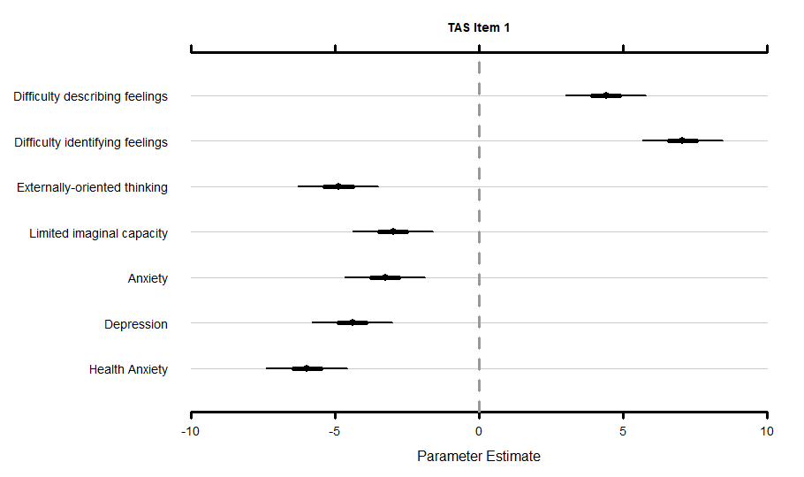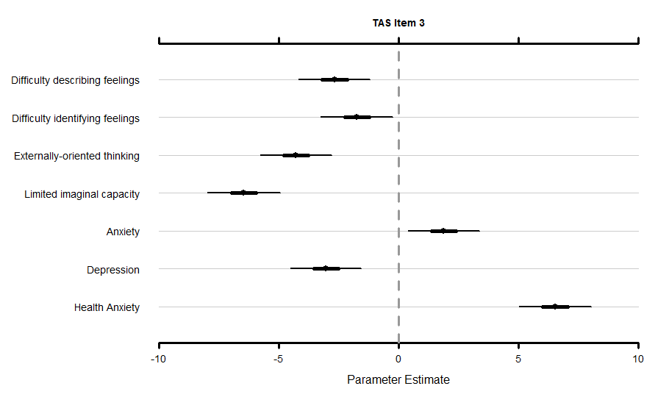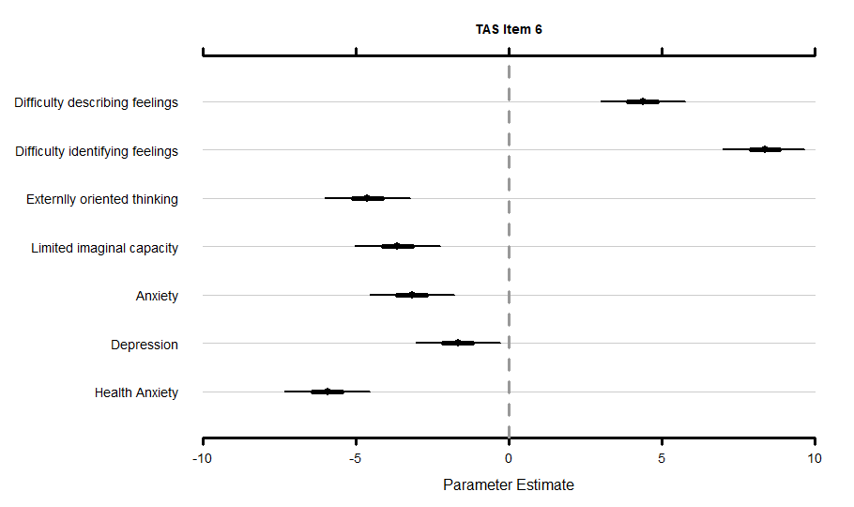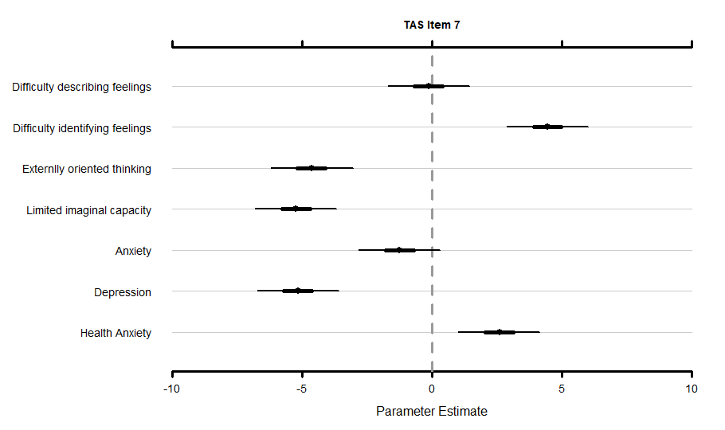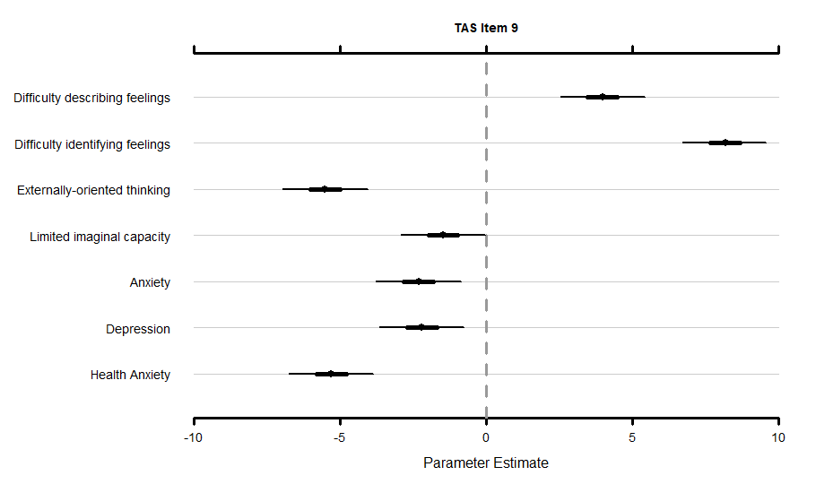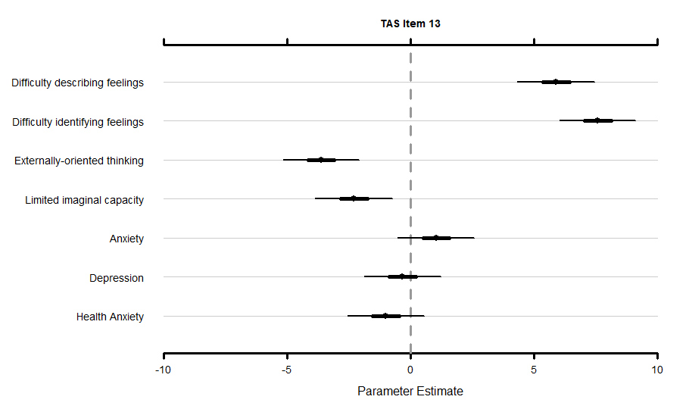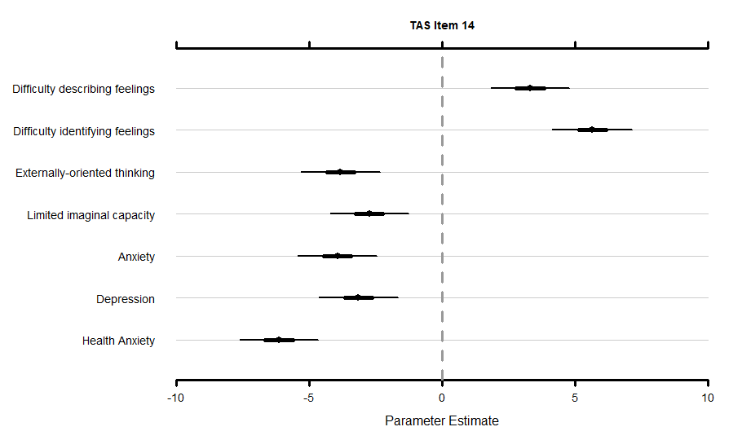
Note. TAS = Toronto Alexithymia Scale – 20; PA = PROMIS® Item Bank v1.0-Emotional Distress-Anxiety – Short Form 4a; PD = PROMIS® Item Bank v1.0 – Emotional Distress-Depression – Short Form 4a; SHAI = Short Health Anxiety Inventory.
Figure S2
Estimates and Associated 95% Credibility Intervals of the Relevance Score for each TAS Item of the Difficulty Describing Feelings Scale for each of the Constructs.
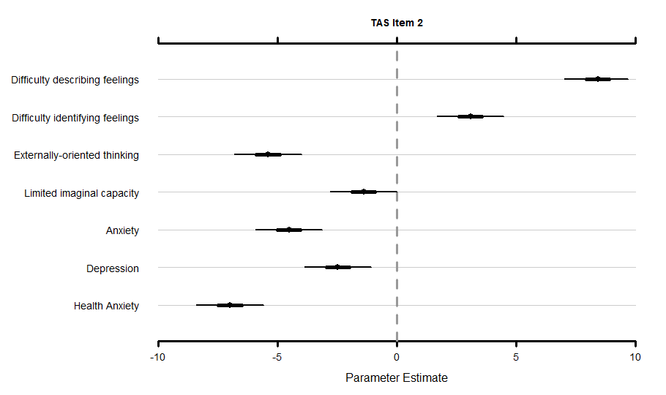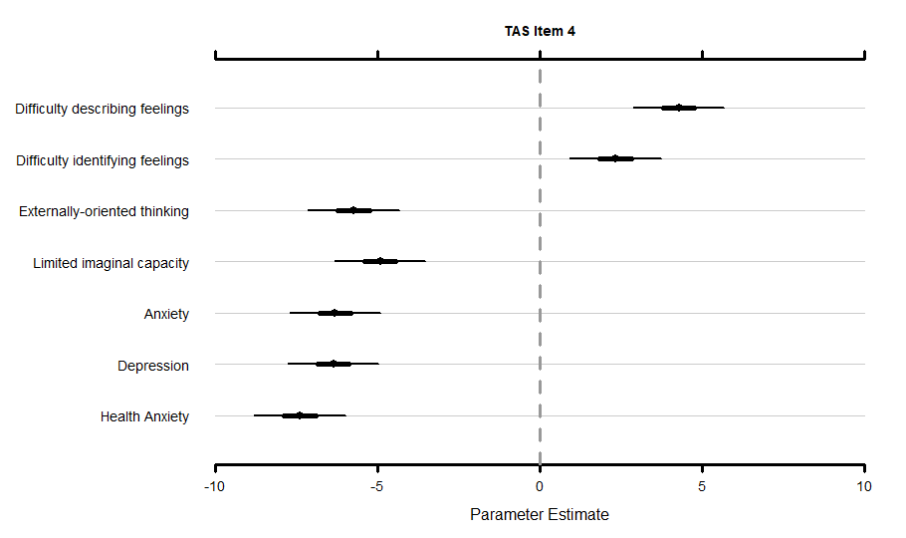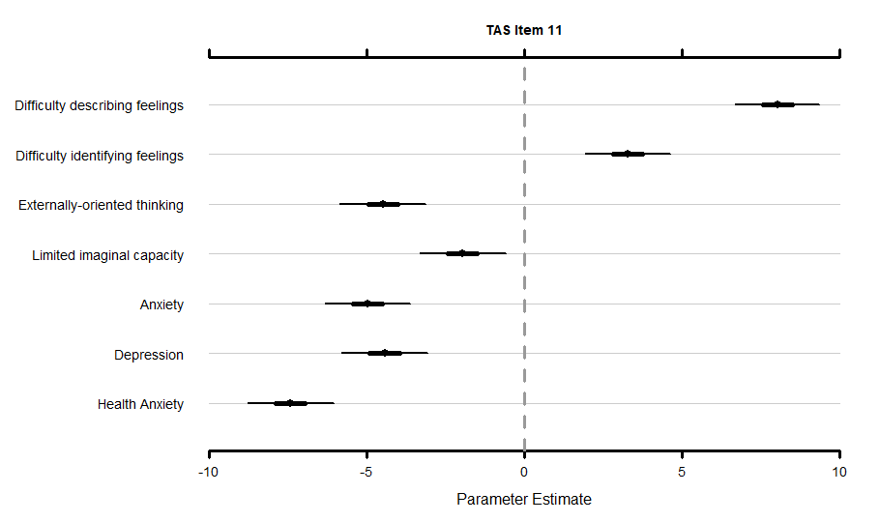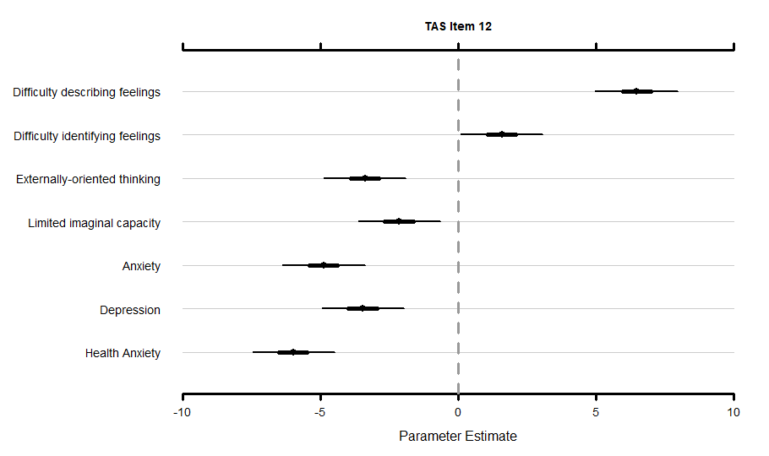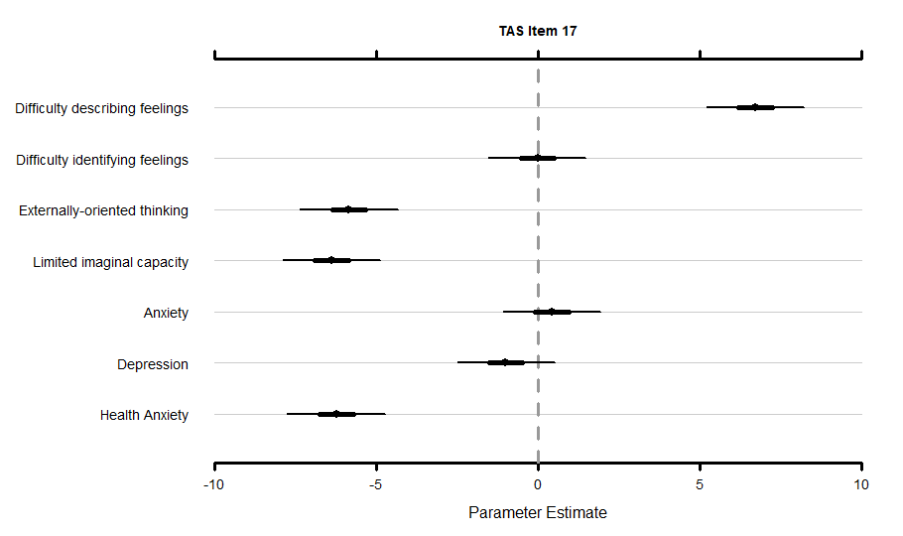
Note. TAS = Toronto Alexithymia Scale – 20; PA = PROMIS® Item Bank v1.0-Emotional Distress-Anxiety – Short Form 4a; PD = PROMIS® Item Bank v1.0 – Emotional Distress-Depression – Short Form 4a; SHAI = Short Health Anxiety Inventory.

Figure S3
Estimates and Associated 95% Credibility Intervals of the Relevance Score for each TAS Item of the Externally-Oriented Thinking Scale for each of the Constructs.
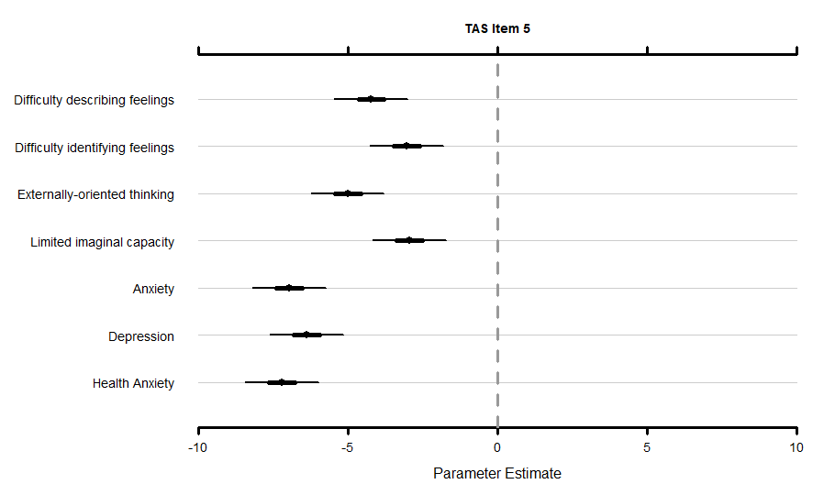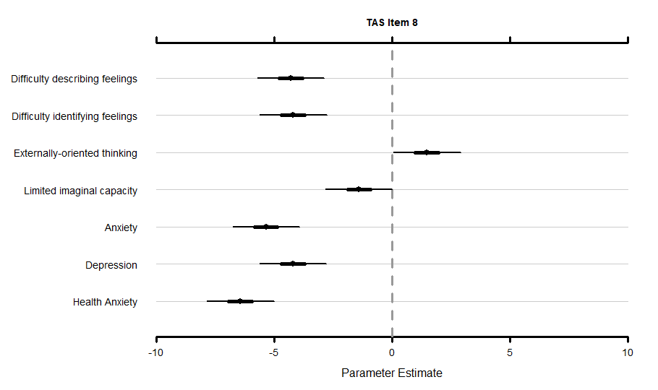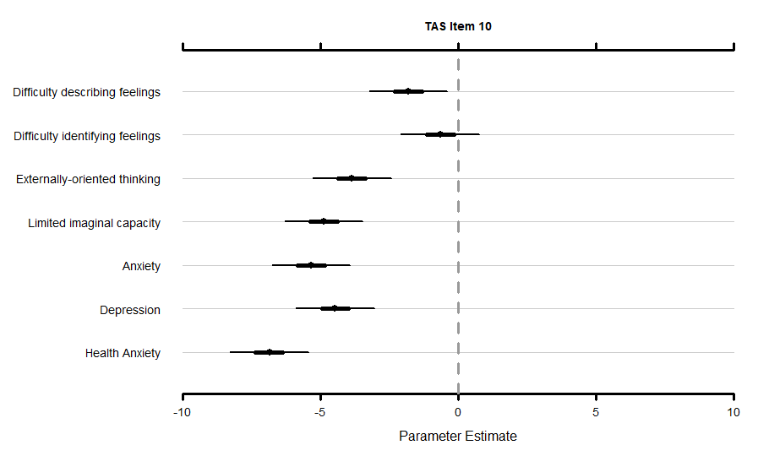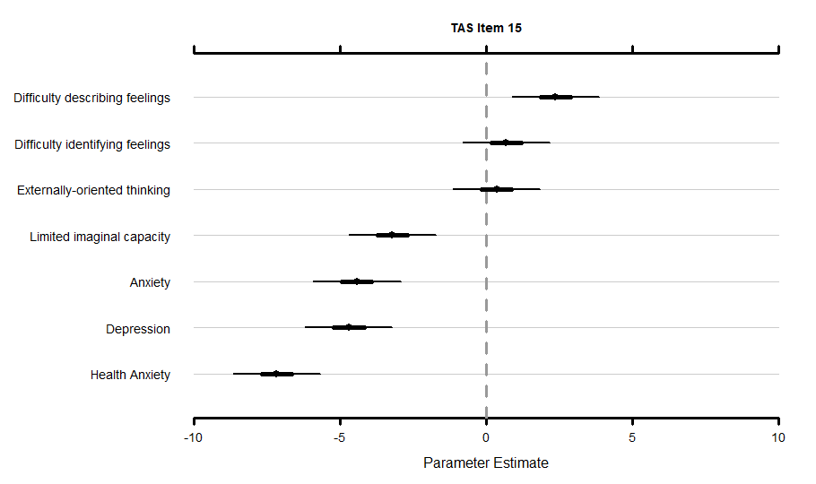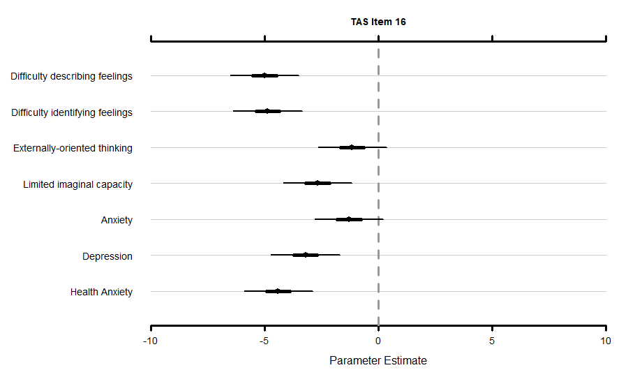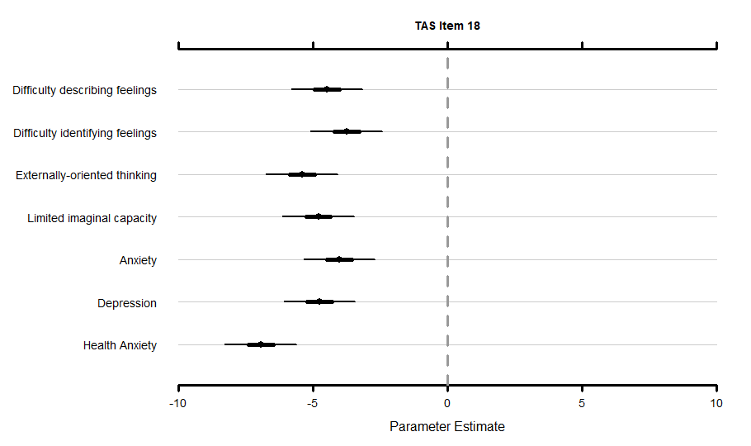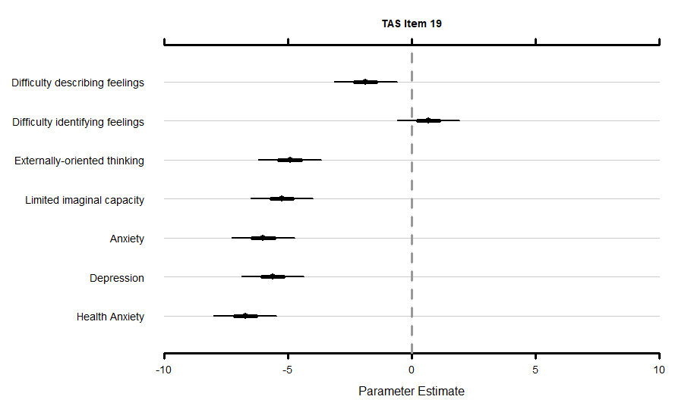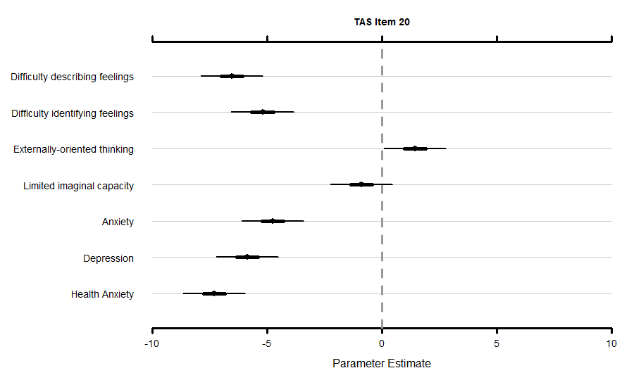
Note. TAS = Toronto Alexithymia Scale – 20; PA = PROMIS® Item Bank v1.0-Emotional Distress-Anxiety – Short Form 4a; PD = PROMIS® Item Bank v1.0 – Emotional Distress-Depression – Short Form 4a; SHAI = Short Health Anxiety Inventory.

Detailed description of the content validity results of the items
Item 1
Item 1, designed to measure difficulty identifying feelings, scored highest on ‘difficulty identifying feelings’ ($\hat{μ}$= 7.08, 95% CI [5.68 to 8.49]). It is not significantly higher than ‘difficulty describing feelings’ ($\hat{μ}$=4.41, 95% CI [3.01 to 5.82]; Δ = 2.66, 95% CI [0.89 to 4.46]). ‘Difficulty identifying feelings’ is significantly higher than ‘externally-oriented thinking’ ($\hat{μ}$=-4.89, 95% CI [-6.29 to -3.49]; Δ = 11.97, 95% CI [10.19 to 13.75]), ‘limited imaginal capacity’ ($\hat{μ}$=-2.99, 95% CI [-4.40 to -1.58]; Δ = 10.06, 95% CI [8.27 to 11.85]), ‘anxiety’ ($\hat{μ}$=-3.26, 95% CI [-4.66 to -1.87]; Δ = 10.34, 95% CI [8.55 to 12.13]), ‘depression’ ($\hat{μ}$=-4.41, 95% CI [-5.81 to -3.00]; Δ = 11.49, 95% CI [9.72 to 13.28]), and ‘health anxiety’ ($\hat{μ}$=-5.99, 95% CI [-7.39 to -4.59]; Δ = 13.06, 95% CI [11.29 to 14.84]).
Item 2
Item 2, designed to measure difficulty describing feelings, scored significantly higher on ‘difficulty describing feelings’ ($\hat{μ}$= 8.42, 95% CI [7.04 to 9.70]), compared to ‘difficulty identifying feelings’ ($\hat{μ}$=3.09, 95% CI [1.69 to 4.50]; Δ = 5.32, 95% CI [3.52 to 7.07]), ‘externally-oriented thinking’ ($\hat{μ}$=-5.41, 95% CI [-6.82 to -4.00]; Δ = 13.83, 95% CI [12.03 to 15.59]), ‘limited imaginal capacity’ ($\hat{μ}$=-1.39, 95% CI [-2.80 to 0.01]; Δ = 9.81, 95% CI [8.01 to 11.57]), ‘anxiety’ ($\hat{μ}$=-4.52, 95% CI [-5.93 to -3.13]; Δ = 12.94, 95% CI [11.15 to 14.69]), ‘depression’ ($\hat{μ}$=-2.48, 95% CI [-3.88 to -1.07]; Δ = 10.90, 95% CI [9.08 to 12.66]), and ‘health anxiety’ ($\hat{μ}$=-7.00, 95% CI [-8.41 to -5.59]; Δ = 15.42, 95% CI [13.63 to 17.19]).
Item 3
Item 3, designed to measure difficulty identifying feelings, scored significantly higher on ‘health anxiety’ ($\hat{μ}$= 6.54, 95% CI [5.02 to 8.04]), compared to ‘difficulty describing feelings’ ($\hat{μ}$=-2.68, 95% CI [-4.19 to -1.19]; Δ = 9.21, 95% CI [7.18 to 11.24]), ‘difficulty identifying feelings’ ($\hat{μ}$=-1.74, 95% CI [-3.24 to -0.25]; Δ = 8.28, 95% CI [6.24 to 10.29]), ‘externally-oriented thinking’ ($\hat{μ}$=-4.29, 95% CI [-5.79 to -2.80]; Δ = 10.83, 95% CI [8.80 to 12.84]), ‘limited imaginal capacity’ ($\hat{μ}$=-6.47, 95% CI [-7.98 to -4.96]; Δ = 13.01, 95% CI [10.98 to 15.04]), ‘anxiety’ ($\hat{μ}$=1.88, 95% CI [0.39 to 3.38]; Δ = 4.66, 95% CI [2.65 to 6.68]), and ‘depression’ ($\hat{μ}$=-3.03, 95% CI [-4.53 to -1.55]; Δ = 9.57, 95% CI [7.54 to 11.59]). The score for ‘difficulty identifying feelings’ ($\hat{μ}$=-1.74, 95% CI [-3.24 to -0.25]) is not significantly different from ‘difficulty describing feelings’ ($\hat{μ}$=-2.68, 95% CI [-4.19 to -1.19]; Δ = 0.94, 95% CI [-1.08 to 2.97]), or ‘externally-oriented thinking’ ($\hat{μ}$=-4.29, 95% CI [-5.79 to -2.80]; Δ = 2.55, 95% CI [0.53 to 4.55]). It is significantly higher compared to ‘limited imaginal capacity’ ($\hat{μ}$=-6.47, 95% CI [-7.98 to -4.96]; Δ = 4.73, 95% CI [2.71 to 6.76]), significantly lower compared to ‘anxiety’ ($\hat{μ}$=1.88, 95% CI [0.39 to 3.38]; Δ = -3.62, 95% CI [-5.65 to -1.61]), not significantly different from ‘depression’ ($\hat{μ}$=-3.03, 95% CI [-4.53 to -1.55]; Δ = 1.29, 95% CI [-0.72 to 3.31]), and significantly lower compared to ‘health anxiety’ ($\hat{μ}$= 6.54, 95% CI [5.02 to 8.04]; Δ = -8.28, 95% CI [-10.29 to -6.24]).
Item 4
Item 4, designed to measure difficulty describing feelings, scored highest on ‘difficulty describing feelings’ ($\hat{μ}$= 4.29, 95% CI [2.89 to 5.69]). It is not significantly higher than ‘difficulty identifying feelings’ ($\hat{μ}$=2.32, 95% CI [0.92 to 3.75]; Δ = 1.97, 95% CI [0.14 to 3.80]). ‘Difficulty describing feelings’ is significantly higher compared to ‘externally-oriented thinking’ ($\hat{μ}$=-5.74, 95% CI [-7.15 to -4.33]; Δ = 10.03, 95% CI [8.21 to 11.85]), ‘limited imaginal capacity’ ($\hat{μ}$=-4.92, 95% CI [-6.33 to -3.52]; Δ = 9.21, 95% CI [7.39 to 11.05]), ‘anxiety’ ($\hat{μ}$=-6.32, 95% CI [-7.72 to -4.92]; Δ = 10.61, 95% CI [8.81 to 12.43]), ‘depression’ ($\hat{μ}$=-6.37, 95% CI [-7.78 to -4.98]; Δ = 10.66, 95% CI [8.84 to 12.49]), and ‘health anxiety’ ($\hat{μ}$=-7.40, 95% CI [-8.81 to -5.99]; Δ = 11.69, 95% CI [9.87 to 13.51]).
Item 5
Item 5, designed to measure externally-oriented thinking, scored highest on ‘limited imaginal capacity’. Its score on ‘externally-oriented thinking’ ($\hat{μ}$= -5.01, 95% CI [-6.22 to -3.80]), is not significantly different from ‘difficulty describing feelings’ ($\hat{μ}$=-4.23, 95% CI [-5.46 to -3.00]; Δ = -0.78, 95% CI [-2.31 to 0.75]), or ‘difficulty identifying feelings’ ($\hat{μ}$=-3.04, 95% CI [-4.27 to -1.81]; Δ = -1.97, 95% CI [-3.50 to -0.43]), or ‘limited imaginal capacity’ ($\hat{μ}$=-2.95, 95% CI [-4.17 to -1.73]; Δ = -2.06, 95% CI [-3.59 to -0.53]). It is significantly higher compared to ‘anxiety’ ($\hat{μ}$=-6.97, 95% CI [-8.21 to -5.75]; Δ = 1.96, 95% CI [0.42 to 3.48]), ‘depression’ ($\hat{μ}$=-6.39, 95% CI [-7.62 to -5.16]; Δ = 1.38, 95% CI [-0.16 to 2.90]), and ‘health anxiety’ ($\hat{μ}$=-7.22, 95% CI [-8.45 to -5.99]; Δ = -1.97, 95% CI [-3.50 to -0.43]).
Item 6
Item 6, designed to measure difficulty identifying feelings, scored significantly higher on ‘difficulty identifying feelings’ ($\hat{μ}$= 8.36, 95% CI [6.99 to 9.66]), compared to ‘difficulty describing feelings’ ($\hat{μ}$=4.38, 95% CI [2.99 to 5.77]; Δ = 3.99, 95% CI [2.27 to 5.67]), ‘externally-oriented thinking’ ($\hat{μ}$=-4.64, 95% CI [-6.04 to -3.25]; Δ = 13.01, 95% CI [11.29 to 14.69]), ‘limited imaginal capacity’ ($\hat{μ}$=-3.64, 95% CI [-5.03 to -2.25]; Δ = 12.00, 95% CI [10.28 to 13.70]), ‘anxiety’ ($\hat{μ}$=-3.19, 95% CI [-4.57 to -1.79]; Δ = 11.55, 95% CI [9.83 to 13.25]), ‘depression’ ($\hat{μ}$=-1.68, 95% CI [-3.06 to -0.29]; Δ = 10.04, 95% CI [8.30 to 11.74]), and ‘health anxiety’ ($\hat{μ}$=-5.94, 95% CI [-7.33 to -4.55]; Δ = 14.31, 95% CI [12.57 to 16.00]).
Item 7
Item 7, designed to measure difficulty identifying feelings, scored significantly higher on ‘difficulty identifying feelings’ ($\hat{μ}$= 4.45, 95% CI [2.88 to 6.01]), compared to ‘difficulty describing feelings’ ($\hat{μ}$=-0.13, 95% CI [-1.68 to 1.43]; Δ = 4.58, 95% CI [2.52 to 6.64]), ‘externally-oriented thinking’ ($\hat{μ}$=-4.63, 95% CI [-6.19 to -3.07]; Δ = 9.08, 95% CI [7.01 to 11.16]), ‘limited imaginal capacity’ ($\hat{μ}$=-5.24, 95% CI [-6.80 to -3.67]; Δ = 9.69, 95% CI [7.63 to 11.75]), ‘anxiety’ ($\hat{μ}$=-1.25, 95% CI [-2.81 to 0.32]; Δ = 5.70, 95% CI [3.62 to 7.75]), ‘depression’ ($\hat{μ}$=-5.17, 95% CI [-6.74 to -3.61]; Δ = 9.62, 95% CI [7.55 to 11.69]), and not significantly compared to ‘health anxiety’ ($\hat{μ}$=2.59 , 95% CI [1.03 to 4.15]; Δ = 1.85, 95% CI [-0.20 to 3.92]).
Item 8
Item 8, designed to measure externally-oriented thinking, scored significantly higher on ‘externally-oriented thinking’ ($\hat{μ}$= 1.48, 95% CI [0.06 to 2.91]), compared to ‘difficulty describing feelings’ ($\hat{μ}$=-4.30, 95% CI [-5.72 to -2.88]; Δ = 5.78, 95% CI [4.02 to 7.55]), ‘difficulty identifying feelings’ ($\hat{μ}$=-4.20, 95% CI [-5.62 to -2.77]; Δ = 5.68, 95% CI [3.90 to 7.45]), ‘limited imaginal capacity’ ($\hat{μ}$=-1.40, 95% CI [-2.82 to 0.01]; Δ = 2.88, 95% CI [1.13 to 4.65]), ‘anxiety’ ($\hat{μ}$=-5.36, 95% CI [-6.76 to -3.94]; Δ = 6.84, 95% CI [5.08 to 8.60]), ‘depression’ ($\hat{μ}$=-4.20, 95% CI [-5.62 to -2.78]; Δ = 5.68, 95% CI [3.90 to 7.46]), and ‘health anxiety’ ($\hat{μ}$=-6.45, 95% CI [-7.86 to -5.01]; Δ = 7.93, 95% CI [6.17 to 9.69]).
Item 9
Item 9, designed to measure difficulty identifying feelings, scored significantly higher on ‘difficulty identifying feelings’ ($\hat{μ}$= 8.17, 95% CI [6.73 to 9.57]), compared to ‘difficulty describing feelings’ ($\hat{μ}$=3.99, 95% CI [2.54 to 5.45]; Δ = 4.19, 95% CI [2.38 to 5.97]), ‘externally-oriented thinking’ ($\hat{μ}$=-5.52, 95% CI [-6.97 to -4.07]; Δ = 13.69, 95% CI [11.87 to 15.47]), ‘limited imaginal capacity’ ($\hat{μ}$=-1.47, 95% CI [-2.91 to -0.02]; Δ = 9.64, 95% CI [7.83 to 11.41]), ‘anxiety’ ($\hat{μ}$=-2.31, 95% CI [-3.77 to -0.86]; Δ = 10.49, 95% CI [8.69 to 12.27]), ‘depression’ ($\hat{μ}$=-2.20, 95% CI [-3.66 to -0.77]; Δ = 10.37, 95% CI [8.56 to 12.18]), and ‘health anxiety’ ($\hat{μ}$=-5.30, 95% CI [-6.75 to -3.87]) (Δ = 13.47, 95% CI [11.66 to 15.26]).
Item 10
Item 10, designed to measure externally-oriented thinking, scored significantly higher on ‘difficulty identifying feelings’ ($\hat{μ}$= -0.65, 95% CI [-2.08 to 0.77]), compared to ‘difficulty describing feelings’ ($\hat{μ}$=-1.81, 95% CI [-3.23 to -0.39]; Δ = 1.16, 95% CI [-0.57 to 2.92]), ‘externally-oriented thinking’ ($\hat{μ}$=-3.86, 95% CI [-5.28 to -2.44]; Δ = 3.21, 95% CI [1.46 to 4.95]), ‘limited imaginal capacity’ ($\hat{μ}$=-4.88, 95% CI [-6.31 to -3.46]; Δ = 4.23, 95% CI [2.49 to 5.97]), ‘anxiety’ ($\hat{μ}$=-5.34, 95% CI [-6.75 to -3.92]; Δ = 4.69, 95% CI [2.94 to 6.44]), ‘depression’ ($\hat{μ}$=-4.47, 95% CI [-5.89 to -3.05]) (Δ = 3.82, 95% CI [2.08 to 5.58]), and ‘health anxiety’ ($\hat{μ}$=-6.87, 95% CI [-8.30 to -5.44]) (Δ = 6.22, 95% CI [4.47 to 7.96]). Its score on ‘externally-oriented thinking’ ($\hat{μ}$= -3.86, 95% CI [-5.28 to -2.44]), is significantly lower compared to ‘difficulty describing feelings’ ($\hat{μ}$=-1.81, 95% CI [-3.23 to -0.39]) (Δ = -2.05, 95% CI [-3.80 to -0.30]), significantly lower compared to ‘difficulty identifying feelings’ ($\hat{μ}$=-0.65, 95% CI [-2.08 to 0.77]; Δ = 0.61, 95% CI [-1.13 to 2.34]), not significantly different from ‘limited imaginal capacity’ ($\hat{μ}$=-4.88, 95% CI [-6.31 to -3.46]; Δ = 1.01, 95% CI [-0.74 to 2.76]), not significantly different from ‘anxiety’ ($\hat{μ}$=-5.34, 95% CI [-6.75 to -3.92]; Δ = 1.47, 95% CI [-0.27 to 3.20]), not significantly different from ‘depression’ ($\hat{μ}$=-4.47, 95% CI [-5.89 to -3.05]; Δ = 0.61, 95% CI [-1.13 to 2.34]), and significantly higher compared to ‘health anxiety’ ($\hat{μ}$=-6.87, 95% CI [-8.30 to -5.44]; Δ = 0.61, 95% CI [-1.13 to 2.34]).
Item 11
Item 11, designed to measure difficulty describing feelings, scored significantly higher on ‘difficulty describing feelings’ ($\hat{μ}$= 8.04, 95% CI [6.68 to 9.37]), compared to ‘difficulty identifying feelings’ ($\hat{μ}$=3.29, 95% CI [1.94 to 4.64]; (Δ = 4.75, 95% CI [2.96 to 6.54]), ‘externally-oriented thinking’ ($\hat{μ}$=-4.49, 95% CI [-5.85 to -3.13]; Δ = 12.53, 95% CI [10.74 to 14.30]), ‘limited imaginal capacity’ ($\hat{μ}$=-1.97, 95% CI [-3.33 to -0.60]; Δ = 10.01, 95% CI [8.22 to 11.79]), ‘anxiety’ ($\hat{μ}$=-4.98, 95% CI [-6.34 to -3.62]; Δ = 13.02, 95% CI [11.24 to 14.79]), ‘depression’ ($\hat{μ}$=-4.43, 95% CI [-5.81 to -3.06]; Δ = 12.47, 95% CI [10.69 to 14.25]), and ‘health anxiety’ ($\hat{μ}$=-7.43, 95% CI [-8.79 to -6.06]; Δ = 15.47, 95% CI [13.68 to 17.24]).
Item 12
Item 12, designed to measure difficulty describing feelings, scored significantly higher on ‘difficulty describing feelings’ ($\hat{μ}$= 6.49, 95% CI [4.99 to 7.99]), compared to ‘difficulty identifying feelings’ ($\hat{μ}$=1.58, 95% CI [0.09 to 3.08]; Δ = 4.90, 95% CI [3.01 to 6.78]), ‘externally-oriented thinking’ ($\hat{μ}$=-3.38, 95% CI [-4.88 to -1.90]; Δ = 9.87, 95% CI [7.98 to 11.76]), ‘limited imaginal capacity’ ($\hat{μ}$=-2.15, 95% CI [-3.64 to -0.65]; Δ = 8.63, 95% CI [6.74 to 10.53]), ‘anxiety’ ($\hat{μ}$=-4.90, 95% CI [-6.39 to -3.38]; Δ = 11.38, 95% CI [9.50 to 13.27]), ‘depression’ ($\hat{μ}$=-3.46, 95% CI [-4.95 to -1.97]; Δ = 9.95, 95% CI [8.05 to 11.85]), and ‘health anxiety’ ($\hat{μ}$=-5.99, 95% CI [-7.47 to -4.50]; Δ = 12.48, 95% CI [10.58 to 14.36]).
Item 13
Item 13, designed to measure difficulty identifying feelings, scored highest on ‘difficulty identifying feelings’ ($\hat{μ}$= 7.60, 95% CI [6.04 to 9.13]). It is not significantly higher compared to ‘difficulty describing feelings’ ($\hat{μ}$=5.90, 95% CI [4.33 to 7.46]; Δ = 1.69, 95% CI [-0.28 to 3.66]). ‘Difficulty identifying feelings’ scores significantly higher compared to ‘externally-oriented thinking’ ($\hat{μ}$=-3.62, 95% CI [-5.17 to -2.07]; Δ = 11.22, 95% CI [9.26 to 13.18]), ‘limited imaginal capacity’ ($\hat{μ}$=-2.30, 95% CI [-3.86 to -0.74]; Δ = 9.90, 95% CI [7.93 to 11.85]), ‘anxiety’ ($\hat{μ}$=1.04, 95% CI [-0.51 to 2.59]; Δ = 6.56, 95% CI [4.59 to 8.51]), ‘depression’ ($\hat{μ}$=-0.33, 95% CI [-1.88 to 1.22]; Δ = 7.92, 95% CI [5.96 to 9.89]), and ‘health anxiety’ ($\hat{μ}$=-1.01, 95% CI [-2.56 to 0.55]; Δ = 8.60, 95% CI [6.64 to 10.55]).
Item 14
Item 14, designed to measure difficulty identifying feelings, scored highest on ‘difficulty identifying feelings’ ($\hat{μ}$= 5.66, 95% CI [4.16 to 7.16]). It is not significantly higher than ‘difficulty describing feelings’ ($\hat{μ}$=3.32, 95% CI [1.83 to 4.81]; Δ = 2.35, 95% CI [0.56 to 4.15]). ‘Difficulty identifying feelings’ scores significantly higher compared to ‘externally-oriented thinking’ ($\hat{μ}$=-3.83, 95% CI [-5.31 to -2.34]; Δ = 9.49, 95% CI [7.68 to 11.29]), ‘limited imaginal capacity’ ($\hat{μ}$=-2.74, 95% CI [-4.22 to -1.26]; Δ = 8.40, 95% CI [6.61 to 10.21]), ‘anxiety’ ($\hat{μ}$=-3.94, 95% CI [-5.43 to -2.45]; Δ = 9.61, 95% CI [7.82 to 11.42]), ‘depression’ ($\hat{μ}$=-3.16, 95% CI [-4.64 to -1.67]; Δ = 8.82, 95% CI [7.02 to 10.62]), and ‘health anxiety’ ($\hat{μ}$=-6.14, 95% CI [-7.62 to -4.66]; Δ = 11.81, 95% CI [10.02 to 13.62]).
Item 15
Item 15, designed to measure externally-oriented thinking, scored highest on ‘difficulty describing feelings’, ($\hat{μ}$= 2.38, 95% CI [0.88 to 3.86]). It is not significantly compared to ‘difficulty identifying feelings’ ($\hat{μ}$=0.69, 95% CI [-0.81 to 2.19]; Δ = 1.68, 95% CI [-0.18 to 3.54]) and ‘externally-oriented thinking’ ($\hat{μ}$=0.36, 95% CI [-1.15 to 1.86]; Δ = 2.02, 95% CI [0.15 to 3.87]). ‘Difficulty describing feelings’ scored significantly higher compared to ‘limited imaginal capacity’ ($\hat{μ}$=-3.21, 95% CI [-4.71 to -1.72]; Δ = 5.59, 95% CI [3.72 to 7.47]), ‘anxiety’ ($\hat{μ}$=-4.43 , 95% CI [-5.92 to -2.93]; Δ = 6.81, 95% CI [4.96 to 8.66]), ‘depression’ ($\hat{μ}$=-4.70, 95% CI [-6.19 to -3.21]; Δ = 7.08, 95% CI [5.20 to 8.94]), and ‘health anxiety’ ($\hat{μ}$=-7.17, 95% CI [-8.66 to -5.68]; Δ = 9.55, 95% CI [7.69 to 11.41]). Its score on ‘externally-oriented thinking’ ($\hat{μ}$= 0.36, 95% CI [-1.15 to 1.86]), is not significantly different from ‘difficulty describing feelings’ ($\hat{μ}$=2.38, 95% CI [0.88 to 3.87]; Δ = -2.02, 95% CI [-3.87 to -0.15]), or ‘difficulty identifying feelings’ ($\hat{μ}$=0.69, 95% CI [-0.81 to 2.19]; Δ = -0.34, 95% CI [-2.21 to 1.54]). It significantly higher compared to ‘limited imaginal capacity’ ($\hat{μ}$=-3.21, 95% CI [-4.71 to -1.72]; Δ = 3.57, 95% CI [1.70 to 5.44]), ‘anxiety’ ($\hat{μ}$=-4.43, 95% CI [-5.92 to -2.93]; Δ = 4.79, 95% CI [2.91 to 6.65]), ‘depression’ ($\hat{μ}$=-4.70, 95% CI [-6.19 to -3.21]; Δ = 5.06, 95% CI [3.19 to 6.93]), and ‘health anxiety’ ($\hat{μ}$=-7.17, 95% CI [-8.66 to -5.68]; Δ = 7.53, 95% CI [5.67 to 9.39]).
Item 16
Item 16, designed to measure externally-oriented thinking, scored significantly higher on ‘externally-oriented thinking’ ($\hat{μ}$= -1.15, 95% CI [-2.66 to 0.36]), compared to ‘difficulty describing feelings’ ($\hat{μ}$=-5.02, 95% CI [-6.52 to -3.50]; Δ = 3.86, 95% CI [2.11 to 5.60]), ‘difficulty identifying feelings’ ($\hat{μ}$=-4.87, 95% CI [-6.38 to -3.36]; Δ = -2.20, 95% CI [-3.94 to -0.46]), not significantly different from ‘limited imaginal capacity’ ($\hat{μ}$=-2.67, 95% CI [-4.17 to -1.15]; Δ = 1.52, 95% CI [-0.22 to 3.25]), not significantly different from ‘anxiety’ ($\hat{μ}$=-1.30, 95% CI [-2.81 to 0.21]; Δ = 0.14, 95% CI [-1.61 to 1.88]), ‘depression’ ($\hat{μ}$=-3.21, 95% CI [-4.73 to -1.70]; Δ = -2.20, 95% CI [-3.94 to -0.46]), and significantly higher compared to ‘health anxiety’ ($\hat{μ}$=-4.41, 95% CI [-5.91 to -2.89]; Δ = -2.20, 95% CI [-3.94 to -0.46]).
Item 17
Item 17, designed to measure difficulty describing feelings, scored significantly higher on ‘difficulty describing feelings’ ($\hat{μ}$= 6.72, 95% CI [5.22 to 8.24]), compared to ‘difficulty identifying feelings’ ($\hat{μ}$=-0.01, 95% CI [-1.53 to 1.48]; Δ = 6.74, 95% CI [4.86 to 8.62]), ‘externally-oriented thinking’ ($\hat{μ}$=-5.86, 95% CI [-7.36 to -4.34]; Δ = 12.58, 95% CI [10.70 to 14.48]), ‘limited imaginal capacity’ ($\hat{μ}$=-6.39, 95% CI [-7.89 to -4.88]; Δ = 13.11, 95% CI [11.22 to 15.00]), ‘anxiety’ ($\hat{μ}$=0.42, 95% CI [-1.08 to 1.93]; Δ = 6.30, 95% CI [4.43 to 8.19]), ‘depression’ ($\hat{μ}$=-1.00, 95% CI [-2.49 to 0.51]; Δ = 7.73, 95% CI [5.85 to 9.61]), and ‘health anxiety’ ($\hat{μ}$=-6.24, 95% CI [-7.76 to -4.74]; Δ = 12.97, 95% CI [11.08 to 14.85]).
Item 18
Item 18, designed to measure externally-oriented thinking, scored highest on ‘difficulty identifying feelings’ ($\hat{μ}$= -3.75, 95% CI [-5.09 to -2.43]). Its score on ‘externally-oriented thinking’ ($\hat{μ}$= -5.41, 95% CI [-6.75 to -4.08]), is not significantly different from ‘difficulty describing feelings’ ($\hat{μ}$=-4.49, 95% CI [-5.81 to -3.15]; Δ = -0.93, 95% CI [-2.60 to 0.75]), ‘difficulty identifying feelings’ ($\hat{μ}$=-3.75 , 95% CI [-5.09 to -2.43]; Δ = 3.20, 95% CI [1.51 to 4.87]), ‘limited imaginal capacity’ ($\hat{μ}$=-4.80 , 95% CI [-6.14 to -3.47]; Δ = -0.61, 95% CI [-2.28 to 1.09]), ‘anxiety’ ($\hat{μ}$=-4.02, 95% CI [-5.36 to -2.70]; Δ = -1.39, 95% CI [-3.06 to 0.28]), ‘depression’ ($\hat{μ}$=-4.76, 95% CI [-6.08 to -3.43]; Δ = 3.20, 95% CI [1.51 to 4.87]), and ‘health anxiety’ ($\hat{μ}$=-6.95, 95% CI [-8.28 to -5.62]; Δ = 3.20, 95% CI [1.51 to 4.87]).
Item 19
Item 19, designed to measure externally-oriented thinking, scored significantly higher on ‘difficulty identifying feelings’ ($\hat{μ}$= 0.67, 95% CI [-0.59 to 1.94]), compared to ‘difficulty describing feelings’ ($\hat{μ}$=-1.86, 95% CI [-3.13 to -0.59]; Δ = 2.53, 95% CI [0.93 to 4.13]), ‘externally-oriented thinking’ ($\hat{μ}$=-4.92, 95% CI [-6.19 to -3.64]; Δ = 5.59, 95% CI [3.99 to 7.20]), ‘limited imaginal capacity’ ($\hat{μ}$=-5.26, 95% CI [-6.52 to -3.98]; Δ = 5.93, 95% CI [4.33 to 7.54]), ‘anxiety’ ($\hat{μ}$=-6.00, 95% CI [-7.27 to -4.74]; Δ = 6.68, 95% CI [5.08 to 8.27]), ‘depression’ ($\hat{μ}$=-5.61, 95% CI [-6.88 to -4.36]; Δ = 6.29, 95% CI [4.69 to 7.89]), and ‘health anxiety’ ($\hat{μ}$=-6.73, 95% CI [-8.00 to -5.48]; Δ = 7.40, 95% CI [5.81 to 9.01]). Its score on ‘externally-oriented thinking’ ($\hat{μ}$= -4.92, 95% CI [-6.19 to -3.64]), is significantly lower compared to ‘difficulty describing feelings’ ($\hat{μ}$=-1.86, 95% CI [-3.13 to -0.59]; Δ = -3.06, 95% CI [-4.65 to -1.46]), significantly lower compared to ‘difficulty identifying feelings’ ($\hat{μ}$=0.67, 95% CI [-0.59 to 1.94]; Δ = 2.53, 95% CI [0.93 to 4.13]), not significantly different from ‘limited imaginal capacity’ ($\hat{μ}$=-5.26, 95% CI [-6.52 to -3.98]; Δ = 0.34, 95% CI [-1.27 to 1.94]), not significantly different from ‘anxiety’ ($\hat{μ}$=-6.00, 95% CI [-7.27 to -4.74]; Δ = 1.08, 95% CI [-0.52 to 2.67]), not significantly different from ‘depression’ ($\hat{μ}$=-5.61, 95% CI [-6.88 to -4.36]; Δ = 2.53, 95% CI [0.93 to 4.13]), and not significantly different from ‘health anxiety’ ($\hat{μ}$=-6.73, 95% CI [-8.00 to -5.48]; Δ = 2.53, 95% CI [0.93 to 4.13]).
Item 20
Item 20, designed to measure externally-oriented thinking, scored significantly higher on ‘externally-oriented thinking’ ($\hat{μ}$= 1.45, 95% CI [0.09 to 2.79]), compared to ‘difficulty describing feelings’ ($\hat{μ}$=-6.53, 95% CI [-7.89 to -5.19]; Δ = 7.98, 95% CI [6.15 to 9.82]), ‘difficulty identifying feelings’ ($\hat{μ}$=-5.20, 95% CI [-6.56 to -3.85]; Δ = 6.65, 95% CI [4.83 to 8.46]), ‘limited imaginal capacity’ ($\hat{μ}$=-0.89, 95% CI [-2.23 to 0.47]; Δ = 2.33, 95% CI [0.50 to 4.16]), ‘anxiety’ ($\hat{μ}$=-4.77, 95% CI [-6.12 to -3.41]; Δ = 6.21, 95% CI [4.39 to 8.05]), ‘depression’ ($\hat{μ}$=-5.87, 95% CI [-7.21 to -4.51]; Δ = 7.31, 95% CI [5.50 to 9.12]), and ‘health anxiety’ ($\hat{μ}$=-7.31, 95% CI [-8.66 to -5.95]; Δ = 8.75, 95% CI [6.92 to 10.56]).
Table S5
Estimates and Associated 95% Credibility Intervals of the Relevance Score for each TAS Item of the Difficulty Identifying Feelings Scale for each of the Constructs
Item | Difficulty identifying feelings  $\hat{μ}$ [CI] | Difficulty  describing  feelings  $\hat{μ}$ [CI] | Limited  imaginal  capacity  $\hat{μ}$ [CI] | Externally-  oriented  thinking  $\hat{μ}$ [CI] | Anxiety  $\hat{μ}$ [CI] | Health anxiety  $\hat{μ}$ [CI] | Depression  $\hat{μ}$ [CI]
1 | 7.08*  [5.68, 8.49] | 4.41*  [3.01, 5.82] | -2.99*  [-4.40, -1.58] | -4.89*  [-6.29, -3.49] | -3.26*  [-4.66, -1.87] | -5.99*  [-7.39, -4.59] | -4.41*  [-5.81, -3.00]
2 | 3.09*  [1.69, 4.50] | 8.42*  [7.04, 9.70] | -1.39  [-2.80, 0.01] | -5.41*  [-6.82, -4.00] | -4.52*  [-5.93, -3.13] | -7.00*  [-8.41, -5.59] | -2.48*  [-3.88, -1.07]
3 | -1.74*  [-3.24, -0.24] | -2.68*  [-4.19, -1.19] | -6.47*  [-7.98, -4.96] | -4.29*  [-5.79, -2.80] | 1.88*  [0.39, 3.38] | 6.54*  [5.02, 8.04] | -3.03*  [-4.53, -1.55]
4 | 2.32*  [0.92, 3.75] | 4.29*  [2.89, 5.69] | -4.92*  [-6.33, -3.52] | -5.74*  [-7.15, -4.33] | -6.32*  [-7.72, -4.92] | -7.40*  [-8.81, -5.99] | -6.37*  [-7.78, -4.98]
5 | -3.04*  [-4.27, -1.81] | -4.23*  [-5.46, -3.00] | -2.95*  [-4.17, -1.73] | -5.01*  [-6.22, -3.79] | -6.97*  [-8.21, -5.75] | -7.22*  [-8.45, -5.99] | -6.39*  [-7.62, -5.16]
6 | 8.36*  [6.99, 9.66] | 4.38*  [2.99, 5.77] | -3.64*  [-5.03, -2.25] | -4.64*  [-6.04, -3.25] | -3.19*  [-4.57, -1.79] | -5.94*  [-7.33, -4.55] | -1.68*  [-3.06, -0.29]
7 | 4.45*  [2.88, 6.01] | -0.13  [-1.68, 1.43] | -5.24*  [-6.80, -3.67] | -4.63*  [-6.19, -3.07] | -1.25  [-2.81, 0.32] | 2.59*  [1.03, 4.15] | -5.17*  [-6.74, -3.61]
8 | -4.20*  [-5.62, -2.77] | -4.30*  [-5.72, -2.88] | -1.40  [-2.82, 0.01] | 1.48*  [0.06, 2.91] | -5.36*  [-6.76, -3.94] | -6.45*  [-7.86, -5.01] | -4.20*  [-5.62, -2.78]
9 | 8.17*  [6.73, 9.57] | 3.99*  [2.54, 5.45] | -1.47*  [-2.91, -0.02] | -5.52*  [-6.97, -4.07] | -2.31*  [-3.77, -0.86] | -5.30*  [-6.75, -3.87] | -2.20*  [-3.66, -0.77]
10 | -0.65  [-2.08, 0.77] | -1.81*  [-3.23, -0.39] | -4.88*  [-6.31, -3.46] | -3.86*  [-5.28, -2.44] | -5.34*  [-6.75, -3.92] | -6.87*  [-8.30, -5.44] | -4.47*  [-5.89, -3.05]
Note: $\hat{μ}$ = mu, estimated mean in the population, CI = 95% confidence interval, * p < 0.05, indicating a significant difference in score with the respective construct.
Table S5 (continued)
Estimates and Associated 95% Credibility Intervals of the Relevance score for each TAS Item of the Difficulty Identifying Feelings Scale for each of the Constructs
Item | Difficulty identifying feelings  $\hat{μ}$ [CI] | Difficulty  describing  feelings  $\hat{μ}$ [CI] | Limited  imaginal  capacity  $\hat{μ}$ [CI] | Externally-  oriented  thinking  $\hat{μ}$ [CI] | Anxiety  $\hat{μ}$ [CI] | Health anxiety  $\hat{μ}$ [CI] | Depression  $\hat{μ}$ [CI]
11 | 3.29*  [1.94, 4.64] | 8.04*  [6.68, 9.37] | -1.97*  [-3.33, -0.60] | -4.49*  [-5.85, -3.13] | -4.98*  [-6.34, -3.62] | -7.43*  [-8.79, -6.06] | -4.43*  [-5.81, -3.06]
12 | 1.58*  [0.09, 3.08] | 6.49*  [4.99, 7.99] | -2.15*  [-3.64, -0.65] | -3.38*  [-4.88, -1.90] | -4.90*  [-6.39, -3.38] | -5.99*  [-7.47, -4.50] | -3.46*  [-4.95, -1.97]
13 | 7.60*  [6.04, 9.13] | 5.90*  [4.33, 7.46] | -2.30*  [-3.86, -0.74] | -3.62*  [-5.17, -2.07] | 1.04  [-0.51, 2.59] | -1.01  [-2.56, 0.55] | -0.33  [-1.88, 1.22]
14 | 5.66*  [4.16, 7.16] | 3.32*  [1.83, 4.81] | -2.74*  [-4.22, -1.26] | -3.83*  [-5.31, -2.34] | -3.94*  [-5.43, -2.45] | -6.14*  [-7.62, -4.66] | -3.16*  [-4.64, -1.67]
15 | 0.69  [-0.81, 2.19] | 2.38*  [0.88, 3.86] | -3.21*  [-4.71, -1.72] | 0.36  [-1.15, 1.86] | -4.43*  [-5.92, -2.93] | -7.17*  [-8.66, -5.68] | -4.70*  [-6.19, -3.21]
16 | -4.87*  [-6.38, -3.36] | -5.02*  [-6.52, -3.50] | -2.67*  [-4.17, 1.15] | -1.15  [-2.66, 0.36] | -1.30  [-2.81, 0.21] | -4.41*  [-5.91, -2.89] | -3.21*  [-4.73, -1.70]
17 | -0.01  [-1.53, 1.48] | 6.72*  [5.22, 8.24] | -6.39*  [-7.89, -4.88] | -5.85*  [-7.36, -4.34] | 0.42  [-1.08, 1.93] | -6.24*  [-7.76, -4.74] | -1.00  [-2.49, 0.51]
18 | -3.75*  [-5.09, -2.43] | -4.49*  [-5.81, -3.15] | -4.80*  [-6.14, -3.47] | -5.41*  [-6.75, -4.08] | -4.02*  [-5.36, -2.70] | -6.95*  [-8.28, -5.62] | -4.76*  [-6.08, -3.43]
19 | 0.67  [-0.59, 1.94] | -1.86*  [-3.13, -0.59] | -5.26*  [-6.52, -3.98] | -4.92*  [-6.19, -3.64] | -6.00*  [-7.27, -4.74] | -6.73*  [-8.00, -5.48] | -5.61*  [-6.88, -4.36]
20 | -5.20*  [-6.56, -3.85] | -6.53*  [-7.89, -5.19] | -0.89  [-2.23, 0.47] | 1.45*  [0.09, 2.79] | -4.77*  [-6.12, -3.41] | -7.31*  [-8.66, -5.95] | -5.87*  [-7.21, -4.51]
Note: $\hat{μ}$ = mu, estimated mean in the population, CI = 95% confidence interval, * p < 0.05, indicating a significant difference in score with the respective construct.

