Supplemental Table 1. List of questions administered on day 28
Outcome | Question | Response choices
Overall health | How would you describe your dog's current overall health after switching to Nom Nom? | - Better  - About the same  - Worse
Physical activity | How would you describe your dog's current activity level after switching to Nom Nom? | - More active  - About the same  - Less active
Weight change | What is your dog's current weight (in lbs)? | Weight in lbs  Weight change is then calculated by subtracting weight on day 0 from weight on day 28
Fecal score change | Which of the following best represents your dog's stool after switching to Nom Nom? | Each response is accompanied by a graphic  - Separate hard lumps, like nuts (score = 1)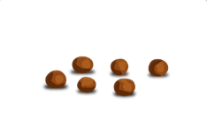  - Sausage-shaped, but lumpy (score = 2)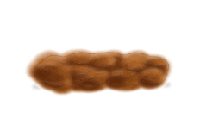  - Sausage-shaped, but with cracks on surface (score = 3)  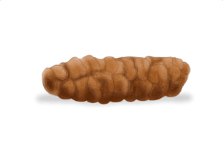  - Sausage or snake-like, smooth and soft (score = 4)  - Soft blobs with clear-cut edges (score = 5)  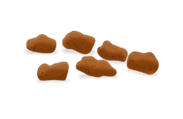  - Fluffy pieces with ragged edges, mushy (score = 6)  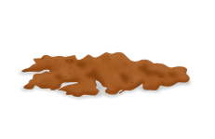  - Watery, no solid pieces (entirely liquid) (score = 7)  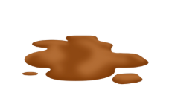  (Fecal score change is then calculated by subtracting fecal score on day 0 from fecal score on day 28)
Defecation frequency | Did Nom Nom have any effect on your dog's defecation frequency? | - Defecation became more frequent  - Defecation became less frequent  - No effect on defecation frequency
Flatulence frequency | Did Nom Nom have any effect on your dog's flatulence frequency? | - Flatulence became more frequent  - Flatulence became less frequent  - No effect on flatulence frequency
Coat condition | Did Nom Nom have any effect on your dog's coat condition? | - Coat condition improved  - Coat condition worsened  - No effect on coat condition
Appetite | Did Nom Nom have any effect on your dog's appetite? | - Appetite increased  - Appetite decreased  - No effect on appetite

