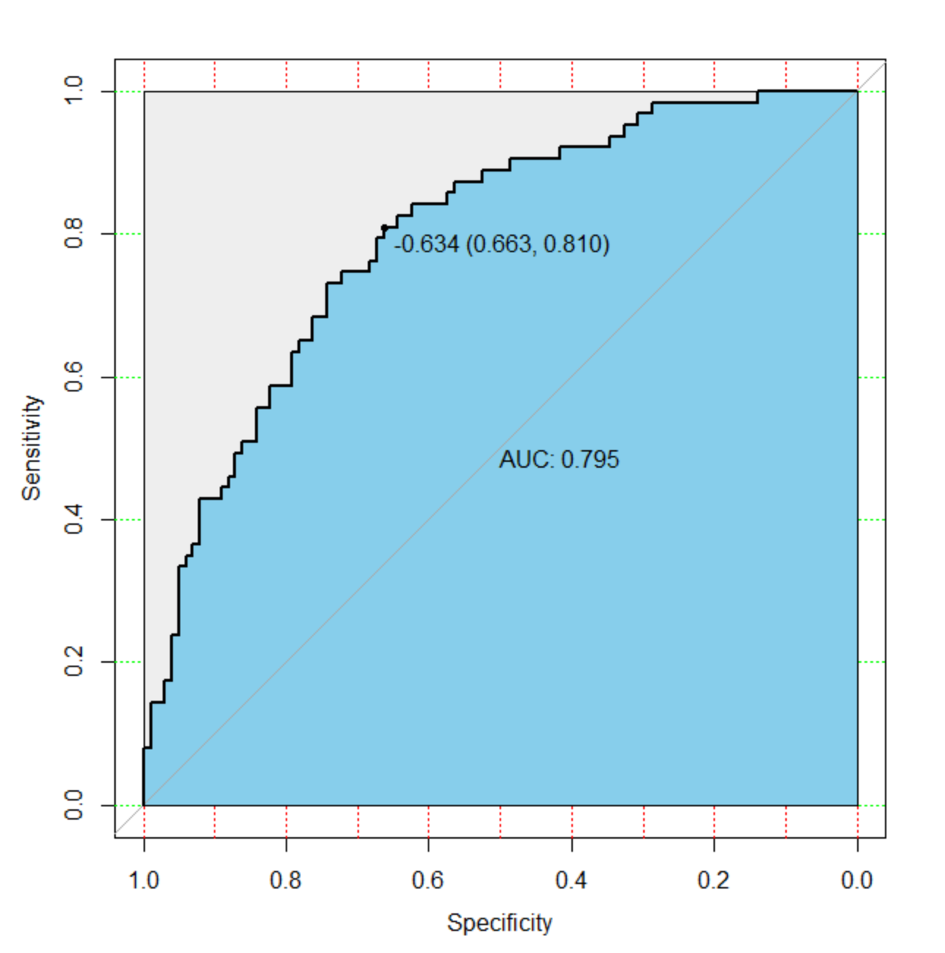
Figure 8.2 Receiver operating characteristic curves (ROC) for the preoperative index’s prediction model predicting postoperative hypokalemia in sensitivity analysis dataset. AUC, area under the curve.

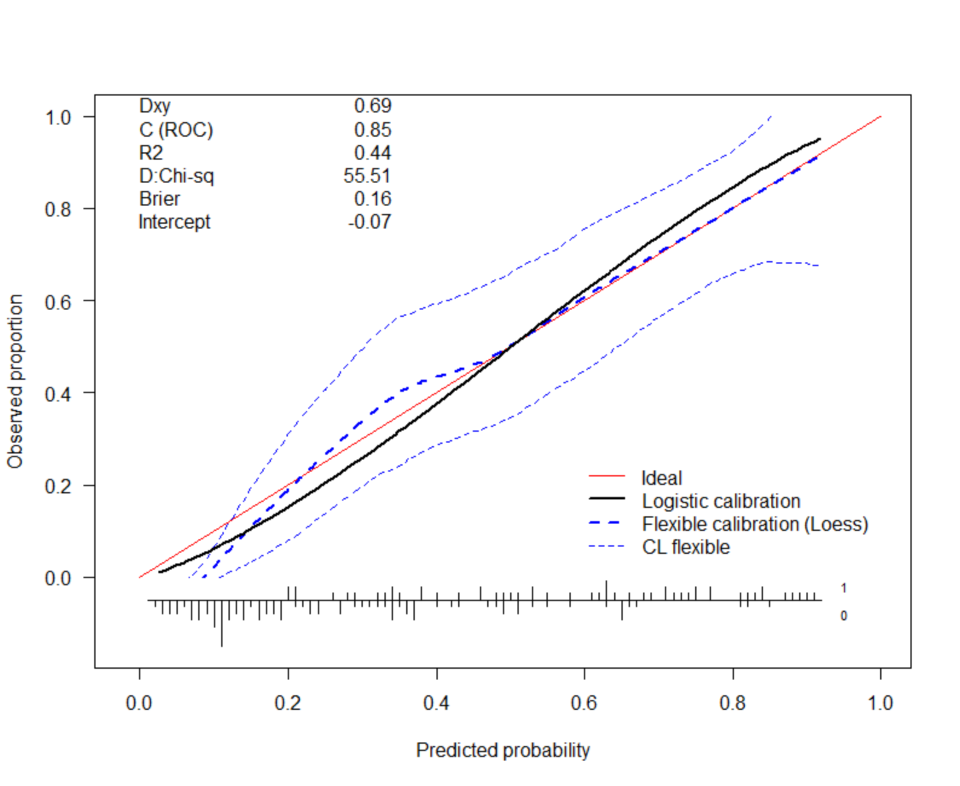
Figure 8.3 Calibration curve of the preoperative indices’ nomogram. The y-axis represents the actual postoperative hypokalemia rate. The x-axis represents the predicted postoperative hypokalemia risk. The diagonal dotted represents a perfect prediction by an ideal model. The dotted line represents the performance of the nomogram, of which a closer fit to the diagonal dotted line represents a better prediction.

