Supporting Materials
Table S1. data are obtained from published and/or public sources, namely Santos et al. (2018) and GBIF and SpeciesLink biodiversity information networks. Checklists for well-sampled communities identified in this study through the analysis of inventory completeness.
Longitude | Latitude
-50.36666667 | -29.4
-44.6129358 | -22.432586
-46.94628608 | -23.23589328
-48.8923108 | -25.9818594
-49.1020372 | -26.8707245
-52.4 | -27.05
-50.1744444 | -29.4808333
-50.26666667 | -29.58333333
-50.386914 | -29.423669
-53.838197 | -29.747514
-49.36666667 | -25.3
-51.170618 | -23.306445
-51.42111111 | -25.40222222
-51.94305556 | -23.43555556
-52.85666667 | -22.61833333
-54.66666667 | -27.51666667
-50.17777778 | -25.76027778
-53.84194444 | -25.15444444
-48.82222222 | -27.68583333
-49.117766 | -26.974148
-48.820565 | -26.351116
-49.121083 | -26.496003
-49.842142 | -27.456714
-50.660883 | -27.269972
-44.662222 | -22.375278
-42.94916667 | -22.49305556
-42.77166667 | -22.45388889
-42.60694444 | -22.40583333
-43.20472222 | -22.54416667
-43.00055556 | -22.455
-42.51361111 | -22.28
-43.09055556 | -22.64722222
-43.22916667 | -22.94611111
-43.30111111 | -22.54694444
-42.01416667 | -22.54361111
-42.26666667 | -22.52416667
-42.06694444 | -22.43972222
-39.94888889 | -18.43666667
-40.565 | -19.92916667
-40.53611111 | -20.04416667
-40.09583333 | -18.18361111
-40.08111111 | -19.43638889
-40.56111111 | -20.08222222
-40.87416667 | -19.62333333
-41.06388889 | -19.4675
-40.04555556 | -19.14861111
-41.84416667 | -20.41916667
-42.63333333 | -19.8
-43.998219 | -20.004822
-46.032097 | -22.877483
-46.33333333 | -22.9
-46.4425 | -23.99861111
-46.30388889 | -23.81527778
-52.16666667 | -22.45
-46.93555556 | -23.23111111
-46.99694444 | -23.71416667
-45.33333333 | -23.33333333
-47.10805556 | -22.82194444
-46.89138889 | -22.93194444
-47.05 | -22.93333333
-46.567749 | -23.137418
-47.42861111 | -21.85138889
-48.41861111 | -24.27833333
-46.92361111 | -22.82888889
-47.31888889 | -22.38111111
-49.50972222 | -20.825
-49.58916667 | -20.80638889
-45.53444444 | -22.72611111
-48.51666667 | -22.83333333
-46.8 | -21.46666667
-47.531903 | -22.421086
-47.28166667 | -21.32222222
-47.271435 | -20.664522
-46.8 | -22.43333333
-47.93333333 | -25.05
-44.844806 | -23.347353
-45.100175 | -23.328222
-45.17611111 | -23.47861111
-47.91666667 | -21.23333333
-45.52305556 | -22.83833333
-45.49277778 | -23.03694444
-39.71944444 | -13.59527778
-39.89222222 | -18.09027778
-39.57916667 | -15.71222222
-39.52333333 | -15.38111111
-40.4225 | -17.12694444
-39.088672 | -15.173781
-39.58583333 | -16.99861111
-38 | -12.25
-35.70916667 | -9.606111111
-35.86888889 | -8.995
-34.94722222 | -8.010833333
-35.03666667 | -7.964444444
-52.417097 | -31.676944
-43.8333 | -14.9333
-49.726016 | -24.305574
-50.15833333 | -25.09944444
-43.96888889 | -20.01027778
-47.89666667 | -22.26055556
-47.10638889 | -22.29916667
-47.80695556 | -21.60105556
-47.625408 | -21.623477
-47.461075 | -20.240917
-48.16666667 | -23.58333333
-50.13333333 | -22.66666667
-41.25027778 | -15.51388889
-50.611356 | -29.44282
-52.432475 | -31.814044
-49.853506 | -29.364375
-51.816454 | -20.993649
-53.889069 | -27.197939
-51.026006 | -30.369561
-51.111174 | -29.559801
-51.157301 | -30.098678
-46.57322491 | -21.76992582
-45.94766311 | -21.42964807
-39.11666667 | -12.65

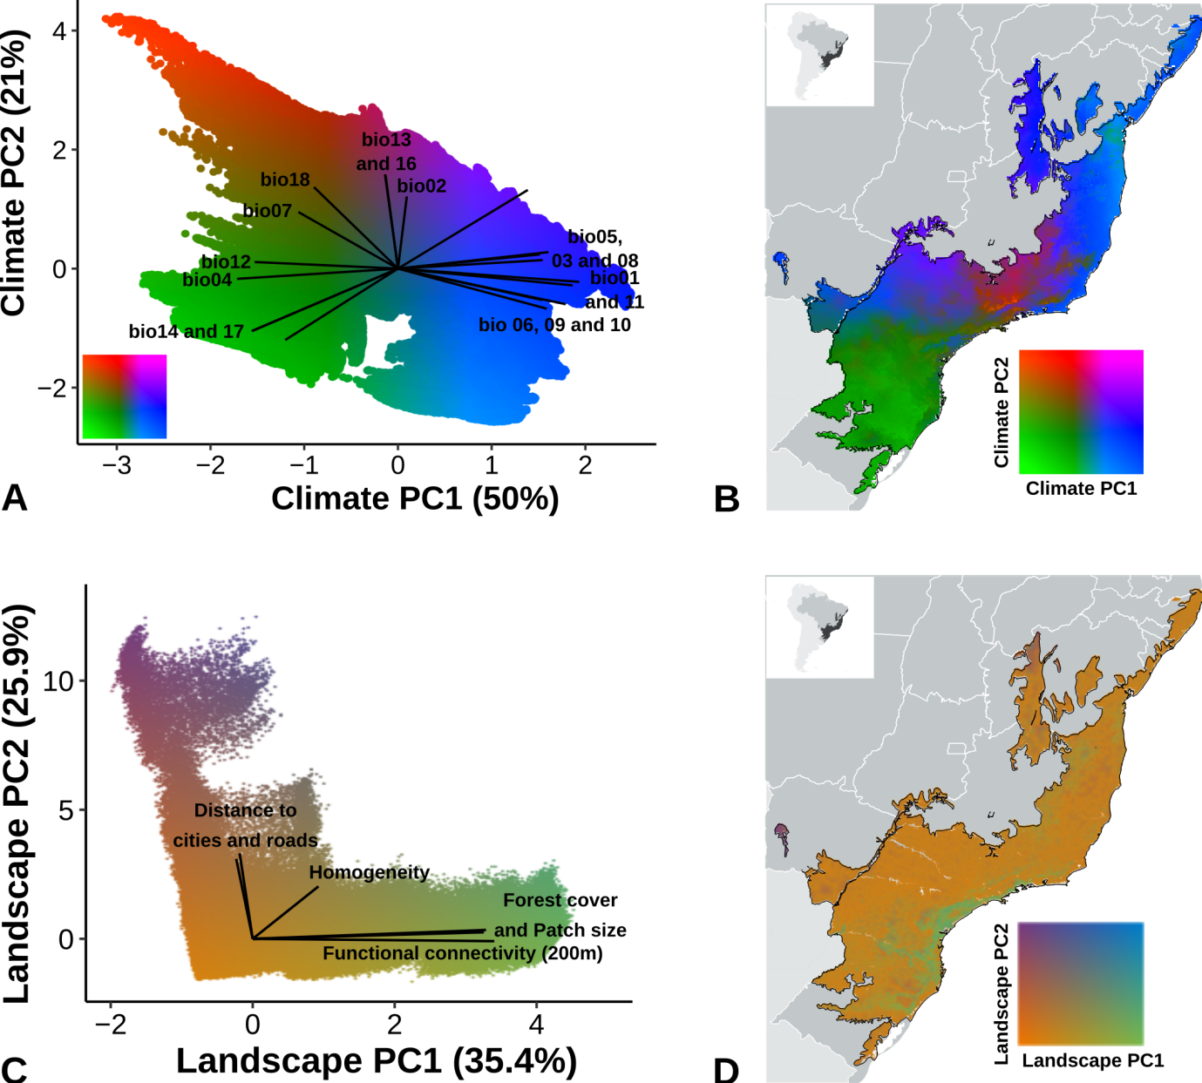
Fig S1. Results of PCA analyses, including the location of all Brazilian Atlantic Forest cells in the PCA axes, and the relationships of the vectors of the original variables with these axes. (a) climate variables (Bio01 – Bio19); (b) landscape metrics (200m functional connectivity, forest cover, patch size, homogeneity, distance to roads, distance to cities).

Table S2. The first four axes of both Principal Component Analysis (PCA) of climate (19 variables extracted from Fick & Hijmans, 2017) and landscape (five variables extracted from the Spatial Ecology and Conservation Laboratory, Ribeiro pers. comm.), and their respective scores. (SD = Standard deviation).
Variables | PC1 | PC2
Climate
Annual Mean Temperature | 0.932 | -0.141
Mean Diurnal Range (Mean of monthly (max temp − min temp)) | 0.047 | 0.606
Isothermality (Mean Diurnal Range/Temperature Annual Range) (×100) | 0.803 | 0.139
Temperature seasonality (SD × 100) | -0.858 | -0.086
Max Temperature of Warmest Month (MTWM) | 0.757 | 0.119
Min Temperature of Coldest Month (MTCM) | 0.895 | -0.299
Temperature Annual Range (MTWM‐MTCM) | -0.531 | 0.475
Mean Temperature of Wettest Quarter | 0.772 | 0.072
Mean Temperature of Driest Quarter | 0.794 | -0.337
Mean Temperature of Warmest Quarter | 0.770 | -0.264
Mean Temperature of Coldest Quarter | 0.967 | -0.112
Annual Precipitation | -0.765 | 0.055
Precipitation of Wettest Month | -0.069 | 0.792
Precipitation of Driest Month | -0.779 | -0.526
Precipitation Seasonality (Coefficient of Variation) | 0.693 | 0.661
Precipitation of Wettest Quarter | -0.067 | 0.785
Precipitation of Driest Quarter | -0.781 | -0.524
Precipitation of Warmest Quarter | -0.448 | 0.685
Precipitation of Coldest Quarter | -0.602 | -0.600
SD | 9.516 | 4.008
Proportion of Variance | 0.501 | 0.211
Cumulative Proportion | 0.501 | 0.712
Landscape
Proportion of habitat | 0.814 | 0.064
Fragment size | -0.058 | 0.774
Functional Connectivity | 0.851 | -0.023
Homogeneity | 0.232 | 0.508
Distance to urban areas | 0.822 | 0.086
Distance to roads | -0.046 | 0.828
SD | 2.121 | 1.555
Proportion of Variance | 0.354 | 0.259
Cumulative Proportion | 0.354 | 0.613

