Supplementary Material For:
The importance of spawning behavior in understanding the vulnerability of exploited marine fishes in the U.S. Gulf of Mexico
Christopher R. Biggs¹, William D. Heyman², Nicholas A. Farmer³, Shinichi Kobara⁴, Derek G. Bolser¹, Jan Robinson⁵, Susan K. Lowerre-Barbieri⁶, and Brad E. Erisman^{1,*}

Table S2.1 Spearman’s correlation coefficients (upper diagonal) and p-value (lower diagonal) of spawning behavior and life history parameters. Significant correlation values are in bold.

 |  | Correlation Coefficient
 |  | Agg | Duration | Rel. Ab. | A_{max} | W_{max} | L_{max} | K | L_{inf} | A_{m} | L_{m} | M
p-value | Agg | NA | -0.351 | 0.819 | -0.110 | 0.174 | 0.037 | -0.028 | 0.189 | 0.202 | 0.358 | -0.089
 | Duration | 0.06 | NA | -0.538 | 0.197 | -0.048 | 0.006 | -0.526 | 0.195 | 0.191 | 0.087 | 0.012
 | Rel. Ab. | 0.00 | 0.01 | NA | -0.192 | 0.077 | -0.050 | 0.203 | -0.015 | 0.062 | 0.220 | 0.005
 | A_{max} | 0.58 | 0.31 | 0.33 | NA | 0.431 | 0.353 | -0.362 | 0.377 | 0.628 | 0.314 | -0.839
 | W_{max} | 0.38 | 0.81 | 0.70 | 0.02 | NA | 0.919 | -0.281 | 0.908 | 0.652 | 0.875 | -0.519
 | L_{max} | 0.85 | 0.98 | 0.80 | 0.07 | 0.00 | NA | -0.212 | 0.844 | 0.524 | 0.844 | -0.465
 | K | 0.89 | 0.01 | 0.30 | 0.06 | 0.15 | 0.28 | NA | -0.410 | -0.442 | -0.274 | 0.248
 | L_{inf} | 0.33 | 0.32 | 0.94 | 0.05 | 0.00 | 0.00 | 0.03 | NA | 0.631 | 0.877 | -0.478
 | A_{m} | 0.30 | 0.33 | 0.75 | 0.00 | 0.00 | 0.00 | 0.02 | 0.00 | NA | 0.726 | -0.495
 | L_{m} | 0.06 | 0.66 | 0.26 | 0.10 | 0.00 | 0.00 | 0.16 | 0.00 | 0.00 | NA | -0.323
 | M | 0.67 | 0.95 | 0.98 | 0.00 | 0.01 | 0.02 | 0.22 | 0.01 | 0.01 | 0.11 | NA

Table S2.2 Eigenvalues and percentage variation explained by the seven principal components axes using life history traits and spawning behavior parameters for the 28 species, and eigenvectors for each of the seven measurement indices.
 | Principal component
Measure | 1 | 2 | 3 | 4 | 5 | 6 | 7 | 8 | 9 | 10
Eigenvalues | 2.083 | 1.498 | 1.168 | 0.890 | 0.738 | 0.557 | 0.478 | 0.340 | 0.238 | 0.192
Variation explained (%) | 0.434 | 0.221 | 0.136 | 0.080 | 0.055 | 0.031 | 0.023 | 0.010 | 0.006 | 0.004
Cumulative variance (%) | 0.434 | 0.655 | 0.791 | 0.871 | 0.926 | 0.957 | 0.980 | 0.990 | 0.996 | 1.000
Eigenvectors
Agg | -0.141 | 0.495 | -0.382 | 0.290 | -0.280 | 0.208 | -0.216 | 0.572 | -0.004 | 0.098
Duration | -0.082 | -0.473 | -0.148 | 0.582 | -0.554 | 0.044 | 0.067 | -0.281 | 0.100 | 0.087
Rel. Ab. | -0.013 | 0.567 | -0.402 | 0.019 | 0.022 | 0.003 | 0.274 | -0.664 | 0.006 | 0.025
A_{max} | -0.215 | -0.327 | -0.443 | -0.471 | -0.025 | 0.614 | -0.021 | -0.035 | 0.063 | -0.214
W_{max} | -0.407 | 0.131 | 0.267 | -0.025 | -0.002 | 0.066 | -0.747 | -0.345 | 0.232 | 0.100
L_{max} | -0.417 | 0.067 | 0.318 | -0.083 | 0.002 | 0.240 | 0.498 | 0.101 | 0.301 | 0.555
K | 0.271 | 0.200 | 0.329 | -0.425 | -0.737 | 0.101 | 0.002 | -0.070 | -0.199 | 0.006
L_{inf} | -0.442 | 0.029 | 0.218 | 0.195 | 0.077 | 0.197 | 0.095 | -0.063 | -0.797 | -0.159
A_{m} | -0.345 | -0.169 | -0.369 | -0.356 | -0.149 | -0.602 | -0.067 | 0.051 | -0.251 | 0.367
L_{m} | -0.446 | 0.113 | 0.102 | -0.047 | -0.207 | -0.323 | 0.233 | 0.107 | 0.323 | -0.677

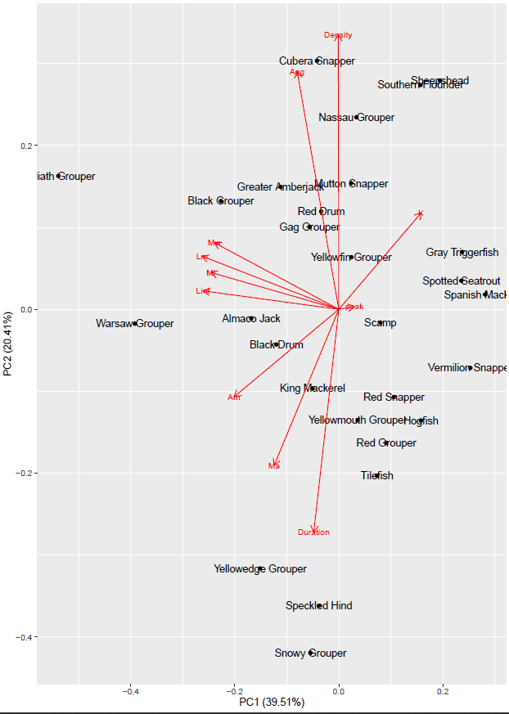
Figure S2.1 Biplot of PCA showing the first two principal components and including Peak Spawning Months. The arrows show the relative loadings of each PC axis.

