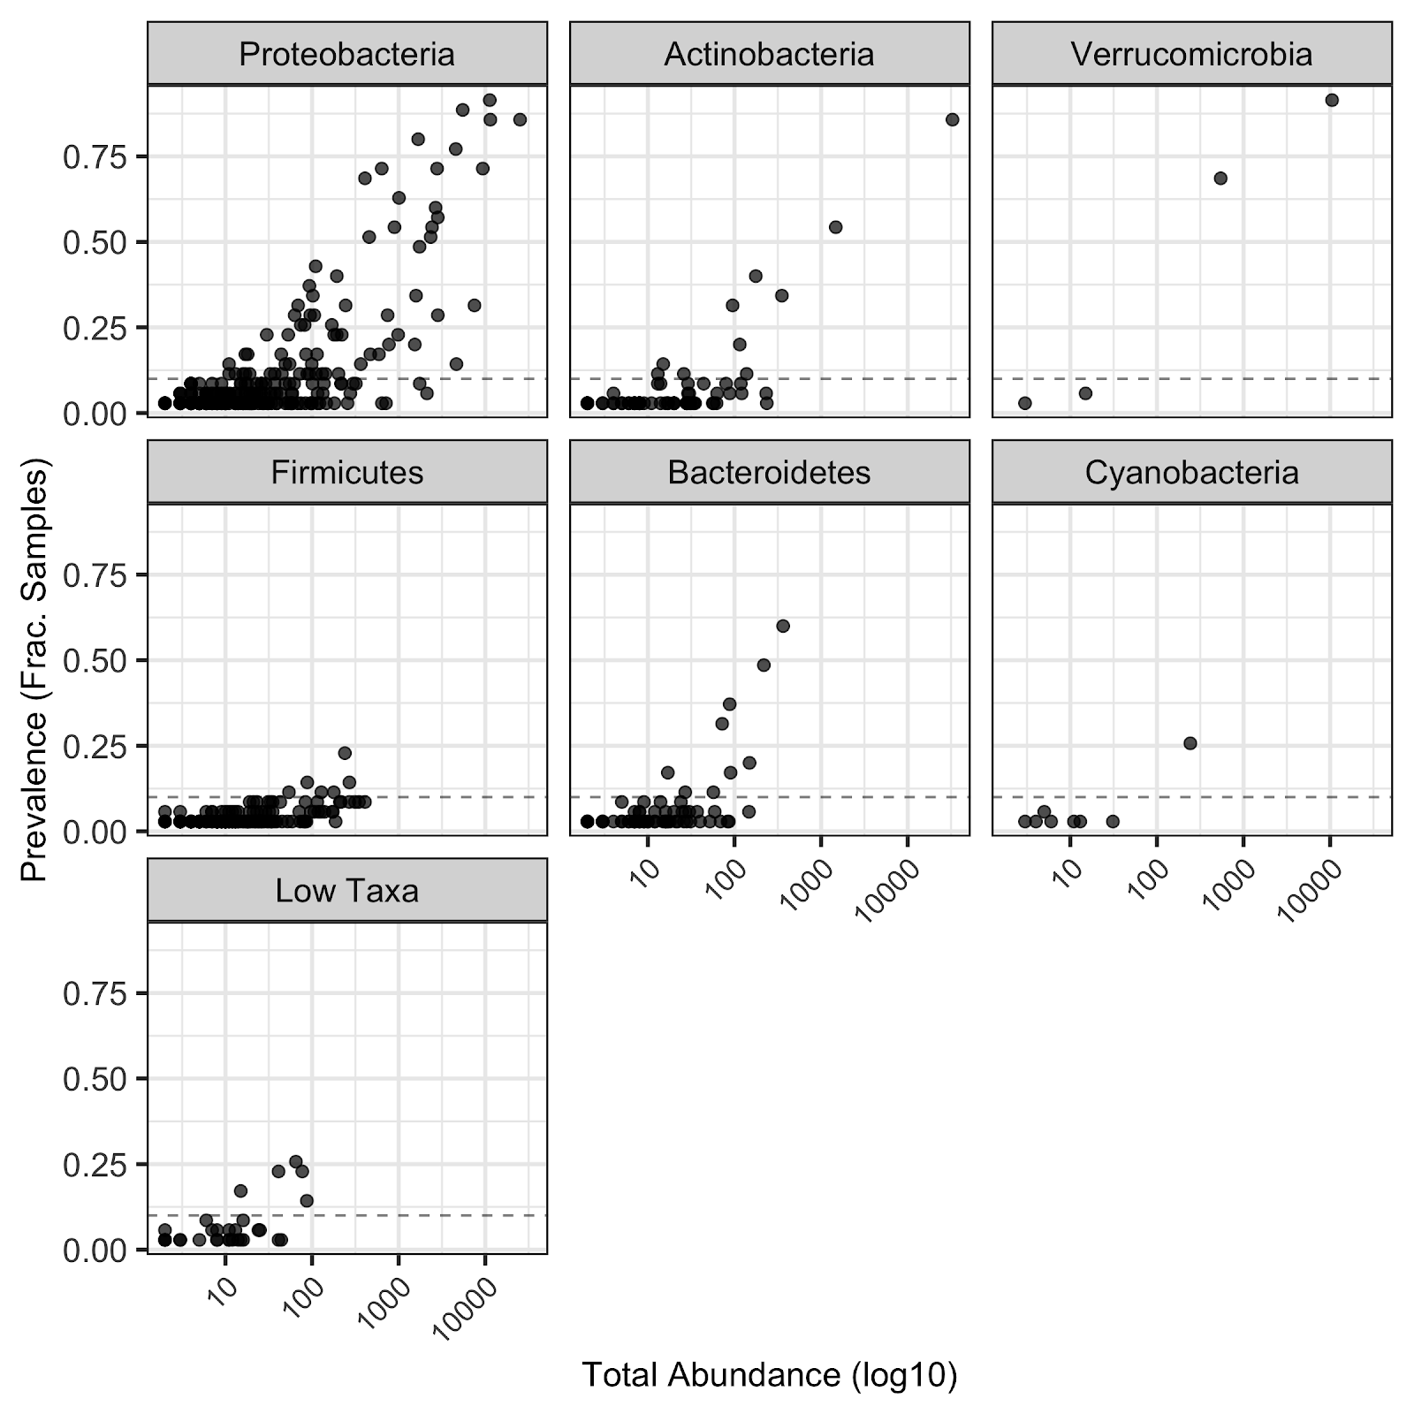

**Figure S2.** The Fraction of Prevalence (y - axis) versus Total abundance (x axis) shows a positive relationship: Proteobacteria (0.643), Actinobacteria (0.743), Verrucomicrobia (0.767), Firmicutes (0.614), Bacteroidetes (0.831), Cyanobacteria (0.983). Low taxa are the group of taxa with abundance lower than 1% of the total abundance.