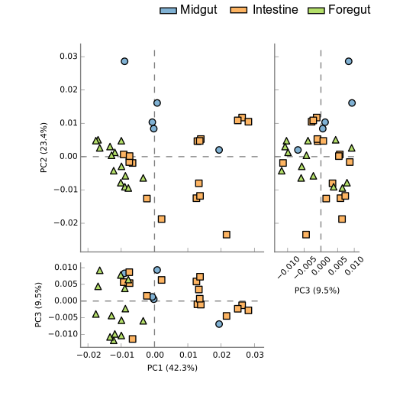

**Figure S4.** Principal component analysis (PCA) profile of predicted functions from digestive tract microbiota of white shrimp (Litopenaeus vannamei). The percentage of variation explained by PC1, PC2, and PC3 are indicated in the axis. Different colors represent different samples. Comparison of predicted microbial function among groups based on KEGG level-3.