Dataset S1: The raw data of Figure 1 (WB).
Protein name | Protein bands | Protein bands (original)
- mTOR  (289kD) |  | 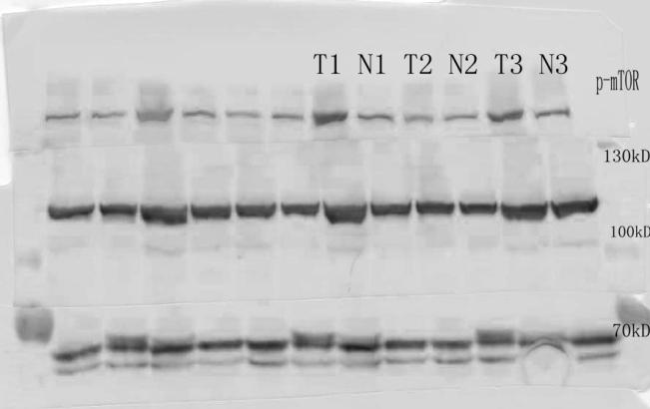
mTOR  (289kD) |  | 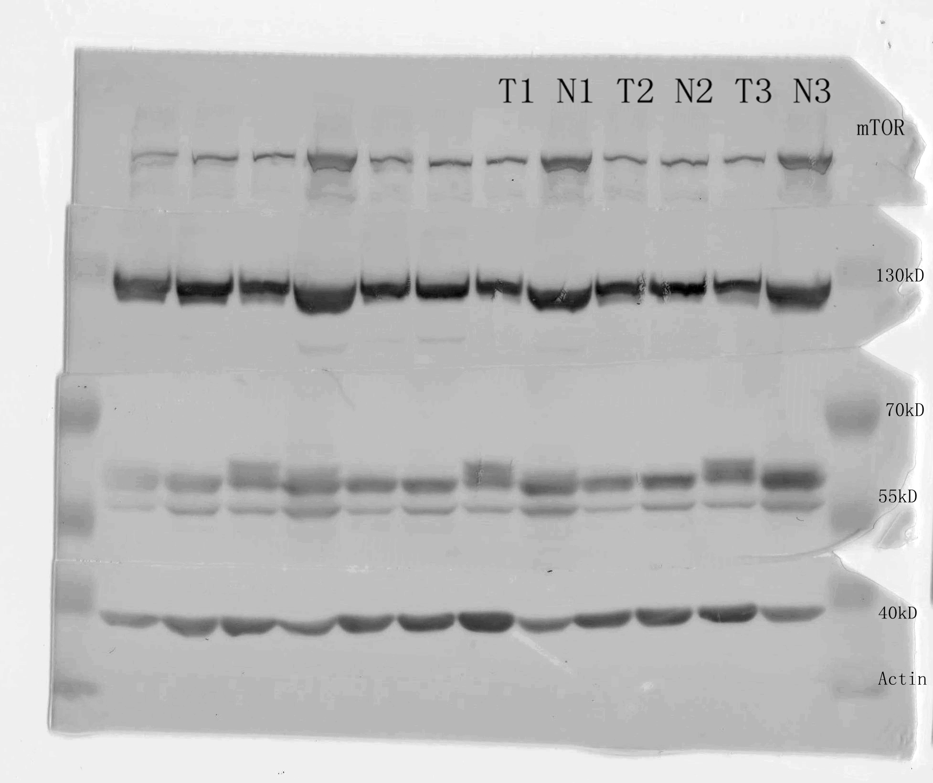
Actin
(43kD)
Note: 1. The blots with same amount of protein, i.e., p-mTOR, mTOR and Actin.
Abbreviation. N: normal kidney tissue, T: ccRCC; M: Marker.

