Full-length uncropped blots
Materials and methods of Western blot assay
Cells were collected, lysed with RIPA lysis buffer, and then centrifuged at 12,000 rpm at 4°C for 15 min. The total protein concentration was measured with a BCA protein assay kit (Beijing Solarbio). The proteins were then heated at 100°C for 5 min for denaturation. Equal amounts of total protein (25 μg per lane) were loaded on 12% SDS-PAGE gels and separated. After sample loading, the voltage was set to 90 V and then to 120 V until the sample reached the bottom of the gel. The proteins were then transferred to a nitrocellulose (NC) film by the sandwich method. The membrane was washed three times with TBST and then blocked with 5% skimmed milk. The membrane was then incubated for 12 h at 4°C with a GAPDH antibody (1:1000, Proteintech Group), TDP-43 antibody (1:1000, Proteintech Group), and CytC antibody (1:1000, Proteintech Group). The membrane was washed with TBST 3 times and incubated with HRP-conjugated Affinipure goat anti-rabbit lgG (H+L) (1:1000, Proteintech Group) for 2 h at room temperature. The membranes were developed using hydrogen peroxide and Supersignal West Pico Luminol (Pierce, Seymour Fisher Technologies). Finally, High-Sig ECL Western Blotting Substrate (Shanghai Tanon Technology Co., Ltd.) was used to visualize the membrane.
Figure 1 Establishment of the TDP-43-transfected SH-SY5Y cell model.
(E) Expression of TDP-43 in SH-SY5Y cells transfected with TDP-43.
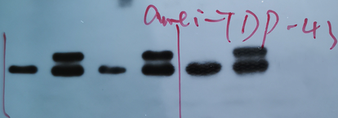
TDP-43-From left to right are Control, TDP-43, Control, TDP-43, Control, TDP-43 group.
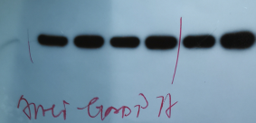
GAPDH-From left to right are Control, TDP-43, Control, TDP-43, Control, TDP-43 group.

Figure 3 Influence of ICT treatment on TDP-43 expression in the control group compared with the TDP-43 group.
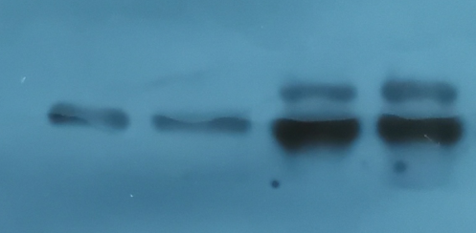
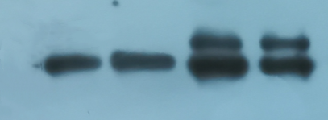
TDP-43-From left to right are Control, Control + ICT, TDP-43, TDP-43 + ICT group.
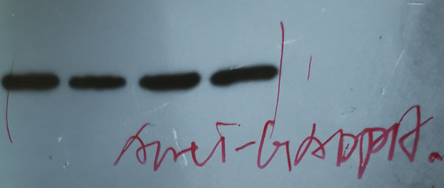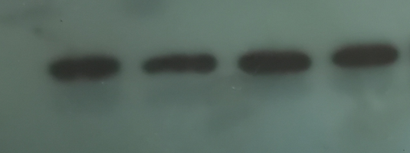
GAPDH-From left to right are Control, Control + ICT, TDP-43, TDP-43 + ICT group.

Figure 4 Effects of ICT on the MMP, ATP content and CytC expression in TDP-43-transfected SH-SY5Y cells.
(D) Influence of ICT on CytC expression in the model cells.
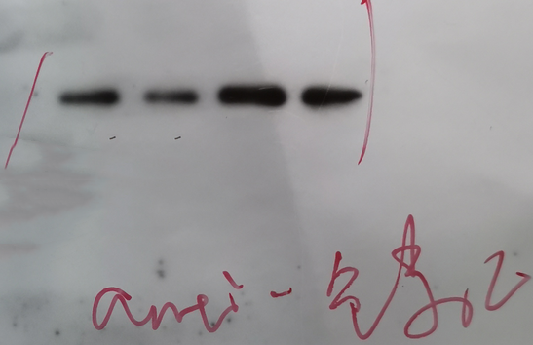
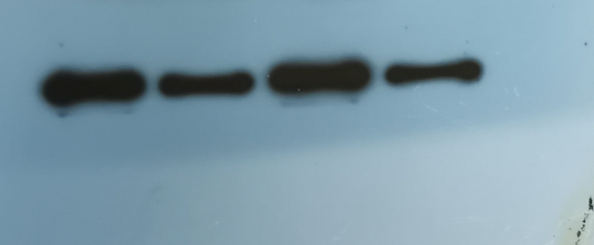
CytC-From left to right are Control, Control + ICT, TDP-43, TDP-43 + ICT group.
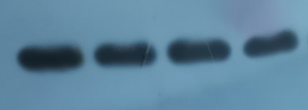
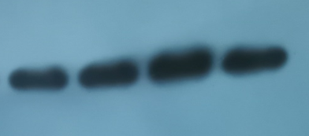
GAPDH-From left to right are Control, Control + ICT, TDP-43, TDP-43 + ICT group.

