Supplementary Materials for:
LitR upregulates luxICDABE genes of bacteria from Aliivibrio genus.
Bazhenov S.V., Melkina O.E., Fomin V.V., Scheglova E.S., Krasnik P.V., Khrulnova S.A., Zavilgelsky G.B., Manukhov I.V.

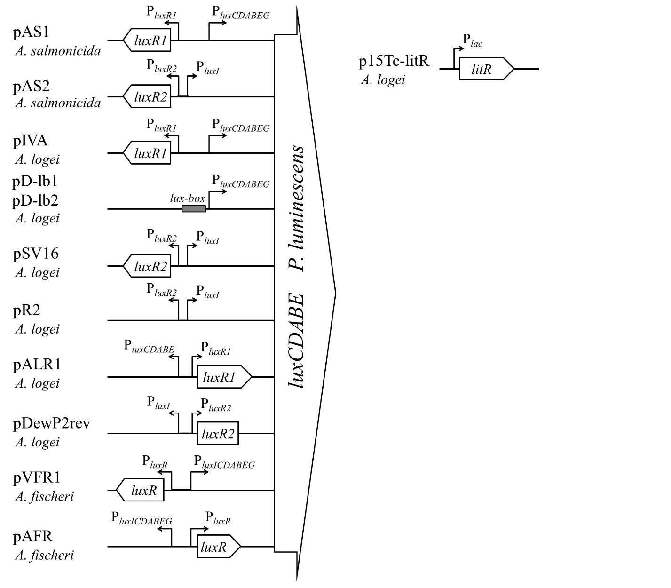
Figure S1 Schemes of used in the study plasmids. Left part of the figure shows promoters and genes being inserted in the pDEW201 promoter probe vector with luxCDABE Photorhabdus luminescens genes with references to biosensor plasmids names. pD-lb1 and pD-lb2 differ only by 5 bp in lux-box. Right part of the figure shows p15Tc-litR.

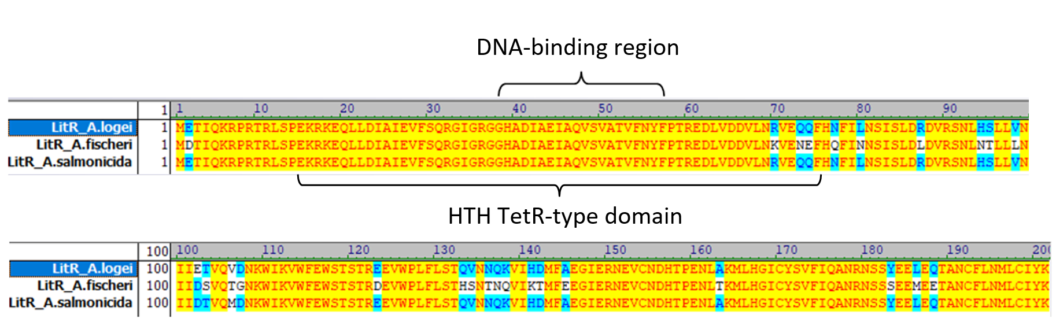
Figure S2 Alignment of amino acid sequences of LitR of Aliivibrio logei, Aliivibrio fischeri, and Aliivibrio salmonicida. DNA-binding region (38-57) and HTH domain are marked with bracket according to UniProt data (A0A1B9P2H3_ALILO, Q5E2S4_ALIF1, and B6ELF1_ALISL, correspondently)
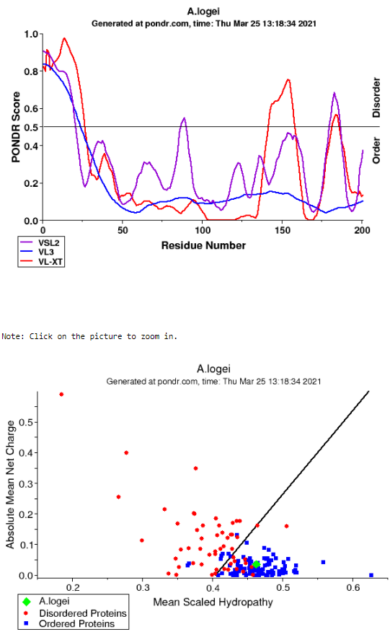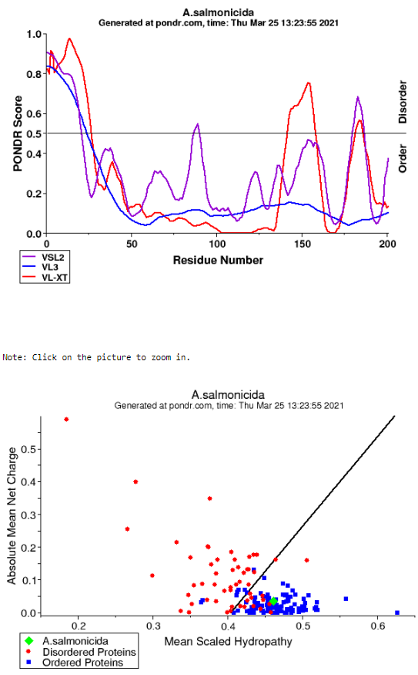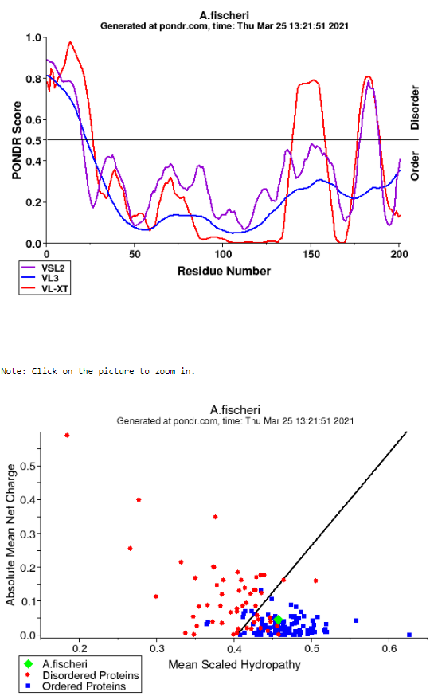
Figure S3 Analysis of natural disordered regions of LitR proteins from A. logei, A. fischeri, and A. salmonicida with VL-XT, VSL2, VL3, and Charge-Hydropathy instruments at pondr.com (A0A1B9P2H3_ALILO, Q5E2S4_ALIF1, and B6ELF1_ALISL, correspondently)

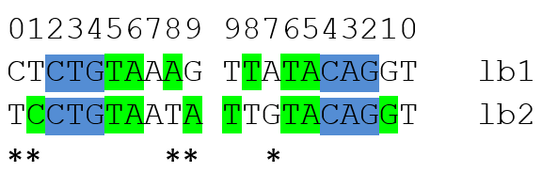
Figure S4 Alignment of nucleotide sequence of lux-boxes from A. logei P_{luxCDABEG} (lb1) and P_{luxI} (lb2). lux-box is 20-bp inverted repeat in promoter upstream region - Aliivibrio LuxR binding site. Dark blue highlights core positions essential for LuxR binding, green – palindromic positions. Stars marks 5 positions, in which lux-boxes from A. logei P_{luxCDABEG} and P_{luxI} differ.

Plasmid constructing
p15Tc-litR plasmid (sequence in GenBank format is given as separate file in Supplementary) was constructed on base of p15Tc-lac vector (Bazhenov et al., 2021), litR gene was amplified with primers litRDEco and litRRKpn from gDNA of A. logei Skal and inserted in EcoRI/KpnI restriction sites of p15Tc-lac.
pAS1 and pAS2 plasmids were obtained by introducing into pDEW201 promoter-probe vector by EcoRI/BamHI restriction sites of two fragments of A. logei KCh1 gDNA: (1) luxR1 gene with P_{luxR1} and P_{luxCDABEG} promoters and (2) luxR2 gene with P_{luxR2} and P_{luxI} promotes. Fragment (1) was amplified with use of luxR1(end) and SV1dir primers, fragment (2) ― luxR2(RevSt) and revpl1 primers. The PCR products were cloned into pTZ57R/T vector (Fermentas, USA) and then were transferred to pDEW201 by EcoRI and BamHI restriction sites.
To obtain the pR2 and pDewP2rev plasmids DNA fragment of KCh1 gDNA, containing divergent P_{luxI} and P_{luxR2} promoters, was amplified with use of P2Irev and P2R2rev primers and then was introduced into EcoRI site of pDEW201. Two opposite orientations of insertion gave two lux-reporter plasmids: lux-reporter for A. logei P_{luxI} where P. luminescens luxCDABE genes are fused with P_{luxI}; and lux-reporter for P_{luxR2}, correspondently.
For constructing of pDlb1 plasmid P_{luxCDABEG} promoter of A. logei KCh1 was amplified with use of luxCrevR1 and lb1Dir primers, subcloned into pTZ57R/T vector and transferred to pDEW201 into EcoRI/BamHI restriction sites upstream from P. luminescens luxCDABE. To obtain pDlb2 plasmid the same operations were done, but luxCrevR1 and lb2Dir primers were used. Use of lb1Dir or lb2Dir primers generate two variants of the lux-box sequence (Figure S4) in cloned P_{luxCDABEG} promoter in pDlb1 and pDlb2.

Table S1 Oligonucleotides used for cloning promoters into promoter-probe vector and litR under P_{tac} promoter in this study.
Nucleotides, which are complementary to matrix, are given in bold, 5’ region of most primers have adapters for cloning through Gibson Assembly or restriction/ligation.
Primer | Sequence, 5’-3’
litRDEco | GAATTCATGGAAACGATCCAAAAAAGACCGA
litRRKpn | GGTACCATTATTTATAAATACACAGCATATTTAAGAAGCAG
lb1Dir | GATACTCTGTAAAGTTATACAGGTTTACCTA
lb2Dir | GATTTCCTGTAATATTGTACAGGTTTACCTAAATAATTACCCTGCTA
luxCrevR1 | GACACCGCCGATGATAATTGGA
P2Irev | GAATTCCCTGACCCCCTTTAATCTTTTAACTG
P2R2rev | GAATTCGTAGTTATCTAAAATTTTAATATCAGATTTGATCATGG
luxR2(RevSt) | TGAAAATTAGAAGTCCGACTGCGT
Revpl1 | GTCATCCTGACCCCCTTTAATCTTT
SV1dir | TCACACCGCCGATGATAATTGGAA
luxR1(end) | GGCCGAATTGTATGTAAAAATAAATGAG

