Full-length gels which have been cropped in the main text

**RT-PCR results in Figure 11 of the main text, red lines represent cropping lines. All gels have been run under the same experimental conditions. DL 1,000 DNA Marker has been used in the experiment. From top to bottom in the lane, the DNA marker size is 1,000bp, 700bp, 500bp, 400bp, 300bp, 200bp and 100bp.**

1.Pt-GPCR-A1

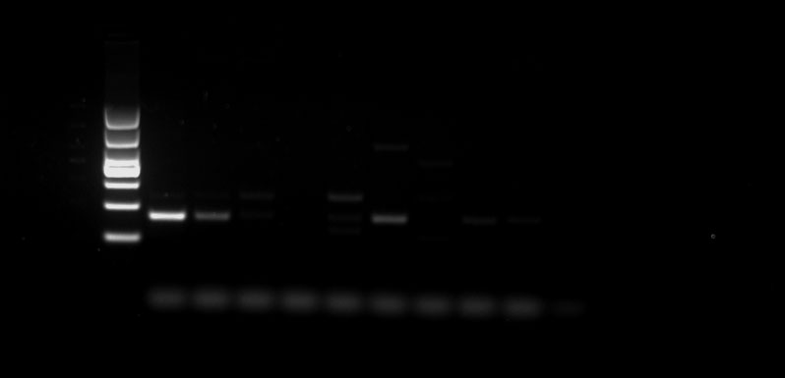

2.Pt-GPCR-A2

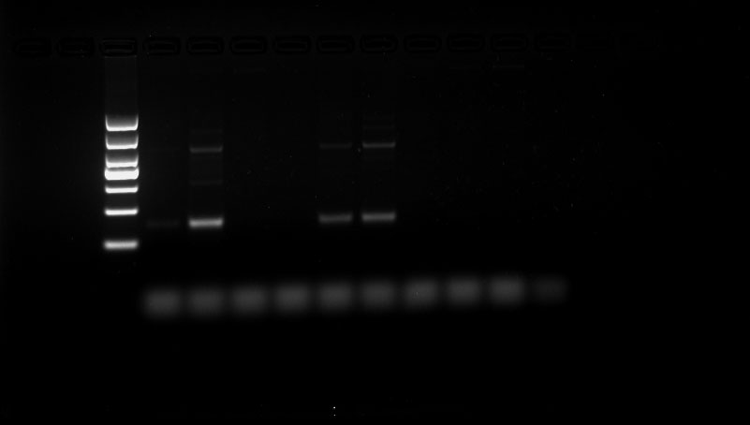

3.Pt-GPCR-A4

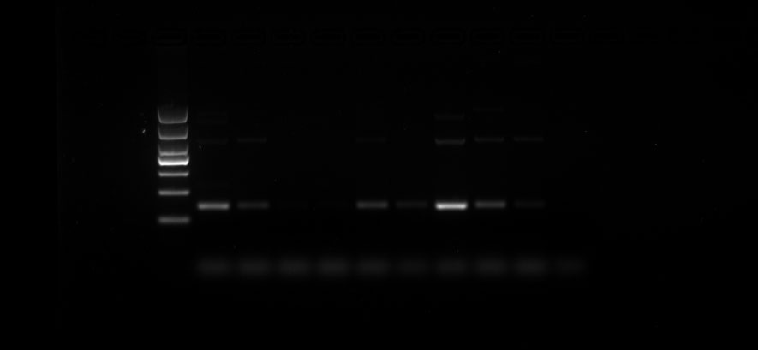

4.Pt-GPCR-A7

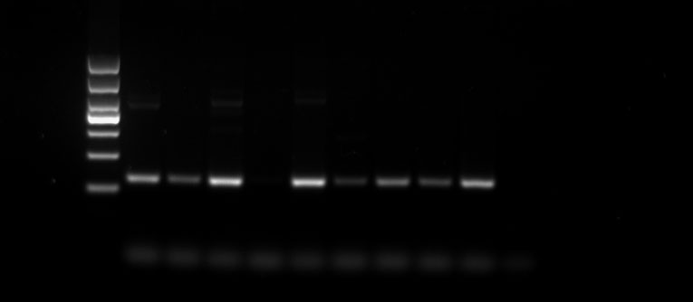

5.Pt-GPCR-A8

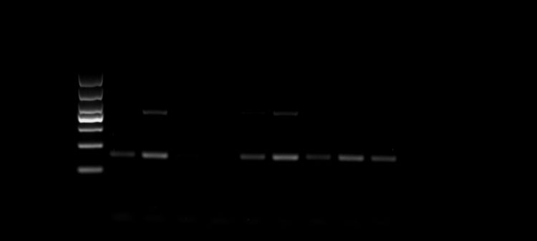

6.Pt-GPCR-A9

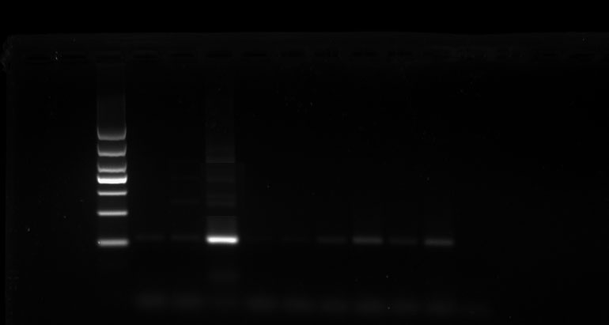

7.Pt-GPCR-A11

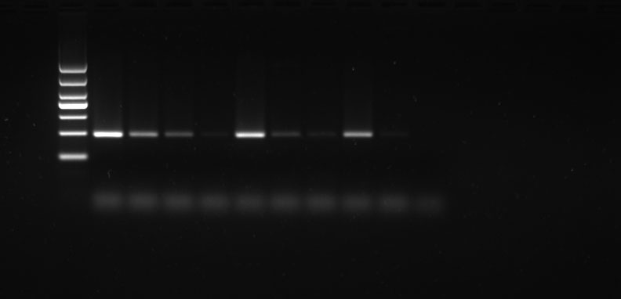

8.Pt-GPCR-A12

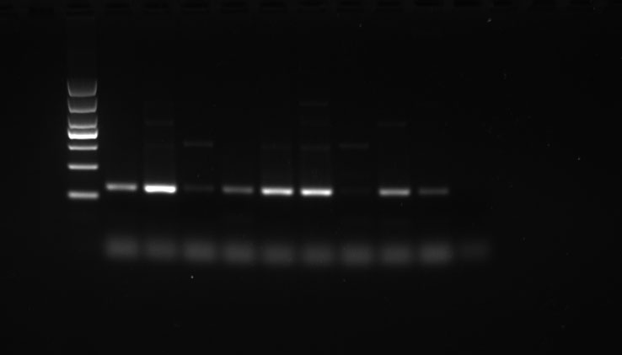

9.Pt-GPCR-A13

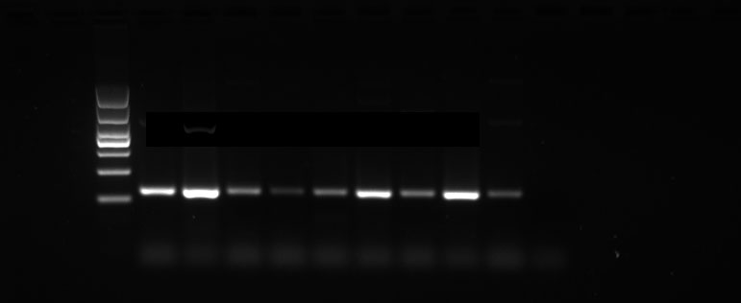

10.Pt-GPCR-A14

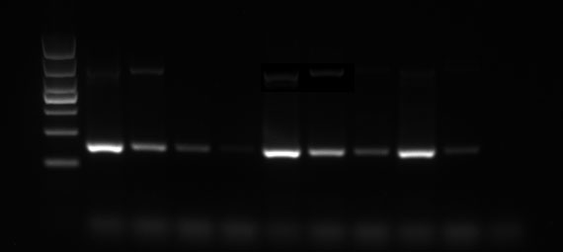

11.Pt-GPCR-A16

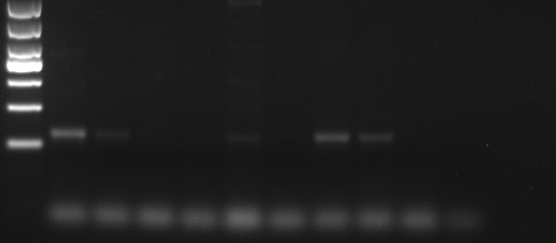

12.Pt-GPCR-A18

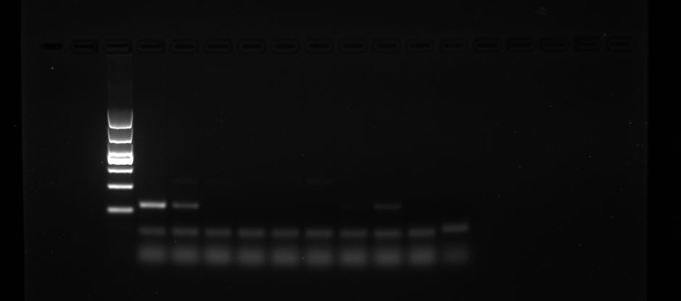

13.Pt-GPCR-A19

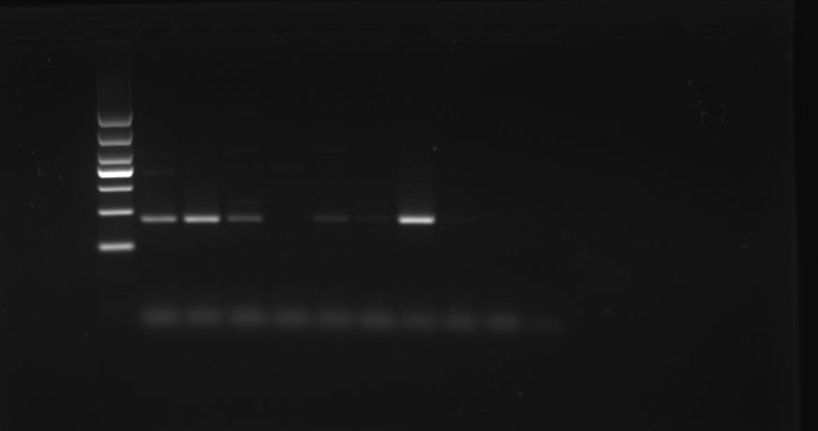

14.Pt-GPCR-A21

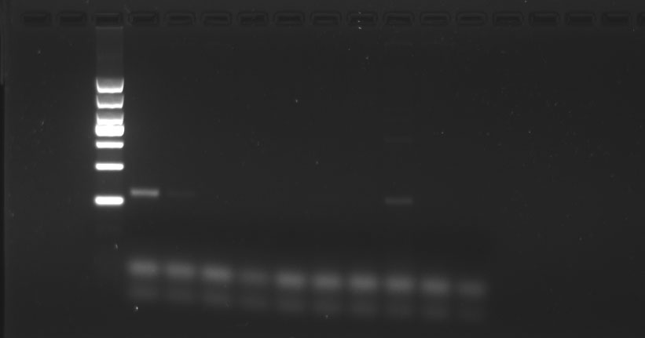

15.Pt-GPCR-A23

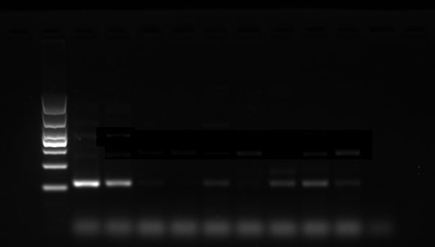

16.Pt-GPCR-A24

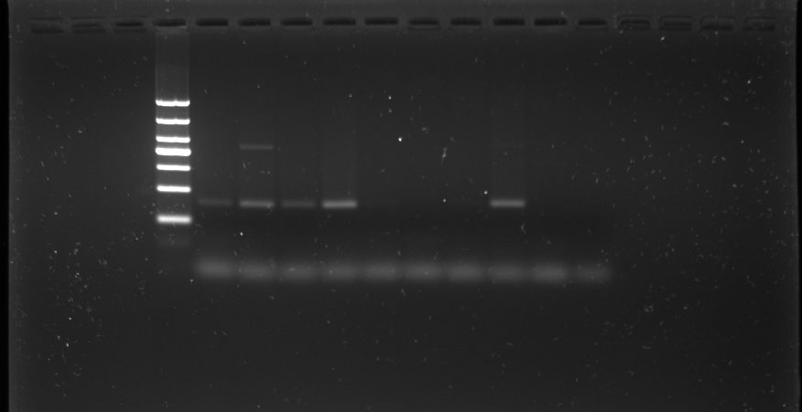

17.Pt-GPCR-A25

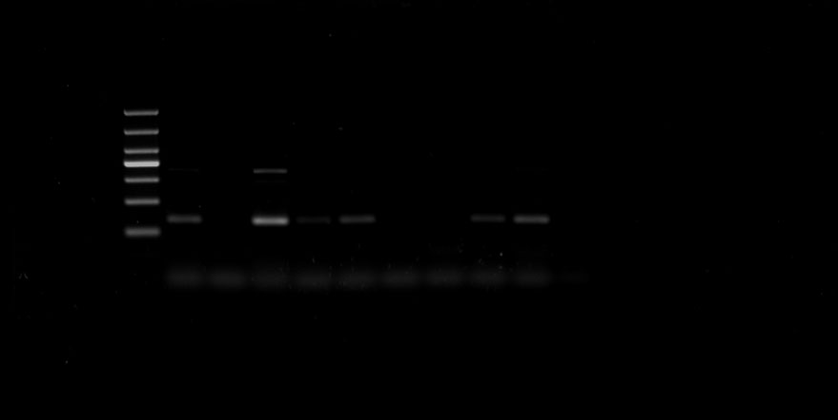

18.Pt-GPCR-A26

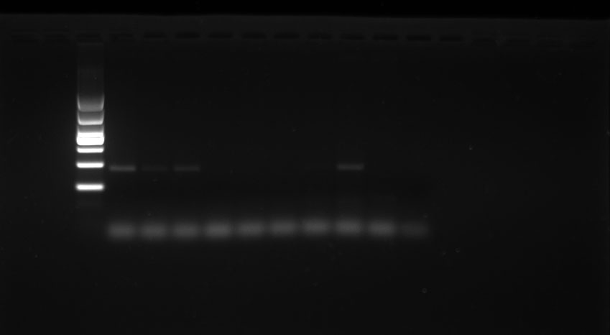

19.Pt-GPCR-A27

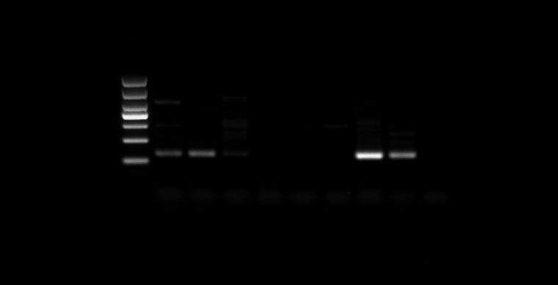

20.Pt-GPCR-A28

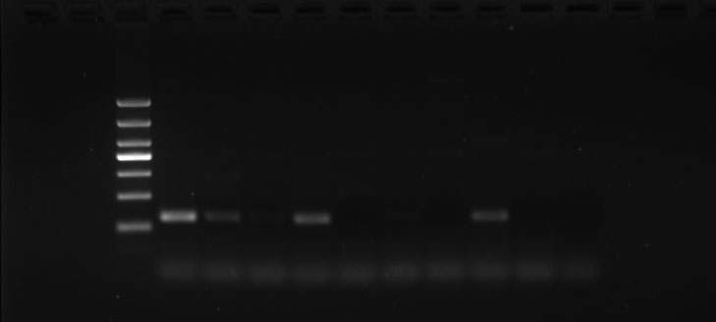

21.Pt-GPCR-A29

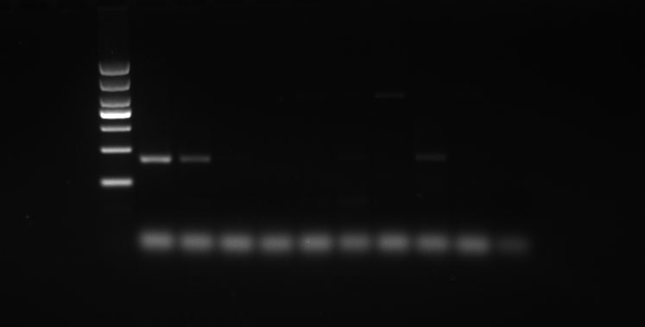

22.Pt-GPCR-A32

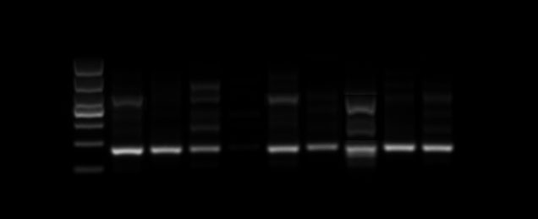

23.Pt-GPCR-A33

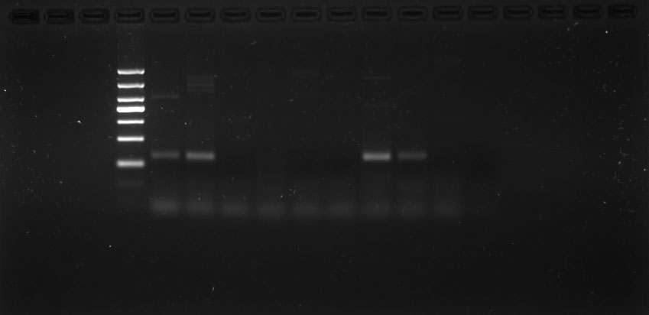

24.Pt-GPCR-A34

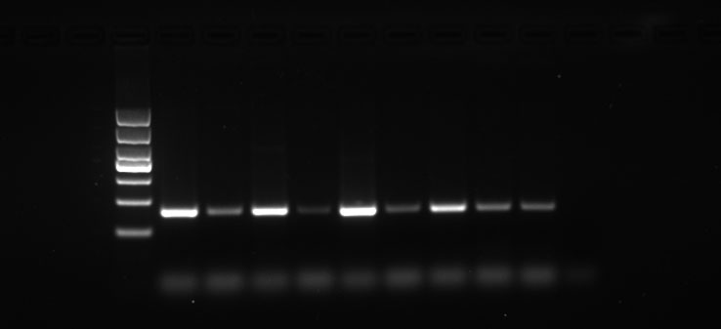

25.Pt-GPCR-A36

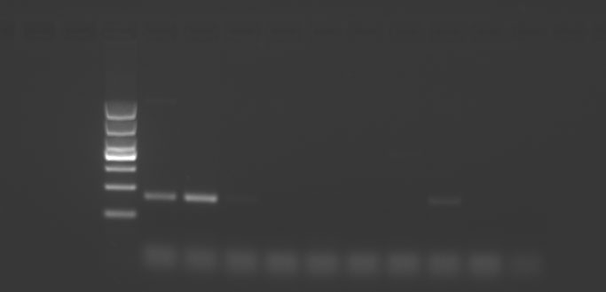

26.Pt-GPCR-A37

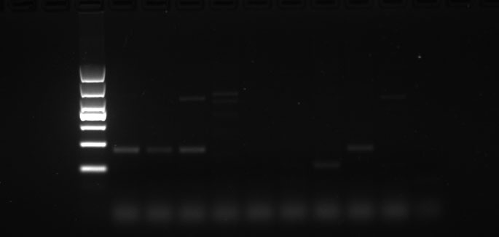

27.Pt-GPCR-A39

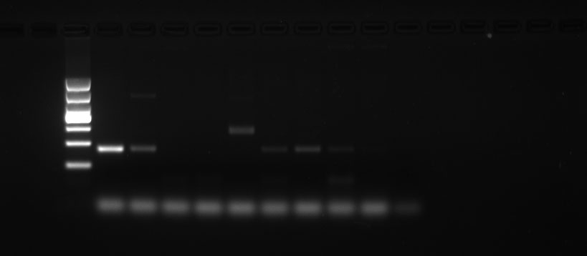

28.Pt-GPCR-B2

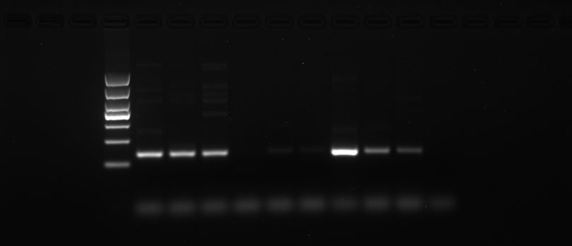

29.Pt-GPCR-B4

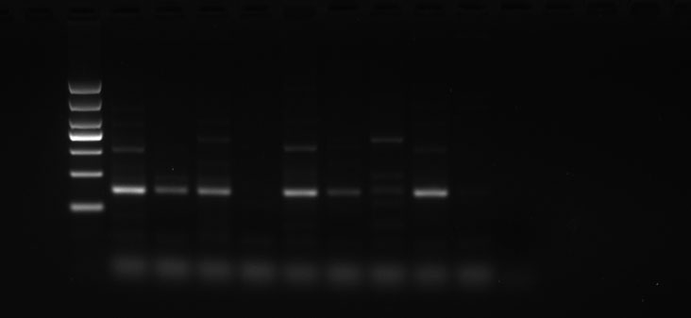

30.Pt-GPCR-B5

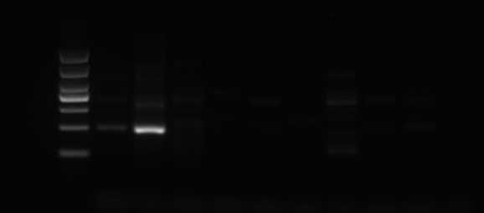

31.Pt-GPCR-B6

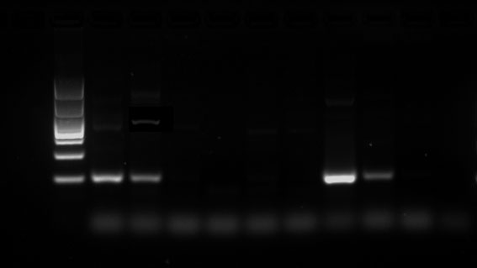

32.Pt-GPCR-B7

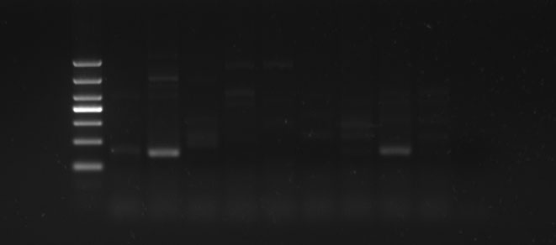

33.Pt-GPCR-B8

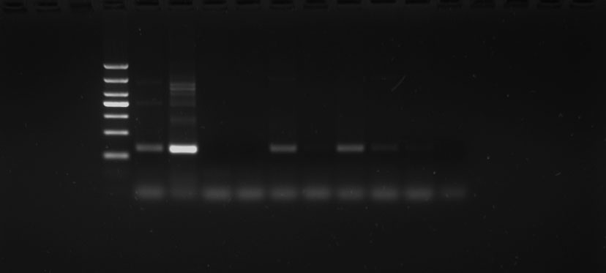

34. β-actin

